Project Based Evaluation

Software Requirements Specification
Semester-IV (Batch 2023)

Library Management System



Submitted to: Submitted by:
Dr. Rajender Kumar Name: Karunya Gupta
Roll No: 2310990625
Group: 8A

Department of Computer Science and Engineering
Chitkara University Institute of Engineering and Technology,
Chitkara University, Punjab
Table Of Content

Sr. No. | Content | Page Number
1 | Introduction | 1
2 | Overall Description | 2-3
3 | System Feature | 4-6
4 | External Interface Requirement | 7-8
5 | Non-functional Requirement | 9-10

Introduction
The Library Management System is a comprehensive Java-based software solution designed to automate and streamline library operations. This system provides an efficient way to manage books, handle member registrations, and track borrowing activities in a library setting.
1.1 Purpose
The Library Management System aims to develop a comprehensive software solution for managing all aspects of library operations, from book inventory and member management to borrowing transactions and fine calculations, enhancing efficiency and accessibility.
1.2 Document Conventions
LMS | Library Management System
DB | Database
OOP | Object Oriented Programming
GUI | Graphical User Interface
CLI | Command Line Interface

1.3 Intended Audience and Reading Suggestions
This project serves as a prototype for a library management system implemented in Java. Target audiences include:
- Library administrators and staff
- Software developers and maintainers
- System administrators
- Academic supervisors and reviewers
1.4 Project Scope
The Library Management System provides:
- Computerized book inventory management
- Member registration and tracking
- Automated borrowing and return processing
- Fine calculation system
- Report generation capabilities
- Data persistence through file storage
- Command-line interface for all operations

Overall Description
2.1 Product Perspective
The system maintains the following information:
- Book details: ISBN, title, author, category, availability status
- Member information: ID, name, contact details, borrowed books
- Transaction records: borrowing dates, due dates, return dates
- Fine calculations: overdue amounts, payment status
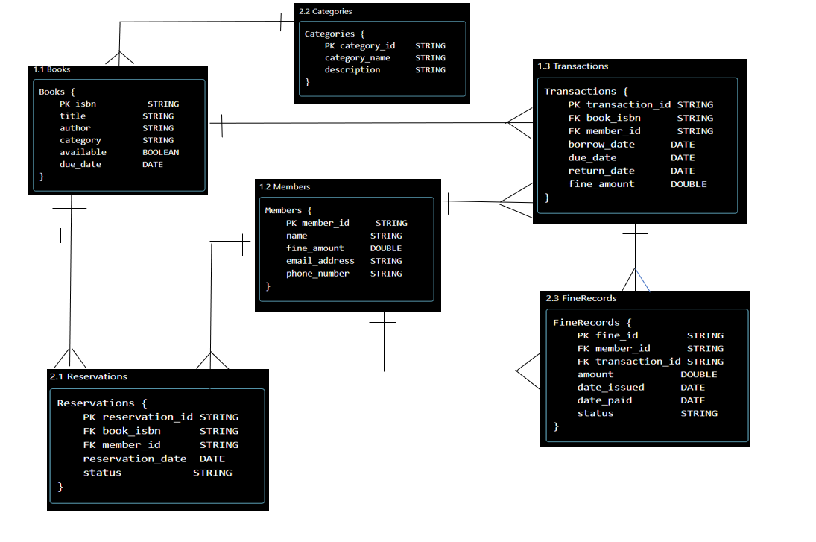

2.3 User Classes and Characteristics

Fig 2.1 Entity – Relationship model
2.2 Product Features
The major features include:
- Book Management Module
- Member Management Module
- Transaction Processing Module
- Fine Calculation System
- Reporting System
The system supports two types of users:
- Librarians/Staff:
  - Full system access
  - Book management capabilities
  - Member management
  - Transaction processing
  - Report generation
- Members:
- Check personal borrowing history
- View Book Availability
- View Dew dates and fine
2.4 Operating Environment
- Platform: Java Runtime Environment 8 or higher
- Operating System: Windows/Linux/MacOS
- Interface: Command Line Interface
- Storage: File-based data persistence
- Memory: Minimum 512MB RAM
2.5 Design and Implementation Constraints
- Java-based implementation
- Object-oriented design principles
- File-based storage system
- Command-line interface
- Single-user access at a time
- Limited to local deployment
3. System Features
3.1 Book Management
3.1.1 Description and Priority
The book management system is a core feature (High Priority) that maintains comprehensive information about all library books including inventory tracking and availability status.
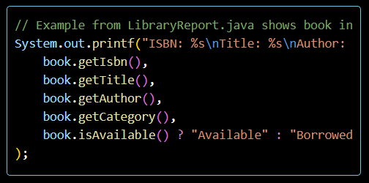
Fig: 3.1 Book available Status
3.1.2 Functional Requirements
- Add new books with details (ISBN, title, author, category)
- Update book information
- Remove books from system
- Search books by various parameters
- Track book availability status
- Maintain book checkout history

3.2 Member Management
3.2.1 Description and Priority
Member management is essential for tracking library users and their activities (High Priority). The system maintains detailed member records and their borrowing history.
3.2.2 Functional Requirements
- Register new members
- Update member information
- Track borrowed books per member
- Calculate and manage fines
- View member borrowing history
- Generate member reports
3.3 Transaction Processing
3.3.1 Description and Priority
Transaction processing handles all book borrowing and returning operations (High Priority). This ensures accurate tracking of book circulation.
3.3.2 Functional Requirements
- Process book checkouts
- Handle book returns
- Calculate due dates
- Track overdue books
- Generate transaction receipts
- Maintain transaction history
3.4 Fine Management
3.4.1 Description and Priority
Fine management system handles the calculation and tracking of overdue fines (Medium Priority).
// Example from LibraryReport.java shows fine calculation
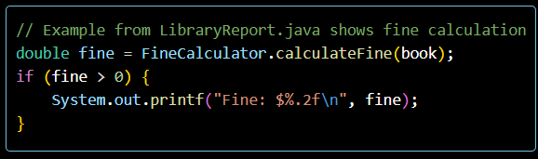
Fig 3.2 Fine Calculate System

3.4.2 Functional Requirements
- Automatic fine calculation for overdue books
- Track fine payments
- Generate fine reports
- Send fine notifications
- Process fine payments
3.5 Reporting System
3.5.1 Description and Priority
The reporting system provides various statistical and operational reports (Medium Priority).
3.5.2 Functional Requirements
- Generate inventory reports
- Create member activity reports
- Produce overdue reports
- Generate fine collection reports
- Export reports in different formats
- Customize report parameters
Each feature includes comprehensive error handling, input validation, and user feedback

External Interface Requirements
4.1 User Interfaces
The Library Management System currently implements a Command Line Interface (CLI) with the following characteristics:
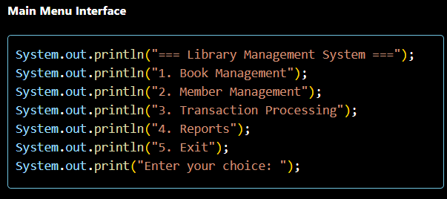
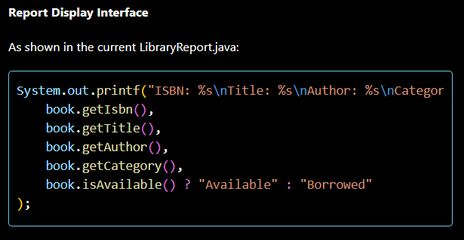

4.2 Hardware Interfaces
- Minimum System Requirements:
  - Processor: Any modern CPU (1 GHz or faster)
  - RAM: 512 MB minimum
  - Storage: 100 MB free space
  - Display: Standard monitor supporting text display
4.3 Software Interfaces
- Development Environment:
  - Java Development Kit (JDK) 8 or higher
  - IDE: Visual Studio Code with Java extensions
- Runtime Environment:
  - Java Runtime Environment (JRE) 8 or higher
  - Operating System: Windows/Linux/MacOS
  - File System: Local storage for data persistence

4.5 Memory Requirements
- Heap Memory: Minimum 256MB
- Stack Memory: Default JVM stack size
- File Storage: Minimum 50MB for data files
4.6 Operations
- System operates in single-user mode
- Data persistence through file operations
- Regular data backup recommended
- Support for concurrent read operations
- Sequential write operations to prevent data corruption

5. Non-functional Requirements
5.1 Performance Requirements
- Book search operations should complete within 2 seconds
- Report generation should complete within 5 seconds
- System should handle up to 10,000 book records efficiently
- Transaction processing (checkout/return) should complete within 3 seconds
5.2 Security Requirements
- User authentication for staff access
- Data validation for all input fields
- Regular backup of system data files
- Secure storage of member information
- Protection against unauthorized access
5.3 Reliability
- System uptime of 99.9% during operating hours
- Automatic data recovery in case of crashes
- Transaction integrity for all operations
- Data consistency checks during file operations
5.4 Availability
- System should be available during library operating hours
- Scheduled maintenance during off-hours only
- Quick recovery from system failures
- Regular system health checks
5.5 Maintainability
- Well-documented code following Java conventions
- Modular design for easy updates
- Clear separation of concerns
- Comprehensive error logging

5.6 Usability
- Clear and consistent command-line interface
- Informative error messages
- Help documentation for all features
- Logical menu structure
- Input validation with meaningful feedback
5.7 Scalability
- Support for growing book collection
- Expandable member database
- Adaptable reporting system
- Modular design for future enhancements
5.8 Documentation Requirements
- User manual for library `staff
- System documentation
- API documentation
- Installation and setup guides
- Troubleshooting documentation

