Project Based Evaluation

Data Structures
Semester-IV (Batch 2023)



Submitted to: Submitted by:
Dr. Name: Karunya Gupta
Roll No: 2310990625
Group: 8A

Department of Computer Science and Engineering
Chitkara University Institute of Engineering and Technology,
Chitkara University, Punjab
Abstract
A comprehensive Java-based Library Management System that streamlines library operations through a command-line interface, featuring robust book and member management capabilities including borrowing, returning, and reservations, along with an automated fine calculation system for overdue materials, detailed reporting functionality, and data persistence, while enforcing business rules such as a 5-book borrowing limit per member and a $0.50 daily fine rate, making it an efficient solution for small to medium-sized libraries to digitize their operations and maintain accurate records of their inventory, member activities, and financial transactions through a user-friendly interface that allows librarians to perform all essential library management tasks seamlessly.

Table of Content

- Introduction
  - Background
  - Objectives
  - Significance

- Problem definition and Requirements
  - Problem Statement
  - Software Requirements
  - Hardware Requirements
  - Data Requirements
  - Performance Requirements

- Proposed design / Methodology
  - System Architecture
  - File Structure
  - Script Components

- Results
  - System update process
  - Health check results
  - Performance Metrics

- Introduction
The Library Management System is a comprehensive Java-based solution designed to automate and streamline library operations through efficient member and book management. This object-oriented project implements essential features such as member registration, book inventory tracking, borrowing operations, reservation handling, and fine management through well-structured classes like Member.java. The system utilizes modern Java features including the Collections Framework for data management, the java.time package for date handling, and follows clean code practices with clearly defined methods and responsibilities. It's particularly suitable for small to medium-sized libraries, educational institutions, and community centers, offering functionality for tracking borrowed books, managing reservations, calculating fines, and processing returns through a modular design that ensures easy maintenance and scalability, making it adaptable to various library management needs while maintaining data integrity and user-friendly operations.
  - Background
This is a Java-based Library Management System designed to help librarians efficiently manage library operations. The system provides the following key features:
- Book Management: Add, search, and track books in the library inventory
- Member Management: Register new members and manage their borrowing activities
- Borrowing System: Handle book checkouts and returns with due date tracking
- Fine Calculation: Automatically calculate fines for overdue books ($0.50 per day)
- Reporting: Generate reports for:
  - Library inventory
  - Member details and borrowed books
  - Overdue books and fines

  - Objective
    - Primary Objective
- Efficient Library Resource Management
  - Streamline book inventory tracking
  - Maintain member records
  - Automate book lending and return processes
- User Management
  - Track member information and activities
  - Manage member borrowing privileges
  - Handle member registration and updates
- Book Management
  - Monitor book availability status
  - Track book reservations
  - Maintain book inventory
- Financial Management
  - Implement fine calculation system
  - Track overdue books
  - Process fine payments
    - Technical Objective
- System Architecture
  - Build a modular, object oriented design
  - Implement core classes ( Member , Book, Library)
  - Ensure code reusability
- Data Management
  - Handle book and member data
  - Implement data persistence
  - Maintain data integrity
- Business Login implementation
  - Book borrowing and return workflow
  - Reservation system
  - Fine Calculation algorithms

- User Interface
  - Create an intuitive console-based interface
  - Implement clear navigation
  - Provide user-friendly error handling

  - Significance
- Operational Efficiency
- Automated Processing: Replaces manual record-keeping with systematic digital management
- Real-time Tracking: Instant access to book availability and member status
- Reduced Human Error: Automated fine calculations and due date tracking
2. Resource Management
- Inventory Control: Better tracking of library resources
- Book Circulation: Efficient management of borrowing and returns
- Reservation System: Organized handling of book reservations
3. User Service Enhancement
- Quick Access: Fast book search and availability checking
- Transparent System: Clear fine calculation and payment tracking
- Fair Resource Distribution: Organized reservation system for popular books
4. Administrative Benefits
- Financial Management: Automated fine tracking and collection
- Data Analytics: Easy generation of usage reports
- Decision Support: Insights for library resource allocation

- Problem Statement and Requirements
2.1 Problem Statement
Traditional library systems face numerous challenges in managing their resources efficiently, leading to:
- Time-consuming manual record keeping
- Difficulty tracking book circulation
- Inefficient member management
- Error-prone fine calculations
- Challenges in resource availability tracking

  - Requirements
    - Software Requirements
  - Development Environment
    - IDE: Visual Studio Code
    - Programming Language: Java SE 8 or higher
    - Version Control: Git
  - Operating system support
    - Window 10/11
    - macOS
    - Linux distributions
    - Hardware Requirements
- Minimum Specifications
    - CPU: 1GHz or faster
    - RAM: 1GB
    - Storage: 100MB free space for logs and updates
    - Network: Active internet connection for package updates

    - Data Requirement
- Tables Requirement
    - Members
    - Books
    - Transactions
    - Fines
    - Reservations
- Data Storage
    - Book Records: ISBN, title, author, status
    - Member Record: ID, name
    - Transaction Data: borrowing history, return
    - Financial Data: fines, payment

- Proposed Design
3.1 System Architecture
The system follows an object-oriented design with clear separation of concerns.
The core architecture is:
- Main Components
  - Library: Central controller class
  - Book: Book entity
  - Member: Member entity
  - DataManager: Data persistence layer
  - Library Report: Reporting functionality
  - FineCalculator: Fine calculation utility

3.2 File Structure
Library-Management-System/
├── Main.java # Entry point and UI
├── Library.java # Core business logic
├── Book.java # Book entity
├── Member.java # Member entity
├── DataManager.java # Data management
├── LibraryReport.java # Reporting functionality
└── FineCalculator.java # Fine calculations
3.3 Core Features
3.3.1 Book Management
  - Book creation and tracking
  - Searching functionality
  - Availability Status
  - Reservation system
  - Due date tracking
3.3.2 Member Management
  - Member Registration
  - Borrowing or returning book

3.4 Key Design Patterns
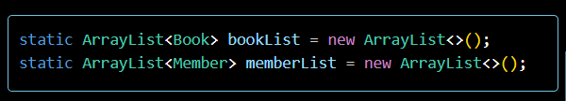

3.5 Repository Pattern
Data access is abstracted through the DataManager class:
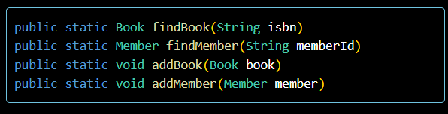
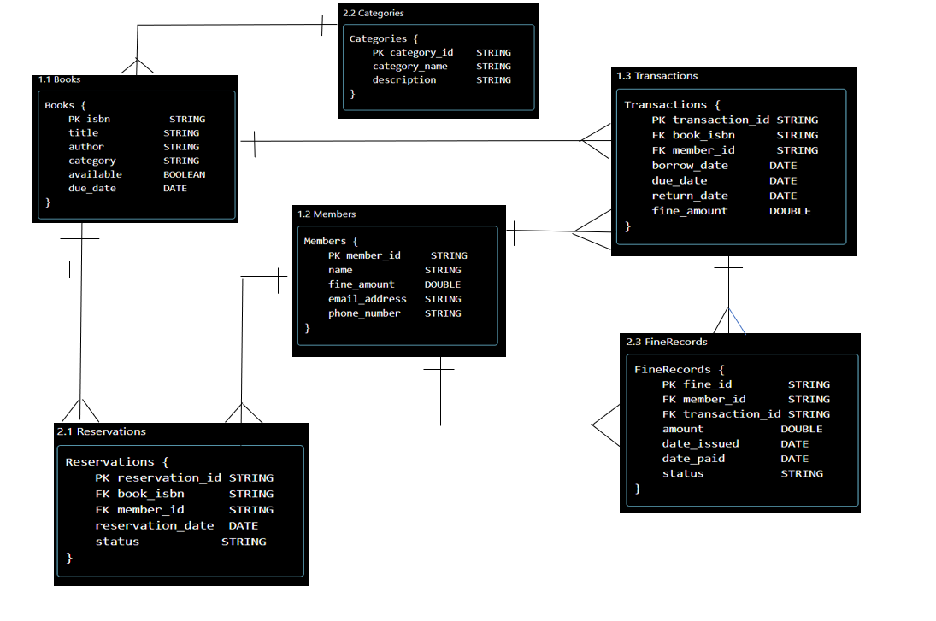
3.6 Entity Relationship

- Result

