ARCHAÍV
QUICK START GUIDE
Quick Start Guide
From a fresh Raspberry Pi to a running system
Archaív Tool Monitoring & Accountability System

Contents
01 Prerequisites
02 Get the Code
03 Configure Environment
04 Install Dependencies
05 First Run & Setup Wizard
06 Enable HTTPS (Caddy)
07 Auto-Start on Boot
08 Pi Controller (RFID/Alarm)
09 Verify Everything Works
10 Where to Go Next

01 Prerequisites
Have these ready before you start:
- A Raspberry Pi 4 B (or newer) running Raspberry Pi OS, with Python 3.11+ available.
- A laptop or PC on the same local network as the Pi, for the staff-facing workstation.
- SSH access to the Pi (or a keyboard/monitor attached to it for the first setup).
- The hardware components: fixed UHF RFID Reader Antenna, HF/NFC Reader/Writer, 2-Channel Relay Module, 2N2222 transistor, 12V Warning Lamp with Buzzer, and a USB UHF RFID Reader/Writer + barcode scanner for the workstation.

02 Get the Code
Copy the project onto the Pi, e.g. under /home/admin/toolroom:
scp -r inventory_system-structured/ admin@<pi-hostname-or-ip>:/home/admin/toolroom
Or, if the project is in a Git repository, clone it directly on the Pi instead.

03 Configure Environment
The application reads its configuration from a .env file in the project root. Copy the example and fill it in:
cd /home/admin/toolroom
cp .env.example .env
At minimum, set:
Variable | Purpose
SECRET_KEY | Flask session-signing key - generate a long random string.
DB_ENCRYPTION_KEY | Optional. If set, the database is encrypted at rest with SQLCipher (AES-256).
RFID_LISTENER_KEY | Shared secret the Pi controller uses to authenticate to this app. Must match pi_controller/.env's copy exactly.
COOKIE_SECURE | Set to 1 once HTTPS (via Caddy, step 6) is in place.
⚠ Don't skip RFID_LISTENER_KEY
Without it, the machine-to-machine endpoints the Pi controller depends on stay disabled (the app fails closed by design), and RFID detection/alarm deactivation silently won't work.

04 Install Dependencies
1 Create a virtual environment for the main app
python3 -m venv .venv then .venv/bin/pip install -r requirements.txt. If you set DB_ENCRYPTION_KEY, also install requirements-encryption.txt.
2 Create a separate virtual environment for the Pi controller
python3 -m venv .venv-pi-controller then .venv-pi-controller/bin/pip install -r pi_controller/requirements.txt. This is a deliberately separate process from the main app - it interfaces directly with the RFID hardware and GPIO.

05 First Run & Setup Wizard
1 Start the app once, manually
Run: .venv/bin/python wsgi.py. Database migrations run automatically on this first start - you'll see a series of "Applied migration: ..." log lines.
2 Open the app and finish setup
From a browser on the same network, visit http://<pi-ip>:5000. On a true fresh install (no staff accounts at all yet), you're taken straight to the first-admin setup wizard - no login needed for this one-time case.
✓ If staff accounts already exist
The app auto-generates a one-time temporary admin account (setup-admin) on first boot and shows its credentials in a modal on the login page - shown once, then cleared. Log in with those to reach the same setup wizard and create your real Admin account.
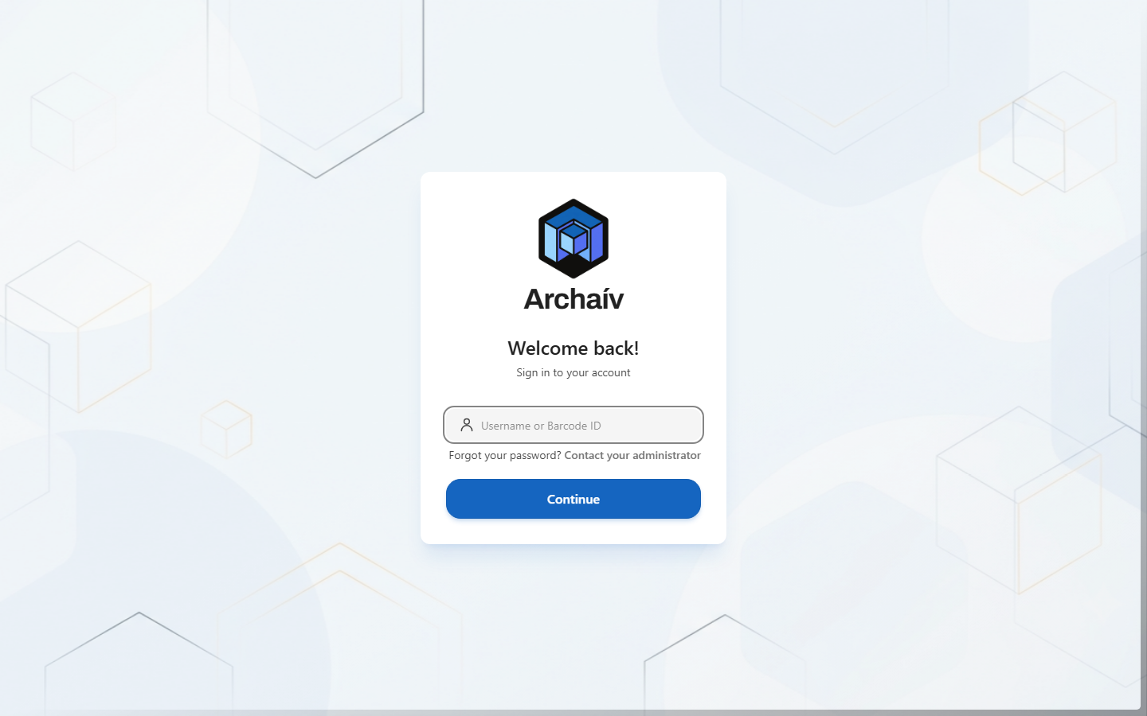
The sign-in screen staff see day to day, once setup is complete.

06 Enable HTTPS (Caddy)
Plain http:// works for basic testing, but staff shouldn't be looking at an unencrypted login page in day-to-day use. Caddy handles this with zero certificate hassle:
1 Install Caddy
Follow Caddy's own install instructions (caddyserver.com/docs/install) for Raspberry Pi OS (Debian-based).
2 Point the Caddyfile at the Pi's mDNS hostname
Edit deploy/Caddyfile and replace the placeholder with the Pi's own mDNS hostname (run hostname on the Pi, then append .local) - not a raw IP address, since that breaks the moment the Pi's network address changes.
3 Flip COOKIE_SECURE on
Set COOKIE_SECURE=1 in .env now that traffic is encrypted, then restart the app.
sudo cp deploy/Caddyfile /etc/caddy/Caddyfile
sudo systemctl restart caddy

07 Auto-Start on Boot
Install the app as a systemd service so it starts automatically on boot and restarts itself if it ever crashes:
sudo cp deploy/toolroom.service /etc/systemd/system/
sudo systemctl daemon-reload
sudo systemctl enable --now toolroom

08 Pi Controller (RFID/Alarm)
This is the separate headless process that actually talks to the RFID antenna, HF/NFC reader, and alarm relay.
1 Configure pi_controller/.env
Set RFID_LISTENER_KEY to the exact same value as the main app's .env, and confirm ALARM_RELAY_GPIO_PIN matches your physical wiring (18, BCM numbering, in the reference build).
2 Install its systemd service
Its After= ordering is configured to start after the main app, closing a brief startup-race window - though its own retry logic tolerates the app being briefly unreachable regardless.
sudo cp pi_controller/toolroom-rfid-listener.service /etc/systemd/system/
sudo systemctl daemon-reload
sudo systemctl enable --now toolroom-rfid-listener

09 Verify Everything Works
- Reboot the Pi and confirm the login page loads over HTTPS without you touching anything.
- Log in with the Admin account you created and confirm the Dashboard loads.
- Scan a test tag at the monitored exit and confirm it shows up under Monitoring.
- Tap the Master Key Card on the HF/NFC reader and confirm the app registers it (even with no alarm active, this proves the reader is wired and talking to the Pi controller correctly).

10 Where to Go Next
Once the system is running:
- Read the User Manual to learn the day-to-day workflows (borrowing, returning, monitoring, reports).
- Read the Architecture Guide if you need to understand how the two processes, hardware, and security layers fit together.
- Keep the Documentation handy as a reference for configuration options, roles/permissions, and troubleshooting.

