ARCHAÍV
USER MANUAL
User Manual
Day-to-day guide for tool room staff
Archaív Tool Monitoring & Accountability System

Contents
01 Introduction
02 Staff Roles
03 Logging In
04 The Dashboard
05 Borrowing a Tool
06 Returning a Tool
07 Managing Inventory
08 Managing Members
09 Managing Staff
10 Approvals
11 Reservations
12 RFID Monitoring & Alarms
13 Reports
14 Printing Barcode Labels
15 System Settings
16 Activity Log
17 Notifications
18 Feedback
19 Help
20 Your Account Menu
21 Keyboard Shortcuts
22 Troubleshooting

01 Introduction
Archaív replaces the manual logbook process in the EIM tool room with an automated, session-based workflow: barcode scans record who borrowed or returned what, while a fixed RFID antenna at the exit independently watches for tagged tools leaving without an authorized transaction, triggering a physical alarm when it sees one.

02 Staff Roles
The system has three staff roles, each with more access than the last:
Role | Can do
Tool Keeper | Scan borrower/tool barcodes, process checkouts and returns, submit unrestriction requests for members.
In Charge | Everything a Tool Keeper can, plus view Reports, access System Settings, directly lift a member's restriction, and approve or deny Tool Keeper-submitted unrestriction requests.
Admin | Everything In Charge can, plus manage staff accounts, database backups, permanent deletion, feedback resolution, and initial system setup. Only Admins hold the Master Key Card used to clear alarms.

03 Logging In
Open the app in a browser on the workstation and enter your username or barcode ID, then your password.
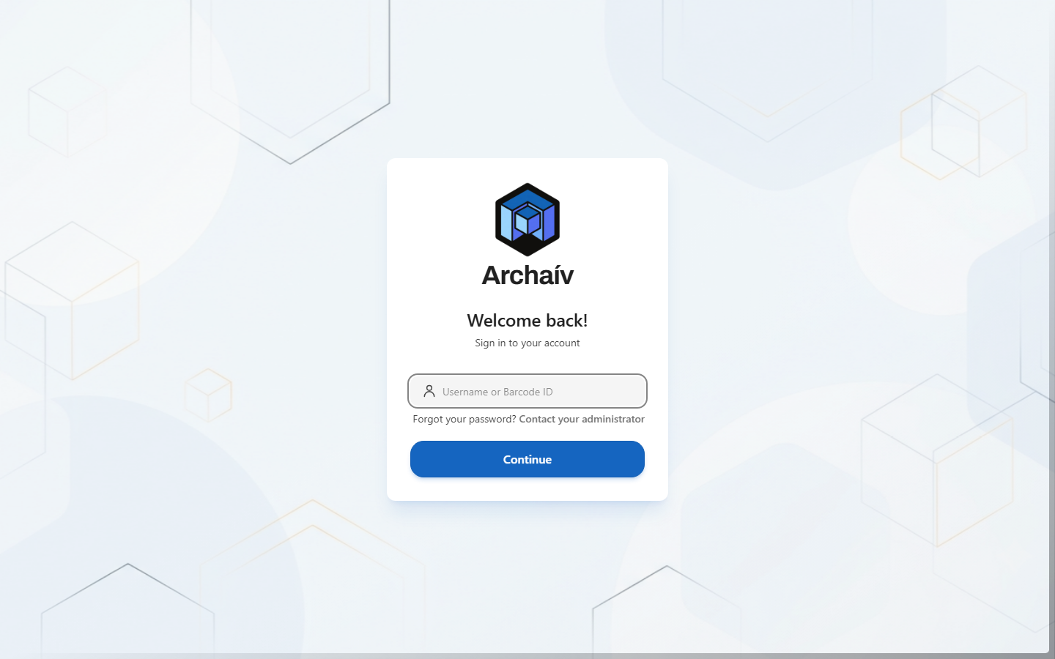
Step 1 - enter your username or barcode ID.
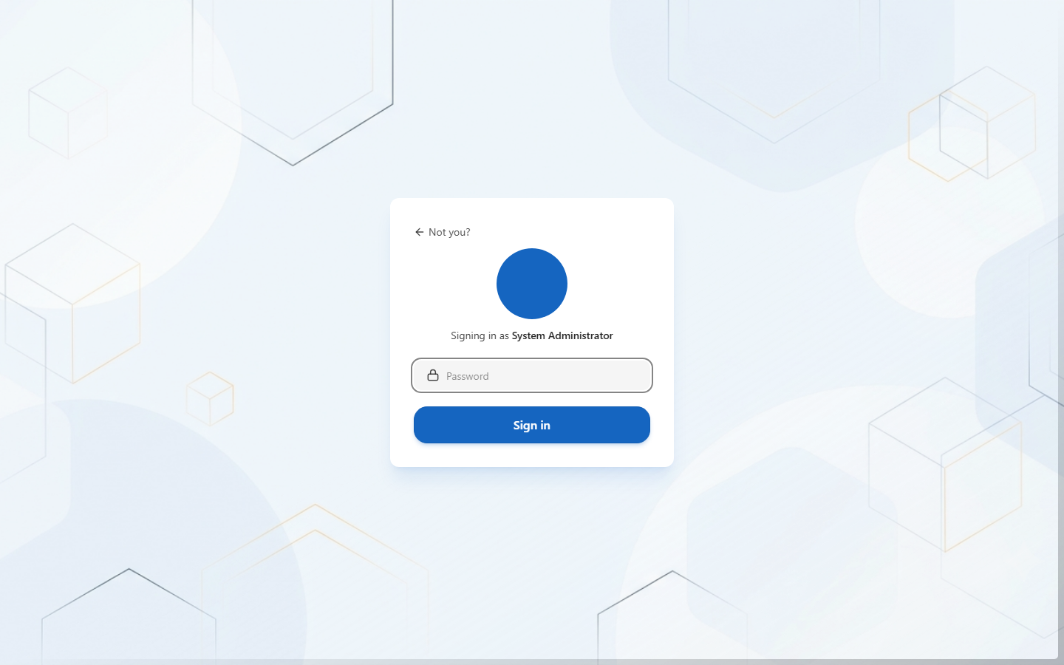
Step 2 - enter your password to finish signing in.
✓ Admin login at the workstation
Admins can also authenticate using the UHF RFID Reader/Writer together with a PIN, instead of typing a password. Any staff member can also opt in to a barcode + PIN login as a faster alternative to typing a password each time - enable it from your account menu.

04 The Dashboard
The Dashboard is the home screen after logging in - a snapshot of the tool room's current state and quick shortcuts to the most common actions.
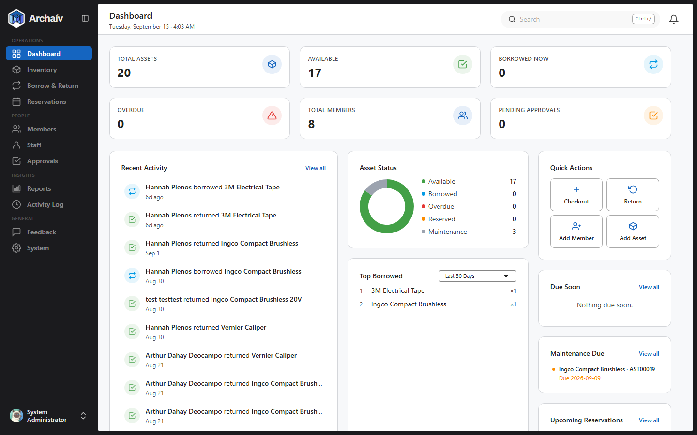
Total assets, availability, active loans, overdue items, and quick-action buttons for Checkout, Return, Add Member, and Add Asset.

05 Borrowing a Tool
From the Dashboard or the Borrow & Return page, click Checkout:
- Scan or enter the member's barcode - this identifies who's borrowing and confirms they're not currently restricted.
- Scan the requested tool(s) - each is added to the checkout session as it's scanned.
- Set the due date and confirm - once confirmed, the tools are recorded as borrowed and the checkout session closes.
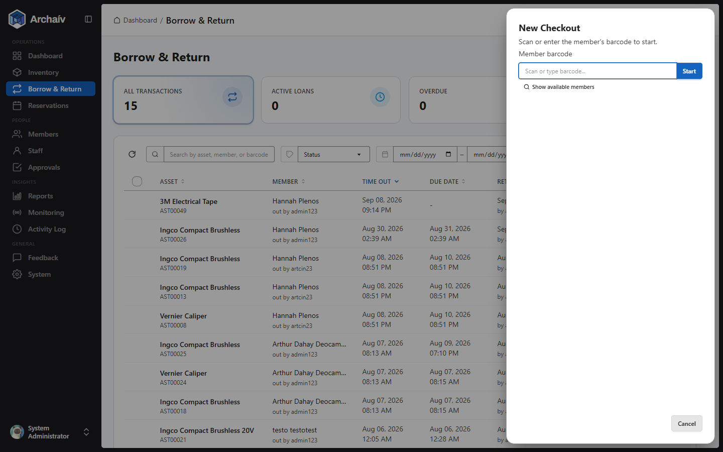
The New Checkout dialog - scan the member's barcode to begin.

06 Returning a Tool
From Borrow & Return, click Return, then:
- Scan the returned tool's barcode together with the borrower's barcode - the system confirms a matching open loan exists.
- Record the tool's condition (functional, damaged, or disposed).
- Complete the return. The transaction is marked returned and the tool's status updates automatically.
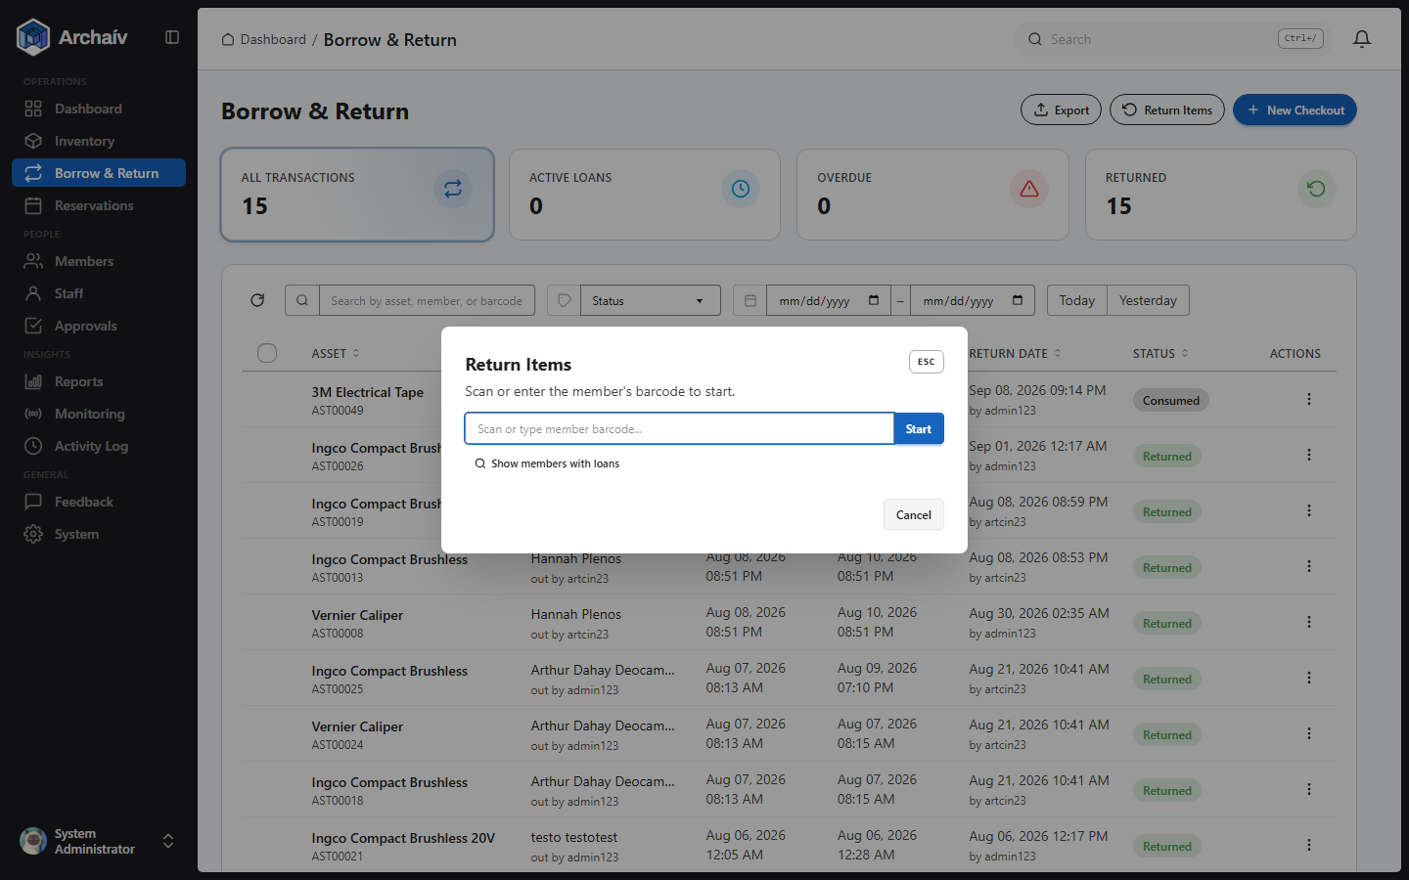
The Return dialog.

07 Managing Inventory
The Inventory page lists every asset with its category, quantity, status, condition, and barcode - searchable and filterable by category, condition, or status.
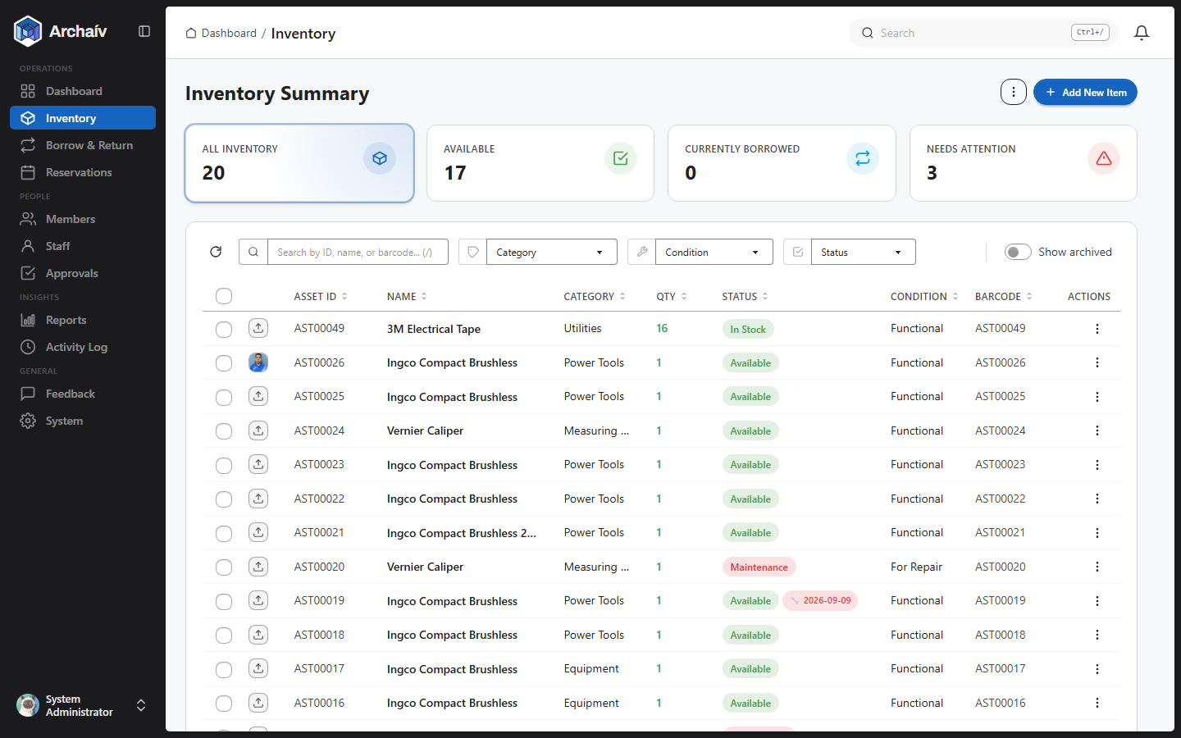
Inventory Summary - total, available, borrowed, and items needing attention (maintenance/overdue).
Use Add New Item to register a new tool, or the row actions menu to edit or archive an existing one. Tags themselves are written separately with RFIDDemo.exe (see Provisioning RFID Tags in the Documentation) - once a tag is written, enter its ID into the asset's RFID Tag ID field here.
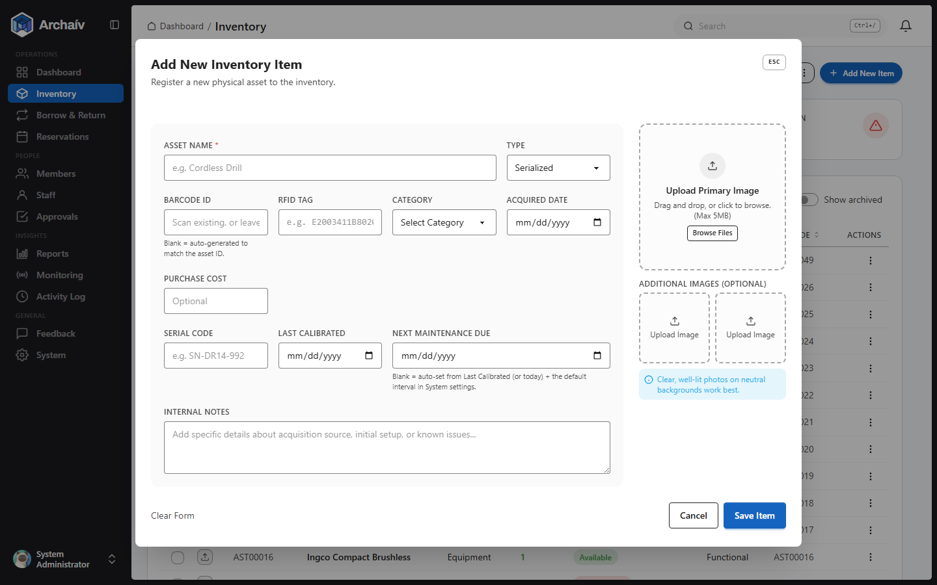
The Add New Item dialog.
✓ Two kinds of inventory items
Serialized assets (one row = one physical tool with its own barcode/RFID tag) are what most of this manual describes. The system also supports consumable stock items (e.g. "50x safety goggles") tracked by quantity instead of by individual unit, with a reorder threshold that flags low stock - useful for supplies that aren't individually tagged.
Assets can also be scheduled for preventive maintenance, either by a fixed date or a usage-interval (e.g. every N checkouts). When an item comes due, it's automatically flagged on the Dashboard's "Maintenance Due" card and a notification is created.

08 Managing Members
The Members page tracks trainees and trainers eligible to borrow tools, including their current restriction status.
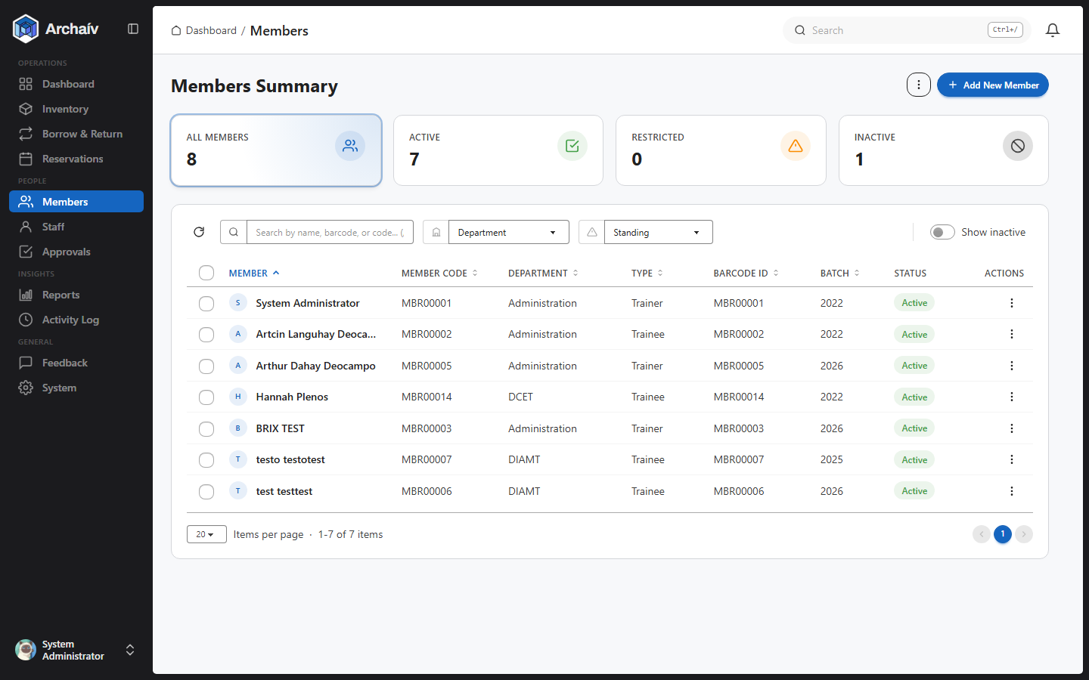
A member's account is automatically restricted when a loan becomes overdue or a returned tool is logged as damaged. Lifting a restriction requires either a Tool Keeper's unrestriction request (approved by In Charge or Admin) or a direct lift by In Charge/Admin.
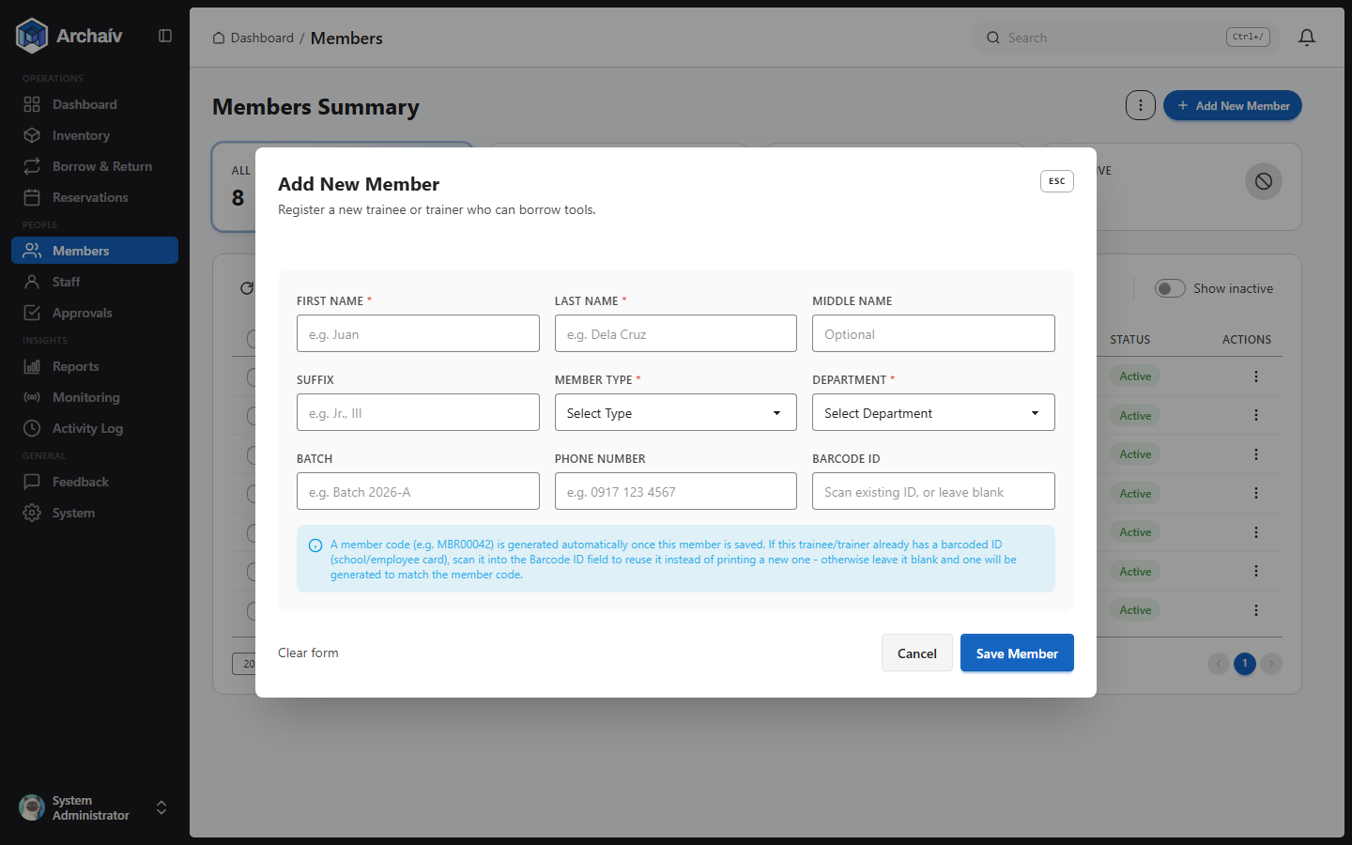
The Add Member dialog.

09 Managing Staff
Admins manage staff accounts (creating, editing, deactivating, reactivating) from the Staff page.
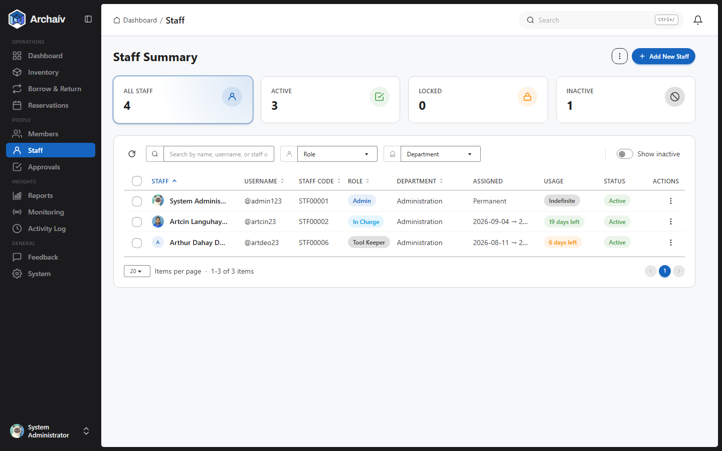
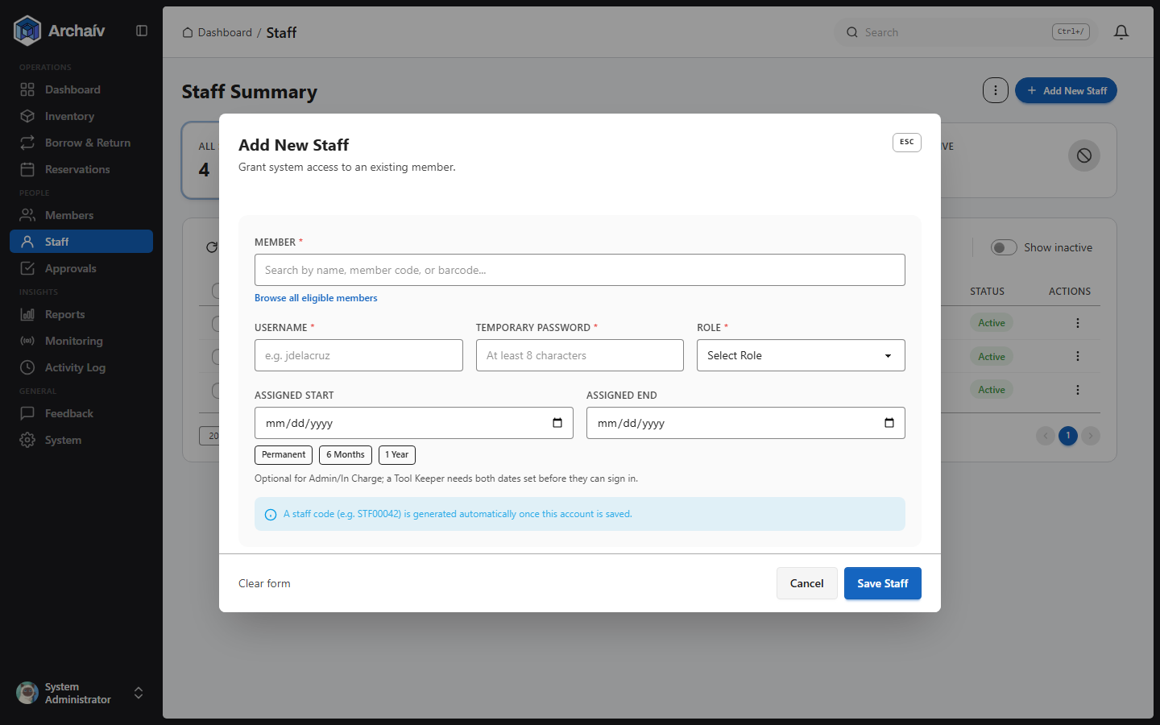
The Add Staff dialog.

10 Approvals
In Charge and Admin review two kinds of pending requests here: member unrestriction requests submitted by Tool Keepers, and admin-deactivation requests.
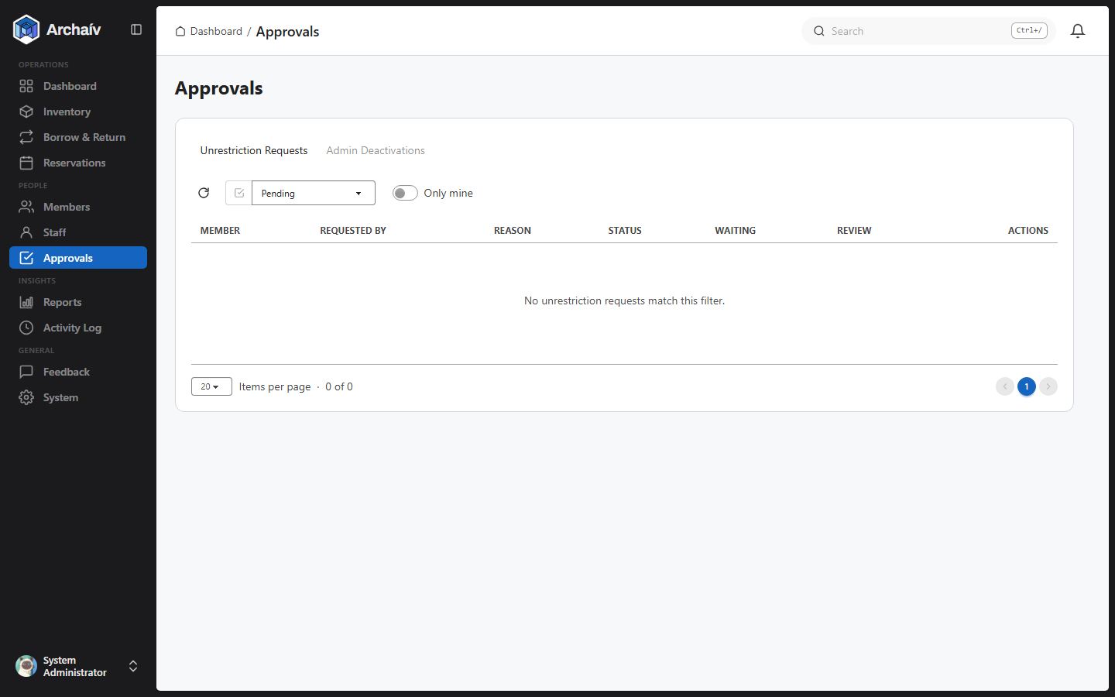

11 Reservations
Staff or members can reserve a tool ahead of time so it's held rather than checked out by someone else in the meantime.
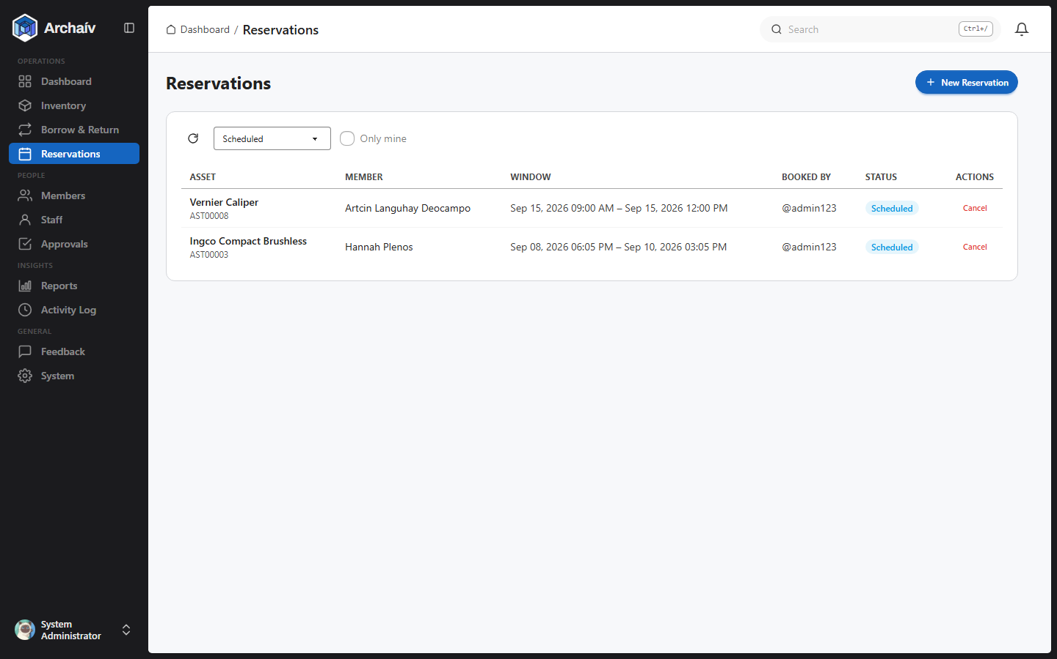

12 RFID Monitoring & Alarms
The fixed UHF RFID antenna at the tool room exit continuously watches for tagged tools. Every detection is classified automatically:
- Authorized - the tool has an active borrowing record. No alarm.
- Unauthorized - the tool is tagged but has no active borrowing record. The alarm activates.
- Unknown tag - the tag doesn't match any registered tool. Logged, but does not alarm.
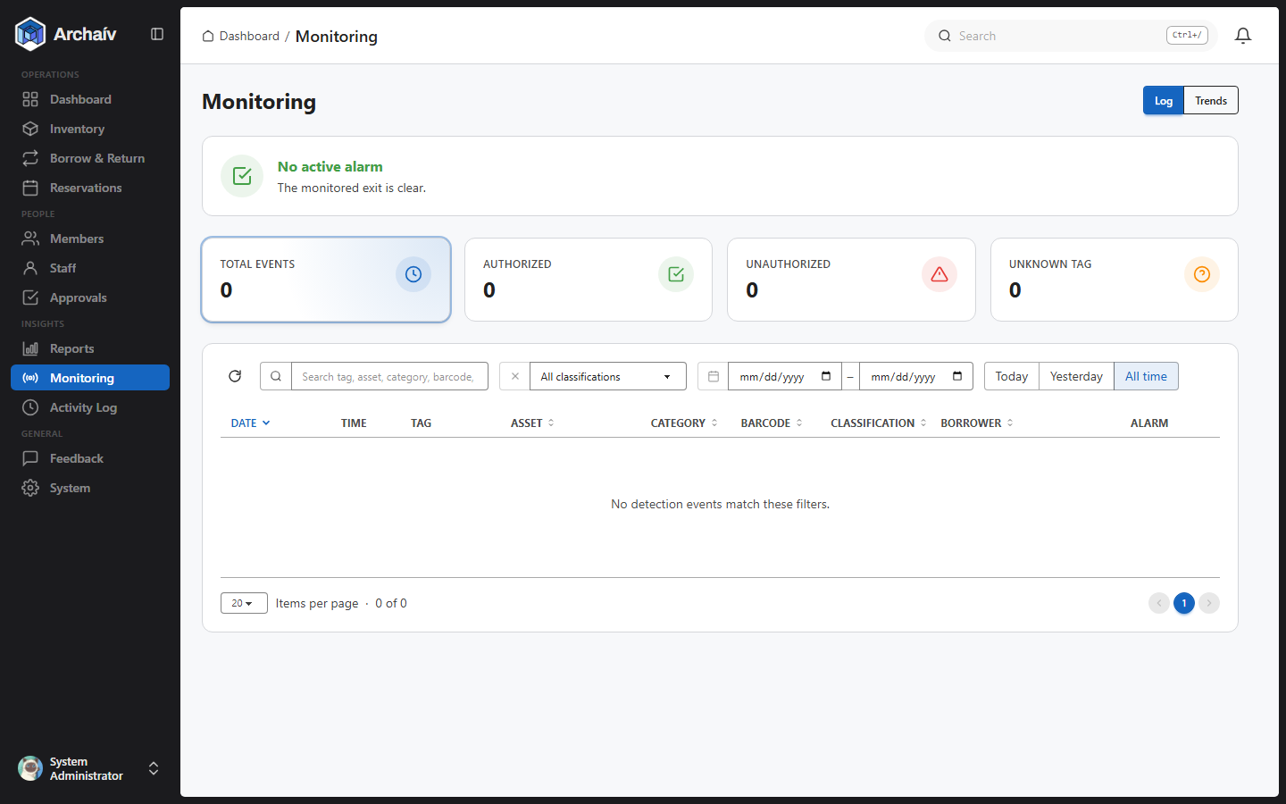
The Monitoring page shows current alarm status and a searchable, filterable log of every detection event. A "Trends" tab shows response-time statistics and charts.
⚠ Clearing an active alarm
The intended way to clear an alarm is an Admin tapping the physical Master Key Card at the HF/NFC reader in the tool room - this requires the Admin to be physically present at the site of the alert. If the reader itself is unavailable, an Admin or In Charge can dismiss it in software instead (System > Alarm) as a fallback, which also silences the physical buzzer/lamp.

13 Reports
Transaction history, asset utilization, and overdue summaries, exportable for record-keeping.
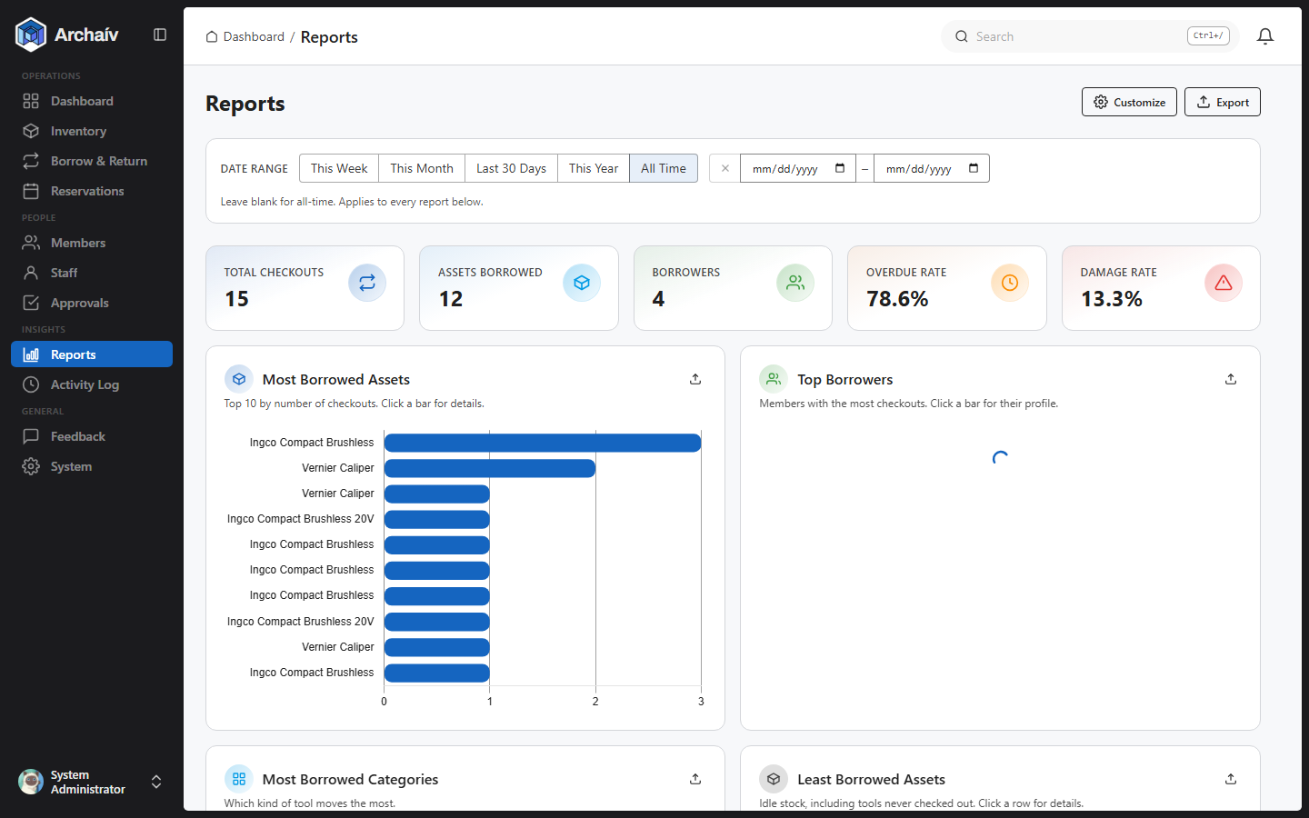

14 Printing Barcode Labels
Generate and print CODE128 barcode labels for members and assets directly from the browser - no external label printer software needed.
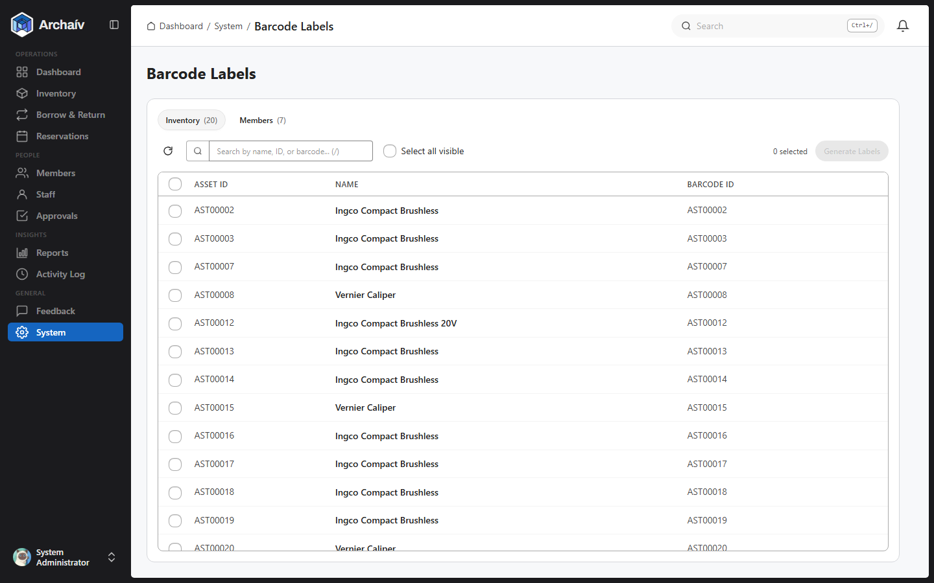
- Switch between the Inventory and Members tabs, then check the items you want labels for - search narrows the list first if there are many.
- Click Generate Labels to open the Label preview dialog, which lays out a barcode card for each item you selected.
- Pick a Label Size - Small, Regular, or Large - at the bottom of the dialog. This only changes the size printed on the PDF; the on-screen preview cards stay the same size no matter which one is selected.
- Click Preview PDF to see the exact print layout (with cut guides) before saving, then Download PDF.
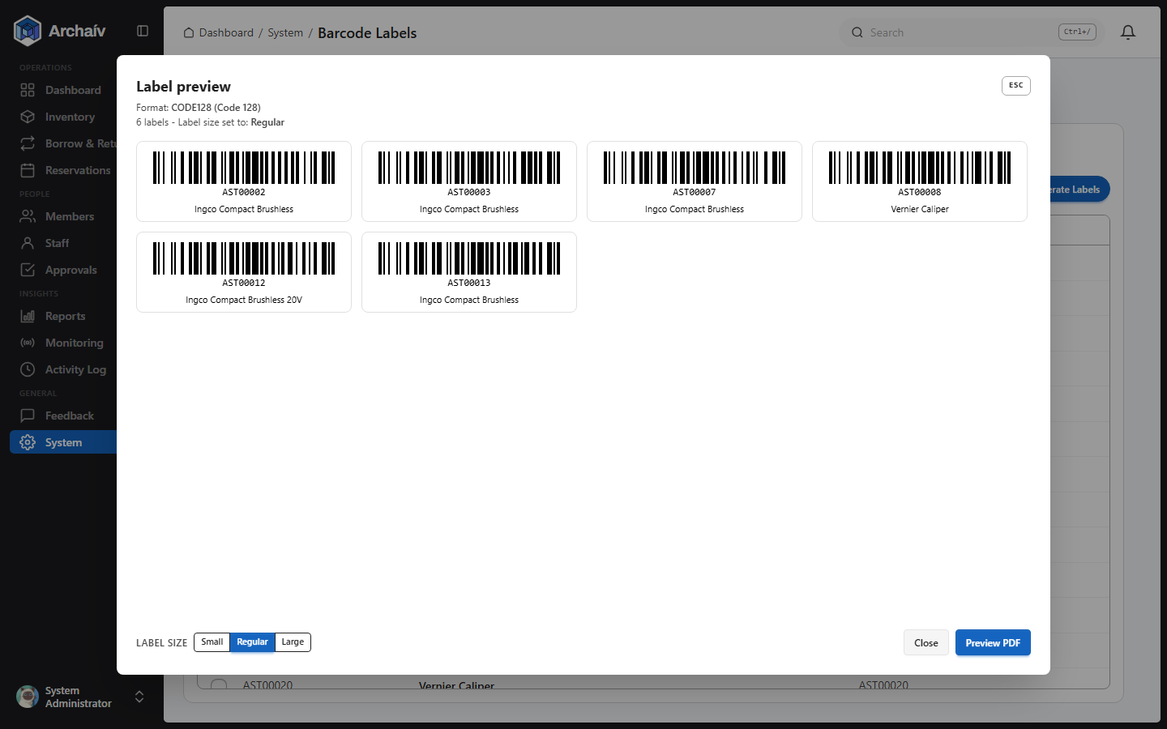
The Label preview dialog - one barcode card per selected item, with the Label Size picker along the bottom.

15 System Settings
In Charge and Admin can configure system-wide options here - feature toggles (including the Monitoring/alarm feature itself), alarm behavior, ID-prefix formats, and more.
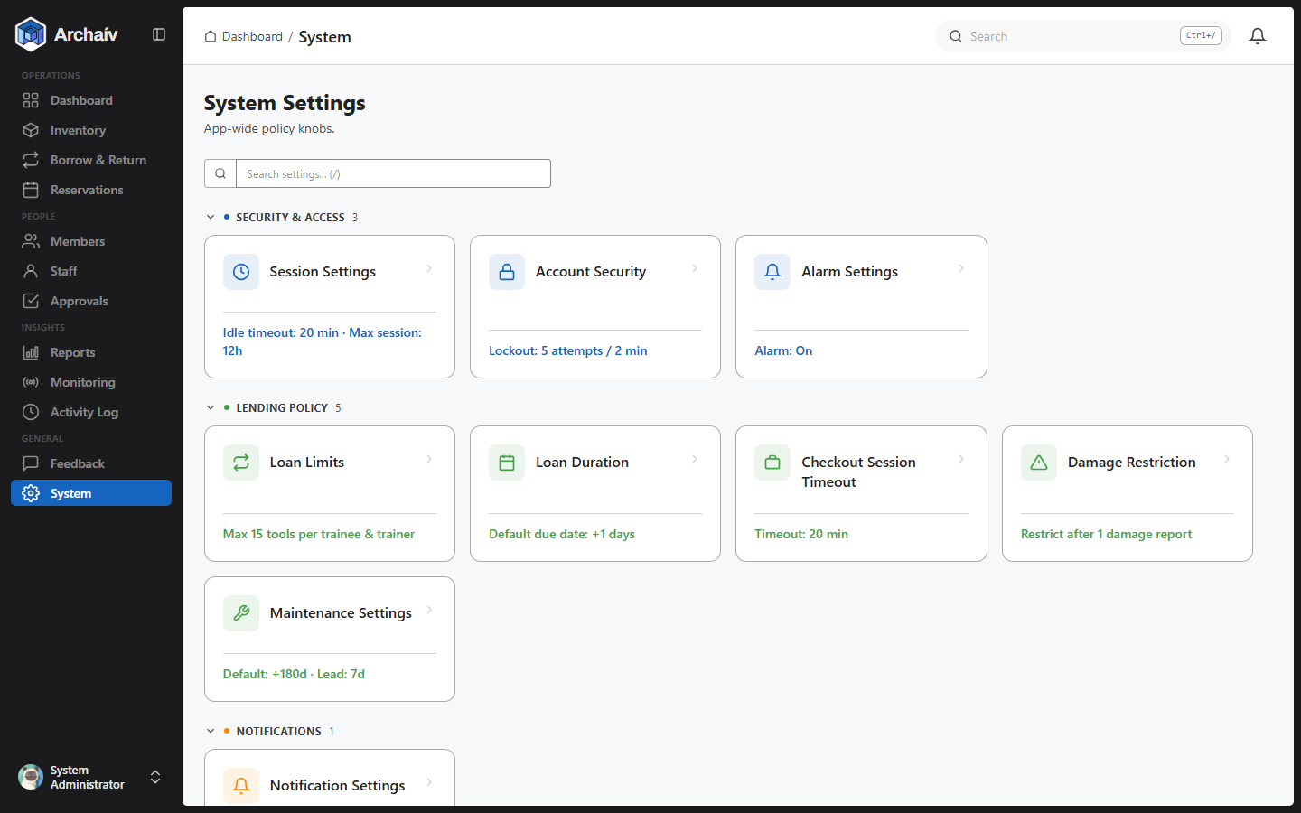

16 Activity Log
A full audit trail of state-changing actions across the system - who did what, and when.
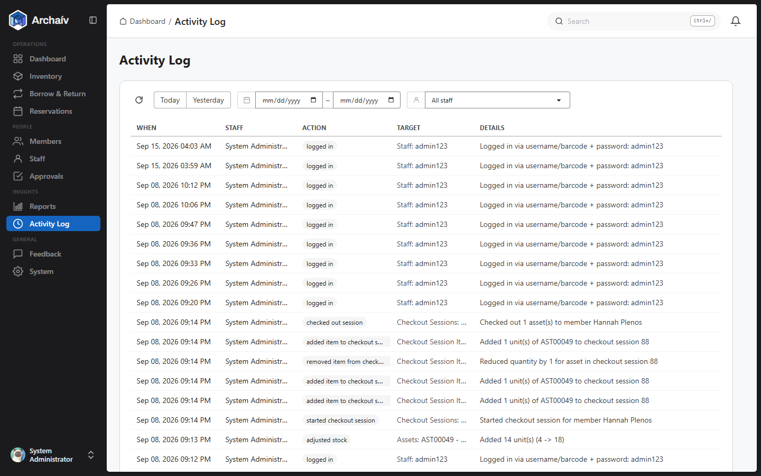

17 Notifications
In-app alerts for things needing attention. Notifications are created automatically for:
- Upcoming or overdue loan due dates
- Assets due (or nearly due) for preventive maintenance
- New unrestriction requests, and their approval/denial
- New admin-deactivation requests, and their approval/denial
- Reservations that get cancelled
- New feedback submissions, and staff responses to feedback you submitted
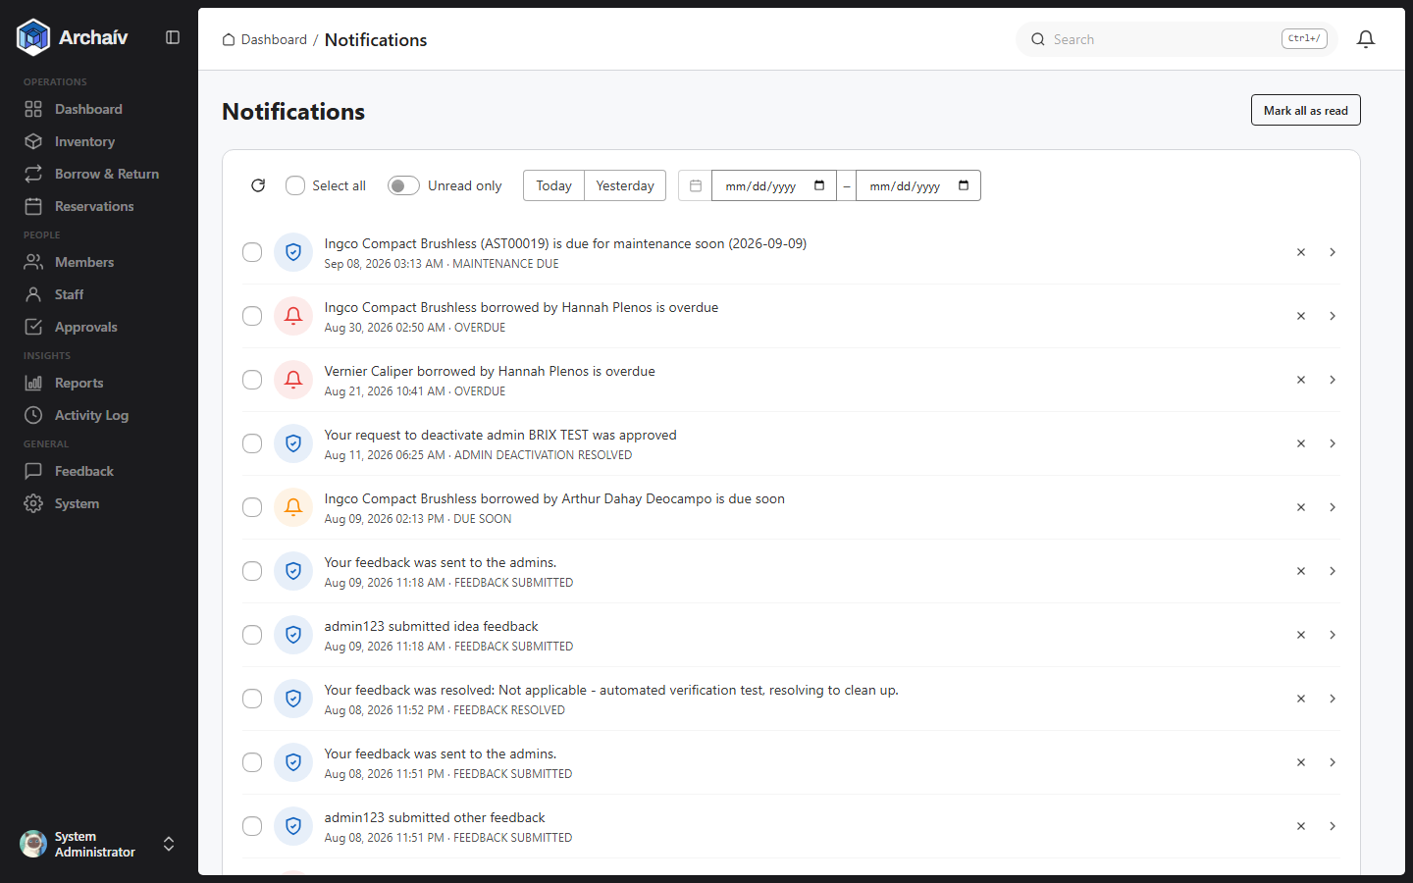

18 Feedback
Any staff member can report a bug, suggest an idea, or leave other feedback directly from inside the app - including attaching a screenshot. Admins review and resolve these from the Feedback page, and the submitter is notified once it's addressed.
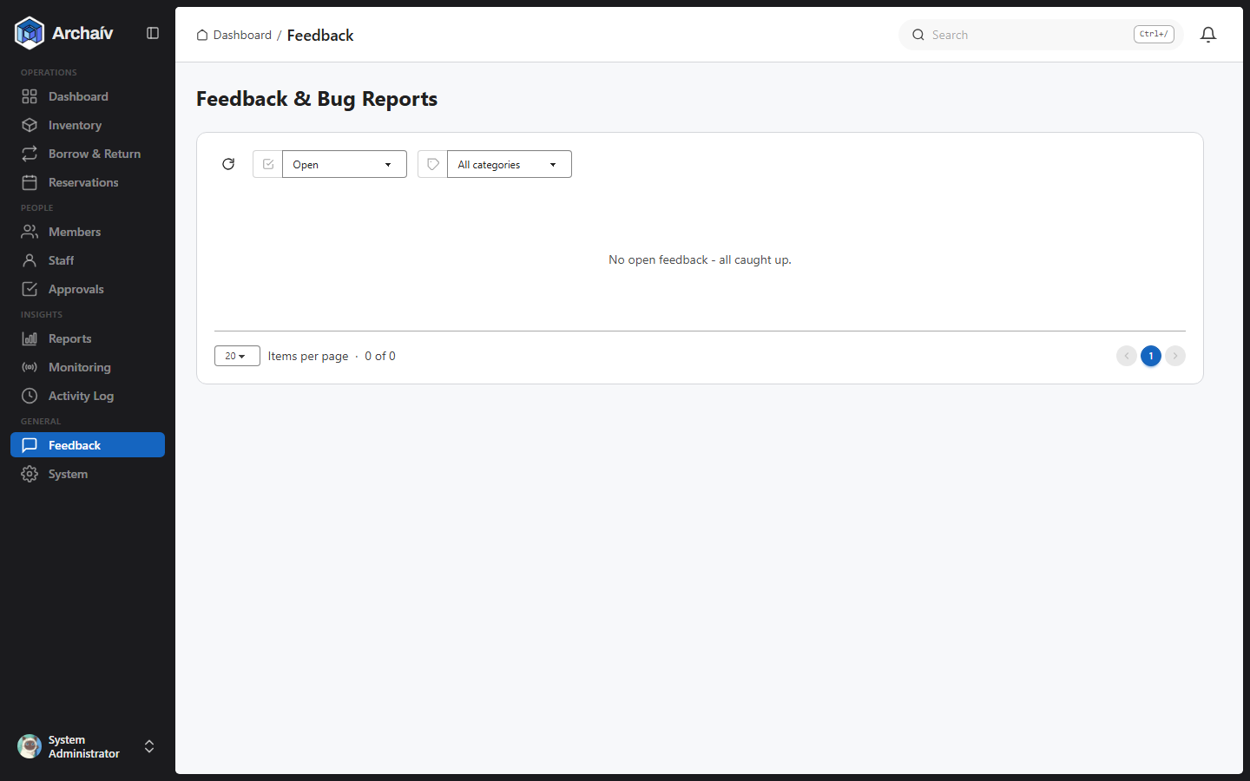

19 Help
A built-in Help page with guidance for using the system, reachable from the sidebar at any time.
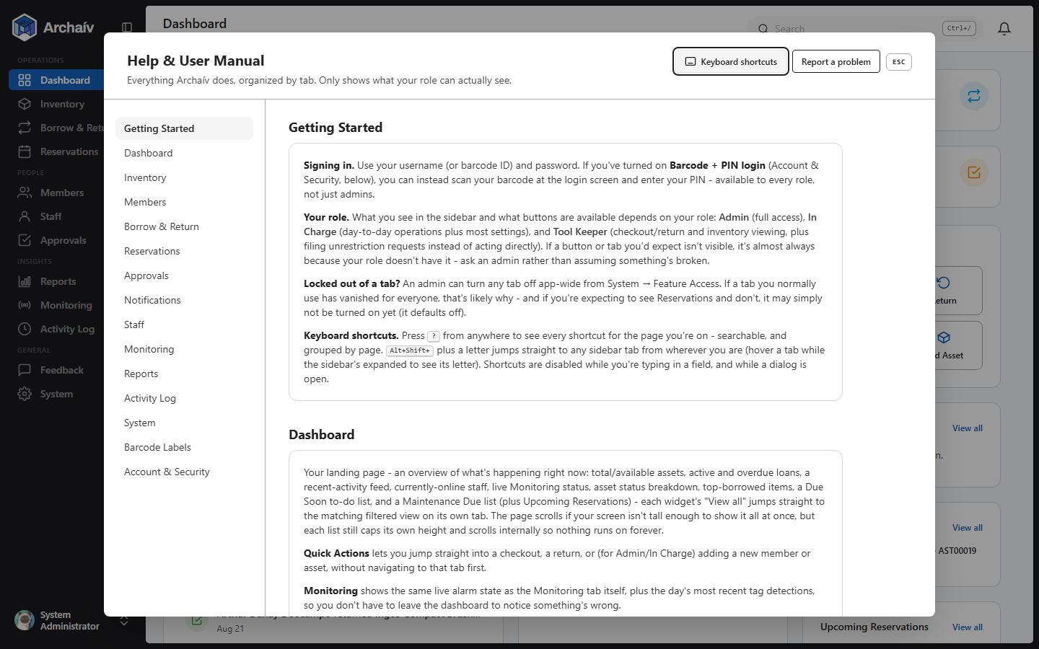
A separate, shorter Help dialog is also reachable from the account menu - a quick FAQ (checking out an item, unrestricting a member, resetting a password, filing feedback) plus buttons straight to the full Help page and the keyboard-shortcuts panel.
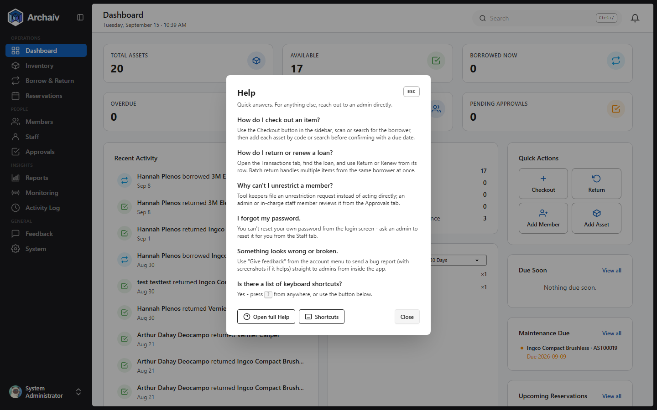
The Help dialog, reachable from anywhere via the account menu.

20 Your Account Menu
Click your name at the bottom of the sidebar to open the account menu, which holds every personal setting: My Account, Settings & Privacy, Help, Keyboard Shortcuts, Display & Accessibility, Give Feedback, and Log Out.
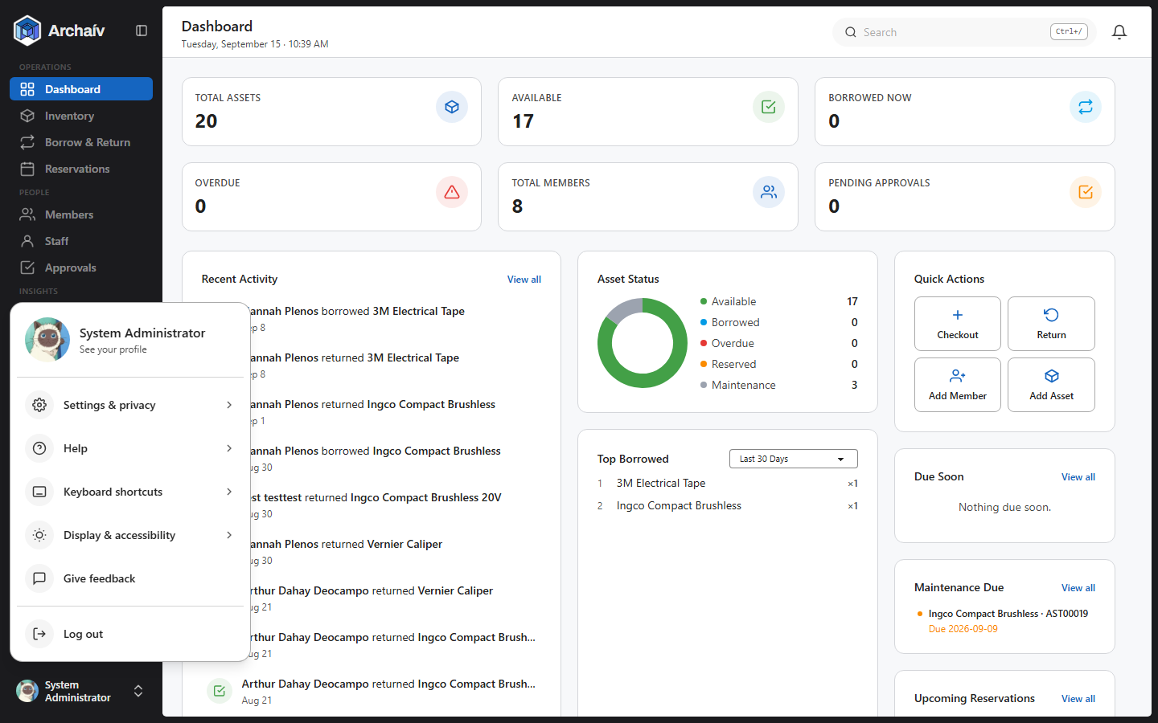
The account menu, opened from the sidebar.

My Account
Your profile card: role, barcode ID, type (trainee/trainer/staff), department, batch, account status, and when you last signed in. From here you can:
- Change your profile photo - drag and drop, paste an image, or pick a file (JPG, PNG, or WebP, up to 5MB).
- Change your password - opens a dedicated dialog requiring your current password.
- Enable, disable, or change your Barcode + PIN login - a faster sign-in that scans your barcode, then asks for a short PIN instead of typing your full password each time.
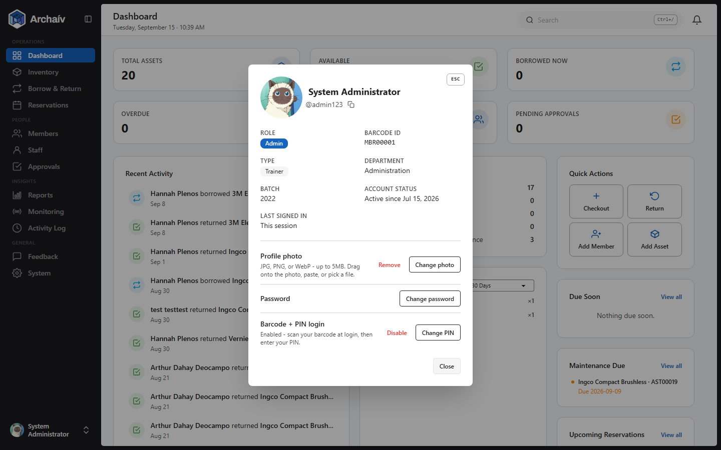
The My Account dialog.
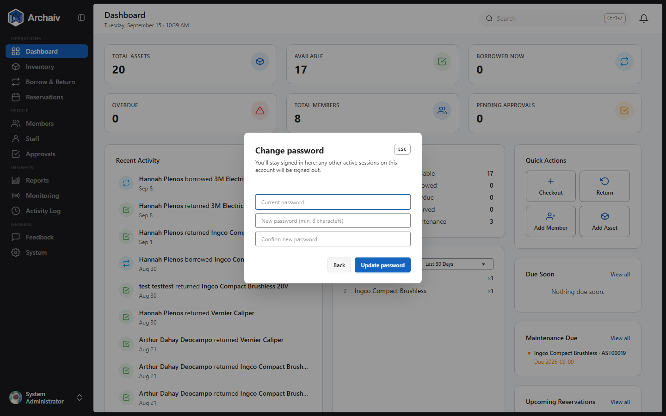
The Change Password dialog, reached from My Account.

Settings & Privacy
Controls which notifications you receive and how long toast pop-ups stay on screen:
- Due-soon reminders
- Overdue alerts
- Unrestriction request updates
- Toast display duration (2-15 seconds, adjustable)
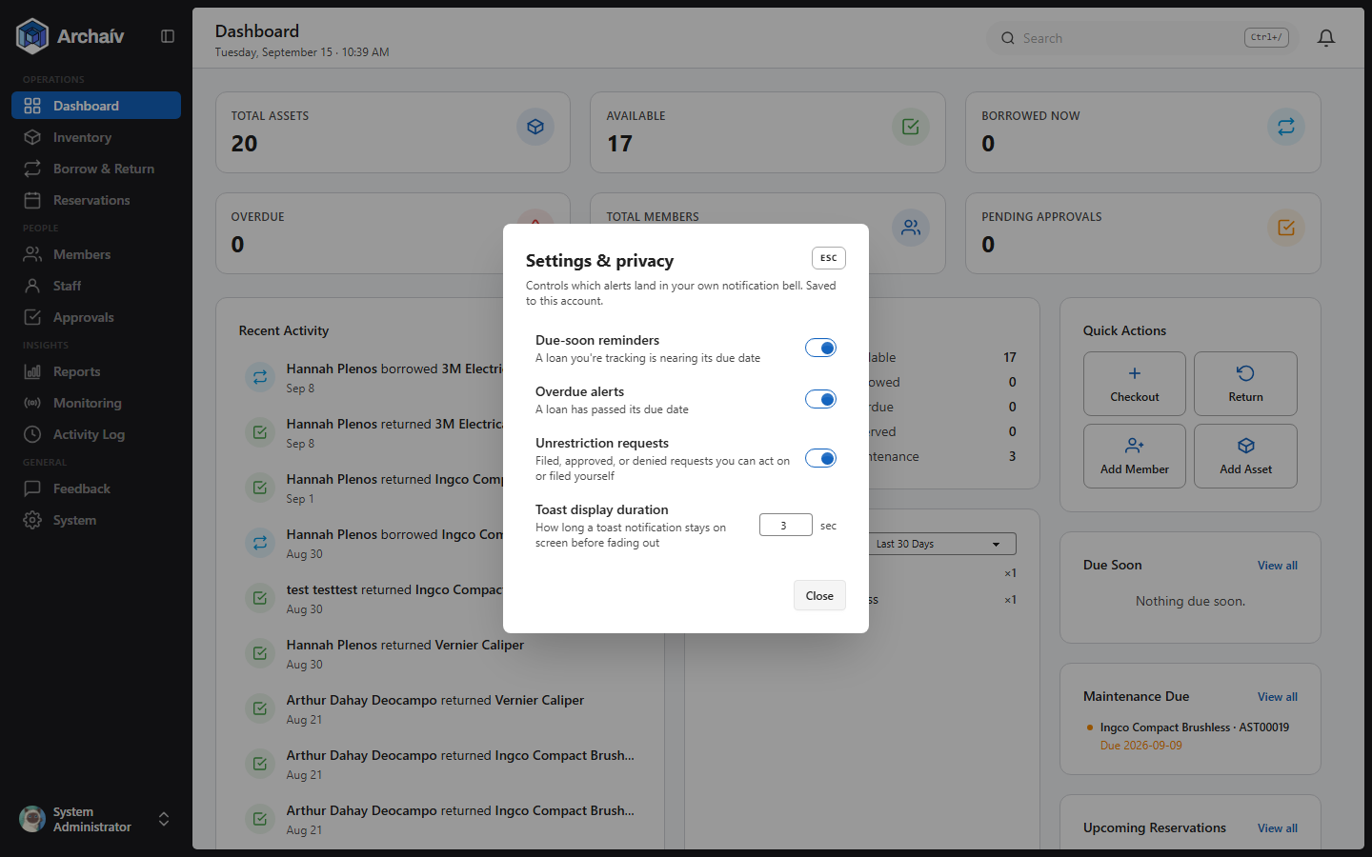
The Settings & Privacy dialog.

Display & Accessibility
Controls the app's visual theme, separate from notification settings:
- Theme mode - Mixed (follows your system setting), Light, or Dark.
- Notification style - Light, Dark, or Material Design toast styling.
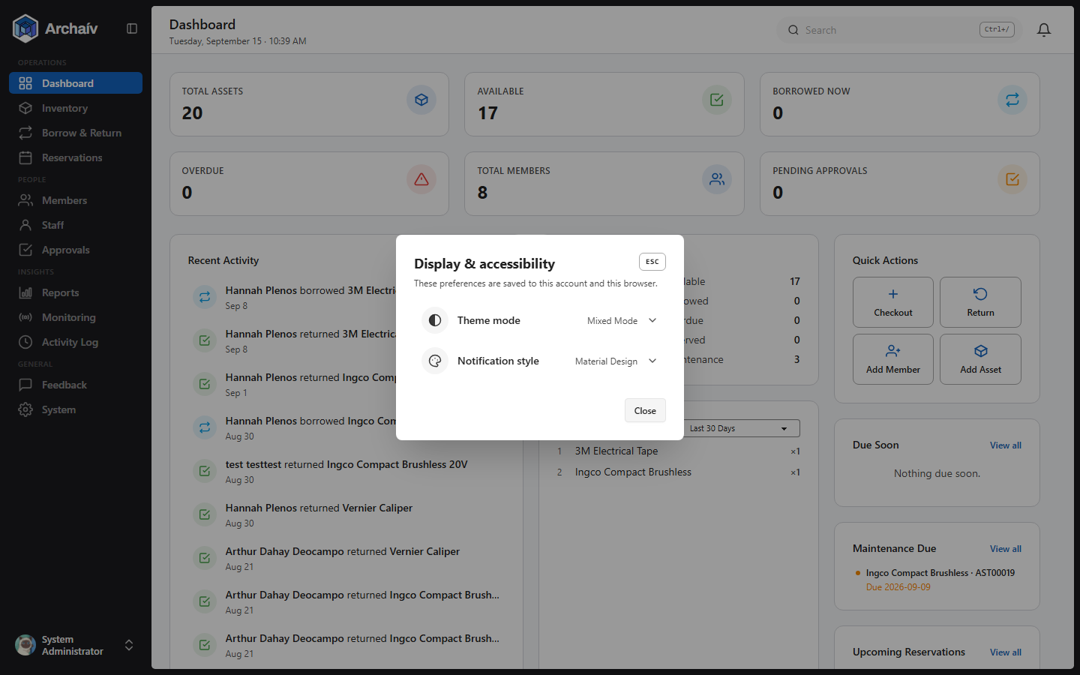
The Display & Accessibility dialog.

Give Feedback
The same feedback form described earlier is also reachable directly from the account menu.
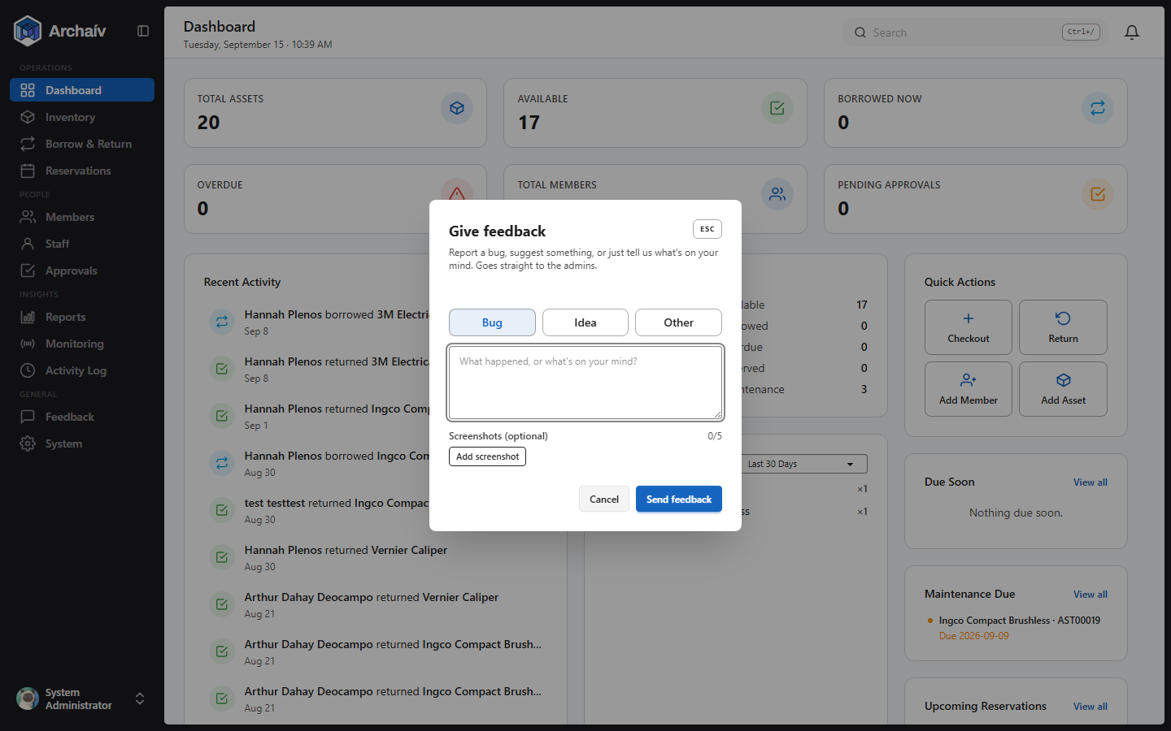
The Give Feedback dialog.

Logging Out
Log Out asks for confirmation before ending your session, so an accidental click doesn't sign you out mid-task.
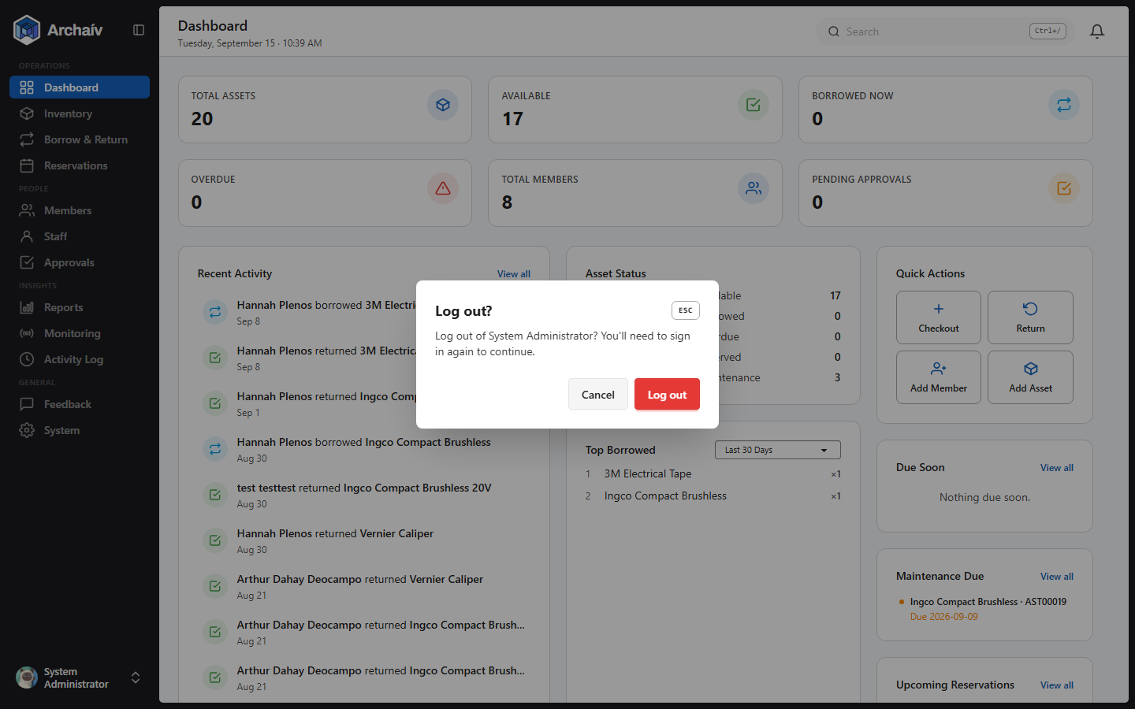
The Log Out confirmation dialog.

21 Keyboard Shortcuts
Press ? anywhere in the app to open the searchable keyboard-shortcuts panel. Shortcuts are disabled while typing in a text field, and while a dialog is open (Esc still works to close it). Every shortcut below is also filtered by your role and by which features are turned on for your deployment - you'll only ever see the ones that apply to you.
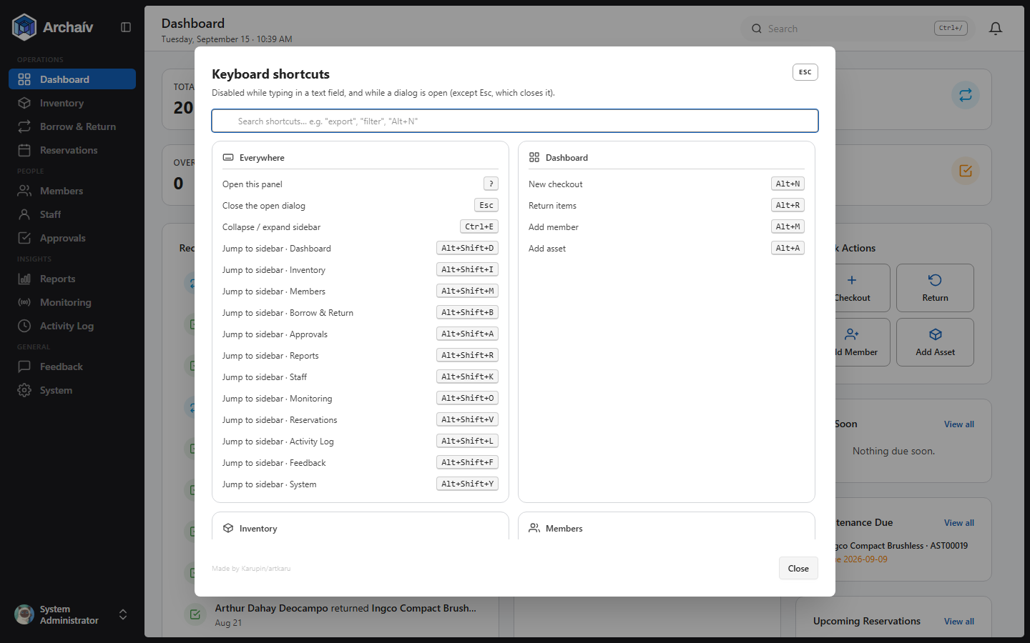
The Keyboard Shortcuts panel - searchable, and grouped by page.

Everywhere
Shortcut | Action
? | Open the keyboard-shortcuts panel
Esc | Close the open dialog
Ctrl+E | Collapse / expand the sidebar
Alt+Shift+<letter> | Jump straight to a sidebar page (D-Dashboard, I-Inventory, M-Members, B-Borrow & Return, A-Approvals, R-Reports, K-Staff, O-Monitoring, V-Reservations, L-Activity Log, F-Feedback, Y-System)

Dashboard
Shortcut | Action
Alt+N | New checkout
Alt+R | Return items
Alt+M | Add member (Admin/In Charge)
Alt+A | Add asset (Admin/In Charge)

Inventory
Shortcut | Action
/ | Focus the search box
Enter | Jump to an item by scanning/typing its barcode
 | Toggle showing archived items
1-4 | Quick status filters
← / → | Page through results
Alt+N / M / I / E | Add item / Manage categories / Import / Export
Esc | Clear filters
E / D / R | Edit / Delete / Restore (inside item details)
M / S / C | Maintenance / Adjust stock / Calibrate (inside item details)
V | Reserve this item

Members, Borrow & Return, Approvals, Notifications, Reports
Each follows the same pattern as Inventory: / to search, 1-4 for quick filters, arrow keys to page, Alt+N and similar to add, and Esc to clear filters or close. Members and Borrow & Return also support row actions (E/D/R to edit, deactivate/delete, restrict/restore); Notifications adds Alt+A to mark all as read; Reports adds Alt+C to customize widgets and Alt+E to export.

Staff, Monitoring, Reservations, System (role- and feature-gated)
Area | Notable shortcuts
Staff (Admin only) | /, Enter, `, 1-4, arrows, Alt+N to add; E/L/P to edit/lock/reset password; D/U to deactivate/reassign
Monitoring (if enabled) | /, L/T to switch Log/Trends tabs, arrows, D to dismiss an active alarm (Admin/In Charge, password-confirmed)
Reservations (if enabled) | Alt+N/R, 1-5 quick filters, ` to show only your own reservations
System (Admin/In Charge) | 1-9 to open a settings card's Manage dialog by number; 0 for Barcode Labels

Barcode Labels, Feedback & Bug Reports, Activity Log
Barcode Labels: / to search, 1/2 to switch tabs, Alt+G to generate, Alt+B to go back. Feedback & Bug Reports: 1-3 to filter, arrows to page. Activity Log: arrows to page, Esc to clear filters.

22 Troubleshooting
Issue | What to check
Can't reach the login page | Confirm your device is on the same network as the Pi, and try the mDNS hostname (e.g. https://toolroom-rpi.local) instead of a bookmarked IP - the IP can change, the hostname doesn't.
Alarm won't stop sounding | Tap the Master Key Card at the reader. If the reader is broken/unavailable, an Admin or In Charge can dismiss it from System > Alarm instead.
Need to write a new RFID tag/card | This isn't done inside the app - use RFIDDemo.exe on the workstation, then enter that ID into the asset's or member's record.
A member can't check out a tool | Check whether their account is currently restricted (overdue loan or damaged return) - they'll need an unrestriction request approved, or an In Charge/Admin to lift it directly.

