SQL
- KARUPPUSAMY

- JOIN
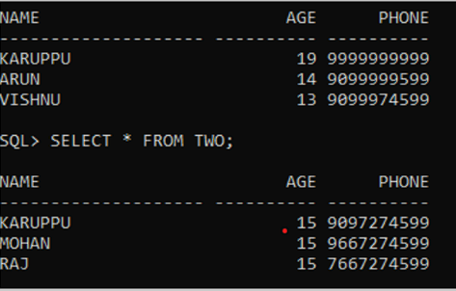

Left join:
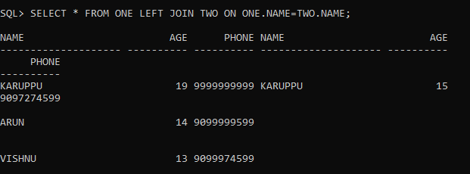
Right join
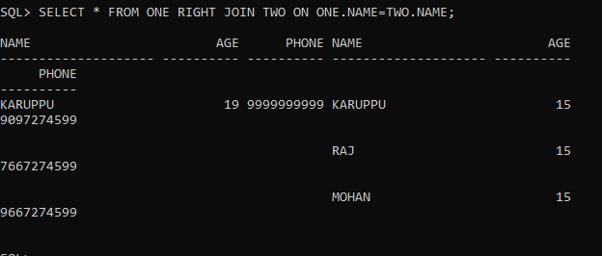

INNER JOIN:
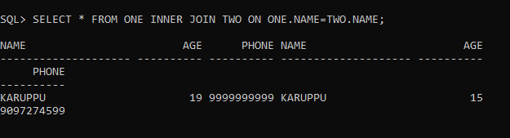

FULL JOIN:
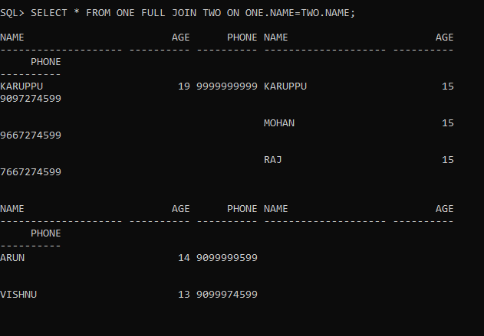

- RENAME COLUMN

BEFORE;
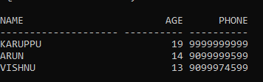

QUERY
ALTER TABLE ONE RENAME COLUMN NAME TO FNAME;

AFTER;
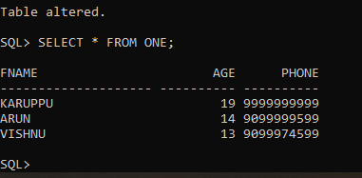

- FIND DUPLICATE RECORDS;
RECORDS:
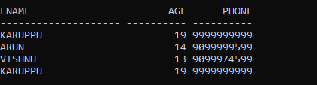
QUERY:
SELECT FNAME FROM ONE GROUP BY FNAME HAVING COUNT(FNAME)>1;
OUTPUT:
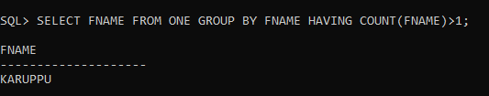

- MAX SALARY

RECORD:
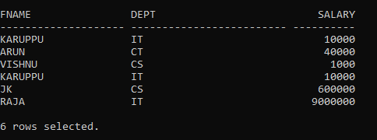
QUERY:
SELECT DEPT, MAX(SALARY) FROM ONE
GROUP BY DEPT;

OUTPUT:
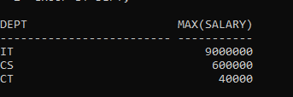

- OPERATORS
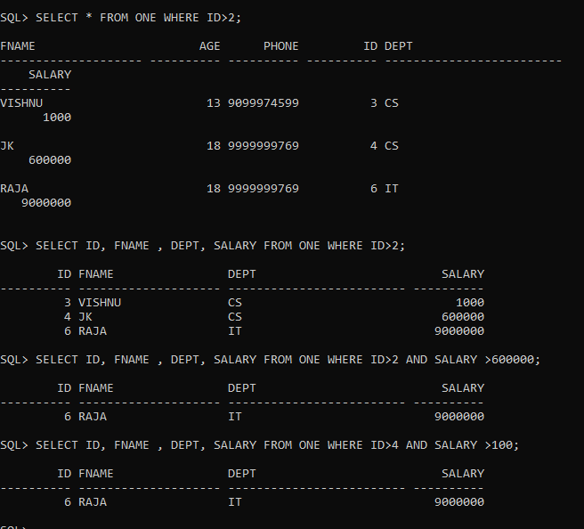

- FIRST 5 RECORDS:
QUERY: SELECT * FROM ONE WHERE ROWNUM<5;
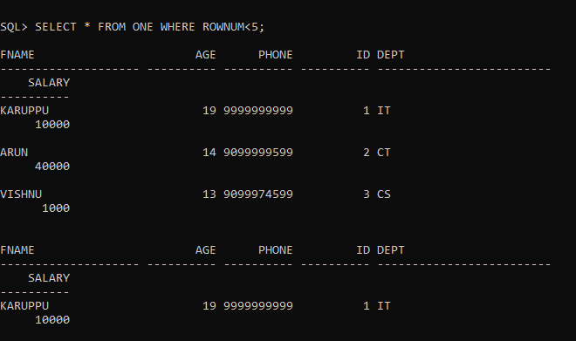

- LIST LAST 3 RECORDS:
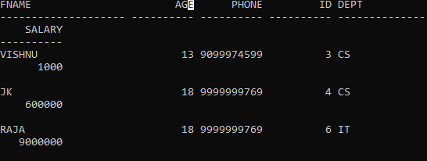

- CREATE TABLE WITH SAME STRUCTURE

QUERIES:
CREATE TABLE NEW_ONE AS SELECT * FROM ONE WHERE 1 = 0;
CREATE TABLE N_ONE AS SELECT * FROM ONE WHERE 1 = 1;

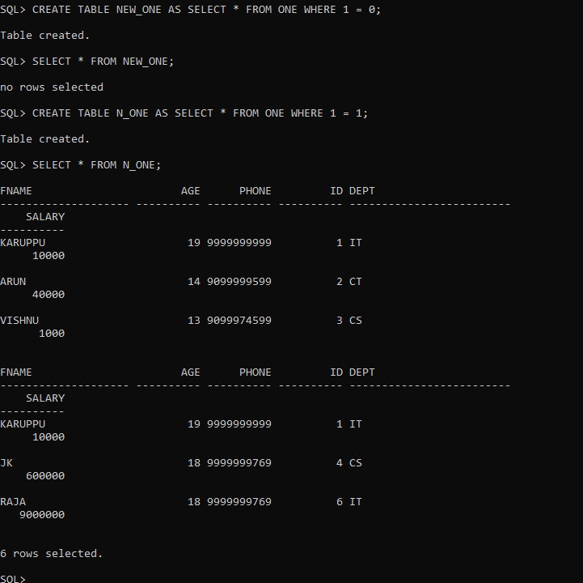

- DISTINCT STATEMENT

BEFORE:
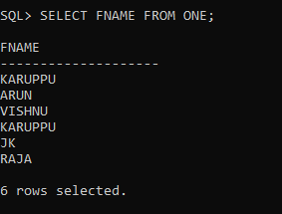
AFTER:
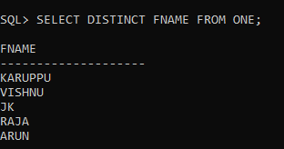

- SCALAR FUNIONS:

These returns single value only
UCASE(), LCASE(),MID(),LEN(),ROUND().

LENGTH:
