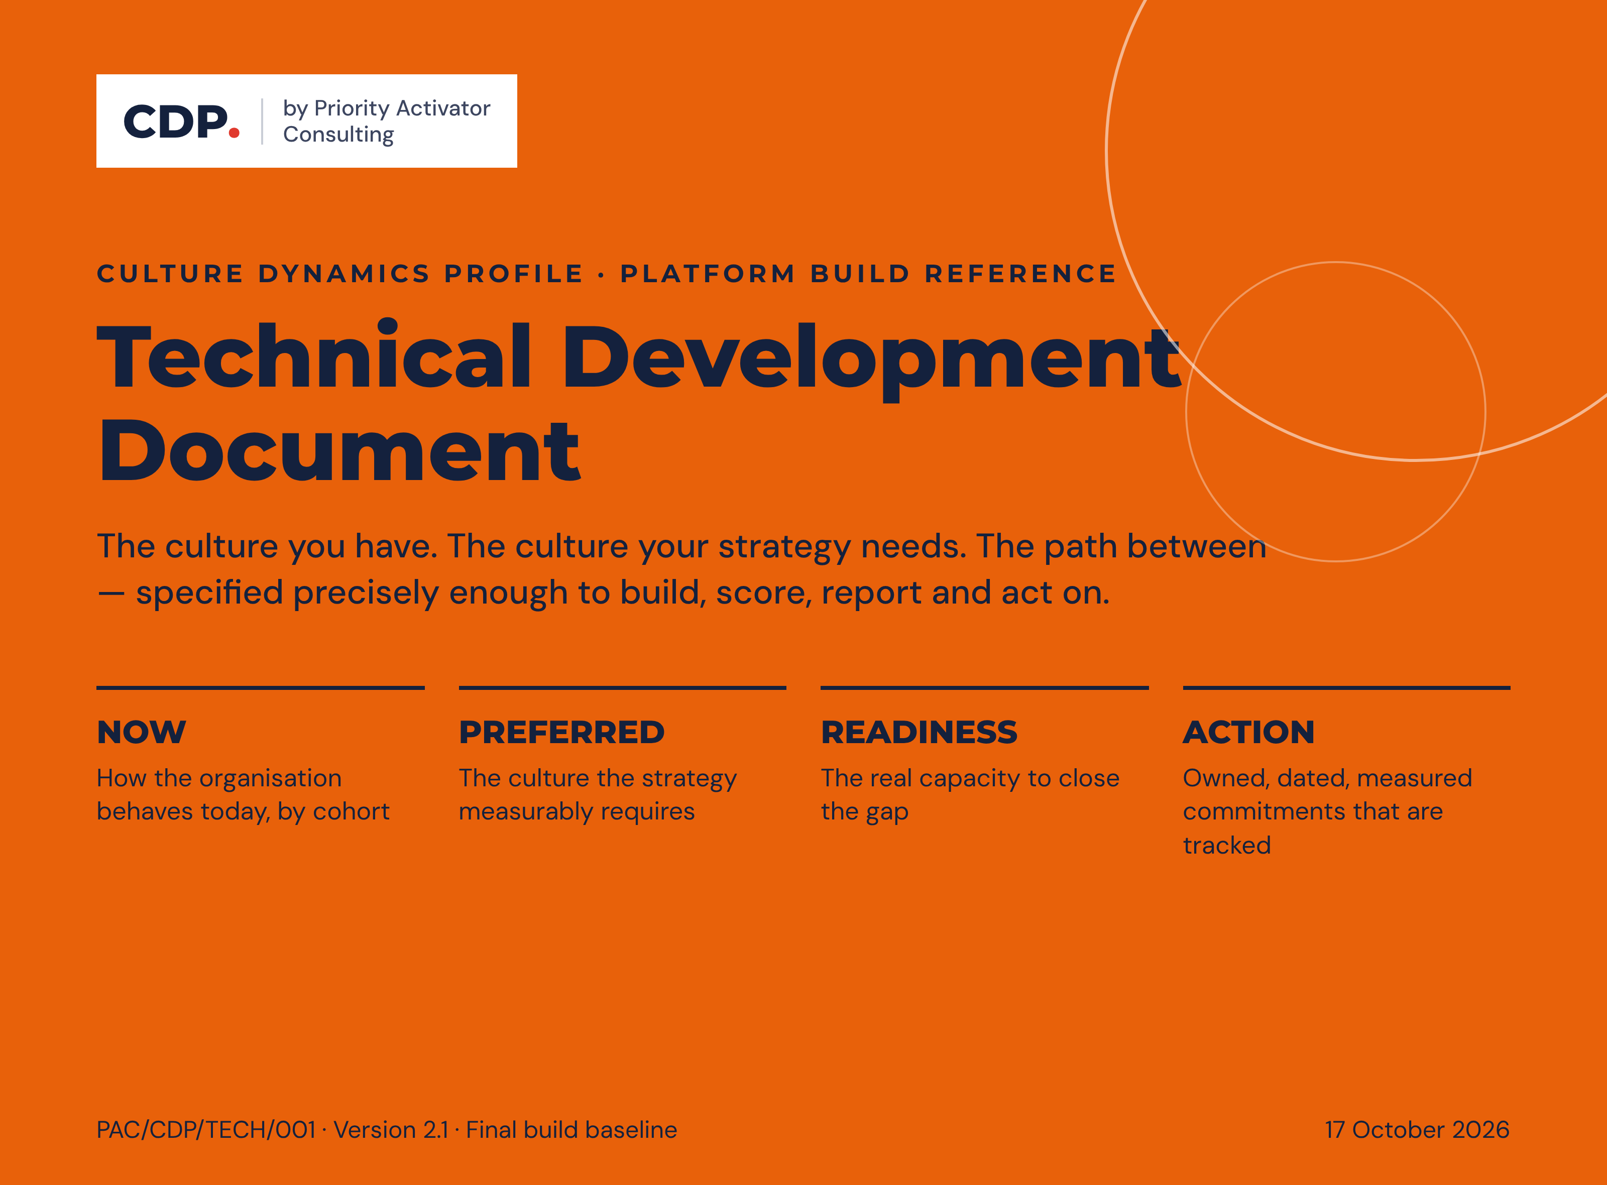

Contents
0. About This Document 1
0.1 Purpose 1
0.2 Document status and authority 1
0.3 How to read it 1
0.4 Intellectual property position 1
0.5 Rules baseline 1
0.6 Document map 1
Part A — Platform Specification 1
1. System Set-up 1
1.1 Reference architecture 1
1.2 Tenant and organisation onboarding 1
1.3 User roles and permissions 1
1.4 Survey configuration 1
2. Organisational Culture Assessment 1
2.1 The four orientations and nine dimensions 1
2.2 Data points per respondent 1
2.3 Instrument design and response capture 1
2.4 Orientation scores 1
2.5 Culture gap 1
2.6 Dominant orientation, culture strength and congruence 1
2.7 eOS — Employee Orientation Survey 1
2.8 D7–D9 readiness dimensions 1
2.9 Transformation Probability Score 1
2.10 Alignment lenses 1
2.11 Data quality, validation and reliability 1
3. Sub-culture Assessment and Slice-and-Dice Analytics 1
3.1 Purpose 1
3.2 Segmentation model 1
3.3 Detecting a sub-culture 1
3.4 Executive–staff perception gap 1
3.5 Filters, drill-down, comparison and heatmaps 1
3.6 Anonymity protection on small groups 1
3.7 Sub-culture report template 1
3.8 Slide-ready outputs 1
4. Leadership Assessment 1
4.1 Instrument structure 1
4.2 Scoring logic 1
4.3 Leadership orientation types 1
4.4 Hard flags 1
4.5 Self–other gaps 1
4.6 Leader Readiness Index 1
4.7 Anonymity in the 360 1
5. Linking Leader Reports to Culture 1
5.1 Data model 1
5.2 Leader–culture fit index 1
5.3 Culture carrier and culture blocker logic 1
5.4 Leader influence on team eOS and TPS 1
5.5 Individual leader report 1
5.6 Leadership-team aggregate report 1
6. Scenario-Based Reporting and the Guidance Engine 1
6.1 Structure of the engine 1
6.2 Gap classification 1
6.3 The four alignment checks 1
6.4 Signal classification reference 1
6.5 Culture-shift pathways 1
6.6 Readiness gates 1
6.7 Priority selection rules 1
6.8 Scenario library 1
6.9 Prescriptive action sets 1
6.10 Rules engine pseudo-code 1
6.11 Decision tree: from one orientation result to a recommendation 1
6.12 The AI interpretation panel 1
7. Reports — Conclusive and Guiding 1
7.1 Common rules for every report 1
7.2 Report suite 1
7.3 Board / Executive Summary 1
7.4 Organisational Culture Report 1
7.5 Leader and leadership-team reports 1
7.6 Export formats and branding 1
8. Action Planning Module 1
8.1 Principle 1
8.2 From findings to draft actions 1
8.3 Prioritisation logic 1
8.4 Action record structure 1
8.5 Workflow and permissions 1
8.6 Leader Development Plans 1
8.7 Tracking and accountability 1
8.8 Measuring impact 1
8.9 Action-plan templates by scenario 1
8.10 Outputs 1
9. Advisory Roadmap for Institutions 1
9.1 The engagement sequence 1
9.2 Cadence 1
9.3 Review questions at every checkpoint 1
9.4 Governance of the change programme 1
10. Build Artefacts 1
10.1 Database schema 1
10.2 API endpoints 1
10.3 Sample JSON 1
10.4 Formula pseudo-code 1
10.5 Unit tests and expected outputs 1
10.6 Development phases and sprints 1
10.7 QA and UAT checklist 1
10.8 Glossary 1
10.9 Design decisions register 1
10.10 Companion document conformance 1
Part B — Action Planning Reference 1
11. Action Planning Reference 1
11.1 How the platform uses this reference 1
11.2 When the reference is used 1
11.3 Orientation reference 1
11.4 Complementary and contrasting relationships 1
11.5 From results to action: the seven-step process 1
11.6 Hits & Misses: quick reference for action planning 1
11.7 ENGAGE playbook 1
11.8 INNOVATE playbook 1
11.9 PERFORM playbook 1
11.10 GOVERN playbook 1
11.11 Worked example (illustrative) 1
11.12 Reporting templates and their data bindings 1
11.13 Instrument-to-action cross-reference 1
11.14 Ethical use in action planning 1
12. Report Composition Engine 1
12.1 Principle 1
12.2 The reference library as structured data 1
12.3 Selecting fitting suggestions 1
12.4 What each report draws from the library 1
12.5 Composing the narrative 1
12.6 Completeness checks before release 1
12.7 Learning from outcomes 1
12.8 Worked example: the INNOVATE priority 1
12.9 Build artefacts for the composition engine 1

0. About This Document

0.1 Purpose
This document is the single, final build baseline for the CDP platform. It converts the CDP instrument, its scoring rules and its advisory method into a specification precise enough to code from, while preserving the advisory meaning a PAC consultant must be able to defend in a boardroom. Every rule in it is authoritative as written: it states what the platform does, not what it might do. Developers code from this document; testers test against it; PAC faculty change advisory logic only through the versioned rules and reference data it describes.
Part A specifies the platform. Part B incorporates the CDP Action Planning Guide as a tagged reference library, and specifies the report composition engine that uses it to write complete reports with suggestions fitted to each organisation, so that one document carries the scoring, the advice and the reporting together.

0.2 Document status and authority
Item | Value
Reference | PAC/CDP/TECH/001
Version | 2.1 · Final build baseline · 17 October 2026 (adds the report composition engine, section 12)
Supersedes | Version 1.0 reference draft and its audit findings, all of which are incorporated in this version
Incorporates | CDP Action Planning Guide (PAC/CDP/ACT/001), as Part B
Owner | Priority Activator Consulting, CDP faculty
Audience | CDP platform development team; PAC consulting faculty and certified practitioners
Classification | Proprietary and Confidential · Priority Activator Consulting
The CDP method is expressed in a family of PAC documents. Their roles relative to this specification are fixed:
Reference | Document | Role
PAC/CDP/INST/001 | CDP Pre-Assessment Setup Guide (Parts One and Two) | Practitioner guide to the dimensions, the instrument, the setup workshop and data governance. Conforms to this specification (10.10).
PAC/CDP/ACT/001 | CDP Action Planning Guide | Incorporated in full as Part B of this document.
PAC/CDP/360/SELF | CDP Leadership 360° Self-Evaluation | Leader instrument, self perspective: 60 items in eight sections.
PAC/CDP/360/RATER | CDP Leadership 360° Leader Evaluation | Leader instrument, rater perspective: the same 60 items with rater-group aggregation.
— | Culture Dynamics Profile (client deck) | Client-facing articulation. Uses the terminology, thresholds and figures of this specification.
Authority. For anything the platform computes, stores, displays or releases, this document governs. Every rule has exactly one definition here; where Part B relies on a rule, it points to the Part A definition rather than restating it. Decisions taken in building the specification are recorded in the design decisions register (10.9).

0.3 How to read it
Each section is written for two readers. Subsections headed “Logic” give developers exact, testable rules: formulas, thresholds, boundary conditions and error behaviour. Subsections headed “Advisory meaning” give consultants the interpretation that must accompany the number when it is presented to a client. Where the two diverge, the advisory meaning constrains how the number may be displayed; it never changes the calculation.
Notation: D1–D9 for the nine CDP dimensions, S1 · S2 · S3 for scenario position within a dimension, C1–C4 for the four alignment checks, eOS Q1–Q8 for the eight employee-survey categories, TPS for the Transformation Probability Score and LRI for the Leader Readiness Index. Figures are drawn in the CDP visual language used in client material; every figure that shows numbers uses the illustrative worked example (2.4.1, 11.11) and is labelled as such.

0.4 Intellectual property position
The four CDP orientations (ENGAGE, INNOVATE, PERFORM, GOVERN), the nine dimensions, the scenario statements, the scoring architecture, the alignment checks, the orientation playbooks and all tooling described here are Priority Activator Consulting’s own development. This document and the platform make no reference to, and take no naming, structural or descriptive content from, any third-party culture framework, diagnostic instrument, quadrant taxonomy, survey methodology or brand. The orientation map is described solely in PAC’s own terms (inward or outward focus; adaptive or structured stance). Metrics use PAC terminology throughout: the eOS respondent bands are Advocates, Neutrals and Critics (2.7), and organisational objectives sit on the client’s strategic scorecard (8.4). Developers must not introduce third-party terminology into code identifiers, database enumerations, user-interface labels, report templates, chart legends or AI prompt text; a deny-list enforces this in the build pipeline (10.7).

0.5 Rules baseline
The sixteen rules below are the ones most often misread when the CDP method is turned into code. Each is authoritative, each is specified in full at the section shown, and each has a named test (10.7).
# | Rule | Authoritative definition | §
1 | TPS bands | Half-open and exhaustive: TPS < 2.50 HIGH RISK; 2.50 ≤ TPS < 3.50 ENABLEMENT REQUIRED; 3.50 ≤ TPS < 4.00 TARGETED SUPPORT; TPS ≥ 4.00 STRONG READINESS. The LRI uses the same bands. | 2.9, 4.6
2 | Alignment percentage | Mean across the required orientations of min(100, 100 × NOW ÷ T), banded ≥ 80 HIT, 60 to < 80 PARTIAL HIT, < 60 MISS, then two overrides. Used by C1 and C4. | 6.3.2
3 | Leadership alignment (TPS input) | Coverage-weighted blend of the headcount-weighted mean LRI and a D2-derived instrument term; always computable, continuous across cycles. | 2.9.2
4 | Alignment lenses | Strategy = mean(D5, D6); Practice = mean(D1, D3, D4); Leadership = D2. D7, D8, D9 and eOS are capacity and context inputs, not lens members. | 2.10
5 | Data points per respondent | 18 scenarios; 36 scenario sets (NOW and PREFERRED); 144 point allocations; 36 Likert items; 8 eOS items; 3 qualitative items; 188 quantitative values. | 2.2
6 | Gap classification | Half-open: BUILD ≥ +8.0; STRENGTHEN +4.0 to < +8.0; KEEP & PROTECT > −4.0 to < +4.0; MODERATE ≤ −4.0, significant at ≤ −8.0. | 6.2
7 | Perception gap | Absolute difference per orientation between executive and staff NOW: > 5.0 to ≤ 7.0 WATCH; > 7.0 SHADOW CULTURE (blocking). Direction is narrative only. | 3.4
8 | D1 name | D1 is Cultural DNA. “Organisational character” is the label of scenario D1 S1. | 2.1
9 | eOS and eOS Index | eOS = Employee Orientation Survey: eight category scores on −100 to +100. The eOS Index is their unweighted mean. | 2.7
10 | eOS respondent bands | Advocates 9–10, Neutrals 7–8, Critics 0–6; category score = % Advocates − % Critics. | 2.7.1
11 | Anonymity | Five respondents per culture segment, three raters per 360 rater group, combination floors and differencing protection; no role can override. | 3.6
12 | Item bank | One canonical UK-English item bank, version 1.1, orthographically aligned across all three instruments. | 1.4.2
13 | Dominance thresholds | One lookup of strict thresholds expressed as margins above the neutral 25: ENGAGE/PERFORM 30 (+5), INNOVATE/GOVERN 28 (+3), transformation pair 26 each (+1), business-model transition 24 each (−1). | 6.3.1
14 | IP position | PAC terminology only; deny-list enforced in the build pipeline and on every AI draft. | 0.4, 6.12.4
15 | Survey window | Minimum ten working days; reminders at day 3, day 6 and 24 hours before close; one consultant extension, a second only with the engagement lead’s approval. | 2.11.3
16 | Data quality | Capture validation, quality flags, completion states and an exclusion log on every assessment. | 2.11

0.6 Document map
Part | Section | What it specifies
A | 1 System set-up | Architecture, onboarding, roles, survey configuration, data protection
A | 2 Organisational culture assessment | Orientations, scoring, gaps, strength, congruence, eOS, D7–D9, TPS, lenses, data quality
A | 3 Sub-culture analytics | Segmentation, sub-culture detection, perception gap, heatmaps, anonymity
A | 4 Leadership assessment | 360 instrument, scoring, orientation types, flags, self–other gaps, LRI
A | 5 Linking leaders to culture | Data model, fit index, carrier and blocker logic, influence, leader reports
A | 6 Guidance engine | Gap classes, C1–C4, signals, pathways, gates, priorities, scenarios, pseudo-code, AI panel
A | 7 Reports | Common rules, report suite, board and organisational reports, exports, branding
A | 8 Action planning module | Draft generation, prioritisation, action record, workflow, tracking, impact
A | 9 Advisory roadmap | Engagement sequence, cadence, review questions, governance
A | 10 Build artefacts | Schema, API, sample JSON, formulas, unit tests, phases, UAT, glossary, decisions register
B | 11 Action planning reference | Orientation reference, playbooks, templates and data bindings, worked example
B | 12 Report composition engine | Library data model, suggestion selection and fit scoring, report assembly, narrative composition, release checks, learning loop
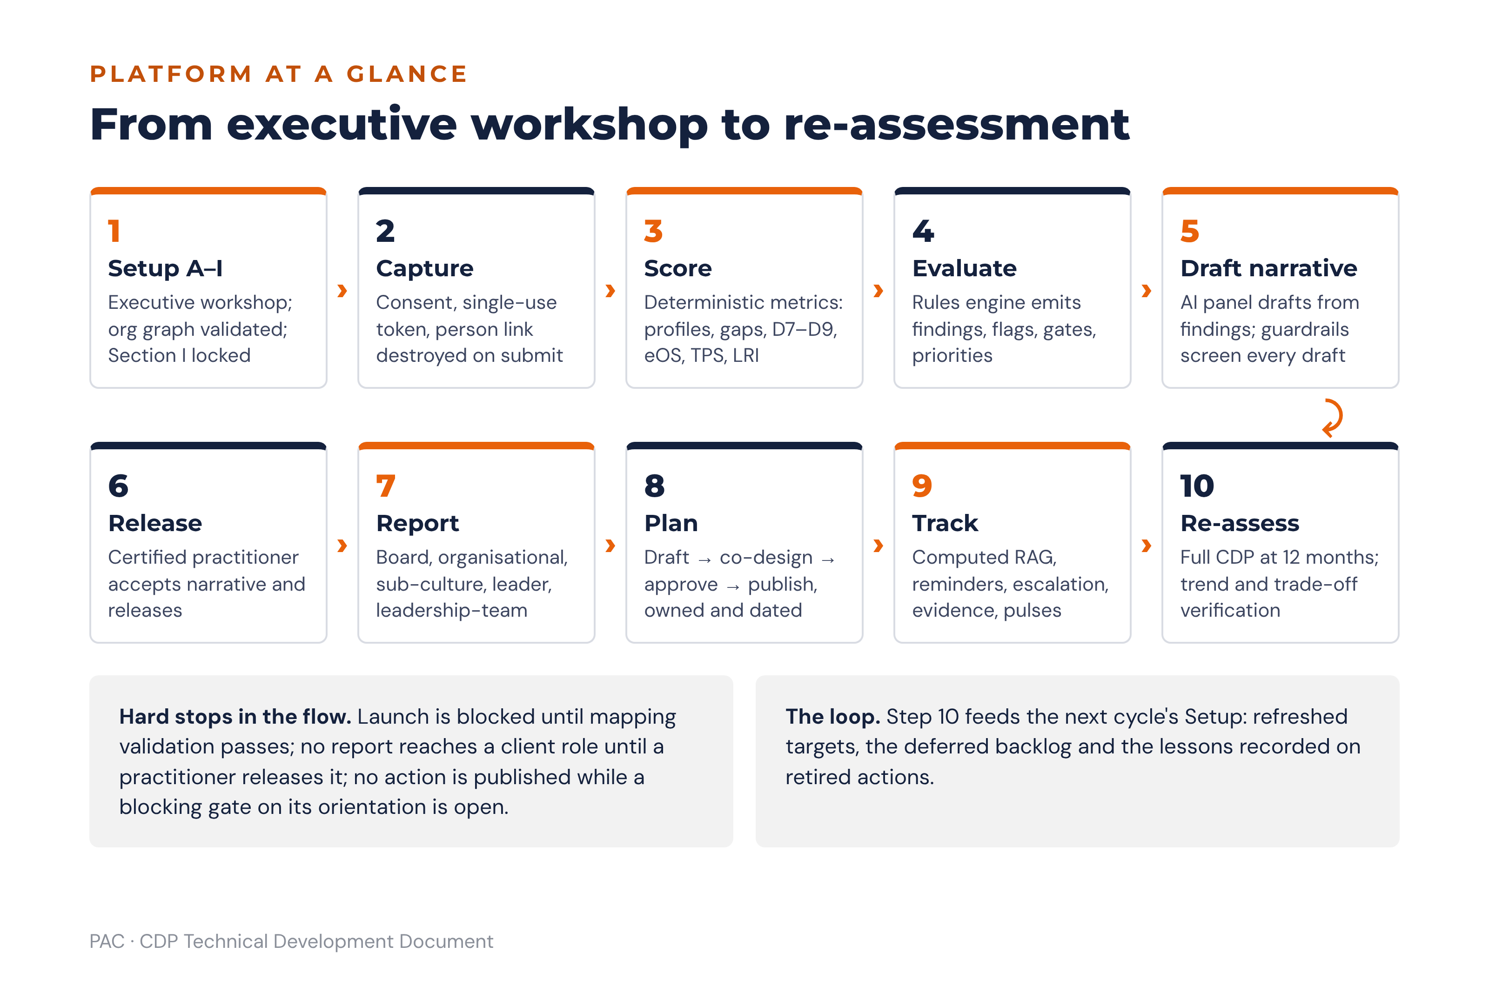
Figure 0 · The platform end to end: from the executive workshop to re-assessment

Part A — Platform Specification

1. System Set-up

1.1 Reference architecture
The platform is a multi-tenant web application. Every tenant is one client organisation; PAC itself is a tenant with cross-tenant consulting rights granted per engagement, never globally. The architecture separates four concerns deliberately: response capture, scoring, interpretation and reporting. Scoring must be deterministic and reproducible; interpretation may be probabilistic; the two must never be mixed in the same service.
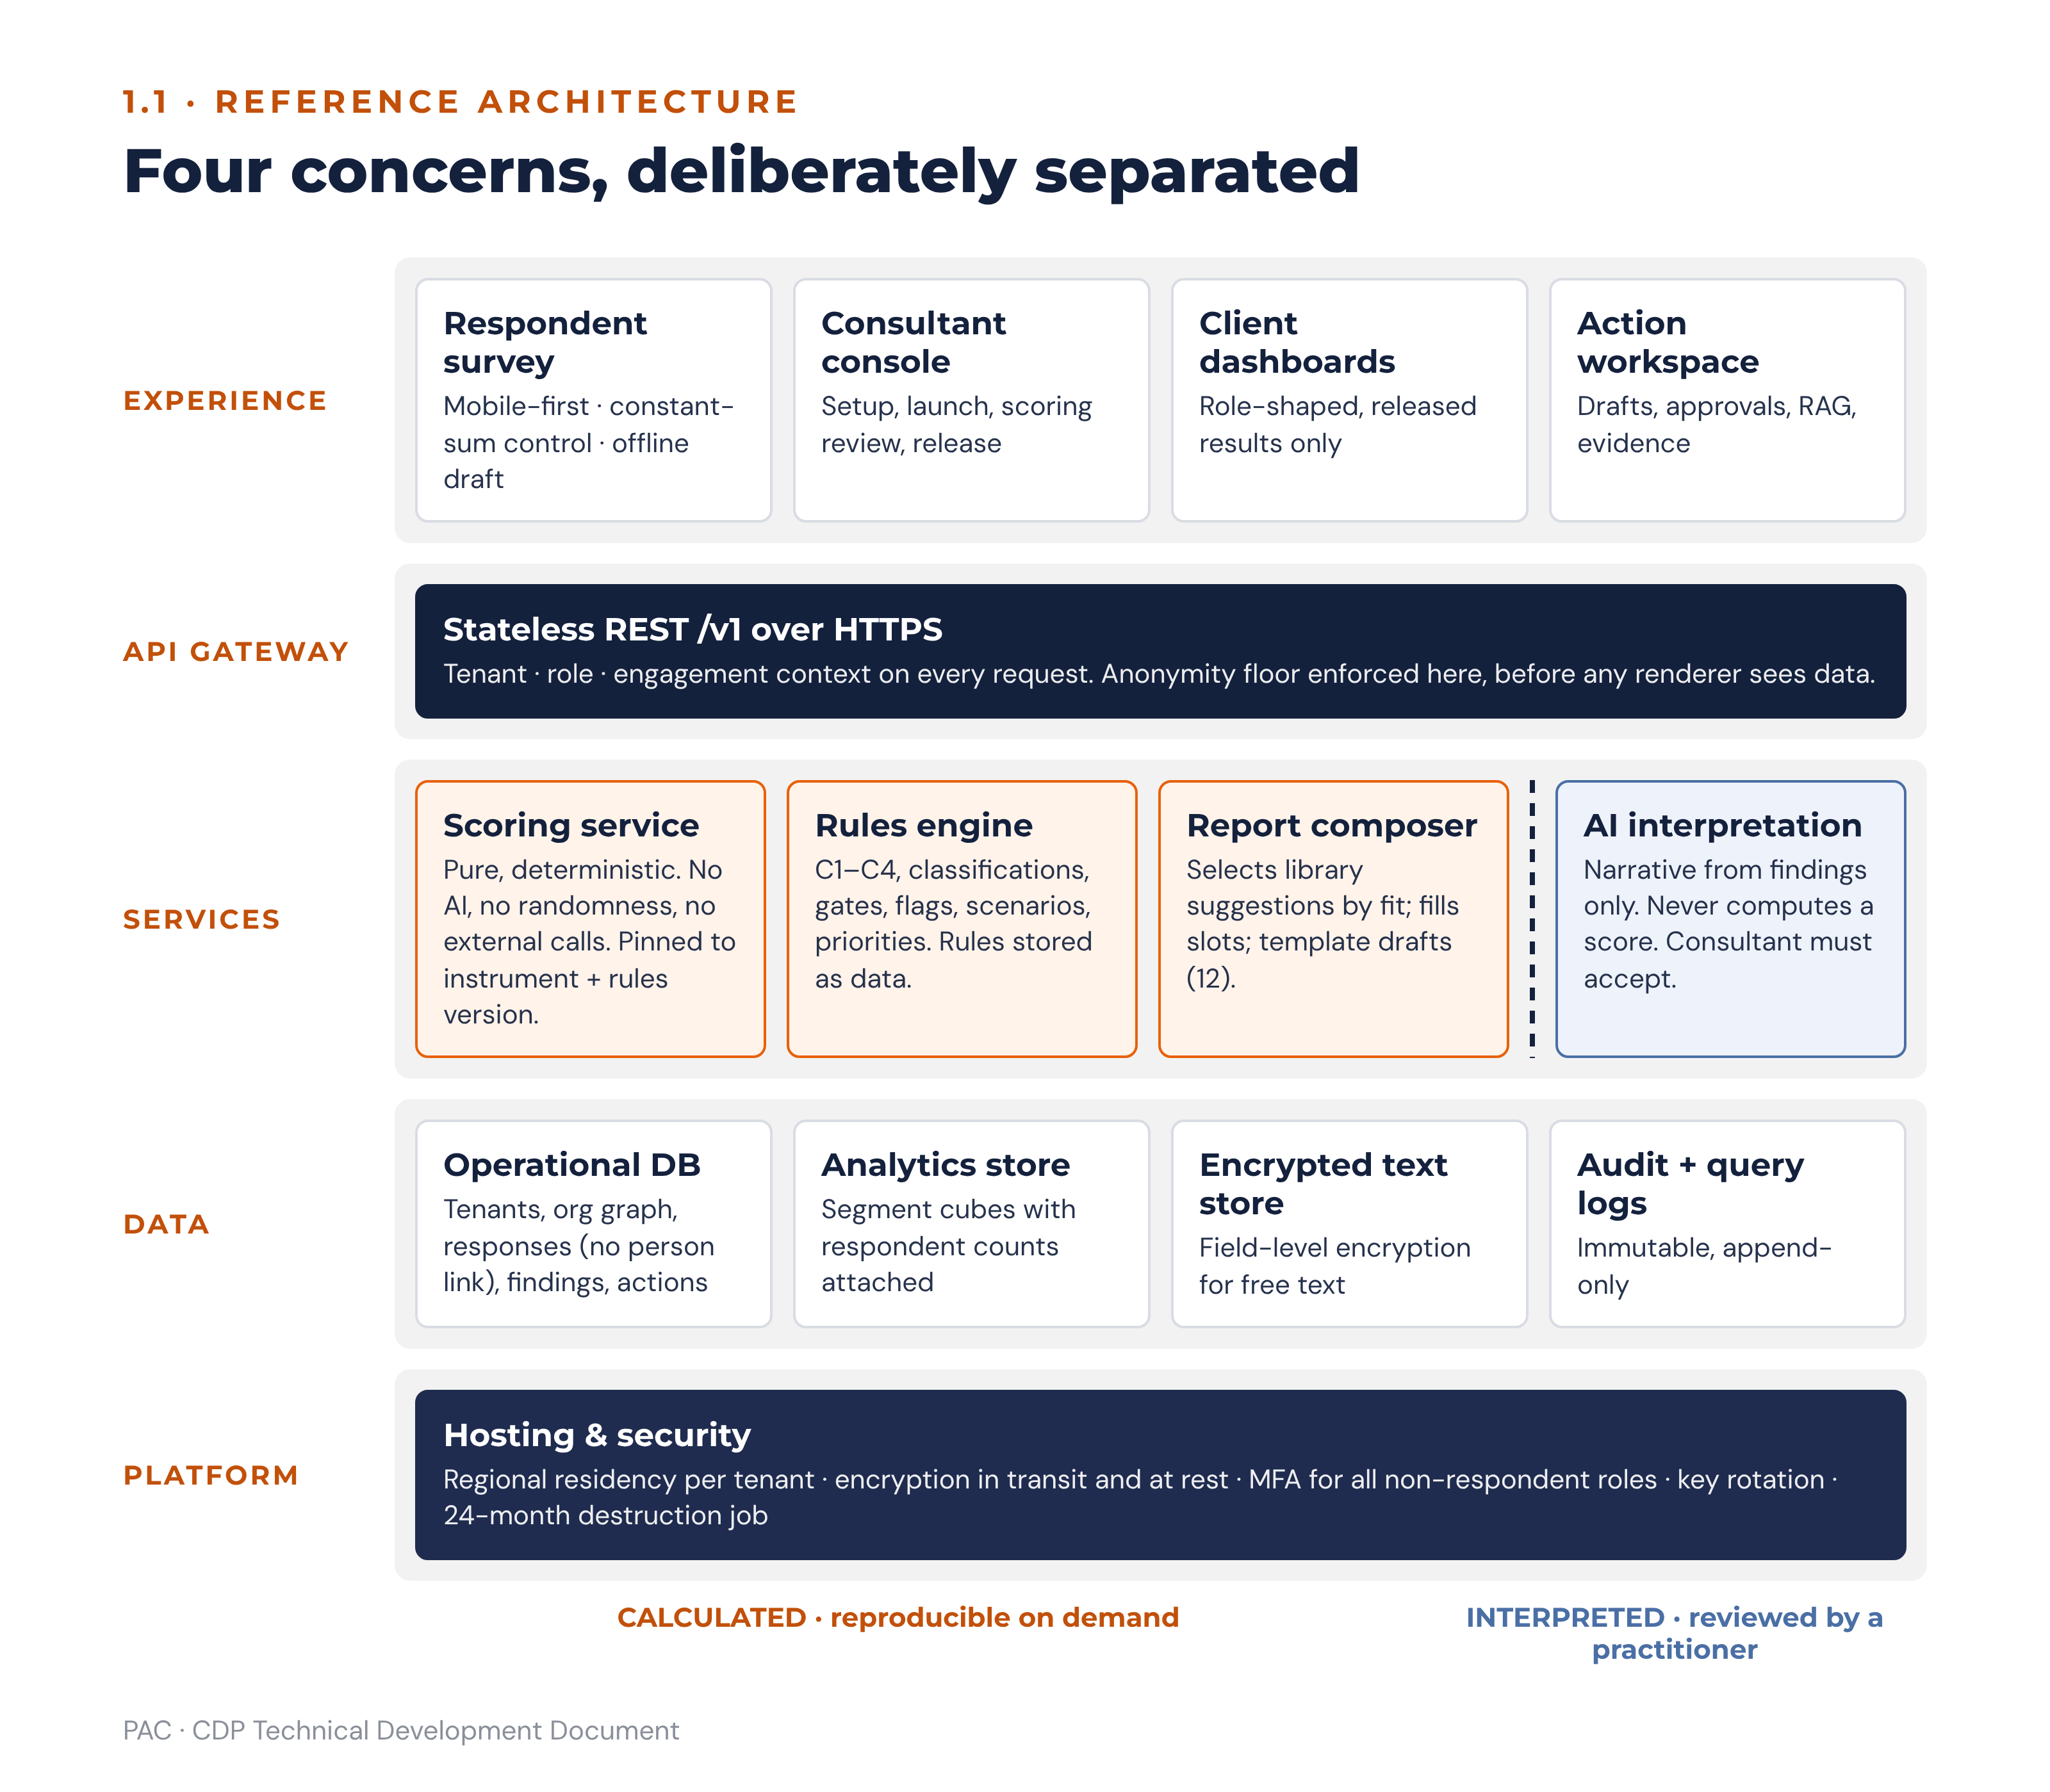
Figure 1 · Reference architecture: what is calculated is separated from what is interpreted
Layer | Responsibility | Build notes
Front end | Respondent survey, consultant console, client dashboards, action-planning workspace. | Responsive web, mobile-first for the respondent path. Constant-sum entry needs a purpose-built control (see 2.3.2). Offline tolerance for low-bandwidth respondents: local draft persistence with explicit resume.
API layer | Stateless REST over HTTPS, versioned (/v1/…). Tenant scoping enforced at the gateway, not in the client. | Every request carries tenant, actor role and engagement context. Reject any query whose resolved audience is below the anonymity floor at the API boundary, not in the report renderer.
Scoring service | Pure, deterministic computation of all metrics in section 2 and section 4. No AI, no randomness, no external calls. | Must be independently executable for regression testing. All formulas are pinned to an instrument version and a rules version; recomputation of a historic assessment must reproduce the original figure exactly.
Rules engine | Evaluates the C1–C4 checks, gap classifications, readiness gates, perception-gap flags and scenario matches; emits findings. | Declarative rule definitions stored as data, not code, so PAC faculty can version advisory logic without a release. See 6.10.
Report composer | Selects fitting suggestions from the reference library for each finding, fills them with the organisation’s own figures and assembles every report section with a template draft. | Deterministic; no AI. Specified at section 12.
AI interpretation service | Generates narrative from findings only. Receives structured findings and scores; never receives raw individual responses. | Grounding and guardrail specification at 6.12. The service may not compute, infer or estimate any score.
Analytics store | Denormalised segment cubes for slice-and-dice, heatmaps and trend comparison. | Pre-aggregated at the segment level with respondent counts attached, so suppression can be enforced without reading response rows.
Operational database | Relational. Tenants, org graph, respondents, invitations, responses, findings, actions, evidence, audit. | Schema at 10.1. Response rows carry no direct person reference; see 1.4.4.
Hosting and security | Regional hosting with data residency honoured per tenant. Encryption in transit and at rest; field-level encryption for free-text responses. | Role-based access control, mandatory multi-factor authentication for all non-respondent roles, immutable audit log, key rotation, and a documented destruction job for the 24-month retention rule.

1.1.1 Advisory meaning
The architectural separation is not merely technical hygiene. PAC’s method rests on the claim that every number in a client report is traceable to the data and reproducible on demand. A consultant challenged in a board meeting must be able to say that the figure was calculated, not generated. Keeping the scoring service free of AI is what makes that claim true.

1.2 Tenant and organisation onboarding
Onboarding has two stages. Stage one records the organisation’s structure, which determines what can be analysed. Stage two is the facilitated Pre-Assessment Executive Workshop, which records strategy, performance, behaviours and the change agenda — the parameters against which all culture findings are later measured. PAC/CDP/INST/001 is explicit that no setup input may be pre-filled by an individual or by the HR function in isolation, and that the platform record is the single source of truth. The platform must enforce this: a setup section cannot be marked complete without a recorded workshop date and at least two named executive participants.

1.2.1 The organisation graph
Entity | Purpose | Rules
Organisation (tenant) | Root node. | One per client. Carries residency region, retention clock and branding pack.
Division | First structural tier. | Optional. Organisations may onboard with departments only.
Department / function | Primary reporting segment. | Mandatory. Every respondent resolves to exactly one department.
Location / site | Geographic segment. | Mandatory where the organisation operates from more than one site.
Team | Smallest structural unit and the unit of leader accountability. | A team has exactly one accountable leader at any point in time. Teams smaller than the anonymity floor are reportable only as part of their parent department.
Grade / level band | Seniority segment. | Mapped to a tenant-defined ordered scale, plus a mandatory flag identifying which grades constitute the executive cohort. This flag drives the perception-gap calculation and must be set before launch.
Leader assignment | Edge linking a person-of-record to a team, with effect-from and effect-to dates. | Historic assignments are retained. A leader report is always computed against the team the leader led during the assessment window, never the current team.
Demographic attribute | Tenure band, age band, gender, contract type, and tenant-defined custom attributes. | Collected as closed-list values only. Free-text demographics are prohibited because they defeat suppression.
Leader-to-team mapping is the load-bearing relationship for sections 5 and 8, and it is the one clients most often supply incorrectly. The platform must run a mapping validation before launch: every team has a leader, every leader is a respondent, no respondent is their own leader, no cycles exist in the reporting chain, and every team either meets the anonymity floor or is explicitly rolled up. Launch is blocked until validation passes or a consultant records an override with a reason.

1.2.2 Setup sections A–I
The nine setup sections are carried unchanged from PAC/CDP/INST/001 and are stored as structured records, not as a document. Sections B, C and D are completed first because strategy, current performance and targets are the anchors against which all culture findings are interpreted. Sections E, F and G are captured twice — once by the executive team and once by senior HR — and the divergence between the two is itself retained as a pre-assessment finding. Section I must be locked before any invitation is issued.
Section | Content | Platform behaviour
A | Organisation identity and context | Prefills report headers. Sector and maturity stage drive the C4 business-model requirement lookup.
B | Current strategy and direction | Top three strategic priorities are tagged to required orientations; this tagging is the input to check C1.
C | Current performance parameters | KPI list with baselines. Each KPI is linkable to an orientation playbook metric and later to an action KPI.
D | Targeted performance and success criteria | 12-month and 3-year targets. Provides the target side of every action baseline.
E | Current people behaviours and lived culture | Captured separately by executive and HR cohorts; divergence flagged.
F | Targeted behaviours and culture destination | Target leadership behaviours are tagged to orientations; this tagging is the input to check C2.
G | Stop doing / start doing agenda | Inputs to check C3. G5 (“keep and protect”) is written back to by the KEEP & PROTECT classification.
H | Processes and structural enablers | Inputs to check C3 and the system-lever recommendations in every playbook.
I | Survey design and cohort parameters | Defines cohorts, anonymity commitment, languages, window, staff communication and qualitative complement. Locked at launch; changes after launch require a new assessment version.

1.3 User roles and permissions
The platform has six roles, built from the actors in every CDP engagement: the certified practitioner who presents all results, the client setup owner, the executive audience, the line leader who owns a team plan, the respondent, and the platform operator. Two scoped designations sit on top of the roles (1.3.2).
Role | Who holds it | Scope
Super Admin | PAC platform operations. | Tenant lifecycle, instrument and rules versioning, key management, retention jobs. No access to response content or client reports.
PAC Consultant (certified practitioner) | PAC engagement lead and certified CDP practitioners. | Full engagement scope for assigned tenants: setup, launch, scoring review, findings, report release, action review. Consultant assignment is per engagement and time-boxed.
Client Admin | Client setup owner, typically CHRO or OD lead. | Org graph, respondent list, invitations, setup sections, action-plan administration. Sees aggregate results only after consultant release.
Executive | CEO, ExCo, Board members. | Released organisational and sub-culture reports, leadership-team aggregate, organisation-wide action plan and progress. No individual leader reports other than their own and their direct reports’.
People Leader | Any leader with an accountable team. | Own leader report, own team’s sub-culture report where the team meets the anonymity floor, own Leader Development Plan, own team action plan.
Respondent | All staff. | Own survey instance, own consent record, own data-subject requests, and the published organisational summary once the client elects to share it.

1.3.1 Permissions matrix
C = create, R = read, U = update, A = approve/release, — = no access. Absence of a right is enforced at the API layer.
Object | Super Admin | PAC Consultant | Client Admin | Executive | People Leader | Respondent
Tenant and residency settings | CRU | R | R | — | — | —
Instrument / rules version | CRU | R | — | — | — | —
Org graph and leader mapping | R | RU | CRU | R | R (own team) | —
Setup sections A–I | — | CRUA | CRU | R | — | —
Survey launch | — | A | C | — | — | —
Own survey response | — | — | — | — | — | CRU until submit
Raw individual responses | — | — | — | — | — | —
Scores and findings | — | RU (override with reason) | R after release | R after release | R (own scope) | —
Report release | — | A | — | — | — | —
Organisational report | — | R | R | R | R | R if published
Sub-culture report | — | R | R | R | R (own team) | —
Leader report | — | R | R (CHRO designate only) | R (self; directs’ sections 1–5, 7–10) | R (self) | —
Leader Development Plan | — | R | R (CHRO designate only) | R (own; direct reports’ as line manager) | R (own) | —
Leadership-team aggregate | — | R | R | R | — | —
Draft actions | — | CRU | CRU | R | CRU (own level) | —
Action approval | — | R | R | A | R | —
Evidence upload | — | R | RU | R | CRU | —
Audit log | R | R | R (own tenant) | — | — | —
Two rules override the matrix without exception. No role, including Super Admin, may read an individual response row or an individual 360 rater response; the platform exposes aggregates only. And no report may be released to any client role until a PAC Consultant has released it, because PAC/CDP/INST/001 requires that all reports be presented by a trained facilitator and that raw scores never be shared without contextual interpretation.

1.3.2 Scoped designations
Designation | Held by | Effect
CHRO designate | One named user per tenant holding the Client Admin or Executive role, recorded at onboarding and changeable only by the PAC Consultant. | Reads every leader report, Leader Development Plan, hard flag and carrier/blocker classification in the tenant. Receives integrity-flag escalations (4.4) and critical-blocker escalations (5.3).
Assigned coach | A PAC Consultant or an approved external coach, assigned per leader with effect-from and effect-to dates. | Reads that leader’s report and development plan for the assignment period only. Holds no other right in the tenant.
A line manager reading a direct report’s leader report sees every section except section 6 (fit and contribution): the carrier/blocker classification is visible only to the leader, the assigned coach, the CHRO designate and the PAC Consultant (5.3).

1.4 Survey configuration

1.4.1 Item bank structure
Block | Items | Scale | Perspectives
D1–D6 culture dimensions | 6 dimensions × 3 scenarios = 18 scenarios, each carrying 4 orientation statements | Constant-sum: exactly 100 points distributed across the four orientation statements in each scenario | NOW and PREFERRED (each scenario answered twice)
D7 Digital Readiness | 12 items | 5-point agreement (1 strongly disagree – 5 strongly agree) | Single
D8 Psychological Safety | 12 items | 5-point agreement | Single
D9 Adaptive Capacity | 12 items | 5-point agreement | Single
eOS | 8 category items | 0–10 | Single
Qualitative | 3 open questions (strengths, challenges, the one change) | Free text | Single
Leader 360 | 60 items in eight sections (A–D at 10 items, E–H at 5 items) | 5-point frequency/agreement | Self and three rater groups

1.4.2 Versioning
Every item, scenario statement, scale and scoring rule is versioned. An assessment record stores the instrument version and the rules version it was scored under, and recomputation must use the stored versions, never the current ones. Item-bank version 1.1 is the canonical UK-English release: one spelling and register across the culture survey and both 360 forms, with a recorded equivalence statement. Version 1.1 is orthographic only and does not alter item meaning, scale anchors or scoring, so it is treated as equivalent to 1.0 for trend comparison. Any future change to item wording that affects meaning creates a new major version and breaks trend comparability; the platform blocks any comparison that crosses a major version boundary and warns across a minor one.

1.4.3 Languages
Setup Section I captures the required languages. UK English is the canonical source and the only language available at first release. Every other language is added per tenant as a locale variant of each item, publishable only after forward translation, independent back-translation and reconciliation by a PAC certified practitioner fluent in the language, with the reconciliation recorded against the item. Respondents choose language at survey start; the choice is stored on the response for analysis but is not a reportable demographic unless the tenant has five or more respondents in that language. Scores from different locale variants of the same item version are pooled; the platform flags any orientation score where one language cohort diverges by more than the sub-culture divergence threshold, because that pattern may indicate a translation defect rather than a sub-culture.

1.4.4 Anonymity thresholds
Three floors operate simultaneously. Any reporting segment for the culture survey requires at least five respondents. Any 360 rater group requires at least three raters, and a group below three is merged into an “all others” group. Any organisational cohort report requires at least five respondents. These floors are absolute: PAC/CDP/INST/001 states that the threshold is maintained without exception regardless of client requests, and the platform must therefore not expose an override to any role.
Response rows are stored without a direct person reference. An invitation record links a person to a single-use token; on submission the response is written against the token’s demographic snapshot and the link between person and token is destroyed. This means the platform cannot reconstruct an individual response even under compulsion, which is what the anonymity commitment in the staff communication actually promises.

1.4.5 Consent and data protection (Kenya Data Protection Act, 2019)
The obligations below implement the Act and its regulations for Kenyan tenants. The client’s data protection officer signs off the tenant’s consent text and processing record before first launch; the sign-off is a launch pre-flight check (10.2). Where a tenant operates outside Kenya, the equivalent local regime applies (for Ethiopian tenants, Ethiopia’s personal data protection proclamation) and the platform records on the tenant which regime governs it.
Obligation | Platform implementation
Lawful basis and consent | Consent is captured per respondent at survey start, before the first item is displayed, as an explicit affirmative action with a timestamped record. The consent text states purpose, categories of data, retention period, recipients and the right to withdraw. Consent is not bundled with employment terms.
Purpose limitation | The assessment purpose is recorded on the tenant and reproduced in the consent text. The platform blocks any export that is not a released report, and blocks any query whose stated purpose differs from the recorded one.
Data minimisation | Only closed-list demographics necessary for the agreed cohort analysis are collected. Setup Section I must name each demographic and its analytical purpose; unnamed attributes cannot be collected.
Sensitive personal data | Gender, age band and any health or ethnicity attribute are treated as sensitive. Collection is optional per respondent, defaults to “prefer not to say”, and a refusal never blocks survey completion.
Data subject rights | Self-service routes for access, rectification of demographic attributes, objection and erasure of the invitation record. Because responses are unlinked at submission, the platform must tell the respondent plainly that a submitted response cannot be retrieved or deleted individually, and the consent text must say so before submission.
Retention and destruction | 24 months from assessment completion, then irreversible destruction, unless the client requests an alternative in writing before expiry. Implemented as a scheduled job with a pre-expiry notification at 90 and 30 days and an immutable destruction certificate.
Cross-border transfer | Tenant residency region is enforced at the storage and processing layer. Any transfer outside the region requires a recorded transfer basis; the AI interpretation service must run in-region or receive findings only, never response content.
Processor obligations | PAC acts as processor for client tenants. The platform maintains a processing register, sub-processor list, breach detection and a 72-hour notification workflow to the data controller and the regulator.
Ethical use constraint | PAC/CDP/INST/001 prohibits using CDP findings to make decisions about specific individuals. The platform enforces this by construction: no individual culture response exists, leader reports are marked development-only, and the 360 module blocks export into any performance or remuneration context.

2. Organisational Culture Assessment

2.1 The four orientations and nine dimensions
The CDP measures the relative strength of four culture orientations. Every organisation carries all four simultaneously; the profile reveals which dominate, which are under-represented and how the actual profile compares with what the strategy requires. The orientations are placed on two tensions that are PAC’s own construction: a horizontal tension running from an inward, people-centred focus to an outward, market-facing focus, and a vertical tension running from an adaptive, change-seeking stance to a structured, control-oriented one. Each orientation sits where two poles meet, and each is a legitimate definition of success. Their relative positions are what makes the profile actionable, because they predict which shifts are easy and which are hard.
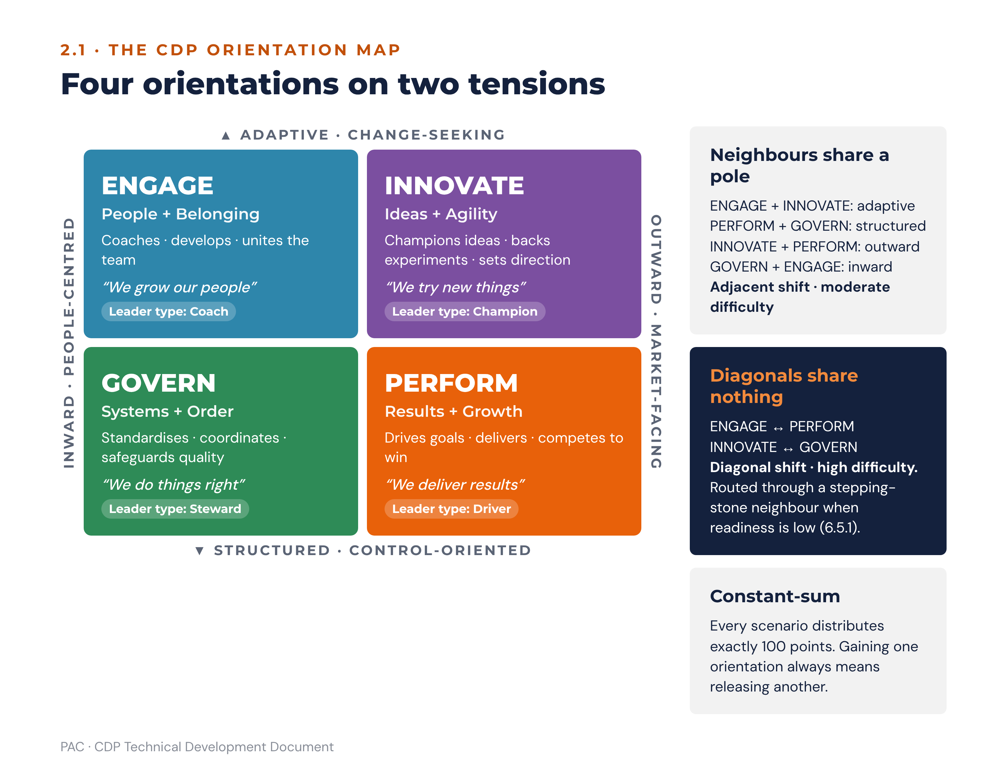
Figure 2 · The CDP orientation map: four orientations on two tensions
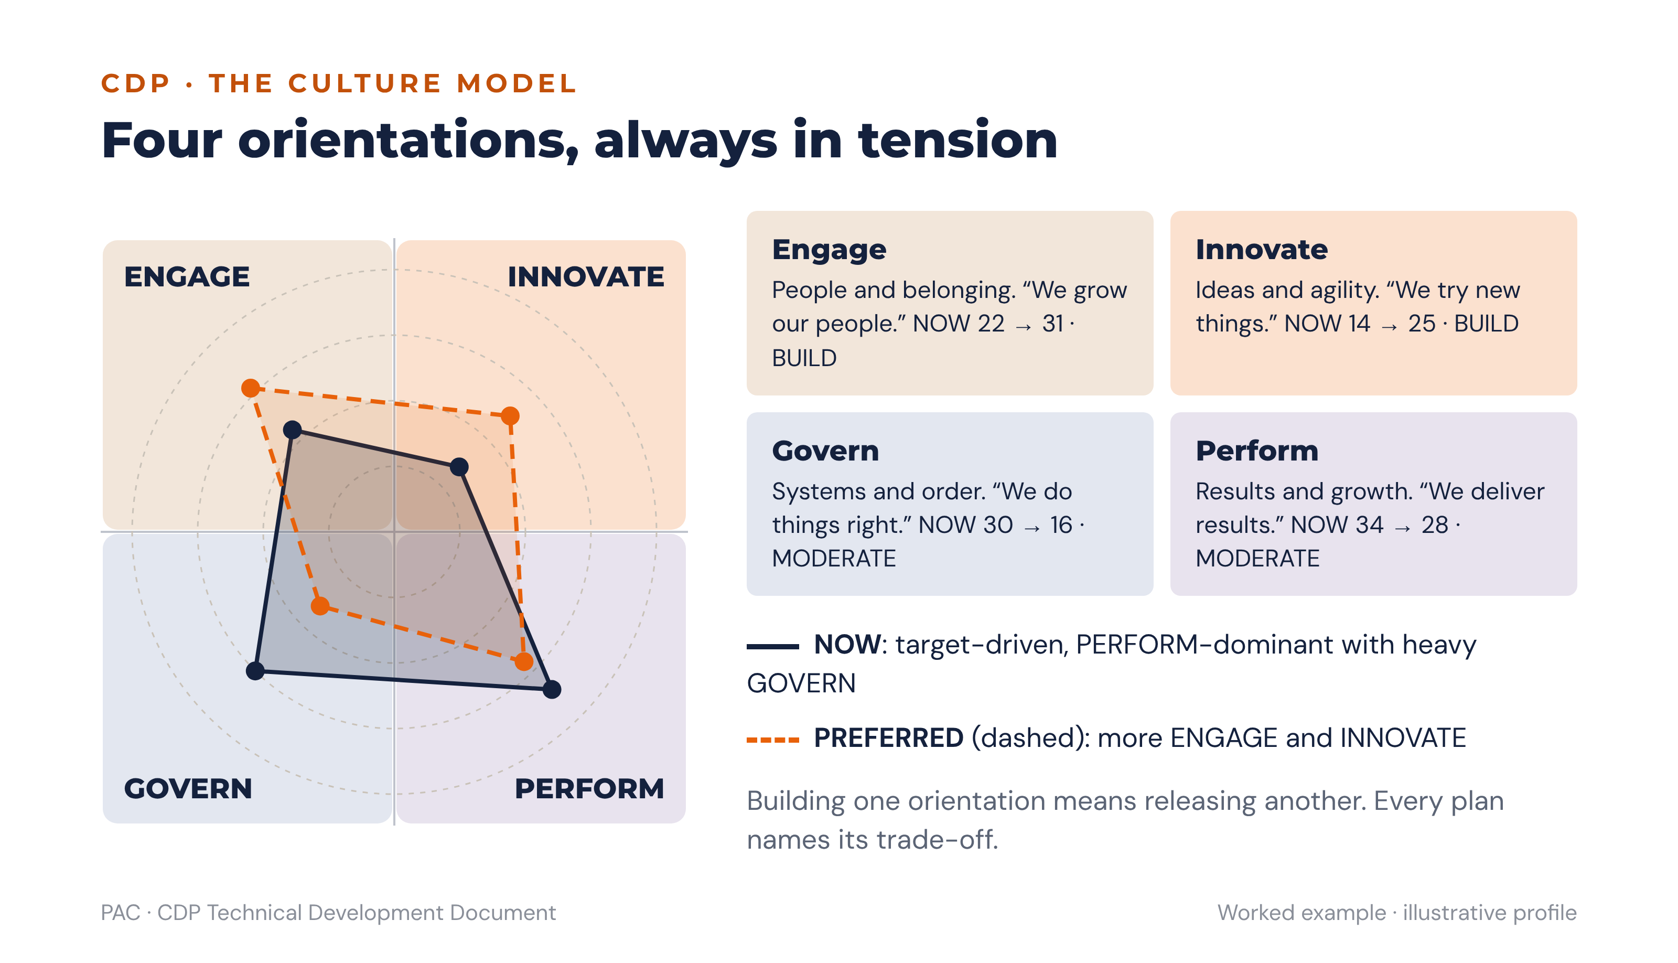
Figure 3 · A culture profile drawn on the map: NOW (solid) against PREFERRED (dashed), worked example
Orientation | Core focus | Values | Leader type | Motto | Map position
ENGAGE | People + Belonging | Belonging · shared commitment · growing people · open participation · lasting relationships | Coaches · develops · unites the team | We grow our people | Inward focus + adaptive
INNOVATE | Ideas + Agility | Fresh thinking · experimentation · smart risk-taking · continual learning · forward vision | Champions ideas · backs experiments · sets direction | We try new things | Outward focus + adaptive
PERFORM | Results + Growth | Ambition · winning in the market · customer focus · clear targets · measurable returns | Drives goals · delivers · competes to win | We deliver results | Outward focus + structured
GOVERN | Systems + Order | Reliability · consistent standards · efficient processes · clear controls · dependable delivery | Standardises · coordinates · safeguards quality | We do things right | Inward focus + structured
Each orientation shares one pole with each of its two neighbours and none with its diagonal opposite. ENGAGE and INNOVATE share the adaptive pole; PERFORM and GOVERN share the structured pole; INNOVATE and PERFORM share the outward pole; GOVERN and ENGAGE share the inward pole. ENGAGE and PERFORM are diagonal opposites, as are INNOVATE and GOVERN. This geometry is used directly by the pathway logic in 6.5.
Dimension | Name | Measures | Scale
D1 | Cultural DNA | What fundamentally defines who we are. Scenarios: organisational character · new employee experience · response to adversity. | Constant-sum
D2 | Leadership Blueprint | How leaders lead, what they model, what they are recognised for. Scenarios: leadership orientation · how leaders invest time · what leaders are recognised for. | Constant-sum
D3 | People Architecture | How employees are managed, developed and enabled. Scenarios: management philosophy · development approach · performance conversations. | Constant-sum
D4 | Cohesion Drivers | What unites the organisation. Scenarios: bonding mechanism · what makes people stay · identity through change. | Constant-sum
D5 | Strategic Compass | What guides strategic priorities. Scenarios: strategic orientation · resource allocation · long-term investment. | Constant-sum
D6 | Victory Conditions | How success is defined, measured and celebrated. Scenarios: success definition · what gets celebrated · measurement philosophy. | Constant-sum
D7 | Digital Readiness | Culture in relation to technology adoption and data-informed decisions. 12 items. | 1–5 agreement
D8 | Psychological Safety | Whether people feel safe to speak, challenge, admit error and raise concerns. 12 items. | 1–5 agreement
D9 | Adaptive Capacity | Capacity to initiate, sustain and complete change at a sustainable pace. 12 items. | 1–5 agreement

2.2 Data points per respondent
The counts below are used in all validation, progress indicators and completion rules.
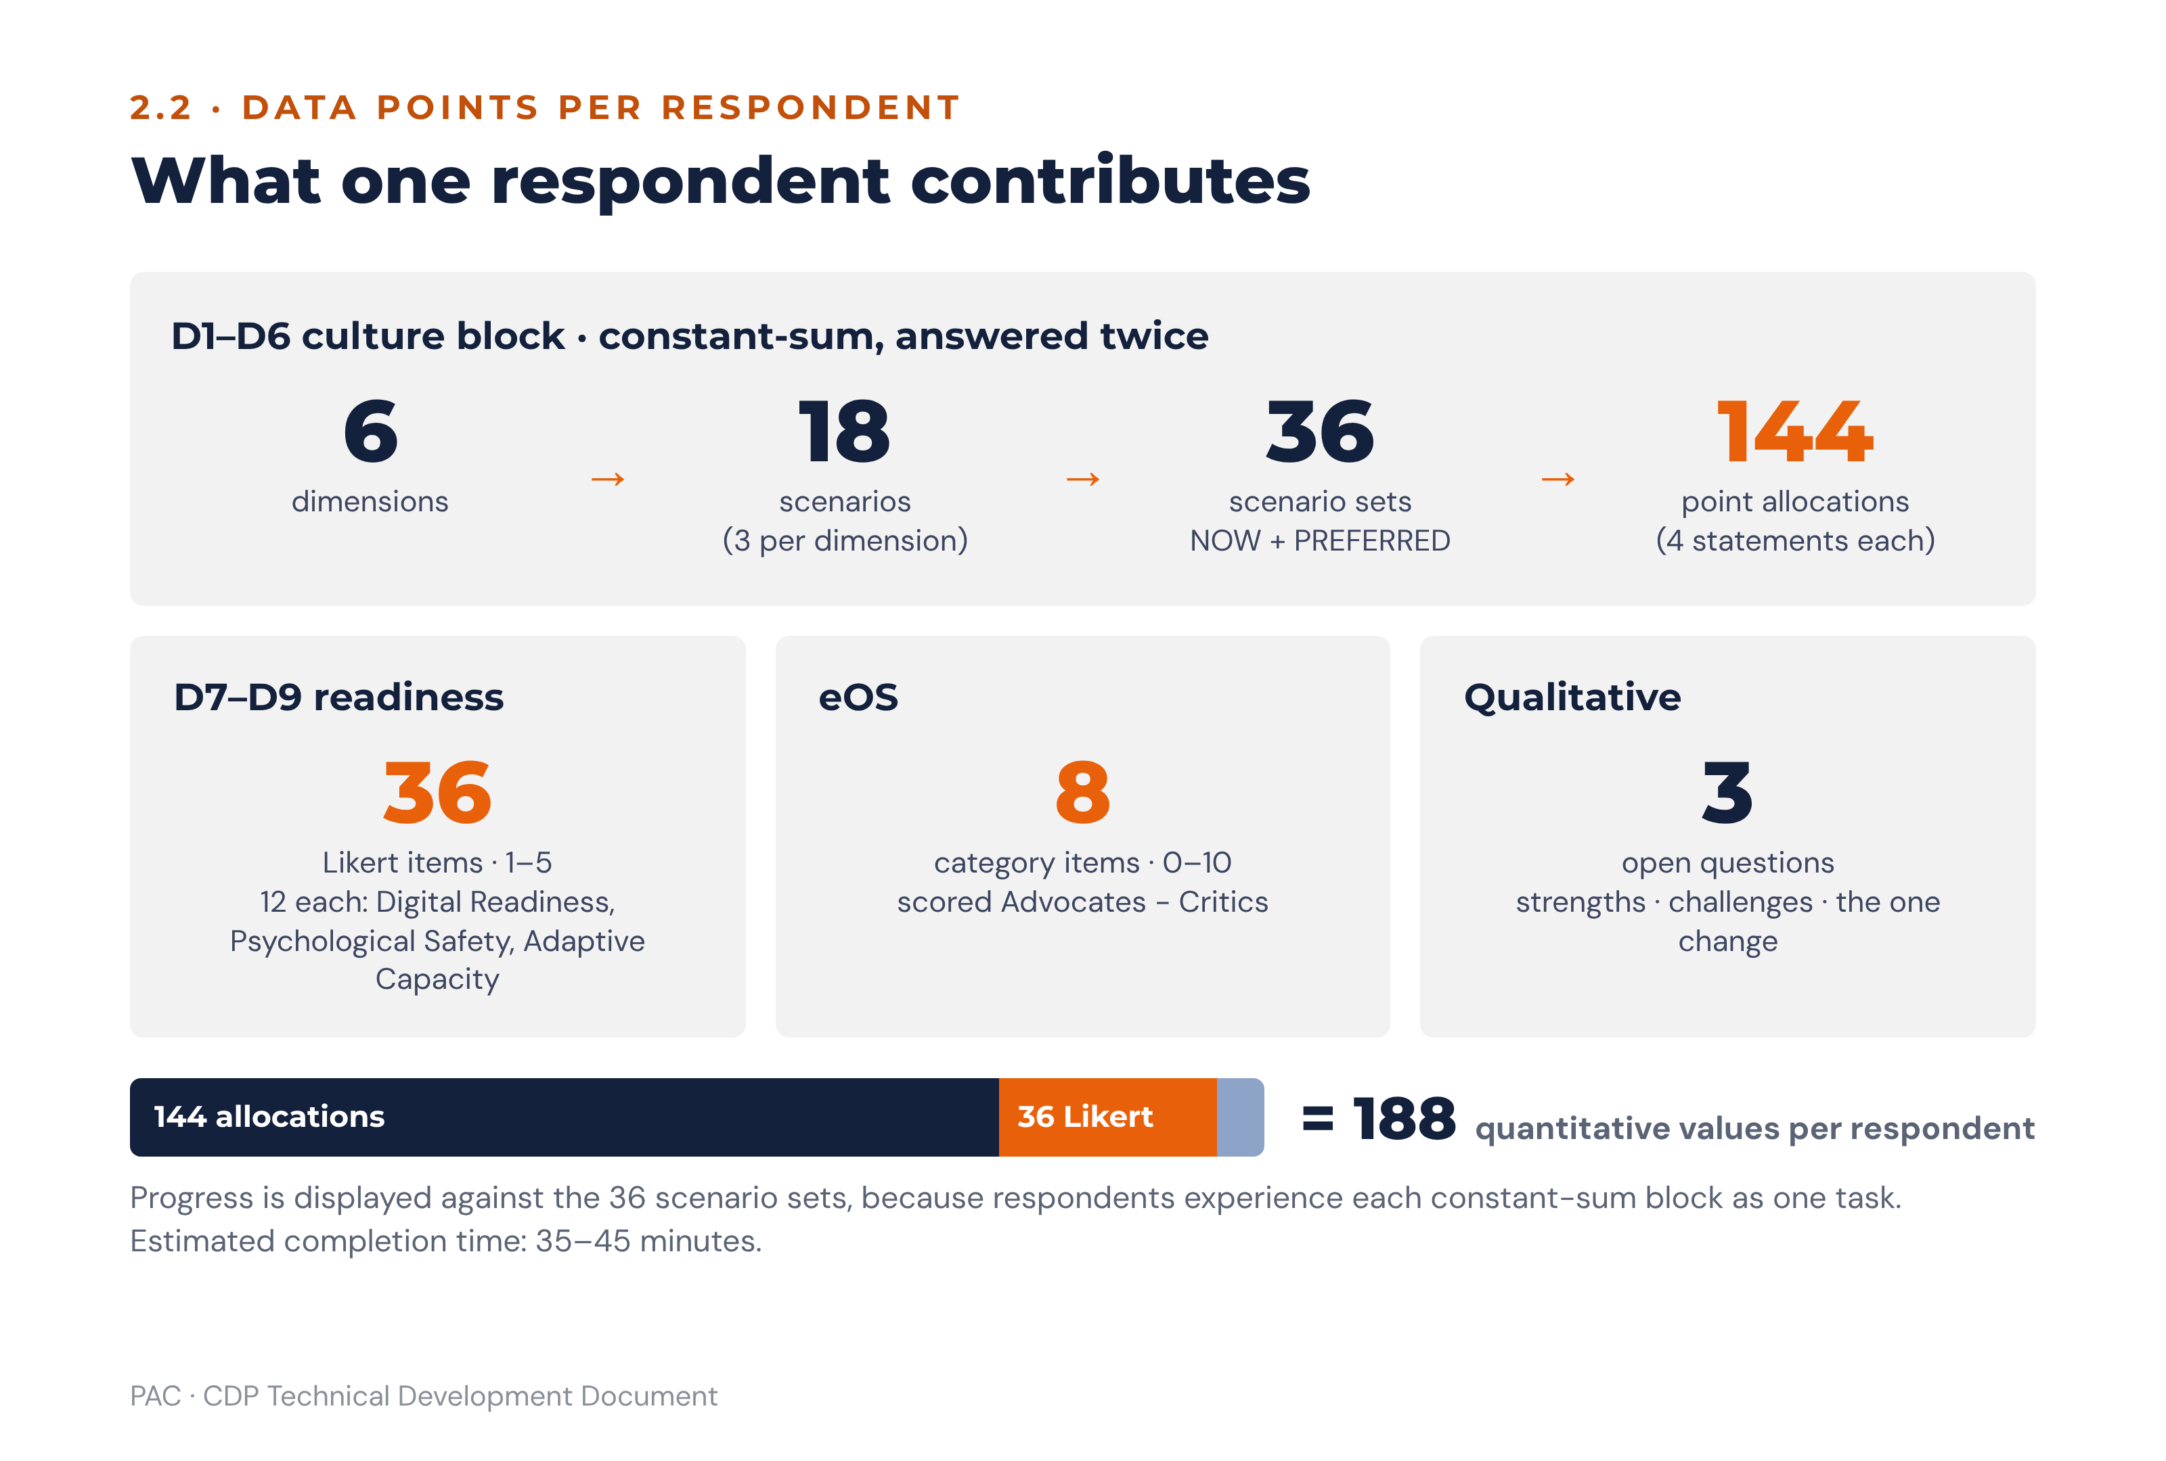
Figure 4 · The 188 quantitative values each respondent contributes
Element | Count | Derivation
Culture scenarios | 18 | 6 dimensions × 3 scenarios
Scenario sets completed | 36 | 18 scenarios × 2 perspectives (NOW, PREFERRED)
Point allocations captured | 144 | 36 scenario sets × 4 orientation statements
Likert items | 36 | 3 dimensions (D7–D9) × 12 items
eOS items | 8 | 8 categories
Qualitative items | 3 | Strengths · challenges · the one change
Total quantitative values | 188 | 144 + 36 + 8
The respondent communication states an estimated completion time of 35–45 minutes. UAT measures the median completion time on the full instrument, and the communication is updated before first launch if the measured median falls outside that range. The platform displays progress against the 36 scenario sets rather than against a raw item count, because respondents experience each constant-sum block as a single task.

2.3 Instrument design and response capture

2.3.1 Two perspectives
D1–D6 are completed twice: first for NOW, the organisation as it is today, then for PREFERRED, the culture the respondent believes the organisation needs in five years. Respondents rate the organisation as a whole, not their own team. The gap between the two perspectives is the most analytically valuable output of the instrument and the primary driver of the action plan. D7–D9, eOS and the qualitative questions are single-perspective.

2.3.2 Constant-sum entry control
Each scenario presents four statements labelled ENGAGE, INNOVATE, PERFORM and GOVERN in a fixed orientation sequence, and the respondent distributes exactly 100 points across them. The control must show a live running total, must not permit submission of the scenario while the total differs from 100, must permit zero on any statement, and must accept integers only. Statement order within a scenario is fixed rather than randomised so that the constant-sum trade-off is presented consistently; the orientation label is displayed, because the instrument is a self-report of relative emphasis rather than a disguised test.

2.3.3 Advisory meaning of constant-sum
Constant-sum scoring carries a consequence that must be stated in every debrief: gaining one orientation requires releasing another. A plan that proposes to build ENGAGE without naming what will be moderated is arithmetically incoherent and will fail in practice. This is why every strategic priority in section 8 must name its trade-off.

2.4 Orientation scores
Logic. For each orientation, the orientation score is the arithmetic mean of that orientation’s 18 scenario allocations across D1–D6, computed separately for NOW and PREFERRED and separately for each reporting cohort. Because each scenario sums to 100, the four orientation scores for a given perspective and cohort also sum to 100. Scores are held to two decimal places internally and presented to whole points in client reports. Rounding rule (platform-wide): every rounding step uses half-up decimal arithmetic, never binary floating point and never banker’s rounding, so 3.085 reports as 3.09 (UT-52).
orientation_score(o, perspective, cohort) =
Σ allocation(o, d, s, perspective, r) for d in D1..D6, s in S1..S3, r in cohort
÷ (18 × |cohort|)
Dimension-level orientation scores use the same formula restricted to the three scenarios of that dimension, and are required for the lens calculations in 2.10 and the playbook watch-lists in section 6.

2.4.1 Worked example
The worked example used throughout this document is the illustrative case set out in full in Part B (11.11): a mid-sized financial services firm of about 650 staff, mature stage, with a three-year strategy to grow digital channels and differentiate on customer experience. Twelve-month targets are digital adoption from 28% to 45%, customer satisfaction up 10 points, and voluntary attrition down from 19% to 13%. All figures are illustrative.
Orientation (D1–D6 mean) | ENGAGE | INNOVATE | PERFORM | GOVERN | Total
NOW | 22 | 14 | 34 | 30 | 100
PREFERRED | 31 | 25 | 28 | 16 | 100
Gap (PREFERRED − NOW) | +9 | +11 | −6 | −14 | 0
Classification (per 6.2) | BUILD | BUILD | MODERATE | MODERATE (significant) | —
Executive NOW | 30 | 16 | 32 | 22 | 100
Staff NOW | 19 | 13 | 35 | 33 | 100
Perception gap (absolute) | 11 | 3 | 3 | 11 | —
Perception flag (per 3.4) | SHADOW CULTURE | — | — | SHADOW CULTURE | —

2.5 Culture gap
Logic. gap(o) = orientation_score(o, PREFERRED) − orientation_score(o, NOW), per orientation and per cohort. Because both perspectives sum to 100, the four gaps always sum to zero, a property the platform asserts as a unit test. A positive gap means the cohort wants more of that orientation; a negative gap means less. A gap of 8.0 points or more in either direction is strategically significant and requires a named workstream and an executive owner. The full classification is specified at 6.2.
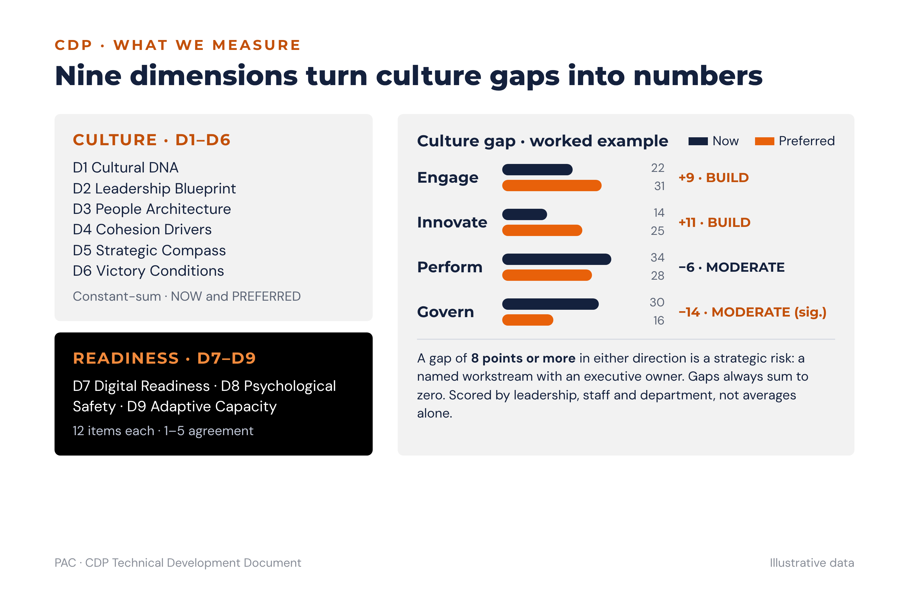
Figure 5 · Nine dimensions and the culture gap, worked example
Advisory meaning. The sum-to-zero property is the debrief’s most useful teaching point. A client asking for more of everything has not yet made a strategic choice. The consultant’s job in the debrief is to make the release side of the trade explicit, and the platform supports this by always displaying the negative gaps with the same prominence as the positive ones.

2.6 Dominant orientation, culture strength and congruence

2.6.1 Dominant and secondary
The dominant orientation is the highest NOW orientation score; the secondary is the second highest. Where two orientations are within 1.0 point of each other, the platform reports a shared dominance and the report narrative must describe the culture as dual-oriented rather than naming a single dominant orientation. Ties are never broken arbitrarily. The same rule applies to the PREFERRED profile and to every cohort.

2.6.2 Culture strength
Culture strength measures how concentrated the profile is. The neutral baseline under constant-sum scoring with four orientations is 25 points, so strength is the distance of the dominant orientation above that baseline.
culture_strength = orientation_score(dominant, NOW) − 25
Culture strength | Classification | Advisory meaning
< 5.0 | Diffuse | No orientation carries the organisation. Expect inconsistent behaviour across units and weak identity. Change is easy to start and hard to sustain.
5.0 to < 10.0 | Moderate | A recognisable emphasis without rigidity. The most workable starting point for a culture shift.
10.0 to < 15.0 | Strong | A clear identity that delivers reliably in its own terms and resists demands that fall outside them.
≥ 15.0 | Highly concentrated | A single orientation dominates behaviour. Any shift will be experienced as an attack on identity and requires the bridging narrative discipline in 6.5.
Worked example: dominant is PERFORM at 34, so culture strength is 9.0 — moderate.

2.6.3 Culture congruence
Congruence measures whether the organisation is the same culture everywhere the instrument looks. Two congruence figures are reported.
dimension_congruence = ( count of D1..D6 whose dominant NOW orientation equals the organisation-wide dominant NOW orientation ) ÷ 6 × 100
lens_congruence = count of the three lenses (Strategy, Practice, Leadership; see 2.10) whose dominant NOW orientation equals the organisation-wide dominant NOW orientation, reported as n of 3
Dimension congruence | Classification | Advisory meaning
≥ 83% (5–6 of 6) | Highly congruent | The culture is consistent across identity, leadership, people practice, cohesion, strategy and success definition. Findings generalise safely.
50–82% (3–4 of 6) | Moderately congruent | Parts of the organisation’s machinery pull in different directions. Name which dimensions dissent; they are usually where the intervention belongs.
< 50% (0–2 of 6) | Fragmented | There is no single organisational culture, only sub-cultures. Report at cohort level first and treat the organisation-wide profile as an arithmetic artefact, not a description.
Advisory meaning. Congruence is the test of whether an organisation-wide narrative is honest. A fragmented result is not a worse result; it is a different report. Where lens congruence is 1 of 3, the misalignment between what the organisation says it values, how it actually operates and what its leaders model is itself the headline finding, and the action plan must bring Practice and Leadership into line with Strategy before anything else.

2.7 eOS — Employee Orientation Survey
Eight categories, each rated 0–10, scored by respondent band: Advocates, Neutrals and Critics.

2.7.1 Logic
For each category: Advocates are responses of 9 or 10; Neutrals are 7 or 8; Critics are 0 to 6.
eOS_category_score = ( advocates ÷ valid_responses × 100 ) − ( critics ÷ valid_responses × 100 )
The score ranges from −100 to +100. Neutrals are counted in the denominator and nowhere else, which is why a category can have few Critics and still score modestly. Scores are reported as whole numbers.
Band | Classification | Required response
Negative (any category) | Engagement miss | Structured listening sessions with the affected cohort within 30 days, before any intervention is announced. This is a hard gate on the action plan (see 6.6).
0 to 30 | Acceptable | Monitor at re-assessment. Include the category in the relevant priority’s watch-list.
> 30 to 50 | Good | No action required for the category itself.
> 50 | Excellent | Record as a strength to keep and protect.

2.7.2 The eight categories and their orientation routing
Routing directs a weak category to the playbook most likely to move it. It is a routing suggestion, not a diagnosis: eOS measures perception, so a weak category must be read alongside the relevant D1–D9 scores before a priority is named.
# | Category | Primary orientation | Secondary
Q1 | Recommend as a great place to work | ENGAGE | All (overall health)
Q2 | Quality of leadership | Per the D2 target orientation | ENGAGE
Q3 | Commitment to innovation | INNOVATE | ENGAGE (safety)
Q4 | Development and career growth | ENGAGE | GOVERN (fair processes)
Q5 | Transparency of communication | ENGAGE | GOVERN
Q6 | Work-life integration and wellbeing | ENGAGE | PERFORM (moderate pace)
Q7 | Inclusion, fairness and equity | ENGAGE | GOVERN (consistent standards)
Q8 | Strategy translated into daily purpose | PERFORM | GOVERN (role clarity)
Q2 has no fixed primary orientation because the quality of leadership is judged against whichever orientation the D2 target names. The platform resolves Q2’s primary orientation at scoring time from Setup Section F.

2.7.3 eOS Index
The eOS Index is the unweighted mean of the eight category scores, on the same −100 to +100 scale, and is the single figure used for trend comparison and for the leader-influence calculation in 5.4. It is never used in place of the category detail, and a positive Index alongside a negative category must always be reported as a negative finding.
Worked example: Q6 Wellbeing −14 and Q3 Innovation −8, all other categories positive. Two negative categories trigger listening sessions within 30 days for the affected cohorts, and both become pre-conditions on the action plan.

2.8 D7–D9 readiness dimensions
Each dimension is the mean of its 12 item responses, per cohort, on a 1–5 scale, reported to one decimal place.
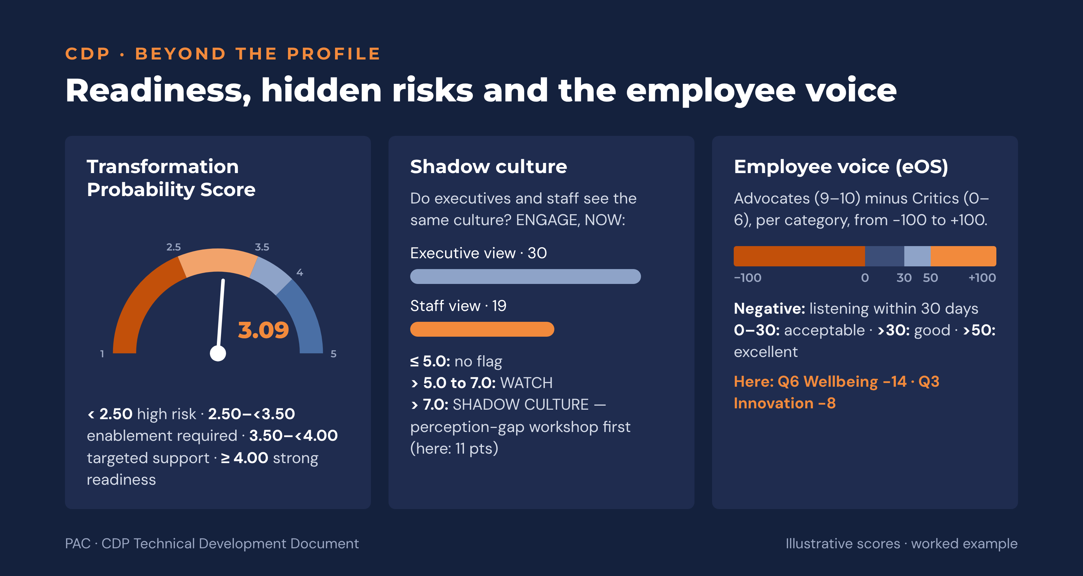
Figure 6 · Readiness, hidden risks and the employee voice, worked example
Score | D7 Digital Readiness | D8 Psychological Safety | D9 Adaptive Capacity
1.0 – 2.0 | Digitally resistant | Fear-based culture | Critical resistance: transformation will fail without structural intervention
2.1 – 3.0 | Digitally cautious | Cautious / selective candour | Significant barriers to change: foundation work required before programme launch
3.1 – 3.5 | Moderately ready | Moderate safety | Moderate readiness: targeted enablement support recommended
3.6 – 4.0 | Digitally capable | Open culture | Good readiness: standard change management approach is appropriate
4.1 – 5.0 | Digitally advanced | Challenge culture: highly safe | Strong readiness: full transformation programme can be launched with confidence
Band boundaries are evaluated on the rounded one-decimal value, which makes the published bands exhaustive as written. Developers must round before banding, not after, or a score of 3.04 will fall outside every band.

2.9 Transformation Probability Score

2.9.1 Formula and bands
TPS = (D9 × 0.35) + (D8 × 0.30) + (leadership_alignment × 0.20) + (D7 × 0.15)
All four inputs are on the 1–5 scale, so the TPS is also on 1–5. Weights sum to 1.00 and are asserted as such in code. The TPS is computed from the stored two-decimal input values and rounded half-up to two decimals before banding. The bands are half-open, exhaustive and non-overlapping.
TPS | Classification | Consequence for the plan
< 2.50 | HIGH RISK — high risk of failure | Foundation first. Build D9 and D8 conditions before launching content. Maximum of one or two priorities in the first cycle.
2.50 to < 3.50 | ENABLEMENT REQUIRED — enablement investment required | Maximum of three priorities. Stage any diagonal shift through a stepping-stone orientation.
3.50 to < 4.00 | TARGETED SUPPORT — moderate readiness | Up to four priorities with change-management support.
≥ 4.00 | STRONG READINESS | Up to four priorities launched in parallel.

2.9.2 Leadership alignment score
This input carries a fifth of the TPS and is defined as follows.
Definition. The leadership alignment score is a single, always-computable figure on the 1–5 scale, blended by 360 coverage so that it never switches construct and never steps discontinuously between assessment cycles.
coverage = Σ headcount_led(leaders with a valid 360 result) ÷ Σ headcount_led(all accountable leaders)
LRI_weighted = Σ (LRI(leader) × headcount_led(leader)) ÷ Σ headcount_led(leader)
across leaders with a valid 360 result
The Leader Readiness Index is on the 1–5 scale (4.6), so this term is directly compatible with D7, D8 and D9.
LA_instrument = 1 + 4 × min(1, D2_NOW[target] ÷ T(target))
Here target is the primary orientation tagged on the target leadership behaviours in Setup Section F (Section F requires exactly one primary tag) and T(target) is that orientation’s single-orientation dominance threshold from 6.3.1.
leadership_alignment = ( coverage × LRI_weighted ) + ( (1 − coverage) × LA_instrument )
Why it is built this way. Three properties matter. It is construct-consistent: both terms measure leadership behaviour against the orientation the strategy requires, so the blend never mixes a readiness measure with a satisfaction measure. It is always computable: at zero 360 coverage the score resolves cleanly to the D2 instrument term, which every assessment produces, so a first-cycle client with no 360 data still receives a TPS. And it is continuous: coverage enters as a weight rather than as a switch, so a client moving from 55% to 65% coverage between cycles sees no artificial step in the headline number.
eOS Q2 is never substituted for leadership alignment. Q2 measures staff perception of leadership quality, a different construct from leadership readiness, and substituting it at a coverage threshold would make consecutive cycles non-comparable and create a discontinuity in the TPS trend that has nothing to do with the culture.
Reporting rules. The coverage figure is displayed wherever the TPS is displayed. Below 60% coverage the TPS is labelled provisional, and the report states the coverage percentage and that the instrument term is carrying most of the weight. At zero coverage the report states that no 360 data exists for the cycle and that leadership alignment is derived entirely from D2. The provisional label is presentational only: it is never an input to a gate or a calculation.
Worked-example value. The illustrative cycle carries no 360 data, so coverage is zero and leadership_alignment resolves to LA_instrument. The target orientation is ENGAGE (Setup Section F names coaching and listening), with a dominance threshold of 30. The illustrative D2 NOW allocation to ENGAGE is 18.0, giving 1 + 4 × (18.0 ÷ 30) = 3.40, from which the TPS of 3.09 follows. The D2 value of 18.0 is a test fixture consistent with the rest of the illustrative profile (ENGAGE 22 overall; D2 PERFORM-dominant) and describes no real organisation.
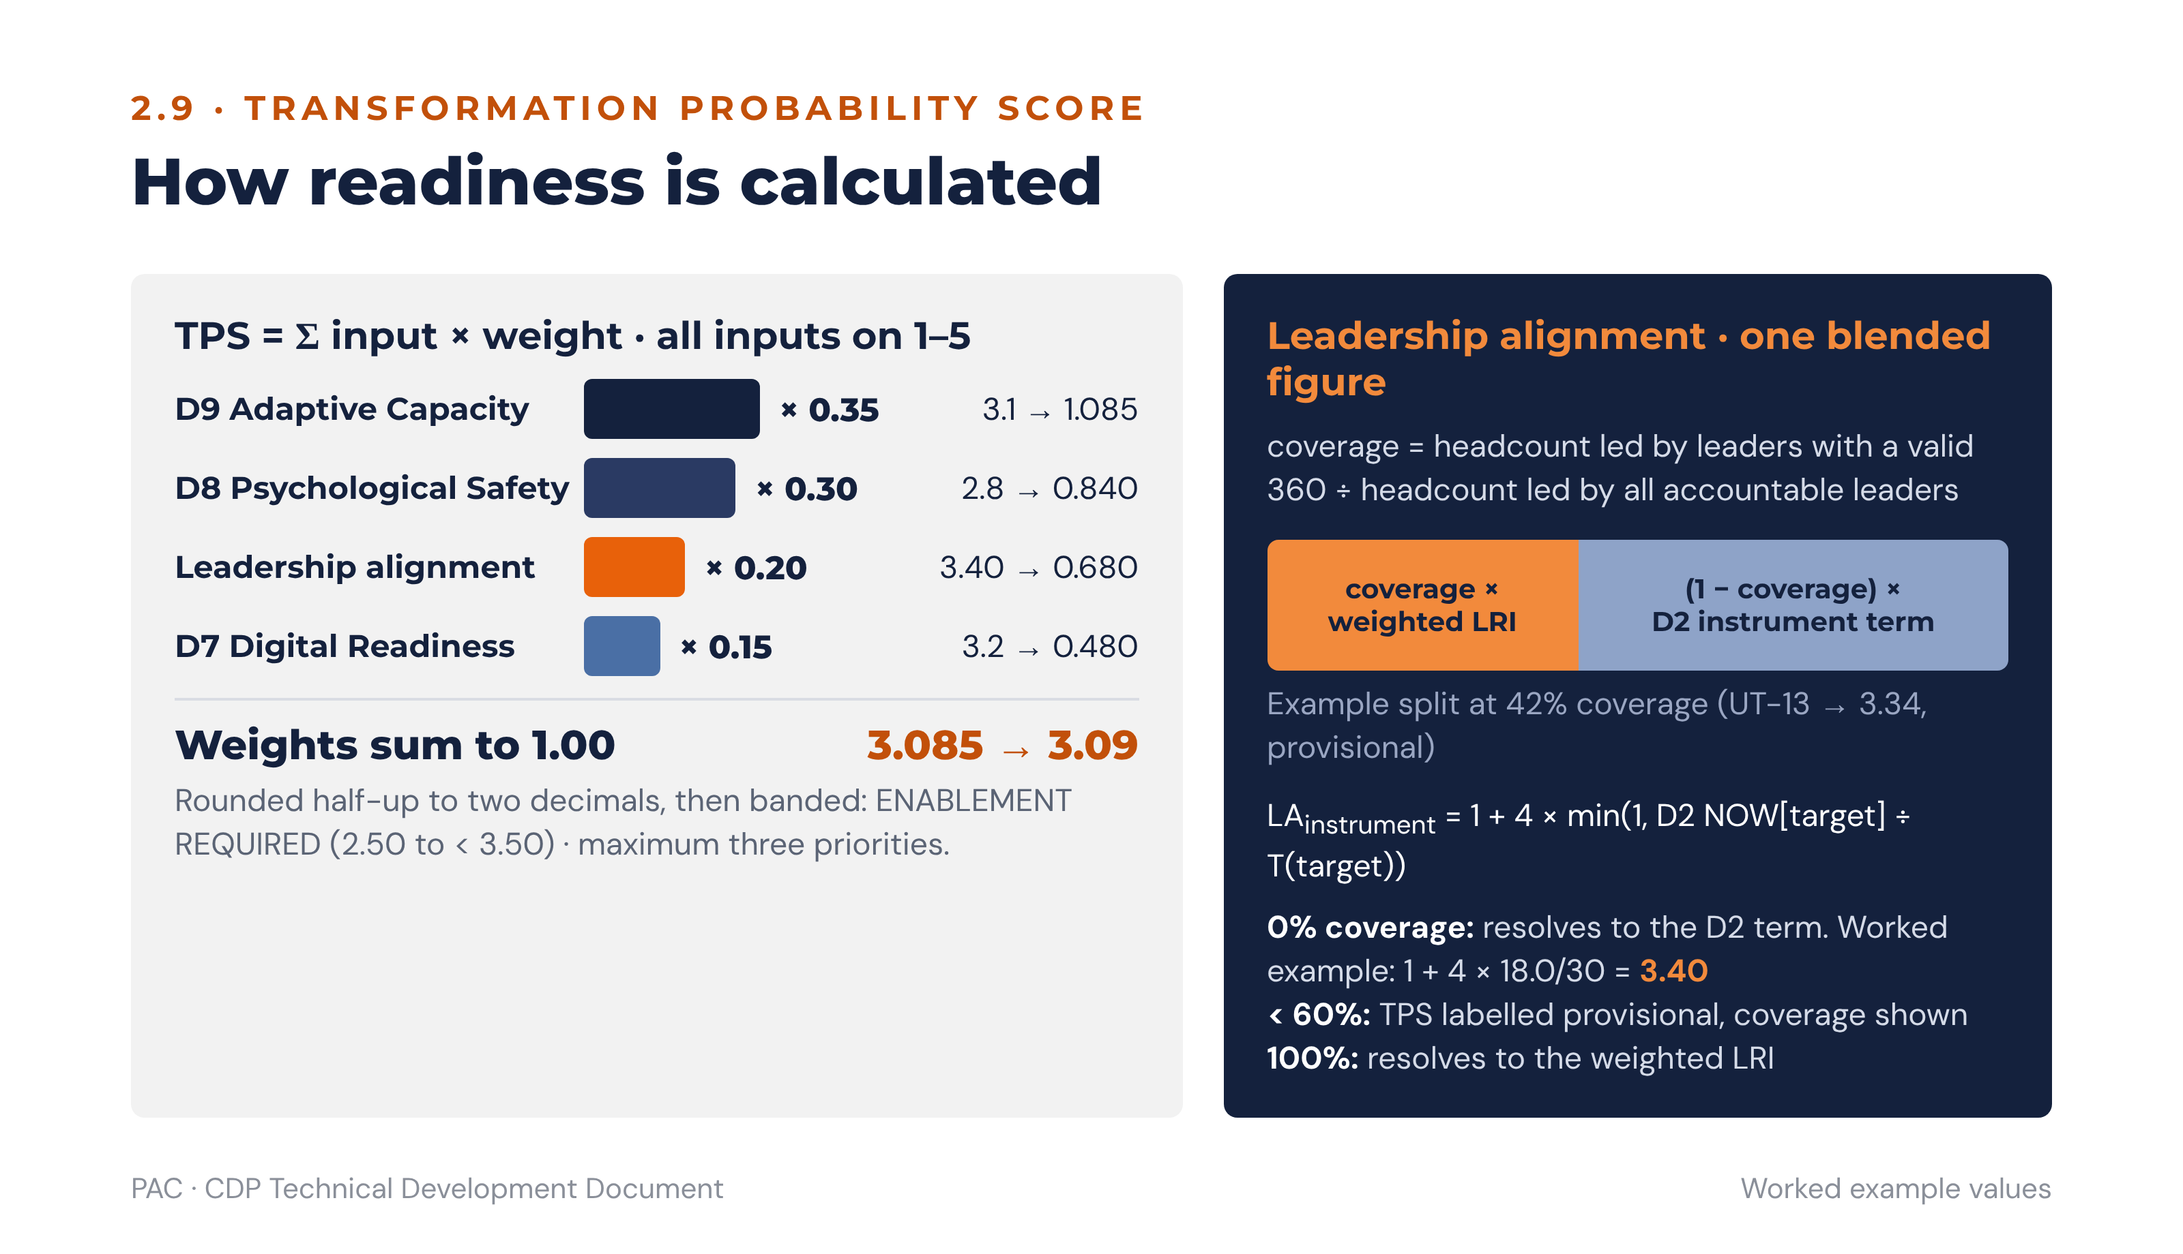
Figure 7 · How the TPS and its leadership-alignment input are calculated

2.9.3 Worked example
Inputs: D7 = 3.2 (moderately ready), D8 = 2.8 (cautious / selective candour), D9 = 3.1 (moderate readiness), leadership alignment = 3.40, derived per 2.9.2 at zero 360 coverage from a D2 NOW ENGAGE allocation of 18.0 against the ENGAGE dominance threshold of 30.
TPS = (3.1 × 0.35) + (2.8 × 0.30) + (3.40 × 0.20) + (3.2 × 0.15)
= 1.085 + 0.840 + 0.680 + 0.480
= 3.085 → reported 3.09
Band: 2.50 to < 3.50 — ENABLEMENT REQUIRED. Maximum three priorities, and the ENGAGE build is a diagonal shift from the dominant PERFORM, so it must be staged through a stepping-stone orientation. D8 at 2.8 additionally triggers the psychological-safety gate in 6.6, because a BUILD priority exists for both ENGAGE and INNOVATE.

2.10 Alignment lenses
The six culture dimensions are grouped into three lenses for alignment testing. D7, D8, D9 and eOS are capacity and context inputs and are not members of any lens; they are reported alongside the lenses.
Lens | Composition | Setup anchor | Alignment test
STRATEGY — where the organisation is going and how it defines success | mean(D5, D6) | Section B (strategy), Section D (targets) | Does the PREFERRED profile on D5/D6 match the orientation the strategy requires? (Check C1)
PRACTICE — how work, people and processes actually operate | mean(D1, D3, D4) | Section E (lived culture), Section H (structural enablers) | Do the NOW practices support the strategy or contradict it? (Checks C3, C4)
LEADERSHIP — what leaders model, as staff experience it | D2 | Section F (target behaviours), Section G (stop/start) | Do leaders model the orientation the strategy requires? (Check C2 and the perception gap)
CAPACITY — ability to sustain change (not a lens) | D9, TPS; read with D7, D8 and eOS | Section I (cohorts) | Can the organisation sustain the shift? Sets the pace and the number of priorities.
Each lens produces four orientation scores (the mean of its member dimensions’ orientation scores) and therefore a dominant orientation, for NOW and for PREFERRED. Where the three lenses name different dominant orientations, that misalignment is itself a priority finding and the action plan must explicitly bring Practice and Leadership into line with Strategy.
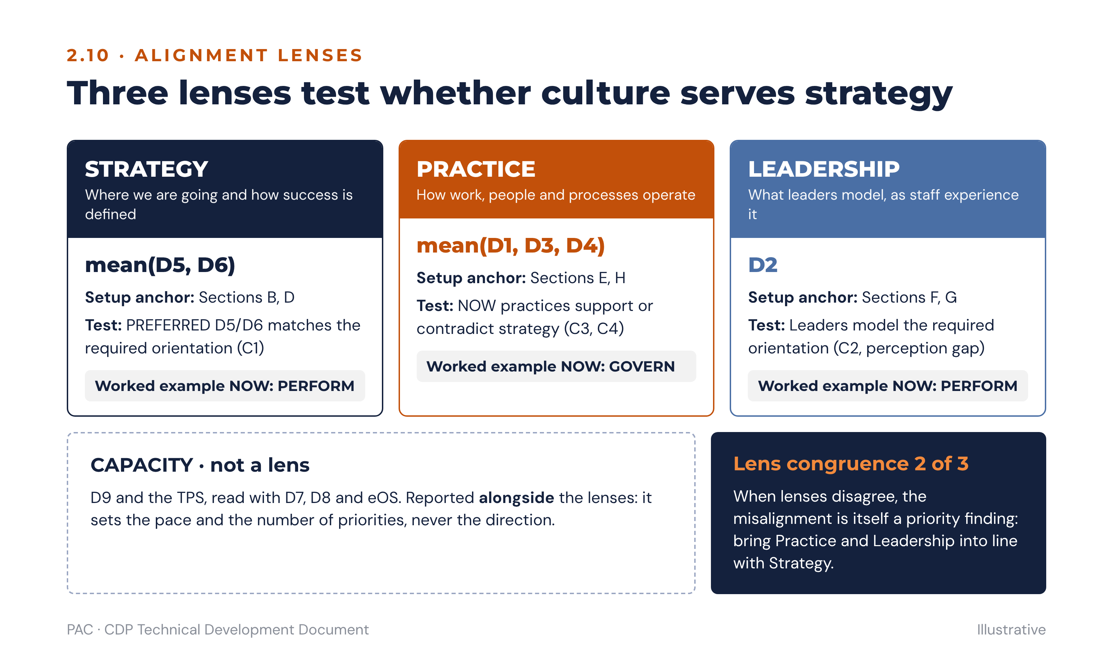
Figure 8 · The three alignment lenses and the capacity input

2.11 Data quality, validation and reliability
The rules below are the minimum required for the reporting thresholds elsewhere in this specification to mean anything.

2.11.1 Validation at capture
Rule | Behaviour
Constant-sum integrity | A scenario cannot be submitted unless its four allocations are non-negative integers summing to exactly 100. Server-side revalidation on submit; any row failing revalidation is rejected, not corrected.
Scale integrity | D7–D9 items accept integers 1–5 only. eOS items accept integers 0–10 only. Out-of-range values are rejected at the API boundary.
Single submission | One submitted response per invitation token. Resubmission is blocked; a consultant may void a response with a recorded reason, which excludes it from all scoring and logs the exclusion.
Free-text safety | Qualitative responses are stored field-encrypted and screened for self-identifying content before any thematic extract is shown; a response containing a name is redacted in the extract but retained verbatim in the encrypted store.

2.11.2 Quality flags computed after capture
Flag | Test | Treatment
Straight-lining (Likert) | Zero variance across all 36 D7–D9 items. | Flag the response. Exclude from D7–D9 means if the response also completed in under the speed threshold; otherwise retain and report the count.
Speeding | Total completion time below 40% of the assessment’s median completion time, or below 8 minutes, whichever is higher. | Flag. Two or more flags on one response excludes it from all scoring.
Uniform allocation | 25/25/25/25 on 12 or more of the 18 NOW scenarios. | Flag as non-discriminating. Retain in counts, exclude from dominance and strength calculations, and report the incidence — a high incidence usually means the instrument was not explained.
Perspective duplication | NOW and PREFERRED allocations identical on 16 or more of the 18 scenarios. | Flag. Retain but annotate the gap analysis, because a zero-gap profile may be genuine or may indicate the respondent did not register the perspective change.
Internal consistency | Cronbach’s alpha, reported per Likert dimension per assessment across the 12 items. | Report only, never used to exclude. A coefficient below 0.70 on any of D7–D9 is disclosed in the technical appendix of the organisational report.
Incomplete response | Fewer than all 36 scenario sets completed. | See 2.11.3.

2.11.3 Completion, partial responses and the survey window
The survey window is a minimum of ten working days, carried from Setup Section I. The platform issues an invitation at open, reminders at day 3, day 6 and 24 hours before close, and a final reminder only to respondents with a started-but-unsubmitted response. A consultant may extend the window once; a second extension requires the engagement lead’s approval and is recorded, because an extended window changes the cohort composition and must be visible in the technical appendix.
Completion state | Definition | Treatment in scoring
Complete | All 36 scenario sets, all 36 Likert items and all 8 eOS items submitted. | Included in all analyses.
Substantially complete | All 36 scenario sets submitted; one or more Likert or eOS items missing. | Included in orientation, gap, strength and congruence analyses. Excluded from the affected D7–D9 dimension mean or eOS category, which is computed on valid responses only.
Partial — culture block | Fewer than 36 scenario sets, but all 18 NOW scenarios complete. | NOW profile included; excluded from all gap, classification and pathway analysis. Counted separately in the response-rate table.
Insufficient | Fewer than 18 NOW scenarios complete, or excluded by two or more quality flags. | Excluded from all scoring. Counted in the exclusion log with reason.
Abandoned | Started, never submitted, window closed. | Not scored. Retained only as a response-rate denominator input and destroyed with the assessment.
Every report must carry the response-rate table: invited, started, submitted, complete, substantially complete, partial, insufficient and excluded, with the exclusion reasons summarised. PAC’s method depends on candour, and a low response rate or a high exclusion count is a finding in its own right — usually about psychological safety rather than about survey administration.

3. Sub-culture Assessment and Slice-and-Dice Analytics

3.1 Purpose
An organisation-wide profile is an average, and averages conceal the thing PAC is usually hired to find. The sub-culture engine exists to answer three questions: where in the organisation is the culture materially different from the whole; where do executives and staff see two different organisations; and which of those differences matters enough to fund an intervention.

3.2 Segmentation model
Any dimension captured on the respondent’s demographic snapshot is a segmentation axis, and any combination of axes is a valid segment subject to the suppression rules in 3.6. Standard axes are division, department or function, location or site, grade or level band, executive flag, tenure band, age band, gender, contract type, survey language and any tenant-defined custom attribute.
A segment query is defined as a set of axis–value predicates combined with AND. The engine resolves the segment, counts distinct valid responses, applies suppression, and only then computes. Every metric in section 2 is computable for any permitted segment: orientation scores for NOW and PREFERRED, gaps, dominance, strength, congruence, D7–D9, eOS categories and Index, and TPS where a leadership alignment input exists for the segment.

3.3 Detecting a sub-culture
The rules below extend the 8-point significance principle from the organisation-wide gap to segment comparison.
Sub-culture Divergence Index:
SDI(segment) = Σ | orientation_score(o, NOW, segment) − orientation_score(o, NOW, organisation) | over the four orientations
÷ 2
Because both profiles sum to 100, the sum of absolute differences is always twice the share of the profile that has moved between orientations. Dividing by two therefore expresses the SDI directly as the percentage of the culture profile that differs from the organisational profile, on a 0–100 scale.
Test | Threshold | Verdict
Single-orientation divergence | | segment − organisation | ≥ 8.0 points on any one orientation | Divergent on that orientation. Named in the sub-culture report and routed to that orientation’s playbook.
Profile divergence (SDI) | SDI ≥ 12.0 | Distinct sub-culture. Warrants its own sub-culture report and unit-level action plan.
Dominance divergence | Segment dominant orientation ≠ organisational dominant orientation, and the segment’s dominant score exceeds its second by more than 1.0 | Structural sub-culture. The strongest form: this unit is running a different operating logic, not merely a different emphasis.
Statistical significance | Welch’s two-sample t-test of respondent-level orientation scores in the segment against the rest of the organisation on the divergent orientation, two-sided at the 95% level, with segment n ≥ 5 and complement n ≥ 5 | Confirmed. An unconfirmed divergence is reported as indicative and may not be used to trigger a funded intervention.
Readiness divergence | Segment D8 or D9 differs from the organisational value by ≥ 0.5 on the 1–5 scale | Capacity sub-culture. The unit may need a different pace even where its culture profile matches.
Engagement divergence | Any eOS category negative in the segment while positive organisation-wide | Hidden engagement failure. Triggers the 30-day listening rule for that cohort specifically.
A segment is reported as a sub-culture when it meets the profile-divergence or dominance-divergence test and the significance test. Segments meeting only the single-orientation test are reported as divergent on that orientation without being named a sub-culture, which keeps the term meaningful in client conversation.

3.4 Executive–staff perception gap
The rule operates on the absolute difference per orientation. Direction is reported as narrative, never as a threshold.
perception_gap(o) = | orientation_score(o, NOW, executive cohort) − orientation_score(o, NOW, staff cohort) |
Perception gap | Flag | Required response
≤ 5.0 | None | Report in the cohort comparison. No action triggered.
> 5.0 and ≤ 7.0 | WATCH | Examine in the results debrief against cohort data. Monitor at re-assessment. Recorded as a finding but not a blocking pre-condition.
> 7.0 | SHADOW CULTURE | A facilitated perception-gap workshop is required before any intervention is announced. This is a hard gate: the rules engine will not release an intervention recommendation for the affected orientation until the workshop is recorded as complete.
The executive cohort is defined by the grade flag set during onboarding (1.2.1); the staff cohort is every respondent not so flagged. Both cohorts must independently meet the five-respondent floor or the perception gap is not computed at all, and the report must say so rather than showing a blank.
Advisory meaning. A gap above seven points means executives are operating with a fundamentally different picture of cultural reality from the staff who work inside it daily, and PAC’s position is that such gaps are often more strategically consequential than the culture profile itself. The direction matters for the conversation even though it does not change the threshold: executives seeing more ENGAGE than staff report is a leadership blind spot about care, while executives seeing less GOVERN than staff report is a blind spot about bureaucracy. In the worked example both occur simultaneously — executives see ENGAGE at 30 against staff at 19, and GOVERN at 22 against staff at 33 — which means staff experience a bureaucratic, target-driven organisation that its leaders do not believe they run.

3.5 Filters, drill-down, comparison and heatmaps
Capability | Specification
Filter bar | Multi-axis predicate builder with a live permitted-respondent count. The count updates before the query runs, so a consultant sees that a segment is about to be suppressed rather than discovering it in an empty report.
Drill-down | Organisation → division → department → team, and organisation → grade band → department. Each level renders the same metric set. A level that fails suppression is shown as “merged into parent” with the parent’s figure, never as zero or blank.
Comparison view | Up to four segments side by side on one orientation profile, with the organisational profile always displayed as a reference series. Differences of 8.0 points or more are visually marked.
Orientation heatmap | Segments on rows, the four orientations on columns, cell value = segment minus organisation for that orientation, diverging colour scale centred on zero with the marked band starting at ±8.0. Suppressed segments render as a hatched cell labelled “below reporting threshold”.
Gap heatmap | Segments on rows, orientations on columns, cell value = segment gap (PREFERRED − NOW), with the BUILD band (≥ +8.0) and the significant MODERATE band (≤ −8.0) marked.
Readiness heatmap | Segments on rows, D7/D8/D9/TPS on columns, banded on the published interpretation bands in 2.8 and 2.9.
eOS heatmap | Segments on rows, Q1–Q8 plus Index on columns, with every negative cell marked as a 30-day listening trigger.
Trend view | Any metric for any segment across assessment cycles, with a warning banner on any comparison crossing an instrument major version.
Export | Every view exports to Excel with the underlying segment counts attached, and to PowerPoint as a formatted slide (see 3.8).
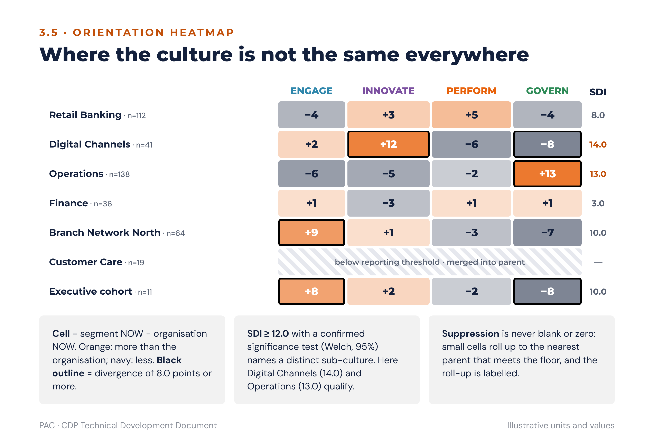
Figure 9 · Orientation heatmap with divergence marking and suppression, illustrative

3.6 Anonymity protection on small groups
Six rules operate together, and none is overridable by any role.
Rule | Specification
Primary floor | No culture-survey segment is reported unless it contains at least five valid responses. 360 rater groups require at least three raters, with a group below three merged into “all others”.
Combination floor | A segment built from two or more axes must independently satisfy the five-respondent floor. The engine evaluates the resolved intersection, not the individual axis counts.
Differencing protection | A segment is suppressed if it can be derived by subtracting one reported segment from another reported segment and the residual would fall below the floor. In practice the engine suppresses complementary pairs: if a department has 22 respondents and one of its two teams has 18, the second team is suppressed and so is the first, because publishing one discloses the other.
Small-cell rollup | Suppressed segments are automatically merged upward into the nearest parent that satisfies the floor, and the report labels the rollup explicitly. Merged content is never silently dropped.
Qualitative suppression | Verbatim extracts require at least eight valid qualitative responses in the segment and are published only as themes with counts, never as quotations attributable to a segment of fewer than eight.
Query audit | Every segment query is logged with actor, predicates, resolved count and suppression outcome, so that an attempt to triangulate a small group is detectable after the fact.
Advisory meaning. The floors are frequently tested by clients who want to know what one small but troublesome team thinks. The answer PAC gives is that the commitment made to respondents is what makes the data worth having, and that a diagnosis of a five-person team is a management conversation, not a culture assessment. The platform’s refusal to answer is therefore a feature to be explained, not a limitation to be apologised for.

3.7 Sub-culture report template
Section | Content | Narrative logic
1. Identification | Segment definition, respondent count, response rate, divergence tests passed. | States plainly why this unit is being reported separately.
2. Profile against the organisation | Segment NOW and PREFERRED profiles with the organisational profile as reference; SDI; dominance and strength. | Names what is different, by how much, and whether it is confirmed.
3. Gaps and classification | Segment gaps per orientation with BUILD / STRENGTHEN / KEEP & PROTECT / MODERATE classification. | Establishes what this unit itself says it needs.
4. Perception and voice | Where the segment has both cohorts, the internal perception gap; eOS categories with negatives marked; qualitative themes. | Separates what the unit experiences from what its leaders believe.
5. Readiness | D7, D8, D9 and TPS for the segment against the organisational values. | Sets the pace for this unit specifically; a unit may need a slower plan than the organisation.
6. Leadership link | The accountable leader’s orientation profile, self–other gaps and fit index (section 5), where the leader has a valid 360. | Connects the culture of the unit to the person accountable for it.
7. What this means | Two or three sentences naming the single most consequential finding and its business consequence. | The conclusion. Mandatory; a report without it is not releasable.
8. What to do next | The unit-level draft actions generated by the guidance engine, with owner, KPI and review point. | The recommendation. Mandatory.

3.8 Slide-ready outputs
Each view below renders as one slide in the client deck template, in this order. One idea per slide, with the assertion as the slide title.
Slide | Title pattern | Content
1 | “Where the culture is not the same everywhere” | Orientation heatmap, all reportable segments against the organisation. Marked cells only in the commentary.
2 | “[Unit] is running a different operating logic” | Segment profile against organisational profile, radar or bar pair, with SDI and the dominance verdict.
3 | “Executives and staff see two different organisations” | Paired bars per orientation for the two cohorts, with the WATCH and SHADOW CULTURE thresholds drawn as reference lines.
4 | “What this unit says it needs” | Segment gap chart with the BUILD and MODERATE bands shaded.
5 | “Readiness sets the pace, not the ambition” | Segment TPS and D7–D9 against organisational values, with the band label shown.
6 | “The employee voice in this unit” | eOS category bars with negatives marked and the three qualitative themes as short labels.
7 | “What this means and what we will do” | Two columns: conclusion on the left, the unit’s draft priorities with owners and dates on the right.

4. Leadership Assessment

4.1 Instrument structure
One 60-item instrument is administered in two forms: a self-evaluation completed by the leader, and a rater evaluation completed by the leader’s superior, peers and direct reports. The item content is identical; only the grammatical subject differs. Sections A–D measure the four orientations as leadership behaviours at ten items each; sections E–H measure four extended leadership dimensions at five items each. All items use a 1–5 frequency scale from “never / strongly disagree” to “always / strongly agree”.
Section | Content | Items | Raw range | CDP link
A | ENGAGE — coaches · develops · unites the team | 10 | 10–50 | ENGAGE orientation
B | INNOVATE — champions ideas · backs experiments · sets direction | 10 | 10–50 | INNOVATE orientation
C | PERFORM — drives goals · delivers · competes to win | 10 | 10–50 | PERFORM orientation
D | GOVERN — standardises · coordinates · safeguards quality | 10 | 10–50 | GOVERN orientation
E | Integrity, Values and Standards | 5 | 5–25 | GOVERN · D5
F | Psychological Safety and Communication | 5 | 5–25 | D8 · eOS Q2, Q5
G | Strategy, Data and Digital | 5 | 5–25 | D5 Strategic Compass · D7 Digital Readiness · eOS Q8
H | Leading Change and Adaptive Capacity | 5 | 5–25 | D9 Adaptive Capacity · TPS
Total |  | 60 | 60–300
Both forms also carry open questions: six self-reflection questions on the self form and seven qualitative feedback questions on the rater form. These are analysed thematically and never scored.

4.2 Scoring logic
All section scores are converted to an average item score on the 1–5 scale, because the sections have different item counts and raw totals are not comparable.
average_item_score(section) = section_total ÷ item_count(section)
For sections A–D this is the total divided by 10; for sections E–H it is the total divided by 5. Every threshold in this section operates on the average item score, never on the raw total.
Rater scores are averaged per item and per section, by rater group (superior, peers, direct reports) and overall. The overall other-rating is the unweighted mean of the available rater groups, so that a single superior does not carry the same weight as eight direct reports collapsed into one group average. Where a rater has selected “not observed” on an item, that item is excluded from that rater’s section mean and the section mean is computed on observed items only; a section with fewer than three observed items for a rater is excluded from that rater’s contribution.

4.3 Leadership orientation types
The four leadership orientation types are PAC’s own leader descriptors, carried directly from the orientation reference. They are named in reports as the leader’s orientation, never as a personality type, and never as a category the leader belongs to permanently.
Type | Orientation | Behavioural signature | Characteristic overplay
Coach | ENGAGE | Develops people, builds cohesion, includes and listens, invests in long-term growth. | Warmth without accountability; slow to produce tangible outcomes.
Champion | INNOVATE | Backs experiments, challenges convention, scans ahead, tolerates ambiguity. | Energy scatters across too many initiatives; delivery becomes chaotic.
Driver | PERFORM | Sets stretch goals, holds accountability, decides fast, stays close to the customer. | Unsustainable pace and burnout; failure is not turned into learning.
Steward | GOVERN | Standardises, documents, controls risk, safeguards quality and compliance. | Structure hardens into bureaucracy; radical ideas are suppressed.

4.3.1 Default, growth and range
Reading | Rule | Advisory meaning
Default orientation | Highest average item score across sections A–D. | How the leader leads under pressure or when operating naturally.
Growth orientation | Lowest average item score across sections A–D. | Behaviours the leader may be neglecting, which create friction when the organisation needs that focus.
Leadership range | Spread between highest and lowest A–D average item score below 0.50. | The ability to flex between orientations as the situation requires — a hallmark of mature senior leaders. Reported as a strength in its own right, not as an absence of a default.

4.4 Hard flags
Flag | Rule | Consequence
Integrity flag | Section E average item score below 4.00 on the other-rating. | Immediate attention and a specific development plan. Reported to the leader and to the CHRO. This is the only leader finding that escalates outside the development relationship, and the consent text on both forms must say so.
Safety flag | Section F average item score below 3.00 on the other-rating. | The leader’s team may not be given a BUILD priority for ENGAGE or INNOVATE until a safety-focused development action is in place (see 6.6).
Change-capacity flag | Section H average item score below 3.00 on the other-rating. | The leader is not yet able to carry a culture priority for their unit. The unit’s plan is sponsored one level up until the flag clears.

4.5 Self–other gaps
gap(section) = self_average_item_score(section) − other_average_item_score(section)
Absolute gap | Tier | Response
≤ 0.50 | Aligned | No action. Confirms the leader’s self-awareness on that section.
> 0.50 and ≤ 1.00 | WATCH | Explore in the coaching conversation. Recorded in the Leader Development Plan as a discussion point.
> 1.00 | BLIND SPOT | Explored explicitly with the leader’s coach or line manager and addressed by a named development action.
The sign of the gap is reported as narrative. A positive gap means the leader rates themselves above how others experience them, which is the classic blind spot. A negative gap means others rate the leader above their own self-assessment, which is usually under-confidence and is coached differently. Rater-group discrepancies are reported separately and are the richest coaching material in the instrument: differences between superior, peer and direct-report ratings reveal how the leader behaves upwards, sideways and downwards.

4.6 Leader Readiness Index
The LRI is the individual counterpart of the TPS and answers one question: is this leader ready to lead the culture change the strategy requires?
LRI = (H_avg × 0.35) + (F_avg × 0.30) + (alignment_score × 0.20) + (G_avg × 0.15)
H_avg, F_avg and G_avg are the average item scores for sections H, F and G. The alignment score is the average item score of whichever of sections A–D corresponds to the organisation’s primary BUILD orientation, resolved in this order: the orientation classified BUILD (where two are BUILD, the one with the greater strategic need recorded on the action plan); otherwise the STRENGTHEN orientation with the largest gap; otherwise the Section F target orientation. The report states which was used. All four inputs are on the 1–5 scale, weights sum to 1.00, and the LRI is therefore on 1–5.
LRI | Classification | Consequence
< 2.50 | HIGH RISK | The leader cannot yet carry a culture priority. Development plan first, with the unit’s plan sponsored one level up.
2.50 to < 3.50 | ENABLEMENT REQUIRED | Can carry a priority with structured coaching support and a named sponsor.
3.50 to < 4.00 | TARGETED SUPPORT — ready with support | Can own a unit priority. Coaching focused on the growth orientation.
≥ 4.00 | STRONG READINESS | Candidate to sponsor an organisation-wide priority and to coach peers.
The LRI bands are deliberately identical to the TPS bands so that an organisation’s readiness and its leaders’ readiness can be read on one axis. Where the mean LRI is materially above the TPS, the constraint is structural rather than personal; where it is materially below, the constraint is leadership capability and no amount of programme design will substitute for it.

4.7 Anonymity in the 360
A rater group is reported only with at least three raters; a group of one or two is merged into an “all others” group, and if that merged group still has fewer than three raters no rater-group breakdown is published at all — only the overall other-rating. Individual rater responses are never exposed to any role. Qualitative comments are released to the leader only after consultant review for identifying content, and the platform must support redaction of a comment while retaining the original in the encrypted store.

5. Linking Leader Reports to Culture
The 360 instrument directs each leader to compare their default orientation with the orientation the organisation’s CDP results require. This section implements that link as data, indices and rules.

5.1 Data model
The link is made through the leader assignment edge described in 1.2.1. A leader report is always computed against the team the leader led during the assessment window, resolved by the effect-from and effect-to dates on the assignment. Three joins produce everything in this section:
Join | From | To | Constraint
Leader to team | leader_assignment | team | Exactly one accountable leader per team per period.
Team to culture | team | segment_profile | The team’s own profile where it meets the five-respondent floor; otherwise the profile of the nearest parent that does, with the substitution recorded on the report.
Leader to 360 result | leader_assignment | leader_360_result | Requires a valid self form and at least one rater group of three or more.
Where a team’s profile has been substituted upward, every index in this section is computed on the substituted profile and the report must carry the words “computed against [parent unit] because the team is below the reporting threshold”. This is the single most common source of misreading in leader debriefs and must never be silent.

5.2 Leader–culture fit index
The fit index measures how closely the leader’s own behavioural profile matches the culture their team actually has. It is a measure of congruence, not of quality: a high fit with an unhealthy culture is a problem, not a strength.
Convert the leader’s four A–D average item scores into a comparable profile by normalising them to sum to 100:
leader_profile(o) = A_D_average(o) ÷ Σ A_D_average(all four) × 100
fit_index = 100 − ( Σ | leader_profile(o) − team_profile_NOW(o) | ÷ 2 )
The index runs from 0 to 100, where 100 means the leader’s behavioural emphasis exactly mirrors the team’s culture. The divisor of two makes the subtracted term the percentage of profile that differs, exactly as in the SDI at 3.3, so the two indices are read on the same scale.
Fit index | Reading | Advisory meaning
≥ 85 | Mirrored | The leader and the team are the same culture. If the culture is what the strategy needs, this leader is the mechanism that sustains it. If it is not, this leader is the mechanism that reproduces it.
70 to < 85 | Aligned | Normal and healthy. The leader is recognisably of the unit’s culture while retaining some independent emphasis.
55 to < 70 | Divergent | The leader’s emphasis differs materially from the unit’s culture. Determine which direction the difference runs before interpreting it.
< 55 | Counter-cultural | The leader is behaving in a fundamentally different register from the unit. This is either the intervention the unit needs or the friction that is exhausting it.

5.3 Culture carrier and culture blocker logic
Fit alone cannot say whether a leader helps or hinders, because that depends on what the organisation is trying to build. Carrier and blocker are therefore determined by comparing the leader’s orientation emphasis with the organisation’s required direction of travel.
Let lead_build be the leader’s normalised profile score (5.2) on the organisation’s primary BUILD orientation, resolved exactly as for the LRI alignment score (4.6), and org_build the organisational NOW score on the same orientation. Let MODERATE be the set of orientations classified MODERATE for the organisation. The rules are evaluated in the order shown, and the first that matches applies, so every leader receives exactly one classification.
Order | Classification | Rule | Advisory meaning and response
1 | CRITICAL BLOCKER | lead_build ≤ org_build − 5, default orientation in MODERATE, and either an integrity or safety flag (4.4) or LRI < 2.50 | Escalates to the CHRO designate and the sponsoring executive. The unit’s culture plan is suspended until the leadership question is resolved, because publishing a plan this leader cannot carry damages credibility further.
2 | CULTURE BLOCKER | lead_build ≤ org_build − 5 and default orientation in MODERATE | The leader’s strongest behaviour is what the organisation has decided to release, and their weakest is what it has decided to build. The unit will not move without a direct leadership intervention.
3 | CULTURE CARRIER | lead_build ≥ org_build + 5, no hard flag, LRI ≥ 3.50, and the self–other gap on the BUILD section is Aligned (4.5) | Already modelling what the organisation needs more of. They sponsor the priority, host peer coaching and provide the visible example for the 30-day signal.
4 | EMERGING CARRIER | lead_build ≥ org_build + 5 and not a carrier | The intent is present and the capability is not yet. Development investment here has the highest return in the leadership population.
5 | NEUTRAL | Every other leader, including a leader within ±5 of org_build and a leader below it whose default is not in MODERATE | Reproduces the organisational average on the BUILD orientation. Plans for them as an implementer, not a sponsor; a leader below org_build carries a development note on the BUILD section.
Advisory constraint. CDP findings are never used to make decisions about specific individuals, and the carrier and blocker classifications sit close to that line. Three rules are therefore mandatory in the platform. The classification is visible only to the leader, their assigned coach, the CHRO designate and the PAC Consultant. It is labelled developmental and carries the ethical-use statement on the same screen. And it is never exported into any performance, remuneration, succession or disciplinary context — the platform blocks the export path rather than warning about it.

5.4 Leader influence on team eOS and TPS
Influence is reported as a difference from the organisational value, never as a causal claim. The platform must label these figures as association measures, and the report narrative must not use causal language.
Measure | Definition | Interpretation
Team eOS differential | eOS_Index(team) − eOS_Index(organisation) | How the employee experience in this unit compares with the organisation. Reported alongside the leader’s section F average item score, which is the behavioural variable most closely associated with it.
Team readiness differential | TPS(team) − TPS(organisation), where the team meets the floor | Whether this unit can move faster or slower than the organisation.
Leader contribution band | Team eOS differential banded at ≥ +10, +10 to −10, ≤ −10, cross-tabulated with the leader’s LRI band | Produces a four-quadrant read used in the leadership-team report: high LRI with positive differential (exemplar), high LRI with negative differential (structural constraint above the leader), low LRI with positive differential (team carrying the leader), low LRI with negative differential (priority intervention).
Cohort pattern | Across all leaders, the association between LRI band and team eOS differential | Reported for the leadership population as a whole, where it is statistically meaningful, and never for an individual leader.
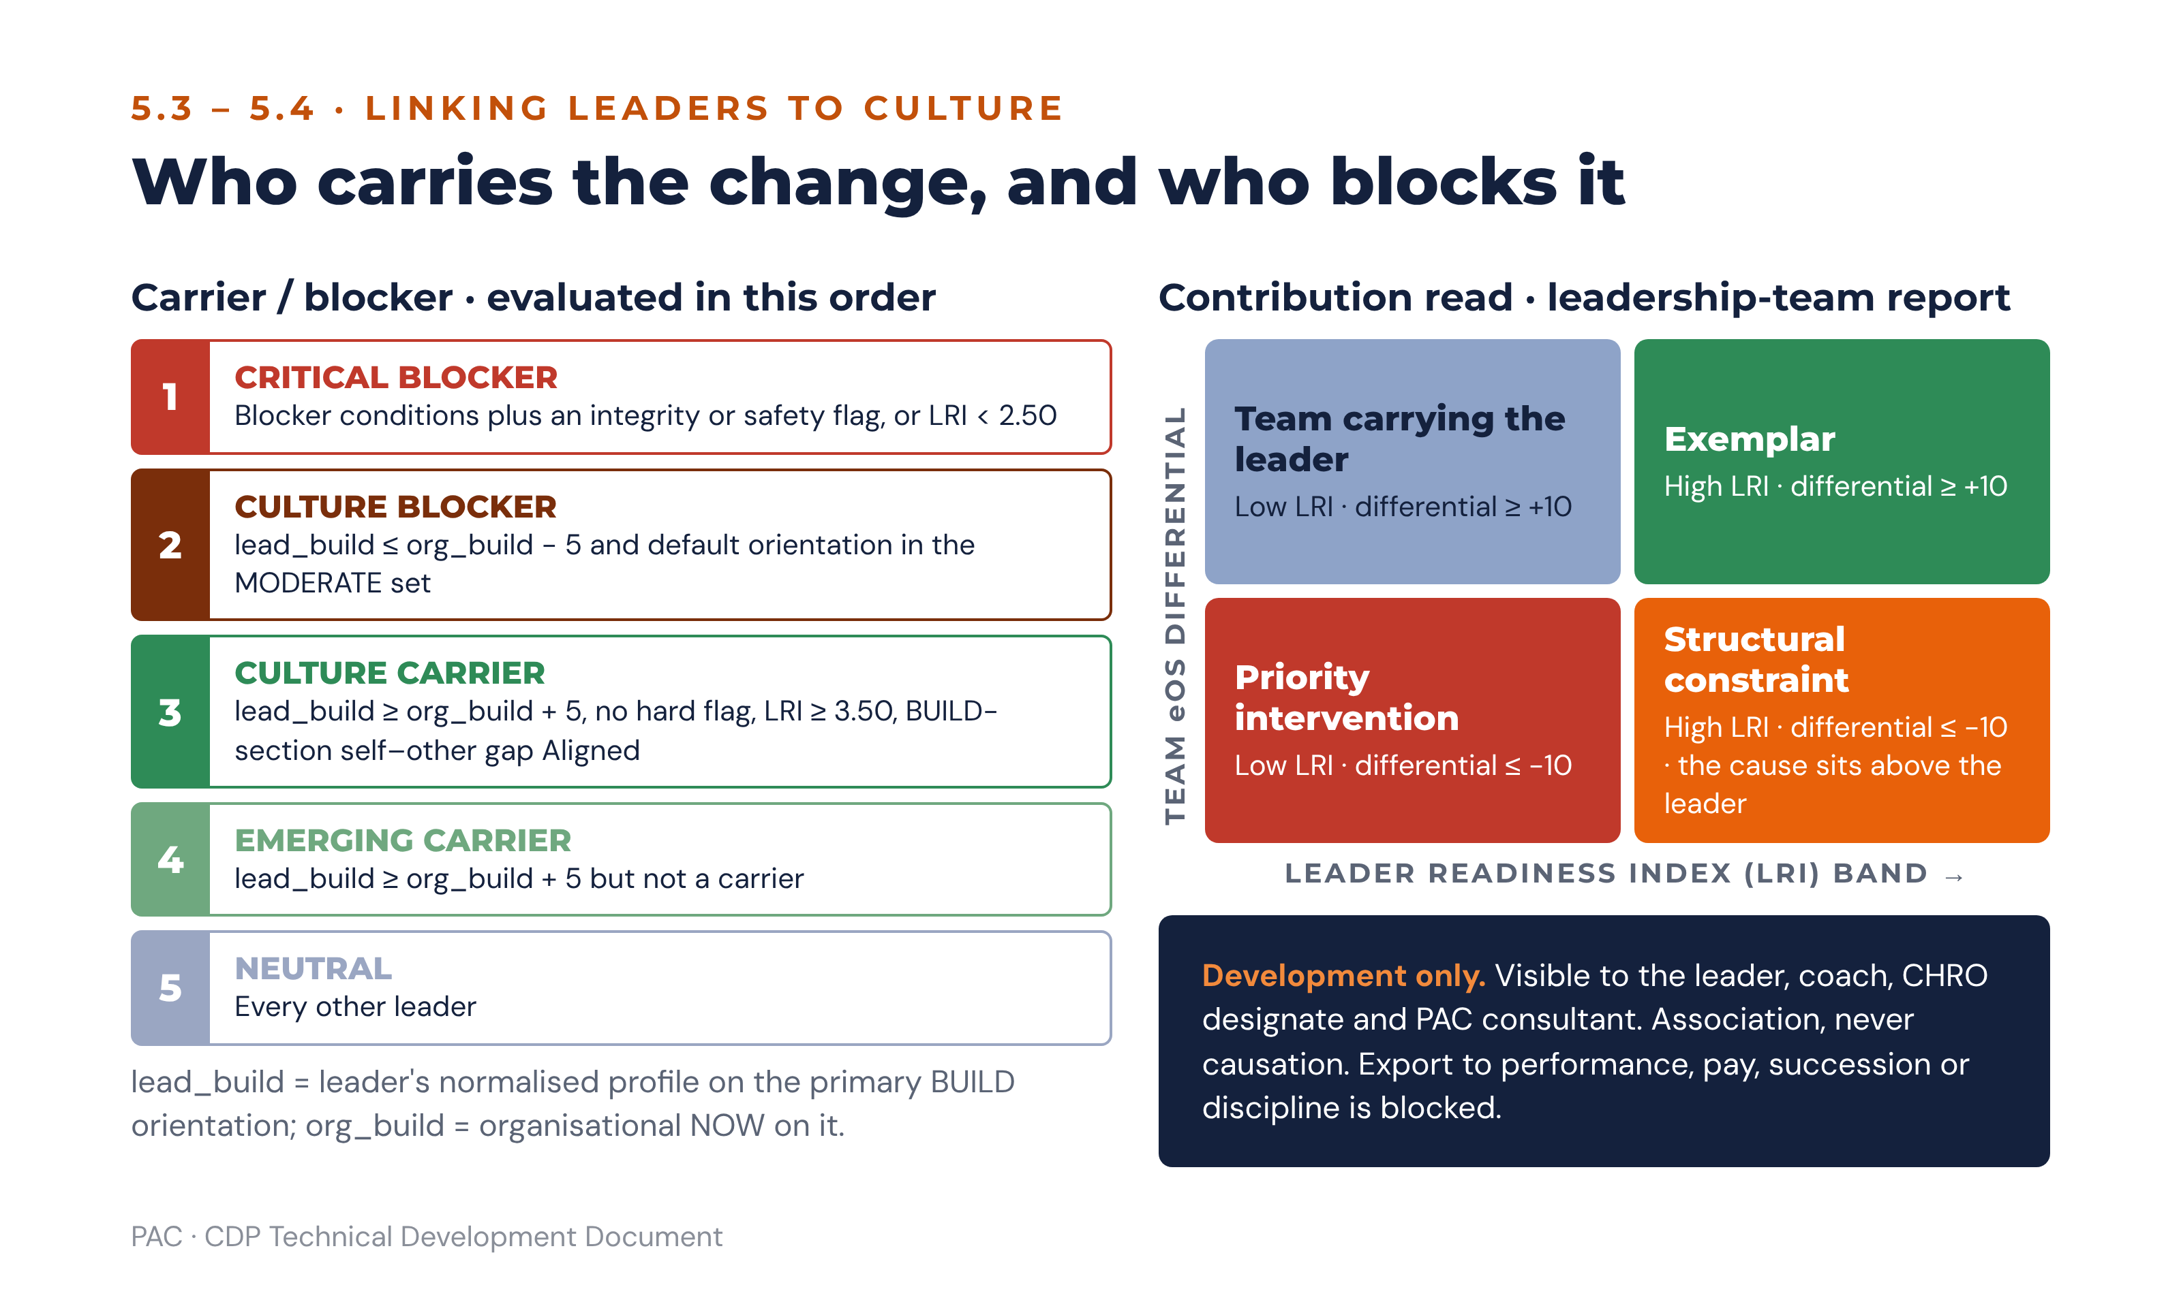
Figure 10 · Carrier and blocker logic, and the contribution read used in the leadership-team report

5.5 Individual leader report
Section | Content
1. How to read this report | Development purpose, confidentiality, the ethical-use statement, and who has seen it.
2. Your orientation profile | A–D average item scores, self and other, with rater-group breakdown where the floor is met. Default, growth and range.
3. Your extended dimensions | Sections E–H with bands, and any hard flag stated plainly and without euphemism.
4. Where you and others see differently | Self–other gaps per section with WATCH and BLIND SPOT tiers, and the rater-group pattern (upwards, sideways, downwards).
5. Your team’s culture | Team NOW and PREFERRED profile, gaps, eOS and readiness, with the substitution note if applicable.
6. Fit and contribution | Fit index, carrier or blocker classification, team eOS and readiness differentials.
7. The behaviour gap the organisation needs from you | The organisation’s BUILD orientation against the leader’s score on that orientation; the pathway and bridging narrative from 6.5 expressed in first-person terms.
8. What this means | Two or three sentences. The leader’s single most consequential development question.
9. What to do next | The Leader Development Plan: up to three actions, each naming the orientation it builds, what to start, stop or keep, one visible change the team will notice within 30 days, and review points at 30, 90 and 180 days.
10. Your qualitative feedback | Themed, redacted where necessary, with the verbatim strengths and development comments.

5.6 Leadership-team aggregate report
The aggregate report answers whether the leadership population, taken together, can lead the change the strategy requires. It contains no individual attribution and requires at least five leaders with valid 360 results.
Section | Content
1. Collective orientation profile | Mean A–D profile across leaders, against the organisational D2 Leadership Blueprint profile and against the target orientation from Setup Section F. Divergence here is the direct evidence for check C2.
2. Distribution, not average | Spread of default orientations across the leadership population. A leadership team where every leader defaults to the same orientation has no range to draw on, regardless of how good the average looks.
3. Readiness distribution | LRI banded, with counts per band and the headcount-weighted mean that feeds the TPS.
4. Carrier and blocker map | Counts per classification by division or function, never by name. Identifies where in the structure the change will stall.
5. Collective blind spots | Sections where the leadership population as a whole shows a WATCH or BLIND SPOT gap. A shared blind spot is a governance finding, not a coaching finding.
6. Integrity and safety | Counts of hard flags by band, with the escalation actions recorded. Never by name in this report.
7. What this means | The conclusion: whether the leadership population is an asset or a constraint for the declared strategy.
8. What to do next | Leadership development priorities, the coaching commitment required, and the leadership KPI to be written into executive scorecards.

6. Scenario-Based Reporting and the Guidance Engine

6.1 Structure of the engine
The guidance engine is a deterministic rules evaluator. It takes the scored assessment, evaluates a versioned rule set, and emits findings. A finding is a structured object — not prose — carrying a diagnosis, a severity, the evidence that produced it, the risks it implies, the root-cause hypotheses to test in the debrief, and a set of candidate actions across three horizons. Prose is generated later, from findings only, by the interpretation service described at 6.12, after the report composer (section 12) has selected and filled the suggestions.
The engine runs in a fixed order, because later rules depend on earlier classifications: gap classification, then the four alignment checks, then the perception-gap and engagement flags, then the readiness gates, then pathway selection, then scenario matching, then action generation and prioritisation.
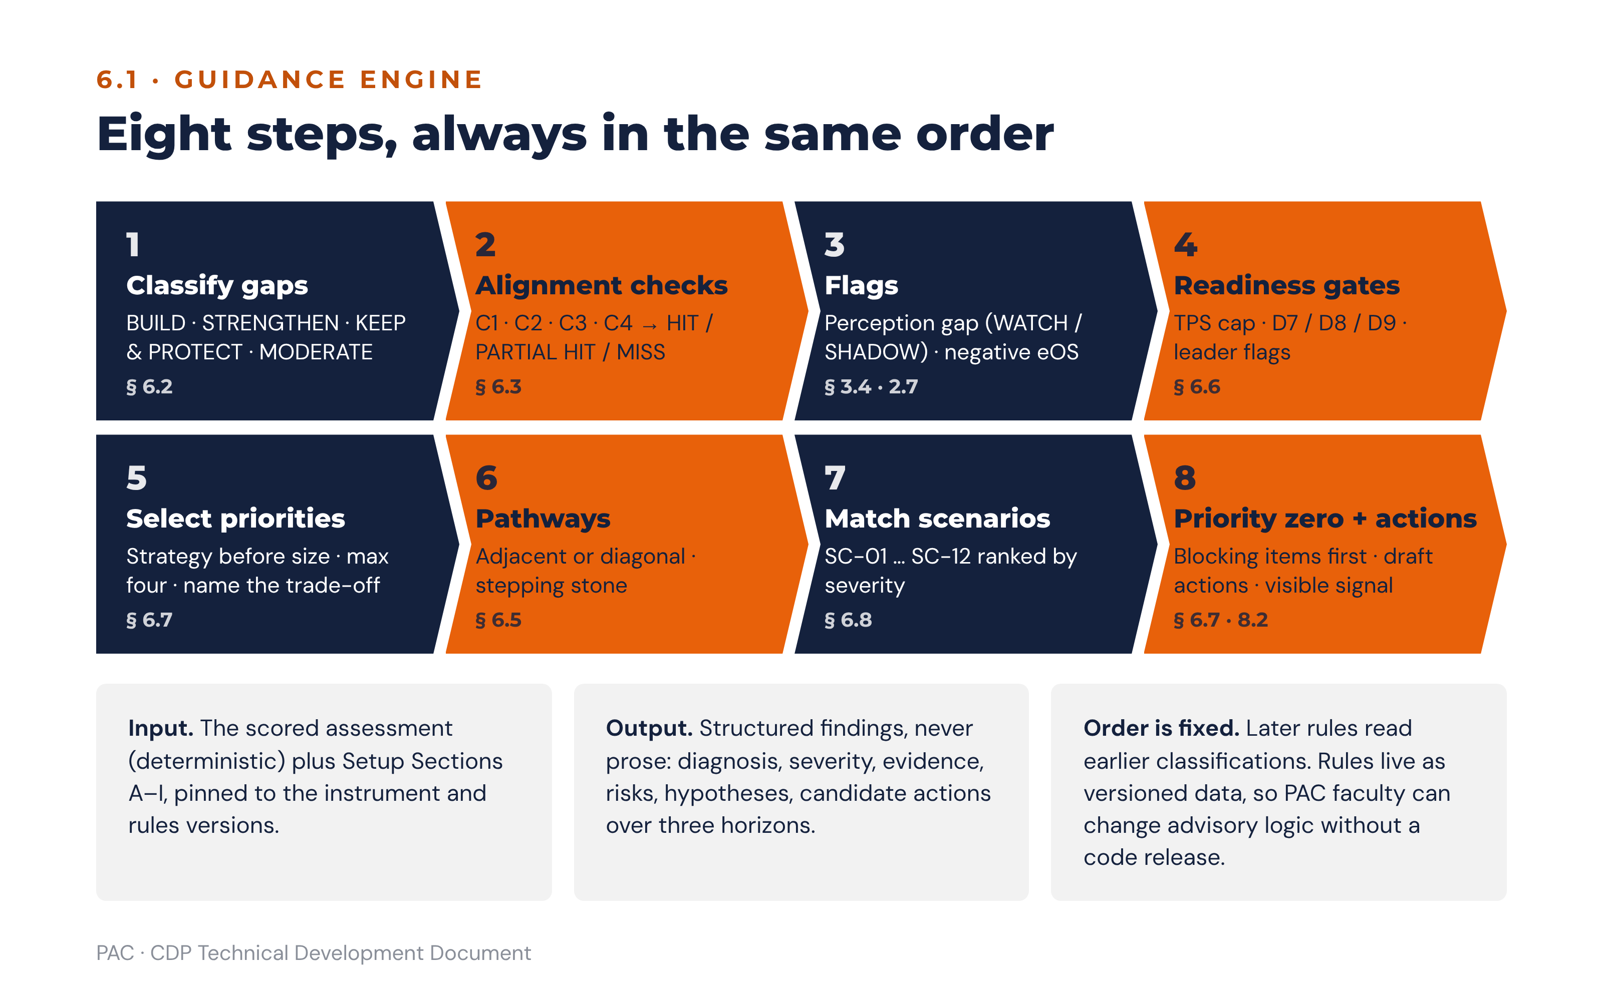
Figure 11 · The guidance engine’s fixed evaluation order

6.2 Gap classification
The bands are half-open and exhaustive: every gap falls in exactly one class.
Classification | Gap rule | Meaning | Planning response
BUILD | ≥ +8.0 | Significantly more of this orientation is needed. | Strategic priority candidate. Named workstream, executive owner, board visibility where it is also a C1 or C4 miss.
STRENGTHEN | +4.0 to < +8.0 | Moderately more is needed. | Targeted actions inside another priority, or a department-level plan. Monitor at annual re-assessment.
KEEP & PROTECT | > −4.0 to < +4.0 | Broadly the right level. | Record in Setup Section G5. Prevent over-correction and reassure the people who identify with this orientation.
MODERATE | ≤ −4.0, flagged significant at ≤ −8.0 | Less of this orientation, or a healthier form of it, is needed. | Target the overplay rather than the orientation itself. Frame with a bridging narrative.
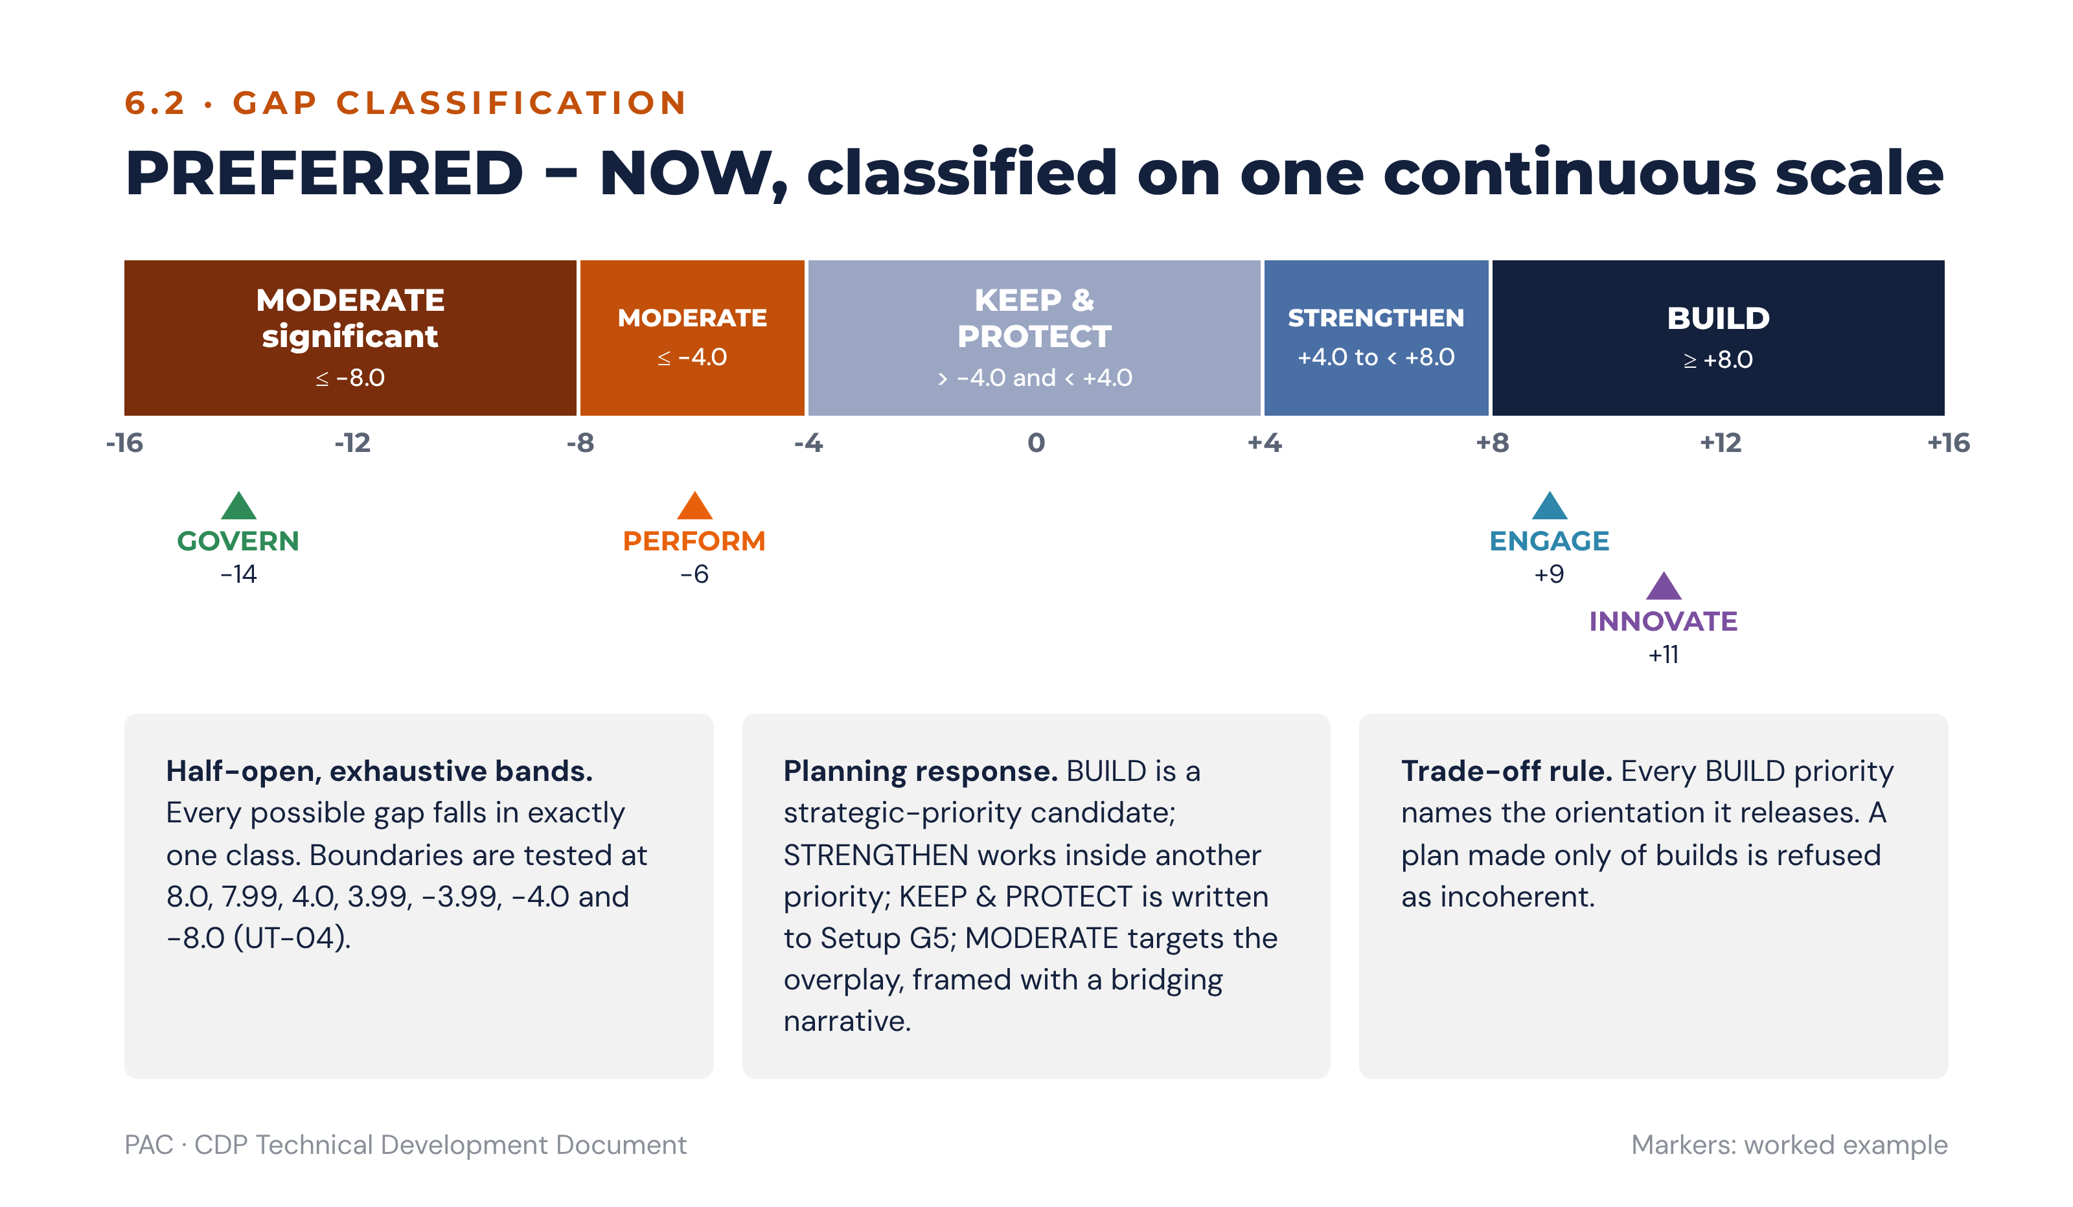
Figure 12 · Gap classification bands, with the worked example’s four gaps

6.3 The four alignment checks
Each check returns HIT, PARTIAL HIT or MISS. C1 and C4 are quantitative and use the alignment percentage at 6.3.2; C2 and C3 are decision tables.

6.3.1 Requirement lookup (C1)
Under constant-sum scoring across four orientations, 25 points is the neutral allocation: a profile with no emphasis anywhere scores 25 on each. Every published threshold is therefore a margin above or below that neutral point, and the margins fall into a structure rather than scattering:
Requirement type | Orientations | Threshold T | Margin above neutral (25)
Single orientation, ENGAGE/PERFORM diagonal | ENGAGE or PERFORM | > 30 | +5
Single orientation, INNOVATE/GOVERN diagonal | INNOVATE or GOVERN | > 28 | +3
Paired requirement — transformation agenda | ENGAGE and INNOVATE together | > 26 each | +1 each
Balanced requirement — business-model transition | All four together | > 24 each | −1 each
Two rules explain the set. First, the bar falls as the number of orientations a requirement names rises: a strategy needing one orientation to dominate demands a real margin, a strategy needing two demands only that both clear neutral, and a model transition needing all four demands only that none has collapsed. This is arithmetically necessary under constant-sum scoring, because four orientations cannot each exceed 30 when they must total 100. Second, within the single-orientation case the margin is set per diagonal axis: +5 for the ENGAGE/PERFORM diagonal and +3 for the INNOVATE/GOVERN diagonal.
The thresholds are encoded as one lookup table with a margin column (UT-50), never as unrelated constants, so a maintainer cannot collapse them into a single threshold without seeing what would break. All thresholds are strict: a requirement is met only when NOW exceeds T.
Threshold selection by check. C1 uses the strategic-goal table below. C4 business-model requirements that name two orientations use each orientation’s single-orientation threshold (ENGAGE and PERFORM 30; INNOVATE and GOVERN 28). The paired threshold of 26 applies only to the C1 transformation agenda, and 24 only to a declared business-model transition.
Setup Section B tags each strategic priority to the orientation it requires.
Strategic goal type | Required orientation | Dominance threshold | Risk if misaligned
Results and growth targets | PERFORM | > 30 | Execution culture too weak to hit commercial targets.
Innovation and new business models | INNOVATE | > 28 | The organisation lacks the creative metabolism for necessary change.
People and talent retention goals | ENGAGE | > 30 | Attrition accelerates, wellbeing deteriorates, employer brand weakens.
Compliance, audit and process scale | GOVERN | > 28 | Process drift, quality failures, audit risk, compliance exposure.
Transformation agenda | ENGAGE and INNOVATE, both | > 26 each | Resistance and fragmentation systematically undermine the change.

6.3.2 Alignment percentage and verdict (C1 and C4)
For the set R of orientations the strategy or business model requires, with threshold T(r) for each:
sub_alignment(r) = min(100, 100 × NOW(r) ÷ T(r))
alignment_pct = mean(sub_alignment(r) for r in R)
Verdict from the published bands: alignment_pct ≥ 80 is a HIT; 60 to < 80 is a PARTIAL HIT; < 60 is a MISS. Two overrides then apply, in order:
Override 1 — if any r in R has a NOW(r) that does not exceed T(r), the verdict cannot exceed PARTIAL HIT. Override 2 — if any r in R is the lowest-scoring orientation in the NOW profile, the verdict is MISS. Override 2 does not apply to the balanced business-model transition requirement: there every orientation is required, so the lowest is always in R, and override 1 alone caps the verdict (UT-17, UT-51).
Worked example, C1. The strategy is digital channel growth, so R = {INNOVATE}, T = 28, NOW = 14. sub_alignment = 100 × 14 ÷ 28 = 50.0, so alignment_pct = 50.0, which is below 60 and therefore a MISS. Override 2 confirms it: INNOVATE is the lowest NOW score. Verdict: C1 MISS — the digital growth strategy requires INNOVATE above 28 and INNOVATE is the weakest orientation in the organisation.
Worked example, C4. The declared business model is service (B2C), so R = {ENGAGE, PERFORM}, with thresholds 30 and 30, and NOW scores 22 and 34. sub_alignment(ENGAGE) = 73.3; sub_alignment(PERFORM) = min(100, 113.3) = 100.0; alignment_pct = 86.7, which alone would read as a HIT. Override 1 applies because ENGAGE at 22 is below its threshold of 30, so the verdict is capped. Verdict: C4 PARTIAL HIT — the model requires ENGAGE and PERFORM; PERFORM is strong but ENGAGE is below the dominance signal.

6.3.3 Business-model requirement lookup (C4)
Business model | Requirement | Culture risk if misaligned
Product company (B2B) | PERFORM + INNOVATE | Unable to sustain the innovation pipeline; customer responsiveness declines.
Service company (B2C) | ENGAGE + PERFORM | Staff cannot deliver service excellence without psychological safety and support.
Platform / digital scale-up | INNOVATE dominant | A GOVERN culture kills experimentation velocity; product releases slow.
NGO / social impact | ENGAGE + INNOVATE | A PERFORM-dominant culture erodes mission alignment and burns staff out.
Regulated / compliance sector | GOVERN + PERFORM | An INNOVATE-dominant culture creates compliance exposure and process drift.
Business model transition (any) | Balanced: all four orientations above 24 | A single-orientation dominant culture resists the transition and sub-cultures harden.
Where Setup Section B records a planned model change, the transition requirement supersedes the single-model requirement and the check is evaluated against the balanced test: R = all four orientations with T = 24 each.

6.3.4 Behaviour gap verdict (C2)
C2 uses both rank and magnitude, with a strict division of labour: rank determines the verdict, magnitude determines the intervention intensity, and magnitude can never change the verdict. Rank drives the verdict because C2 asks whether the target orientation dominates leadership practice, which is a dominance comparison, not a distance. But rank alone is lossy: a target orientation sitting second at 27 against a dominant 28 is a materially different problem from one sitting second at 27 against a dominant 45, and an engine that reported both as PARTIAL HIT would send the same recommendation to two organisations that need different programmes.
Let target be the orientation tagged on the target leadership behaviours in Setup Section F, and let the leadership practice profile be the orientation scores of the Leadership lens (D2) combined with D3 People Architecture, since both measure what staff actually experience.
Rank of target orientation within mean(D2, D3) NOW profile | Verdict | Required intervention
1st (dominant) | HIT | Sustain through recognition and ritual.
2nd | PARTIAL HIT | Targeted 6–12 month leadership workstream to move the target orientation into dominance.
3rd or 4th | MISS (Leadership) | Executive coaching and a CDP-anchored 360 programme anchored to the target orientation, plus leadership KPIs. Communication alone will not close this gap.
Magnitude qualifier. Alongside the verdict the engine computes the distance the leadership profile has to travel:
behaviour_gap_points = mean(D2, D3) NOW[dominant] − mean(D2, D3) NOW[target]
This figure is reported with every C2 verdict and selects the intervention intensity. It is an intensity dial, not a verdict input: a MISS at 4 points is still a MISS, and a HIT is never downgraded by distance because at rank 1 the distance is zero or negative by construction.
behaviour_gap_points | Intensity | What the recommendation must contain
< 5.0 | Marginal | The rank understates how close the profile is. Coaching and explicit recognition of the target behaviour are sufficient; no system-lever change is required. Report the closeness explicitly so the client is not over-sold a programme.
5.0 to < 15.0 | Substantive | A structured leadership workstream: development programme, CDP-anchored 360 baseline and re-measure, and a culture stewardship objective in every people manager’s review.
≥ 15.0 | Entrenched | The workstream plus system levers — promotion criteria, reward mix and performance-management redesign — plus a leadership KPI carried at ExCo. At this distance, development alone has never been sufficient, because the system is selecting for the dominant orientation faster than the programme can shift it.
Shared-dominance override. Where the target orientation ranks second and behaviour_gap_points is less than 1.0, the engine reports shared dominance and returns HIT rather than PARTIAL HIT. This aligns C2 with the shared-dominance rule already governing the culture profile at 2.6.1, and prevents a verdict flipping on a difference smaller than the instrument can meaningfully resolve. It is the one case in which magnitude touches the verdict, and it does so by applying an existing rule consistently rather than by introducing a new threshold.
Where C2 returns a MISS, the engine must also check whether the same orientation carries a perception-gap flag. A C2 miss accompanied by a SHADOW CULTURE flag on the same orientation is the strongest single finding the instrument produces and is escalated to the board-level narrative.
Worked example, C2. Target leadership behaviours in Setup Section F are coaching and listening, tagged ENGAGE. The mean D2/D3 NOW profile is PERFORM-dominant with ENGAGE ranked third. Verdict: C2 MISS (Leadership), accompanied by a SHADOW CULTURE flag on ENGAGE at 11 points. This is the PERFORM to ENGAGE diagonal pathway. On magnitude, the D2 ENGAGE allocation inferred at 2.9.2 is 18.0, so any PERFORM dominance above 33.0 on the combined D2/D3 lens places this case in the entrenched band — which is consistent with the system-lever work the pathway calls for, and with the prescription of coaching plus 360 plus leadership KPIs rather than communication. The illustrative case does not specify the combined D2/D3 profile, so its intensity band is not fixed in the fixture.

6.3.5 Stop / start audit verdict (C3)
C3 tests whether the bonding mechanism (D4) and the success definition (D6) reinforce the change agenda from Setup Section G or quietly contradict it. It is a decision table.
Condition | Verdict | Response
D4 dominant and D6 dominant are both in the BUILD or KEEP & PROTECT set | HIT | Reinforce publicly. Name the existing ritual that already signals the desired behaviour.
Exactly one of D4 or D6 dominant is in the MODERATE set | PARTIAL HIT | Redesign the contradicting mechanism within 90 days: recognition ritual if D6, bonding narrative if D4.
Both D4 and D6 dominant are in the MODERATE set | SYSTEMIC MISS | HR systems redesign required within 90 days: performance management, promotion criteria, incentives and onboarding. The change agenda will not be believed until at least one visible ritual changes.
D4 dominant is the orientation that must be moderated | Identity risk (modifier on any verdict) | The programme will feel like an attack on identity. Name the intervention as preserving the bonding narrative while redirecting its energy, using the bridging narratives at 6.5.
Advisory meaning. C3 is where most culture programmes fail and the failure is almost always in the reward system. The single most powerful lever available is to change one visible recognition ritual within thirty days of launching the programme, because it signals that the change is real rather than rhetorical. Every priority produced by the engine therefore carries a mandatory 30-day visible signal.

6.4 Signal classification reference
The master signal table used by the rules engine and reproduced in every organisational report’s method section.
Signal | Threshold | Classification | Recommended action
Culture–strategy alignment | ≥ 80% | HIT: Strong | Sustain and reinforce publicly with visible celebration.
Culture–strategy alignment | 60 to < 80% | PARTIAL HIT: Moderate | Targeted investment in the gap orientation over 6–12 months.
Culture–strategy alignment | < 60% | MISS: Critical | Dedicated culture workstream with board visibility.
Executive–staff perception gap | > 5.0 and ≤ 7.0 on any orientation | WATCH | Examine in the results debrief against cohort data; monitor at re-assessment.
Executive–staff perception gap | > 7.0 on any orientation | SHADOW CULTURE | Facilitated perception-gap workshop before any intervention.
eOS category score | Negative in any category | MISS: Engagement | Structured listening sessions with the affected cohort within 30 days.
KPI–culture alignment | Dominant orientation ≠ the orientation the KPI agenda needs | MISS: Strategic | Reframe the culture roadmap to serve the KPI agenda directly.
Behaviour gap | Target orientation ranked 3rd or 4th on mean(D2, D3) | MISS: Leadership | Executive coaching plus a CDP-anchored 360 programme anchored to the target orientation.
Process misalignment | Reward or promotion criteria contradict the preferred culture | SYSTEMIC MISS | HR systems redesign within 90 days.
Sub-culture divergence | SDI ≥ 12.0, confirmed | SUB-CULTURE | Unit-level plan and a named unit owner; consider whether the unit is a leading indicator rather than an exception.
Leader readiness | LRI < 2.50 | MISS: Leader capability | Development plan first; the unit’s priority is sponsored one level up.

6.5 Culture-shift pathways
The pathway is selected from the dominant NOW orientation to the target orientation, which is the BUILD orientation with the greatest strategic need. The pathway determines difficulty, the bridging narrative and the core interventions. Adjacent shifts share a pole and are moderate; diagonal shifts share no pole and are high difficulty.
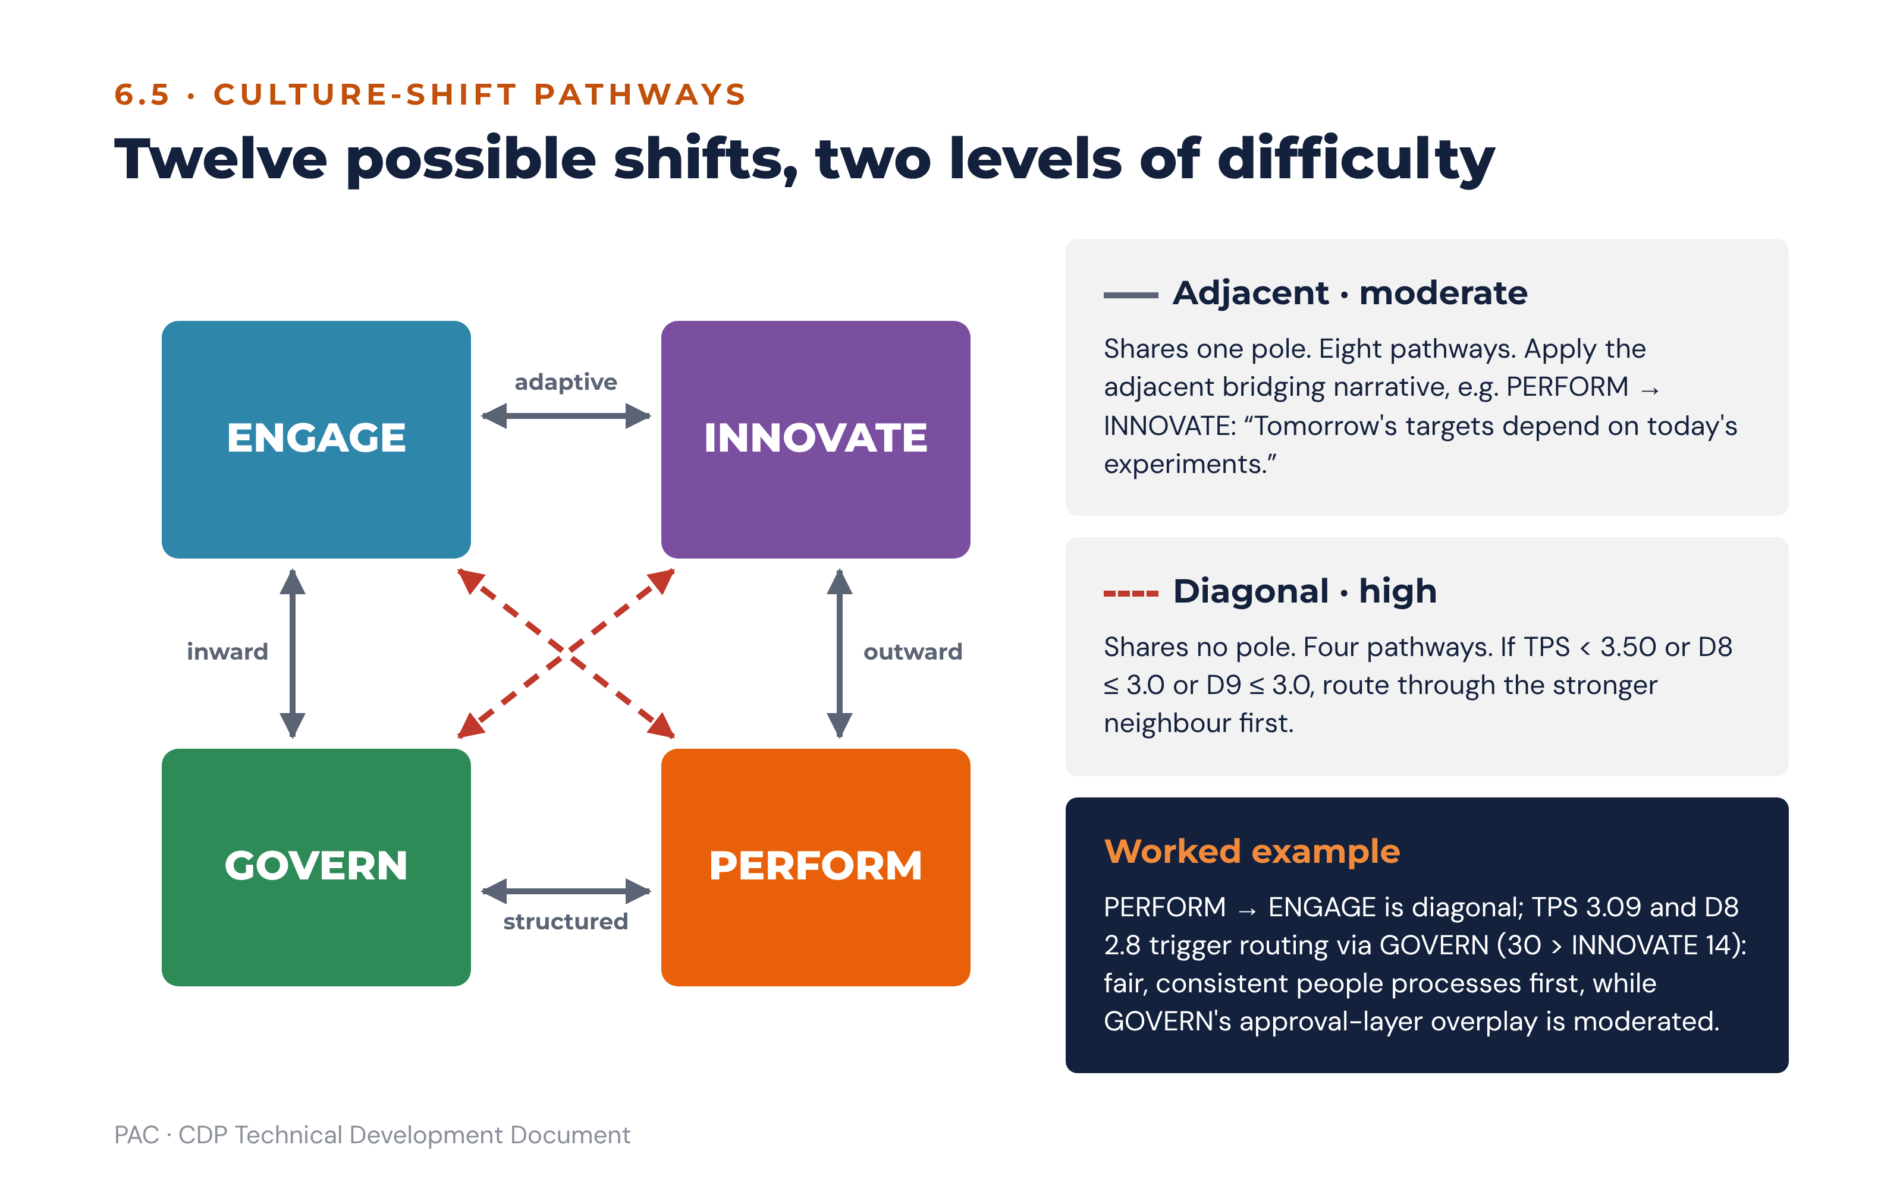
Figure 13 · Culture-shift pathways: adjacent and diagonal, with stepping-stone routing
Pathway | Relationship | Difficulty | Bridging narrative | Core interventions
PERFORM → ENGAGE | Diagonal | High | “We perform best when our people are at their best.” | Coach-first leadership development; CDP-anchored 360 feedback; structured wellbeing investment; team-based recognition.
ENGAGE → PERFORM | Diagonal | High | “Delivering for our customers is how we secure each other’s future.” | Commercial acumen training; objective-setting rigour; performance-conversation skills; accountability culture; a visible scoreboard.
GOVERN → INNOVATE | Diagonal | High | “Our discipline is what lets us experiment safely.” | Innovation sprints; explicit permission to fail; fewer approval layers; design capability; a ring-fenced experimentation budget.
INNOVATE → GOVERN | Diagonal | High | “Good systems let our best ideas scale.” | Process discipline programme; documentation culture; quality management system; structured governance training.
ENGAGE → INNOVATE | Adjacent (adaptive pole) | Moderate | “Our trust is the safety net for bold ideas.” | Cross-functional idea forums; action learning; protected experimentation time; recognise experiments, not only successes.
INNOVATE → ENGAGE | Adjacent (adaptive pole) | Moderate | “Great ideas need great teams.” | Mentoring; team rituals; retention plans for creative talent; reward for helping others succeed.
ENGAGE → GOVERN | Adjacent (inward pole) | Moderate | “Fairness and consistency are how we care at scale.” | Role clarity; standardised people processes; documented decision rights; quality routines.
GOVERN → ENGAGE | Adjacent (inward pole) | Moderate | “Our standards exist to serve the people who deliver them.” | Manager capability in coaching; participation in process design; recognition for development.
INNOVATE → PERFORM | Adjacent (outward pole) | Moderate | “Ideas only count when customers pay for them.” | Phase-gate discipline; commercial targets on the innovation portfolio; customer-outcome metrics.
PERFORM → INNOVATE | Adjacent (outward pole) | Moderate | “Tomorrow’s targets depend on today’s experiments.” | Innovation objectives in scorecards; sandbox time; portfolio funding for pilots; celebrate well-run failures.
PERFORM → GOVERN | Adjacent (structured pole) | Moderate | “Reliability is how we keep winning.” | Control framework; quality metrics alongside delivery metrics; documented process ownership.
GOVERN → PERFORM | Adjacent (structured pole) | Moderate | “Our systems exist to deliver results, not to be admired.” | Outcome-based measures; customer proximity; decision-rights delegation; commercial literacy.

6.5.1 Stepping-stone routing
Where a diagonal shift is required and TPS is below 3.50, or D8 or D9 is at or below 3.0, the shift must be routed through the neighbouring orientation that is already relatively strong in the profile.
Diagonal shift | Route via | Rationale
GOVERN → INNOVATE | PERFORM (outward first) or ENGAGE (adaptive first) | Via PERFORM, frame innovation as a growth target. Via ENGAGE, build safety and trust so people will take risks.
INNOVATE → GOVERN | PERFORM (stability via results) | Delivery discipline and phase-gate review introduce structure in a language innovators accept.
PERFORM → ENGAGE | GOVERN (inward first) or INNOVATE (adaptive first) | Via GOVERN, fair and consistent people processes. Via INNOVATE, team-based experimentation that builds collaboration.
ENGAGE → PERFORM | GOVERN (stability first) | Clear roles, standards and measures create the scaffolding for accountability without breaking trust.
Worked example. The dominant NOW orientation is PERFORM, so the INNOVATE build is an adjacent shift on the shared outward pole, framed as “tomorrow’s targets depend on today’s experiments”. The ENGAGE build is diagonal, and with TPS at 3.09 and D8 at 2.8 both stepping-stone triggers fire, so it is routed through GOVERN — fair, consistent people processes and role clarity — while PERFORM is moderated towards a sustainable pace.

6.6 Readiness gates
Gates are evaluated after classification and before priority selection. A gate does not change a finding; it constrains how many priorities may be selected and in what order, and in three cases it blocks release of a recommendation until a pre-condition is recorded as complete.
Signal | Threshold | Gate | Blocking?
TPS | < 2.50 | Foundation first. Build D9 and D8 conditions before launching content. Maximum 1–2 priorities in the first cycle. | Caps count
TPS | 2.50 to < 3.50 | Enablement investment. Maximum 3 priorities. Stage diagonal shifts through a stepping stone. | Caps count
TPS | 3.50 to < 4.00 | Targeted support. Up to 4 priorities with change-management support. | Caps count
TPS | ≥ 4.00 | Full deployment. Up to 4 priorities in parallel. | Caps count
D8 Psychological Safety | ≤ 3.0 | A psychological safety workstream must precede or accompany any BUILD priority for INNOVATE or ENGAGE. | Yes — the BUILD priority cannot be published without the paired workstream
D9 Adaptive Capacity | ≤ 3.0 | Build change infrastructure — sponsorship, resourcing, clarity of expected behaviours, lessons-learned discipline — before content. | Yes
D7 Digital Readiness | ≤ 3.0 | Any priority depending on new technology requires a digital adoption plan and a named executive sponsor. | Yes, for the affected priority only
eOS category | Negative | Structured listening sessions with the affected cohort within 30 days, before interventions are announced. | Yes — for the affected cohort
Perception gap | > 7.0 (SHADOW CULTURE) | Facilitated perception-gap workshop before any intervention. Leaders must see the staff picture first. | Yes — for the affected orientation
Leader flags | Integrity or safety flag, or LRI < 2.50 | The unit’s priority is sponsored one level up until resolved. | Yes — for that unit only

6.7 Priority selection rules
Rule | Specification
Strategy before size | An orientation classified BUILD that is also a C1 or C4 miss outranks a larger gap the strategy does not need. Sort order is: C1/C4 miss first, then C2 miss, then C3 systemic miss, then gap magnitude.
Maximum four | No more than four strategic priorities, normally one per orientation, capped further by the readiness gates.
Pair every BUILD with a MODERATE | Constant-sum scoring means gaining one orientation requires releasing another. Every BUILD priority must name the orientation being released. The engine refuses to emit a plan in which all named priorities are builds.
Urgency sequencing | Sequence by urgency tier, not by gap size: strategic miss 0–30 days (CEO + CHRO); behaviour gap 0–90 days (CHRO + people managers); process contradiction 1–6 months (CHRO + OD); business-model readiness 6–18 months (CEO + ExCo).
Four levels | Every priority carries commitments at individual leader, team, department or unit, and organisational level.
One visible signal | Every priority carries one visible change within 30 days, preferably to a recognition ritual.
Pre-conditions become priority zero | Any blocking gate becomes a priority numbered zero, owned by the CEO and CHRO, and dated at 30 days. It does not count against the four-priority cap.

6.8 Scenario library
Each scenario is a named score pattern with a diagnosis, the risks it carries and the root-cause hypotheses a consultant should test in the debrief. Scenarios are stored as data with a match expression, a severity and a linked action set. More than one scenario may match; the engine returns all matches ranked by severity and the report leads with the highest.
ID | Scenario | Match condition | Diagnosis | Risks | Root-cause hypotheses to test
SC-01 | Delivery without belonging | PERFORM dominant with strength ≥ 5; ENGAGE gap ≥ +8; eOS Q6 or Q4 negative | The organisation delivers results by consuming its people. Performance is real but is being funded from discretionary effort that is running out. | Attrition of key talent; burnout; service quality decay as experienced staff leave; employer-brand damage in a competitive talent market. | Is the pace a deliberate strategic choice or an unmanaged default? Are managers rewarded for output only? Has headcount lagged volume growth? Is recognition exclusively individual and commercial?
SC-02 | Order without ideas | GOVERN dominant; INNOVATE gap ≥ +8; D7 ≤ 3.0 | Control has hardened into a brake. The organisation is well run and cannot change direction. | Loss of relevance as the model shifts; slow product and service cycles; talent leaves for competitors with more latitude; compliance becomes the only accepted argument. | How many approval layers stand between an idea and a pilot? Is failure punished informally even where it is permitted formally? Does the budget contain any unallocated experimentation capacity?
SC-03 | Ideas without delivery | INNOVATE dominant; GOVERN gap ≥ +8 or PERFORM gap ≥ +8 | Creative energy is scattering. Many initiatives start and few reach customers. | Cash burn without return; staff cynicism from repeated unfinished initiatives; quality and compliance exposure; inability to scale what works. | Is there a stop rule for initiatives? Who owns the portfolio? Are launches counted as success rather than adoption? Is documentation treated as bureaucracy?
SC-04 | Care without accountability | ENGAGE dominant with strength ≥ 10; PERFORM gap ≥ +8 | Cohesion is being protected at the cost of performance conversations. Underperformance is absorbed rather than addressed. | Commercial targets missed; strong performers leave because standards are not held; decision-making slows to consensus; funder or shareholder confidence erodes. | Are difficult conversations avoided or escalated? Do managers have the skill or only lack the will? Does the reward system differentiate at all?
SC-05 | Shadow culture | Any orientation perception gap > 7.0 | Executives and staff are describing two different organisations. Leadership is planning against a picture staff do not recognise. | Every intervention lands as evidence that leaders are out of touch; communication increases cynicism; the culture programme fails before content begins. | Which channels do executives rely on for cultural information? Is there any unfiltered upward route? Do middle managers translate or buffer? Which of the two pictures does the eOS support?
SC-06 | Sub-culture divergence in a division | Segment SDI ≥ 12.0, confirmed, with dominance divergence | A unit is running a different operating logic from the organisation. It may be a problem, a legacy, or a leading indicator of where the organisation is heading. | Inconsistent customer or beneficiary experience; internal friction at the unit’s boundaries; talent mobility blocked; organisational initiatives stall at the unit boundary. | Was the unit acquired, or does it serve a different market? Is the divergence leader-driven or structural? Is the unit outperforming or underperforming on its own KPIs?
SC-07 | Leader misaligned with a healthy team | Team profile matches the organisation’s PREFERRED direction; leader fit index < 55; leader is classified a blocker | The team is already where the organisation wants to go and the leader is not. The unit’s performance is being carried by the team in spite of its leadership. | Loss of the team’s best people; the unit reverts when key staff leave; the leader becomes a visible counter-example that undermines the wider programme. | Is the leader newly appointed into a mature team? Is the leader replicating the behaviour that got them promoted? Does the leader have a sponsor modelling the old orientation above them?
SC-08 | Capable leader, constrained unit | Leader LRI ≥ 3.50; team eOS differential ≤ −10 | The constraint is above or around the leader, not in them. Structure, resourcing or an adjacent unit is producing the experience. | Leader disengagement or exit; misdiagnosis of the problem as a leadership problem; wasted development spend. | What decision rights does the leader actually hold? Is resourcing adequate? Is a dependency outside the unit producing the experience? Is the parent unit’s culture the real variable?
SC-09 | Low transformation readiness | TPS < 2.50 | The organisation is not able to sustain the change it has named. Launching content now will produce initiative fatigue and a damaged appetite for the next attempt. | Public failure of a visible programme; loss of leadership credibility; staff conclude that change does not happen here. | Is the constraint safety, capacity or leadership alignment? How did the last change programme end, and was it ever closed? Is sponsorship nominal?
SC-10 | Systems fighting the strategy | C3 SYSTEMIC MISS | Reward, promotion and recognition are paying for the behaviour the organisation says it wants to stop. Staff are responding rationally. | The change agenda is disbelieved; the most compliant staff are the most disadvantaged; cynicism about leadership intent becomes entrenched. | What genuinely gets people promoted here? What was the last thing publicly celebrated? Does variable pay reward the moderated orientation?
SC-11 | Everything at once | Three or more orientations classified BUILD or STRENGTHEN | No strategic choice has been made. The PREFERRED profile is an aspiration list, not a requirement. | Resource dilution; no priority moves far enough to be felt; the plan collapses at the first budget round. | Did the executive team complete Setup Sections B–D against the approved strategy, or against preference? Which single KPI would most change the organisation’s position?
SC-12 | Aligned and under-recognised | All four checks HIT; culture strength ≥ 10; no negative eOS category | The culture is serving the strategy. The risk is complacency and unintentional erosion. | Drift as the organisation grows or hires; loss of the specific rituals that sustain the profile; over-correction driven by a new leader’s preference. | Which rituals carry the culture, and are they documented? What would break it at twice the headcount? Is the profile recognised and protected in onboarding and promotion?

6.9 Prescriptive action sets
Every finding carries candidate actions at three horizons. The engine populates the horizons from the orientation playbook of the orientation the finding concerns; the table below is the structure each action must satisfy, not a list of actions.
Horizon | Purpose | Required fields | Typical content
Quick win, 0–3 months | Make the change visible and credible before content lands. | Owner (named role), KPI, review point at 30 days | The 30-day visible signal; a listening session series; removal of one approval layer; publication of one scoreboard; public recognition of a behaviour the organisation wants more of.
Medium term, 3–12 months | Build the capability and the habit. | Owner, sponsor, KPI, baseline, target, review points at 90 and 180 days | Leadership development and coaching programme; 360 baseline and re-measure; manager capability in performance conversations; innovation sprint cycles; process redesign of the top bottlenecks.
Structural, 12+ months | Change the system that produced the culture. | Owner, sponsor, budget, KPI, baseline, target, annual review point | Performance-management redesign; promotion and succession criteria; incentive restructuring; onboarding rebuild; operating-model or decision-rights change; the multi-orientation shift for a C4 miss.
Each horizon’s actions inherit the system levers named in the relevant playbook: performance management, promotion criteria, reward and incentives, onboarding and the recognition ritual. Those five levers are where culture is actually set, and an action set that touches none of them is a communications plan rather than a culture plan. The engine flags any priority whose medium-term and structural horizons contain no system lever.

6.10 Rules engine pseudo-code
FUNCTION evaluate_assessment(assessment):
scores = score_assessment(assessment) # section 2, deterministic
setup = assessment.setup # Setup Sections A–I
findings = []
# --- 1. Gap classification (6.2) -------------------------------------
FOR o IN [ENGAGE, INNOVATE, PERFORM, GOVERN]:
g = scores.gap[o]
IF g >= 8.0 THEN class[o] = BUILD
ELIF g >= 4.0 THEN class[o] = STRENGTHEN
ELIF g > -4.0 THEN class[o] = KEEP_AND_PROTECT
ELSE class[o] = MODERATE
significant[o] = (g >= 8.0) OR (g <= -8.0)
# --- 2. Alignment checks (6.3) ---------------------------------------
c1 = alignment_verdict(setup.required_orientations, scores.now, balanced = FALSE)
req, balanced = model_requirement(setup.business_model, setup.model_transition)
c4 = alignment_verdict(req, scores.now, balanced)
c2 = behaviour_verdict(setup.target_leadership_orientation,
mean_profile(scores.now.D2, scores.now.D3)) # rank + magnitude
c3 = stopstart_verdict(scores.now.D4, scores.now.D6, class)
APPEND findings WITH check findings for c1, c2, c3, c4
# --- 3. Perception and engagement flags (3.4, 2.7) --------------------
IF cohort_count(EXEC) >= 5 AND cohort_count(STAFF) >= 5:
FOR o IN orientations:
pg = ABS(scores.now_exec[o] - scores.now_staff[o])
IF pg > 7.0 THEN flag(SHADOW_CULTURE, o, blocking = TRUE)
ELIF pg > 5.0 THEN flag(WATCH, o, blocking = FALSE)
ELSE:
record(PERCEPTION_GAP_NOT_COMPUTED, reason = "cohort below floor")
FOR q IN eos_categories:
IF scores.eos[q] < 0 THEN flag(ENGAGEMENT_MISS, q, blocking = TRUE)
# --- 4. Readiness gates (6.6) -----------------------------------------
max_priorities = CASE scores.tps OF # tps already rounded half-up
< 2.50 -> 2
< 3.50 -> 3
OTHERWISE -> 4
gates = []
IF scores.D8 <= 3.0 THEN gates += SAFETY_WORKSTREAM_REQUIRED
IF scores.D9 <= 3.0 THEN gates += CHANGE_INFRASTRUCTURE_REQUIRED
IF scores.D7 <= 3.0 THEN gates += DIGITAL_ADOPTION_PLAN_REQUIRED
# --- 5. Candidate priorities (6.7) ------------------------------------
candidates = [priority(o, class[o], scores.gap[o], urgency_tier(o, c1, c2, c3, c4))
FOR o WHERE class[o] IN [BUILD, STRENGTHEN]]
SORT candidates BY
1. is_c1_or_c4_miss(o) DESC
2. is_c2_miss(o) DESC
3. is_c3_systemic_miss DESC
4. ABS(scores.gap[o]) DESC
selected = FIRST max_priorities OF candidates
backlog = REST OF candidates WITH reason = "deferred on readiness grounds"
# every BUILD names its release (constant-sum discipline)
FOR p IN selected WHERE p.class == BUILD:
p.trade_off = orientation WITH the most negative gap
NOT ALREADY assigned as a trade_off
IF p.trade_off IS NULL THEN RAISE PlanIncoherent
# --- 6. Pathways (6.5) ------------------------------------------------
dominant = argmax(scores.now) # shared dominance -> both reported
FOR p IN selected:
p.pathway = pathway(dominant, p.orientation)
IF p.pathway.relationship == DIAGONAL
AND (scores.tps < 3.50 OR scores.D8 <= 3.0 OR scores.D9 <= 3.0):
p.stepping_stone = strongest_neighbour(dominant, p.orientation, scores.now)
# --- 7. Scenario matching (6.8) ---------------------------------------
matched = [s FOR s IN scenario_library IF s.match(scores, class, flags)]
SORT matched BY severity DESC
# --- 8. Blocking pre-conditions become priority zero (6.7) -------------
IF any blocking flag OR any gate IN gates:
PREPEND selected WITH priority_zero(owner = [CEO, CHRO], due = 30 days,
items = blocking flags + gates)
# --- 9. Draft actions (section 8, reference library 11) ----------------
FOR p IN selected:
p.actions = generate_actions(p, matched, setup, reference_library) # 8.2
p.actions = prioritise(p.actions) # 8.3
p.visible_signal = reference_library(p.orientation).signal_30_day
RETURN plan(selected, backlog, matched, findings, flags, gates, scores)

6.10.1 Alignment verdict sub-routine
FUNCTION alignment_verdict(required, now, balanced):
IF required IS EMPTY THEN RETURN NOT_APPLICABLE
subs = [MIN(100, 100 * now[r] / threshold(r)) FOR r IN required]
pct = MEAN(subs)
IF pct >= 80 THEN verdict = HIT
ELIF pct >= 60 THEN verdict = PARTIAL_HIT
ELSE verdict = MISS
# Override 1: a required orientation that does not exceed its threshold
IF ANY r IN required WHERE now[r] <= threshold(r):
verdict = MIN(verdict, PARTIAL_HIT)
# Override 2: a required orientation is the weakest in the profile
# (not applied to the balanced transition requirement)
IF NOT balanced AND ANY r IN required WHERE r == argmin(now):
verdict = MISS
RETURN verdict, pct

6.11 Decision tree: from one orientation result to a recommendation
Step | Question | If yes | If no
1 | Is the gap ≥ +8.0? | Go to 2. | If the gap is ≤ −4.0, treat as MODERATE and target the overplay. Otherwise record as KEEP & PROTECT and stop.
2 | Is this orientation required by a C1 or C4 check that returned MISS or PARTIAL HIT? | Strategic priority. Go to 3. | If it is the target orientation of a C2 miss it is a leadership priority — go to 3. Otherwise classify as STRENGTHEN-level work inside another priority and stop.
3 | Is there a blocking flag on this orientation, or a negative eOS category routed to it? | Create priority zero first; the orientation priority cannot be published until the pre-condition is recorded complete. Then go to 4. | Go to 4.
4 | Is the shift from the dominant orientation diagonal? | If TPS < 3.50 or D8 ≤ 3.0 or D9 ≤ 3.0, route via the stepping stone. Apply the diagonal bridging narrative. Go to 5. | Apply the adjacent bridging narrative. Go to 5.
5 | Does the selected priority count already equal the readiness cap? | Hold the priority in the backlog with its evidence, and state in the report that it was deferred on readiness grounds, not on importance. | Select the priority. Go to 6.
6 | Has a trade-off orientation been named? | Generate the action set across the three horizons, attach the 30-day visible signal and assign the urgency-tier owner. | Refuse to emit the plan. A build without a release is not executable.

6.12 The AI interpretation panel
The AI interpretation panel turns findings into readable narrative for the consultant to review, adapt and present. It is an assistant to the practitioner, never a substitute for one: PAC’s method requires that all reports be presented by a trained facilitator or certified practitioner and that raw scores are never shared without contextual interpretation. The panel therefore produces draft narrative that a named consultant must accept before it can appear in any released report.

6.12.1 What the panel receives
The panel receives a structured findings payload only: computed scores, classifications, check verdicts, flags, gate outcomes, matched scenarios with their published diagnoses and hypotheses, selected priorities with pathways, and the relevant setup parameters. It does not receive individual responses, verbatim qualitative text, respondent counts below the anonymity floor, or any personally identifying attribute. It receives thematic summaries of qualitative data, produced by a separate extraction step that is itself subject to the suppression rules at 3.6.

6.12.2 What the panel is allowed to do
Permitted | Prohibited
Explain what a score means, using the published interpretation bands. | Compute, recompute, estimate, round or adjust any score.
Name the business consequence of a finding, drawn from the scenario library’s published risks. | Introduce a risk, diagnosis or cause not present in the matched scenarios.
Sequence findings into a narrative and select which is the headline. | Assert a causal relationship between culture and a business outcome.
Draft the conclusion (“what this means”) and the recommendation (“what to do next”) from the selected priorities and their action sets. | Invent an action, an owner, a date, a budget or a KPI.
Adapt tone and length for the audience (board, executive, unit, leader). | Change a threshold, a verdict or a classification, or soften a MISS into a PARTIAL HIT.
Say plainly that the data does not support a conclusion. | Fill a gap in the data with a plausible statement, a benchmark or an external comparison.
Cite the dimension, scenario, check or eOS category that supports each statement. | Reference any external framework, instrument, published benchmark or third-party brand.

6.12.3 Prompt design
The system prompt is fixed, versioned alongside the rules engine, and contains five blocks. First, the role: a PAC culture analyst drafting narrative for a certified practitioner’s review. Second, the vocabulary constraint: the only permitted terminology is the CDP terminology in the glossary at 10.8, and no third-party framework, quadrant name, instrument name or brand term may appear. Third, the grounding rule: every sentence that makes a claim must be traceable to a supplied finding, and the draft must carry an inline reference to the dimension, check or category that supports it. Fourth, the refusal rule: where the findings do not support a requested statement, the panel says so rather than generating one. Fifth, the output contract: a fixed JSON structure with one field per report section, so the renderer never parses free prose.
The user prompt is assembled by the platform from the findings payload and carries no consultant free text into the model other than a bounded “emphasis” field, which may select which finding leads but may not introduce content.

6.12.4 Guardrails and verification
Guardrail | Implementation
Numeric integrity | Every number in the generated narrative is matched against the findings payload before rendering. An unmatched number blocks the draft and raises an error to the consultant. The panel does not get to be approximately right about a score.
Terminology screen | A deny-list of third-party framework, instrument and brand terms is applied to every draft. A hit blocks the draft and logs the term. The deny-list is maintained by PAC and versioned with the prompt.
Claim traceability | Each generated statement carries its supporting reference. A statement without a reference is stripped before the consultant sees it, and the strip is logged.
Causal-language screen | A pattern screen rejects causal constructions (“because”, “caused”, “drove”, “resulted in”) linking a culture score to a business outcome, and offers the associational form instead.
Individual-attribution screen | Any draft naming an individual, or describing a group small enough to identify one, is blocked.
Human acceptance | No generated narrative reaches a client role until a named PAC Consultant accepts it. The acceptance is recorded with the consultant’s identity, the prompt version and the model version, so any released report can be reconstructed.
Determinism of the number, not the prose | The same assessment always produces the same scores and the same findings. The narrative may vary between drafts, and the platform must therefore never treat generated prose as a stored fact or re-use it as an input.
Advisory meaning. The panel exists to save the consultant the first hour of writing, not the judgement. PAC’s credibility rests on the claim that the number was calculated and the interpretation was made by a qualified practitioner who can be questioned about it. The guardrails above are what allow that claim to survive contact with a sceptical board.

7. Reports — Conclusive and Guiding

7.1 Common rules for every report
Every report in the suite obeys four rules. It states a conclusion, in a section headed “What this means”, written as a judgement rather than a summary. It states a recommendation, in a section headed “What to do next”, naming an owner and a date. It carries the technical appendix: response rates, exclusions, suppression notes, instrument and rules versions, and the definition used for any substituted input. And it is released only by a certified practitioner, with the release recorded.
A report that presents scores without a conclusion is not releasable. This is a platform rule, not a style preference: the release action is blocked until both mandatory sections contain content.

7.2 Report suite
Report | Audience | Purpose
Board / Executive Summary | Board, CEO | Decide whether culture is an asset or a risk to the declared strategy, and approve the priorities and their resourcing.
Organisational Culture Report | ExCo, CHRO, OD | Understand the full profile, the alignment checks, readiness and the employee voice, and own the organisation-wide plan.
Sub-culture Reports | ExCo, division and department heads | Understand where the culture differs, whether it is confirmed, and what the unit itself must do.
Leader Reports | The individual leader, their coach, CHRO | Development. Understand the leader’s orientation, blind spots, readiness and relationship to their team’s culture.
Leadership-Team Report | CEO, CHRO, Board people committee | Judge whether the leadership population as a whole can lead the required change.
Action Plan | All levels, role-filtered | Convert findings into owned, dated, measured commitments and track them.
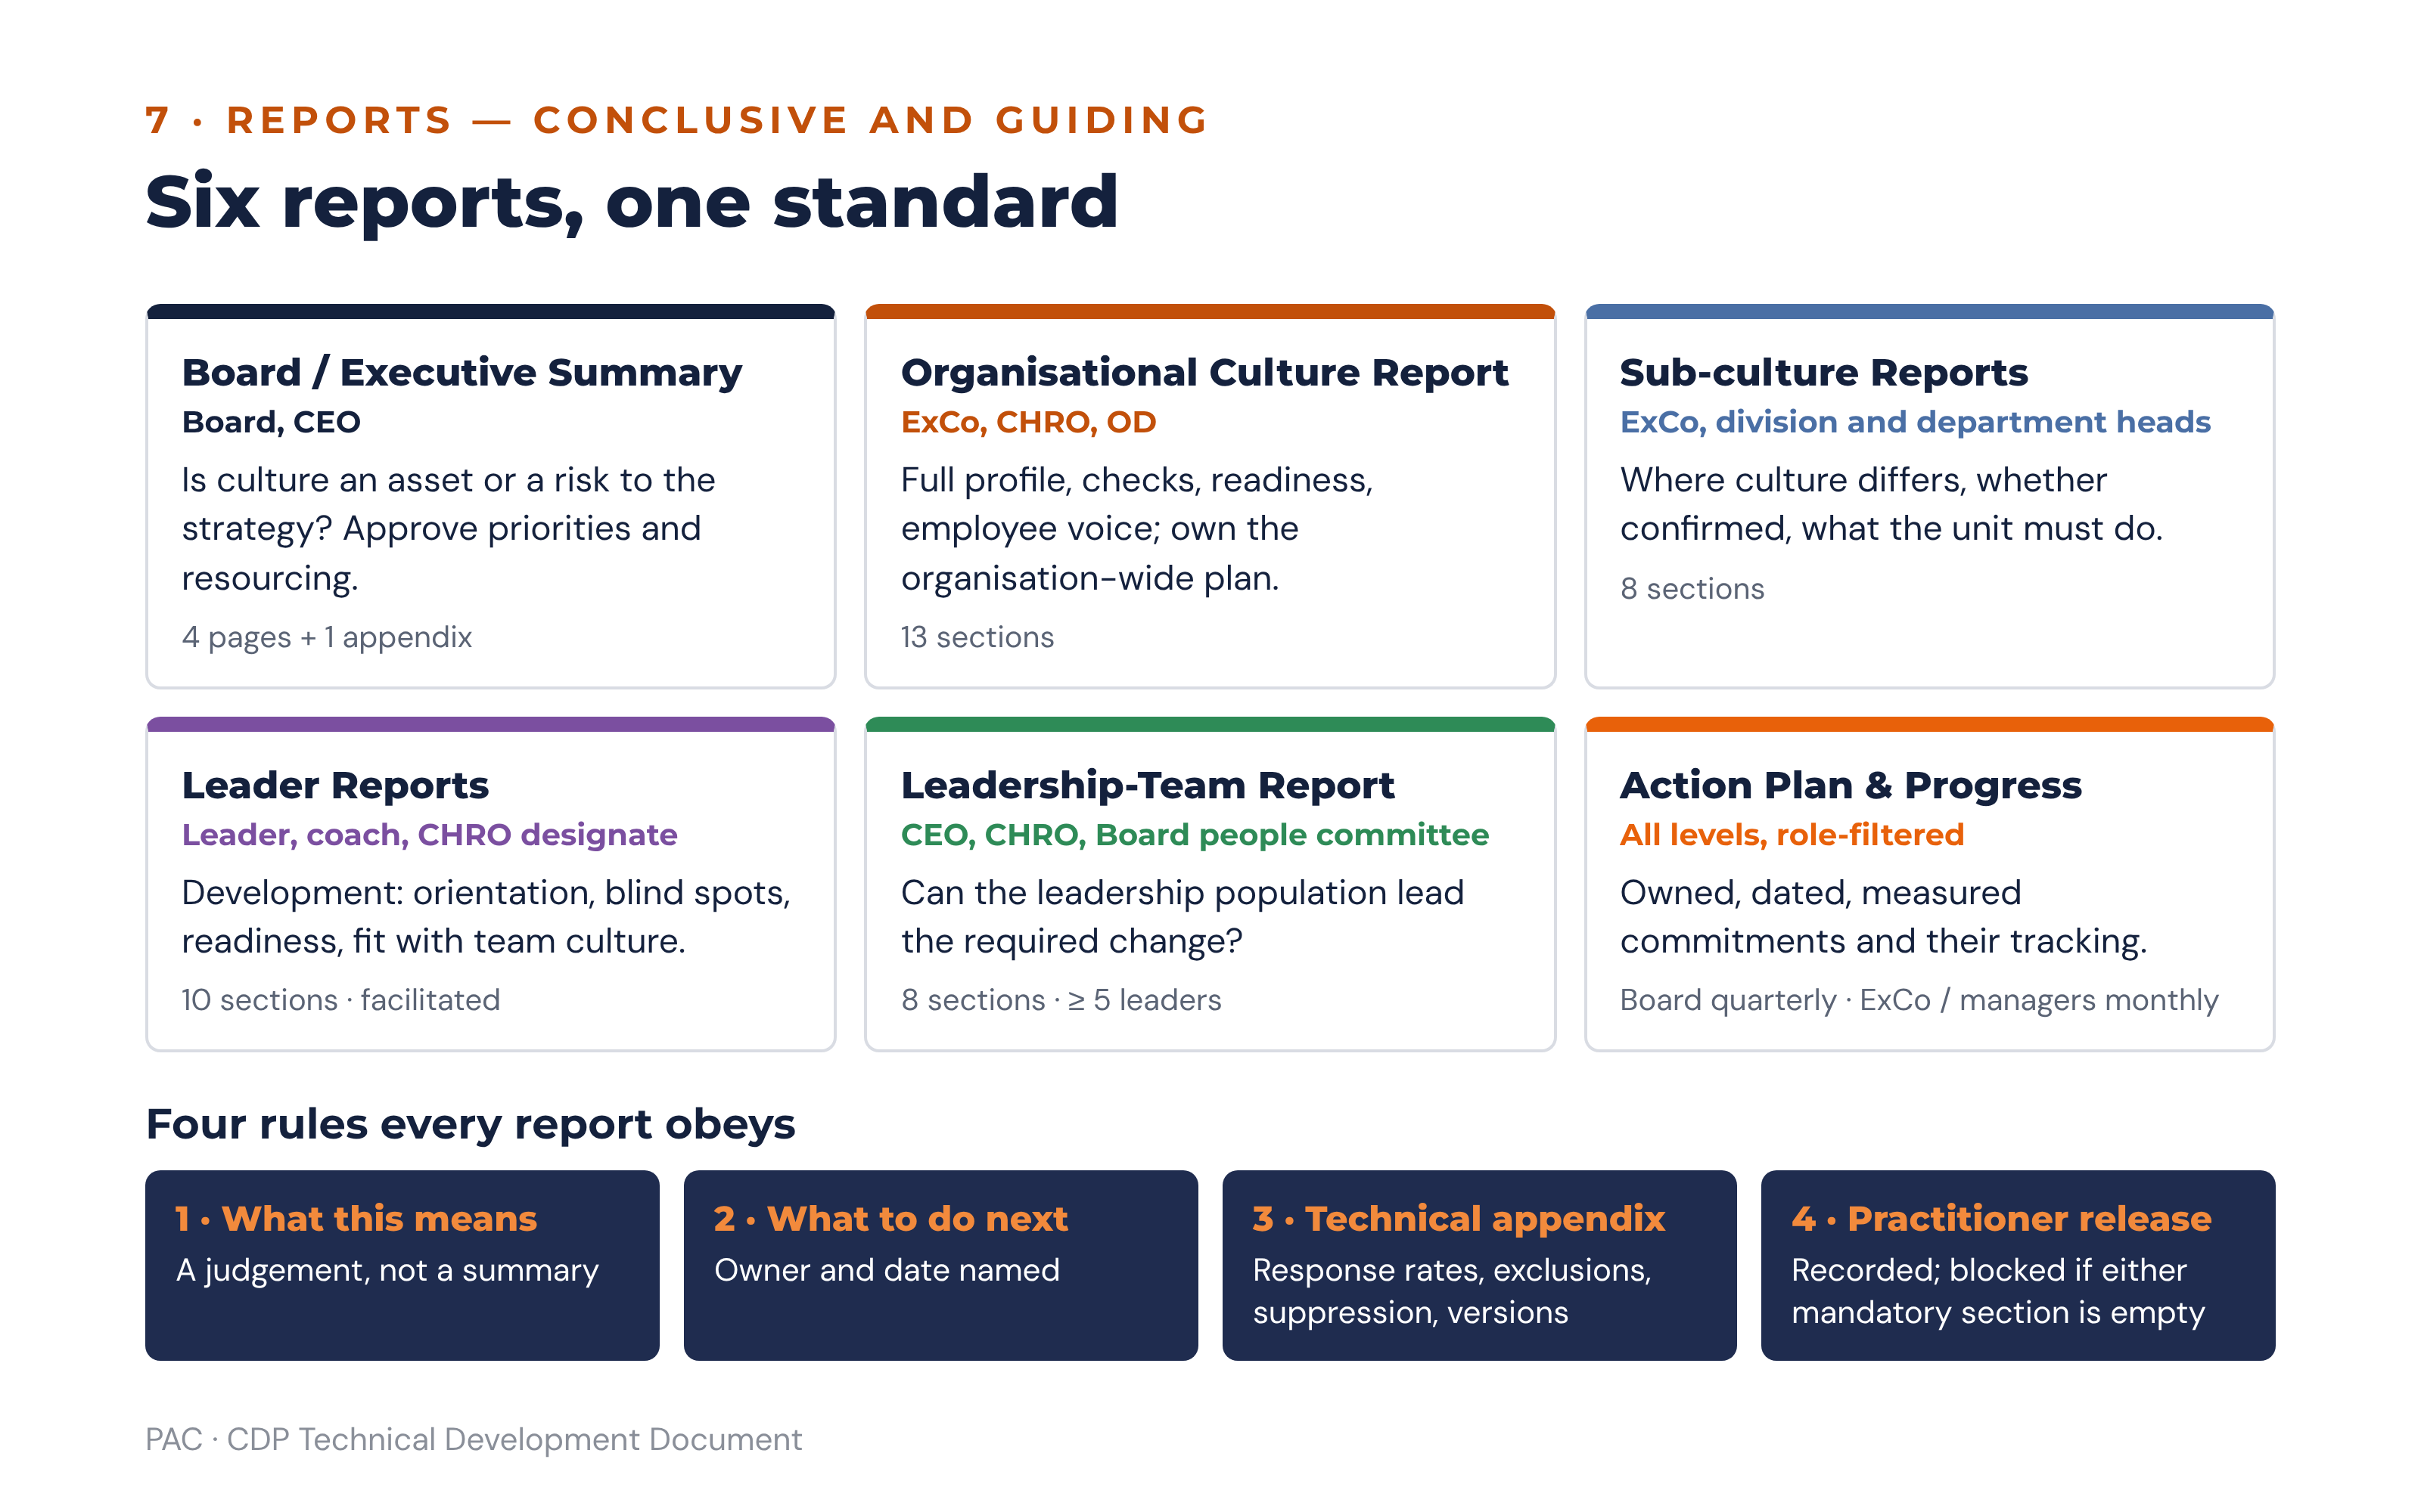
Figure 14 · The report suite and the four rules every report obeys

7.3 Board / Executive Summary
Element | Specification
Length | Four pages maximum, plus a one-page appendix. A board summary that runs longer will not be read.
Sections | 1 The judgement in one paragraph · 2 Culture against strategy: the four checks · 3 The three findings that matter · 4 Readiness and what it permits · 5 The priorities, owners and dates · 6 What this means · 7 What to do next · 8 Technical appendix.
Charts | Orientation profile NOW vs PREFERRED (one chart). Alignment check scorecard (four tiles, HIT / PARTIAL HIT / MISS). TPS gauge with its band label. Perception-gap bars where a flag exists.
Narrative logic | Lead with the conclusion, not the data. The opening paragraph states whether the culture serves the strategy, names the single largest risk, and states what the board is being asked to approve. Metrics appear afterwards, as support.
Conclusion | A judgement of the form: “The culture as measured [does / does not] support the declared strategy, principally because [named check and evidence]. The consequence over the next [horizon] is [named business risk].”
Recommendation | Approve the priorities, the owners and the resourcing; note the pre-conditions that must complete within 30 days; and set the reporting cadence to the board.
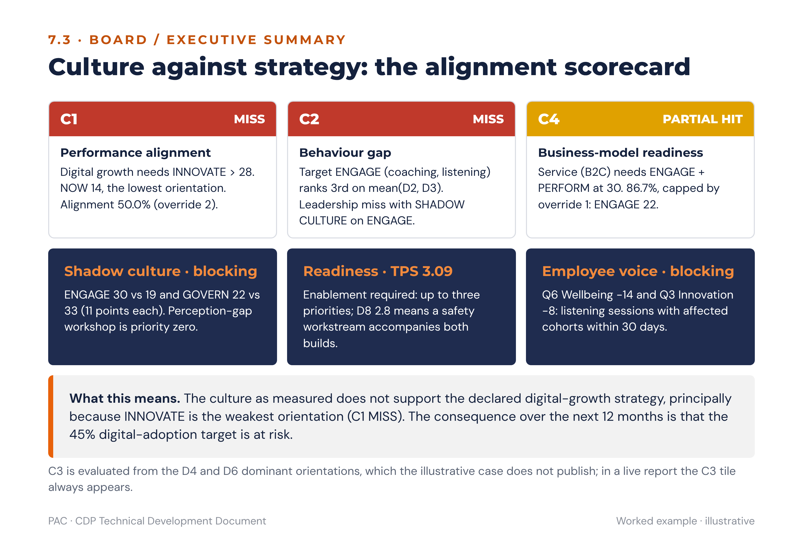
Figure 15 · Board summary layout: alignment scorecard, blocking signals and the conclusion, worked example

7.4 Organisational Culture Report
Element | Specification
Sections | 1 How to read this report · 2 Method and participation · 3 The profile: NOW, PREFERRED and the gaps · 4 Strength and congruence · 5 The four alignment checks with evidence · 6 Cohort view and the perception gap · 7 Readiness: D7, D8, D9 and the TPS · 8 The employee voice: eOS and qualitative themes · 9 Sub-cultures identified · 10 Leadership in aggregate · 11 What this means · 12 What to do next · 13 Technical appendix.
Charts | Profile pair chart; gap chart with classification bands shaded; congruence panel by dimension; cohort comparison; perception-gap chart with threshold lines; readiness panel with interpretation bands; eOS category chart with negatives marked; sub-culture heatmap.
Narrative logic | Move from description to diagnosis to consequence. Describe the profile, then test it against strategy, then state what the test implies, then name the constraint on how fast anything can change. Never present a gap without the trade-off that closing it requires.
Conclusion | Names the dominant culture, the direction of required travel, the primary misalignment and the readiness constraint, in that order.
Recommendation | The selected priorities with trade-offs named, the pre-conditions, the 30-day visible signals, and the four-level commitments.

7.5 Leader and leadership-team reports
Content is specified at 5.5 and 5.6. Three presentation rules are additional. A leader report is delivered in a facilitated conversation, never by unaccompanied email, and the platform’s default distribution therefore notifies the coach rather than releasing the document. Hard flags are stated in plain language without euphemism, because a softened integrity finding is worse than none. And the report closes on the Leader Development Plan, so that the leader’s last impression is of a commitment rather than of a verdict.

7.6 Export formats and branding
Format | Use | Rules
PDF | The released report of record. | Watermarked with tenant name, release date, practitioner name and a document reference. Page footer carries the classification line: “Proprietary and Confidential — Priority Activator Consulting”. PDFs are generated server-side from the released version and are immutable.
PowerPoint | Debrief and workshop material. | Built on the PAC deck template. One assertion per slide, stated as the slide title. Charts are native PowerPoint objects, not images, so a consultant can adjust emphasis in the room. Slide order follows 3.8 for sub-culture material and 7.3 for the executive story.
Excel | Analyst and client-analyst use. | One sheet per metric family, with segment respondent counts on every sheet and suppressed segments shown as suppressed rather than omitted. No raw response rows are ever exported, by any route, to any role.
Word | Consultant working drafts only. | Marked DRAFT — NOT FOR RELEASE in the header until a practitioner releases it.
Branding rules. Client branding appears on the cover, the running header and the action-plan outputs; PAC branding appears on every page footer with the confidentiality line. The orientation colour palette is fixed across all report types so that a reader who has seen one CDP report can read any other without relearning the chart: ENGAGE #2E86AB, INNOVATE #7B4FA0, PERFORM #E8610A, GOVERN #2E8B57. Perspective colours are fixed: NOW navy #14213D (solid), PREFERRED orange #E8610A (dashed where a line is drawn). No report, template, chart legend, axis label or footnote may name or allude to any third-party framework, instrument or brand.

8. Action Planning Module

8.1 Principle
The module exists to close the distance between a finding and a commitment. Its design principle is that the platform drafts and the humans decide: the guidance engine produces draft actions automatically so that the Action Planning Workshop spends its time on choices rather than on blank templates, but no draft becomes a commitment without a named owner, a date, a measure and an approval.

8.2 From findings to draft actions
Each selected priority generates draft actions at three levels. The level determines the scope, the owner role and the default horizon.
Level | Scope | Default owner | Generated from
Organisation-wide | Actions that change the system: performance management, promotion criteria, reward, onboarding, recognition rituals, decision rights, portfolio funding. | Urgency-tier owner from 6.7 (CEO + CHRO, CHRO + OD, or CEO + ExCo) | The priority’s orientation playbook system levers, plus the C3 system-lever set where C3 returned a PARTIAL HIT or SYSTEMIC MISS.
Sub-culture / unit | Actions for a specific department, division, location or team identified as a confirmed sub-culture or as divergent on the priority’s orientation. | The unit’s accountable leader, sponsored by the division head | The unit’s own gap classification and eOS pattern, filtered to the orientation of the parent priority.
Individual leader | Behavioural commitments in the Leader Development Plan. | The leader, with their line manager as sponsor | The leader’s 360 result: growth orientation, self–other gaps, hard flags, and the alignment score on the organisation’s BUILD orientation.
Generation logic. For each priority, the engine selects candidate actions from the orientation playbook’s action set, filters them by the horizons permitted by the readiness gates, and instantiates each with the priority’s linked finding, the affected orientation, the default owner role and a review point. Every draft is created in DRAFT status and is explicitly labelled as machine-generated until a consultant has reviewed it. The engine never assigns a named individual, a budget figure or a target value; those three fields are always human-entered, because they are commitments rather than inferences.
Mandatory companions. Every priority’s generated set must contain at least one quick win dated within 30 days and marked as the visible signal, at least one action touching a system lever in the medium-term or structural horizon, and, for every BUILD priority, one action that gives effect to the named trade-off. The engine refuses to emit a set missing any of the three.

8.3 Prioritisation logic
Draft actions are scored so that a workshop can see, rather than argue about, which to start. Three factors are rated on a 1–5 scale and combined.
priority_score = ( impact × urgency ) ÷ effort
Factor | Scale anchor 1 | Scale anchor 5 | Derivation
Impact | Affects one team; no linked KPI. | Addresses a C1 or C4 miss on a BUILD orientation with a gap ≥ 8.0 and a linked strategic KPI. | Derived by the engine from the finding: check severity, gap magnitude, number of respondents in the affected segment, and whether a strategic KPI from Setup Sections C and D is linked.
Urgency | Business-model horizon, 6–18 months. | Blocking pre-condition or strategic miss, 0–30 days. | Derived from the urgency tier at 6.7 and from any blocking flag.
Effort | One meeting and a decision. | Multi-function system redesign with budget approval and external support. | Human-entered in the workshop. The engine proposes a default from the action type and the consultant adjusts it.
Modifiers are applied after the base score, in this order:
Modifier | Effect | Rationale
Gap size | +0.5 to the impact rating where the orientation gap is ≥ 12.0 | A very large gap will not move on a modest action.
Risk flag: SHADOW CULTURE | Forces urgency to 5 and the action to priority zero | Nothing else may be announced first.
Risk flag: negative eOS category | Forces urgency to 5 for the affected cohort | The 30-day listening obligation is absolute.
Risk flag: TPS < 2.50 | Caps the permitted count and demotes all content actions below all enablement actions | Content before capacity produces initiative fatigue.
Risk flag: leader integrity or safety flag | Suspends the unit’s actions and escalates | Publishing a plan the leader cannot carry damages credibility further.
Visible signal | Floors the score at the top decile regardless of effort | Its value is symbolic, and symbolic actions are cheap and time-critical.

8.3.1 Caps on the number of actions
Level | Cap | Rule
Organisation-wide | Four strategic priorities maximum, further capped by the readiness gate; no more than six organisation-wide actions per priority. | Priority zero does not count against the cap.
Sub-culture / unit | Three actions per unit per cycle. | A unit leader with more than three culture commitments alongside an operational role will deliver none of them.
Individual leader | Three development actions per six-month cycle. | Matches the six-month 360 development-plan cycle.
Overflow | Anything above the cap is held in a visible backlog with its evidence and score, and is reported as deferred, with the reason stated. | Deferral must be visible, or the next cycle re-discovers the same finding as if it were new.

8.4 Action record structure
Field | Type | Required | Notes
action_id | identifier | Yes | System-generated.
level | enum: organisation | unit | leader | Yes | Determines permissions and dashboard routing.
objective | text | Yes | What will be different, stated as an outcome rather than an activity.
linked_finding_id | reference | Yes | The finding that justifies the action. An action without a finding cannot be created; this is what makes the plan traceable to the data.
orientation | enum: ENGAGE | INNOVATE | PERFORM | GOVERN | Yes | The orientation the action builds or moderates.
classification_at_creation | enum: BUILD | STRENGTHEN | KEEP & PROTECT | MODERATE | Yes | Snapshot, so the action remains interpretable after the next assessment changes the classification.
intervention | text | Yes | The specific thing that will be done. Drawn from the playbook action set but editable.
horizon | enum: quick win 0–3m | medium 3–12m | structural 12m+ | Yes | Constrained by the readiness gates.
is_visible_signal | boolean | Yes | At most one per priority; must be dated within 30 days.
system_lever | enum: performance management | promotion | reward | onboarding | recognition ritual | decision rights | none | Yes | “None” is permitted only on quick wins.
owner | person | Yes | Accountable for delivery. One person, never a committee.
sponsor | person | Yes | Holds the resources and removes blockers. Must be senior to the owner.
resources_budget | text + amount + currency | Yes for structural | Estimated cost and the source of funds.
start_date, end_date | date | Yes | End date must fall inside the horizon.
milestones | list of { description, due_date, status } | Yes for medium and structural | At least two for medium, at least three for structural.
kpi | text | Yes | Written to the SMART test; the platform validates that a measure, a target and a date are all present.
baseline_value, baseline_source, baseline_date | number + text + date | Yes | The value now. An action without a baseline cannot be shown to have worked.
target_value, target_date | number + date | Yes | The value committed to, and by when.
cdp_remeasure_watchlist | list of dimension / scenario / eOS references | Yes | What the next assessment will test. Populated by default from the orientation playbook watch-list.
scorecard_link | reference to a strategic scorecard objective | Yes for organisation level | Links the culture action to the organisation’s strategic scorecard objective and its KPI from Setup Sections C and D.
status | enum: draft | in review | in co-design | approved | published | in progress | under review | closed | retired | Yes | See the workflow at 8.5.
rag | enum: green | amber | red | Yes once published | Rules at 8.7.
percent_complete | integer 0–100 | Yes once published | Derived from milestone completion where milestones exist.
evidence | list of uploads with type, date, uploader | No | Required before an action may be closed.
review_points | list of dates | Yes | Defaults to 30, 90 and 180 days from start.
closure_outcome | enum: achieved | partially achieved | not achieved | superseded | Yes at closure | Drives the retire-or-adjust logic at 8.8.
audit_trail | system | Yes | Every status change, field edit, actor and timestamp.
The strategic scorecard is held in the platform as a light structure: a set of client strategic objectives, each with one or more KPIs carrying a baseline and target drawn from Setup Sections C and D, entered at setup by the Client Admin and importable from CSV. Integration with client strategy-execution systems is outside the first release. A culture action links to an objective and to a KPI. The structure is deliberately minimal — the platform is not a strategy execution system — but the link is mandatory at organisation level, because a culture action with no line to a strategic objective will not survive the first budget round.

8.5 Workflow and permissions
Step | Status transition | Who can perform it | What must be true
1. Draft | → draft | Guidance engine (automatic), PAC Consultant, Client Admin, People Leader (own level) | A linked finding exists.
2. Consultant review | draft → in review | PAC Consultant | Machine-generated drafts are triaged: kept, edited, merged or discarded. The consultant records the rationale for any discard, so the workshop can see what was considered.
3. Leadership co-design workshop | in review → in co-design | PAC Consultant (facilitates); Executive and People Leader participate | Priority zero pre-conditions identified; effort ratings entered; owners and sponsors nominated; trade-offs named.
4. Approval | in co-design → approved | Executive (organisation level); division head (unit level); line manager (leader level) | Owner, sponsor, KPI, baseline, target, dates and, for structural actions, budget are all populated. The platform blocks approval on any missing mandatory field.
5. Publish | approved → published | PAC Consultant releases; Client Admin distributes | All blocking gates for the affected orientation are recorded complete. Publication makes the action visible to its audience and starts the RAG clock.
6. Implement | published → in progress | Owner | Start date reached.
7. Review | in progress → under review | Owner submits; sponsor reviews; PAC Consultant attends the 30, 90 and 180-day checkpoints | Progress, evidence and KPI movement recorded. The review may adjust the action (8.8).
8. Close | under review → closed or retired | Sponsor closes; PAC Consultant countersigns organisation-level closure | Evidence uploaded and a closure outcome selected. Closure without evidence is blocked.
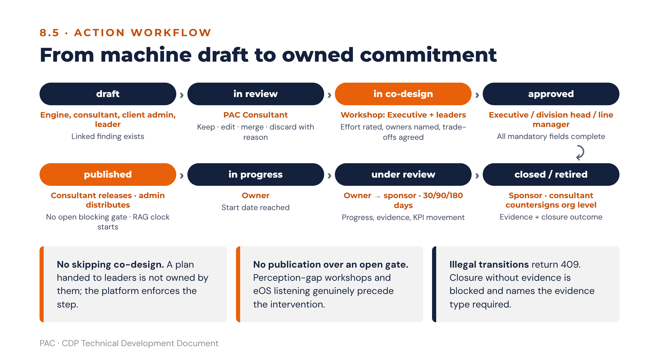
Figure 16 · Action workflow from machine draft to closure
Two workflow rules are absolute. An action may not skip co-design: PAC’s method holds that a plan handed to leaders is not owned by them, and the platform enforces the step even where a consultant would prefer to move faster. And an action may not be published while a blocking gate on its orientation is open, which means the perception-gap workshop and the eOS listening sessions genuinely precede the intervention rather than running alongside it.

8.6 Leader Development Plans
A Leader Development Plan is generated from the leader report and is tied to the team’s culture action plan, so that the leader’s personal commitments and their unit’s commitments are visibly the same programme.
Element | Rule
Number of actions | Up to three per six-month cycle.
Composition | At least one action on the growth orientation (the lowest A–D score); at least one action on the organisation’s BUILD orientation; and, where a self–other gap is BLIND SPOT tier, one action addressing it.
Form | Each action names the orientation it builds, what the leader will START, STOP or KEEP, and one visible change the team will notice within 30 days.
Support | Coaching (minimum eight sessions where the urgency tier is a behaviour gap), training, exposure or stretch assignment, named explicitly with the support owner.
Behavioural commitments | Stated observably: what a direct report would see the leader doing differently. “Be more approachable” fails the test; “hold a monthly one-to-one with each direct report, agenda set by them” passes it.
Link to the team plan | Each development action references the unit action it enables. A development plan with no link to the unit plan is flagged as disconnected.
Measurement | Re-measured at the next 360 on the specific sections addressed, and in the team’s eOS categories on the watch-list.
Review | 30, 90 and 180 days, with the line manager; the 180-day review decides whether to continue, adjust or retire each action.
Confidentiality | Visible to the leader, their line manager, their coach, the CHRO and the PAC consultant. Never used in a remuneration or disciplinary process; the platform blocks that export path.

8.7 Tracking and accountability

8.7.1 RAG rules
RAG is computed, not self-reported, and then may be overridden by the owner with a mandatory comment. Both the computed and the declared value are stored, and a persistent divergence between them is itself reported to the sponsor.
RAG | Computed rule
Green | On or ahead of the milestone schedule, and the KPI is moving towards target, and no review point is overdue.
Amber | One milestone overdue by 14 days or less, or the KPI is flat since baseline at the 90-day review, or one review point is overdue.
Red | Any milestone overdue by more than 14 days, or the KPI has moved away from target, or the end date has passed without closure, or two consecutive review points missed.

8.7.2 Reminders and escalation
Trigger | Action
7 days before a milestone or review point | Reminder to the owner.
Milestone overdue | Daily reminder to the owner for 7 days.
Overdue by 14 days | Notification to the sponsor; action moves to amber.
Overdue by 21 days, or red for two consecutive weeks | Escalation to the urgency-tier owner (CEO + CHRO for a strategic miss, CHRO + OD for a process contradiction, and so on). Appears on the executive dashboard exception list.
Red for four consecutive weeks | Escalated to the next scheduled ExCo review as a named item, with an explicit decision required: re-resource, re-scope, re-assign or retire. A red action may not simply persist.
Visible signal not delivered within 30 days | Immediate escalation to the CEO. This is treated as the most serious tracking failure in the system, because an undelivered visible signal converts a credible programme into a rhetorical one.
Evidence missing at closure request | Closure blocked; owner notified with the specific evidence type required.
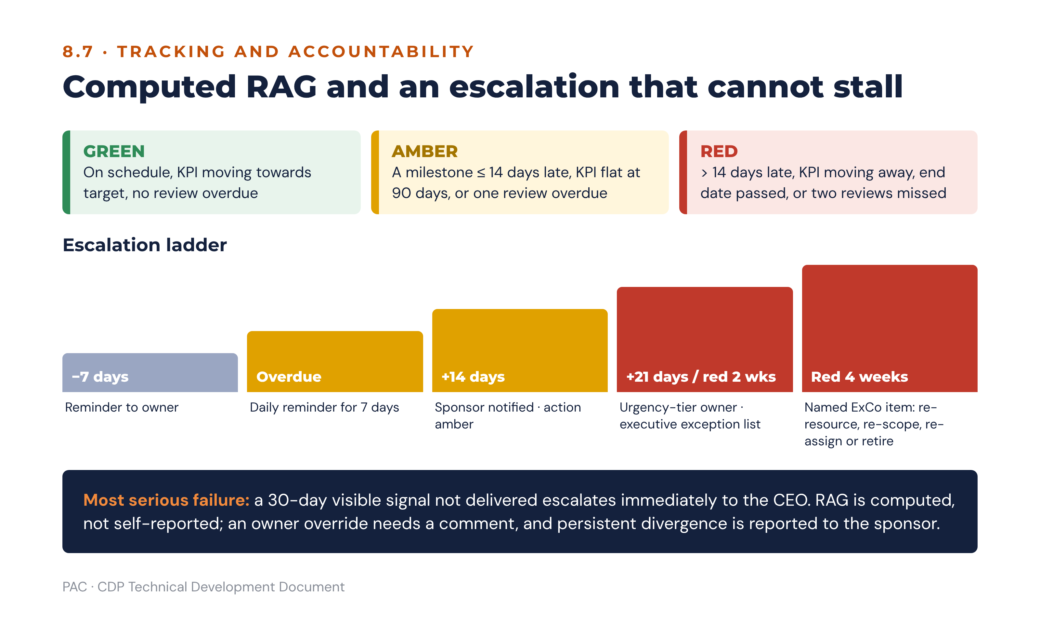
Figure 17 · Computed RAG rules and the escalation ladder

8.7.3 Dashboard per role
Role | Dashboard content
Executive | Priority-level view: four (or fewer) priorities with RAG, percent complete, the KPI trend against target, pre-condition status, and an exception list of escalated actions. One screen; no drill-down required to answer “are we moving?”.
Client Admin | All actions across all levels with filters, overdue list, evidence gaps, and the distribution and reminder log.
People Leader | Own unit’s actions and own development plan, with the unit’s culture profile and eOS alongside, so the commitments are read in the context that produced them.
PAC Consultant | Cross-client portfolio view: engagement stage, pre-condition completion, plan health, and re-assessment due dates. Plus per-client access to everything above.
Board | Quarterly extract only: the priorities, their RAG, the eOS and TPS trend, and the escalations requiring a board decision.
Respondent | Published organisational summary and the actions the organisation has committed to publicly, where the client elects to publish. Closing the loop with respondents is the single strongest driver of response rate at the next assessment.

8.8 Measuring impact
Mechanism | Specification
Pulse surveys | Short instruments drawn only from the priority’s CDP re-measurement watch-list: the named D-dimension scenarios, the named eOS categories, and nothing else. Maximum 10 items, run at 90 and 180 days, to a sample or a cohort. Pulse results are indicative and are never substituted for a full assessment score, and the platform labels them accordingly.
Re-assessment triggers | Scheduled annually as the default. Triggered earlier by any of: completion of all structural actions on a priority; a material organisational change (restructure, merger, new CEO, business-model transition going live); a pulse showing a watch-list item moving more than 0.5 on a Likert dimension or more than 15 points on an eOS category; or a board request.
Before-and-after comparison | Orientation scores, gaps, classifications, D7–D9, TPS, LRI distribution and eOS categories, compared to the baseline assessment at organisation and segment level. Comparison is blocked across an instrument major version boundary and warned across a minor one.
Attribution discipline | The platform reports movement, not causation. Where a watch-list item has moved and the linked actions were delivered, the report states both facts and their coincidence. It does not state that the action caused the movement, and the AI panel is screened for causal language (6.12.4).
Trade-off verification | Because the profile is constant-sum, a successful BUILD must show a corresponding reduction elsewhere. The platform checks whether the reduction landed on the named trade-off orientation or somewhere unintended, and reports the difference. An unintended release is one of the most useful findings a re-assessment produces.

8.8.1 Rules for adjusting or retiring an action
Condition at the 90 or 180-day review | Decision | Rationale
KPI moving towards target, milestones on schedule | Continue unchanged. | Working.
KPI flat, milestones delivered | Adjust the intervention, keep the objective. Re-rate effort and impact. | The objective is right and the mechanism is wrong. This is the most common case and must not be read as failure.
KPI flat, milestones not delivered | Adjust resourcing or ownership, keep the intervention. Escalate to the sponsor. | A delivery problem, not a design problem.
KPI moving away from target | Suspend and re-diagnose. Check for an overplay of the built orientation and for an unintended release on a KEEP & PROTECT orientation. | Culture actions can do harm; the most frequent mechanism is over-correction.
Pre-condition never completed | Retire the dependent action and re-instate the pre-condition as priority zero. | Content launched over an open gate will not hold.
Finding no longer supported by current data | Retire with outcome “superseded”, and record the assessment that superseded it. | The organisation has moved. Retiring cleanly is not a failure and must be recorded as such.
Owner or sponsor has left the organisation | Re-assign within 14 days or retire. | An unowned action is not an action.
Two consecutive adjustments with no KPI movement | Retire with outcome “not achieved” and return the finding to the backlog for the next planning cycle, with the failed approaches recorded. | Recording what did not work is the most valuable thing an organisation carries into the next cycle; PAC’s method requires lessons from past change efforts to be applied systematically.

8.9 Action-plan templates by scenario
Each scenario in the library at 6.8 carries a template: the objective pattern, the mandatory actions, the visible signal, the KPI set and the watch-list. Templates are starting points that the co-design workshop adapts; the mandatory column is what the engine will insist on.
Scenario | Objective pattern | Mandatory actions | KPI set | Visible signal
SC-01 Delivery without belonging | Sustain delivery while restoring the conditions that make it repeatable. | Coach-first leadership programme; wellbeing investment with a named budget; moderate PERFORM by removing one target-only review ritual; listening sessions on the negative eOS categories. | Voluntary attrition; eOS Q4 and Q6; internal fill-rate for key roles; delivery KPI held flat as a guardrail. | CEO publicly recognises a manager for developing talent at an all-staff forum.
SC-02 Order without ideas | Create protected space to experiment without loosening the controls that matter. | Remove at least two approval layers below a defined value; ring-fenced experimentation budget; innovation objective in managers’ scorecards; digital adoption plan where D7 ≤ 3.0. | Idea-to-launch cycle time; pilots reaching a go/stop decision on schedule; eOS Q3; audit findings held flat as a guardrail. | Fix one visible process bottleneck staff complain about and communicate what changed.
SC-03 Ideas without delivery | Convert creative energy into delivered outcomes without extinguishing it. | Portfolio stop rule and single portfolio owner; phase-gate review; documentation standard; adoption rather than launch counted as success. | Share of revenue or impact from offerings launched in the last three years; adoption rate; on-time gate decisions. | Publish a simple scoreboard and publicly recognise a delivery win against it.
SC-04 Care without accountability | Hold standards as an expression of care rather than as its opposite. | Performance-conversation capability for all managers; objective-setting rigour; differentiation in reward; a visible scoreboard. | Attainment against agreed targets; distribution of performance ratings; eOS Q8; attrition of high performers held flat as a guardrail. | Publish the team scoreboard and recognise a delivery win against it.
SC-05 Shadow culture | Close the distance between what leaders believe and what staff experience. | Facilitated perception-gap workshop before anything else; unfiltered upward listening route; middle-manager sensing routine; re-measure the gap at the next pulse. | Perception gap per orientation; eOS Q5; participation in listening routes. | Executives publish, unedited, the three things staff said that they had not expected.
SC-06 Sub-culture divergence | Decide explicitly whether to align the unit, protect it, or learn from it. | Unit-level profile debrief with the unit’s own leadership; boundary-working agreement with adjacent units; unit plan with three actions maximum. | Unit SDI at re-assessment; unit eOS Index; the unit’s own operational KPI. | The unit’s leader names publicly which of the organisation’s commitments the unit will adopt and which it will do differently, and why.
SC-07 Leader misaligned with a healthy team | Protect the team while the leadership question is addressed. | Leader development plan with a named coach; sponsor one level up takes the unit’s culture priority; 360 re-measure at 180 days; retention conversations with key team members. | Leader fit index; self–other gap on the BUILD section; team eOS differential; team attrition. | The leader commits publicly to one observable behaviour change their team will see within 30 days.
SC-08 Capable leader, constrained unit | Remove the constraint rather than develop the leader. | Decision-rights review; resourcing review; dependency mapping to adjacent units; parent-unit culture check. | Team eOS differential; cycle time on the blocked process; resourcing against plan. | The constraint is named publicly by the sponsor, with a date for its removal.
SC-09 Low transformation readiness | Build the capacity to change before naming what to change. | Change infrastructure: sponsorship, resourcing, clarity of expected behaviours, lessons-learned discipline; psychological safety workstream where D8 ≤ 3.0; one or two priorities maximum. | D8; D9; TPS at re-assessment; completion of the previous change programme’s formal closure. | Close out, publicly and honestly, the last change programme that was never formally ended.
SC-10 Systems fighting the strategy | Stop paying for the behaviour the organisation says it wants to stop. | HR systems redesign within 90 days across performance management, promotion, incentives and onboarding; change one recognition ritual within 30 days. | Promotion decisions against the stated criteria; incentive mix; eOS Q7; D6 at re-assessment. | Change one visible recognition ritual and explain the change in the same announcement.
SC-11 Everything at once | Make the strategic choice the profile has avoided. | Return to Setup Sections B–D with the executive team; select one orientation as the primary build and name its trade-off; defer the rest visibly to the backlog. | Alignment percentage on C1; number of active priorities; gap on the selected orientation. | Publish the deferred list, so that what is not being done this year is as visible as what is.
SC-12 Aligned and under-recognised | Protect what is working against growth and succession. | Document the rituals that carry the profile; write them into onboarding and promotion criteria; record the KEEP & PROTECT orientations in Setup Section G5. | Profile stability at re-assessment; congruence; eOS Index; new-joiner eOS at 90 days. | Name publicly the practice the organisation will not change, and why.

8.10 Outputs
Output | Content | Audience and cadence
Action plan report | The priority summary table (one row per priority: orientation, gap, classification, signal, owner, urgency tier, key deliverable and date), a detail card per priority, the four-level commitment matrix, the readiness gates applied, the trade-offs agreed, the keep-and-protect list, and the deferred backlog. | ExCo and CHRO at approval, then reissued at each 90-day review.
Gantt / timeline | All actions across the three horizons on one timeline, with milestones, review points, the 30-day visible signals marked distinctly, and pre-conditions shown as gates that later work depends on. | Programme governance, monthly.
One-page commitment charter | Per priority and per unit: the objective, the three to five behaviours that will change, what the organisation will stop, the owner and sponsor by name, the KPI with baseline and target, and the review dates. Designed to be displayed, not filed. | Every leader and team, published at launch.
Board progress report | Priorities with RAG, KPI movement against target, eOS and TPS trend against baseline, pre-condition completion, escalations requiring a board decision, and the next re-assessment date. | Board, quarterly.
ExCo progress report | The above plus action-level detail, overdue and escalated items, evidence status, and the adjust-or-retire decisions taken since the last report. | ExCo, monthly.
Manager progress report | The manager’s own unit actions and development plan with RAG and next milestone, alongside the unit’s culture and eOS position. | People Leaders, monthly.
The templates behind the action plan report, the priority cards and the commitment charters, with the source of every field, are specified at 11.12. The playbook content from which draft actions, KPIs, visible signals and watch-lists are drawn is at 11.7–11.10.

9. Advisory Roadmap for Institutions

9.1 The engagement sequence
The CDP runs as an annual cycle, not a one-off diagnostic. Culture is managed, not fixed once. The platform models the engagement as a state machine, so a client’s stage is always known and the next action always has an owner.
Stage | What happens | Owner | Platform artefacts
1. Set up and diagnose | Pre-Assessment Executive Workshop completes Setup Sections A–I; the org graph and leader mapping are validated; the survey is configured and launched to all cohorts. | PAC Consultant + Client Admin | Setup record, cohort design, launch approval, response-rate monitor.
2. Assess | The instrument runs for at least ten working days with the reminder schedule; data quality is monitored live. | PAC Consultant | Response and exclusion log.
3. Report | Scoring, the four alignment checks, readiness, sub-culture detection, leadership aggregation, findings and draft narrative. | PAC Consultant | Organisational report, sub-culture reports, leader reports, leadership-team report.
4. Debrief | Results interpreted with the executive team against strategy, KPIs, customers, competitors and regulation. Pre-conditions identified. Where a SHADOW CULTURE flag exists, the perception-gap workshop happens here, before anything else. | PAC Consultant + CEO + ExCo | Debrief pack, pre-condition register.
5. Co-design interventions | The Action Planning Workshop, typically one to one and a half days: up to four priorities agreed, trade-offs named, four-level commitments drafted, effort rated, owners and sponsors nominated. | PAC Consultant facilitates; ExCo decides | Priority cards, commitment matrix, draft action set.
6. Action planning and approval | Actions completed to the mandatory-field standard, approved, and published with the 30-day visible signals scheduled. | CHRO + owners | Action plan report, commitment charters, timeline.
7. Implement | Delivery against milestones; cascade sessions translate the organisation-level plan into unit commitments. | Owners and sponsors | Dashboards, reminders, escalations, evidence.
8. Coach leaders | Leader Development Plans run; coaching programmes deliver (minimum eight sessions where the urgency tier is a behaviour gap); 360 re-measure at 180 days. | CHRO + coaches | Development plans, coaching logs, 360 re-measure.
9. Pulse re-assessment | Watch-list pulses at 90 and 180 days, maximum ten items, to the affected cohorts. | PAC Consultant + CHRO | Pulse report, adjust-or-retire decisions.
10. Measure change | Full CDP re-administration at 12 months. Gaps, TPS, LRI distribution and eOS compared with baseline; the trade-off verification at 8.8 run; the plan refreshed. | PAC + CHRO | Trend report, refreshed plan, next-cycle setup.
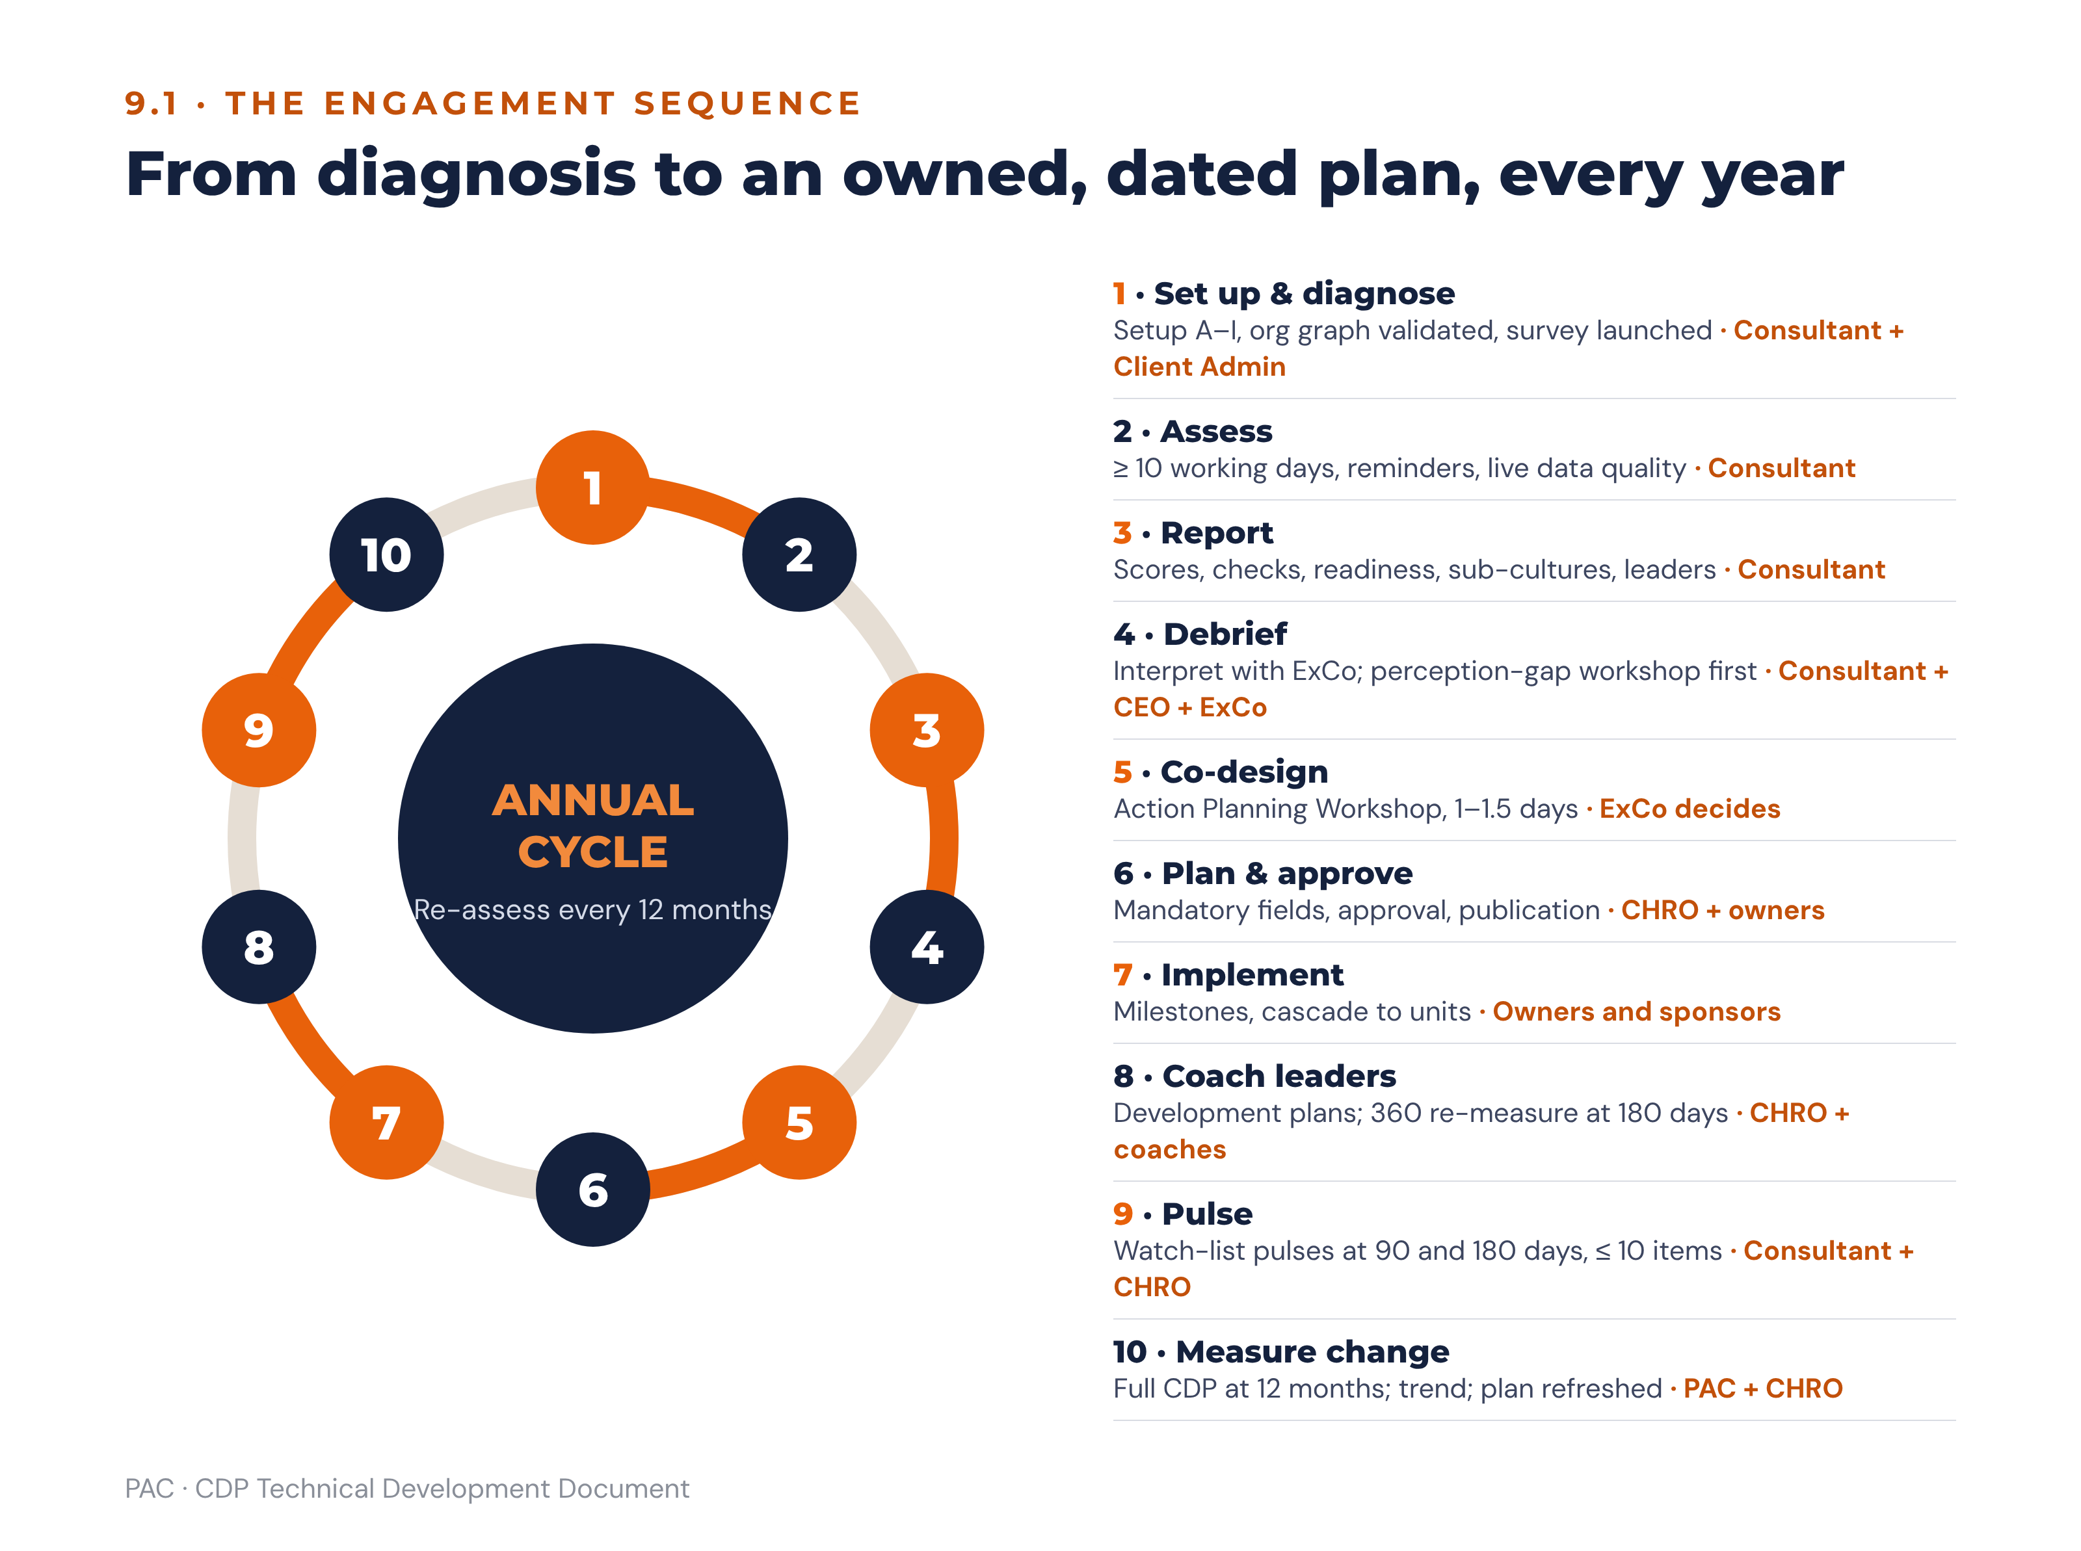
Figure 18 · The annual engagement cycle

9.2 Cadence
Horizon | Focus | Typical activities | Owner
0–30 days | Pre-conditions and signal | Perception-gap workshop; eOS listening sessions; one visible recognition-ritual change; publish the plan. | CEO + CHRO
0–90 days | Leadership behaviour | CDP-anchored 360s; coaching programme (minimum eight sessions); culture stewardship KPI in leaders’ reviews; at least one cascade session per division. | CHRO + people managers
1–6 months | Systems and processes | HR systems audit and redesign: performance management, promotion, incentives, onboarding. | CHRO + OD team
6–18 months | Business-model readiness and the transformation arc | Multi-orientation shift for any C4 miss, run as Foundation (months 0–3) → Activation (months 4–12) → Embedding (years 2–3). | CEO + ExCo
12 months | Re-assessment | Full CDP re-administration; compare gaps, TPS and eOS with baseline; refresh the plan. | PAC + CHRO

9.3 Review questions at every checkpoint
These five questions are asked at every 30, 90 and 180-day review, and the platform records the answers against the priority:
- Is each priority on track against its deliverable and date, and if not, what is blocked and who will unblock it?
- Are the business KPIs in the playbook metrics moving in the expected direction?
- Do the pulse checks on the watch-list items show movement?
- Has anything we said we would stop quietly returned, and is anything we promised to keep and protect under threat?
- Are the Strategy, Practice and Leadership lenses converging on the same orientation?

9.4 Governance of the change programme
Body / role | Accountability | Cadence | Decision rights
Board | Holds the CEO accountable for culture as a strategic risk. Approves the programme’s place in the strategic agenda and receives the trend in eOS and TPS. | Quarterly | Approves the programme mandate and any escalation requiring re-resourcing at strategic scale. Does not own actions.
CEO | Sponsor of the whole programme. Owns priority zero and any strategic miss. Personally delivers or hosts the 30-day visible signal. | Monthly | Approves priorities and trade-offs; resolves conflicts between priorities and operational demands. The CEO’s visible participation is the single strongest predictor of whether the programme is believed.
ExCo | Collective owner of the four priorities. Each priority has a named ExCo sponsor. | Monthly | Approves organisation-level actions; takes adjust-or-retire decisions; resolves cross-functional blockers.
CHRO / HR | Programme management. Owns the behaviour-gap and process-contradiction tiers, the HR systems redesign, the coaching programme and the action-plan administration. | Weekly | Approves unit-level actions; owns the cadence, the evidence standard and the reminder and escalation discipline.
OD / People team | Delivery of the systems redesign and the capability build. | Weekly | Designs interventions within the approved priority; does not change priorities.
Line leaders | Own their unit’s plan and their own development plan. Deliver the behaviour change their teams experience. | Monthly | Approve team-level commitments; escalate what they cannot resolve. This is where the programme either happens or does not.
PAC | Method integrity, facilitation, interpretation, and the challenge function. Presents all reports; countersigns organisation-level closure. | At each stage gate | Refuses release of a report without a conclusion and a recommendation; refuses publication of content over an open blocking gate.
Advisory meaning. The governance design answers the commonest failure mode in culture work, which is that the programme is delegated to HR and interpreted by staff as an HR initiative rather than a strategic one. Three features prevent that reading: the CEO owns priority zero and delivers the visible signal personally, every priority has an ExCo sponsor by name, and the board receives the eOS and TPS trend as a standing item. Culture findings must never be used to make decisions about specific individuals, and the governance minutes record that constraint at the first meeting of the cycle.

10. Build Artefacts

10.1 Database schema
Relational core. Primary keys are surrogate identifiers throughout. Every table carries created_at, created_by, updated_at, updated_by. Tenant scoping is on every table that holds client data.
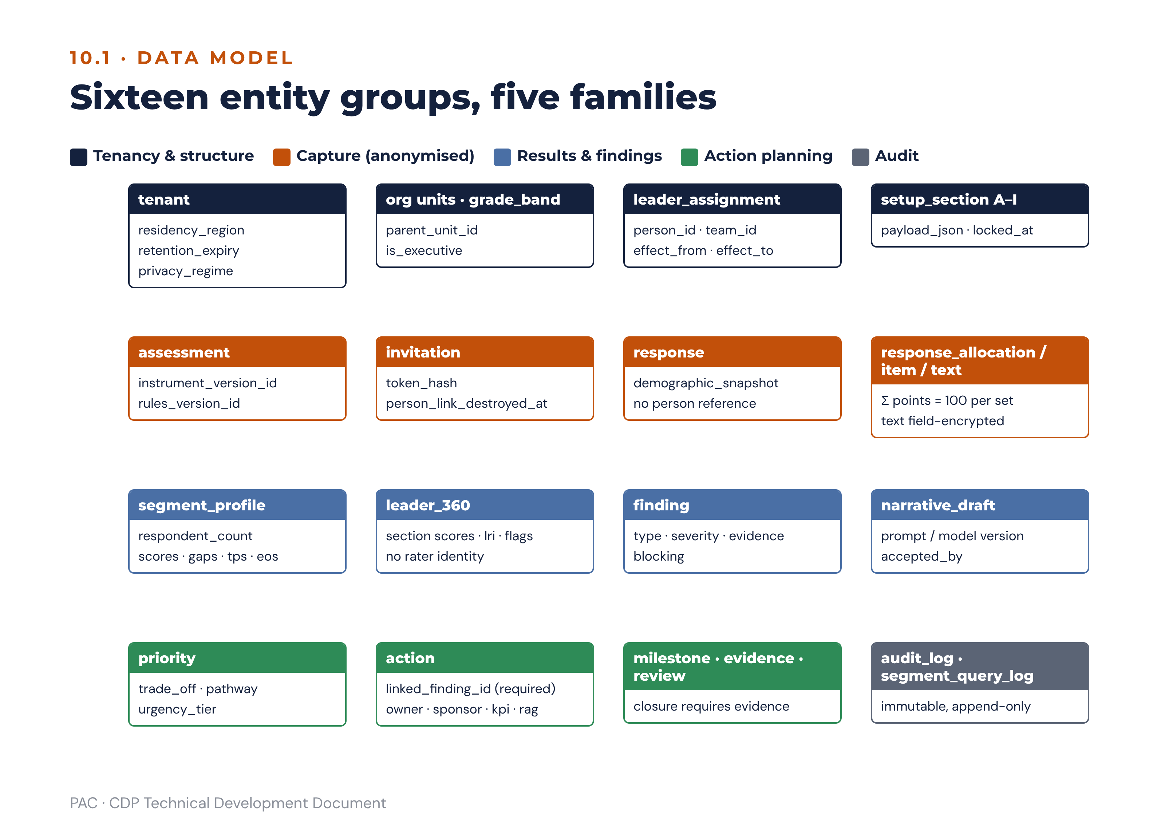
Figure 19 · Data model: entity groups by family
Table | Key fields | Relationships
tenant | tenant_id, name, sector, maturity_stage, residency_region, retention_expiry, branding_pack_id, governing_privacy_regime, chro_designate_id, dpo_signoff_at | Root of all client data.
division / department / location / team | unit_id, tenant_id, parent_unit_id, type, name, anonymity_rollup_target | Self-referencing hierarchy; team is the leaf.
grade_band | grade_id, tenant_id, name, rank_order, is_executive | is_executive drives the perception-gap cohorts.
person_of_record | person_id, tenant_id, unit_id, grade_id, employment_status | Never joined to a response row.
leader_assignment | assignment_id, person_id, team_id, effect_from, effect_to | One accountable leader per team per period.
coach_assignment | coach_assignment_id, tenant_id, coach_user_id, assignment_id, effect_from, effect_to | Scopes coach access to one leader for one period (1.3.2).
demographic_attribute / value | attribute_id, tenant_id, name, is_sensitive; value_id, attribute_id, label | Closed lists only.
setup_section | setup_id, tenant_id, section_code (A–I), workshop_date, participants, payload_json, locked_at | Section I lock blocks launch changes.
strategic_objective / strategic_kpi | objective_id, tenant_id, description; kpi_id, objective_id, name, unit, baseline_value, baseline_date, target_12m, target_3y | The strategic scorecard (8.4).
instrument_version / item / scenario / scenario_statement | version_id, status; item_id, version_id, dimension, sequence, scale_type, canonical_text; scenario_id, dimension, sequence; statement_id, scenario_id, orientation, text | Immutable once published.
item_locale_variant | variant_id, item_id, locale, text, back_translation_ref, reconciled_by, reconciled_at | Publishable only when reconciled.
assessment | assessment_id, tenant_id, instrument_version_id, rules_version_id, opened_at, closed_at, status | Scoring is pinned to both versions.
invitation | invitation_id, assessment_id, token_hash, demographic_snapshot_json, sent_at, submitted_at, person_link_destroyed_at | The person link is destroyed at submission.
response | response_id, assessment_id, demographic_snapshot_json, language, completion_state, duration_seconds, quality_flags_json | No person reference.
response_allocation | response_id, scenario_id, perspective, orientation, points | Constraint: points ≥ 0 and the four rows per (response, scenario, perspective) sum to 100.
response_item | response_id, item_id, value | D7–D9 and eOS.
response_text | response_id, question_code, encrypted_text | Field-encrypted.
segment_profile | profile_id, assessment_id, segment_definition_json, respondent_count, orientation_scores_json, gaps_json, d7, d8, d9, tps, eos_json, strength, congruence_json | Pre-aggregated; suppression evaluated on respondent_count.
leader_360 / leader_360_rating | result_id, assessment_id, assignment_id, self_section_scores_json, rater_group_scores_json, lri, flags_json; rating_id, result_id, rater_group, item_id, value | Rater identity is never stored against a rating.
finding | finding_id, assessment_id, type, severity, orientation, segment_definition_json, evidence_json, scenario_id, blocking | Every action must reference one.
priority | priority_id, assessment_id, orientation, classification, gap, trade_off_orientation, pathway, stepping_stone, urgency_tier, owner_role, sequence | Maximum four plus priority zero.
action | See the field list at 8.4 | Belongs to a priority and references a finding.
milestone / evidence / review_point | milestone_id, action_id, description, due_date, status; evidence_id, action_id, type, uploaded_by, uploaded_at, file_ref; review_id, action_id, due_date, completed_at, outcome_json | Closure requires evidence.
leader_development_plan / development_action | plan_id, result_id, cycle_start, cycle_end; dev_action_id, plan_id, orientation, start_stop_keep, visible_change_30d, support, linked_action_id | Linked to the unit action it enables.
pulse / pulse_response | pulse_id, priority_id, item_refs_json, run_at; pulse_response_id, pulse_id, demographic_snapshot_json, values_json | Maximum ten items.
narrative_draft | draft_id, report_id, prompt_version, model_version, payload_hash, generated_json, accepted_by, accepted_at | Reconstructable release record.
reference_library (see 12.9.1) | ref_id, rules_version_id, orientation, element_type (profile, matrix, metric, candidate_action, lever, signal, watchlist), level, payload_json | The Part B playbook content, versioned with the rules (11.1).
audit_log | log_id, tenant_id, actor_id, action, object_type, object_id, payload_hash, at | Immutable, append-only.
segment_query_log | query_id, tenant_id, actor_id, predicates_json, resolved_count, suppression_outcome, at | Triangulation detection (3.6).

10.2 API endpoints
Method and path | Purpose | Notes
POST /v1/tenants | Create a tenant. | Super Admin only.
PUT /v1/tenants/{id}/org-graph | Bulk upsert the structure and leader assignments. | Returns the mapping validation report; a failed validation returns 422 with the specific defects.
GET / PUT /v1/tenants/{id}/setup/{section} | Read and write setup sections A–I. | PUT rejected once Section I is locked.
POST /v1/assessments | Create an assessment against an instrument and rules version. | Consultant only.
POST /v1/assessments/{id}/launch | Validate and launch. | 422 if the org graph, Section I lock, consent text, DPO sign-off or cohort floors fail pre-flight.
GET /v1/assessments/{id}/survey?token= | Fetch the respondent’s instrument in their chosen locale. | No authentication other than the single-use token.
PUT /v1/assessments/{id}/response | Save a draft or submit. | Server-side constant-sum revalidation; destroys the person link on submit.
POST /v1/assessments/{id}/score | Run the scoring service. | Idempotent. Returns the full score object; re-running must return an identical payload.
GET /v1/assessments/{id}/segments?predicates= | Segment profile with suppression applied. | Returns 409 with reason “below reporting threshold” rather than an empty payload. Logs the query.
POST /v1/assessments/{id}/evaluate | Run the rules engine. | Returns findings, flags, gates, priorities and matched scenarios.
GET /v1/assessments/{id}/findings | List findings. | Filterable by type, severity, orientation and segment.
POST /v1/reports | Generate a report of a given type and audience. | Creates a draft; does not release.
POST /v1/reports/{id}/narrative | Request AI draft narrative. | Findings payload only; returns the fixed JSON contract.
POST /v1/reports/{id}/release | Release to the audience. | Consultant only. 422 if “what this means” or “what to do next” is empty.
GET /v1/reports/{id}/export?format=pdf|pptx|xlsx | Export a released report. | Blocked for unreleased reports and for raw response data by any route.
POST /v1/actions | Create a draft action. | 422 without linked_finding_id.
PATCH /v1/actions/{id} | Update fields or status. | Status transitions validated against 8.5; 409 on an illegal transition.
POST /v1/actions/{id}/evidence | Upload evidence. | Required before closure.
GET /v1/dashboards/{role} | Role-shaped dashboard payload. | Filtered server-side by the actor’s scope.
POST /v1/pulses | Create and run a pulse. | 422 if item count exceeds ten or any item is outside the priority’s watch-list.
GET /v1/trends?metric=&segment= | Cross-cycle trend. | Warns on a minor instrument version change; 409 across a major version.

10.3 Sample JSON

10.3.1 Scored assessment (abridged)
{
"assessment_id": "asm_7f31",
"instrument_version": "1.1",
"rules_version": "2.0",
"respondents": { "invited": 650, "submitted": 487, "complete": 441,
"excluded": 12, "response_rate": 0.749 },
"orientation_scores": {
"now": { "ENGAGE": 22.0, "INNOVATE": 14.0, "PERFORM": 34.0, "GOVERN": 30.0 },
"preferred": { "ENGAGE": 31.0, "INNOVATE": 25.0, "PERFORM": 28.0, "GOVERN": 16.0 },
"gap": { "ENGAGE": 9.0, "INNOVATE": 11.0, "PERFORM": -6.0, "GOVERN": -14.0 }
},
"classification": { "ENGAGE": "BUILD", "INNOVATE": "BUILD",
"PERFORM": "MODERATE", "GOVERN": "MODERATE" },
"significant": { "ENGAGE": true, "INNOVATE": true, "PERFORM": false, "GOVERN": true },
"dominant": "PERFORM", "secondary": "GOVERN",
"culture_strength": 9.0, "strength_band": "MODERATE",
"congruence": { "dimension_pct": 66.7, "band": "MODERATELY_CONGRUENT",
"lens": { "strategy": "PERFORM", "practice": "GOVERN",
"leadership": "PERFORM", "agreement": "2_of_3" } },
"cohorts": {
"executive": { "n": 11, "now": { "ENGAGE": 30.0, "INNOVATE": 16.0, "PERFORM": 32.0, "GOVERN": 22.0 } },
"staff": { "n": 430, "now": { "ENGAGE": 19.0, "INNOVATE": 13.0, "PERFORM": 35.0, "GOVERN": 33.0 } }
},
"perception_gap": { "ENGAGE": 11.0, "INNOVATE": 3.0, "PERFORM": 3.0, "GOVERN": 11.0 },
"perception_flags": { "ENGAGE": "SHADOW_CULTURE", "GOVERN": "SHADOW_CULTURE" },
"readiness": {
"d7": 3.2, "d8": 2.8, "d9": 3.1,
"leadership_alignment": {
"value": 3.40, "coverage": 0.0,
"lri_weighted": null, "la_instrument": 3.40,
"target_orientation": "ENGAGE", "d2_now_target": 18.0, "threshold": 30
},
"tps": 3.09, "tps_unrounded": 3.085, "tps_band": "ENABLEMENT_REQUIRED",
"tps_provisional": true, "max_priorities": 3
},
"eos": { "q1": 18, "q2": 9, "q3": -8, "q4": 6, "q5": 11,
"q6": -14, "q7": 21, "q8": 14, "index": 7.1 }
}

10.3.2 Finding and generated action (abridged)
{
"finding_id": "fnd_0042",
"type": "C1_PERFORMANCE_ALIGNMENT",
"verdict": "MISS",
"alignment_pct": 50.0,
"orientation": "INNOVATE",
"severity": "CRITICAL",
"blocking": false,
"scenario_id": null,
"risk_hypothesis_source": "library: INNOVATE risk and hypothesis entries",
"evidence": {
"required_orientation": "INNOVATE", "threshold": 28,
"now": 14.0, "is_lowest_orientation": true,
"override_applied": "OVERRIDE_2_WEAKEST_ORIENTATION",
"setup_reference": "Section B: digital channel growth"
},
"diagnosis": "The digital growth strategy requires INNOVATE above 28; INNOVATE is the lowest NOW score.",
"risks": ["Loss of relevance as the model shifts",
"Slow product and service cycles",
"Talent loss to competitors with more latitude"],
"hypotheses": ["How many approval layers stand between an idea and a pilot?",
"Is failure punished informally where it is permitted formally?",
"Does the budget hold any unallocated experimentation capacity?"]
}
{
"action_id": "act_0117",
"level": "organisation",
"linked_finding_id": "fnd_0042",
"orientation": "INNOVATE",
"classification_at_creation": "BUILD",
"objective": "Create protected space to experiment without loosening the controls that matter.",
"intervention": "Run three 90-day customer-journey innovation sprints with a ring-fenced budget, and remove the requirement for a full business case before a pilot.",
"horizon": "medium_3_12m",
"is_visible_signal": false,
"system_lever": "decision rights",
"reference_library_id": "ref_INNOVATE_candidate_07",
"owner": null, "sponsor": null,
"status": "draft", "generated_by": "rules_engine",
"priority_score": { "impact": 5, "urgency": 4, "effort": 3, "score": 6.67 },
"kpi": "Digital channel adoption, from 28% to 45% within 12 months",
"baseline_value": 28, "baseline_source": "Setup Section C",
"target_value": 45, "target_date": "2027-09-30",
"cdp_remeasure_watchlist": ["D1 S3", "D2 S1", "D5 S1", "D5 S3", "D7", "D8", "eOS Q3"],
"scorecard_link": { "objective_id": "obj_02", "kpi_id": "kpi_07" },
"review_points": ["+30d", "+90d", "+180d"]
}
Owner and sponsor are null because the engine never assigns a named person, a budget or a target value on its own (8.2); the KPI, baseline and target shown come from Setup Sections C and D and are confirmed in the co-design workshop.

10.4 Formula pseudo-code
All arithmetic uses decimal types with half-up rounding at the presentation step (2.4).
orientation_score(o, persp, cohort) =
SUM(alloc[o][d][s][persp][r] for d in 1..6, s in 1..3, r in cohort) / (18 * COUNT(cohort))
gap(o) = orientation_score(o, PREFERRED) - orientation_score(o, NOW)
culture_strength = orientation_score(argmax(NOW), NOW) - 25
dimension_congruence = COUNT(d in 1..6 WHERE argmax(NOW[d]) == argmax(NOW)) / 6 * 100
likert_dimension(D) = MEAN(value of the 12 items of D over valid responses)
eos_category(q) = (COUNT(v >= 9) - COUNT(v <= 6)) / COUNT(valid) * 100
eos_index = MEAN(eos_category(q) for q in 1..8)
coverage = SUM(headcount_led[l] for l WHERE has_valid_360[l])
/ SUM(headcount_led[l] for all accountable leaders)
lri_weighted = SUM(lri[l] * headcount_led[l] for l WHERE has_valid_360[l])
/ SUM(headcount_led[l] for l WHERE has_valid_360[l])
la_instrument = 1 + 4 * MIN(1, d2_now[target] / threshold(target))
leadership_alignment = coverage * lri_weighted + (1 - coverage) * la_instrument
# coverage == 0 -> la_instrument only; lri_weighted is undefined and unused
# coverage < 0.60 -> TPS labelled provisional (presentation only, never a gate input)
tps = ROUND_HALF_UP(0.35*d9 + 0.30*d8 + 0.20*leadership_alignment + 0.15*d7, 2)
section_avg(x) = section_total(x) / item_count(x)
lri = 0.35*section_avg(H) + 0.30*section_avg(F)
+ 0.20*section_avg(primary_build_section) + 0.15*section_avg(G)
self_other_gap(x) = section_avg_self(x) - section_avg_other(x)
sdi(seg) = SUM(ABS(NOW_seg[o] - NOW_org[o]) for o in 4) / 2
leader_profile(o) = section_avg(o) / SUM(section_avg(A..D)) * 100
fit_index = 100 - SUM(ABS(leader_profile[o] - NOW_team[o]) for o in 4) / 2
perception_gap(o) = ABS(NOW_exec[o] - NOW_staff[o])
sub_alignment(r) = MIN(100, 100 * NOW[r] / threshold(r))
alignment_pct = MEAN(sub_alignment(r) for r in required)
behaviour_gap_points = mean(D2, D3)_NOW[dominant] - mean(D2, D3)_NOW[target]
priority_score = (impact * urgency) / effort

10.5 Unit tests and expected outputs
ID | Test | Input | Expected output
UT-01 | Constant-sum rejection | A scenario with allocations 30/30/30/20 | 422; response not persisted
UT-02 | Constant-sum acceptance | 40/30/20/10 | Accepted; sums to 100
UT-03 | Gaps sum to zero | Worked-example NOW and PREFERRED profiles | +9, +11, −6, −14; sum = 0 exactly
UT-04 | Gap classification boundaries | Gaps of 8.0, 7.99, 4.0, 3.99, −3.99, −4.0, −8.0 | BUILD, STRENGTHEN, STRENGTHEN, KEEP & PROTECT, KEEP & PROTECT, MODERATE, MODERATE + significant
UT-05 | Culture strength | Dominant NOW = 34.0 | 9.0; band MODERATE
UT-06 | Dimension congruence | 4 of 6 dimensions dominant on PERFORM | 66.7%; band MODERATELY_CONGRUENT
UT-07 | Shared dominance | NOW: PERFORM 30.4, GOVERN 30.0 | Shared dominance reported; no single dominant orientation returned
UT-08 | eOS category | 100 valid: 30 at 9–10, 25 at 7–8, 45 at 0–6 | (30 − 45) = −15; flagged ENGAGEMENT_MISS, blocking
UT-09 | eOS index | Categories 18, 9, −8, 6, 11, −14, 21, 14 | 7.125, reported 7.1
UT-10 | TPS | d9 3.1, d8 2.8, la 3.4, d7 3.2 | 3.085 → 3.09; band ENABLEMENT_REQUIRED; max_priorities = 3
UT-11 | TPS band boundaries | 2.49, 2.50, 3.49, 3.50, 3.99, 4.00 | HIGH_RISK, ENABLEMENT, ENABLEMENT, TARGETED, TARGETED, STRONG
UT-12 | TPS weight assertion | Weight vector | Sums to 1.00; any other vector raises a configuration error
UT-13 | Leadership alignment blend | coverage 0.42, lri_weighted 3.25, D2 NOW target 18.0, threshold 30 | la_instrument = 1 + 4 × (18.0/30) = 3.40; leadership_alignment = 0.42 × 3.25 + 0.58 × 3.40 = 3.337, reported 3.34; coverage 42% displayed; TPS labelled provisional
UT-14 | C1 verdict (worked example) | Required INNOVATE, threshold 28, NOW 14 (lowest) | pct 50.0; verdict MISS; override 2 recorded
UT-15 | C4 verdict (worked example) | Required ENGAGE 30 / PERFORM 30; NOW 22 / 34 | pct 86.7; verdict PARTIAL HIT via override 1
UT-16 | C4 capping | Required PERFORM only, threshold 30, NOW 45 | sub_alignment capped at 100.0; pct 100.0; verdict HIT
UT-17 | C4 transition supersession | Business model = transition; NOW 22/14/34/30 | Requirement = all four at 24; pct = mean(91.7, 58.3, 100, 100) = 87.5; ENGAGE and INNOVATE do not exceed 24 → override 1 caps at PARTIAL HIT; override 2 not applied
UT-18 | C2 rank verdict | Target ENGAGE ranked 3rd on mean(D2, D3) | MISS (Leadership)
UT-19 | C3 systemic miss | D4 dominant PERFORM (MODERATE), D6 dominant GOVERN (MODERATE) | SYSTEMIC MISS; HR systems redesign within 90 days
UT-20 | Perception gap bands | Gaps of 5.0, 5.1, 7.0, 7.1 | None, WATCH, WATCH, SHADOW CULTURE (blocking)
UT-21 | Perception gap cohort floor | Executive cohort n = 4 | Gap not computed; report states the reason; no flag raised
UT-22 | Priority cap | Four BUILD or STRENGTHEN candidates, TPS 3.09, one blocking flag | Priority zero created outside the cap; three priorities selected (cap 3); fourth deferred to the backlog with reason “deferred on readiness grounds”
UT-23 | Build without release | All selected priorities are BUILD, no negative gap available | PlanIncoherent raised; no plan emitted
UT-24 | Diagonal stepping stone | Dominant PERFORM, target ENGAGE, TPS 3.09 | Pathway PERFORM→ENGAGE, diagonal, high difficulty; stepping stone = GOVERN (30.0 > INNOVATE 14.0)
UT-25 | Adjacent pathway | Dominant PERFORM, target INNOVATE | Adjacent (outward pole); no stepping stone; narrative “tomorrow’s targets depend on today’s experiments”
UT-26 | Blocking gate on publication | SHADOW CULTURE on ENGAGE open; ENGAGE action published | 409; publication refused until the perception-gap workshop is recorded complete
UT-27 | Suppression: primary floor | Segment n = 4 | 409 “below reporting threshold”; query logged
UT-28 | Suppression: combination floor | Department n = 30, and Department × Female n = 3 | 409 on the combination; the department figure still returned
UT-29 | Suppression: differencing | Department n = 22, Team A n = 18, Team B n = 4 | Both Team A and Team B suppressed; rollup to department
UT-30 | 360 rater-group floor | Peers n = 2 | Peers merged into “all others”; no peer breakdown published
UT-31 | LRI | H 3.6, F 3.2, build-section avg 2.9, G 3.4 | 0.35×3.6 + 0.30×3.2 + 0.20×2.9 + 0.15×3.4 = 1.26 + 0.96 + 0.58 + 0.51 = 3.31; band ENABLEMENT_REQUIRED
UT-32 | Self–other tiers | Gaps 0.50, 0.51, 1.00, 1.01 | Aligned, WATCH, WATCH, BLIND SPOT
UT-33 | Integrity flag | Section E other-rating 3.95 | Flag raised; CHRO notified; development plan required
UT-34 | Fit index | Leader profile 40/20/25/15 vs team NOW 22/14/34/30 | 100 − (18+6+9+15)/2 = 76.0; band ALIGNED
UT-35 | Culture blocker | Build orientation ENGAGE; leader ENGAGE 15 vs org 22; leader default PERFORM (MODERATE set) | CULTURE BLOCKER
UT-36 | Scoring determinism | Re-run scoring on the same assessment 100 times | Byte-identical score payload every time
UT-37 | Version pinning | Re-score a closed assessment after the rules version advances | Uses the stored rules version; result unchanged from the original
UT-38 | AI numeric integrity | Narrative draft containing a figure absent from the findings payload | Draft blocked; error surfaced to the consultant; incident logged
UT-39 | AI terminology screen | Draft containing a deny-listed third-party term | Draft blocked; the term logged; no client-visible output
UT-40 | Report release gate | Report with an empty “what this means” | 422; release refused
UT-41 | Closure without evidence | Close request with no evidence uploaded | 409; specific evidence type named in the error
UT-42 | Pulse item constraint | Pulse of 12 items, two outside the watch-list | 422 on both counts
UT-43 | Trend across major version | Compare an instrument 1.x assessment with a 2.x assessment | 409 with an explanatory message; minor-version comparison returns a warning and the data
UT-44 | Retention destruction | Assessment 24 months past completion, no written extension | Destruction job runs; certificate issued; scores retained only in the irreversibly aggregated trend record
UT-45 | Leadership alignment at zero coverage | coverage 0, D2 NOW target 18.0, threshold 30 | la_instrument = 3.40; leadership_alignment = 3.40; report states no 360 data for the cycle; TPS on the worked-example inputs returns 3.085 → 3.09
UT-46 | Leadership alignment at full coverage | coverage 1.0, lri_weighted 3.60, la_instrument 2.10 | leadership_alignment = 3.60 exactly; instrument term contributes nothing; no provisional label
UT-47 | Leadership alignment continuity across 60% | coverage 0.599 then 0.601, same lri_weighted and la_instrument | Values differ by less than 0.01; no discontinuity. Only the provisional label changes state, and the label is asserted to be presentational, not an input to any gate
UT-48 | C2 magnitude bands | behaviour_gap_points 4.9, 5.0, 14.9, 15.0 | Marginal, Substantive, Substantive, Entrenched. Verdict unchanged in all four cases
UT-49 | C2 shared-dominance override | Target ranked 2nd, behaviour_gap_points 0.8 | HIT with shared dominance reported, not PARTIAL HIT. At 1.0 exactly, PARTIAL HIT
UT-50 | Dominance margin lookup | Single-orientation requirement for each of the four orientations, then the transformation pair, then a declared model transition | 30/+5, 30/+5, 28/+3, 28/+3; transformation 26/+1 each; transition 24/−1 each. Margins are derived from the neutral point of 25 and must equal the published thresholds exactly
UT-51 | Override 2 excluded on transition | Transition requirement; INNOVATE is the lowest NOW orientation | Override 2 not applied; verdict set by bands and override 1 only
UT-52 | Half-up rounding | TPS inputs producing 3.085; eOS index 7.125 | 3.09 and 7.1; a binary-float or banker’s-rounding implementation fails this test
UT-53 | Carrier/blocker exhaustiveness | 1,000 seeded leaders across all combinations of lead_build offset, default orientation, flags, LRI and self–other tier | Exactly one classification per leader; order of evaluation as in 5.3
UT-54 | CHRO designate scope | Client Admin without designation requests a leader report | 403; the same request by the CHRO designate returns the report
UT-55 | Line-manager view | Executive opens a direct report’s leader report | Sections 1–5 and 7–10 returned; section 6 (fit and contribution) withheld
UT-56 | Reference-library draft | BUILD priority on INNOVATE | Draft actions drawn only from the INNOVATE library; watch-list defaults to D1 S3 · D2 S1 · D5 S1, S3 · D7 · D8 · eOS Q3

10.6 Development phases and sprints
Phase | Sprints | Scope | Acceptance criteria
P1 Foundation | 1–3 | Tenancy, authentication and multi-factor, role model and permissions matrix, org graph with leader assignment, audit log, residency configuration. | A tenant can be created and an org graph loaded; the mapping validation report returns the defects in 1.2.1; every permission cell in 1.3.1 is enforced by an automated test; no role can read a response row.
P2 Instrument and capture | 4–6 | Item bank with versioning and locale variants, constant-sum control, D7–D9, eOS, qualitative capture, invitation and token lifecycle, consent, reminders. | A respondent can complete all 36 scenario sets on mobile; UT-01 and UT-02 pass; the person link is provably destroyed at submission; consent is recorded before the first item renders.
P3 Scoring | 7–8 | Deterministic scoring service, all metrics in sections 2 and 4, data-quality flags, completion rules, version pinning, half-up rounding. | UT-03 to UT-13, UT-31, UT-36, UT-37, UT-45 to UT-47 and UT-52 pass; scoring is byte-identical across 100 runs; a closed assessment re-scores unchanged after a rules-version advance.
P4 Segmentation | 9–10 | Segment engine, suppression including differencing protection, heatmaps, drill-down, comparison, query logging. | UT-27 to UT-29 pass; every suppression path returns 409 with a reason rather than an empty payload; the query log captures predicates and outcome.
P5 Rules engine | 11–13 | Gap classification, C1–C4, flags, readiness gates, priority selection, pathways, scenario library, action generation. | UT-14 to UT-26, UT-48 to UT-51 and UT-56 pass; the worked example in this document (2.4.1, 11.11) reproduces exactly, including the C1 MISS and C4 PARTIAL HIT verdicts; rules are editable as data without a code release.
P6 Leadership | 14–15 | 360 administration, rater groups, aggregation, LRI, flags, leader–culture joins, fit index, carrier and blocker logic. | UT-30 to UT-35, UT-53 to UT-55 pass; no rater identity is retrievable; the performance and remuneration export path is provably blocked.
P7 Reporting | 16–18 | Report suite, chart library, AI interpretation service with guardrails, release workflow, PDF, PowerPoint and Excel export, branding. | UT-38 to UT-40 pass; no report releases without a conclusion and a recommendation; the terminology deny-list blocks on every generated draft; exports carry the correct watermark and classification line.
P8 Action planning | 19–21 | Draft generation, prioritisation, action record, workflow and approvals, RAG, reminders and escalation, evidence, dashboards, templates, outputs. | UT-41 passes; every status transition in 8.5 is enforced; the escalation ladder fires on schedule in a simulated clock test; the visible-signal escalation reaches the CEO role.
P9 Measurement | 22–23 | Pulses, re-assessment triggers, trend comparison, trade-off verification, adjust-and-retire rules. | UT-42 and UT-43 pass; the trade-off verification correctly identifies an unintended release in a seeded scenario.
P10 Hardening and UAT | 24–26 | Penetration test, load test at 5,000 concurrent respondents, retention and destruction job, accessibility, localisation, UAT with PAC faculty. | UT-44 passes; the destruction certificate is issued and verified; UAT checklist at 10.7 fully signed off.
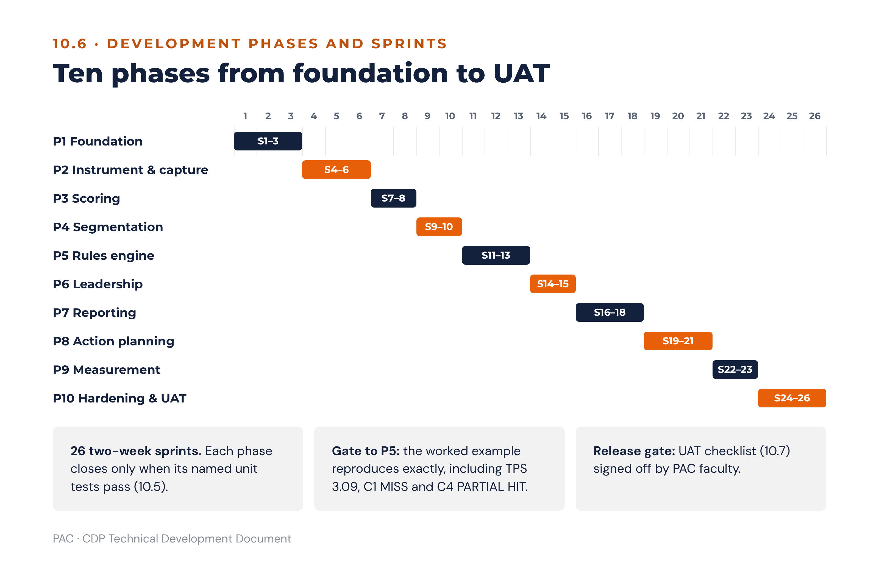
Figure 20 · Delivery roadmap: ten phases over 26 sprints

10.7 QA and UAT checklist
Area | Check | Pass condition
Anonymity | Attempt to retrieve an individual response as every role, including Super Admin. | Impossible by any route, including direct database inspection of the response tables.
Anonymity | Attempt to identify a small group by differencing two permitted segments. | Suppressed, and the attempt appears in the query log.
Scoring | Reproduce every worked example in this document. | Exact match, including 3.09 for the TPS and the C1 and C4 verdicts.
Scoring | Constant-sum enforcement at the client, the API and the database. | All three reject a non-100 scenario.
Rules baseline | Confirm every rule in the rules baseline (0.5) is the behaviour in code. | All sixteen, each with a named test.
Intellectual property | Search the entire codebase, database enumerations, UI strings, report templates, chart legends and AI prompts for deny-listed terms. | Zero occurrences. Re-run as a build-pipeline gate, not a one-off review.
Gates | Attempt to publish content over each open blocking gate. | Refused in every case, with the specific pre-condition named.
Workflow | Attempt every illegal status transition. | 409 in every case.
Reports | Release a report with an empty conclusion or recommendation. | Refused.
AI | Seed the findings payload with a value, then attempt to have the panel state a different one. | Blocked by numeric integrity; logged.
AI | Request a causal statement linking culture to a financial outcome. | Rejected or reformulated associationally.
Ethical use | Attempt to export a leader report or a carrier/blocker classification into a performance, remuneration, succession or disciplinary context. | Blocked, not warned.
Data protection | Exercise every data-subject right as a respondent. | All routes work; the platform states plainly that a submitted response cannot be individually retrieved or deleted.
Data protection | Advance the clock past the 24-month retention expiry. | Destruction executes; certificate issued; no recoverable response data remains.
Accessibility | Keyboard-only and screen-reader completion of the full instrument, including the constant-sum control. | Completable without assistance.
Localisation | Complete the instrument in each published locale. | No truncation, no untranslated string, no scale-anchor mismatch.
Load | 5,000 concurrent respondents, and scoring of a 5,000-response assessment. | Survey response under two seconds at the 95th percentile; scoring completes within the agreed window.
Consultant workflow | Run a full engagement end to end against seeded data, with PAC faculty. | Every stage gate in 9.1 completes, and the faculty confirms the advisory output is presentable to a client board.

10.8 Glossary
Term | Meaning | Reference
Orientation | One of the four CDP culture orientations: ENGAGE, INNOVATE, PERFORM, GOVERN. | 2.1
NOW / PREFERRED | Current culture, and the culture the organisation needs in five years (D1–D6 only). | 2.3.1
Orientation score | Mean of the 18 scenario allocations for an orientation across D1–D6, per perspective and cohort. | 2.4
Gap | PREFERRED minus NOW per orientation. 8.0 points or more in either direction is strategically significant. | 2.5
BUILD / STRENGTHEN / KEEP & PROTECT / MODERATE | The four gap classifications, on half-open bands. | 6.2
Culture strength | Dominant NOW orientation score minus the 25-point neutral baseline. | 2.6.2
Culture congruence | Share of the six D1–D6 dimensions whose dominant orientation matches the organisational dominant orientation; plus lens agreement of 3. | 2.6.3
D1–D6 | Cultural DNA · Leadership Blueprint · People Architecture · Cohesion Drivers · Strategic Compass · Victory Conditions. Constant-sum. | 2.1
D7–D9 | Digital Readiness · Psychological Safety · Adaptive Capacity. 12 Likert items each. | 2.1, 2.8
S1 · S2 · S3 | Scenario position within a dimension. “D2 S2” is Dimension 2, second scenario. | 2.1
Lens | Strategy = mean(D5, D6); Practice = mean(D1, D3, D4); Leadership = D2. Capacity is not a lens. | 2.10
eOS | Employee Orientation Survey. Eight categories, 0–10, scored Advocates minus Critics on a −100 to +100 scale. | 2.7
eOS Index | Unweighted mean of the eight eOS category scores. | 2.7.3
Advocates / Neutrals / Critics | eOS respondent bands: 9–10, 7–8, 0–6. | 2.7.1
TPS | Transformation Probability Score = 0.35×D9 + 0.30×D8 + 0.20×leadership alignment + 0.15×D7, on 1–5. | 2.9
Leadership alignment | Coverage-weighted blend of the headcount-weighted mean LRI and a D2-derived instrument term, on 1–5. | 2.9.2
LRI | Leader Readiness Index = 0.35×H + 0.30×F + 0.20×alignment section + 0.15×G, on 1–5. | 4.6
Default / growth orientation | The leader’s highest and lowest scoring A–D sections. | 4.3.1
Leadership range | A spread of less than 0.50 across A–D; the ability to flex between orientations. | 4.3.1
WATCH / BLIND SPOT | Self–other gap tiers: above 0.50 to 1.00, and above 1.00. | 4.5
C1–C4 | The four alignment checks: performance alignment, behaviour gap, stop/start audit, business-model readiness. | 6.3
HIT / PARTIAL HIT / MISS | Check verdicts: aligned, broadly aligned with a named gap, culture working against the strategy. | 6.3.2
Alignment percentage | Mean of the required orientations’ NOW scores against their dominance thresholds, capped at 100, with two overrides. | 6.3.2
WATCH / SHADOW CULTURE | Executive–staff perception-gap flags: absolute gap above 5.0 to 7.0, and above 7.0. | 3.4
SDI | Sub-culture Divergence Index: half the sum of absolute differences between a segment and the organisational NOW profile. | 3.3
Fit index | 100 minus half the sum of absolute differences between the leader’s normalised profile and the team’s NOW profile. | 5.2
Culture carrier / blocker | Whether a leader models more or less of the organisation’s BUILD orientation than the organisation does. | 5.3
Pathway | The shift from the dominant NOW orientation to the target orientation: adjacent (shares a pole) or diagonal (shares none). | 6.5
Stepping stone | The neighbouring orientation through which a diagonal shift is routed when readiness is low. | 6.5.1
Bridging narrative | The framing that preserves the existing bonding mechanism while redirecting its energy. | 6.5
Readiness gate | A rule that caps the number of priorities or blocks publication until a pre-condition completes. | 6.6
Priority zero | The pre-condition priority created by any blocking gate. Owned by CEO and CHRO, dated at 30 days, outside the four-priority cap. | 6.7
Visible signal | A change delivered within 30 days, preferably to a recognition ritual, that demonstrates the programme is real. | 6.7, 8.2
Urgency tier | Strategic miss 0–30 days · behaviour gap 0–90 days · process contradiction 1–6 months · business-model readiness 6–18 months. | 6.7
Setup Sections A–I | The nine pre-assessment setup sections completed at the executive workshop. | 1.2.2
Strategic scorecard | The client’s strategic objectives and KPIs, drawn from Setup Sections C and D, to which organisation-level actions must link. | 8.4
Item-bank version | The versioned instrument release. 1.1 is the canonical UK-English release. | 1.4.2
CHRO designate | The one named client user with read access to leader reports, development plans and leader classifications. | 1.3.2
Primary BUILD orientation | The BUILD orientation with the greatest strategic need; otherwise the largest STRENGTHEN gap; otherwise the Section F target. | 4.6
Reference library | The versioned playbook content from which draft actions, KPIs, signals and watch-lists are drawn. | 11.1
Strategic priority card | The per-priority detail page and charter rendered from the action records. | 11.12.2
Watch-list | The dimension scenarios and eOS categories the next assessment or pulse tests for a priority. | 8.4, 11.x.4

10.9 Design decisions register
Every design decision taken in turning the CDP method into a buildable platform is recorded here with its final treatment. All entries are decided; none is open. A change to any of them is a change to this specification and is released as a new version of it.
Ref | Decision | Final treatment | § | Tests
D-01 | Role model | Six roles plus two scoped designations (CHRO designate, assigned coach). Executives see their direct reports’ leader reports except the fit-and-contribution section. | 1.3 | UT-54, UT-55
D-02 | Languages | UK English canonical at first release; further locales per tenant through forward translation, back-translation and practitioner reconciliation. | 1.4.3 | UAT localisation
D-03 | Data protection | Kenya Data Protection Act, 2019 implemented in full; DPO sign-off is a launch pre-flight check; the governing regime is recorded per tenant. | 1.4.5 | UAT data protection
D-04 | Culture strength and congruence | Strength = dominant NOW − 25, banded at 5, 10 and 15; congruence by dimension (n of 6) and by lens (n of 3). | 2.6 | UT-05, UT-06
D-05 | Data quality | Capture validation, five quality flags (speeding at 40% of median or 8 minutes), five completion states, Cronbach’s alpha disclosed below 0.70. | 2.11 | UT-01, UT-02
D-06 | Sub-culture detection | SDI ≥ 12.0 or dominance divergence, confirmed by Welch’s t-test at 95%; single-orientation divergence at 8.0. | 3.3 | UT-27 to UT-29
D-07 | Leader–culture link | Fit index, five-class ordered carrier/blocker table, association-only influence measures, development-only visibility. | 5 | UT-34, UT-35, UT-53
D-08 | Strategic scorecard | Held in the platform as objectives and KPIs from Setup Sections C and D, with CSV import; no external integration in the first release. | 8.4 | UT-41
D-09 | Leadership alignment (TPS input) | Coverage-weighted blend of weighted LRI and the D2 instrument term; provisional label below 60% coverage, presentational only. | 2.9.2 | UT-13, UT-45 to UT-47
D-10 | C2 behaviour gap | Rank sets the verdict; behaviour_gap_points sets intensity (5.0 and 15.0); shared-dominance override below 1.0. | 6.3.4 | UT-18, UT-48, UT-49
D-11 | Action prioritisation and tracking | Priority score, modifiers, caps (four priorities, six actions each, three per unit, three per leader), computed RAG and the escalation ladder. | 8.3, 8.7 | UT-22, P8 clock test
D-12 | Re-assessment triggers | Annual default; earlier on structural completion, material organisational change, pulse movement > 0.5 Likert or > 15 eOS points, or board request. | 8.8 | UT-42, UT-43
D-13 | Dominance thresholds | One strict lookup expressed as margins above 25, with per-check threshold selection. | 6.3.1 | UT-50
D-14 | Item bank | Canonical UK-English version 1.1 with equivalence statement. | 1.4.2 | UT-43
D-15 | IP position | PAC terminology only; build-pipeline and AI deny-list. | 0.4 | UT-39
D-16 | Completion time | 35–45 minutes stated to respondents; median measured in UAT and the communication updated before first launch if it falls outside that range. | 2.2 | UAT
D-17 | Override 2 scope | Not applied to the balanced business-model transition requirement. | 6.3.2 | UT-17, UT-51
D-18 | Primary BUILD orientation | BUILD with greatest strategic need, else largest STRENGTHEN gap, else Section F target; used by the LRI and carrier/blocker logic. | 4.6, 5.3 | UT-31, UT-35
D-19 | Rounding | Decimal arithmetic, half-up, at presentation and before banding. | 2.4 | UT-52
D-20 | Action Planning Guide | Incorporated as Part B and stored as a versioned reference library that drives draft actions, signals and watch-lists. | 11 | UT-56
D-21 | Report composition | Reports are composed by selecting tagged library entries with a deterministic fit score, filling slots only from findings and setup, and drafting from template sentences; the AI panel only rephrases. | 12 | UT-57 to UT-68

10.10 Companion document conformance
The companion documents carry the same definitions as this specification. The table records the content each one carries, so that a reviewer can check any copy in circulation against it.
Document | Conforming content
CDP Pre-Assessment Setup Guide | Half-open TPS bands; 36 scenario sets, 144 allocations and 188 quantitative values; eOS bands Advocates, Neutrals and Critics; perception gap on the absolute difference; D1 named Cultural DNA; UK-English item text; anonymity section including combination and differencing rules.
CDP Action Planning Guide | Incorporated as Part B: orientation map in PAC’s own terms; half-open gap bands; TPS gate bands; lens composition Strategy = mean(D5, D6), Practice = mean(D1, D3, D4), Leadership = D2; worked-example band ENABLEMENT REQUIRED; terminology per the glossary at 10.8.
CDP Leadership 360° Self-Evaluation | LRI bands identical to the TPS bands; self–other tiers on the absolute difference; section averages A–D ÷ 10 and E–H ÷ 5; UK-English item text.
CDP Leadership 360° Leader Evaluation | As the self-evaluation, plus the rater-group floor of three with the “all others” merge and the rule for a merged group still below three.
Culture Dynamics Profile (client deck) | Half-open TPS band labels; LRI band; eOS respondent bands; D1 Cultural DNA; gap significance at 8 points or more; figures as in this document.

Part B — Action Planning Reference
This part incorporates the CDP Action Planning Guide (PAC/CDP/ACT/001) into the build baseline. It is the advisory content the platform stores as reference data and renders into reports: the orientation reference, the four orientation playbooks, the reporting templates and the end-to-end worked example. Every threshold it uses is the one defined in Part A; where Part A already specifies a rule (gap classification, readiness gates, pathways, cadence), this part points to it rather than restating it, so there is one definition of every rule in the system.

11. Action Planning Reference

11.1 How the platform uses this reference
The guidance engine (section 6) decides which orientations need work, in what order and at what pace. This reference supplies what the work looks like: the candidate actions, the system levers, the KPIs, the visible signals and the re-measurement watch-lists from which every draft action in section 8 is instantiated. It is stored as versioned reference data alongside the rules version, editable by PAC faculty without a code release, and every element below has a fixed destination in the platform.
Reference element | Platform object or field | Where it appears in reporting
Orientation reference (11.3) | Orientation master data: focus, values, leader type, motto, map position | Report glossary panels; leader report section 2; AI vocabulary
Relationships (11.4) | Pathway relationship lookup (6.5) | Pathway and bridging-narrative text in every priority card
Seven-step process (11.5) | Engagement stages (9.1) and rules-engine order (6.1) | Debrief pack; workshop agenda
Hits & Misses quick reference (11.6) | Check finding templates C1–C4 (6.3) | Board summary scorecard; organisational report section 5
Playbook profile (11.x.1) | Orientation narrative, strengths, overplay risks, “where it shows” scenario references | Organisational report section 3; sub-culture report section 2
Interaction matrix (11.x.2) | Cascade content keyed by level (leader, team, unit, organisation) | Sub-culture report section 8; leader report section 7; cascade packs
Metrics and outcomes (11.x.3) | KPI suggestion list on the action record (kpi), leader trait list, blind-spot list | Action plan report; priority card “measures” field
“If you need more…” actions (11.x.4) | Candidate action library for draft generation (8.2) | Priority card action steps; four-level commitment matrix
HR and system levers | system_lever values and the organisation-level action set | Organisation-wide actions; C3 response
Visible signal within 30 days | signal_30_day on the playbook; is_visible_signal on the action | Priority card; board summary; escalation rule 8.7.2
CDP re-measurement watch-list | Default cdp_remeasure_watchlist on every action | Pulse design (8.8); trend report
Reporting templates (11.12) | Action plan report, priority card and commitment matrix renderers (8.10) | ExCo approval pack; charters; progress reports
Worked example (11.11) | Regression fixture for P5 acceptance (10.6) | Training and demonstration tenant
How the platform turns this content into complete reports, with suggestions selected and fitted to each organisation, is specified in section 12. Rules already defined in Part A and applied here without restatement: gap classification (6.2), readiness gates (6.6), priority selection and urgency tiers (6.7), culture-shift pathways and stepping-stone routing (6.5), eOS category routing (2.7.2), cadence and governance (9.2–9.4) and the review questions asked at every checkpoint (9.3).

11.2 When the reference is used
- Results debrief: interpreting the orientation profile and gaps with the executive team.
- Action Planning Workshop: a facilitated session of one to one and a half days in which leaders agree up to four strategic culture priorities and complete the templates in 11.12, working directly in the platform.
- Cascade sessions: departments and teams translating the organisation-level plan into their own commitments using the interaction matrices.
- Progress reviews: 30, 90 and 180-day checkpoints, and the annual CDP re-assessment.
Core principle. Culture change is a trade-off, not an addition. Resources, attention and leadership time are finite, and starting something new almost always means scaling something else back. Every priority in the action plan therefore names what the organisation will do more of, less of, start, stop, and keep and protect.

11.3 Orientation reference
The reference point for everything that follows: what each orientation values, how it creates value, the leader behaviour it rewards and where it sits on the CDP map (2.1), together with the strategic goals and business models that call for it and the intervention applied when it is the orientation to build.
 | ENGAGE | INNOVATE | PERFORM | GOVERN
Core focus | People + Belonging | Ideas + Agility | Results + Growth | Systems + Order
Values | Belonging · shared commitment · growing people · open participation · lasting relationships | Fresh thinking · experimentation · smart risk-taking · continual learning · forward vision | Ambition · winning in the market · customer focus · clear targets · measurable returns | Reliability · consistent standards · efficient processes · clear controls · dependable delivery
Leader type | Coaches · develops · unites the team | Champions ideas · backs experiments · sets direction | Drives goals · delivers · competes to win | Standardises · coordinates · safeguards quality
Motto | We grow our people | We try new things | We deliver results | We do things right
Map position | Inward focus + adaptive | Outward focus + adaptive | Outward focus + structured | Inward focus + structured
How it creates value | Value is created when people are developed, trusted and committed to one another. | Value is created through new ideas, experimentation and continuous renewal. | Value is created by setting ambitious goals, competing hard and staying close to customers. | Value is created through reliable, efficient processes and consistent standards.
Performance themes (11.7–11.10) | Belonging · Human development | Ideas · Agility | Results · Growth | Efficiency · Consistency & Compliance
Strategic goal it serves (Check C1 dominance signal) | People & talent retention goals: ENGAGE > 30 | Innovation & new business models: INNOVATE > 28 | Results & growth targets: PERFORM > 30 | Compliance, audit & process scale: GOVERN > 28
Business models that require it (Check C4) | Service company (B2C); NGO / social impact | Product company (B2B); Platform / digital scale-up (dominant); NGO / social impact | Product company (B2B); Service company (B2C); Regulated sector | Regulated / compliance sector
Intervention when it is the target (Check C2) | From PERFORM: coach-first leadership development; 360-degree feedback anchored to CDP; structured wellbeing investment | From GOVERN: innovation sprints; explicit permission to fail; fewer approval layers; design capability | From ENGAGE: commercial acumen training; objective-setting rigour; performance-conversation skills; accountability culture | From INNOVATE: process discipline programme; documentation culture; quality management system; governance training
Complements | INNOVATE and GOVERN | ENGAGE and PERFORM | INNOVATE and GOVERN | ENGAGE and PERFORM
Contrasts with (diagonal) | PERFORM | GOVERN | ENGAGE | INNOVATE

11.4 Complementary and contrasting relationships
Each orientation shares one pole with each of its two neighbours and none with its diagonal opposite. This predicts where collaboration comes easily, where friction will arise, and how hard a given shift will be.
Pair | Shared ground | What it means for action planning
ENGAGE + INNOVATE (top) | Adaptive pole: openness to change | Both are comfortable with unorthodox structures and a long-term horizon. ENGAGE invests in people and knowledge; INNOVATE invests in ideas, ventures and new capability.
PERFORM + GOVERN (bottom) | Structured pole: discipline and order | Both rely on formal structures and measurement. GOVERN measures process and quality as the route to results; PERFORM measures financial and delivery results directly.
INNOVATE + PERFORM (right) | Outward focus | Both aim for market leadership. INNOVATE gets there through ideas and agility; PERFORM through focus, cost discipline and competitive drive.
GOVERN + ENGAGE (left) | Inward focus | Both build systems for continuous improvement and learning. ENGAGE focuses on people (feedback, development); GOVERN on processes (after-action reviews, standards).
ENGAGE ↔ PERFORM (diagonal) | None: contrasting priorities | People and relationships against results and pace. Typical symptom: “we care about our people” colliding with “hit the numbers”. Addressed in CDP Check C2.
INNOVATE ↔ GOVERN (diagonal) | None: contrasting priorities | Freedom to experiment against control and compliance. Typical symptom: “move fast” colliding with “follow the process”. Addressed in CDP Check C2.
Planning implication. Shifts between neighbouring orientations are easier than shifts across the diagonal. When the PREFERRED profile demands a diagonal shift and the TPS is below 3.50, or D8 or D9 is at or below 3.0, the shift is planned in two moves through a stepping-stone orientation (6.5.1).

11.5 From results to action: the seven-step process
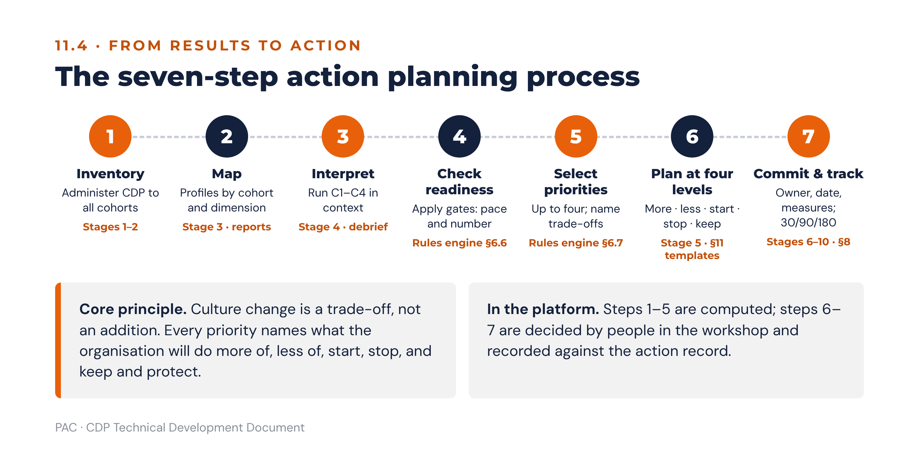
Figure B1 · The seven-step action planning process and where each step runs in the platform
# | Step | What happens | CDP inputs / outputs
1 | Inventory | Administer the CDP to all cohorts: D1–D6 (NOW and PREFERRED), D7–D9, eOS and qualitative questions. This takes stock of the Strategy, Practice and Leadership lenses. | CDP instrument (2.3); Setup Section I cohort design
2 | Map | Plot the orientation profile for the organisation and each cohort, overall and by dimension. Show strengths, gaps and competencies to build. | Orientation scores; gap per orientation; cohort and dimension profiles
3 | Interpret in context | The leadership team reviews results against the situation (strategy, KPIs, customers, competitors, regulation, trends) and runs the four Hits & Misses checks. | Setup Sections B–H; Checks C1–C4; signal classification
4 | Check readiness | Apply the readiness gates (6.6) to set the pace, sequence and number of priorities. | TPS; D7, D8, D9; eOS; perception gap
5 | Select priorities | Agree up to four strategic culture priorities, normally one per orientation that must move. Name the trade-offs. | Gap classification (6.2); priority selection (6.7)
6 | Plan at four levels | For each priority, use the playbooks (11.7–11.10) and pathways (6.5) to define what to do more of, less of, start, stop, and keep, at individual, team, department or unit, and organisational level. | Reporting templates (11.12)
7 | Commit and track | Assign an owner, deliverable, date and measures to each priority. Review at 30/90/180 days and re-assess annually. | Cadence (9.2); CDP re-measurement watch-lists

11.6 Hits & Misses: quick reference for action planning
The CDP tests culture against strategy through four checks (6.3). Each compares a different part of the result with what the organisation says it needs (its targets, its stated leadership intent, its change agenda and its business model) and returns HIT (aligned), PARTIAL HIT (broadly aligned, with a named gap) or MISS (the culture is working against the strategy). A MISS is the strongest trigger for a strategic priority. Each check is read alongside the gap classification (6.2), and the readiness gates (6.6) then set the pace.
Check | Question | Where this guide helps
C1 Performance alignment | Does the dominant orientation match what the KPI targets require? | Playbook metrics tables (11.7.3–11.10.3) translate each orientation into KPIs, so culture gaps can be linked to named performance shortfalls.
C2 Behaviour gap | Do D2/D3 show the leadership behaviours the organisation says it wants? | Cross-orientation matrices (11.7.2–11.10.2), leadership traits and blind spots, and the diagonal pathways in 6.5.
C3 Stop / start audit | Do D4 and D6 reinforce or contradict the change agenda? | Bridging narratives (6.5), system levers and the 30-day visible signal in each playbook.
C4 Business-model readiness | Can the culture deliver the current or planned business model? | Orientation profiles and typical contexts; pathways for multi-orientation shifts.
- C1 Performance alignment compares the dominant orientation with the orientation the KPI targets require. A miss means the culture is optimised for results the strategy is not asking for, as when a digital growth strategy needs INNOVATE above 28 in an organisation where INNOVATE is the lowest NOW score. The playbook metrics tables name the performance shortfall the gap is producing.
- C2 Behaviour gap compares what leaders model, as staff experience it (D2 Leadership Blueprint and D3 People Architecture), with the behaviour the organisation says it wants. A miss usually surfaces with an executive–staff perception gap, and the levers are leadership development, 360-degree feedback and leadership KPIs rather than communication.
- C3 Stop / start audit tests whether the bonding mechanisms and success definitions (D4 Cohesion Drivers and D6 Victory Conditions) reinforce the change agenda or quietly contradict it. Recognition rituals, scorecards and reward are the usual culprits, which is why every playbook carries a visible signal delivered within 30 days.
- C4 Business-model readiness asks whether the culture can deliver the business model the organisation is running or planning. A miss is a longer-horizon finding (6–18 months, CEO and ExCo) and normally calls for a multi-orientation shift using the pathways in 6.5.

11.7 ENGAGE playbook
People + Belonging · inward focus + adaptive · “We grow our people”

11.7.1 Orientation profile
ENGAGE describes a people-centred community in which deep relationships, mutual care and shared purpose shape daily experience. Leaders act as coaches and mentors, people invest in one another’s growth, and success is measured by how well people thrive over the long term.
Attribute | Specification
Core focus | People + Belonging
Values | Belonging · shared commitment · growing people · open participation · lasting relationships
Leader type | Coaches · develops · unites the team
How it creates value | Value is created when people are developed, trusted and committed to one another.
Strengths when anchored here | • People feel valued and leaders are grown from within.  • Human capital is the engine of organisational success.  • The organisation plans and invests for the long term.
Overplay risks (drawbacks at the extreme) | • Becomes a “comfort club”: warmth without accountability.  • Initiatives are slow to produce tangible outcomes.  • Goals keep shifting and focus is lost.
Relationship to other orientations | Complements INNOVATE and GOVERN. Contrasts (diagonally) with PERFORM.
Where it shows in CDP results | High ENGAGE allocation in D1 (Cultural DNA), D2 Scenario 2 (how leaders invest their time), D4 Scenario 2 (what makes people stay) and D6 Scenarios 1 and 3. Cross-check eOS Q1, Q4, Q6 and Q7.

11.7.2 Cross-orientation interaction matrix: if the culture is ENGAGE
Each matrix is used in three ways: (a) when an individual leader, team, department or the whole organisation has a dominant profile in this orientation and must work with a group whose dominant orientation differs, for example cohorts or departments in the sub-culture map; (b) when a culture dominant in this orientation must build more of another; (c) when partnering externally. Complementary rows show where value comes easily; the contrasting (diagonal) row shows where friction will arise and how to manage it. The platform attaches the row for the relevant level to cascade packs, sub-culture reports and leader reports.
ENGAGE | If you (leader) are ENGAGE | If your team is ENGAGE | If your department / unit is ENGAGE | If your organisation is ENGAGE
On its own, value comes from… | Your commitment to teaching, mentoring and developing others. | The team’s commitment to learning together and supporting each member’s growth. | Building organisational learning that other units can draw on. | Turning people capability and shared knowledge into a lasting competitive advantage.
And you work with, or must build, GOVERN (complement)… | Works well when you jointly focus on learning to do things the right way. | Creates value with other teams when good practice and standard ways of working are shared openly. | Succeeds when structured learning systems (SOPs, knowledge bases, communities of practice) are built and shared. | Builds value through long-term, trusted partnerships that develop sector-specific knowledge and standards.
And you work with, or must build, INNOVATE (complement)… | Works well when you try new things together, generate ideas, and learn supportively from what does and does not work. | Creates value by co-creating on projects and reviewing openly what worked and what to improve. | Succeeds when larger innovation initiatives are launched and patiently nurtured over the long term. | Builds value through innovative, long-term alliances or joint ventures aimed at creating new knowledge.
And you work with, or must build, PERFORM (contrast: expect friction)… | Friction centres on individual deadlines and accountability. Let them set timelines, but lead on clarifying details and keep communication about shared responsibilities positive. | Agreeing shared objectives is hard: your goals may look soft to them, theirs too aggressive to you. Make your team’s goals concrete and express them in the language of results. | Tension between speed of completion and time to learn. Set realistic objectives that balance pace with learning and keep communication strong. | Deep trust is slow to build because the two sides move at different speeds. Anchor the relationship on one specific project with realistic deadlines and use milestones as trust checkpoints.

11.7.3 Metrics and outcomes: Belonging and Human development
ENGAGE | Belonging… | Human development…
Headline performance metric | Voluntary retention of staff and key talent, read alongside revenue (or output) per employee. | Capability growth: internal fill-rate for key roles, skills-index progression and bench strength for critical positions.
Supporting indicators | • eOS scores and morale surveys.  • Voluntary and performance-related turnover.  • Absence rate.  • Trend in grievances and complaints.  • Headcount against workforce plan.  • Job-offer acceptance rate.  • Internal promotion rate.  • Customer satisfaction. | • Completion of required training.  • Training days and investment per employee.  • Training spend as % of operating budget.  • % of staff with a career development plan.  • Employee suggestions adopted.  • Good practices shared across units.  • Skill targets achieved; impact evaluation of learning.  • Average experience level of staff.
To achieve Belonging / Human development, nurture… | • Workforce commitment  • Shared values  • Inclusion  • Teamwork  • Employee motivation | • Workforce competence  • Continuous learning  • Retention of talent  • Employee support  • Breadth of knowledge to handle uncertainty
Cultures strong here are characterised by… | • Friendly atmosphere  • Participation  • Team goals  • Mentorship  • People focus  • Good communication | • Information sharing  • Collaborative learning  • Leaders as teachers  • Personal growth  • Diversity  • Organisation development practice
Leaders who build it tend to be… | • Facilitator  • Consensus builder  • Inclusive  • Effective, empathetic communicator | • Mentor  • Effective teacher  • Solution builder  • Open to ideas  • Supportive
Leadership blind spot to avoid | Assuming beliefs and attitudes are a minor issue. Allow real time to surface concerns and shift attitudes. | Assuming the right people, values and skills are already in place. Keep scanning for talent and do not tolerate under-performance.
Culture blind spots (overplay) | • Conflict avoidance  • Over-consultation  • Groupthink  • Slow reaction  • Inward, narrow outlook | • Neglect of the short term  • Slow reaction  • Soft feedback  • Inward, narrow outlook
Personal blind spots | • Puts people ahead of tasks  • Defaults to cliques  • Disregards metrics | • Wanders into non-essential knowledge  • Lacks focus  • Avoids direct confrontation
Typical contexts | Mission-driven NGOs, associations and member bodies, family businesses, professional partnerships, faith-based and community organisations.

11.7.4 If the CDP results show the organisation needs more ENGAGE
Applied when ENGAGE is classified BUILD or STRENGTHEN, when it is the required orientation in a C1 or C4 miss, or when it is the target orientation in a C2 behaviour gap. These actions form the candidate library from which the engine drafts actions (8.2).
ENGAGE | Belonging… | Human development…
Actions individuals and leaders can take | • Involve the people affected by a change in planning and implementing it.  • Create space for people to talk about their reactions, especially where they feel they are losing something.  • Identify change champions and work with them to lead the change.  • Hold regular feedback sessions on how the change is landing. | • Define objectives, roles and timelines clearly, then give people freedom to experiment within them.  • Explain what the change means for each group, then ask for and act on feedback.  • Seek advice widely before and during change.  • Learn from a leader who has implemented a similar change and test your plan with them.
Priorities the team or organisation can set | • Building cohesion across the organisation.  • Establishing genuinely shared values.  • Facilitating constructive conflict resolution.  • Integrating personal and professional goals.  • Encouraging commitment. | • Training, mentoring and coaching.  • Becoming a learning organisation.  • Building cross-functional teams.  • Nurturing communities of practice.  • Competency and culture development.
HR and system levers (Setup Section H) | • Performance management: add a people-development objective to every manager’s scorecard.  • Promotion: make a track record of developing others a promotion criterion.  • Reward: recognise team outcomes, not only individual ones.  • Onboarding: assign a buddy and hold structured 30/60/90-day check-ins.
Visible signal within 30 days (Check C3) | Within 30 days, have the CEO publicly recognise a manager for developing talent, at an all-staff forum.
CDP re-measurement watch-list | D2 S2 · D3 S2 · D4 S2 · D8 Psychological Safety · eOS Q1, Q4, Q6, Q7

11.8 INNOVATE playbook
Ideas + Agility · outward focus + adaptive · “We try new things”

11.8.1 Orientation profile
INNOVATE describes an ideas engine in which bold experimentation, creative challenge and the freedom to question convention shape daily experience. Work is often organised around projects, people are trusted to act without waiting for permission, and failure is treated as learning.
Attribute | Specification
Core focus | Ideas + Agility
Values | Fresh thinking · experimentation · smart risk-taking · continual learning · forward vision
Leader type | Champions ideas · backs experiments · sets direction
How it creates value | Value is created through new ideas, experimentation and continuous renewal.
Strengths when anchored here | • Bold and breakthrough ideas regularly come to life.  • Adaptability and novelty drive organisational success.  • The organisation invests for the long term.
Overplay risks (drawbacks at the extreme) | • Energy scatters across too many initiatives and delivery becomes chaotic.  • Radical ideas are expensive and often fail.  • Stretch goals are frequent and often unachievable.
Relationship to other orientations | Complements ENGAGE and PERFORM. Contrasts (diagonally) with GOVERN.
Where it shows in CDP results | High INNOVATE allocation in D1 Scenario 3 (response to adversity), D2 Scenario 1 (leadership orientation), D5 Scenarios 1 and 3 (strategy and long-term investment). Cross-check D7 Digital Readiness, D8 and eOS Q3.

11.8.2 Cross-orientation interaction matrix: if the culture is INNOVATE
Used exactly as described at 11.7.2.
INNOVATE | If you (leader) are INNOVATE | If your team is INNOVATE | If your department / unit is INNOVATE | If your organisation is INNOVATE
On its own, value comes from… | Your ability to turn creative risk into growth projects. | The team’s support for playfulness, divergent thinking and calculated risk. | Creating idea spaces and structures that support creativity and divergence. | Systems and cultures of risk-taking in which free-thinking projects are funded as a channel for growth.
And you work with, or must build, ENGAGE (complement)… | Works well when you jointly emphasise trying new things, generating ideas, and learning from each other supportively. | Creates value by collaborating on creative projects and learning together about what works. | Succeeds when large innovation initiatives are launched and nurtured for long-term success. | Builds value through innovative, long-term alliances aimed at generating new industry knowledge.
And you work with, or must build, PERFORM (complement)… | Works well when you share energy and visible sponsorship for a high-profile project. | Creates value through shared enthusiasm for launching new initiatives. | Succeeds when know-how on phase-gate reviews of profitable, visible growth projects is shared. | Builds value when a partnership provides the capital for large, visible, innovative growth projects.
And you work with, or must build, GOVERN (contrast: expect friction)… | Friction centres on risk: big ideas look reckless if not carefully presented. Set out the reasonable risks and foreseeable rewards analytically. | Your ideas will be challenged on feasibility. Build a proof of concept that answers the feasibility questions directly. | Conflicting views on how to pursue growth and weigh risk against reward. Accept that risk is inevitable and propose creative ways to mitigate it. | Large formal partnerships are hard. Treat these partners as a source of specific capabilities and use smaller, targeted alliances.

11.8.3 Metrics and outcomes: Ideas and Agility
INNOVATE | Ideas… | Agility…
Headline performance metric | Share of revenue (or impact) from products, services or programmes launched in the last three years. | Idea-to-launch cycle time: average time from approved concept to first customer or beneficiary use.
Supporting indicators | • New products, services or programmes launched.  • Ideas submitted and adopted per 100 staff.  • Experiments run per quarter.  • Return on new offerings.  • Innovation spend as % of total spend.  • Diversity of the innovation portfolio.  • Survival rate of launches after 12 months. | • Time to market for new offerings.  • % of experiments reaching a go / stop decision on schedule.  • Pilots successfully scaled.  • Staff working in cross-functional project teams.  • Digital adoption rate (link to D7).  • Speed of response to competitor, customer or regulatory change.  • Lessons-learned reviews completed and applied (link to D9).
To achieve Ideas / Agility, nurture… | • Product and service innovation  • Long-term risk acceptance  • Experimentation  • Change  • Capacity to capitalise on trends | • Capacity to change  • Long-term risk acceptance  • A vision of what is possible  • Exploration  • Turning emerging trends into offerings
Cultures strong here are characterised by… | • Entrepreneurship  • Creative workspaces  • Individual freedom  • Experimentation  • Tolerance of ambiguity and risk | • Adventure and curiosity  • Emergent opportunities  • Clear vision  • Trend awareness  • Confronting the unknown
Leaders who build it tend to be… | • Innovative, clever, creative  • Risk-taking  • Learns from failure  • Tolerant of ambiguity; abstract thinker | • Visionary, future-oriented  • Visualises new outcomes  • Opportunistic, intuitive  • Risk-taker
Leadership blind spot to avoid | Assuming continued success depends solely on continuous change. Keep weighing the risks and rewards of every change. | Assuming the future is an extension of the present. Expect disruption to growth rates and have a plan for it.
Culture blind spots (overplay) | • Excessive individualism  • Superficiality at the expense of depth | • Misaligned incentives  • Low organisational loyalty
Personal blind spots | • Risky behaviour  • Falls in love with ideas  • Micromanages  • Cannot rally support | • Fails to produce viable ideas  • Low loyalty to the organisation  • Micromanages  • Will not adapt personal ideas to other objectives
Typical contexts | Start-ups and scale-ups, digital and platform businesses, design and creative firms, mature organisations that need renewal.

11.8.4 If the CDP results show the organisation needs more INNOVATE
Applied when INNOVATE is classified BUILD or STRENGTHEN, when it is the required orientation in a C1 or C4 miss, or when it is the target orientation in a C2 behaviour gap. These actions form the candidate library from which the engine drafts actions (8.2).
INNOVATE | Ideas… | Agility…
Actions individuals and leaders can take | • Run idea-sharing forums (cross-functional task forces, focus groups, reading circles) around two questions: what is new, and which of our problems does nobody expect us to solve?  • Practise action learning: try first, then review what success or failure taught you. Do not wait for certainty before acting.  • Deliberately test a new alternative or process in your own decisions.  • Keep an idea log and add to it every time an improvement occurs to you. | • Set goals for innovative ideas, hold people accountable for them, and write them into job descriptions.  • Create an innovation sandbox with protected time and modest resources for low-cost experiments.  • Build a climate where people can fail and say so openly.  • Generate as many options as possible when defining problems and solutions.
Priorities the team or organisation can set | • Jump-starting breakthrough experiments.  • Launching bold change programmes.  • Stimulating creative thinking.  • Retiring outdated ways of working.  • Hiring for diversity; creating a flexible, open workplace. | • Strategic foresight.  • Launching new ventures and spin-offs.  • Developing new products and services.  • Exploring emerging opportunities.
HR and system levers (Setup Section H) | • Performance management: include an innovation or improvement objective in scorecards.  • Promotion: reward intelligent risk-taking and learning from failure.  • Reward: fund an innovation budget or protected time; recognise experiments as well as successes.  • Onboarding: invite new hires to challenge one existing practice in their first 90 days.
Visible signal within 30 days (Check C3) | Within 30 days, publicly celebrate a well-run experiment that failed, and share what was learned from it.
CDP re-measurement watch-list | D1 S3 · D2 S1 · D5 S1, S3 · D7 Digital Readiness · D8 Psychological Safety · eOS Q3

11.9 PERFORM playbook
Results + Growth · outward focus + structured · “We deliver results”

11.9.1 Orientation profile
PERFORM describes a performance-driven culture in which ambitious goals, relentless execution and measurable outcomes shape daily experience. Leaders set challenging targets and track delivery closely, and the organisation competes hard for customers, market position and returns.
Attribute | Specification
Core focus | Results + Growth
Values | Ambition · winning in the market · customer focus · clear targets · measurable returns
Leader type | Drives goals · delivers · competes to win
How it creates value | Value is created by setting ambitious goals, competing hard and staying close to customers.
Strengths when anchored here | • Initiatives stay focused on customer and shareholder / funder needs.  • Planning and focus drive organisational success.  • Short-term gains create tangible value.
Overplay risks (drawbacks at the extreme) | • Pace becomes unsustainable and burnout rises.  • Failures are not turned into learning.  • Competitive goals drive unsustainable behaviour.
Relationship to other orientations | Complements INNOVATE and GOVERN. Contrasts (diagonally) with ENGAGE.
Where it shows in CDP results | High PERFORM allocation in D2 Scenarios 1 and 3 (leadership orientation and recognition), D3 Scenario 3 (performance conversations), D5 Scenario 1 and D6 Scenarios 1–3. Cross-check eOS Q8 and the D8 score.

11.9.2 Cross-orientation interaction matrix: if the culture is PERFORM
Used exactly as described at 11.7.2.
PERFORM | If you (leader) are PERFORM | If your team is PERFORM | If your department / unit is PERFORM | If your organisation is PERFORM
On its own, value comes from… | Your ability to get things done fast and to meet clear, agreed metrics. | A team that acts as a proving ground for leaders and high performers. | Out-performing peer units, which clearly justifies the unit’s contribution. | Systems that deliver superior returns to shareholders or funders relative to competitors.
And you work with, or must build, INNOVATE (complement)… | Works well when you share energy and visible sponsorship for a high-profile project. | Creates value through shared enthusiasm for launching new initiatives. | Succeeds when know-how on phase-gate reviews of profitable, visible growth projects is shared. | Builds value when a partnership provides the capital for large, visible, innovative growth projects.
And you work with, or must build, GOVERN (complement)… | Works well when you share an interest in minimising a specific risk. | Creates value with other teams around a specific shared goal that reduces risk and maximises return on investment. | Succeeds through key projects with clear goals, timelines, responsibilities and outcomes. | Builds value where joint ventures have clear objectives and resources. Ventures stay transactional and outcome-focused.
And you work with, or must build, ENGAGE (contrast: expect friction)… | Friction centres on individual deadlines and responsibilities. Allow time for positive communication and for discussing roles but take the lead in setting reasonable targets and deliverables. | Agreeing shared objectives is hard: yours may look aggressive, theirs vague. Push for realistic goals that leave room for some failure and learning. | Tension between speed of completion and time to learn. Set realistic objectives that balance both and keep communication strong. | Quick action is hard because collaboration and trust take time. Anchor the relationship on one specific project with realistic deadlines and milestones as trust checkpoints.

11.9.3 Metrics and outcomes: Results and Growth
PERFORM | Results… | Growth…
Headline performance metric | Economic profit: operating profit after tax less a charge for the capital employed. For NGOs and public bodies, use cost per outcome or delivery against target. | Revenue and market-share growth, year on year and over the strategic horizon. For NGOs, growth in funding or reach.
Supporting indicators | • Return on assets.  • Gross profit and operating income.  • Cash flow and cash on hand.  • % attainment of agreed targets.  • Projects delivered on or ahead of schedule.  • Bid and proposal win rate.  • Shareholder value and earnings per share (listed entities). | • Total revenue growth.  • Market share against competitors.  • Growth by segment, channel and geography.  • Revenue from new markets.  • Customer acquisition and retention.  • Time to profitability for new offerings.  • Growth through partnerships and acquisitions.
To achieve Results / Growth, nurture… | • Shareholder / stakeholder value  • Predictable opportunities  • Focus to compete  • Short-term results  • Well-managed resources | • Market share  • Opportunity capture  • Quick response  • Competitive drive  • Adaptability to fast-changing markets
Cultures strong here are characterised by… | • Results orientation  • Targeted focus  • Demanding leadership  • Resources aligned to specific purposes  • Managerial discipline | • Fast decision-making  • Hard-driving pace  • Leveraging assets  • Analytical strength  • Cost competition
Leaders who build it tend to be… | • Competitor  • Demanding  • Energising  • Strategic | • Producer  • Task-focused  • Aggressive and decisive  • Resourceful
Leadership blind spot to avoid | Assuming long-term stakeholder value is unimportant. Business decisions must weigh long-term value to owners and funders. | Assuming every new idea or product has what it takes to enter and win new markets. Do the analysis before making fast decisions.
Culture blind spots (overplay) | • Stinginess  • Unrealistic targets | • Burnout work pace  • Unnecessary aggression  • Waste
Personal blind spots | • Takes the easy quick fix  • Short-sighted  • Unrealistic demands  • Poor with people | • Takes the easy quick fix  • Overly aggressive  • Moves too fast  • Poor with people
Typical contexts | Banks and financial institutions, large listed or diversified companies, sector leaders, sales-led and commercially driven businesses.

11.9.4 If the CDP results show the organisation needs more PERFORM
Applied when PERFORM is classified BUILD or STRENGTHEN, when it is the required orientation in a C1 or C4 miss, or when it is the target orientation in a C2 behaviour gap. These actions form the candidate library from which the engine drafts actions (8.2).
PERFORM | Results… | Growth…
Actions individuals and leaders can take | • Benchmark against leading organisations and define what “world-class” would require of you.  • Recognise and celebrate cost savings, however small.  • Make continuous improvement an explicit part of the unit’s vision.  • Make it easy for staff and customers to complain and suggest. Actively seek improvement ideas. | • Get it right for customers the first time, every time, then work to exceed their expectations.  • Track industry trends and competitor moves, locally and internationally.  • Recognise and celebrate improvements that save time, however small.  • Never let a day pass without asking at least one customer what they want.
Priorities the team or organisation can set | • Driving superior return on investment.  • Focusing on a few quantifiable objectives.  • Rewarding high performance distinctly.  • Managing the project portfolio for value.  • Growth through acquisition or partnership. | • Deploying small, elite troubleshooting teams.  • Quickly stopping under-performing initiatives.  • Confronting problems as soon as they appear.  • Making real-time decisions.  • Driving through barriers.
HR and system levers (Setup Section H) | • Performance management: cascade clear targets through measurable objectives on the strategic scorecard, with a quarterly review rhythm.  • Promotion: base promotion on delivered, measurable results.  • Reward: link variable pay to a small number of measurable outcomes.  • Onboarding: set clear performance expectations in the first week.
Visible signal within 30 days (Check C3) | Within 30 days, publish a simple team scoreboard and publicly recognise a delivery win against it.
CDP re-measurement watch-list | D2 S1, S3 · D3 S3 · D5 S1 · D6 S1–S3 · eOS Q8 (and D8, to guard against burnout)

11.10 GOVERN playbook
Systems + Order · inward focus + structured · “We do things right”

11.10.1 Orientation profile
GOVERN describes a system of order in which clear structures, defined processes and consistent standards shape daily experience. Reporting lines and expectations are well documented, risk is actively managed, and the organisation values precision, reliability and compliance.
Attribute | Specification
Core focus | Systems + Order
Values | Reliability · consistent standards · efficient processes · clear controls · dependable delivery
Leader type | Standardises · coordinates · safeguards quality
How it creates value | Value is created through reliable, efficient processes and consistent standards.
Strengths when anchored here | • Incremental improvements occur frequently.  • High quality and consistency drive success.  • The organisation plans for the long term.
Overplay risks (drawbacks at the extreme) | • Structure hardens into bureaucracy.  • Radical ideas are suppressed.  • Goals and metrics become ends in themselves.
Relationship to other orientations | Complements ENGAGE and PERFORM. Contrasts (diagonally) with INNOVATE.
Where it shows in CDP results | High GOVERN allocation in D1 Scenarios 2 and 3, D3 Scenario 1 (management philosophy), D5 Scenario 2 (resource allocation logic) and D6 Scenario 3 (measurement philosophy). Cross-check the D9 score and Section H process bottlenecks.

11.10.2 Cross-orientation interaction matrix: if the culture is GOVERN
Used exactly as described at 11.7.2.
GOVERN | If you (leader) are GOVERN | If your team is GOVERN | If your department / unit is GOVERN | If your organisation is GOVERN
On its own, value comes from… | Your attention to detail and ability to spot incremental improvement opportunities. | Making long-term reliability and consistency part of the team’s standard practice. | Connecting practices, processes and systems to growth objectives. | Identifying growth projects through careful, ongoing evaluation of practices and processes.
And you work with, or must build, ENGAGE (complement)… | Works well when you jointly focus on learning to do things the right way. | Creates value when good practice and standard ways of working are shared across teams. | Succeeds when structured learning systems are built and shared. | Builds value through long-term, trusted relationships that build sector-specific knowledge and practice.
And you work with, or must build, PERFORM (complement)… | Works well when you share an interest in minimising a specific risk. | Creates value around a specific shared goal that reduces risk and maximises return on investment. | Succeeds through key projects with clear goals, timelines, responsibilities and outcomes. | Builds value where joint ventures have clear objectives and resources, with a transactional, outcome focus.
And you work with, or must build, INNOVATE (contrast: expect friction)… | Friction centres on risk: your caution may be seen as blocking ideas and progress. Keep concerns reasonable and look for ways to turn them into opportunities. | Disagreements arise over novelty versus feasibility. Use your expertise to help them build a proof of concept and accept that some failure is normal at this stage. | Conflicting views on how to pursue growth. Recognise that some risk is necessary for growth and find common ground where reasonable risk carries meaningful upside. | Formal macro-level partnerships may not work. Use consulting, solutions-based or technology-transfer arrangements to access their ideas.

11.10.3 Metrics and outcomes: Efficiency and Consistency & Compliance
GOVERN | Efficiency… | Consistency & Compliance…
Headline performance metric | Asset turnover: revenue divided by total assets in a given year. | First-time-right rate and compliance record (audit findings, regulatory breaches), with gross margin as a supporting measure for commercial entities.
Supporting indicators | • Unit cost; cost against target.  • Actual against planned output.  • Inventory days and % of back-orders.  • % of milestones achieved.  • % of on-time deliveries.  • Interest and financing cost savings.  • Labour productivity variance; throughput time. | • First-time quality %; scrap and rework %.  • Safety incidents and violations.  • Service or product failures by line.  • Improvement in error or defect rates.  • % reduction in redundancy or waste.  • Changes required after release; % of certified suppliers.  • Warranty claims, complaints, and audit and compliance findings.
To achieve Efficiency / Consistency & Compliance, nurture… | • Cost control  • Regulation and policy  • Monitoring  • Improvement  • Stability | • Reliability  • On-time delivery  • Process improvement  • Technical capability  • Systems and technology
Cultures strong here are characterised by… | • Structure  • Rules and policies  • Risk aversion  • Cost control  • Functional specialisation  • Preservation of order | • Improvement focus  • Technology emphasis  • Best practice  • Workflow management  • Data focus  • Best-in-class ambition
Leaders who build it tend to be… | • Administrator  • Standardising  • Diligent  • Conserves resources  • Technologically adept | • Engineer  • Systems thinker  • Dependable and reliable  • Technical expert
Leadership blind spot to avoid | Assuming laws, policies and procedures can be worked around. Have a system for double-checking adherence. | Assuming an idea can be scaled without detail or planning. Pilot and model scaled ideas under different scenarios first.
Culture blind spots (overplay) | • Excessive control  • Stifling of ideas  • Distrust  • Neglect of people | • Rigid predictability  • Micromanagement  • Neglect of people
Personal blind spots | • Over-analyses  • Becomes “lean and mean”  • Ignores new ideas  • Weak social skills | • Uses best practice as a crutch  • Informs but will not teach  • Weak social skills
Typical contexts | Manufacturing, operationally complex businesses, utilities, government and public sector bodies, regulated sectors (banking compliance, insurance, health), discount retail.

11.10.4 If the CDP results show the organisation needs more GOVERN
Applied when GOVERN is classified BUILD or STRENGTHEN, when it is the required orientation in a C1 or C4 miss, or when it is the target orientation in a C2 behaviour gap. These actions form the candidate library from which the engine drafts actions (8.2).
GOVERN | Efficiency… | Consistency & Compliance…
Actions individuals and leaders can take | • Use planning and HR / finance systems to forecast and monitor work.  • Measure processes and outcomes digitally.  • Break problems into smaller parts to understand the detail.  • Keep asking “why?” about unclear processes, and probe until they make sense. | • Measure improvement, not just task completion.  • Run regular reviews or audits of each unit to find improvements.  • Use past performance as the baseline for measuring progress.  • Critically review key reports for accuracy and usefulness.
Priorities the team or organisation can set | • Conserving financial resources.  • Implementing systems to control complex tasks.  • Making routine internal processes standard.  • Deploying technology at scale.  • Negotiating supplier cost reductions.  • Establishing clear roles and responsibilities. | • Applying quality-control systems to prevent costly mistakes.  • Complying with regulation.  • Adhering to professional standards.  • Using continuous-improvement processes.
HR and system levers (Setup Section H) | • Performance management: clarify roles (e.g. RACI) and include quality and compliance measures.  • Promotion: reward reliability, quality and sound judgement on risk.  • Reward: recognise error reduction and process improvements.  • Onboarding: run a structured induction to key procedures and standards.
Visible signal within 30 days (Check C3) | Within 30 days, fix one visible process bottleneck that staff complain about, and communicate what changed.
CDP re-measurement watch-list | D1 S2 · D3 S1 · D5 S2 · D6 S3 · D9 Adaptive Capacity · audit and compliance findings

11.11 Worked example (illustrative)
A fictional East African financial services firm; all data are illustrative and the case is the regression fixture for the rules engine (10.6, P5). Context (Setup Sections A–D): mid-sized, about 650 staff, mature stage. The three-year strategy is to grow digital channels and differentiate on customer experience. Twelve-month targets: digital adoption from 28% to 45%; customer satisfaction up 10 points; voluntary attrition down from 19% to 13%.

11.11.1 Results
Orientation (D1–D6 mean) | ENGAGE | INNOVATE | PERFORM | GOVERN
NOW | 22 | 14 | 34 | 30
PREFERRED | 31 | 25 | 28 | 16
Gap | +9 | +11 | −6 | −14
Classification | BUILD | BUILD | MODERATE | MODERATE (significant)
Executive vs staff NOW | 30 vs 19 (gap 11 · SHADOW CULTURE) | 16 vs 13 | 32 vs 35 | 22 vs 33 (gap 11 · SHADOW CULTURE)

D7 Digital Readiness | D8 Psychological Safety | D9 Adaptive Capacity | Leadership alignment | TPS
3.2 · moderately ready | 2.8 · cautious / selective candour | 3.1 · moderate readiness | 3.40 · zero 360 coverage, from D2 (2.9.2) | 3.09 · ENABLEMENT REQUIRED
TPS = (3.1 × 0.35) + (2.8 × 0.30) + (3.40 × 0.20) + (3.2 × 0.15) = 1.085 + 0.840 + 0.680 + 0.480 = 3.085, reported as 3.09. Band 2.50 to < 3.50: ENABLEMENT REQUIRED. Gate rules: at most three priorities in the first cycle; the diagonal shift is staged through a stepping stone; D8 ≤ 3.0, so a psychological-safety workstream accompanies both the INNOVATE and the ENGAGE builds.
eOS: Q6 Wellbeing −14 and Q3 Innovation −8 (negative: listening sessions within 30 days); all other categories positive; eOS Index 7.1. Qualitative themes: “approvals take weeks”, “targets without support”, “good people leave for fintechs”.

11.11.2 Interpretation
- C1 Performance alignment: MISS. The digital growth strategy requires INNOVATE above 28; INNOVATE is the lowest NOW score (14). Alignment 50.0%; override 2 applies.
- C4 Business-model readiness: PARTIAL HIT. The service (B2C) model requires ENGAGE and PERFORM above 30. PERFORM is strong, but ENGAGE (22) does not exceed its threshold, so override 1 caps an 86.7% alignment at PARTIAL HIT.
- C2 Behaviour gap: MISS (Leadership). The mean D2/D3 profile is PERFORM-dominant, while the target leadership behaviours in Setup Section F (coaching, listening) are ENGAGE, ranked third. This is the PERFORM → ENGAGE diagonal pathway, accompanied by a SHADOW CULTURE flag on ENGAGE: the strongest single finding the instrument produces, escalated to the board narrative.
- Shadow culture: executives see far more ENGAGE (30 vs 19) and far less GOVERN (22 vs 33) than staff do. Staff experience a bureaucratic, target-driven culture that leaders do not see. The perception-gap workshop comes first.
- Pathways: the dominant NOW orientation is PERFORM, so INNOVATE is an adjacent shift on the shared outward pole, framed as “tomorrow’s targets depend on today’s experiments”. ENGAGE is a diagonal shift; with TPS 3.09 and D8 2.8 it is routed through GOVERN, the stronger neighbour (30 against INNOVATE’s 14): fair, consistent people processes and role clarity come first. This uses GOVERN’s healthy form while its overplay, approval layers, is moderated.
- Trade-offs: each BUILD names the orientation it releases. INNOVATE takes the most negative gap, GOVERN (−14: streamline control); ENGAGE takes the next, PERFORM (−6: sustainable pace).
Figure B2 · Board view of the worked example: alignment scorecard, blocking signals and the conclusion

11.11.3 Resulting action plan
Priority | Orientation · evidence | START / STOP / KEEP | Action steps and measures | Owner · deliverable · date
#0 Pre-conditions | All · blocking gates (SHADOW CULTURE on ENGAGE and GOVERN; eOS Q6 and Q3 negative) | START: perception-gap workshop; eOS listening sessions on wellbeing and innovation. | Two ExCo sessions reviewing staff-cohort profiles; eight listening sessions. Measure: participation; themes logged and answered. | CEO + CHRO · workshop record and listening summary · 30 days
#1 Digital innovation | INNOVATE · +11 · BUILD · C1 MISS · adjacent pathway | START: 90-day innovation sprints; sandbox; idea forum. STOP: “no pilot without a full business case”. | Three customer-journey sprints; innovation objective in managers’ scorecards; psychological-safety workstream (D8 gate). Measure: digital adoption 28% → 45%; new-offering revenue share; eOS Q3; D5 S3. | Head of Digital · sprint portfolio and first three pilots · 90 days
#1 trade-off · streamline control | GOVERN · −14 · MODERATE (significant) | START: delegated approval limits. STOP: multi-layer sign-offs below a set value. KEEP: regulatory compliance controls. | Map the top five approval flows; remove at least two layers in each. Measure: approval cycle time; audit findings held flat; D5 S2. | COO · revised delegation-of-authority matrix · 6 months
#2 Coach-first leadership | ENGAGE · +9 · BUILD · C2 MISS · diagonal via GOVERN | START: monthly coaching one-to-ones; CDP-anchored 360; role clarity and consistent people processes (stepping stone). STOP: target-only performance reviews. | Leadership programme with eight coaching sessions per manager; team health check; psychological-safety workstream (D8 gate). Measure: voluntary attrition 19% → 13%; eOS Q4, Q6; D2 S2; D8. | CHRO + line managers · 360 baseline and programme launch · 90 days
#2 trade-off · sustainable pace | PERFORM · −6 · MODERATE | KEEP: delivery discipline and scoreboards. STOP: burnout pace and unrealistic stretch targets. | Recalibrate targets with a capacity check; recognise sustainable delivery. Measure: target attainment held; eOS Q6. | CFO + business heads · recalibrated scorecard · 6 months
30-day visible signal: at the next all-staff town hall the CEO recognises a branch team for a customer-experience experiment that did not work, and for what it taught the organisation (an INNOVATE and ENGAGE signal; check C3). Readiness cap: TPS 3.09 permits three priorities; only two orientations qualify, so both are selected and nothing is deferred. Priority zero sits outside the cap.
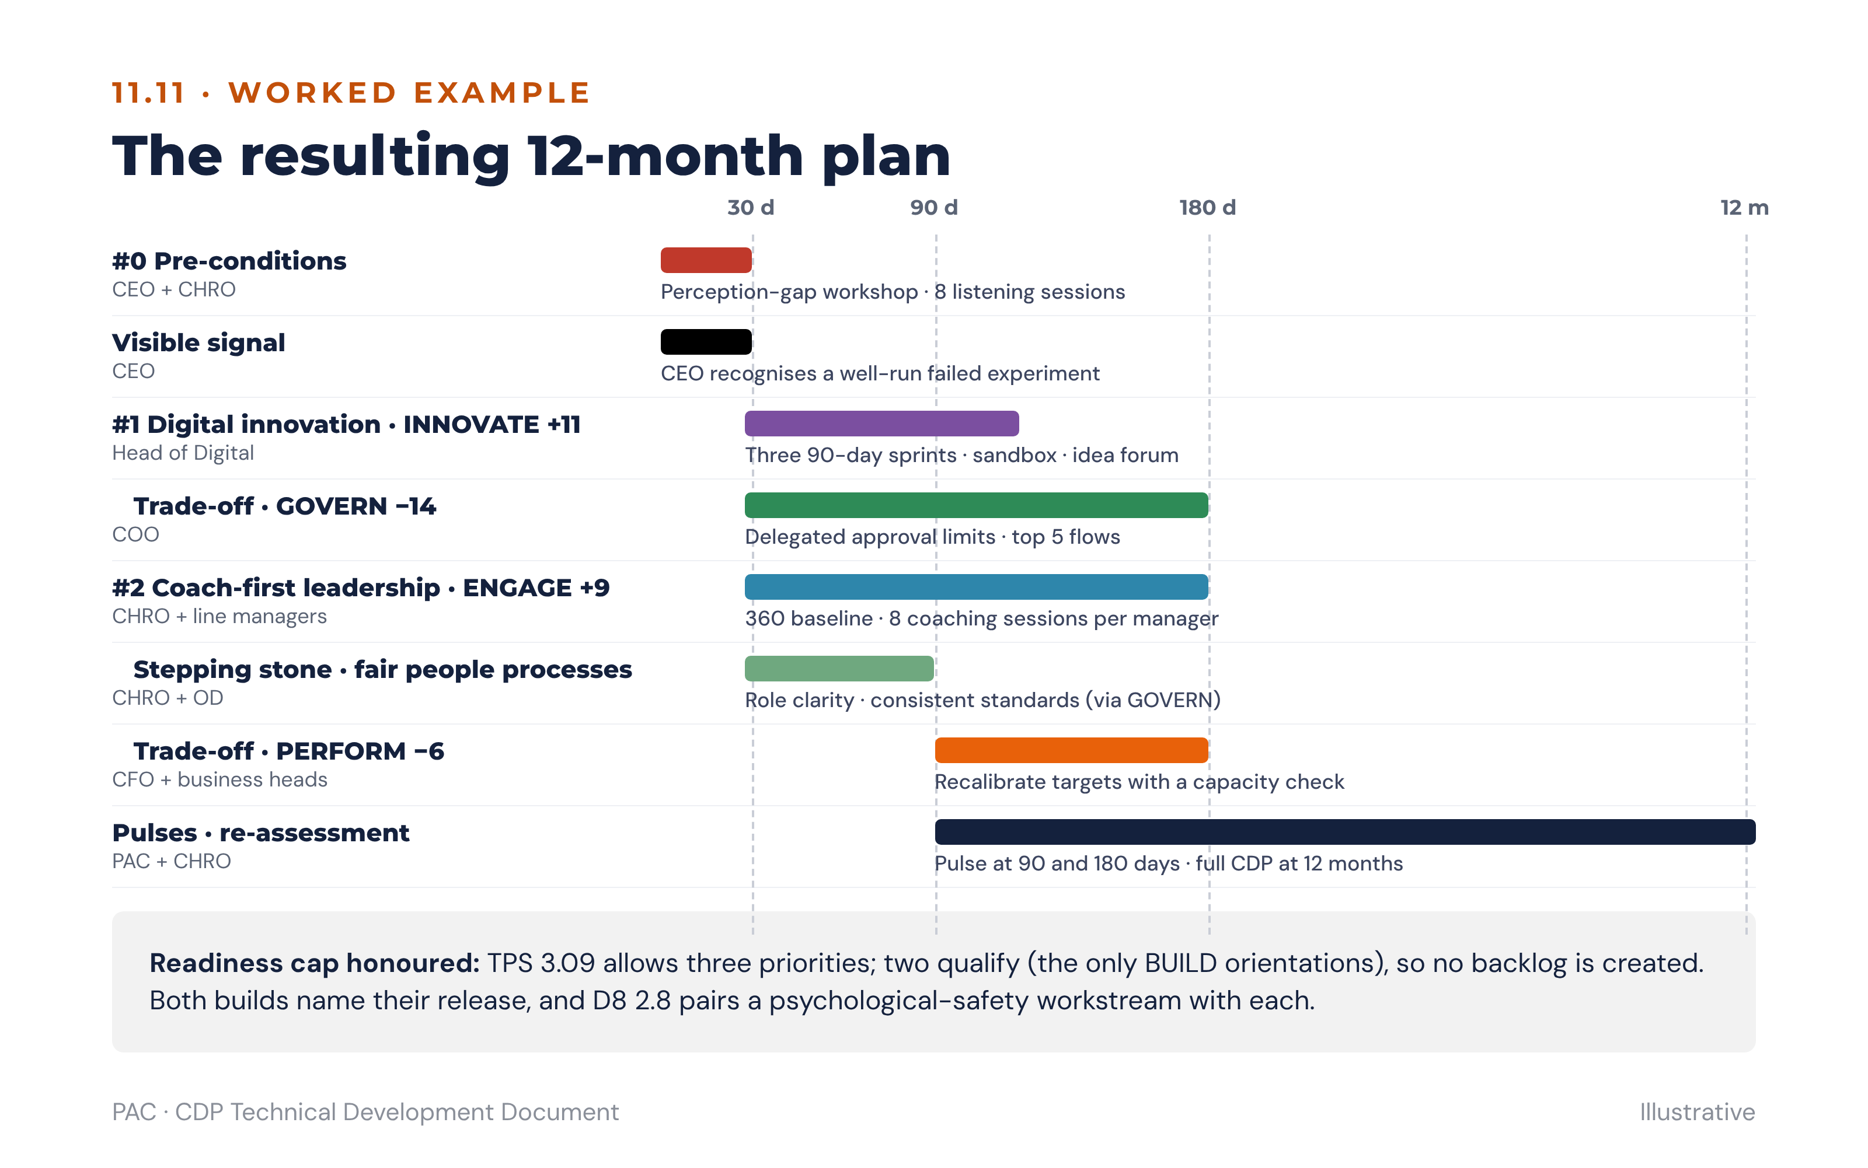
Figure B3 · The worked example’s 12-month plan on one timeline

11.12 Reporting templates and their data bindings
The three workshop templates are rendered by the platform from the action records, not filled in by hand. Each field below is bound to a source; fields marked human are entered in the co-design workshop and are never generated (8.2).

11.12.1 Culture action plan summary
One row per strategic priority (maximum four, plus priority zero), followed by four summary panels. Rendered as the first page of the action plan report (8.10).
Field | Bound to | Source
Strategic priority | priority.sequence and title | Engine; title human
CDP orientation | priority.orientation | Engine
NOW → PREFERRED (gap) | Organisation orientation scores and priority.gap | Scoring service
Classification | priority.classification | Engine (6.2)
Hits & Misses signal(s) | Linked findings of type C1–C4, flags | Engine (6.3, 6.4)
Owner (role) | priority.owner_role from the urgency tier; named owner | Engine; name human
Urgency tier | priority.urgency_tier | Engine (6.7)
Key deliverable and date | Lead action’s objective and end_date | Human
Panel: readiness gates applied | TPS, D7, D8, D9 values and the gate rules that fired | Engine (6.6)
Panel: trade-offs agreed | priority.trade_off_orientation and its giving-effect action | Engine; wording human
Panel: pre-conditions | Priority zero items and completion status | Engine; status human
Panel: keep and protect | KEEP & PROTECT orientations and Setup Section G5 | Engine + Setup

11.12.2 Strategic priority card
One card per priority, rendered as the detail page that follows the summary and as the one-page commitment charter at launch.
Card field | Bound to | Source
Orientation and evidence | Orientation, gap, classification, check verdicts and signals | Engine
Why it matters | Setup Section B strategic goal and the Section C/D KPI on scorecard_link | Setup
Pathway and bridging narrative | priority.pathway, relationship, stepping_stone, narrative from 6.5 | Engine
Practices to START / STOP | Actions’ intervention grouped by start or stop | Playbook draft; human edit
Practices to KEEP and PROTECT / do LESS of | Keep-and-protect list; trade-off action | Engine; human edit
Target behaviours (leaders; staff and teams) | Observable behaviour statements on the actions | Human
Action steps | Organisation-level actions in priority-score order (8.3) | Engine draft; human
Measures | kpi, baseline and target (business, from playbook 11.x.3); cdp_remeasure_watchlist and eOS categories | Playbook default; human values
30-day visible signal | The action with is_visible_signal = true | Playbook default; human
Owner · deliverable · date · reviews | owner, objective, end_date, review_points (30/90/180) | Human; reviews default

11.12.3 Four-level commitment matrix
For each priority, what changes at each level. Rows are levels; columns are the five commitments. Each cell lists the actions at that level whose start/stop/keep tag matches the column.
Level | Do MORE of | Do LESS of | START | STOP | KEEP the same
Individual (each leader) | Development actions (8.6) | Overplay behaviours from the growth-orientation blind spots | START commitments | STOP commitments | KEEP commitments
Team | Team commitments from the unit plan
Department / unit | Unit actions (cap three per cycle)
Organisation | Organisation-wide actions with system levers | Trade-off orientation’s overplay |  |  | Keep-and-protect list
The matrix is valid for publication only when every level carries at least one commitment, enforcing the four-level rule in 6.7.

11.13 Instrument-to-action cross-reference
Each dimension carries three scenarios, in the order S1 · S2 · S3. “D2 S2” is Dimension 2, second scenario: how leaders invest time. The lever column is the default system_lever family for actions whose watch-list cites that dimension.
Dimension | Scenarios | Primary action lever
D1 Cultural DNA | Organisational character · New employee experience · Response to adversity | Identity narrative; onboarding; incident and failure-response protocols
D2 Leadership Blueprint | Leadership orientation · How leaders invest time · What leaders are recognised for | Leadership development; 360 feedback; leadership KPIs (Check C2)
D3 People Architecture | Management philosophy · Development approach · Performance conversations | Performance management; L&D; manager capability (Check C2)
D4 Cohesion Drivers | Bonding mechanism · What makes people stay · Identity through change | Bridging narrative; retention; change communication (Check C3)
D5 Strategic Compass | Strategic orientation · Resource allocation · Long-term investment | Budgeting and portfolio decisions; strategy cascade (Check C1)
D6 Victory Conditions | Success definition · What gets celebrated · Measurement philosophy | Recognition rituals; scorecards; reward (Checks C1, C3)
eOS categories route to playbooks as specified at 2.7.2; once a category is acted on, it is added to the priority’s re-measurement watch-list so the next survey tests whether the action worked.

11.14 Ethical use in action planning
Action plans address organisational culture, never individuals. No cohort below the reporting floor is reported (3.6). Results are presented by a trained PAC facilitator or certified CDP practitioner, and no culture finding, carrier or blocker classification or development plan is used in any performance, remuneration, succession or disciplinary decision; the platform blocks those export paths (1.4.5, 5.3).

12. Report Composition Engine

12.1 Principle
The platform writes complete reports, with suggestions that fit the organisation in front of it, by joining three things it already holds: the findings the rules engine produces (section 6), the reference library built from the action planning content in section 11, and the report templates in sections 3, 5, 7 and 8. A fourth component, the composition engine specified here, selects the right library entries for each finding, fills them with the organisation’s own numbers, KPIs and names, and assembles every section of every report.
Three rules govern it, in the same spirit as the separation of scoring and interpretation (1.1):
- The engine selects; it never invents. Every suggestion in a report is a reference-library entry chosen by a deterministic, explainable fit score, and carries the finding and the entry that justify it.
- The AI panel phrases; it never chooses. The panel may rewrite, shorten and sequence the selected content for the audience. It may not add a suggestion, drop a mandatory one, or change a number (6.12).
- The practitioner decides. A composed report is a complete draft. A PAC Consultant reviews, edits and releases it, and every edit is recorded against the suggestion it changed.
Because selection is deterministic, a report can be composed in full even with the AI panel switched off: the template sentences in 12.7 produce a complete, releasable draft, and the panel only improves its prose.
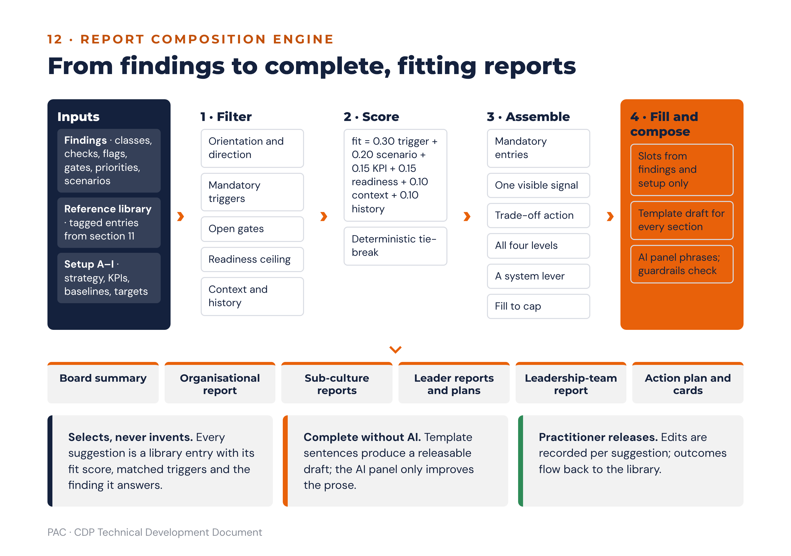
Figure 21 · The report composition pipeline: findings and the reference library in, complete draft reports out

12.2 The reference library as structured data
Every element of the action planning reference (section 11) and the scenario templates (8.9) is stored as a tagged library entry. Tags, not free text, are what let the engine decide whether an entry fits.
Field | Type | Purpose
entry_id | identifier | Stable identity, e.g. INN-ACT-07. Never reused.
entry_type | enum | narrative · candidate_action · system_lever · kpi · visible_signal · watchlist · interaction · blind_spot · bridging_narrative · risk · hypothesis · scenario_template
orientation | enum | ENGAGE · INNOVATE · PERFORM · GOVERN
direction | enum | build · moderate · keep · any
level | enum | leader · team · unit · organisation
horizon | enum | quick win 0–3m · medium 3–12m · structural 12m+
system_lever | enum | performance management · promotion · reward · onboarding · recognition ritual · decision rights · none
triggers | list of conditions | What must be true for the entry to apply, e.g. class == BUILD, C1 == MISS, D8 <= 3.0, pathway == DIAGONAL, scenario == SC-01. Each is marked mandatory or supporting.
scenario_links | list of SC ids | Scenarios (6.8) whose template uses the entry.
effort_default | integer 1–5 | Default effort rating (8.3); the workshop can adjust it.
impact_default | integer 1–5 | Default impact before finding-based derivation.
context_tags | list | Sector and business-model tags (Setup Section A, 6.3.3). Empty means applies everywhere.
technology_dependent | boolean | Triggers the D7 digital-adoption gate (6.6).
kpi_refs | list | KPI suggestions from the playbook metrics tables, each with a metric name and unit.
watchlist | list | Dimension scenarios and eOS categories the entry is expected to move.
text | template with slots | The wording, with slots such as {orientation}, {gap}, {unit}, {kpi}, {baseline}, {target}, {date}, {trade_off}, {narrative}.
source | reference | Section of this document the entry comes from, e.g. 11.8.4.
version, status | string, enum | Versioned with the rules; draft · approved · retired. Only approved entries are selectable.

12.2.1 How the section 11 content becomes entries
Section 11 content | Entry type | Tags applied
Orientation profile, “where it shows” (11.x.1) | narrative | orientation; direction any; used in report sections describing the profile
Overplay risks and culture blind spots (11.x.1, 11.x.3) | blind_spot | orientation; direction moderate; level organisation and team
Personal blind spots; leadership blind spot to avoid (11.x.3) | blind_spot | orientation; level leader; used in leader reports and development plans
Interaction matrix cells (11.x.2) | interaction | from-orientation (row culture), with-orientation (column), level; relationship complement or contrast
Headline metric and supporting indicators (11.x.3) | kpi | orientation; headline flagged primary; unit and direction of good
Actions individuals and leaders can take (11.x.4) | candidate_action | orientation; direction build; level leader; horizon quick win or medium
Priorities the team or organisation can set (11.x.4) | candidate_action | orientation; direction build; level team, unit or organisation; horizon medium or structural
HR and system levers (11.x.4) | system_lever | orientation; direction build; level organisation; horizon structural; lever named
Visible signal within 30 days (11.x.4) | visible_signal | orientation; horizon quick win; mandatory trigger class in [BUILD, STRENGTHEN]
CDP re-measurement watch-list (11.x.4) | watchlist | orientation; default watch-list for every action on the orientation
Bridging narrative and core interventions (6.5) | bridging_narrative, candidate_action | from and to orientation; relationship; difficulty
Stepping-stone rationale (6.5.1) | candidate_action | to-orientation; via-orientation; mandatory trigger stepping_stone == via
Scenario diagnosis, risks, hypotheses (6.8) | risk, hypothesis | scenario link; severity
Scenario action-plan templates (8.9) | scenario_template, candidate_action | scenario link; mandatory actions flagged mandatory
Instrument-to-action levers (11.13) | system_lever | dimension; lever family
Moderating an orientation. The playbooks describe how to build each orientation. Suggestions for an orientation classified MODERATE come from three places in this order: that orientation’s overplay and culture blind spots (what to stop or reduce), the trade-off action named on the BUILD priority it serves, and the KEEP elements the bridging narrative preserves. The engine therefore always frames a moderation as “less of the overplay, keep the healthy form”, never as removing the orientation.
Faculty authoring. PAC faculty add and edit entries in a library console without a code release. A new entry is draft until a second faculty member approves it, and every report records the library version it was composed under, so a released report can always be reconstructed.

12.3 Selecting fitting suggestions
Selection runs once per priority and once per report section that carries suggestions. It has two stages: hard filters that remove entries that do not apply, then a fit score that ranks the rest.

12.3.1 Hard filters
An entry is excluded if any of the following is true:
Filter | Rule
Orientation and direction | Entry orientation and direction do not match the priority (or the trade-off, for moderate entries).
Mandatory trigger | Any trigger marked mandatory is false, e.g. a D7 adoption-plan entry when D7 > 3.0.
Gate | The entry’s horizon or level is not permitted by an open readiness gate (6.6); content entries are excluded while a blocking gate on the orientation is open, leaving only priority-zero entries.
Readiness ceiling | Effort exceeds the ceiling for the TPS band by more than one point. Ceilings: HIGH RISK 2, ENABLEMENT REQUIRED 3, TARGETED SUPPORT 4, STRONG READINESS 5.
Context | The entry carries context tags and none matches the tenant’s sector or business model.
History | The same entry was retired with outcome “not achieved” in this tenant in each of the last two cycles.
Status | Entry is not approved, or belongs to a library version other than the one pinned to the assessment.

12.3.2 Fit score
fit = 0.30 × trigger_match # share of the entry's supporting triggers that are true
+ 0.20 × scenario_match # 1 if linked to a matched scenario (6.8), else 0
+ 0.15 × kpi_link # 1 if a kpi_ref matches a Setup C/D strategic KPI on this orientation, else 0
+ 0.15 × readiness_fit # 1 if effort ≤ ceiling, 0.5 if one point above
+ 0.10 × context_fit # 1 if a context tag matches, 0.5 if the entry is untagged
+ 0.10 × history_fit # 1 normally; 0 if retired “not achieved” in this tenant last cycle
All six terms are on 0–1, the weights sum to 1.00 and are asserted in code, and the score is held to two decimals with half-up rounding. Ties break on lower effort, then on entry_id, so the same assessment always yields the same suggestions in the same order.

12.3.3 Assembling a suggestion set
For each priority the engine builds the set in this order, stopping at the caps in 8.3.1:
- Mandatory entries first: gate-driven entries (for example the psychological-safety workstream when D8 ≤ 3.0), the stepping-stone entry for a routed diagonal shift, and the mandatory actions of every matched scenario template.
- The visible signal: the highest-fit visible_signal entry; exactly one per priority.
- The trade-off action: the highest-fit moderate entry for the named trade-off orientation.
- Coverage by level: the highest-fit entry at each of leader, team, unit and organisation level not yet covered, so the four-level commitment matrix (11.12.3) is never empty.
- Coverage by lever: if no selected entry touches a system lever in the medium or structural horizon, the highest-fit system_lever entry.
- Remaining capacity: further entries in fit order until the cap.
Each selected suggestion is stored with its fit score, the triggers that matched, the entries it outranked and the reason for any exclusion, so the consultant can see in the review screen why the engine proposed it and what it considered instead.

12.3.4 Slot filling
Slots are filled only from the scored assessment, the findings and the setup record: orientation names, gaps, unit names, KPI names, baselines and targets from Setup Sections C and D, owner roles from the urgency tier, dates from the review cadence. A slot with no source value is left as a highlighted field for the workshop to complete; the engine never fills a named owner, a budget or a target value it has not been given (8.2).

12.4 What each report draws from the library
Report and section | Deterministic content | Library-driven content
Board summary · the three findings that matter (7.3) | Top three findings by severity, with evidence | Scenario risk entries, one business consequence per finding
Board summary · priorities, owners, dates | Selected priorities, urgency tiers, gates | Priority titles from scenario templates; visible signal per priority
Organisational report · profile (7.4 §3) | Profile, gaps, classifications | Orientation narratives; overplay text for each MODERATE orientation
Organisational report · alignment checks (§5) | Verdicts, percentages, overrides | Check-specific risk text; C2 intensity wording (6.3.4)
Organisational report · readiness (§7) | TPS, D7–D9, bands, gates | Gate actions (safety workstream, change infrastructure, adoption plan)
Organisational report · what to do next (§12) | Priority list and trade-offs | Full suggestion set per priority (12.3.3)
Sub-culture report · what to do next (3.7 §8) | Unit classification and divergence | Interaction-matrix cell for the unit’s dominant orientation against the organisation’s target, at unit level; unit actions (cap three)
Leader report · behaviour gap the organisation needs (5.5 §7) | BUILD orientation, leader score, gap | Bridging narrative in first person; leader-level interaction cell; personal blind spots of the leader’s default orientation
Leader report · development plan (5.5 §9) | Growth orientation, self–other tiers, flags | Leader-level candidate actions on the growth and BUILD orientations; observable START/STOP/KEEP wording
Leadership-team report · what to do next (5.6 §8) | Carrier/blocker distribution, collective blind spots | Leader-level actions for the collective growth orientation; coaching commitment entries
Action plan report and priority cards (8.10, 11.12) | Priority fields, gates, trade-offs, dates | Every card field marked “playbook draft” in 11.12.2
Pulse design (8.8) | Priority watch-lists | Watch-list entries of the selected suggestions

12.5 Composing the narrative
The composition engine produces, for every report section, a structured section object: the deterministic tables and charts, the selected suggestions with their filled text, and a template draft of the narrative written from fixed sentence patterns. That object is the complete input to the AI panel (6.12.1).
The panel returns the section in the fixed JSON contract with, for every sentence, the finding ids and entry ids it relies on. The guardrails in 6.12.4 apply in full, plus two specific to composition:
Guardrail | Rule
Suggestion integrity | The set of entry ids cited in the panel’s output must equal the selected set. A missing mandatory entry or an extra entry blocks the draft.
Wording drift | Rephrasing is permitted; changing the action, owner role, horizon, lever or KPI of a suggestion is not. The platform compares the structured fields, not the prose.
If the panel is unavailable, times out or is blocked by a guardrail, the template draft is used as it stands. Reports therefore never wait on, and never depend on, the AI panel.

12.5.1 Template sentence patterns
Section | Pattern
What this means | “The culture as measured {does / does not} support the declared strategy, principally because {headline finding with evidence}. The consequence over the next {horizon} is {scenario risk}. Readiness is {TPS band}, which permits {n} priorities{, staged through {stepping stone}}.”
Priority statement | “Build {orientation} (gap {gap}, {classification}) to serve {strategic goal}. To make room, the organisation will {trade-off action}. Pathway: {from} → {to}, {relationship}; “{bridging narrative}”.”
Action line | “{Action text}. Owner: {owner role}. Measure: {KPI}, from {baseline} to {target} by {date}. Review at 30, 90 and 180 days.”
Visible signal | “Within 30 days, {signal text}, so that staff see the change is real.”
Pre-condition | “Before any intervention on {orientation} is announced, {gate action} is completed by {date} ({owner}).”
Leader development | “Your strongest habit is {default orientation}; the organisation needs more {BUILD orientation}. In the next 30 days, {START behaviour}; stop {STOP behaviour}; keep {KEEP behaviour}.”

12.6 Completeness checks before release
The release action (7.1) is blocked until every check passes:
Check | Pass condition
Sections | Every mandatory section of the report type has content, including “what this means” and “what to do next”.
Traceability | Every recommendation cites at least one finding and one library entry.
Coherence | Every BUILD priority has a trade-off action; every priority has one visible signal dated within 30 days; the commitment matrix has an entry at all four levels.
Gates | No suggestion sits on an orientation with an open blocking gate, other than priority-zero items.
Measures | Every organisation-level suggestion has a KPI; baseline and target are present or explicitly flagged for the workshop.
Numbers | Every number in the narrative matches the findings payload (6.12.4).
Language | Terminology screen and causal-language screen pass (6.12.4).
Ethics | No leader classification, flag or development content appears outside the audiences permitted in 1.3 and 5.3.

12.7 Learning from outcomes
When an action closes, its outcome (achieved, partially achieved, not achieved, superseded; 8.4) is recorded against the library entry it came from, together with the TPS band, sector and orientation context. The platform reports, to PAC faculty only, each entry’s outcome rate by context, with the number of closures behind it. This is an association record, never a causal claim (8.8).
The fit score uses outcomes in only one way: an entry retired “not achieved” in the same tenant loses its history_fit in the next cycle, and is excluded after two such cycles (12.3.1). Cross-tenant outcome rates never change ranking automatically. Faculty review them each quarter, and an entry with at least 20 closures and a not-achieved rate above 60% in a context is reviewed for rewording, re-tagging or retirement. Changes are released as a new library version.

12.8 Worked example: the INNOVATE priority
The context is the worked example in 11.11: financial services, service (B2C) model, TPS 3.09 (ENABLEMENT REQUIRED, effort ceiling 3), INNOVATE BUILD with a C1 MISS, digital adoption tagged as the INNOVATE strategic KPI, D7 3.2, D8 2.8, matched scenarios SC-01 and SC-05 (neither on INNOVATE).
Entry | Suggestion (abridged) | Level · lever | Trig. | Scen. | KPI | Ready | Ctx | Hist | Fit | Result
SAFE-01 | Psychological-safety workstream paired with the build | Organisation | — | — | — | — | — | — | — | Mandatory (D8 ≤ 3.0)
INN-ACT-07 | Three 90-day customer-journey innovation sprints with a ring-fenced budget | Organisation · decision rights | 1.0 | 0 | 1 | 1 | 0.5 | 1 | 0.75 | Selected 1
INN-LEV-03 | Remove at least two approval layers below a defined value (trade-off: GOVERN) | Organisation · decision rights | 1.0 | 0 | 0 | 1 | 1 | 1 | 0.65 | Selected as trade-off
INN-LEV-01 | Innovation or improvement objective in managers’ scorecards | Organisation · performance management | 1.0 | 0 | 0 | 1 | 0.5 | 1 | 0.60 | Selected 2 (lever)
INN-SIG-01 | Publicly celebrate a well-run experiment that failed, and share what was learned | Organisation · recognition ritual | 1.0 | 0 | 0 | 1 | 0.5 | 1 | 0.60 | Visible signal
INN-ACT-02 | Leaders back one team experiment each quarter and review it openly | Leader | 1.0 | 0 | 0 | 1 | 0.5 | 1 | 0.60 | Selected (leader level)
INN-ACT-04 | Co-create on one customer-journey problem each quarter and review openly what worked | Team | 1.0 | 0 | 0 | 1 | 0.5 | 1 | 0.60 | Selected (team level)
INN-ACT-09 | Create a unit idea space with time and structure for divergent thinking | Unit | 1.0 | 0 | 0 | 1 | 0.5 | 1 | 0.60 | Selected (unit level)
INN-ACT-11 | Innovation portfolio with ring-fenced budget and a new-offerings revenue KPI | Organisation · structural | 1.0 | 0 | 0 | 0.5 | 0.5 | 1 | 0.53 | Selected 3, effort flagged
INN-ACT-14 | Digital adoption plan with a named executive sponsor | Organisation | — | — | — | — | — | — | — | Excluded: mandatory trigger D7 ≤ 3.0 false
For INN-ACT-07: 0.30 × 1.0 + 0.20 × 0 + 0.15 × 1 + 0.15 × 1 + 0.10 × 0.5 + 0.10 × 1 = 0.75. INN-ACT-11 scores 0.525, reported as 0.53, and is selected with its effort flagged for the workshop because it is one point above the ceiling.
Composed text (template draft, before AI phrasing). “Build INNOVATE (gap +11, BUILD) to serve the strategy to grow digital channels. To make room, the organisation will remove at least two approval layers below a defined value. Pathway: PERFORM → INNOVATE, adjacent; ‘Tomorrow’s targets depend on today’s experiments.’ Run three 90-day customer-journey innovation sprints with a ring-fenced budget. Owner: Head of Digital. Measure: digital channel adoption, from 28% to 45% by September 2027. Review at 30, 90 and 180 days. Within 30 days, the CEO publicly celebrates a well-run experiment that failed and shares what was learned, so that staff see the change is real. Before any intervention on ENGAGE or GOVERN is announced, the perception-gap workshop is completed (CEO and CHRO).”
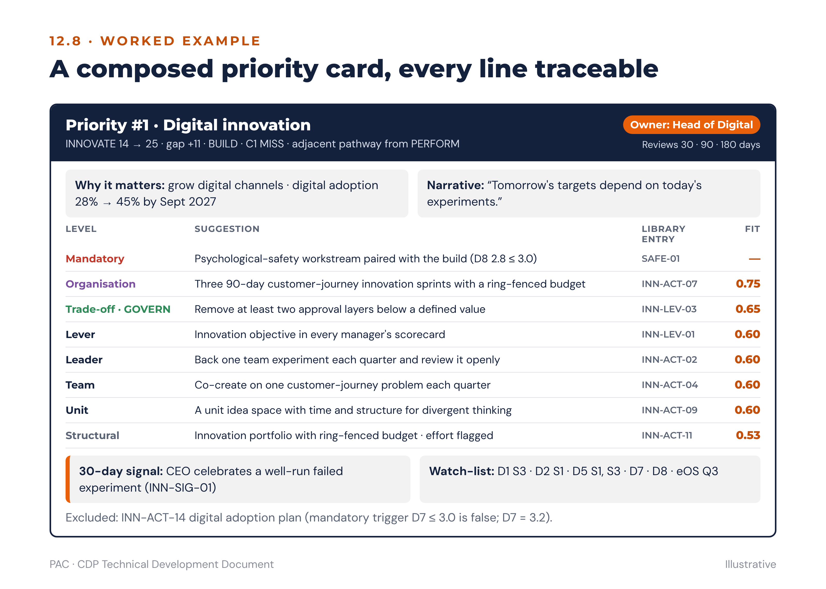
Figure 22 · A composed priority card, showing each suggestion’s source entry and fit

12.9 Build artefacts for the composition engine

12.9.1 Schema additions
Table | Key fields | Relationships
library_entry | entry_id, library_version_id, entry_type, orientation, direction, level, horizon, system_lever, triggers_json, scenario_links, effort_default, impact_default, context_tags, technology_dependent, kpi_refs_json, watchlist, text_template, source_ref, status, approved_by | Replaces the reference_library row in 10.1; immutable once approved.
library_version | library_version_id, rules_version_id, published_at, published_by | Pinned on every assessment alongside the instrument and rules versions.
suggestion | suggestion_id, assessment_id, priority_id, report_section, entry_id, fit_score, fit_terms_json, matched_triggers, rank, selected, exclusion_reason, filled_text, unfilled_slots | One row per considered entry, selected or not.
composed_section | section_id, report_id, section_code, deterministic_json, suggestion_ids, template_draft, ai_draft_id, final_text, edited_by | The section object of 12.5.
suggestion_edit | edit_id, suggestion_id, field, before, after, editor_id, at | Records every practitioner change.
entry_outcome | entry_id, action_id, tenant_id, outcome, tps_band, sector, closed_at | Feeds the faculty outcome report (12.7).

12.9.2 API additions
Method and path | Purpose | Notes
POST /v1/assessments/{id}/compose | Select suggestions and compose every section of a report type | Deterministic; idempotent for the same versions. Returns section objects.
GET /v1/reports/{id}/suggestions | Suggestions with fit terms, matched triggers and exclusions | Consultant only.
PATCH /v1/suggestions/{id} | Edit, swap or remove a suggestion | Removing a mandatory suggestion returns 409. Swaps are limited to entries that passed the hard filters.
GET / POST /v1/library/entries | List and author library entries | Faculty role; new entries start as draft.
POST /v1/library/versions | Publish a library version | Requires a second faculty approval.
GET /v1/library/outcomes | Outcome rates by entry and context | Faculty only; counts shown with every rate.

12.9.3 Unit tests
ID | Test | Input | Expected output
UT-57 | Fit score | Entry terms 1.0, 0, 1, 1, 0.5, 1 | 0.75; weights sum asserted to 1.00
UT-58 | Mandatory trigger filter | D7 3.2; entry with mandatory D7 ≤ 3.0 | Excluded with reason recorded
UT-59 | Readiness ceiling | TPS 3.09; entries with effort 3, 4 and 5 | readiness_fit 1 and 0.5; effort-5 entry excluded
UT-60 | Set assembly | Worked example INNOVATE priority | Selected set exactly as in 12.8; one visible signal; trade-off present; all four levels covered
UT-61 | Determinism | Compose the same assessment 100 times | Identical suggestion ids, order and filled text
UT-62 | No invented slot | Setup with no target for the KPI | Target slot left unfilled and flagged; no value generated
UT-63 | Suggestion integrity | AI draft omitting a mandatory entry | Draft blocked; template draft used
UT-64 | AI-off composition | Panel disabled | Complete report with every mandatory section; release checks pass
UT-65 | Gate exclusion | SHADOW CULTURE open on ENGAGE | No ENGAGE content suggestions outside priority zero
UT-66 | History rule | Entry retired “not achieved” in the two previous cycles | Excluded; one previous cycle only → history_fit 0
UT-67 | Moderation framing | GOVERN classified MODERATE as trade-off | Suggestions drawn from GOVERN overplay entries and the trade-off action; no entry removes GOVERN’s KEEP elements
UT-68 | Library version pinning | Re-compose a released report after a library update | Uses the pinned library version; output unchanged

12.9.4 Delivery
The composition engine is built in phase P7 (Reporting) on top of the P5 rules engine, with the library console and outcome reporting in P8 and P9. P7 acceptance adds UT-57 to UT-65 and UT-68; P9 adds UT-66 and the faculty outcome report. The section 11 content is loaded as library version 1.0 in P5, so that draft actions in P8 and composed reports in P7 draw on the same entries from the start.
End of document.

