**NAME: KARUSALA DEEPAK CHOWDARY**

**REGISTRATION NUMBER: 19BCS050**

**DBMS LAB ASSIGNMENT – 2**

**travel agency**

1. Show how to Create and Drop Database

**QUERY**

CREATE DATABASE COMPANY

DROP DATABASE COMPANY

**OPUTPUT**

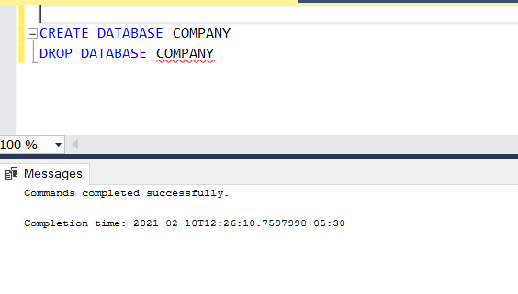

1. Show all the Databases are in the system

**QUERY**

SELECT * FROM sys.databases where database_id>0

**OPUTPUT**

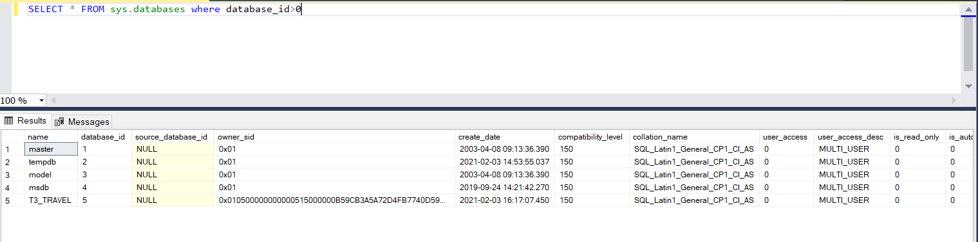

1. Create Table for your Database

**QUERY**

USE TEAM3_TRAVEL;

CREATE TABLE T3_CUSTOMER_DETAILS

(

Customer_ID CHAR(10) PRIMARY KEY NOT NULL,

First_Name VARCHAR(20) NOT NULL,

Last_Name VARCHAR(20) NOT NULL,

Age INT NOT NULL,

Gender CHAR(1) NOT NULL,

Phone_No VARCHAR(12) NOT NULL,

A1ddress TEXT NOT NULL

);

CREATE TABLE T3_BOOKING_DETAILS

(

Customer_ID CHAR(10) FOREIGN KEY REFERENCES T3_CUSTOMER_DETAILS(Customer_ID) NOT NULL,

Booking_ID CHAR(7) PRIMARY KEY NOT NULL,

Payment_Amount DECIMAL(10,2) NOT NULL,

Payment_Date_Time DATETIME NOT NULL,

Refund CHAR(1),

Refunded_Amount DECIMAL(10,2),

Refund_Date_Time DATETIME

);

CREATE TABLE T3_HOTELS_AT_DESTINATION

(

City_ID CHAR(4) PRIMARY KEY NOT NULL,

Hotel_ID CHAR(3) NOT NULL,

Hotel_Name VARCHAR(10) NOT NULL,

Hotel_Description TEXT NOT NULL,

Address TEXT NOT NULL

);

CREATE TABLE T3_PACKAGE_DETAILS

(

Package_Name VARCHAR(15) PRIMARY KEY NOT NULL,

Package_Description TEXT NOT NULL,

Cost DECIMAL(10,2) NOT NULL,

Starting_Point VARCHAR(15) NOT NULL,

Booking_ID CHAR(7) FOREIGN KEY REFERENCES T3_BOOKING_DETAILS(Booking_ID) NOT NULL

);

CREATE TABLE T3_DESTINATION_DETAILS

(

Package_Name VARCHAR(15) PRIMARY KEY NOT NULL,

City_ID CHAR(4) FOREIGN KEY REFERENCES T3_HOTELS_AT_DESTINATION(City_ID) NOT NULL,

City VARCHAR(15) NOT NULL

);

CREATE TABLE T3_EMPLOYEE_DETAILS

(

Employee_ID CHAR(5) PRIMARY KEY NOT NULL,

Name VARCHAR(10) NOT NULL,

Designation VARCHAR(15) NOT NULL,

Phone_Number VARCHAR(12) NOT NULL,

Salary DECIMAL(10,2) NOT NULL

);

CREATE TABLE T3_CAR

(

Package_Name VARCHAR(15) FOREIGN KEY REFERENCES T3_PACKAGE_DETAILS(Package_Name) NOT NULL,

Car_ID CHAR(10) PRIMARY KEY NOT NULL,

Car_Model VARCHAR(10) NOT NULL,

Employee_ID CHAR(5) FOREIGN KEY REFERENCES T3_EMPLOYEE_DETAILS(Employee_ID) NOT NULL,

DateAndTime_Of_Pickup DATETIME NOT NULL,

DateAndTime_Of_Drop DATETIME NOT NULL

);

CREATE TABLE T3_BUS

(

Package_Name VARCHAR(15) FOREIGN KEY REFERENCES T3_PACKAGE_DETAILS(Package_Name) NOT NULL,

Bus_ID CHAR(4) PRIMARY KEY NOT NULL,

Bus_Type VARCHAR(10) NOT NULL,

Employee_ID CHAR(5) FOREIGN KEY REFERENCES T3_EMPLOYEE_DETAILS(Employee_ID) NOT NULL,

DateAndTime_Of_Arrival DATETIME NOT NULL,

DateAndTime_Of_Departure DATETIME NOT NULL

);

CREATE TABLE T3_FLIGHT

(

Package_Name VARCHAR(15) FOREIGN KEY REFERENCES T3_PACKAGE_DETAILS(Package_Name) NOT NULL,

Flight_ID CHAR(8) PRIMARY KEY NOT NULL,

Flight_Class VARCHAR(10) NOT NULL,

DateAndTime_Of_Boarding DATETIME NOT NULL,

DateAndTime_Of_Landing DATETIME NOT NULL

);

CREATE TABLE T3_TRAIN

(

Package_Name VARCHAR(15) FOREIGN KEY REFERENCES T3_PACKAGE_DETAILS(Package_Name) NOT NULL,

Train_No CHAR(8) PRIMARY KEY NOT NULL,

Train_Class VARCHAR(10) NOT NULL,

DateAndTime_Of_Arrival DATETIME NOT NULL,

DateAndTime_Of_Departure DATETIME NOT NULL

)

**OUTPUT**

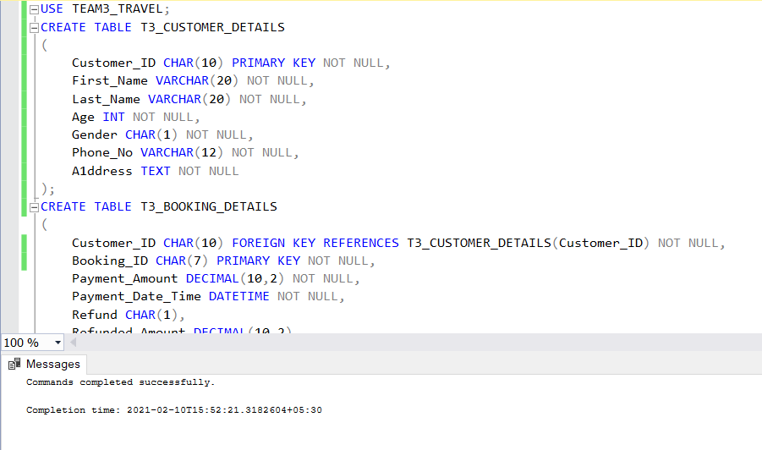

1. Drop table

**QUERY**

CREATE TABLE MY_FRIENDS

(

First_Name VARCHAR(20) NOT NULL,

Last_Name VARCHAR(20) NOT NULL,

Gender CHAR(1) NOT NULL,

Phone_Number VARCHAR(12) NOT NULL,

DOB DATE NOT NULL,

Address_details TEXT,

Intrests TEXT

)

DROP TABLE MY_FRIENDS

**OUTPUT**

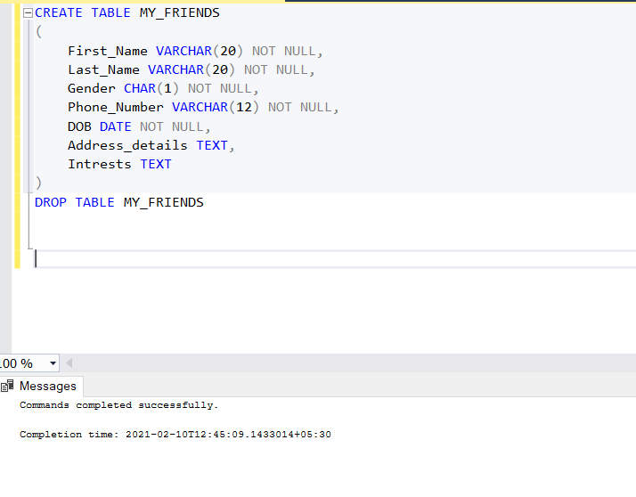

1. Show how to check the schema of the tables

**QUERY**

USE TEAM3_TRAVEL;

EXEC sp_help T3_BOOKING_DETAILS

**OUTPUT**

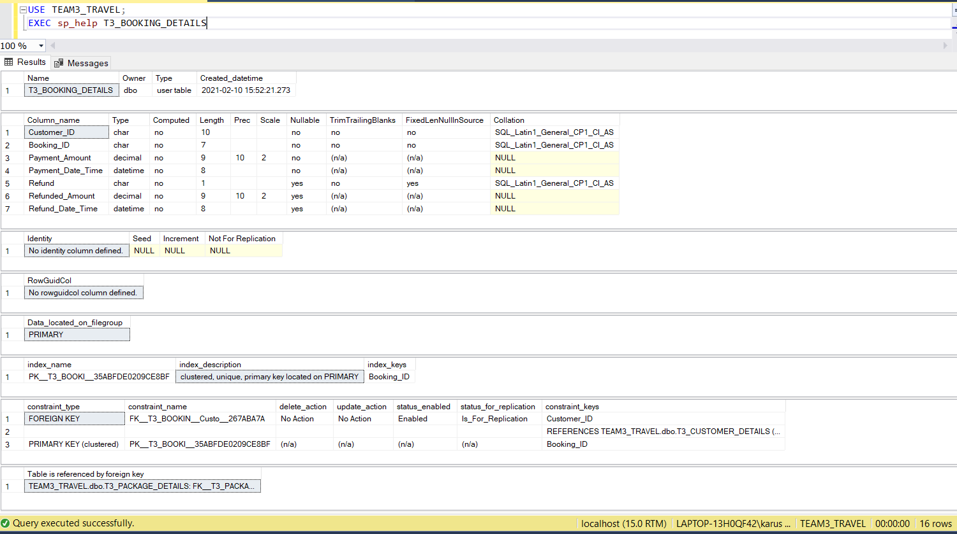

1. Show all the tables from the database (This is not done in class.)

**QUERY**

SELECT * FROM SYSOBJECTS WHERE xtype='U';

**OUTPUT**

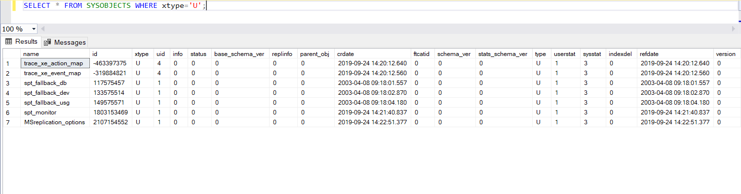

1. Create Table using Select Statement (I haven’t showed you this. I want you to try, it is very simple you should not have any problem).

**QUERY**

USE TEAM3_TRAVEL;

SELECT Employee_ID, Name, Salary INTO EMPLOYEE_INFO FROM T3_EMPLOYEE_DETAILS

**OUTPUT**

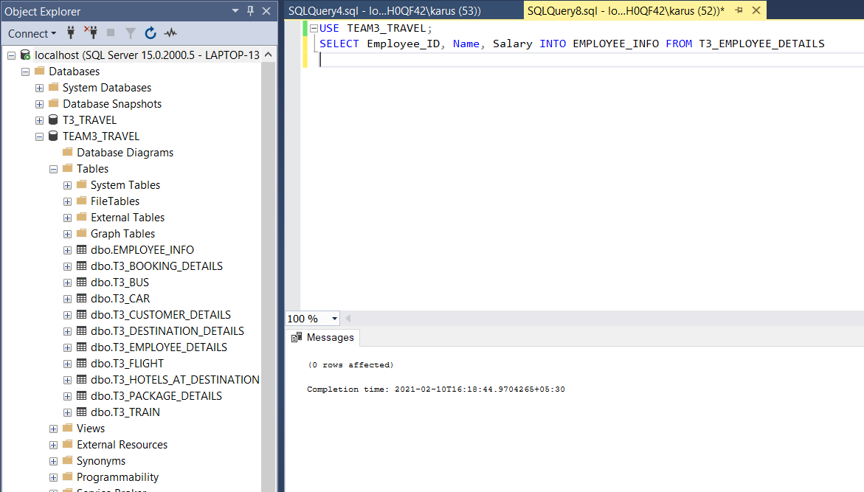

1. Create a table which has derived attribute. (Example can be Age is a derived attribute from Date of Birth. You should try this as well).

**QUERY**

CREATE TABLE MY_FRIENDS_DETAILS

(

First_Name VARCHAR(20) NOT NULL,

Last_Name VARCHAR(20) NOT NULL,

Gender CHAR(1) NOT NULL,

Phone_Number VARCHAR(12) NOT NULL,

DOB DATE NOT NULL,

Age AS DATEDIFF(YEAR,DOB,GETDATE() ) ,

Address_details TEXT

}

**OUTPUT**

