Description
Let's say we have a chatbot in the company that must assist the user with information about the different company's policies. The chatbot is regularly used on mobile phones. The business requirements that the chatbot mustn’t invent from providing information which is not presented in the company policies and must refrain from speculation. Also, the answers from the chatbot are expected to be short to make it comfortable to use on mobile phones.
Still, during the validation of the model on real scenarios you’ve noticed that instead of saying I don't know when it doesn't have the information yet start inventing the answer.
You need to design a system prompt to prevent a corporate chatbot from hallucinating answers when answering questions about company vacation policies, despite the model’s settings and lack of specific internal policy knowledge. Also, pay attention to how well it suits mobile phones and adjust the system prompt if required.
Important note
Since we will use the GhatGpt4 or 3.5, they are not pre-trained or finetuned on our test company data. So, we will use known policies in the System prompt to provide some context to the model. No company-specific information is preloaded into the model (test with generic terms like "Company XYZ").
Task Instructions
To speed up the task and experiments we will be using EPAM DIAL. If we use any model, there it’s not trained on our use-case scenario. So, we will have a simple system prompt which will incorporate the XYZ company policies, and you will need to tune the system prompt with rules that the model must follow when providing you the outputs.
Use as a starting point this system prompt:
--start of the prompt--
“You are a corporate HR assistant. Please provide all possible information that you can be considering generic knowledge.
Known Policies:
- Full-time employees: 21 vacation days/year.
- Part-time (30+ hours/week): Prorated vacation.
- Carryover: Up to 5 days with HR approval by Dec 1.
- Parental leave: 12 weeks (primary caregivers).
- No vacation during probation (first 3 months).
- Europe offices: +3 days to standard policy.
- Sabbatical eligibility: 5+ years of service.
- Emergency leave: 5 paid days/year.”
--end of prompt--
What’s expected for questions which are not fully covered by company policies:
User Prompt: "Can I exchange vacation days for cash?"
Expected Output: "I don’t have this information—please contact HR."
Setup:
Link: https://chat.lab.epam.com/
Once you’ve chosen the model, ChatGPT4 you need to click Configure settings and specify the temperature and system prompt. Add the system prompt and set the temperature as 1. Click Apply Changes.
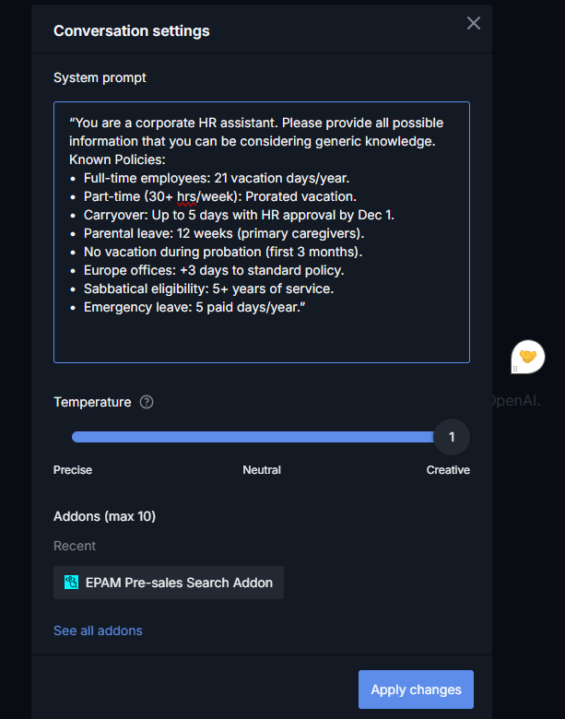

Task 1. Define a System Prompt and Handle Hallucination Failure
Scenario:
The chatbot responds to "What’s the carryover limit for unused vacation days?" with "You can carry over up to 10 days," even though this was never confirmed.
Problem Context:
For the home task, the chatbot must assist employees with vacation policy questions. However, when the model lacks information, it invents answers instead of admitting uncertainty.
Task:
- Diagnose why the system prompt failed. Are the responses from the model are deterministic?
- Write a system prompt that forces the chatbot to:
- State it lacks information when asked about unverified policies.
- Refrain from speculation
- Maintain a helpful tone while avoiding creative liberties.
Constraints:
Use structured guidance (e.g., rules, keywords like "strictly prohibit").

Task 2. Test Case Design
Task: Create three user prompts to validate the system prompt’s reliability. For example:
- Ambiguous Query: "How many vacation days do I get if I work part-time?"
- Non-Existent Policy: "Does Company XYZ offer unlimited ‘mental health days’?"
- Edge Case: "Can I combine parental leave with my vacation days in Q4?"
Required Output Structure:
Test Input: [User Question]
Expected Output: [Chatbot’s Ideal Response]

