**HANOI UNIVERSITY OF SCIENCE AND TECHNOLOGY**

**

**TECHNICAL REPORT**

On the security and reliability performance of SWIPT-enabled full-duplex relaying in the nonorthogonal multiple access networks

**HA VINH PHUOC**

Phuoc.hv215455@sis.hust.edu.vn

**School of Information and Communication Technology**

**Faculty of Computer Science**

|  |  |
| --- | --- |
| **Lecturer:** | PhD. Duong Thanh Tung  Signature of Lecturer |
| **Subject:** | Technical Writing and Presentation |
| **Faculty:** | International Training Institute for Materials Science |
| **HANOI, 12/2023** | |

**Acknowledgement**

I sincerely thank you for your excellent instruction in the Technical Writing and Presentation course in semester 20231. The practical insights and real-life examples you incorporate into the curriculum enrich the curriculum. . added to my understanding of technical writing principles and enhanced my presentation skills. Your constructive feedback on assignments and presentations has been invaluable to my professional development. The collaborative atmosphere you have fostered in your classroom not only deepens students' understanding of the subject matter but also fosters a sense of community among students. Thank you for your unwavering support and dedication to our studies. I look forward to applying the skills and knowledge gained from this course to my future academic and career goals. Thank you again for a truly rewarding learning experience.

**Abstract**

The performance of the simultaneous wireless information and power transfer (SWIPT) enabled full-duplex (FD) relaying in nonorthogonal multiple access (NOMA) networks is investigated in both reliability and security aspects. More precisely, for the viewpoint of reliability, we derive in the closed-form expression the outage probability (OP) at both end-users. On the other hand, intercept probability (IP) is considered a helpful metric to measure the security of the considered systems. Moreover, we derive the IP in the closed-form expression too. Numerical results are also given to confirm the correctness of the derived mathematical framework as well as to identify the insights of both metrics as a function of some key parameters such as the transmit power, the power-splitting (PS) ratio, and the power allocation ratio.

**Table of Contents:**

1. INTRODUCTION 1

2. SYSTEM MODEL 3

2.1. CHANNELL MODELLING 4

2.1.1. Smaill-scale fading 4

2.1.2. Large-scale path-loss 4

2.2. Transmission procedure 4

3. PERFORMANCE ANALYSIS 6

3.1. Outage probability 6

4. NUMERICAL RESULTS 10

5. CONCLUSION 14

REFERENCE 15

**List of figure:**

Figure 1. 3

Figure 2. 8

Figure 3. 9

Figure 4. 10

Figure 5. 11

Figure 6. 12

Figure 7. 13

Figure 8. 13

# INTRODUCTION

*Significance and scope of SWIPT*

[1] Future networks are envisioned to host enormous amount of wirelessly connected devices. Beside their need for information, they could possibly harvest energy too. To satisfy this dual demand, researchers have recently been attracted to investigate the new concept of simultaneous wireless information and power transfer (SWIPT).Its concept is to allow wireless power transfer (WPT) and wireless information transfer (WIT) to coexist in the same system while sharing their resources or even sometimes using the same ones.

SWIPT is a recently developed technique out of various WPT technologies and it enables the simultaneous transfer of information and power wirelessly. Just now, simultaneous wireless information and power transfer (SWIPT) has gained lots of attraction from both industry and academia thanks to its capabilities to both bear information and charge a battery of low energy devices.

*Identify a Research Gaps*

[2] Wireless communication has been progressing enormously for the last two decades and has become an indispensable part of our everyday lives. With the rising inclination towards smart devices aiming to support rigorous and advanced data applications, some significant challenges are anticipated in wireless communications due to environmental impact and high energy utilization constraints . The Fifth Generation (5G) mobile communication networks have been started to be deployed in various countries as the next standard following the Fourth Generation (4G). Primarily, 5G technology provides higher data rates, broader coverage, greater bandwidth, reliable connectivity, a massive decrease in energy consumption, and low latency. However in the course of standardization of 5G networks, it has been witnessed that there is no distinct enabling technology to support all 5G application demands. Thus researchers have already started working on Beyond 5G (B5G) systems by evading from the safety zone of 5G based solutions.

Existing 5G technology integrates with new communication technology to work together in offering communication services, such as IoT and Low Earth Satellite (LES) system. IoT technology is a smart framework involving uniquely recognizable devices capable of communicating wirelessly with each other on a massive scale via the Internet . Usually, part of these wireless devices is equipped with batteries having a limited life span. With a large number of energy-constrained wireless sensors, especially those entrenched in high-risk environments, replacing batteries cannot be carried out very easily. Also, in order to extend the lifetime of these small sensors by battery replacement, high cost is usually associated. Inspired by this, the primary focus is given on wireless Energy Harvesting (EH) techniques. Natural resources of energy such as solar, thermal and wind energy can be used to perform EH .However, the random and impulsive nature of these resources makes it problematic to be used for applications where utmost significance is given to Quality-of-Service (QoS)

*Solutions and methods*

[3] We can use RF energy because it harvesting offers significant advantages as it is wireless, has low cost, and is readily accessible in the form of energy transmitted from Base Stations (BS), TV/radio broadcasting signals, and handheld radios. There are two Wireless Power Transfer (WPT) methods for energy harvesting, i.e., from ambient signals or by using a fully controlled and dedicated source of power.

Use stochastic geometry (SG) tools to study the interference coming from multiple transceivers coexisting in the same propagation environment. Next, propose a framework to analyze such interference when several power heads (PHs) transmit power pulses from different locations and consider an indoor environment generated by means of a Manhattan Poisson Line Process (MPLP). The analytical results enable to study the impact of potential desynchronization errors between power heads. Also, the derived framework allows to analyze the rate-energy trade-off as function of the nodes density. Besides, the influence of frequency selective channels is investigated using Winner II indoor models.

# SYSTEM MODEL

Figure 1 depicts the system model of the proposed networks, in which a source S communicates with two users denoted by D1 and D2 (D1: weak user and D2: strong user) via the help of a full-duplex relay denoted by R.1 Besides, there is an eavesdropper denoted by E attempting to wiretap the secure information at R, D1, and D2. It is assumed that the direct link between S and two users does not exist owing to long transmission distance and deep shadow fading (Minh Nam et al., 2022). Since the relay is not connected to the power grid, it counts only on the harvested energy from S to operate and forward information to two destinations. It is noted that all nodes in the considered networks are equipped with an antenna except for the relay which is equipped with two antennae. It is noted that if the eavesdropper is equipped with multiple antennae, the wiretap channel will be enhanced. As a consequence, the intercept probability will go up and the systems

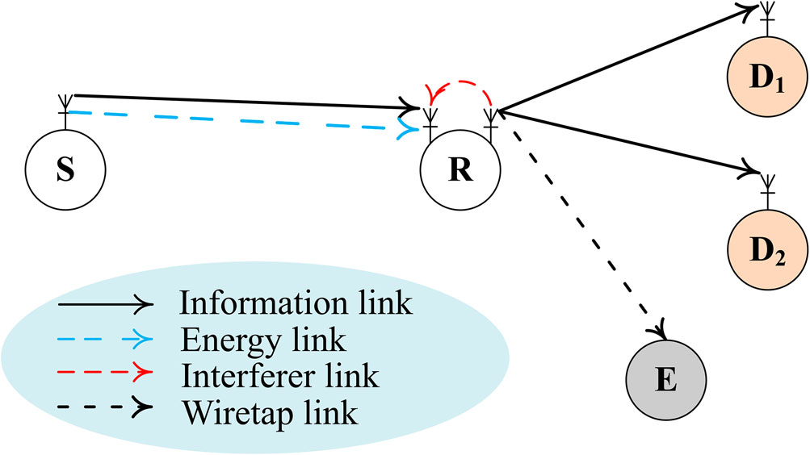

Figure 1. The considered SWIPT-enabled full-duplex relaying NOMA networks.

will be less secure. One of the effective ways to mitigate such cases is to employ artificial noise from the source node and/or the destination to deteriorate the quality of the eavesdropper links. On the other hand, multiple antennae at eavesdropper have a tiny effect on the performance of the outage probability since the signal-to-noise-ratio (SNR) at both destinations is independent of the eavesdropper. As a consequence, the relay node is able to work in the full-duplex mode while all remaining operate in the half-duplex mode.

## 2.1. CHANNEL MODELLING

Both large-scale path-loss and small-scale fading are studied in this paper. The impact of shadowing is not taken into account as it is a general case in the literature (Lam & Di Renzo, 2020).

### 2.1.1. Smaill-scale fading

Let us denote $h_{SR},h_{{RD}_{i}},i∈\{1,2\}$, and $h_{RE}$ as the channel coefficients from $S→R$, from R $→D_{1}$, and from R $→E$, respectively. We also denote $h_{RR}$ as the self-interference from the transmit antenna to the receive antenna at the relay node. Assuming that $h_{SR},h_{{RD}_{i}},i∈\{1,2\}$, and $h_{RE}$ are followed by a complex Gaussian distribution, their channel gains denoted by $γ_{SR}={\left|h_{SR}\right|}^{2},γ_{{RD}_{j}}={\left|h_{{RD}_{j}}\right|}^{2},γ_{RE}={\left|h_{RE}\right|}^{2}$ are then modelled by an exponential distribution whose cumulative distribution function (CDF) are given as Pham et al. (2020)

$\begin{matrix}F_{γ_{SR}}(x) & =1−exp⁡\left(−λ_{SR}x\right), \\ F_{γ_{RD}}(x) & =1−exp⁡\left(−λ_{RD}x\right), i∈\{1,2\}, \\ F_{γ_{RE}}(x) & =1−exp⁡\left(−λ_{RE}x\right),\end{matrix}$ (1)

where $λ_{SR},λ_{RE},λ_{{RD}_{i}}$ are the average channel gain from S to R, from R to two destinations, and from R to E that are a function of the transmission distance deﬁned in the following Section. In the present work, we assume that the global channel state information of all nodes is available at the source node via a high-accuracy feedback network. Nonetheless, it is true that obtaining the global CSI in wireless networks is an extreme task, thus, con- sidering imperfect CSI is a promising extension for the current work. However, it is proven in Tu et al. (2022) that the negative impact of the imperfect CSI can be eﬀectively miti- gated by employing multiple antennae and/or multiple relays.

### 2.1.2. Large-scale path-loss

Let us denote $λ_{a,b}$ as the large-scale path-loss from node $a∈\{S,R\}$ to node $b∈\left\{R,E,D_{i}\right\}$ and is given as follows (N.-L. Nguyen et al., 2023):

$λ_{a,b}={\left(d_{a,b}\right)}^{β}$ (2)

where $d_{a,b}$ is the transmission distance from node *a* to node *b* and β is the path-loss exponent.

## 2.2. Transmission procedure

### The transmission commences with the transmission from the source S to the relay R. At the relay, it employs one of its antennae to both decode information and harvest energy thanks to the power splitting protocol in the simultaneous wireless information and power transfer enabled systems. Particularly, the incoming signals are split into two parts. The first part is sent to the harvesting circuit which will absorb and store the harvested energy in a super capacity battery. The harvested energy denoted by $E_{R}$ is formulated as

$E_{R}=ηρTP_{s}γ_{sR}$ (3)

where $0<η≤1$ is the conversion efficiency, $0<ρ<1$ is the PS ratio, $T$ is the transmission duration (in second), $P_{S}$ is the transmit power of $S$, and $γ_{SR}$ is the channel gain from $S$ to $R$. The transmit power of $R$ is then formulated as

$P_{R}=\frac{E_{R}}{T}=ηpP_{s}γ_{sR}.$ (4)

Besides, the remained part is sent to the information decoding circuit, the received signal denoted by $y_{R}$ at the input of this circuit is given below

$y_{R}=\sqrt{1−ρ}\sqrt{P_{s}}h_{sR}\left(\sqrt{α_{1}}x_{1}+\sqrt{α_{2}}x_{2}\right)+\sqrt{P_{R}}h_{RR}x_{R}+n_{R},$ (5)

where $\sqrt{α_{1}}x_{1}+\sqrt{α_{2}}x_{2}$ is the transmitted signal from $S$ which is superimposed of two signals for $D_{1}$ and $D_{2};α_{1}>α_{2},α_{1}+α_{2}=1$ are the power allocation for the destination $D_{1}$ and $D_{2}$, respectively. Here, the near and far users are identified based on the largescale path-loss criteria. Particularly, a user who enjoys the larger path-loss is labelled as the far user and another will be the nearer. In the present work, without any explicit explanations, we assume that $D_{1}$ is the far user. Other criteria such as one based on simultaneously received power are left for future work. $h_{RR}$ is the self-interference at R owing to the full-duplex mode and the imperfect cancellation; $x_{R}$ is the transmitted signal from relay; $E\left\{{\left|x_{R}\right|}^{2}\right\}=E\left\{{\left|x_{1}\right|}^{2}\right\}=E\left\{{\left|x_{2}\right|}^{2}\right\}=1$; $\{$. $\}$ is the expectation operator. $n_{R}$ is the additive white Gaussian noise. Based on the successive interference cancellation (SIC) principle, the relay first decodes the signal $x_{1}$ while considering $x_{2}$ as the background noise. It then removes the signal $x_{1}$ from the received signal and decodes the signal $x_{2}$. Therefore, the instantaneous signal-to-interference-plus-no ise-ratio (SINR) of signals $x_{1}$ and $x_{2}$ at $R$ are expressed as

$$\begin{matrix}γ_{R}^{x_{1}} & =\frac{(1−ρ)P_{S}{\left|h_{SR}\right|}^{2}α_{1}}{(1−ρ)P_{S}{\left|h_{SR}\right|}^{2}α_{2}+P_{R}{\left|h_{RR}\right|}^{2}+N_{0}}=\frac{(1−ρ)P_{S}γ_{SR}α_{1}}{(1−ρ)P_{S}γ_{SR}α_{2}+P_{R}γ_{RR}+N_{0}}, \\ γ_{R}^{x_{2}} & =\frac{(1−ρ)P_{S}γ_{SR}α_{2}}{P_{R}γ_{RR}+N_{0}} (6)\end{matrix}$$

where $N_{0}$ is the noise variance. Next, substituting (4) into (6), we have

$$\begin{matrix}γ_{R}^{K_{1}} & ≈\frac{(1−ρ)α_{1}}{(1−ρ)α_{2}+ηργ_{RR}} \\ γ_{R}^{K_{2}} & ≈\frac{(1−ρ)α_{2}}{ηργ_{RR}}. (7)\end{matrix}$$

After decoding the information of both destinations, the relay re-encodes and forwards this information to both destinations. The received signals at two destinations are then given as

$y_{D_{i}}=h_{RD,}\sqrt{P_{R}}\left(\sqrt{α_{1}}x_{1}+\sqrt{α_{2}}x_{2}\right)+n_{D_{j}}, i∈\{1,2\}.$ (8)

Here $n_{D_{i}}$ is the AWGN at the ith destination; the SINR at $D_{1}$ is formulated as

$$γ_{D_{1}}^{x_{1}}=\frac{α_{1}ηρΨγ_{SR}γ_{{RD}_{1}}}{α_{2}ηρΨγ_{SR}γ_{{RD}_{1}}+1}, (9)$$

and the SNR of $D_{2}$ is held by first subtracting the $x_{1}$ and is given as

$$γ_{D_{2}}^{x_{2}}=\frac{α_{2}P_{R}{\left|h_{{RO}_{2}}\right|}^{2}}{N_{0}}=α_{2}ηρΨγ_{SR}γ_{{RD}_{2}}. (10)$$

Finally, the instantaneous rate of $D_{i}$ is computed as

$$C_{D_{i}}=\log_{2}⁡\left(1+min\left(γ_{R}^{χ_{1}},γ_{D_{A}}^{γ_{1}}\right)\right)=\log_{2}⁡\left(1+{\overset{˜}{γ}}_{D_{i}}\right), i∈\{1,2\}. (11)$$

# PERFORMANCE ANALYSIS

In this section, we evaluate the performance of the reliability and security of the considered networks. More precisely, outage probability is chosen as a key metric of the reliability while intercept probability is a representation from the security aspect.

## 3.1. Outage probability

Outage probability is referred to the probability that the instantaneous rate is below the predefined threshold. Particularly, the OP of the ith destination is mathematically computed as

$$\begin{matrix} & {OP}_{D_{1}}=1−2\left[1−exp⁡\left(−\frac{λ_{RR}(1−ρ)\left[α_{1}−γ_{th}α_{2}\right]}{γ_{th}ηρ}\right)\right] \\ & ×\sqrt{\frac{γ_{th}λ_{SR}λ_{{RD}_{1}}}{ηρ\left(α_{1}−α_{2}γ_{th}\right)}}K_{1}\left(2\sqrt{\frac{γ_{th}λ_{SR}λ_{{RD}_{1}}}{ηρ\left(α_{1}−α_{2}γ_{th}\right)}}\right) \\ & {OP}_{D_{2}}=1−2\left(1−exp⁡\left(−\frac{λ_{RR}(1−ρ)α_{2}}{ηργ_{th}}\right)\right)\sqrt{\frac{λ_{SR}λ_{{RD}_{2}}γ_{th}}{α_{2}ηρΨ}}K_{1}\left(2\sqrt{\frac{λ_{SR}λ_{{RD}_{2}}γ_{th}}{α_{2}ηρΨ}}\right). \\ & \end{matrix} (12)$$

Proof. Let us commence with the derivation of the $D_{1}$, we have

$$\begin{matrix}{OP}_{D_{1}} & =Pr⁡\left(C_{D_{1}}<R\right)=Pr⁡\left({\overset{˜}{γ}}_{D_{1}}<γ_{th}\right) \\ & =Pr⁡\left(min\left(\frac{(1−ρ)α_{1}}{(1−ρ)α_{2}+ηργ_{RRR}},\frac{α_{1}ηρΨγ_{SR}γ_{{RD}_{1}}}{α_{2}ηρΨγ_{SR}γ_{{RD}_{1}}+1}\right)<γ_{th}\right) \\ & \overset{(a)}{=}1−\underset{Ξ_{1}}{\underbrace{Pr⁡\left(\frac{(1−ρ)α_{1}}{(1−ρ)α_{2}+ηργ_{RRR}}≥γ_{th}\right)}}\underset{Ξ_{2}}{\underbrace{Pr⁡\left(\frac{α_{1}ηρΨγ_{SR}γ_{RD}}{α_{2}ηρΨγ_{SR}γ_{{RD}_{1}}+1}≥γ_{th}\right)}},\end{matrix} (13)$$

where $γ_{th}=2^{R}−1,(a)$ is held by employing the independent properties of two hops. $Ξ_{1}$ and $Ξ_{2}$ are given as follows:

$$\begin{matrix} & Ξ_{1}=Pr⁡\left(\frac{(1−ρ)α_{1}}{(1−ρ)α_{2}+ηργ_{RR}}≥γ_{th}\right)=1−Pr⁡\left(\frac{(1−ρ)α_{1}}{(1−ρ)α_{2}+ηργ_{RR}}<γ_{th}\right) \\ & =1−Pr⁡\left(γ_{RR}>\frac{(1−ρ)\left[α_{1}−γ_{th}α_{2}\right]}{γ_{th}ηρ}\right)=1−exp⁡\left(−\frac{λ_{RR}(1−ρ)\left[α_{1}−γ_{th}α_{2}\right]}{γ_{th}ηρ}\right) \\ & Ξ_{2}=Pr⁡\left(\frac{α_{1}ηρΨγ_{SR}γ_{{RD}_{1}}}{α_{2}ηρΨγ_{SR}γ_{RD}+1}≥γ_{th}\right)=1−Pr⁡\left(γ_{SRγ_{{RD}_{1}}}<\frac{γ_{\text{th }}}{ηρ\left(α_{1}−α_{2}γ_{th}\right)}\right) \\ & =1−\int_{0}^{∞}{ } F_{xnn}\left(\frac{γ_{th}}{ηρ\left(α_{1}−α_{2}γ_{t_{h}}\right)x}\right)f_{η_{O_{1}}}(x)dx \\ & =\int_{0}^{∞}{ } λ_{RD,}exp⁡\left(−\frac{γ_{th}λ_{SR}}{ηρ\left(α_{1}−α_{2}γ_{th}\right)x}−λ_{{RD}_{1}}x\right)dx (14) \\ & =2\sqrt{\frac{γ_{th}λ_{SR}λ_{{RD}_{1}}}{ηρ\left(α_{1}−α_{2}γ_{th}\right)}}K_{1}\left(2\sqrt{\frac{γ_{th}λ_{SR}λ_{{RD}_{1}}}{ηρ\left(α_{1}−α_{2}γ_{th}\right)}}\right), \\ & \end{matrix}$$

where $K_{1}(∙)$ is the modified Bessel function of second kind with the 1 st order. Finally, by substituting $Ξ_{1}$ and $Ξ_{2}$ from (14) into (13), we obtain the OP of $D_{1}$. Next, we derive the OP

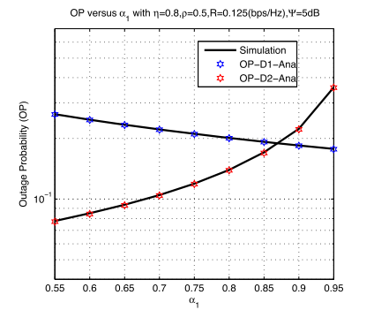

Figure 2. Outage probability vs. a1; solid lines are from Monte-Carlo simulation while markers are from (12).

of $D_{2}$ as follows:

$$\begin{matrix}{OP}_{D_{2}} & =Pr⁡\left(min\left(\frac{(1−ρ)α_{2}}{ηργ_{RR}},α_{2}ηρΨγ_{SR}γ_{RD}\right)<γ_{th}\right) \\ & =1−Pr⁡\left(\frac{(1−ρ)α_{2}}{ηργ_{RR}}≥γ_{th}\right)Pr⁡\left(α_{2}ηρΨγ_{SR}γ_{{RD}_{2}}≥γ_{th}\right) \\ & =1−\underset{Ξ_{1}}{\underbrace{Pr⁡\left(γ_{RR}≤\frac{(1−ρ)α_{2}}{ηργ_{th}}\right)}}\underset{Ξ_{4}}{\underbrace{\left[1−Pr⁡\left(α_{2}ηρΨγ_{SR}γ_{{RD}_{2}}<γ_{th}\right)\right]}}\end{matrix} (15)$$

where

$$\begin{matrix} & Ξ_{3}=1−exp⁡\left(−\frac{λ_{RR}(1−ρ)α_{2}}{ηργ_{\text{th }}}\right) \\ & Ξ_{4}=2\sqrt{\frac{λ_{SR}λ_{RD}γ_{\text{th }}}{α_{2}ηρΨ}}K_{1}\left(2\sqrt{\frac{λ_{SR}λ_{RD}γ_{th}}{α_{2}ηρΨ}}\right).\end{matrix} (16)$$

We conclude the proof here.

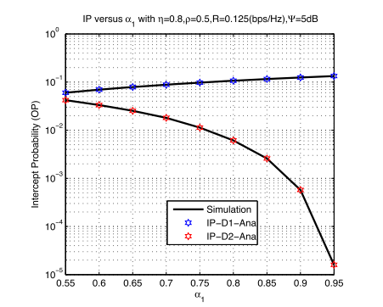

Figure 3. Intercept probability vs. a1; solid lines are from Monte-Carlo simulation while markers are from (17).

The considered system will be wiretapped if E can successfully decode $x_{1}$ or $x_{2}$ from the relay. Mathematical speaking, the IP of $x_{1}$ and $x_{2}$ is computed as follows:

$$\begin{matrix} & {Iℙ}^{x_{1}}=Pr⁡\left(C_{E}^{x_{1}}≥R\right)=1−Pr⁡\left(C_{E}^{α_{1}}<R\right)=1−Pr⁡\left(α_{1}ηρΨγ_{SR}γ_{FE}<γ_{th}\right) \\ & =2\sqrt{\frac{λ_{SR}λ_{RE}γ_{\text{th }}}{α_{1}ηρΨ}}K_{1}\left(2\sqrt{\frac{λ_{SR}λ_{PE}γ_{th}}{α_{1}ηρΨ}}\right), \\ & {Iℙ}^{x_{2}}=1−Pr⁡\left(C_{E}^{x_{2}}<R\right)=1−Pr⁡\left(α_{2}ηρΨγ_{SR}γ_{RE}<γ_{th}\right) (17) \\ & =2\sqrt{\frac{λ_{SR}λ_{RE}γ_{\text{th }}}{α_{2}ηρΨ}}K_{1}\left(2\sqrt{\frac{λ_{SR}λ_{FE}γ_{\text{th }}}{α_{2}ηρΨ}}\right). \\ & \end{matrix}$$

Here the last equation is achieved by applying the same steps as the outage probability.

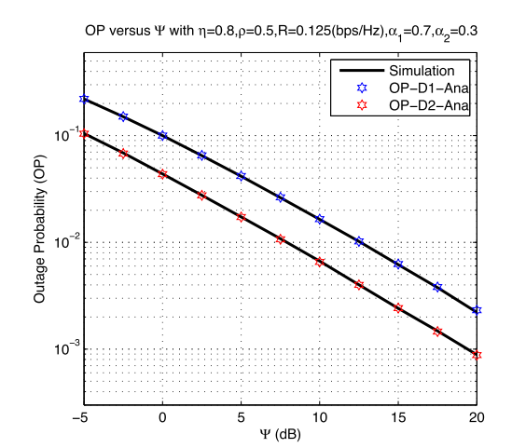

Figure 4. Outage probability vs. Ψ [dB]; solid lines are from Monte-Carlo simulation while markers are from (12).

# 4. NUMERICAL RESULTS

Simulation results based on the Monte-Carlo method as T. N. Nguyen et al. (2018) are given in this section to clarify the accuracy of the developed mathematical frameworks as well as to give some insights into the considered metrics. Without loss of generality, the following set of parameters is used in this section: $β=2.5,η=0.8,R=0.125$ [bits/ $s/Hz],α_{1}=0.7,α_{2}=0.3,ρ=0.5,d_{SR}=0.5,d_{{RD}_{1}}=0.75,d_{{RD}_{2}}=0.35$, and $d_{RE}=3$.

Figures 2 and 3 depict the OP and IP versus $α_{1}$. We observe that there is a good agreement between the developed mathematical framework and the Monte-Carlo simulation in both figures. Additionally, increasing $α_{1}$ is beneficial for the $D_{1}$ but not necessarily for the $D_{2}$. In particular, when $α_{1}$ increases from 0.55 to 0.95 , the OP of $D_{1}$ steadily decreases from 0.2 to below 0.1 while OP of $D_{2}$ dramatically scales up from 0.08 to above 0.2 . In Figure 3, we also observe a contrary behaviour of ${IP}_{1}$ and ${IP}_{2}$ regarding $α_{1}$. More precisely, we see that increasing $α_{1}$, the security of $D_{2}$ improves significantly while the security of $D_{1}$ is gradually lost.

Figures 4 and 5 illustrate the performance of the outage probability and intercept probability with respect to the transmit power of source $S$. We experience again that the derived mathematical frameworks have coincided with the simulation results.

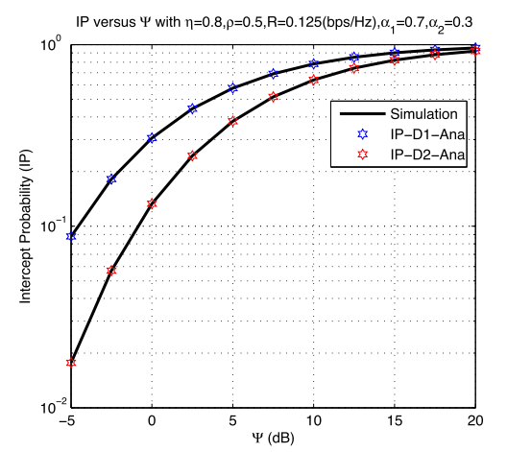

Figure 5. Intercept probability vs. Ψ [dB]; solid lines are from Monte-Carlo simulation while markers are from (17)

Furthermore, surging the transmit power is useful for both OP and IP. More precisely, the OP improves 100 times when the transmit power increases from -5 to $20 dB$ for two destinations. Looking at Figure 4, we observe that ${OP}_{2}$ is substantially better than ${OP}_{1}$, and the gap between the two curves is almost stable for the whole range of observation. Regarding IP, we see that increasing $Ψ$ will increase IP regardless of destinations. However, the ${Iℙ}_{2}$ seems to increase quicker than ${ℙℙ}_{1}$ especially when the system is in the low transmit power regime. Finally, from Figures 4 and 5, it is important to optimize the transmit power of the source node since we experience a contrary behaviour of the reliability and security aspects.

Figures 6 and 7 show the impact of the power-splitting ratio $ρ$ on the performance of the OP and IP. In Figure 6, we see that the OP has a U-shape behaviour with respect to $ρ$. Particularly, OP starts decreasing when $ρ$ increases after reaching its minimum, it keeps increasing. Interestingly, the OP of $D_{2}$ does not consistently outperform the OP of $D_{1}$. As for the IP, we observe a different behaviour regarding $ρ$. More precisely, increasing $ρ$ monotonically increases IP.

Figure 8 studies the interaction between OP and IP. We observe that the smaller the OP the larger the IP. As a consequence, it is important to optimize a set of parameters that simultaneously satisfies both the reliability and security aspects of the networks.

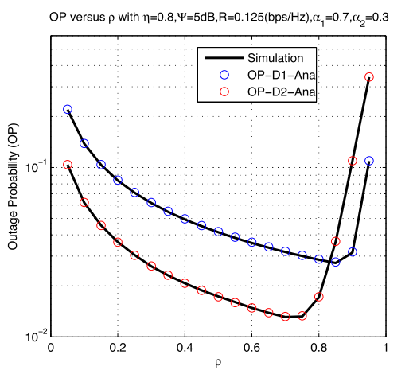

Figure 6. Outage probability vs. ρ; solid lines are from Monte-Carlo simulation while markers are from (12).

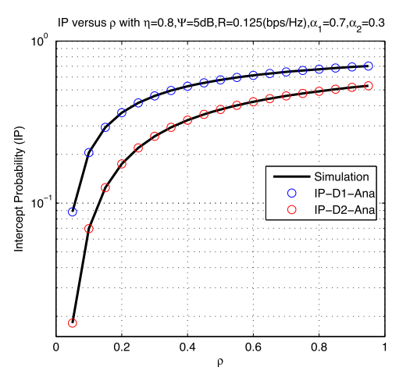

Figure 7. Intercept probability vs. ρ; solid lines are from Monte-Carlo simulation while markers are from (17).

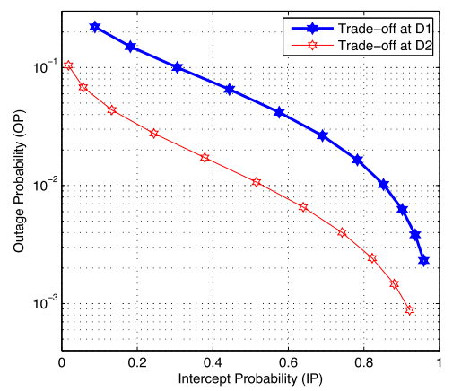

Figure 8. Outage probability vs. Intercept Probability; solid lines and markers are from (12) and (17).

# 5. CONCLUSION

In the present work, we studied both the intercept and outage probability of the dual-hop SWIPT-enabled networks. In particular, we derived the outage probability (OP) and intercept probability (IP) of the considered networks in the closed-form expressions. Simulation results were given to confirm the correctness of the derived frameworks. Finally, the performance of the considered networks can be enhanced in several ways. One of the feasible extensions is to consider the random position of all nodes in the networks via tools from stochastic geometry. Additionally, the imperfect cancellation at the relay could also be considered to capture the practical hardware constraint. Another possible extension was to install more antennae at both source and destinations to further improve the system’s reliability and security.

# REFERENCE

|  |
| --- |
| [1] Bariah, L., Muhaidat, S., & Al-Dweik, A. (2019). Error probability analysis of NOMA-based relay networks with SWIPT. IEEE Communications Letters, 23(7), 1223–1226. |
| [2] Kurup, R. R., & Babu, A. V. (2020). Power adaptation for improving the performance of time switching SWIPT-based full-duplex cooperative NOMA network. IEEE Communications Letters, 24(12), 2956 – 2960. |
| [3] Lam, T. T., & Di Renzo, M. (2020). On the energy efficiency of heterogeneous cellular networks with renewable energy sources–A stochastic geometry framework. IEEE Transactions on Wireless Communications, 19(10), 6752–6770. |
| [4] Lam, T. T., Di Renzo, M., & Coon, J. P. (2016a). System-level analysis of receiver diversity in SWIPTenabled cellular networks. Journal of Communications and Networks, 18(6), 926–937. |
| [5] Lam, T. T., Di Renzo, M., & Coon, J. P. (2016b). System-level analysis of SWIPT MIMO cellular networks. IEEE Communications Letters, 20(10), 2011–2014. |
| [6] Li, X., Li, J., & Li, L. (2020). Performance analysis of impaired SWIPT NOMA relaying networks over imperfect weibull channels. IEEE Systems Journal, 14(1), 669–672. |
| [7] Liu, Y., Ding, H., Shen, J., Xiao, R., & Yang, H. (2019). Outage performance analysis for SWIPT-based cooperative non-orthogonal multiple access systems. IEEE Communications Letters, 23(9), 1501 – 1505. |
| [8] Liu, Y., Ye, Y., Ding, H., Gao, F., & Yang, H. (2020). Outage performance analysis for SWIPT-based incre mental cooperative NOMA networks with non-linear harvester. IEEE Communications Letters, 24 (2), 287–291.  [9] Minh Nam, P., Hung, H. D., Tu, L. -T., P. V. Tuan, Duy, T. T., & Hanh, T. (2022). Outage performance of interference cancellation-aided two-way relaying cognitive network with primary TAS/SC communication and secondary partial relay selection. Electronics, 11(22), 3645. |
| [10] Nguyen, B. C., Tran, M. H., Tran, T. P., & Nguyen, N. T. (2019). Outage probability of NOMA system with wireless power transfer at source and full-duplex relay. AEU – International Journal of Electronics and Communications. 2019. |
| [11] Nguyen, N.-L., Tu, L.-T., Nguyen, T. N., Nguyen, P.-L. T., & Nguyen, Q.-S. (2023). Performance on cognitive broadcasting networks employing fountain codes and maximal ratio transmission. Radioengineering, 32(1), |
| [12] Nguyen, T. N., Duy, T. T., Tran, P. T., Voznak, M., Li, X., & Poor, H. V. (2022a). Partial and full relay selection algorithms for AF multi-relay full-duplex networks with self-energy recycling in non-identically distributed fading channels. IEEE Transactions on Vehicular Technology, 71(6), 6173–6188. |
| [13] Nguyen, T. N., Quang Minh, T. H., Tran, P. T., Voznak, M., Duy, T. T., T. -L. Nguyen, & Tin, P. T. (2019). Performance enhancement for energy harvesting based two-way relay protocols in wireless adhoc networks with partial and full relay selection methods. Ad Hoc Networks, 84, 178–187. |
| [14] Nguyen, T. N., Tran, M., Nguyen, T. -L., Ha, D. -H., & Voznak, M. (2019a). Multisource power splitting energy harvesting relaying network in half-duplex system over block Rayleigh fading channel: System performance analysis. Electronics, 8(1), 67. |
| [15] Nguyen, T. N., Tran, M., Nguyen, T. -L., Ha, D. -H., & Voznak, M. (2019b). Performance analysis of a user selection protocol in cooperative networks with power splitting protocol-based energy harvesting over Nakagami-m/Rayleigh channels. Electronics, 8(4), 448.  [16] Nguyen, T. N., Tran, P. T., & Vozňák, M. (2018). Power splitting-based energy-harvesting protocol for wireless-powered communication networks with a bidirectional relay. International Journal of Communication Systems, 31(13), e3721. |
| [17] Nguyen, T. N., Tu, L.-T., Tran, D.-H., Phan, V.-D., Voznak, M., Chatzinotas, S., & Ding, Z. (2022). Outage performance of satellite terrestrial full-duplex relaying networks with co-channel interference. IEEE Wireless Communications Letters, 11(7), 1478–1482. |
| [18] Pham, N. S., Tran, T. D., & Ho, V. K. (2020). SIC-Coding schemes for underlay two-way relaying cognitive networks. Wireless Communications and Mobile Computing. Article ID 8860551, 17 pages. |
| [19] Phu, T. T., Phan, V. -D., Nguyen, N. T., & Le, A. V. (2021a). Performance analysis in the decode-andforward full-duplex relaying network with SWIPT. The Scientific World Journal. Article ID 5548802, 8 pages. |
| [20] Phu, T. T., Phan, V. -D., Nguyen, N. T., & Le, A. V. (2021b). Performance analysis in the decode-andforward full-duplex relaying network with SWIPT. The Scientific World Journal. Article ID 5548802, 8 pages. |
| [21] Tran, T. D., Pham, T. D. N., & Tran, T. P. (2021). Performance enhancement for multihop cognitive DF and AF relaying protocols under joint impact of interference and hardware noises: NOMA for primary network and best-path selection for secondary network. Wireless Communications and Mobile Computing, 2021, |
| [22] Tu, L. -T., Di Renzo, M., & Coon, J. P. (2018). Stochastic geometry analysis of receiver diversity in cellular networks with SWIPT. In 2018 IEEE 19th International Workshop on Signal Processing Advances in Wireless Communications (SPAWC). IEEE. |
| [23] Tu, L. -T., Nguyen, T. N., Tran, T. D., Tran, P. T., Voznak, M., & Aravanis, A. I. (2022). Broadcasting in cognitive radio networks: A fountain codes approach. IEEE Transactions on Vehicular Technology, 71(10), 1128911294. |
| [24] Tu, L. -T., Phan, V. -D., Nguyen, T. N., Tran, P. T., Duy, T. T., Nguyen, Q. -S., Nguyen, N. -T., & Voznak, M. (2023). Performance analysis of multihop full-duplex NOMA systems with imperfect interference cancellation and near-field path-loss. Sensors, 23(1), 524. |
| [25] Van Chien, T., Tu, L. T., Chatzinotas, S., & Ottersten, B. (2021). Coverage probability and ergodic capacity of intelligent reflecting surface-enhanced communication systems. IEEE Communications Letters, 25(1), 69–73. |
| Wang, D., Zhang, R., Cheng, X., & Yang, L. (2017). Capacity-Enhancing full-duplex relay networks based on power-splitting (PS-)SWIPT. IEEE Transactions on Vehicular Technology, 66(6), 5445– 5450. |
| Wu, W., Yin, X., Deng, P., Guo, T., & Wang, B. (2019). Transceiver design for downlink SWIPT NOMA systems with cooperative full-duplex relaying. IEEE Access, 7, 33464–33472. |
| [26] Yang, H., Xia, X., Li, J., Zhu, P., & You, X. (2022). Joint transceiver design for network-assisted fullduplex systems with SWIPT. IEEE Systems Journal, 16(1), 1206–1216. |