TASK 3 – YOUTUBE UI CLONE

Name: Kasaali Asmiya A

Internship Domain: Frontend Development

Objective:
To design and develop a responsive YouTube user interface clone using HTML and CSS. The project aims to replicate the layout and appearance of YouTube while improving frontend development skills.

Technologies Used:
• HTML5
• CSS3
• GitHub
• GitHub Pages

Features:
• Responsive Design
• Navigation Bar
• Search Bar
• Sidebar Navigation
• Video Thumbnail Section
• Hover Effects
• Mobile-Friendly Layout

Project Description:
This project is a YouTube UI Clone created using HTML and CSS. The website includes a navigation bar, search functionality design, sidebar menu, and video cards with thumbnails. The layout is responsive and adapts to different screen sizes.

GitHub Repository Link:
https://github.com/KasaaliAsmiya/Asmiya-youtube-clone

Hosted Website Link:
https://kasaaliasmiya.github.io/Asmiya-youtube-clone/

Screenshots:

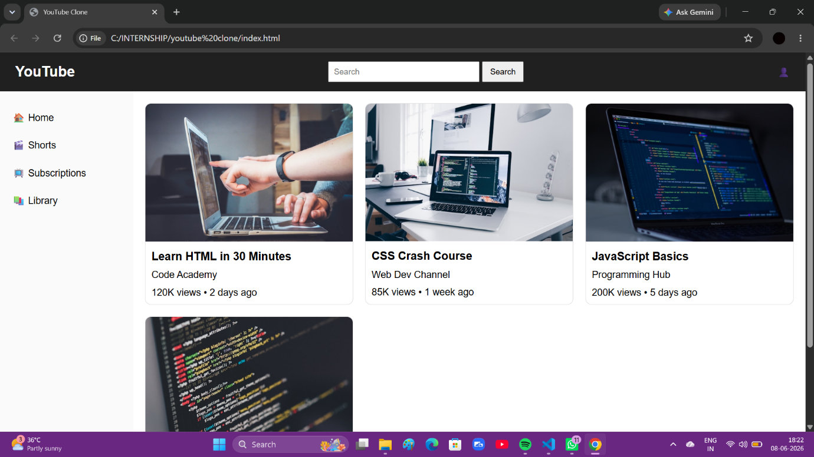
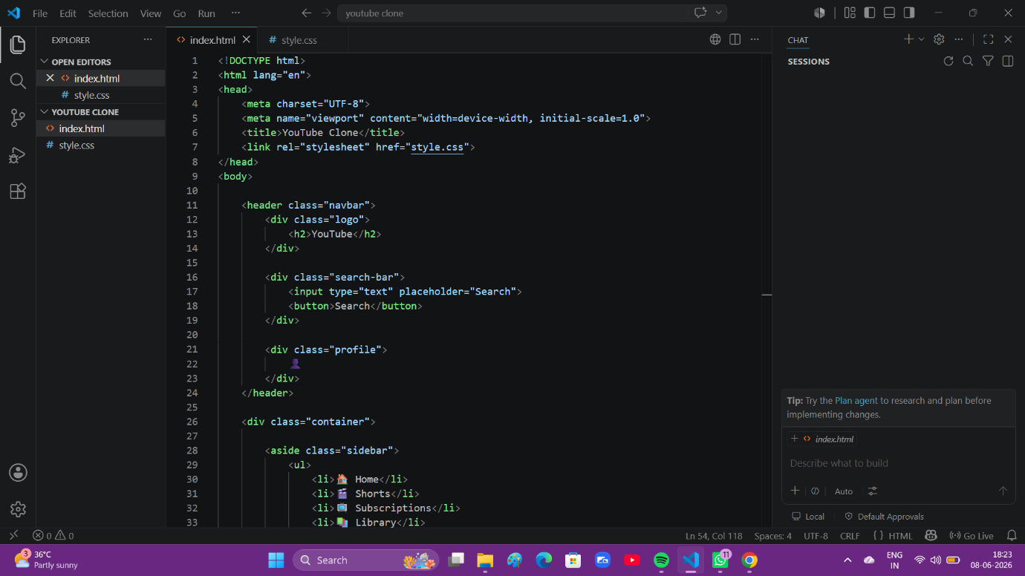
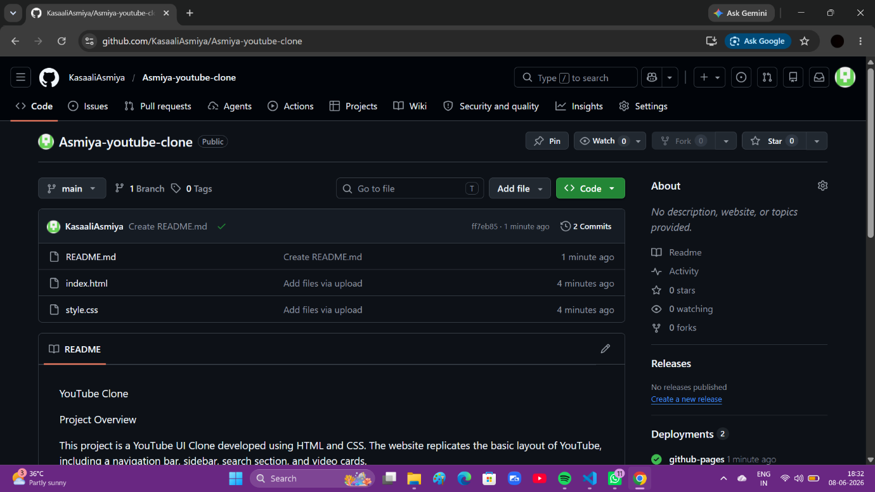

Conclusion:
Successfully developed and deployed a responsive YouTube UI Clone using HTML and CSS. This project helped improve understanding of webpage layouts, responsive design, and frontend development concepts.

