H. P. Lovecraft's
Call of Cthulhu
Starring
Sarah Ann Bateman van Buren
Table of Contents
1. Sarah Ann Bateman van Buren 2
1.1 Appearance 2
1.2 Interests 2
1.3 Personality 2
1.4 Education 3
1.5 Background 3
2. Grover Charles van Buren 5
2.1 Appearance 5
2.2 Interests 5
2.3 Personality 5
2.4 Education 5
2.5 Background 6
World War 1 6
After World War 1 6

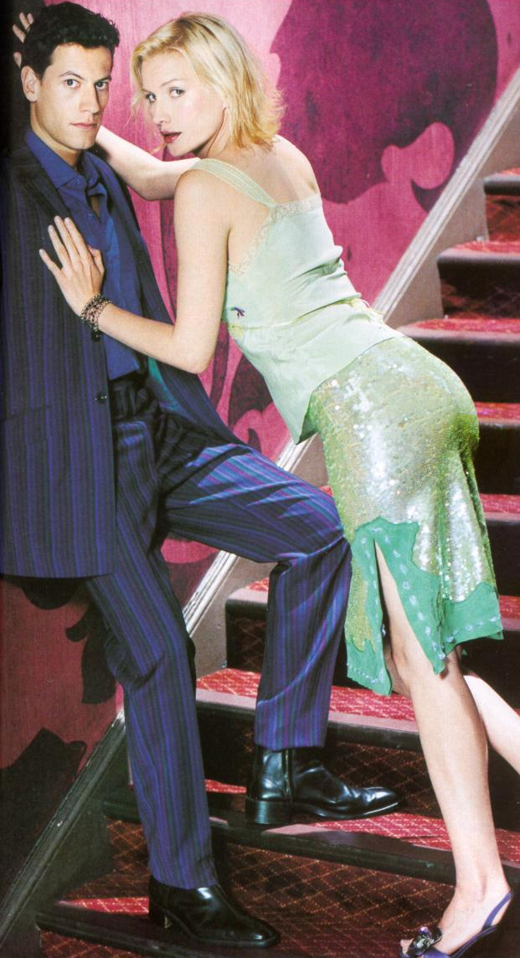
Sarah and Charles van Buren

Sarah Ann Bateman van Buren
Sarah “Princess” - Hebrew
Ann “grace” - Hebrew (“Hannah”)
Born 6th April, 1897 in Falmouth, Cornwall (England)
Birth sign Aries, the Ram – Cardinal Fire Sign with Positive Polarity
Natural House 1st – the Self – personality, appearance, mannerisms, health, vitality, temperament
Birthstones Diamond, ruby, bloodstone, carnelian, garnet
Flowers Wild cherry, sweet pea, and daisy
Colour Red
Metals Iron and steel
Day of the Week Tuesday
Planet Mars

Appearance
Sarah is a tall, slender woman - 5ft 11.5ins, 158 lbs - with long legs, blond hair, dark green eyes and a low, husky contralto voice that men find irresistible. She is always beautifully dressed and has a flair for wearing clothes that suit her colouring, her flawless, lightly tanned skin and her great legs.

Interests
Although Sarah is a qualified architect, she has an interest in Egyptology sparked by her father, a retired merchant banker with a life long interest in archaeology. Sarah has developed skills in reading and writing Demotic, Hieroglyphics, Coptic and Hieratic, and is learning to speak, read and write Japanese from Charles.
She and Charles own the “Silk Scorpion”, a 120-foot long luxury sloop with oak and brass fittings registered in London. They also own a red Mercedes-Benz SSKL two-seater roadster that they love to drive at breakneck pace along tight, windy roads.
They divide their time between homes in London, Boston and Long Island, New York. When not at home they travel aboard the “Silk Scorpion”, taking care of Charles’ many and varied business interests.

Personality
Sarah has a gregarious nature and likes to laugh and have fun. She is possessed of a wicked sense of humour and delights in joking, laughing and playing up to her husband Charles in public. She is very much in love with and devoted to Charles. Sarah exhibits a streak of high-spirited independence and has an ability to think for herself and make her own decisions. Her relationship with Charles is based on a meeting of equals, and though sparks often fly, their love runs very deep.
Sarah is robust, has initiative and enterprise, exudes tremendous vitality and craves excitement. She is eager for new experiences and can face up to any challenge, believing it is up to her to create opportunities to get ahead. She is impetuous and unrestrained and so enthusiastic about the current focus of attention that she can be quite single minded.
Sarah possesses driving force, self-assurance and ambition, is courageous to the point of being foolhardy and always ready to take risks to obtain the objective. A trailblazer, she will be the first to go where no one has dared go before.
Mentally Sarah is imaginative and often brilliantly creative, but not deeply reflective (too impatient). She is firm in her convictions and will argue fiercely to defend them, however she is no match for people skilled in the art of debate. Sarah is apt to jump to conclusions far too quickly and can display a lack of sound judgement. However, she will not take too kindly to anyone who points this out.
Sarah has no guile and will speak her mind frankly and make her motives very clear. She will not employ underhand methods to gain her ends. Tact is not one of her strong points and she will probably be considered outspoken.
Her quick temper will cause Sarah to say more than she means and she finds it difficult to apologise for this. On the other hand, she will never bear a grudge or be vindictive. Emotionally Sarah is very ardent, passionate in love and extremely loyal to people she loves and respects. She has a very romantic streak and can fall in love on first sight, idealising the object of her affections while being possessive and a little domineering.
Sarah is somewhat accident prone, usually as a result of carelessness, haste or wilful disregard of safety precautions. Travel has great appeal for her, as she loves the outdoors, especially warmth and fresh air.
Sarah can make her way ahead in a man’s world, as men like the masculine streak in her personality. She can think like a man, though her feelings are those of a romantic ardent woman. When in love she will sacrifice all for romance, but she is a careerist by temperament and not very interested in domesticity.
She can be very jealous, but is very loyal and even if a marriage turns out badly she will not become involved with anyone else. If the partnership is not working she will make a clean break.
Sarah can be a good friend with other women. As a parent she will maintain strict discipline over her children, but give them plenty of encouragement to become self-reliant. She will be especially proud of her sons but may find it difficult to get on with her daughters when they pass beyond childhood.

Education
Primary – 1904 to 1909, Secondary – 1910 to 1915.
Bachelor of Architectural Studies (B. Arch. St.)
First Year 1916: Building Studies I, Design Studies I, History and Theories of Architecture I, Geography (Physical) IH, Archaeology IH.
Second Year 1917: Building Studies II, Design Studies II, History and Theories of Architecture II, Geography IIH (A).
Third Year 1918: Design and Building Studies III, Anthropology IIIA.

Background
Sarah is English. Her mother’s family are descendants of Cornish shipbuilders from Falmouth (surname of “Penrose”), and of landowners from eastern Cornwall (surname of “Heale”) who made their money in tin mining. Sarah’s Cornish grandmother, Grania Heale, is a witch, a healer with prophetic powers.
“Penrose” – Cornish name meaning “top/end of the heath” local to places in Cornwall and Devon (mid and west Cornwall).
Sarah’s father’s family has a long history of association with the Royal Navy. They come from Plymouth (surname of “Bateman”), and from Southampton and Portsmouth (surname of “Templar”). The men of the family joined the Royal Navy, while the women married officers and sailors.
“Bateman” – occupational name meaning servant of Bate (“boatman” in Old English), in northern dialect form. Also could be a nickname meaning “profit, gain and good husbandry”. From Old English and Old Norse.
Arthur Bateman was one of the very few men of the family who did not join the Royal Navy, deciding instead that the world of banking was more attractive than a life at sea. His father never forgave him.
In early February 1858 Thomas Bateman, an older brother of Sarah’s paternal grandfather Franklin Lloyd Bateman, dredged a Celtic shield up from the Thames at Battersea. This shield – known as the Battersea Shield – now resides in the British Museum. It was this incident that sparked Arthur’s interest in archaeology, which is now an interest of Sarah’s as well.

Grover Charles van Buren
Grover
Charles
Born 16th November 1896 in Boston, Massachusetts (USA)
Birth sign Scorpio, the Scorpion and the Eagle – Fixed Water Sign with Negative Polarity
Natural House 8th – Crisis – sex, birth, death, rebirth, reincarnation, healing, the occult
Birthstones Beryl, obsidian, ruby, sardonyx, topaz
Flowers Wormwood
Colour Dark red
Metals Iron, steel, plutonium
Day of the Week Tuesday
Planet Pluto (was Mars)

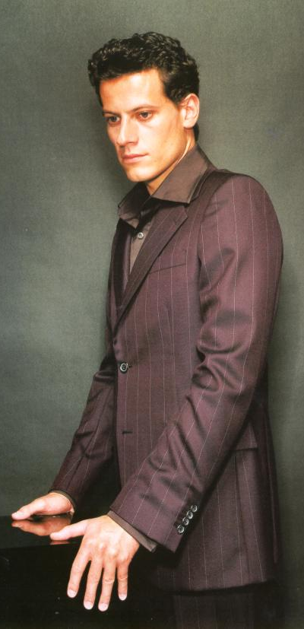
Appearance
Charles van Buren is very attractive – tall with dark curly hair and dark brown eyes and a mouth that curls upward on one side when he’s amused.
He likes to spend a good deal of money on his clothes and is always particularly well dressed.

Interests
Charles makes his money as a bootlegger and smuggler, using the “Silk Scorpion” to transport large amounts of alcohol and restricted goods from Britain via Cuba to secret locations along the New York coast.

Personality

Education
Charles was educated at home. He learnt French, Latin, geography and history in the main, with a smattering of other subjects as suited his parents.
Since returning from the war, where he learnt a great deal of first aid, Charles has concentrated on developing skills in business and accounting.

Background
Charles is American. He was born into a middle class family in Boston. Prior to WW1 Charles spent several years living in Japan, where he learnt Japanese language, history and swordsmanship. He brought two katana swords back from Japan and maintains his considerable skill in using them.

World War 1
Charles served as a pilot officer - Lieutenant (brevet Captain) - during WW1 and was awarded the Silver Star for his efforts in the conflict. He joined the 90th Aero Squadron organised on 20th August 1917 at Kelly Field, Texas. The squadron was re-designated as the 90th Squadron (Surveillance) on 13th August 1919, and the 90th Squadron (Attack) on 15th September 1921.
The 90th Aero Squadron was posted to Garden City, New York from 5th to the 27th October 1917, then to France. While in France Charles’ squadron was located at:
- Colombey-les- Belles from 20th November 1917
- Amanty from 19th April 1918
- Ourches from 13th Jun 1918
- Souilly from 20th September 1918
- Bethelainville from 29th October 1918
- Belrain from 15th January 1919
- Colombey-les-Belles from 18th January 1919
- Libourne from 25th January 1919
- St. Denis-de-Piles from 29th January 1919
- Libourne from 2nd February 1919
- Bordeaux from 10th to the 19th April 1919.
The squadron was attached to I Air Depot from 20th November 1917, I Corps Observation Group from 19th April 1918, IV Corps Observation Group from 13th June 1918, III Corps Observation Group from 21st September 1918, I Corps Observation Group from 30th November to December 1918, and Army Surveillance (later 1st Surveillance; 3d Attack; 3d Bombardment) Group from 1st July 1919 until the end of the war.
Charles saw combat in Sopwith 1, Salmson 2, Spad XI, and Breguet 14 aircraft while undertaking corps observation for the American I, III, and IV Army Corps, and French XVII Army Corps, from the 16th June to the 10th November 1918. The 90th was posted to Hazelhurst Field, New York from 5th May 1919, where Charles left the squadron to rejoin civilian life.

After World War 1
Charles returned to his family in Boston, then struck out again to make a success of himself in a variety of business opportunities, some of them not strictly legal. Once Prohibition became a reality, Charles took to bootlegging and became very successful very quickly.

