Player Ben

Personal Data
Name Gwyn
Homeland Salisbury
Culture Cymric Religion Pagan
Father’s Name Rhodri
Father’s Class Lord Son # 2
Liege Lord Lord
Current Class Knight Year Born 499
Current Home Chalke Age 21

Personality Traits
Chivalry Bonus [•] (total =80+) 87
Religious Bonus [] (traits all 16+) Yes
◻ Chaste 4 / 16  Lustful ◻
◻ Energetic • 17 / 3 Lazy ◻
◻ Forgiving 10 / 10 Vengeful ◻
◻ Generous • 16 / 4 Selfish ◻
◻ Honest  16 / 4 Deceitful ◻
◻ Just • 11 / 9 Arbitrary ◻
◻ Merciful • 12 / 8 Cruel ◻
◻ Modest • 1 / 19  Proud ◻
◻ Pious 14 / 6 Worldly ◻
◻ Prudent 7 / 13 Reckless ◻
◻ Temperate 7 / 13 Indulgent ◻
◻ Trusting 13 / 7 Suspicious ◻
◻ Valorous • 18 / 2 Cowardly ◻
Directed Trait - Suspicious (Fae) 14
Directed Trait

Passions
Loyalty (Lord) 15 ◻
Love (Family) 13 ◻
Love (Raven) 16 ◻
Hospitality 12 ◻
Honor 16 ◻
◻
◻
◻
◻

Equipment Carried
Armour (0) = 0 + 3 (chiv) + 6 (shield)
◻ Personal Gear (on horse #)
◻ Travel Gear (on horse #)
◻ War Gear (on horse #)
Weapons Shield, Spear, Sword, Dagger

Money Exchange 1£ = 20s = 240d

Statistics
SIZ 12 (Knockdown)
DEX 17
STR 15
CON(+3) 12 (Major Wound)
APP 18
Damage ((STR+SIZ)/6) 5d6
Healing Rate ((STR+CON)/10) 5(3)
Movement Rate ((STR+DEX)/10) 3
Total Hit Points (SIZ+CON) 24
Unconscious (HP/4) 6

Distinctive Features
Piercing Glance,
Darkly Tanned, Smooth Skin

Skills
Awareness (5) 10 ◻
Boating (1) 1 ◻
Chirurgery (0) 0 ◻
Compose (0) 0 ◻
Courtesy (3) 5 ◻
Dancing (2) 2 ◻
Faerie Lore (1) 1 ◻
Falconry (3) 3 ◻
First Aid (10) 10 ◻
Flirting (3) 3 ◻
Folk Lore (2) 2 ◻
Gaming (3) 3 ◻
Heraldry (3) 5 ◻
Hunting (2) 6 ◻
Industry (0) 0 ◻
Intrigue (3) 5 ◻
Orate (3) 3 ◻
Play Harp (3) 18 ◻
Read ( ) (0) 0 ◻
Recognise (3) 3 ◻
Religion (Mithras) 5 ◻
Romance (2) 2 ◻
Singing (2) 2 ◻
Stewardship (2) 2 ◻
Swimming (2) 2 ◻
Tourney (5) 5 ◻
◻
Celestial Lore (2) ◻
Geomantic Lore (2) ◻
Sight (3) ◻

Squire
Name
Age
First Aid ( ) ◻
Battle ( ) ◻
Horsemanship ( ) ◻
Sword ( ) ◻
Hunting ( ) ◻
◻
◻

Glory
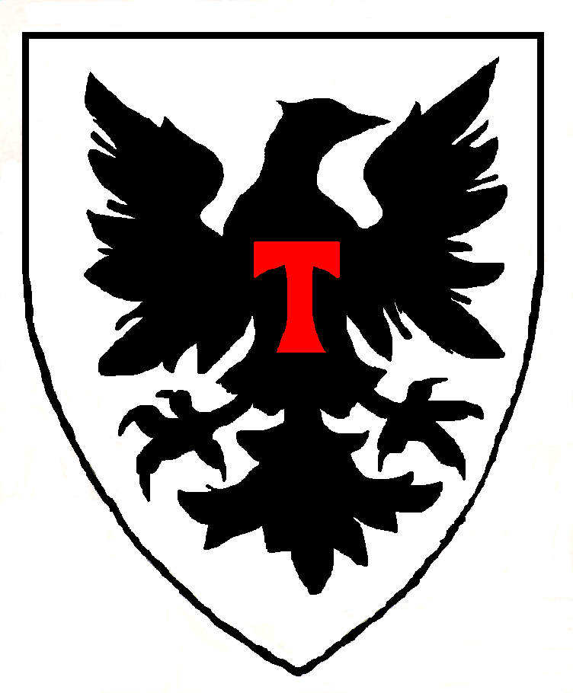

Current Hit Points 24
Wounds

◻ Chirurgery Needed

Combat Skills
Battle (3) 10 ◻
Horsemanship (4) 10 ◻

Weapon Skills
Sword (7) 18 ◻
Lance (2) 10 ◻
Spear (2) 4 ◻
Dagger (3) 2 ◻
◻
◻
◻
◻
◻
◻
◻
◻
◻
◻

Joust Score
Wins 0 Losses 0

Horses
Best warhorse (#1) Dinadan
Type ½ Breed Destrier
Dam 8d6 Move 7
Armor 5 HP 52
SIZ 42 CON 10
DEX 10 STR 38
Other Horses
Own Riding (#2) Celtic Pony
Squire’s (#3) Celtic Pony
(#4)
(#5)

Selected Events
Born 499
Ennobled
Squired
Landed
Knighted
Member of Round Table
Died

Holdings

Equipment
Denarii
Libra
1 Charger
2 Rouncies

Army
Old Knights 0
Middle Aged Knights 0
Young Knights 0
Total Family Knights 0
Vassal Knights 0
Other Lineage Men 0
Levy 0

Family
Year Wed
Spouse Name

Family Characteristics
Natural Musicians (+15)

Will

Children to Reach Majority

History Glory

Date Important Event New Total
520 Began career as PC
520

Gwyn Notes

Player Characters
Sir Decmus (Simon)
Niani (Jenny) & Sir Brennos (NPC)
Sir Cynon (Mike - retired) – Steward Of Levcomagus
Sir Amils of Champagne (Michael)
Drust (Stewart)

Principal Characters
King Arthur
Sir Lancelot (new French follower of Arthur)
Lady Jeanne (my wife,mage)
Sir Caradoc (my son, Arthur’s ex-squire,new King of Malahaut)
Nia (my eldest daughter)
Gwyn & Gwen (my youngest twins, boy & girl)
Earl Robert of Salisbury (my liege)
Sir Jaradan (Earl Robert’s seneshal)
Sir Gondrins (Earl Robert’s son)
Duke Ulfius of Silchester (Cynon’s liege)
Captain Bellator (Ulfius’ Captain of the Guard)
Lady Margot (Arcavius’s wife)
Sir Hywel (my vassal, ex-squire)
Sir Nai (my vassal, ex-squire)
Sir Edar (my vassal, steward of Mildenhall)
Lady Aneirin (Edar’s wife, Oberon’s daughter)
Praetor Jonathel (Arcavius’s liege, missing)
Duke Corneus of Lindsey
Bishop Bawdwin
Merfyn (Mage)
The Lady Voklaine, Annwyn, Carwyn and Illisander (Dragon and 3 Unicorns)
Oberon (Fae king) & Titania (Fae queen)
Ailil (Unseleighe prince)
Morgaine (Arthur’s ½ sister, Ailil’s ex-consort)
Morgause (Arthur’s ½ sister, Lot’s wife)
Lyzianor (Ailil’s daughter)
Sir Cynrain (Jeanne’s ex-champion, my vassal, husband of Lyzianor)
King Lot of Lothian & Orkney (Arthur’s vassal)
King Clovis (ex-French King, deceased)
Lady Ygraine (Arthur’s mother, nun)
Uther (Arthur & Lyzianor’s son)
* * (Oberon & Lyzianor’s son)
Varis (Black Dragon – deceased, necromancer – coming back)
Lady Bethannon (crazy animate skull, ex-wife of Varis, with Oberon)

Fae Items of Power
Falaius (Stone of Destiny) Fomori King
Feneus (Spear) Glastonbury Tor & Angel
Gorius (Sword) Oberon
Marius (Cauldron) Voklaine

