Player Ben

Personal Data
Name Rhodri
Homeland Lindsey
Culture Cymric Religion Pagan
Father’s Name Gwrfelling
Father’s Class Merc. Knight Son # 3
Liege Lord Earl Robert of Salisbury
Current Class Super. Knight Year Born 474
Current Home Chalke Age 31 (40)

Personality Traits
Chivalry Bonus [•] (total =80+) 81
Religious Bonus [] (traits all 16+) No
◻ Chaste 6 / 14  Lustful ◻
◻ Energetic • 17 / 3 Lazy ◻
◻ Forgiving 17 / 3 Vengeful ◻
◻ Generous • 16 / 4 Selfish ◻
◻ Honest  11 / 9 Deceitful ◻
◻ Just • 14 / 6 Arbitrary ◻
◻ Merciful • 11 / 9 Cruel ◻
◻ Modest • 4 / 16  Proud ◻
◻ Pious 14 / 6 Worldly ◻
◻ Prudent 11 / 9 Reckless ◻
◻ Temperate 17 / 3 Indulgent ◻
◻ Trusting 7 / 13 Suspicious ◻
◻ Valorous • 19 / 1 Cowardly ◻
Directed Trait - Suspicious of Other Lands 4
Directed Trait

Passions
Loyalty (Lord/Vassals) 15/14 ◻
Loyalty (Arthur) 20 ◻
Love (Jeanne/Family) 16/15 ◻
Love (Mithras) 16 ◻
Hospitality 14 ◻
Honor 13 ◻
Hate (Saxons) 7 ◻
Love (Party) 16 ◻

Equipment Carried
Armour Silver Fae Mail = 15 + 3 (chiv) + 6 (shield)
Clothing
◻ Personal Gear (on horse #)
◻ Travel Gear (on horse #)
◻ War Gear (on horse #)
Weapons Shield, Spear, Sword, Dagger
Silver Fae Mail– ( ≡ leather armour for Dex adj)

Money Exchange 1£ = 20s = 240d

Statistics
SIZ 15 (Knockdown)
DEX 10
STR 15
CON(+3) 14 (Major Wound)
APP 8
Damage ((STR+SIZ)/6) 5d6
Healing Rate ((STR+CON)/10) 3
Movement Rate ((STR+DEX)/10) 3
Total Hit Points (SIZ+CON) 29
Unconscious (HP/4) 7

Distinctive Features
Big vertical scar on left cheek

Skills
Awareness (5) 15 ◻
Boating (1) 1 ◻
Chirurgery (0) 1 ◻
Compose (0) 0 ◻
Courtesy (3) 5 ◻
Dancing (2) 2 ◻
Faerie Lore (1) 9 ◻
First Aid (10) 10 ◻
Flirting (3) 3 ◻
Folk Lore (2) 6 ◻
Gaming (3) 3 ◻
Hawking (3) 3 ◻
Heraldry (0) 0 ◻
Hunting (2) 6 ◻
Industry (0) 0 ◻
Intrigue (3) 13 ◻
Orate (3) 14 ◻
Play Harp (3) 19 ◻
Read ( ) (0) 0 ◻
Recognise (3) 11 ◻
Religion (Mithras) 9 ◻
Romance (0) 0 ◻
Singing (2) 11 ◻
Stewardship (2) 9 ◻
Swimming (2) 3 ◻
Tourney (0) 0 ◻
◻
◻
◻
◻

Squire
Name Perin
Age 19
First Aid (7) ◻
Battle (1) ◻
Horsemanship (12) ◻
Sword (8) ◻
Hunting (8) ◻
◻
◻

Glory 13719
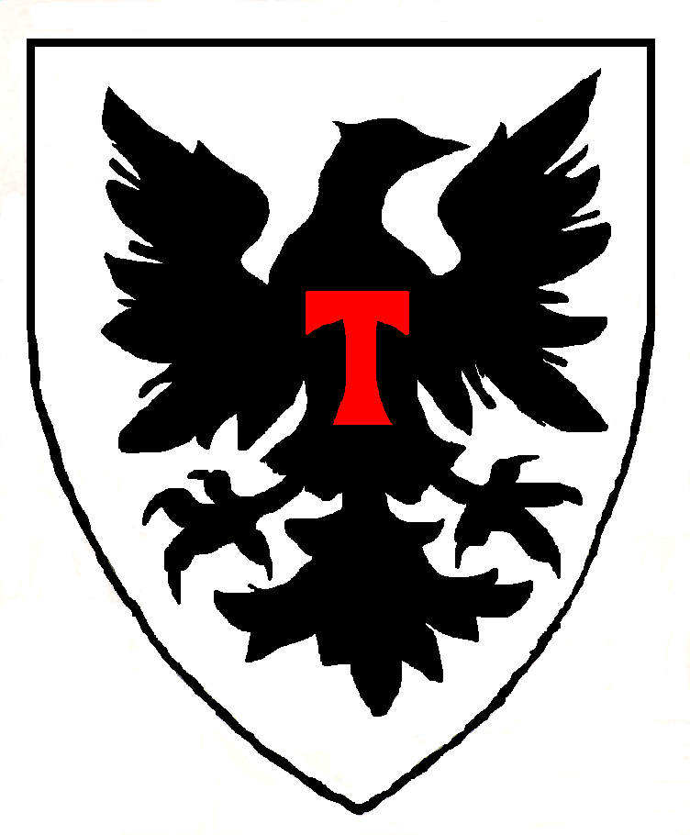

Current Hit Points 29
Wounds

◻ Chirurgery Needed

Combat Skills
Battle (10) 19 ◻
Horsemanship (10) 18 ◻

Weapon Skills
Sword (10) 24 ◻
Lance (0) 13 ◻
Spear (2) 2 ◻
Dagger (5) 7 ◻
◻
◻
◻
◻
◻
◻
◻
◻
◻
◻

Joust Score
Wins Losses

Horses
Best warhorse (#1) Dinadan
Type ½ Breed Destrier
Dam 8d6 Move 7
Armor 5 HP 52
SIZ 42 CON 10
DEX 10 STR 38
Other Horses
Own Riding (#2) Celtic Pony
Squire’s (#3) Celtic Pony
(#4)
(#5)

Selected Events
Born 474
Ennobled
Squired 489
Landed 495
Knighted 495
Member of Round Table
Died

Holdings
Broad Castle 14
Chalke (Ravensgate) Castle 26
Marlborough Castle 36
Mildenhall Town 30
Woodreach Manor (Silch.) 6
Sunbull Manor (Lindsey) 6

Equipment
Denarii
Libra 2
1 Charger
2 Rouncies

Army
Old Knights 0
Middle Aged Knights 0
Young Knights
Total Family Knights
Vassal Knights 80
Other Lineage Men
Levy

Family
Year Wed 495
Spouse Name Jeanne
Lady of Broad Chalke
Family Characteristics
Natural Musicians (+15)

Will

Children to Reach Majority
Caradoc (brn 496)
Nia (brn 498)
Gwyn & Gwen (brn 499)

History Glory

Date Important Event New Total
495 Began career as PC; knighted on Battlefield of Wareham Woods;met Merfyn, Oberon; wed
496
497
498
499 Saxon invasion, with Fomori alliance; Morgaine marries Ailil; Child in extended family 776 3935
500 Nianni arrives; Gain village; Skip forward to 510; Child in extended family 0 3935
503 Cousin is missing 0 3935
504 Uncle in Malahaut accused of horse stealing 0 3935
505 Cousin marries 0 3935
506 Sister gives birth 0 3935
507 Cousin dies 0 3935
508 Cousin gives birth 0 3935
509 Uncle Gwion dies; inherit large family manor near Lincoln, including Mithras temple in Lincoln 0 3935
510 Time travel 1000 4935
Slay Fomori, Slay Saxons 170 5190
Battle of Sarum 1610 5864
Battle of Carlion 252 6116
Witness the Test of the Red Dragon Cymry 1000
511 uncle dies
Battle of Carohaise 330
Siege of Shirburn 475
512 see Arthur survive a fatal blow 50
Battle of Bedegraine Forest; see dragons fight 760

Rhodri Notes

Player Characters
Sir Arcavius (Simon)
Sir Brion (Simon – decd)
Niani (Jenny) & Sir Brennos (NPC)
Sir Cynon (Mike - retired) – Steward Of Levcomagus
Sir Amils of Champagne (Michael)

Principal Characters
King Arthur
Lady Jeanne (my wife)
Sir Caradoc (my son, Arthur’s ex-squire)
Nia, Gwyn & Gwen (my daughters)
Earl Robert of Salisbury (my liege)
Sir Jaradan (Earl Robert’s seneshal)
Duke Ulfius of Silchester (Cynon’s liege)
Lady Margot (Arcavius’s wife)
Sir Hywel (my vassal, ex-squire)
Sir Edar (my vassal, steward of Mildenhall)
Lady Aneirin (Edar’s wife, Oberon’s daughter)
Sir Nai (my vassal, ex-squire)
Praetor Jonathel (Arcavius’s liege, missing)
Duke Corneus of Lindsey
Bishop Bawdwin
Merfyn (Mage)
The Lady Voklaine, Annwyn and Carwyn (Dragon and 2 Unicorns)
Oberon (Fae king) & Titania (Fae queen)
Ailil (Unseleighe prince)
Morgaine (Arthur’s ½ sister, Ailil’s ex-consort)
Morgause (Arthur’s ½ sister, Lot’s wife)
Lyzianor (Ailil’s daughter)
Sir Cynrain (Jeanne’s ex-champion, my vassal, husband of Lyzianor)
Sir Gondrins (Earl Robert’s son)
King Lot of Lothian & Orkney

Fae Items of Power
Falaius (Stone of Destiny) Fomori King
Feneus (Spear) Glastonbury Tor & Angel
Gorius (Sword) Oberon
Marius (Cauldron) Ben Nevis & Black Dragon

