Player Ben

Personal Data
Name Rhodri
Homeland Lindsey
Culture Cymric Religion Pagan
Father’s Name Gwrfelling
Father’s Class Merc. Knight Son # 3
Liege Lord King Arthur Pendragon
Current Class Earl Year Born 474
Current Home Jagent Age 37 (46)

Personality Traits
Chivalry Bonus [•] (total =80+) 81
Religious Bonus [] (traits all 16+) No
◻ Chaste 7 / 13  Lustful ◻
◻ Energetic • 17 / 3 Lazy ◻
◻ Forgiving 17 / 3 Vengeful ◻
◻ Generous • 16 / 4 Selfish ◻
◻ Honest  11 / 9 Deceitful ◻
◻ Just • 14 / 6 Arbitrary ◻
◻ Merciful • 11 / 9 Cruel ◻
◻ Modest • 4 / 16  Proud ◻
◻ Pious 14 / 6 Worldly ◻
◻ Prudent 11 / 9 Reckless ◻
◻ Temperate 17 / 3 Indulgent ◻
◻ Trusting 7 / 13 Suspicious ◻
◻ Valorous • 19 / 1 Cowardly ◻
Directed Trait - Suspicious of Other Lands 4
Directed Trait

Passions
Loyalty (Lord/Vassals) 15/14 ◻
Loyalty (Arthur) 20 ◻
Love (Jeanne/Family) 16/15 ◻
Love (Mithras) 16 ◻
Hospitality 14 ◻
Honor 13 ◻
Hate (Saxons) 7 ◻
Love (Party) 16 ◻

Equipment Carried
Armour Silver Fae Mail (26) = 15 + 3 (chiv) + 8 (shield)
◻ Personal Gear (on horse #)
◻ Travel Gear (on horse #)
◻ War Gear (on horse #)
Weapons Shield, Spear, Sword, Dagger
Silver Fae Mail– ( ≡ leather armour for Dex adj)
Unbreakable Shield-(defense 8)
Swift Sword-(strikes twice, if 1st 1 hits)
Money Exchange 1£ = 20s = 240d

Statistics
SIZ 17 (Knockdown)
DEX 12
STR 18
CON(+3) 14 (Major Wound)
APP 11
Damage ((STR+SIZ)/6) 6d6
Healing Rate ((STR+CON)/10) 3
Movement Rate ((STR+DEX)/10) 3
Total Hit Points (SIZ+CON) 31
Unconscious (HP/4) 8

Distinctive Features
Big vertical scar on left cheek

Skills
Awareness (5) 17 ◻
Boating (1) 1 ◻
Chirurgery (0) 1 ◻
Compose (0) 0 ◻
Courtesy (3) 12 ◻
Dancing (2) 2 ◻
Faerie Lore (1) 9 ◻
First Aid (10) 11 ◻
Flirting (3) 3 ◻
Folk Lore (2) 6 ◻
Gaming (3) 3 ◻
Hawking (3) 3 ◻
Heraldry (0) 9 ◻
Hunting (2) 7 ◻
Industry (0) 0 ◻
Intrigue (3) 15 ◻
Orate (3) 15 ◻
Play Harp (3) 20 ◻
Read ( ) (0) 0 ◻
Recognise (3) 11 ◻
Religion (Mithras) 10 ◻
Romance (0) 0 ◻
Singing (2) 11 ◻
Stewardship (2) 15 ◻
Swimming (2) 4 ◻
Tourney (0) 13 ◻
◻
◻
◻
◻

Squire
Name Blaen
Age 20
First Aid (8) ◻
Battle (2) ◻
Horsemanship (13) ◻
Sword (9) ◻
Hunting (9) ◻
◻
◻

Glory 24,461
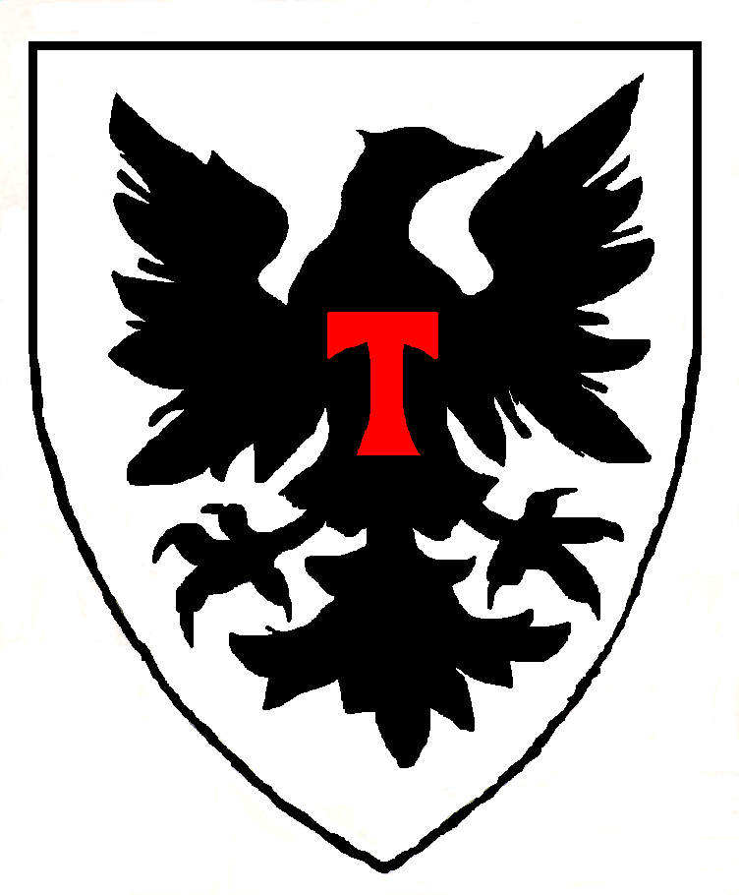

Current Hit Points 31
Wounds

◻ Chirurgery Needed

Combat Skills
Battle (10) 20 ◻
Horsemanship (10) 18 ◻

Weapon Skills
Sword (10) 24 ◻
Lance (0) 15 ◻
Spear (2) 2 ◻
Dagger (5) 7 ◻
◻
◻
◻
◻
◻
◻
◻
◻
◻
◻

Joust Score
Wins 1 Losses 1

Horses
Best warhorse (#1) Dinadan
Type ½ Breed Destrier
Dam 8d6 Move 7
Armor 5 HP 52
SIZ 42 CON 10
DEX 10 STR 38
Other Horses
Own Riding (#2) Celtic Pony
Squire’s (#3) Celtic Pony
(#4)
(#5)

Selected Events
Born 474
Ennobled 515
Squired 489
Landed 495
Knighted 495
Member of Round Table
Died

Holdings (Max 200)
Broad Castle 14
Chalke (Ravensgate) Castle 26
Marlborough Castle 36
Mildenhall Town 30
Woodreach Manor (Silch.) 6
Sunbull Manor (Lindsey) 6
Ilminster Town (Jagent) 30
Ilchester Town (Jagent) 30
Jagent Town (Jagent) 30
Jagent Castle (Jagent) 26

Equipment
Denarii
Libra 2
1 Charger
2 Rouncies

Army
Old Knights
Middle Aged Knights
Young Knights
Total Family Knights
Vassal Knights 225
Other Lineage Men 300
Levy

Family
Year Wed 495
Spouse Name Jeanne
Lady of Broad Chalke
Family Characteristics
Natural Musicians (+15)

Will

Children to Reach Majority
Caradoc (brn 496)
Nia (brn 498)
Gwyn & Gwen (brn 499)

History Glory

Date Important Event New Total
495 Began career as PC; knighted on Battlefield of Wareham Woods;met Merfyn, Oberon; wed
496 Rescued Arthur from Tintagel to Reavensgate; meet Lida & Lucienne; gain Mildenhall & Marlborough; fight Wizard under Marlborough; druid & banshees; Caradoc born
497 slew waterleaper; Saxon raid; Fomori, goblins & ghouls slain under Silchester; Brion lost; slay Sissa; Fae feast 100
498 fight Gorboduc the Devil; general in hell; return Angus lover/harp; Nia born
499 fight 3 Coloured Serpent (Ailil in disguise); meet Voklain& Annwyn for 2nd time & the Salmon for the 1st; rescue Margot; Saxon invasion, with Fomori alliance; Child in extended family; Gwyn & Gwen born 776 3935
500 raid into Anglia; Morgaine elopes withAilil; Morgaine betrays Jeanne & I rescue her; Child in extended family
501 Nianni arrives; Gain village; Skip forward to 510; my sister missing 0 3935
503 Cousin is missing 0 3935
504 Uncle in Malahaut accused of horse stealing 0 3935
505 Cousin marries 0 3935
506 Sister gives birth 0 3935
507 Cousin dies 0 3935
508 Cousin gives birth 0 3935
509 Uncle Gwion dies; inherit large family manor near Lincoln, including Mithras temple in Lincoln 0 3935
510 Time travel 1000 4935
Slay Fomori, Slay Saxons 170 5190
Battle of Sarum 1610 5864
Battle of Carlion 252 6116
Witness the Test of the Red Dragon Cymry 1000
511 uncle dies
Battle of Carohaise 330
Siege of Shirburn 475
512 see Arthur survive a fatal blow 50
Battle of Bedegraine Forest; see dragons fight 760
First Tourney of Arthur’s rule 100
Battle of Bassus River; slay Centurion King 3400
Fomori fight & giant Fomori slain 250
Black Dragon Hunt 2000 19887
513 Nia got sick but improved; cousin goes missing
Battle of Dorchester 410
Battle Of Dunum Forest 300
Battle Of Dunum 300 21273
514 Arthur & Maeve wed, Caradoc & Guenevere wed
made Earl of Jagent 350 22096
515 22569
516 sister gives birth 23042
517 sister accused of adultery 23515
518 sister goes missing, suffer evil eye 23988
519 grandparent almost proved to be in a messy love affair, suffer pox 24461

Rhodri Notes

Player Characters
Sir Arcavius (Simon)
Sir Brion (Simon – decd)
Niani (Jenny) & Sir Brennos (NPC)
Sir Cynon (Mike - retired) – Steward Of Levcomagus
Sir Amils of Champagne (Michael)
Drust (Stewart)

Principal Characters
King Arthur
Sir Lancelot (new French follower of Arthur)
Lady Jeanne (my wife,mage)
Sir Caradoc (my son, Arthur’s ex-squire,new King of Malahaut)
Nia (my eldest daughter)
Gwyn & Gwen (my youngest twins, boy & girl)
Earl Robert of Salisbury (my liege)
Sir Jaradan (Earl Robert’s seneshal)
Sir Gondrins (Earl Robert’s son)
Duke Ulfius of Silchester (Cynon’s liege)
Captain Bellator (Ulfius’ Captain of the Guard)
Lady Margot (Arcavius’s wife)
Sir Hywel (my vassal, ex-squire)
Sir Nai (my vassal, ex-squire)
Sir Edar (my vassal, steward of Mildenhall)
Lady Aneirin (Edar’s wife, Oberon’s daughter)
Praetor Jonathel (Arcavius’s liege, missing)
Duke Corneus of Lindsey
Bishop Bawdwin
Merfyn (Mage)
The Lady Voklaine, Annwyn, Carwyn and Illisander (Dragon and 3 Unicorns)
Oberon (Fae king) & Titania (Fae queen)
Ailil (Unseleighe prince)
Morgaine (Arthur’s ½ sister, Ailil’s ex-consort)
Morgause (Arthur’s ½ sister, Lot’s wife)
Lyzianor (Ailil’s daughter)
Sir Cynrain (Jeanne’s ex-champion, my vassal, husband of Lyzianor)
King Lot of Lothian & Orkney (Arthur’s vassal)
King Clovis (ex-French King, deceased)
Lady Ygraine (Arthur’s mother, nun)
Uther (Arthur & Lyzianor’s son)
* * (Oberon & Lyzianor’s son)
Varis (Black Dragon – deceased, necromancer – coming back)
Lady Bethannon (crazy animate skull, ex-wife of Varis, with Oberon)

Fae Items of Power
Falaius (Stone of Destiny) Fomori King
Feneus (Spear) Glastonbury Tor & Angel
Gorius (Sword) Oberon
Marius (Cauldron) Voklaine

