1



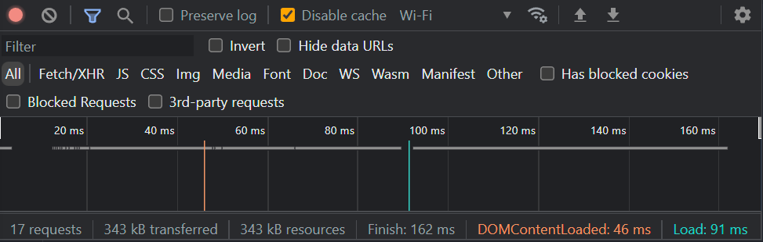

10

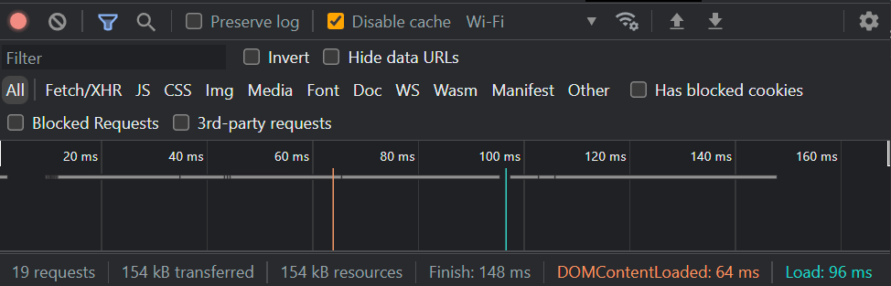

10ii

The optimizations didn’t seem to have much impact on load times, but my internet may have been acting up. The data transferred was cut in half, so I think overall it was worth the optimizations.