Team Financially Illiterate

10/23/2022

**Project Wireframes**

1. **Creating an Account**

A user wants to get better at organizing his finances, so he decides to use our site. When he first opens the site, he is greeted by our landing page:

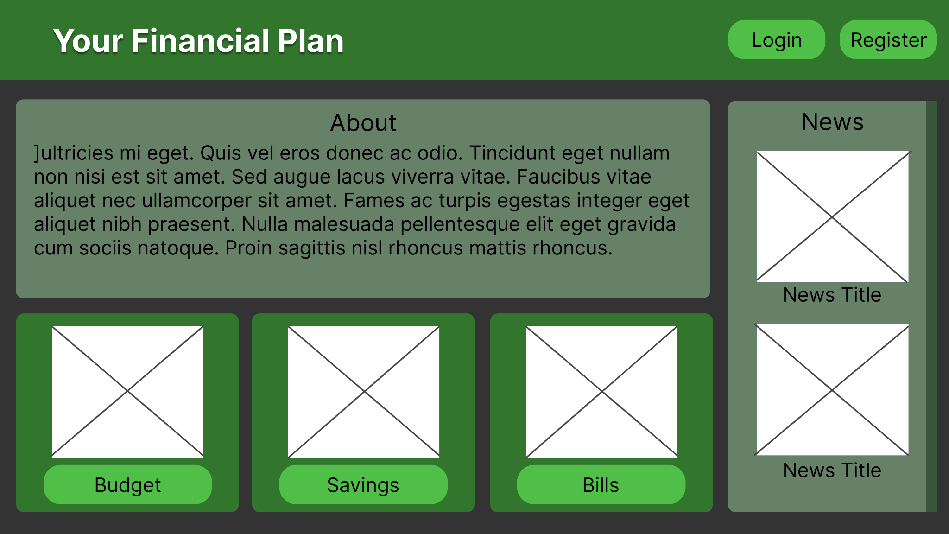

After reading the About section and deciding to try our site, he clicks the Register button on the top left of the screen to create an account. He is brought to this page:

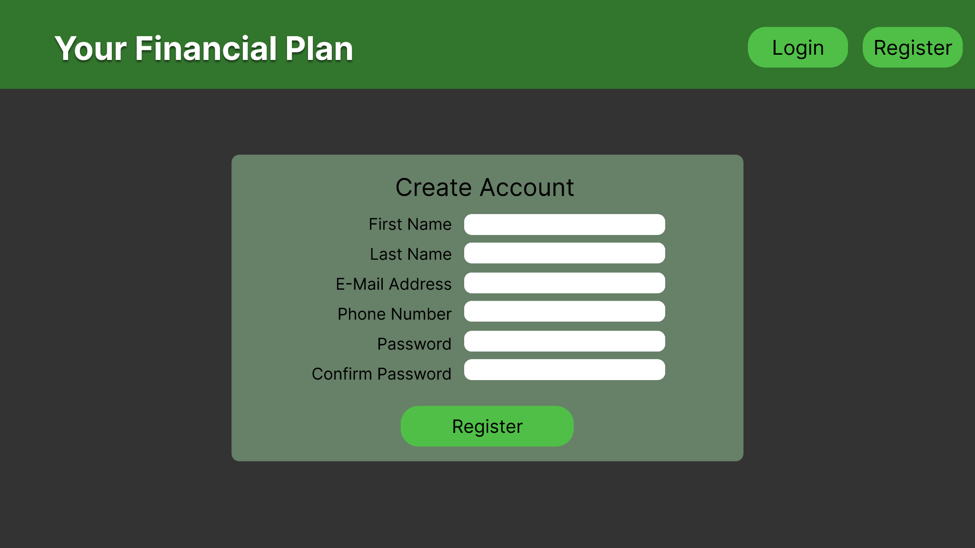

From here, he puts in his information, presses Register to complete the process, and is redirected to the user dashboard:

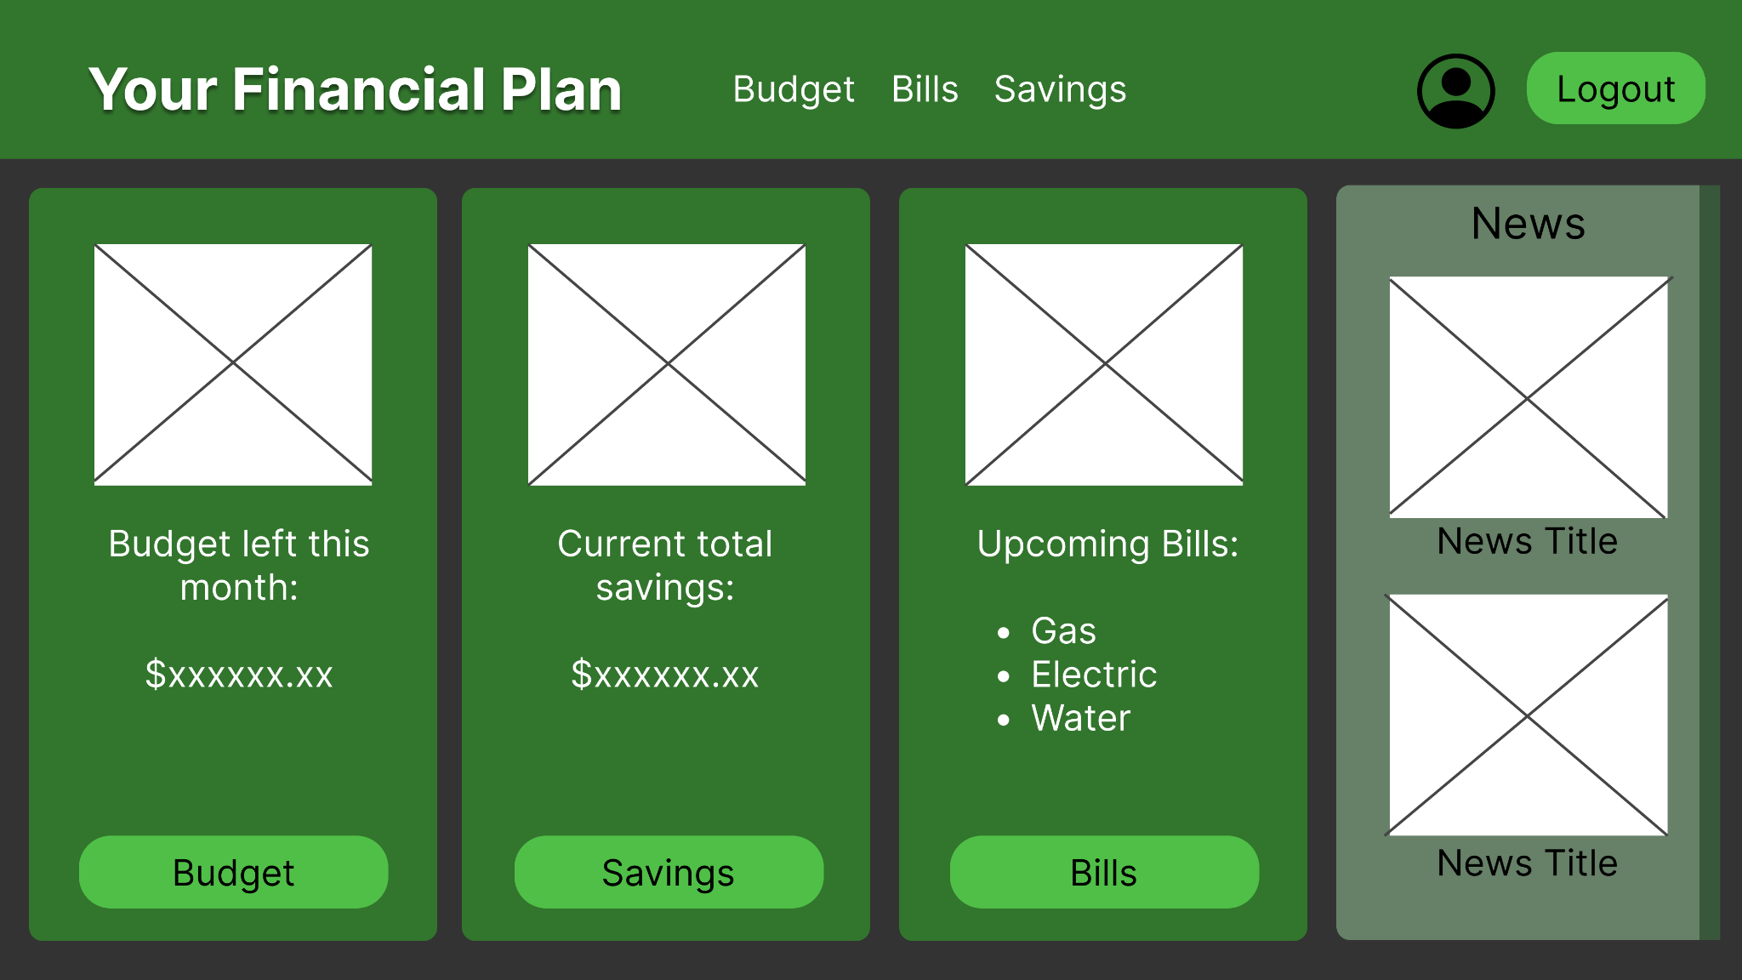

1. **Logging Into an Account**

After the user registers, they can then go to the login page from the homepage by pressing the login button in the upper right-hand corner of the site.



This will redirect you to the login page, where the user will type in their email address and password and press the submit button to login into their account.

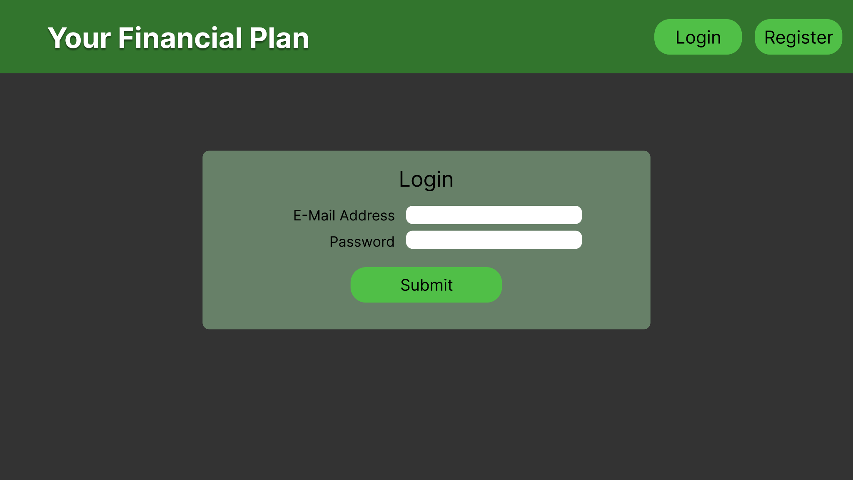

1. **Editing User Account**

To edit the user account, the user must log in and be on the user dashboard.



After logging in, the user must press the user symbol in the upper right corner of the user dashboard, which will lead you to the screen to edit user account information.

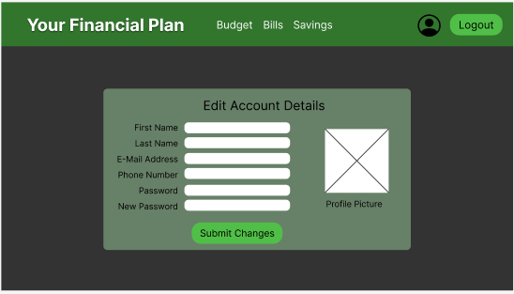

Once on the edit account page, users can change their account information.

1. **View Financial News Article**

To view financial news articles, you can click on the column on either the home page or the user dashboard. Each article will direct to the site the news originated from.





1. **Add or Edit Income**

A user, who is logged into the site, wants to determine her monthly budget. She opens the site to see her dashboard:



The user clicks on the Budget button to access the details of her budget. It takes her to the following page:

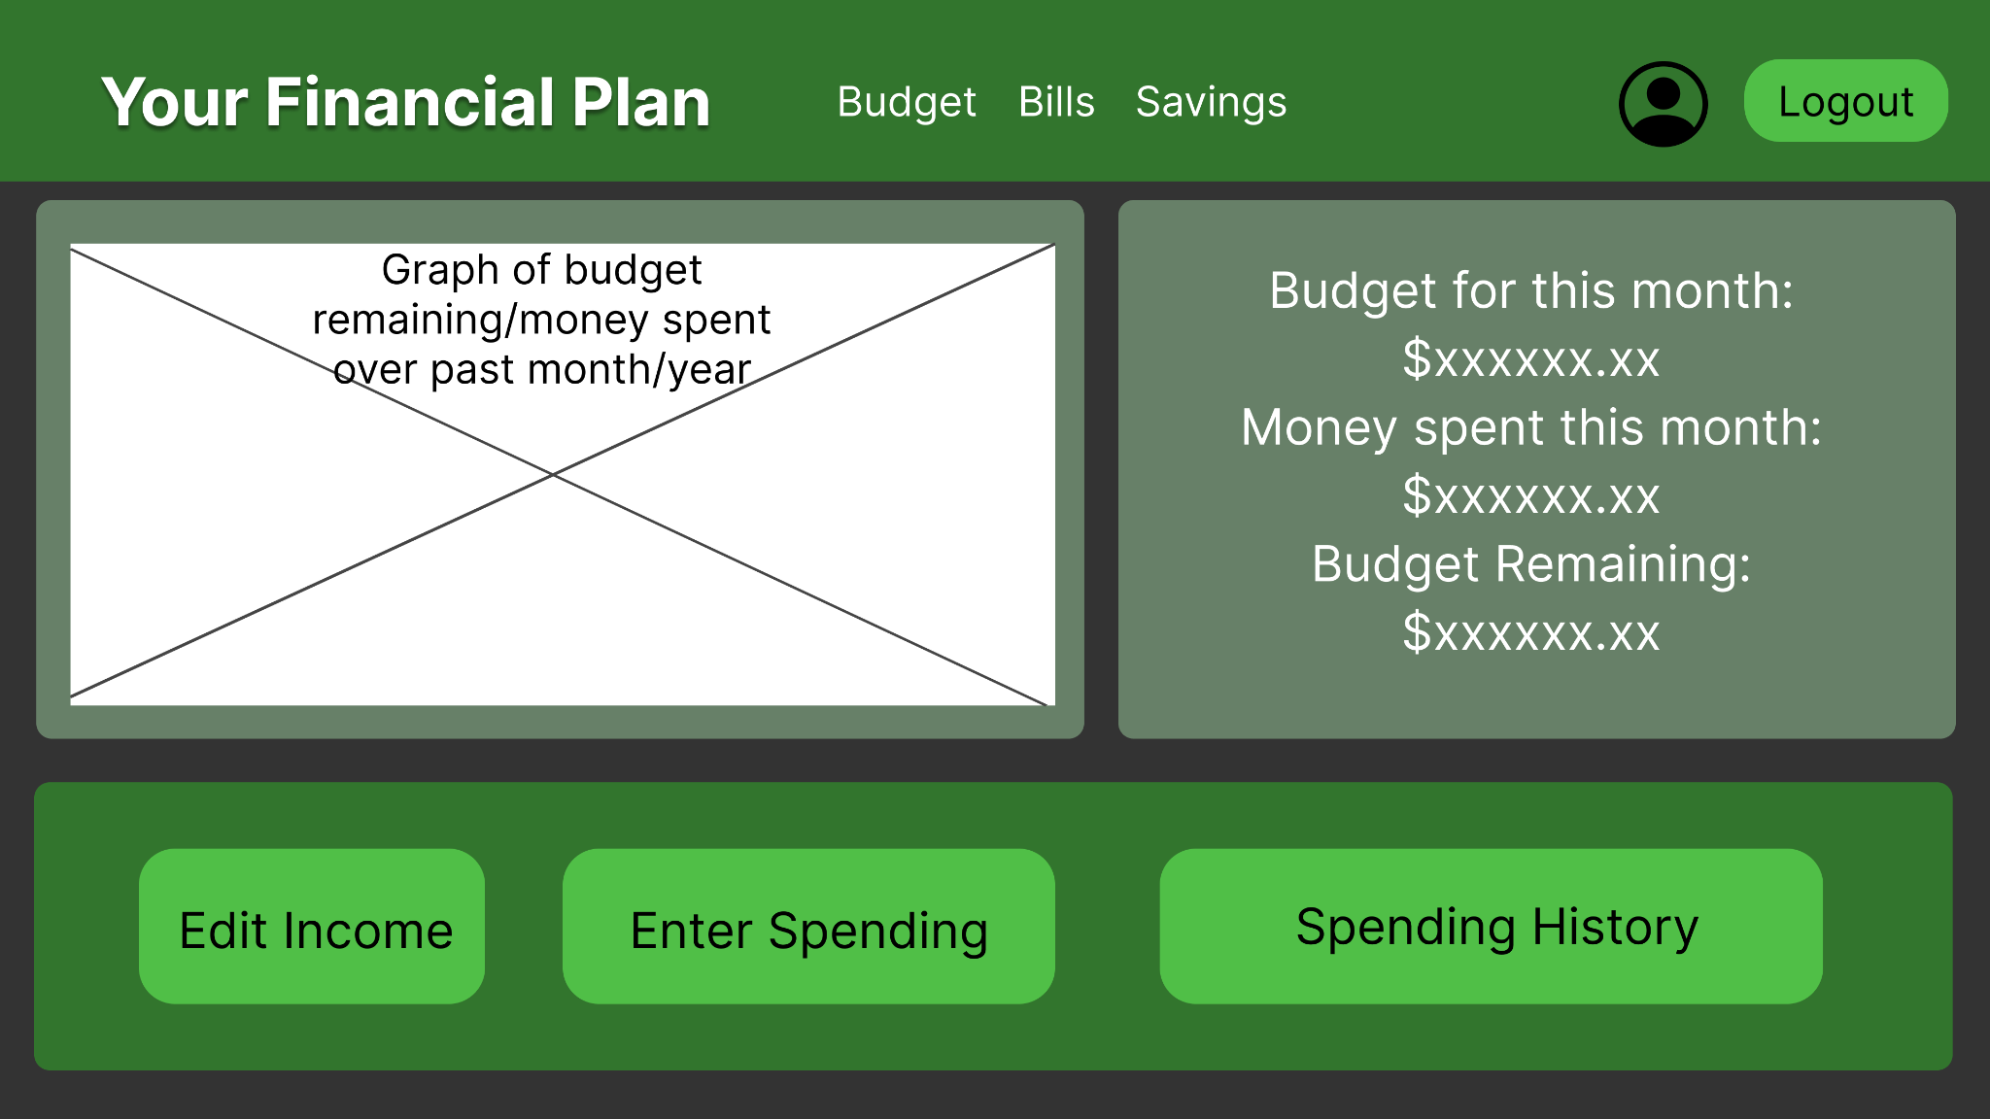

The user first wants to add the income from her job and other sources. She clicks on Edit Income and is taken to this form:

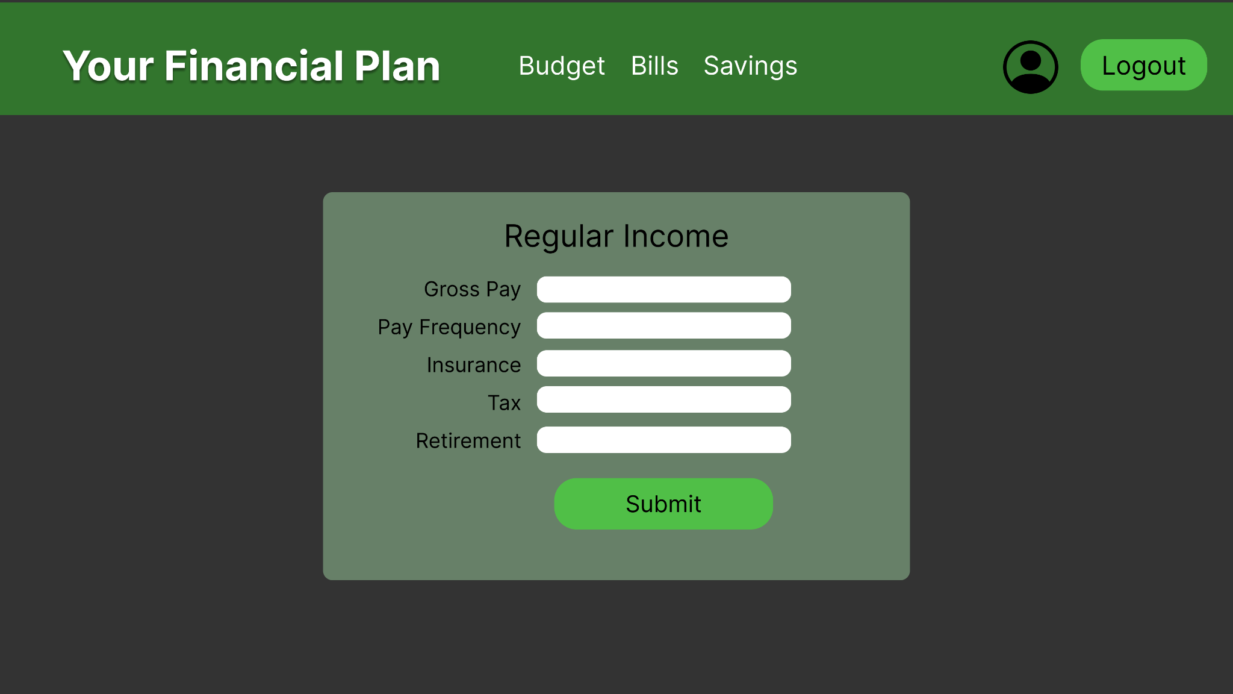

The user enters the details of her regular income and presses Submit. It brings her back to the Budget page but now shows their regular income as her monthly budget. So far, this calculation does not include her regular bills, so she uses the navigation bar at the top of the page to go to Bills to enter those details.

1. **View, add, edit, and delete bills**

From either the homepage or the navigation bar, our user clicks the Bills button and is brought to this page:

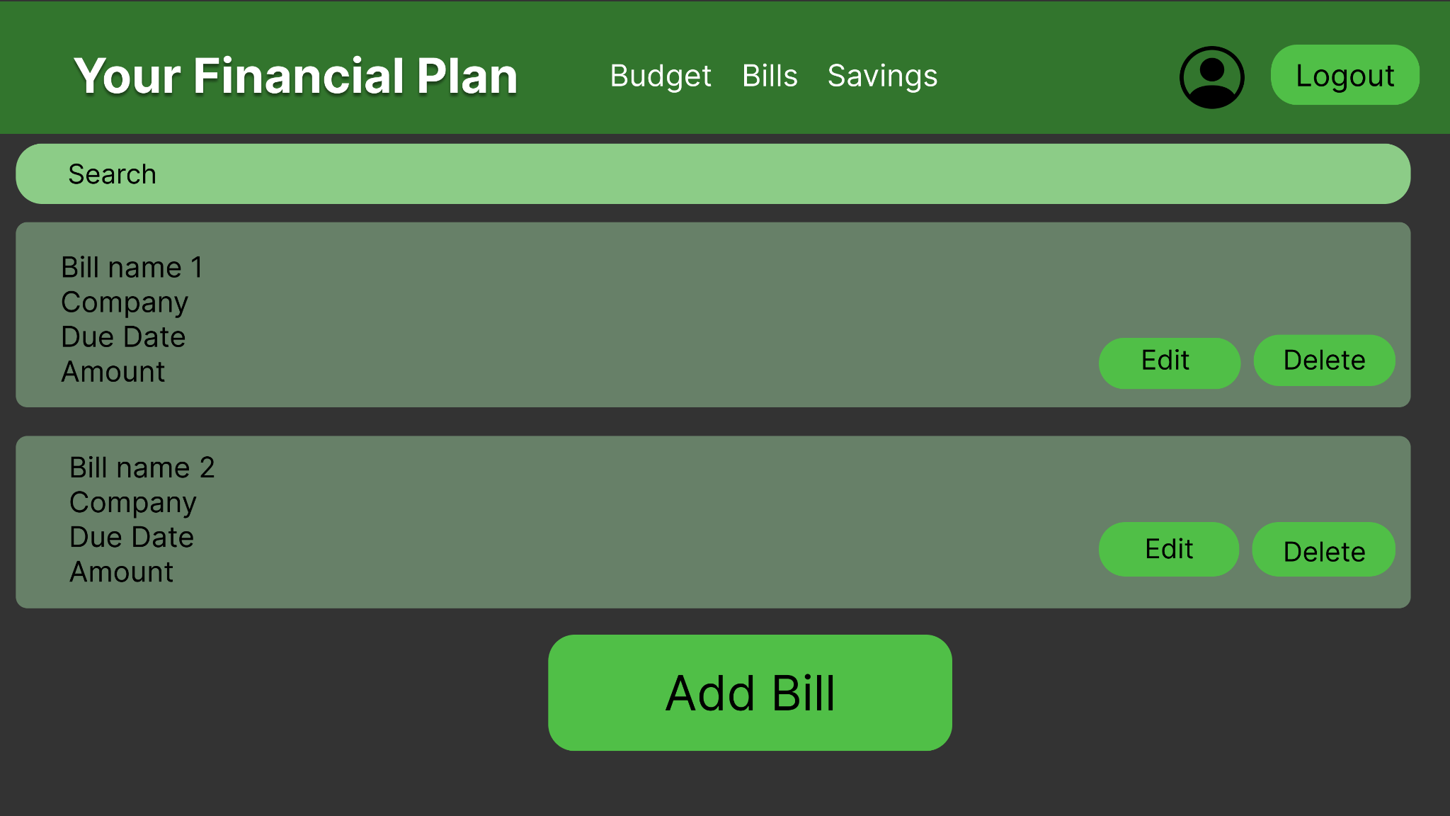

Initially, there are no bills displayed, so the user clicks the Add Bill button and is brought to this form:

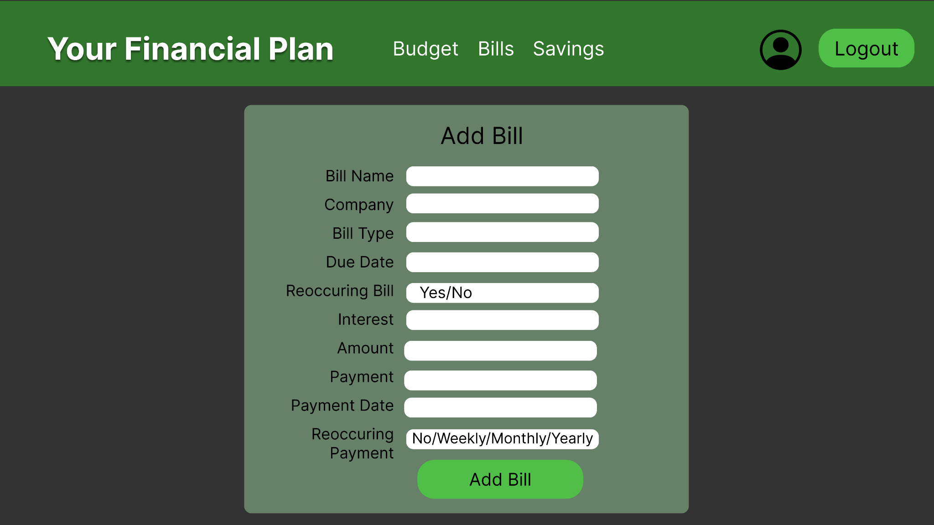

The user enters the details of each bill, hitting the Add Bill button to confirm, which brings the user back to the bills list. The user can also click on the Edit button next to each bill to be brought to the same form, but it will be prefilled with previously entered information which they can edit to update the bill. Additionally, the budget page will now automatically have the user's monthly payments subtracted when the user visits it.

1. **View, add, edit, and delete bank accounts**

To view, add, or edit accounts, the user must go to the savings page. After entering the savings page through the user dashboard or navigation bar, the user will see three buttons at the bottom of the savings page. To view accounts, the user must press the accounts button.

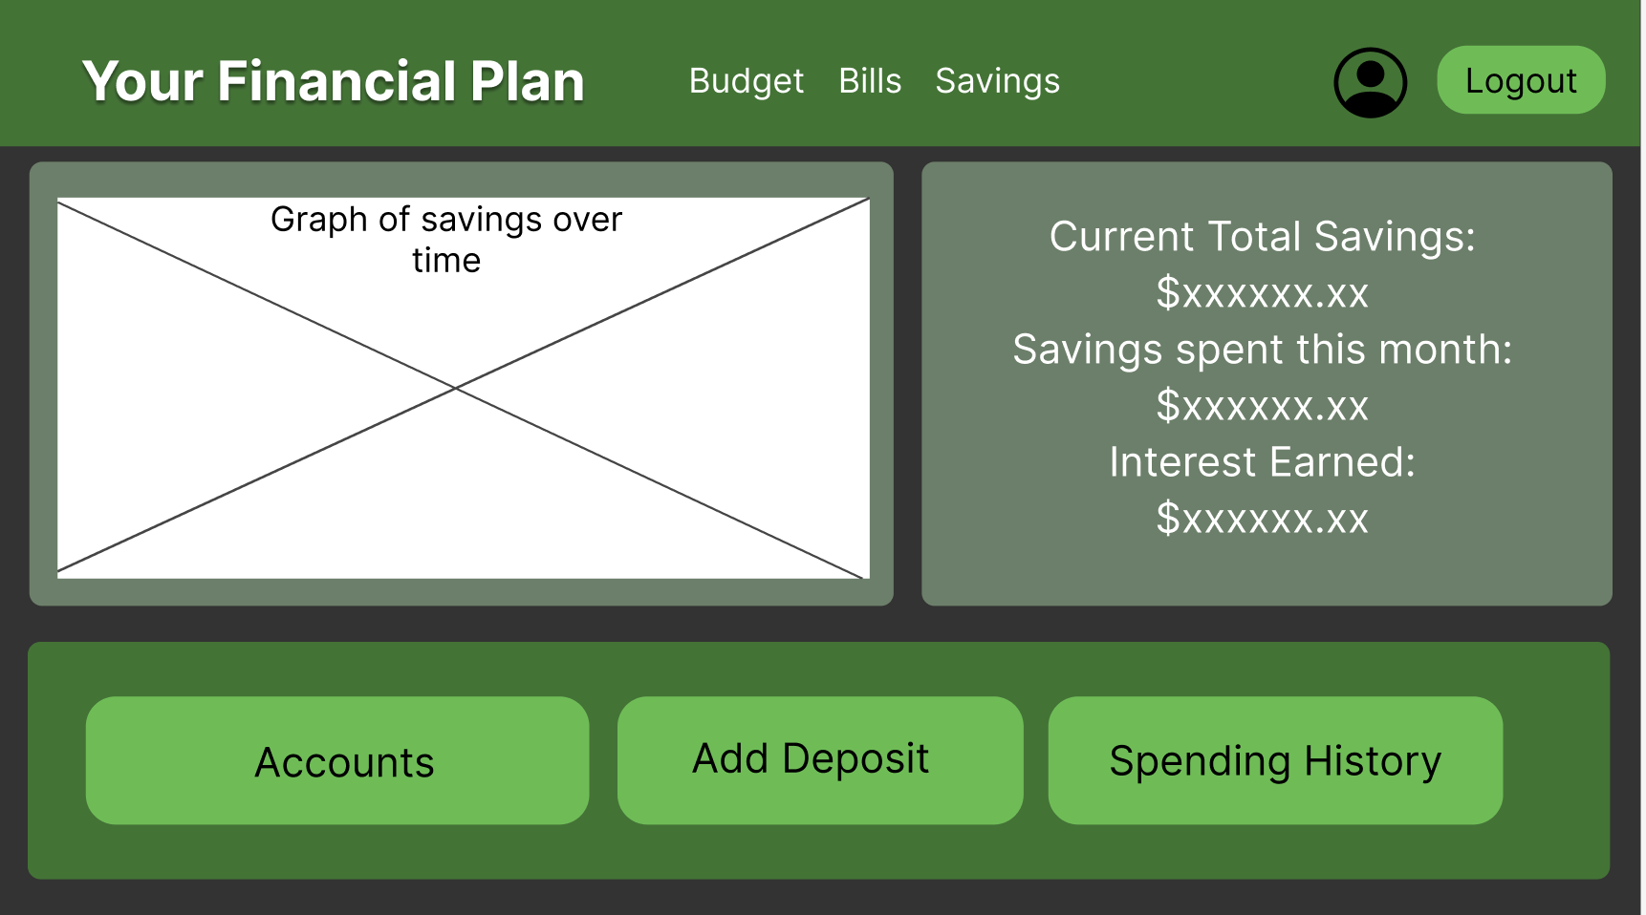

After clicking the accounts button, the user will be greeted with the accounts page. Initially, there are no accounts, similar to the bills page. To add a statement, the user must press the add account button.

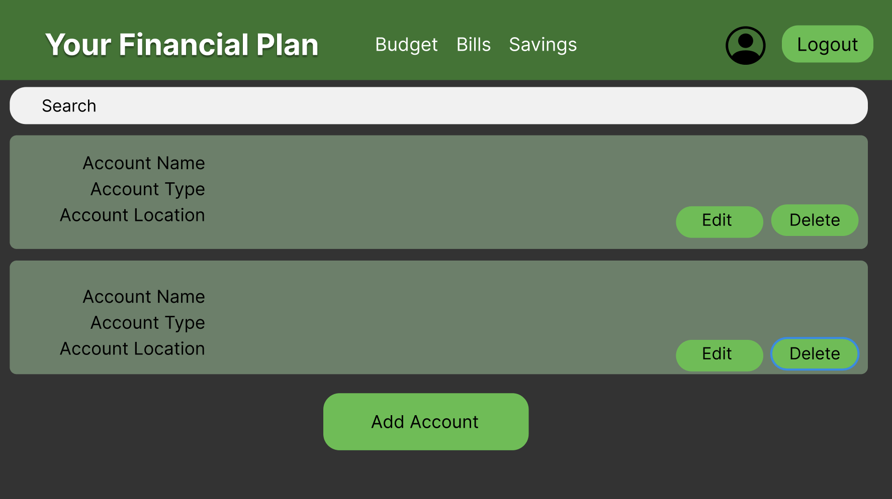

On the add account page, you will see a form asking for details about your bank account. After filling in the information, the user may press the add account button to add an account to their profile.

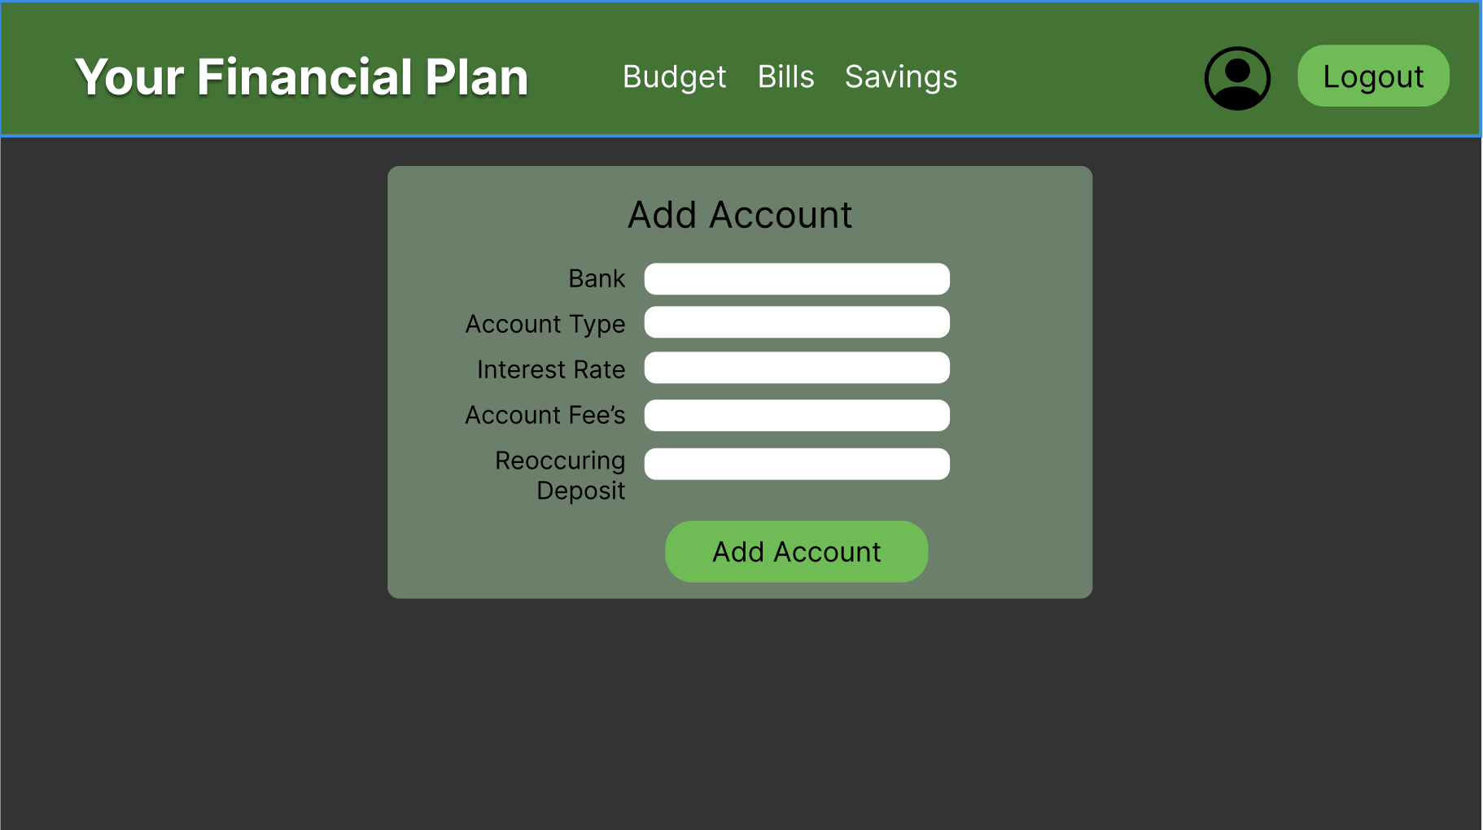

After adding an account, you will be brought back to the accounts page. Here you will now see your account. You’ll also see an edit and delete button. Upon clicking the edit page, you’ll see a form similar to the add account page.



When clicking the delete button, a modal pop-up will appear, prompting you to confirm your account name and password. After entering the account name and password, the user may click the confirm button. Once the confirm button is pressed, the account linked will be deleted.

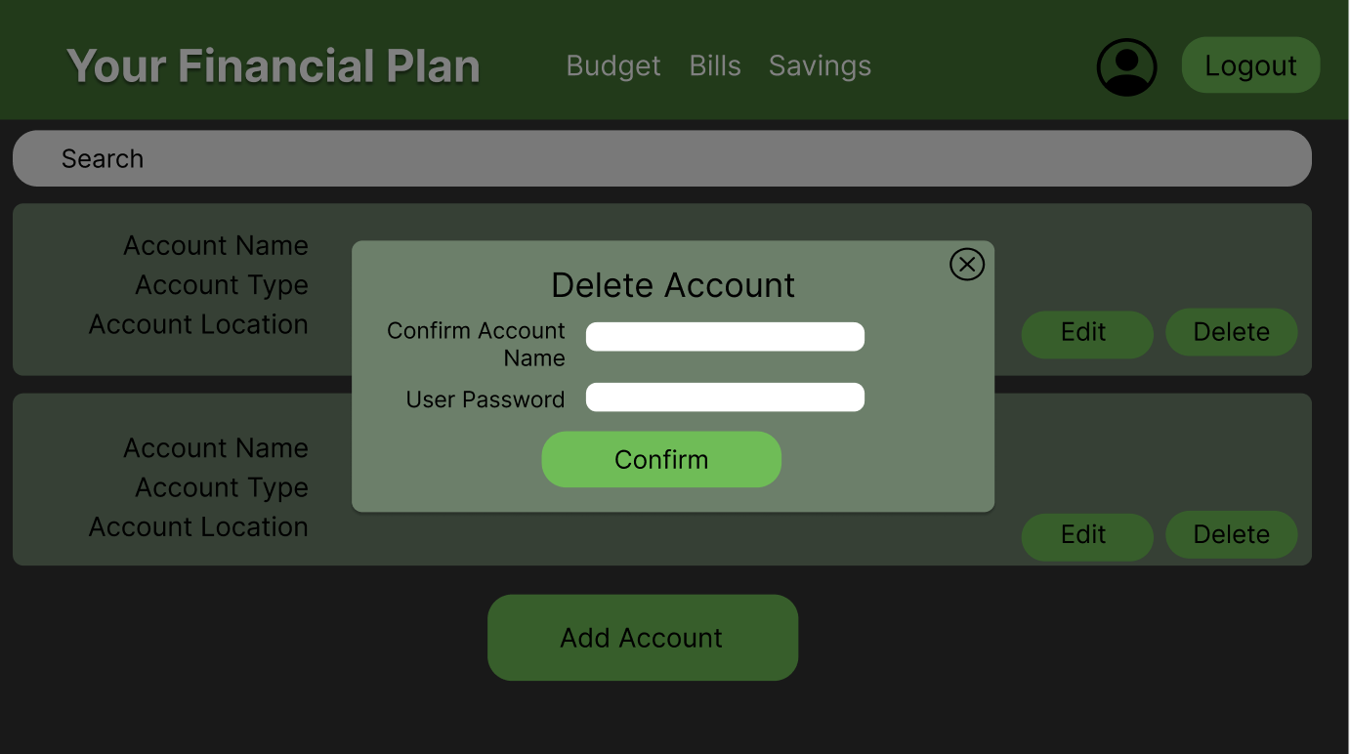

1. **View, Add, Edit, and Delete Expenditures**

The user must go to the budget page to view, add, or edit expenditures. Once on the budget page, the user can press the Enter Spending button to add expenditures or the Spending History button to view expenditures.

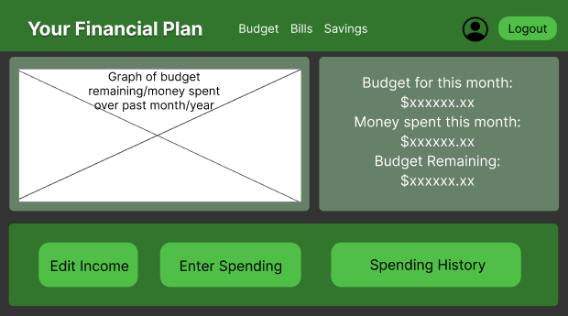

After entering the expenditures page through the budget page, the user will see three buttons at the bottom of the savings page. To view and manipulate expenditures, the user must press the Enter Spending button, which brings them to the following page:

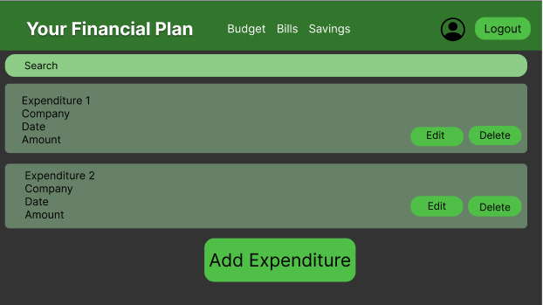

The user can add an expenditure with the button at the bottom or edit an existing expenditure with the button on the expenditure itself. Both will redirect to the following form, with prefilled information if the edit button was clicked:

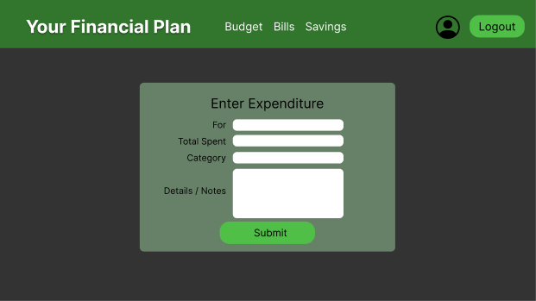

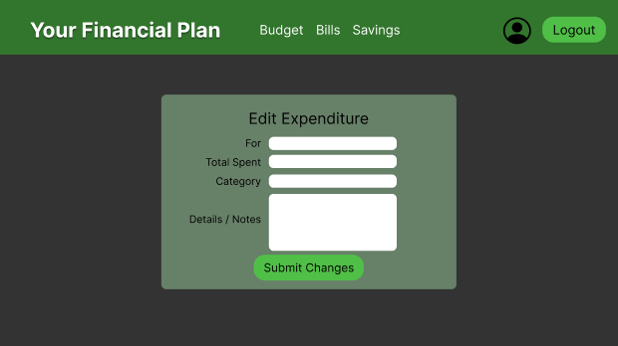

Here, the user can enter information and edit existing information, the hit the Submit Changes button to enter it into the system. From the expenditures page, if the Delete button is pressed, the user will be asked to confirm by a modal:

