This is the link to the node_modules folder:

https://drive.google.com/drive/folders/1RAyxsjDmdQIKWI7efub4Ntjz9uuPQtPR?usp=sharing

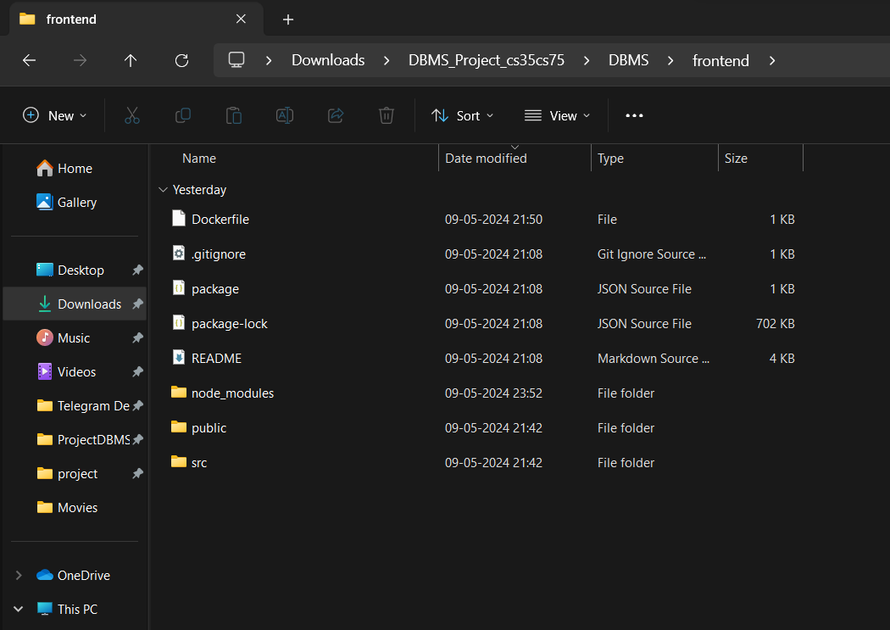This is how the frontend folder should look (it has been uploaded on git in parts)

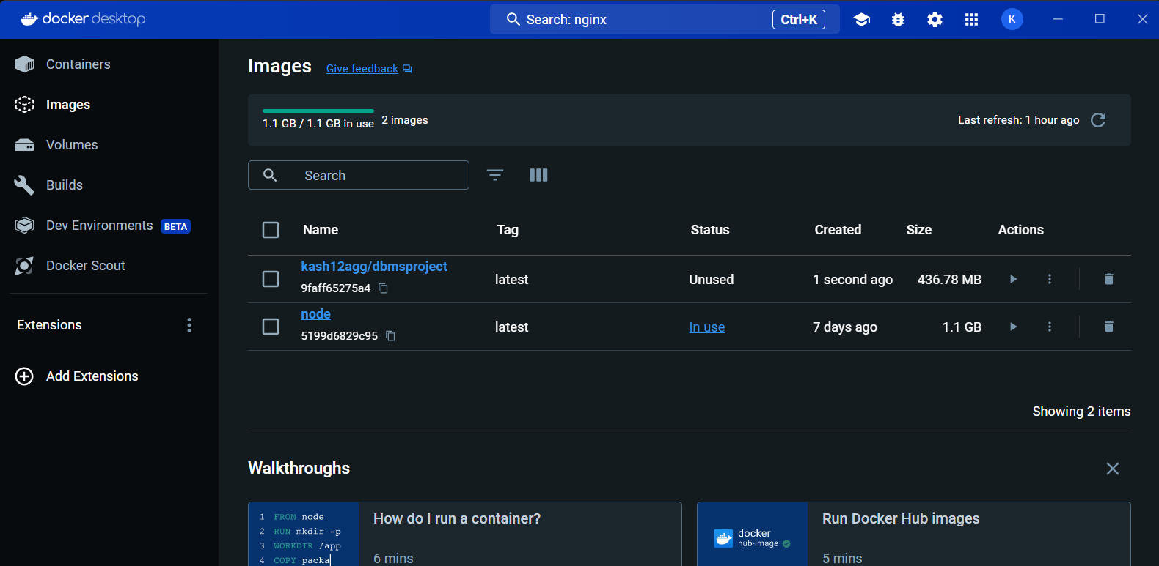This is how Docker Looks: