**Database Management System**



**Session: 2022 – 2026**

**Submitted by:**

**ALEENA SHEIKH 2022-CS-130**

**Supervised by:**

**Prof. Nazeef**

**Queries of: Lab 03**

**Department of Computer Science**

**University of Engineering and Technology**

**Lahore, Pakistan**

# **Home Tasks:**

**Question 01:**

Write a query to report orders which were delayed shipped.

**Query:**

SELECT OrderID, CustomerID,ShippedDate,OrderDate FROM Northwind.dbo.Orders WHERE ShippedDate > OrderDate;

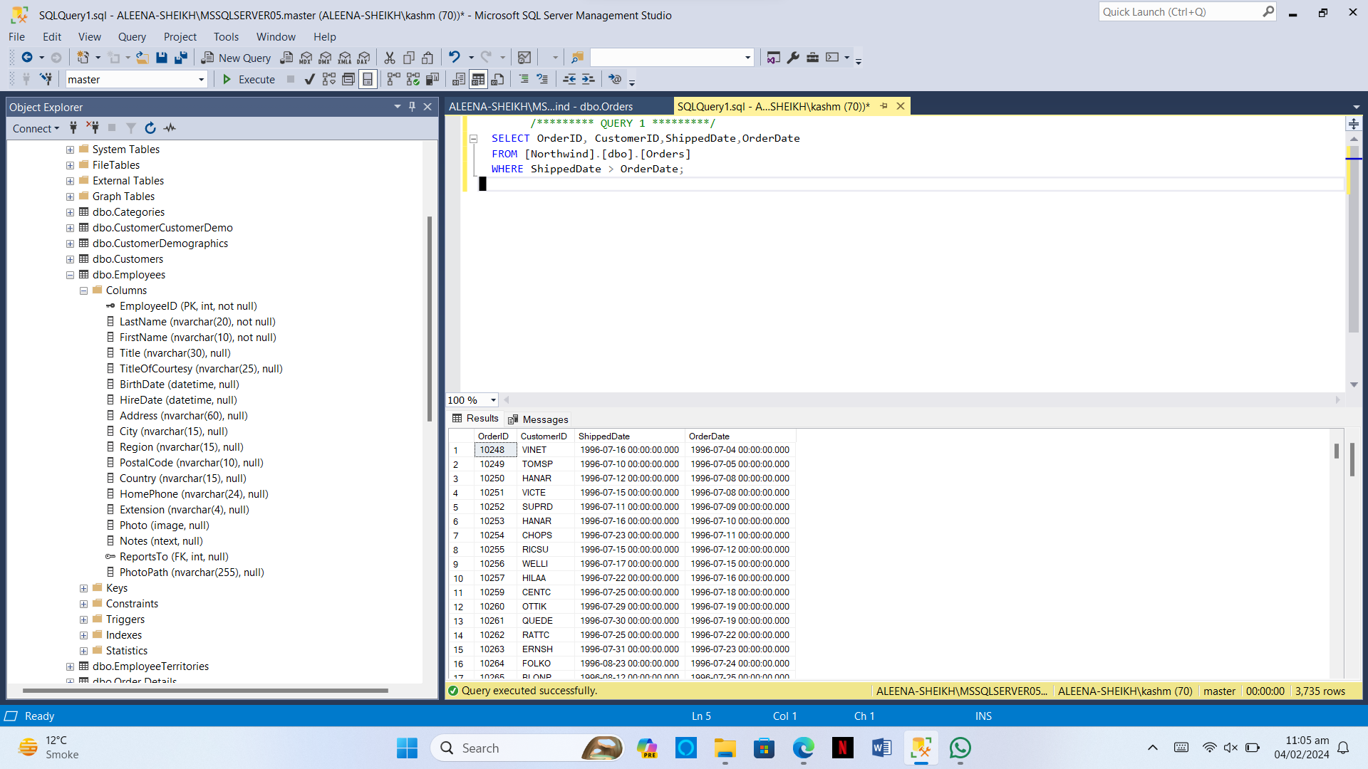

**Question 02:**

Our employees belong to how many countries. List the names.

**Query:**

SELECT DISTINCT Country FROM Northwind.dbo.Employees;

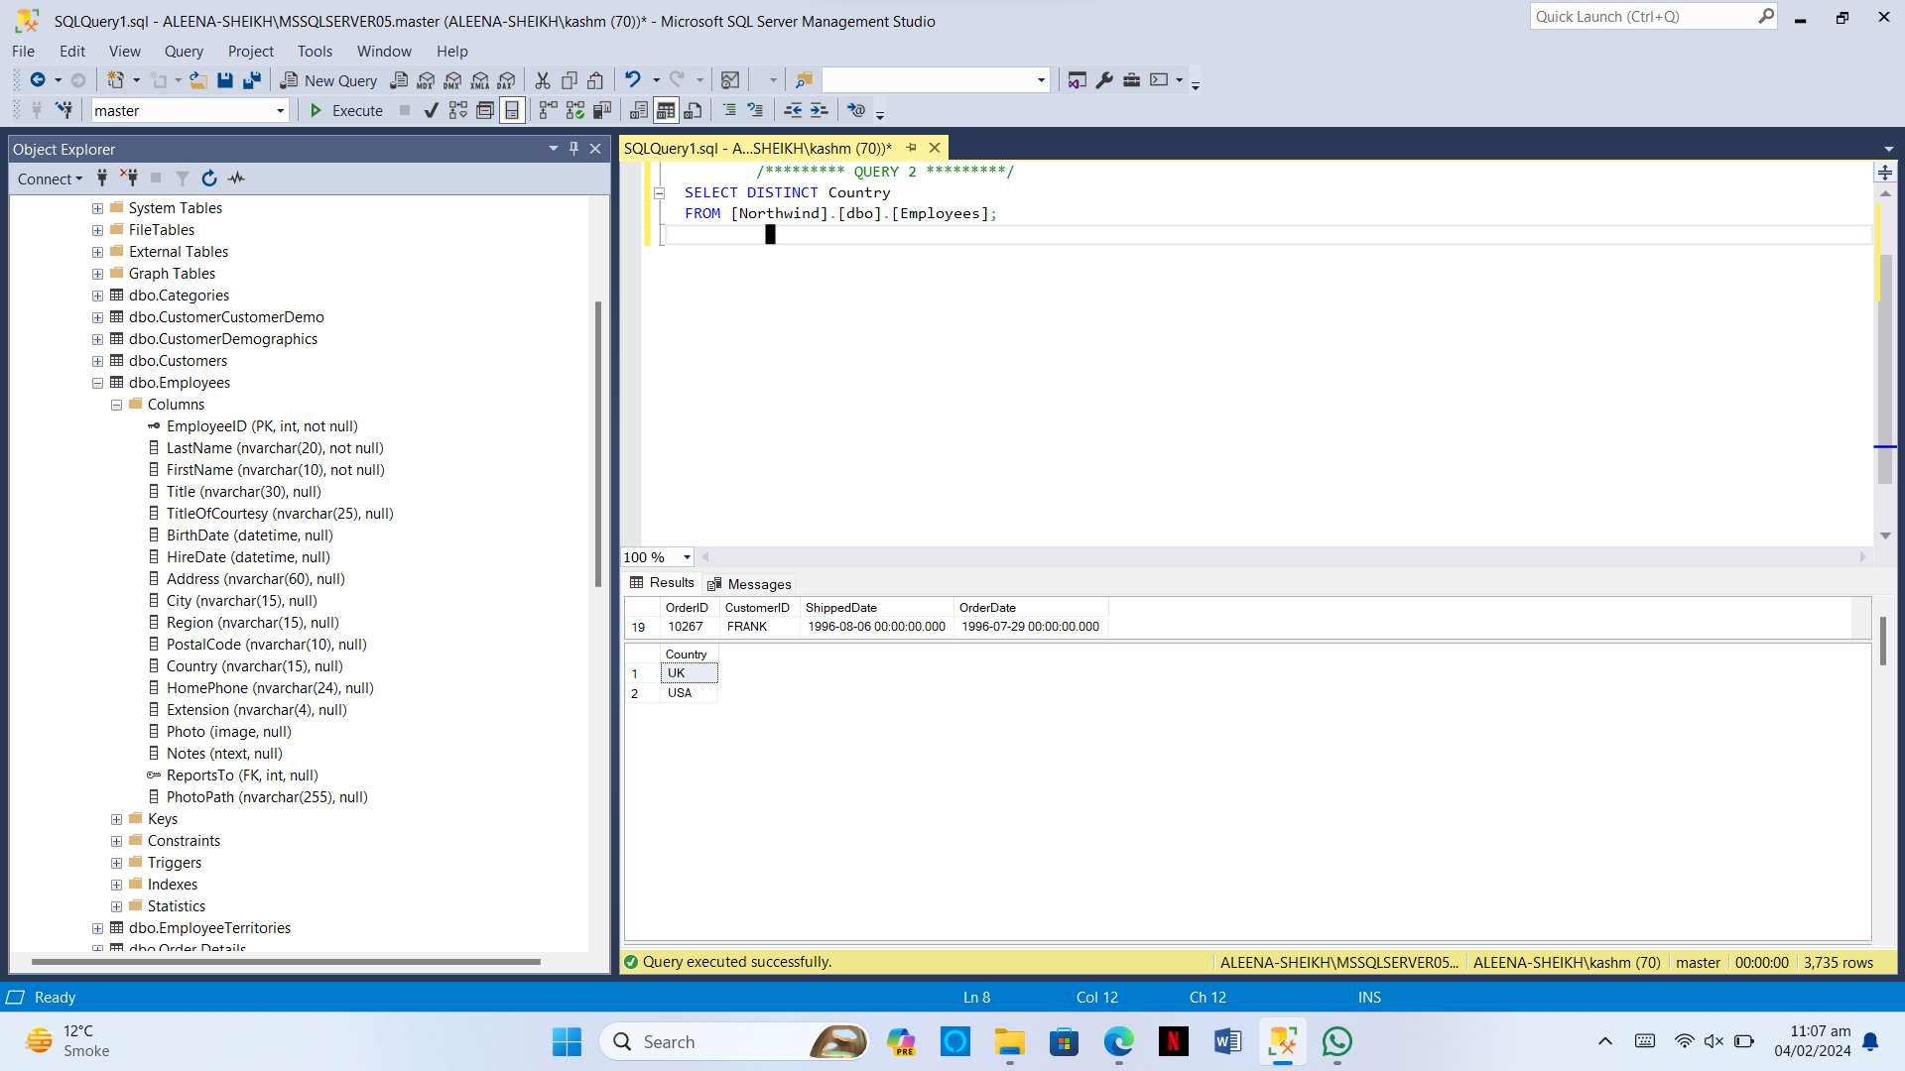

**Question 03:**

Is there any employee who is not accountable?

**Query:**

SELECT EmployeeID,LastName,FirstName FROM Northwind.dbo.Employees WHERE ReportsTo IS NULL;

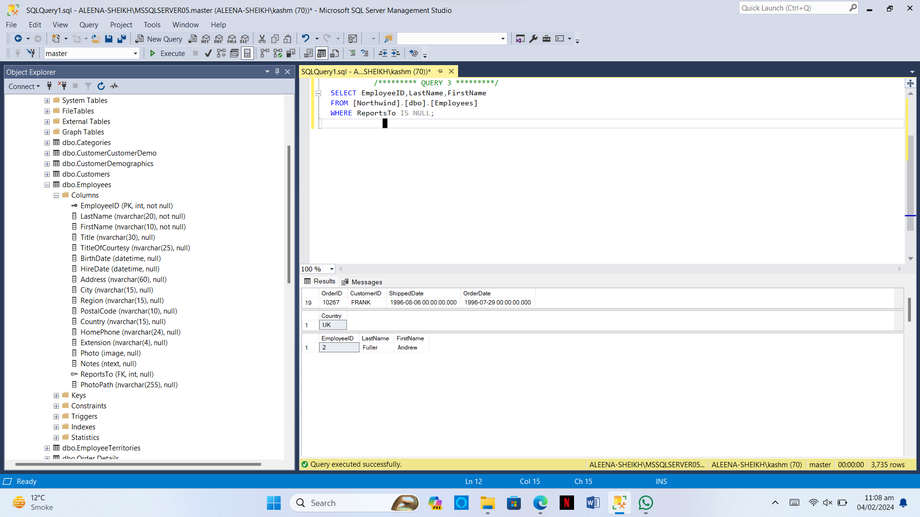

**Question 04:**

List the names of products which have been discontinued.

**Query:**

SELECT ProductName FROM Northwind.dbo.Products WHERE Discontinued = 1;

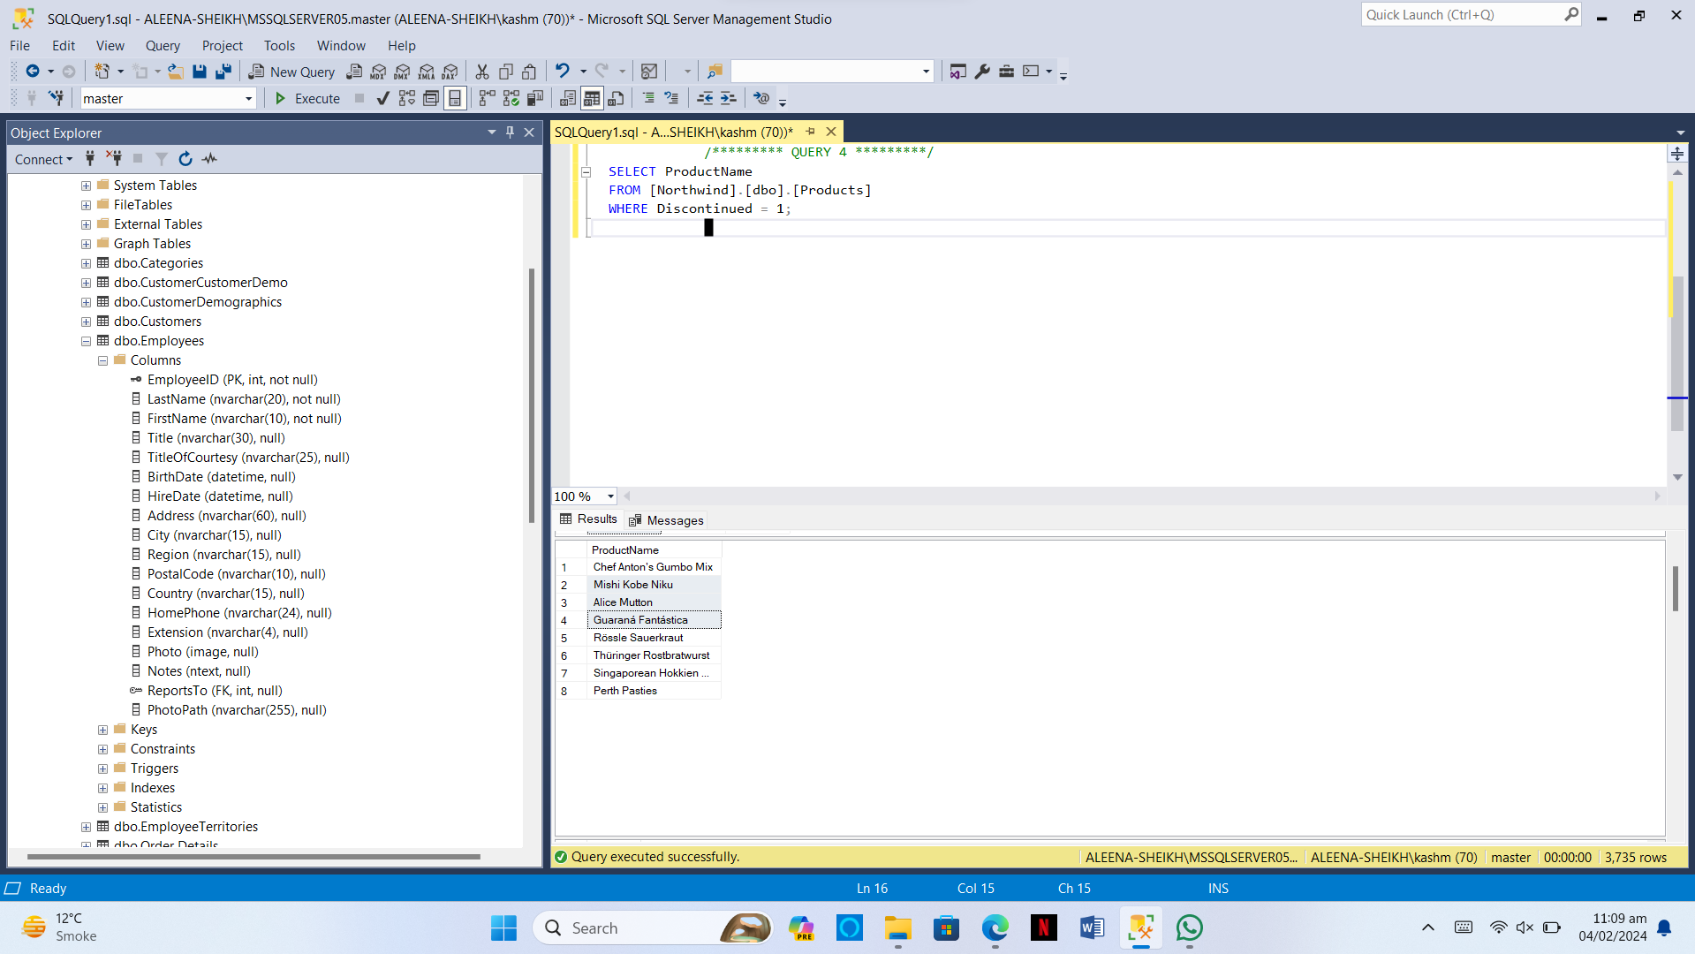

**Question 05:**

List the IDs the orders on which discount was not provided.

**Query:**

SELECT OrderID FROM Northwind.dbo.Order Details WHERE Discount = 0;

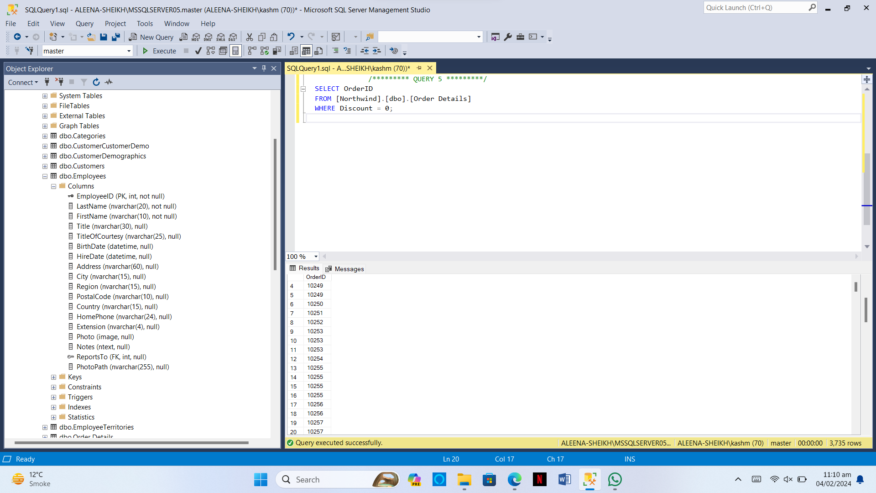

**Question 06:**

Enlist the names of customers who have not specified their region.

**Query:**

SELECT ContactName FROM Northwind.dbo.Customers WHERE Region IS NULL;

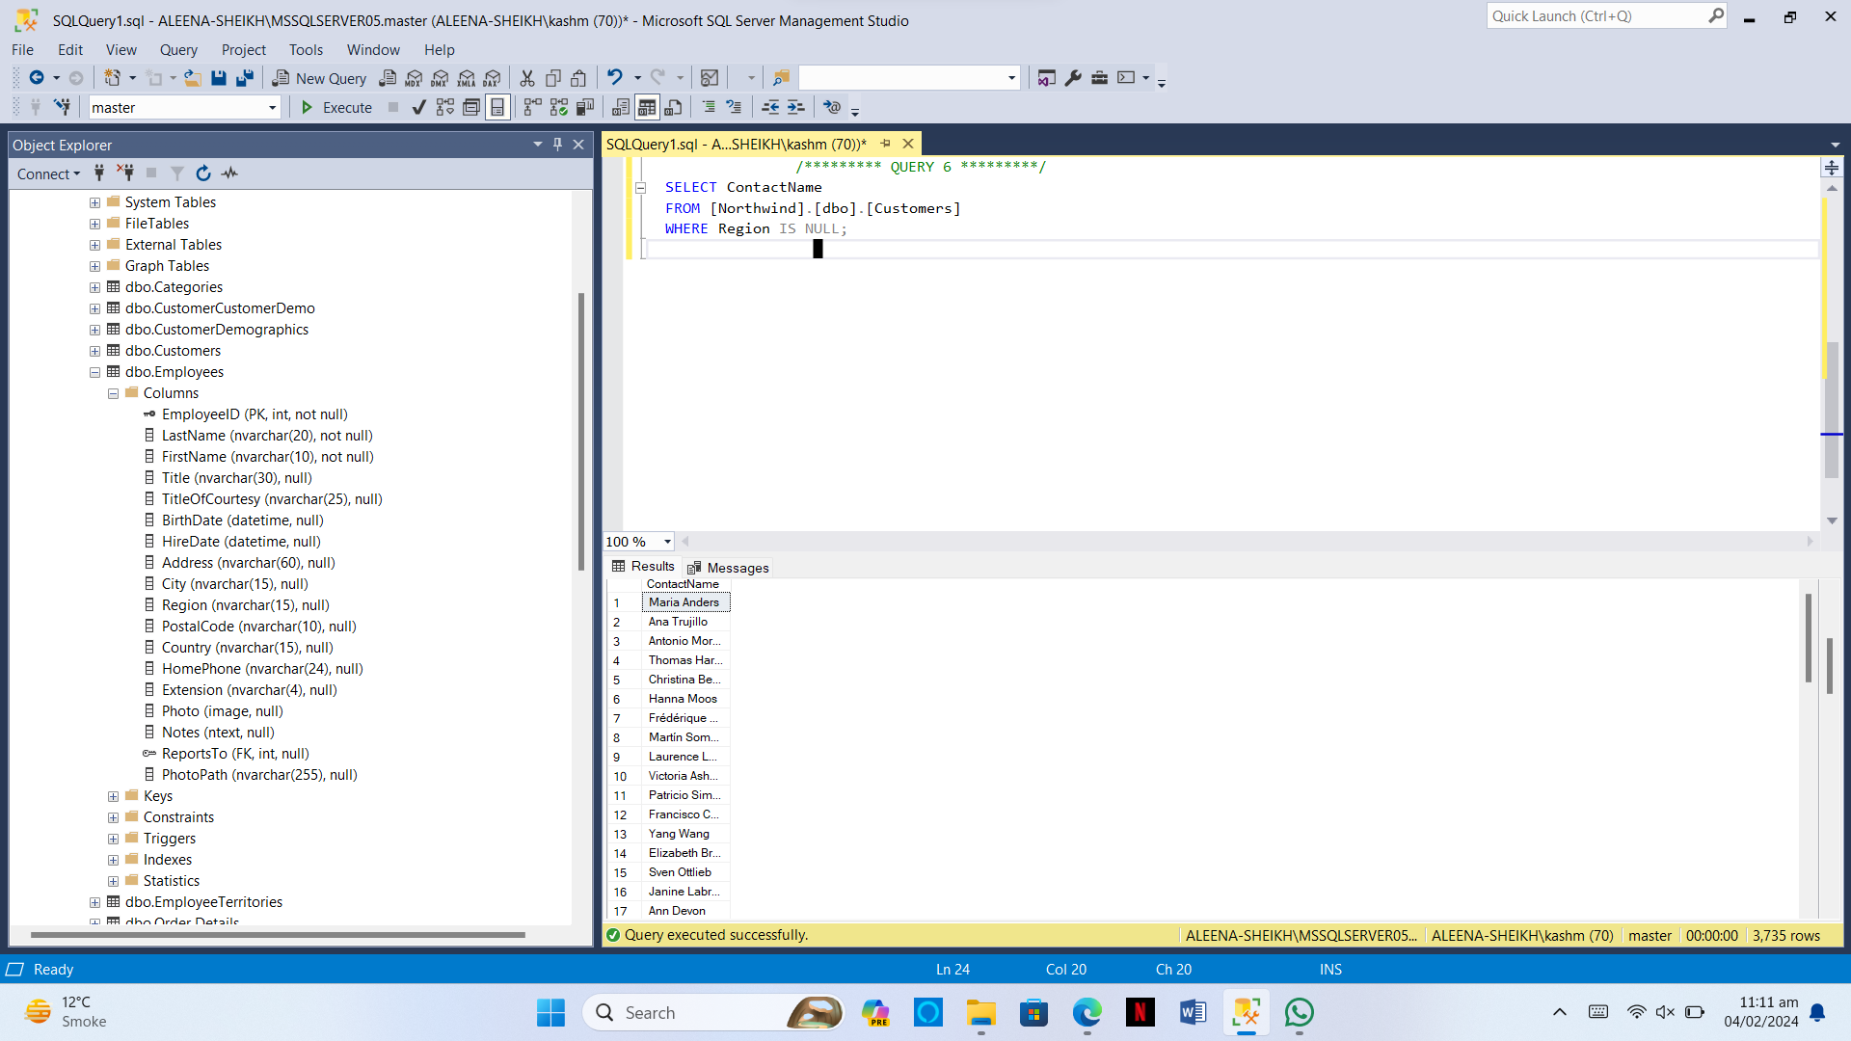

**Question 07:**

Enlist the names of customers along with contact number who either belongs to UK or USA.

**Query:**

SELECT ContactName,Phone FROM Northwind.dbo.Customers WHERE Country = 'UK' OR Country = 'USA';

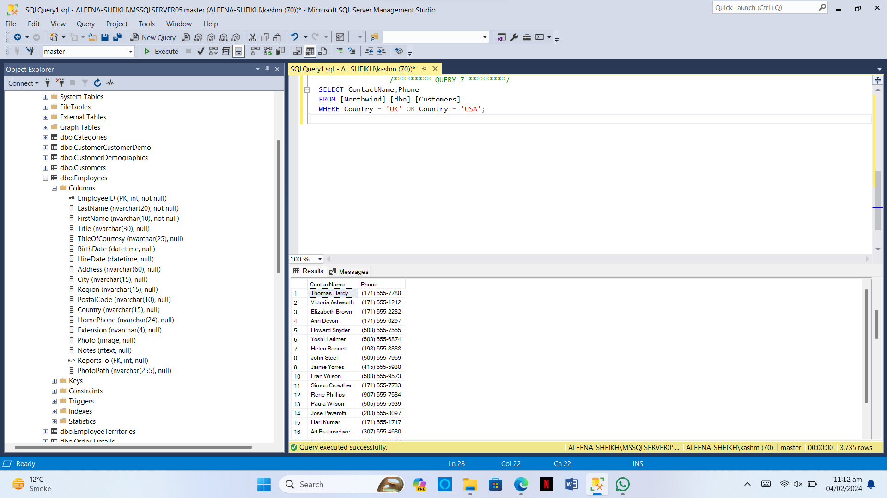

**Question 08:**

Report the names of companies who have provided their web page.

**Query:**

SELECT CompanyName,HomePage FROM Northwind.dbo.Suppliers WHERE HomePage IS NOT NULL;

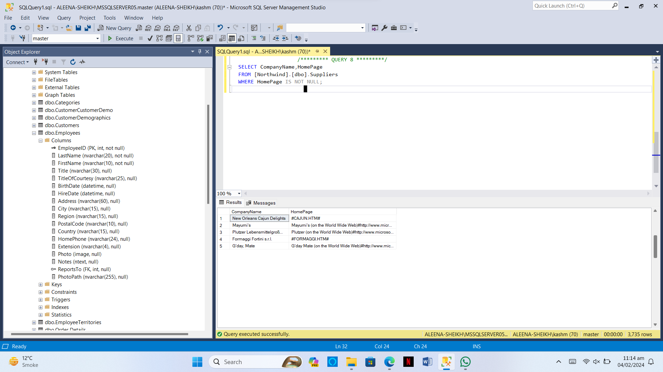

**Question 09:**

In which countries, products were sold in year 1997.

**Query:**

SELECT ShipCountry FROM Northwind.dbo.Orders WHERE YEAR(ShippedDate) = 1997;

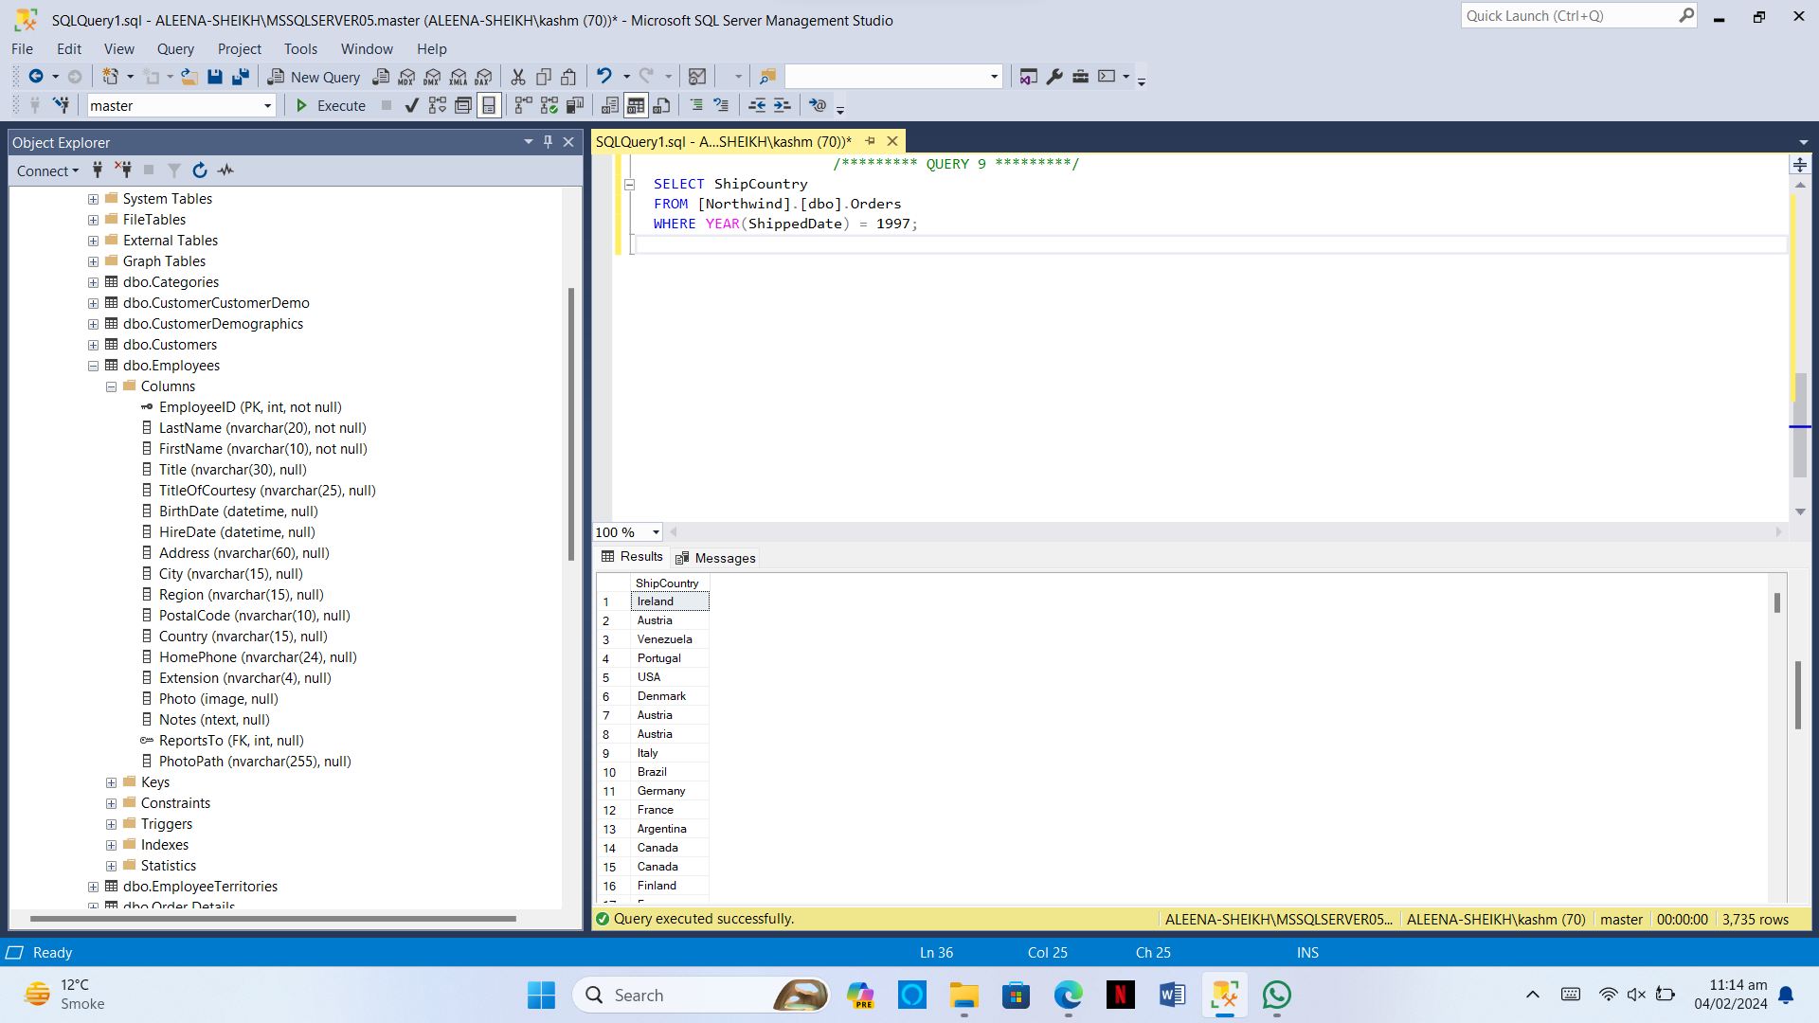

**Question 10:**

List the ids of customers whose orders were never shipped.

**Query:**

SELECT CustomerID FROM Northwind.dbo.Customers WHERE CustomerID NOT IN (Select DISTINCT CustomerID from Northwind.dbo.Orders);

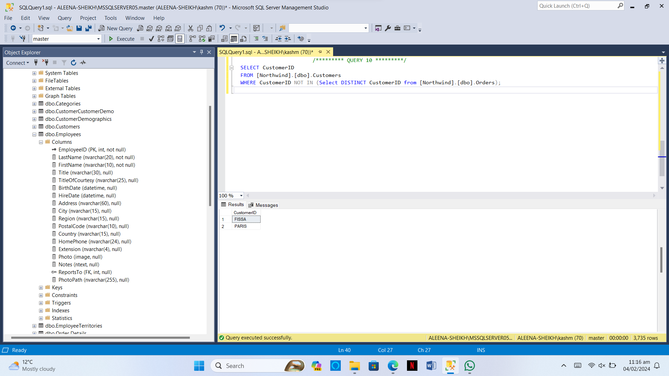

**Question 11:**

Write a query to report suppliers with their id, company name and city.

**Query:**

SELECT SupplierID, CompanyName, City FROM Northwind.dbo.Suppliers;

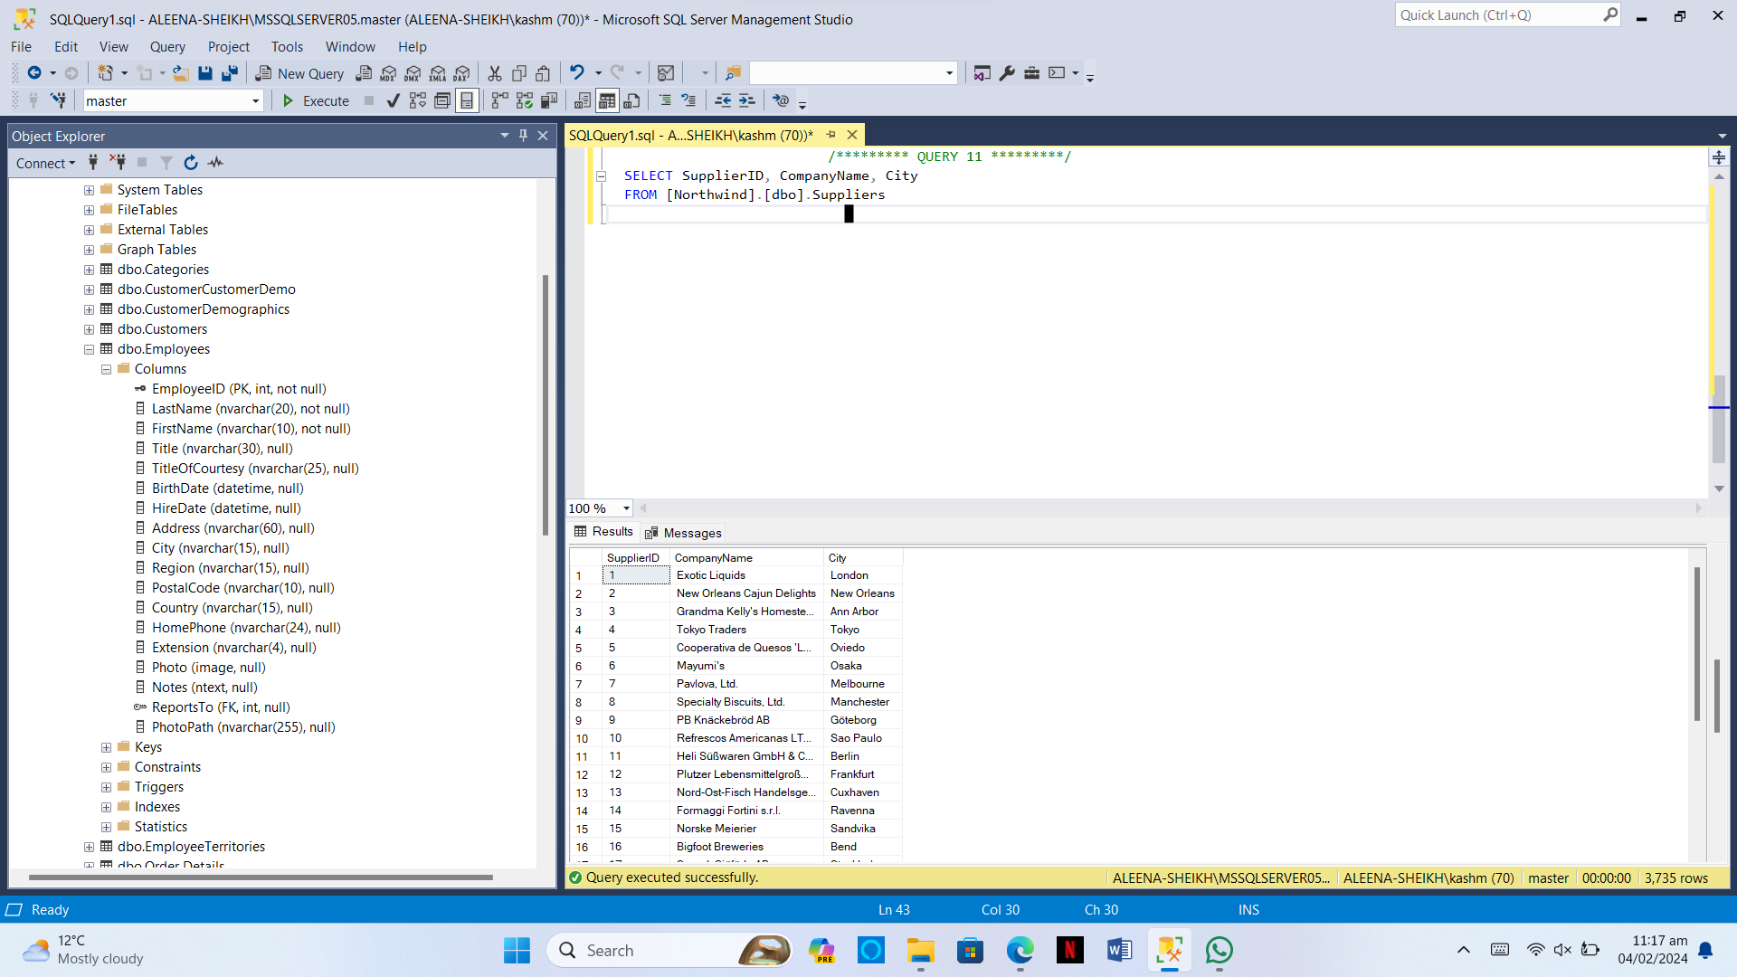

**Question 12:**

Our employees belong to how many countries. List them who are used to live in London.

**Query:**

SELECT LastName,FirstName FROM Northwind.dbo.Employees WHERE Country = 'London';

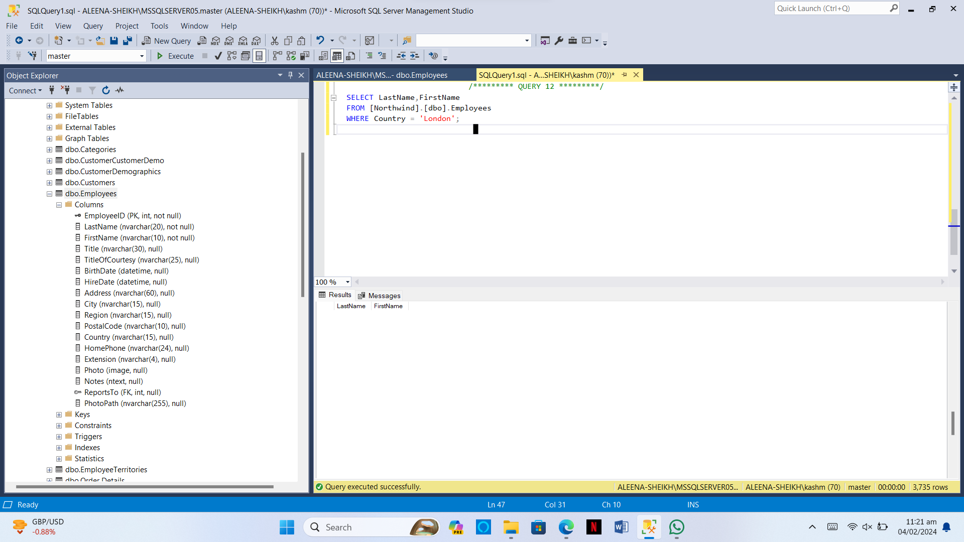

**Question 13:**

List the names of products which have not been discontinued.

**Query:**

SELECT ProductName FROM Northwind.dbo.Products WHERE Discontinued = 0;

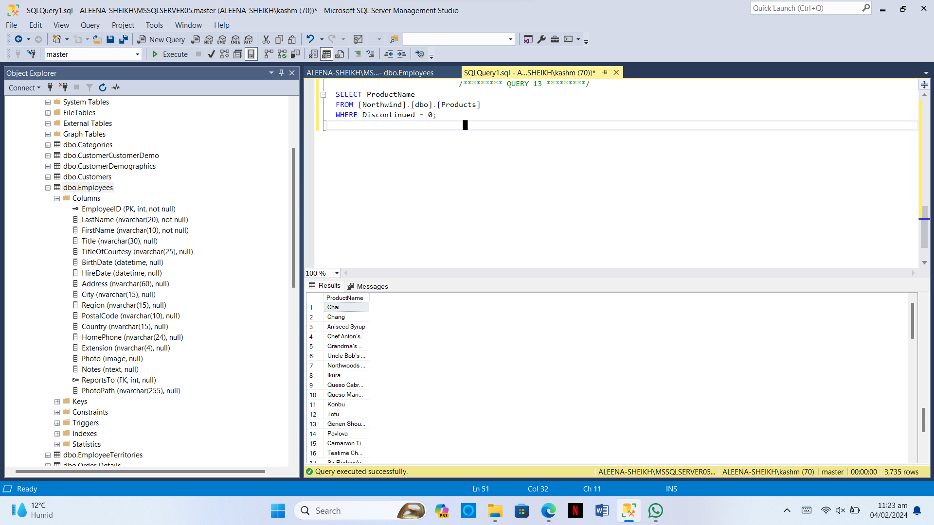

**Question 14:**

List the IDs the orders on which discount was 0.1 or less.

**Query:**

SELECT OrderID FROM Northwind.dbo.Order Details WHERE Discount <= 0.1;

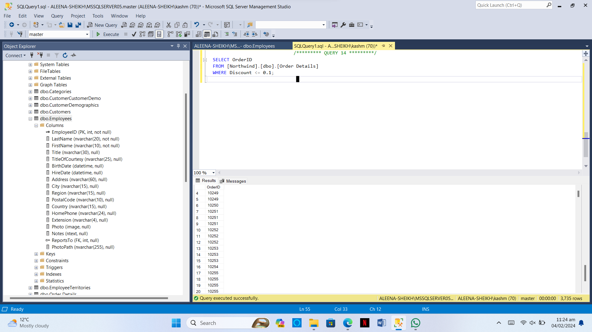

**Question 15:**

Enlist the IDS, names of employees and their contact number with extensions who have not specified their region.

**Query:**

SELECT EmployeeID, LastName, FirstName, HomePhone, Extension FROM Northwind.dbo.Employees WHERE Region IS NULL;

