Report for the Date : 2023/12/04
Name : Kasha Singh
ITE No : ITE001456

Previous:
Training the model

Today:
- Tested the model
python3 test.py --cfg_file ../output/custom_models/pv_rcnn/default/pv_rcnn.yaml --ckpt ../output/custom_models/pv_rcnn/default/ckpt/latest_model.pth

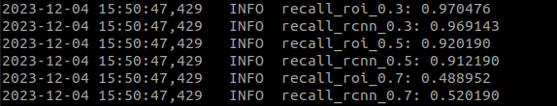

- Plot for robot test data
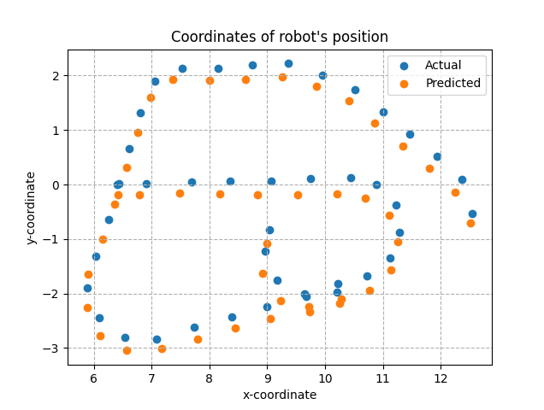

- Accuracy
Average displacement error: 0.27

- Converted the .npy robot pointcloud files to .bin for testing
The script which I wrote was not working,so got it from Garima san

Next:
-

