|  |  |  |  |  |  |  |  |  |  |
| --- | --- | --- | --- | --- | --- | --- | --- | --- | --- |
| BAHRIA UNIVERSITY KARACHI CAMPUS  DEPARTMENT OF COMPUTER SCIENCE  DATA COMMUNICATION & NETWORKING  (CEL-222)    **Internet Café Network**  Group Members (4A)   |  |  |  | | --- | --- | --- | | 1 | Rezan Sohail | 02-134231-103 | | 2 | Sonia Rafique | 02-134231-009 | | 3 | Kashaf Fatima | 02-134231-045 |   SUBMITTED TO:  LAB INSTRUCTOR : Sir Mirza Waqas  COURSE INSTRUCTOR : Dr Ghulam Muhammad |

Table of Contents

|  |  |  |
| --- | --- | --- |
| No. | Content | Page number |
| 1. | Introduction | 3 |
| 2. | Objective | 3 |
| 3. | Description of System | 3 |
| 4. | Network Topology | 5 |
| 5. | Configuration Details | 5 |
| 6. | Conclusion | 12 |

### **Introduction**

This project involves the meticulous design and detailed configuration of a comprehensive network infrastructure specifically tailored for an internet café environment, leveraging the capabilities of Cisco Packet Tracer. The proposed network architecture integrates multiple essential components, including the configuration of serial routers to facilitate efficient communication between network segments, the implementation of robust password security measures to ensure data protection and secure access, and the deployment of DHCP services to simplify and automate IP address allocation. These features collectively aim to enhance the operational efficiency and reliability of the network, catering to both customer-facing systems and administrative operations within the internet café.

### **Objective**

The primary objective of this project is to design and implement a robust, efficient, and well-structured network infrastructure tailored to address the specific operational requirements of an internet café. This includes the development of segmented VLANs to ensure effective traffic management and enhanced performance, configuring routers to enable seamless inter-VLAN communication, and establishing stringent security measures, such as password protection, to safeguard network access. Additionally, the project entails deploying a web server to support customer-centric services, such as user account management or online reservations, and integrating DHCP services to automate and streamline the process of IP address allocation across all connected devices.

### **Description of System**

1. **Admin Office:**
   * Monitors network usage and manages customer accounts.
   * Secure VLAN ensures isolation of sensitive data.
   * Equipped with tools for configuration and network oversight.
2. **Customer Stations:**
   * Standard PCs used for browsing, studying, or casual use connected to a separate VLAN for optimal internet access.
3. **Gaming Zone:**
   * This area caters to customers using high-performance PCs for gaming.
   * A separate VLAN is configured for the gaming zone to prioritize network resources for latency-sensitive applications.
   * This ensures efficient communication within the gaming department while maintaining security.
4. **Technical Support Department:**
   * This department manages the maintenance and troubleshooting of customer PCs and other equipment.
   * A dedicated VLAN allows the tech team to securely access and manage devices for maintenance tasks and updates.
   * The technical support team has access to the admin network for monitoring and resolving technical issues.
5. **Printer and File Sharing Area:**
   * Shared printers for wired and wireless printing.
   * Temporary file-sharing storage for customer convenience.
   * VLAN isolates printing tasks, maintaining security and performance.
6. **Wi-Fi Zone:**
   * Wireless connectivity for personal devices (laptops, smartphones, etc.).
   * Separate VLAN ensures secure and high-speed internet.
   * Optimized for user convenience without compromising network security.
7. **Server Room:**
   * Hosts web server for customer portals and payment systems.
   * VLAN ensures secure communication with other departments.
   * Redundant configurations maintain service availability and reliability.

### **Network Topology**

The network topology comprises the following components:

1. **Routers:** Facilitate interconnection between VLANs and provide gateway access to the internet.
2. **Switches:** Serve to connect devices within each VLAN segment.
3. **PCs:** Represent customer devices, including user stations and gaming PCs.
4. **Web Server:** Hosts essential services such as customer portals, session management, and billing systems.
5. **DHCP Server:** Facilitates automatic IP address assignment to all network devices.

### **Configuration Details**

1. **Serial Router Configuration:**
   * Router 1 (Admin Office)

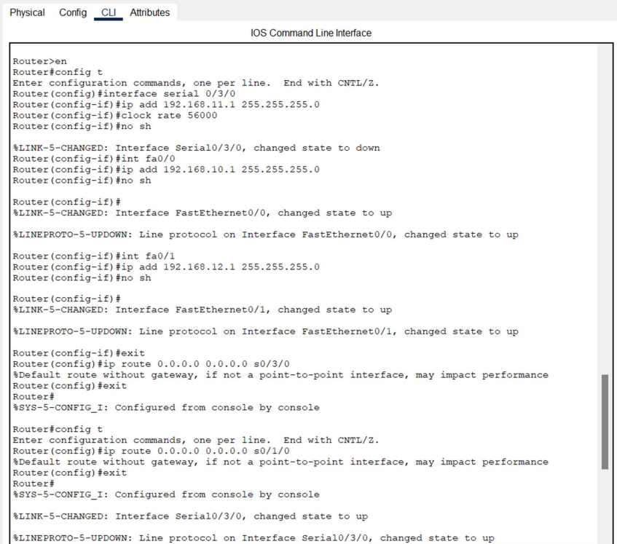

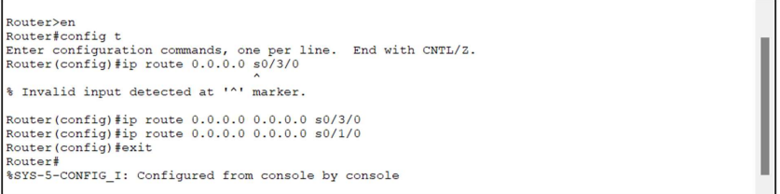

* + Router 2 (Server Room)

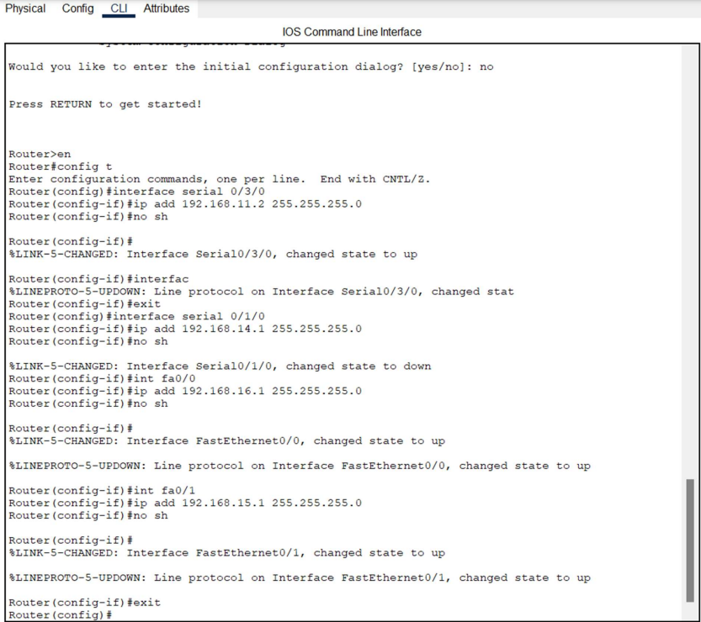

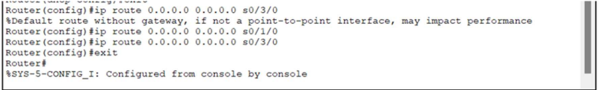

* + Router 3 (Wi-Fi Zone)

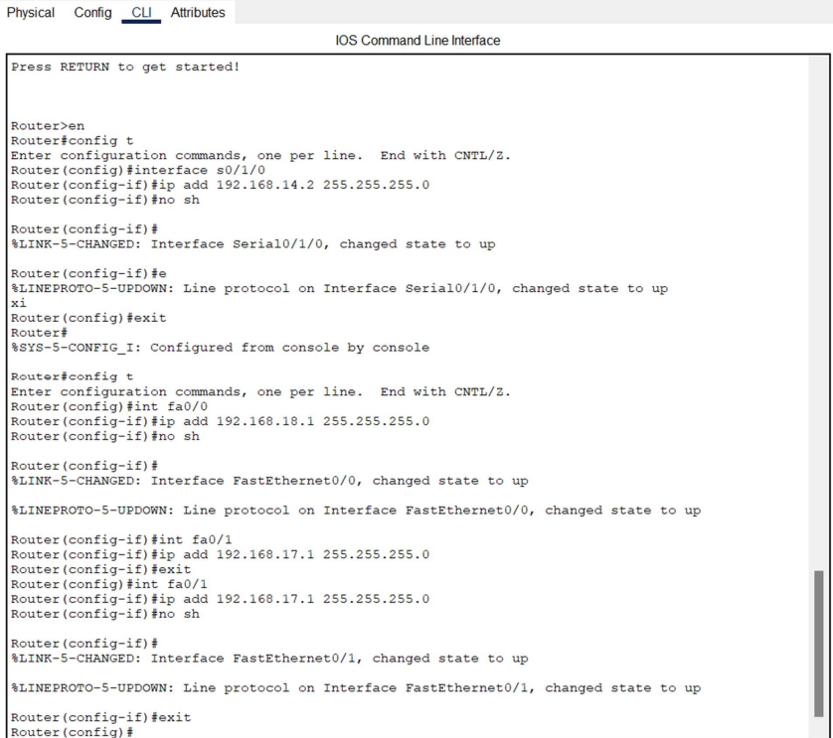

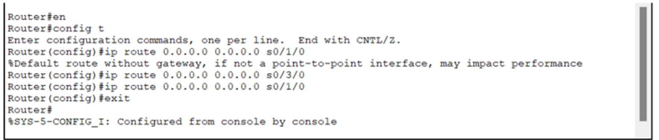

1. **VLAN Implementation:**
   * Switch (Customer Stations, Gaming Zone, Printer Area)

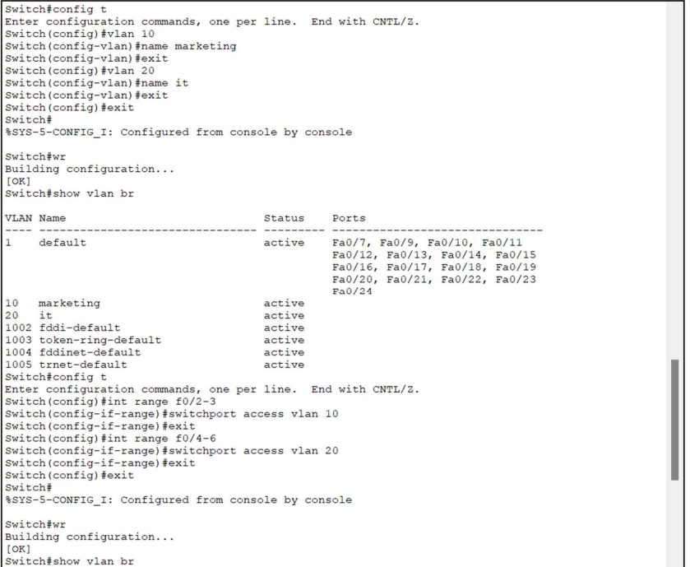

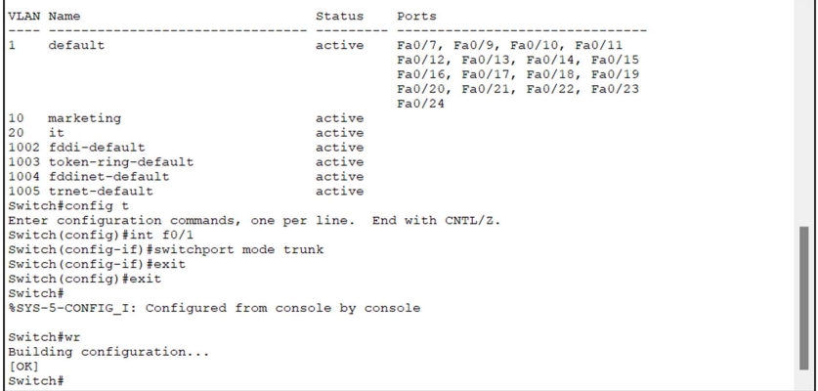

* + Router 2 (Server Room VLANs)

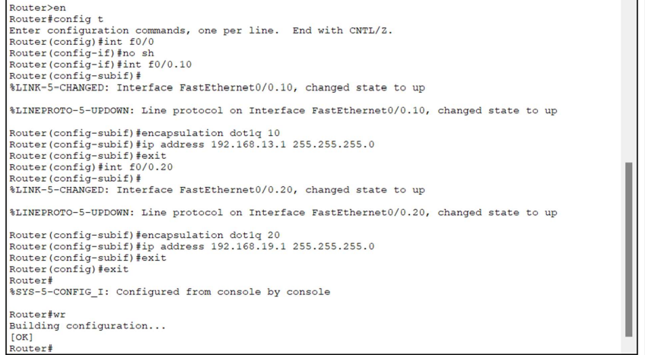

1. **Password Setting:**
   * Admin Office (Secure admin systems)

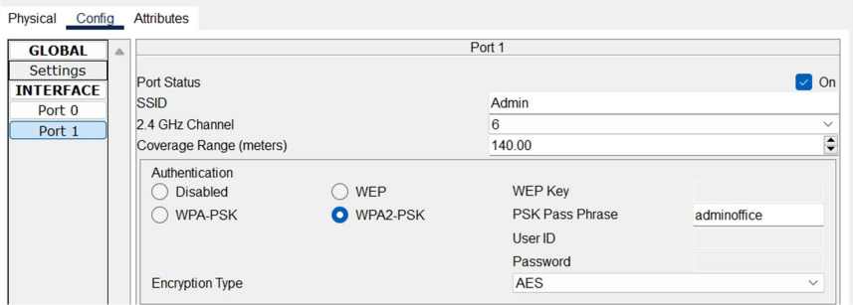

* + Customer Stations (Ensure individual access control)

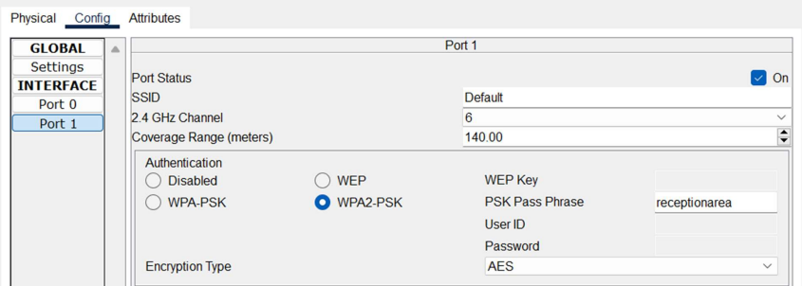

* + Gaming Zone (Restrict unauthorized access)

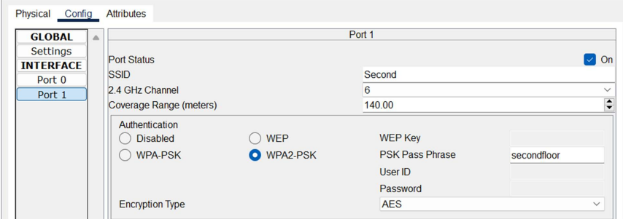

1. **DHCP Implementation:**
   * Router 1 (Admin Office)

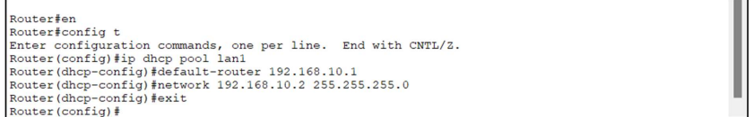

* + Router 2 (Gaming Zone and Wi-Fi Zone)

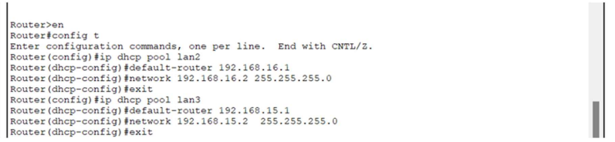

* + Router 3 (Printer Area)

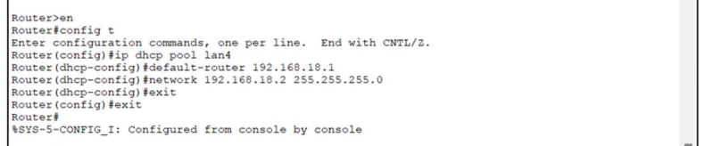

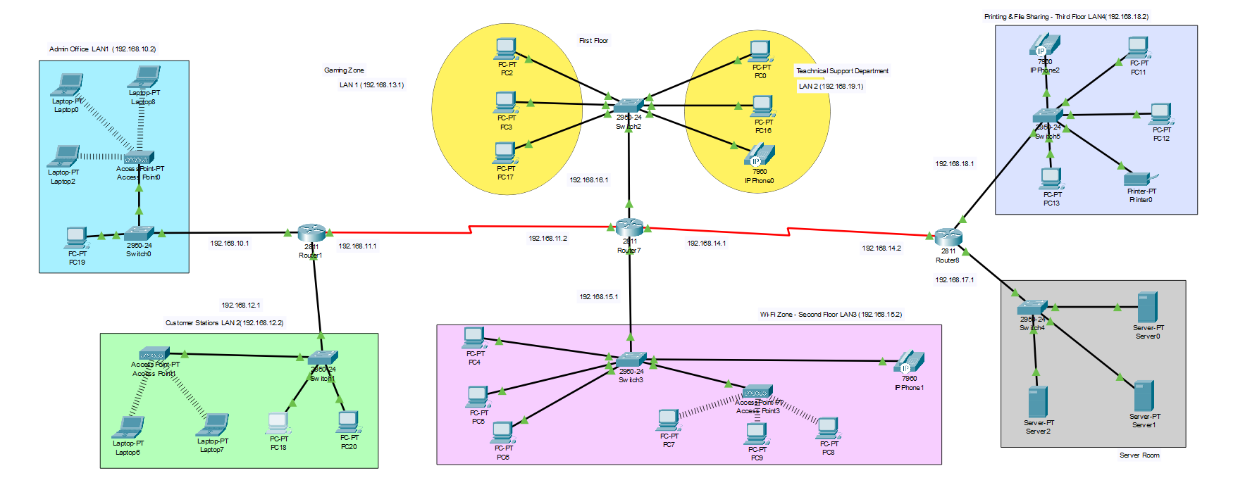

### **Conclusion**

By implementing this network infrastructure, the internet café ensures efficient communication, robust security, and seamless access to essential services for customers and staff. The segmented VLANs, DHCP services, secure passwords, and routing configurations facilitate smooth operations across different sections while maintaining network integrity and user satisfaction.