KASHAN BAIG CT-24178

LEETCODE PROFILE LINK:

<https://leetcode.com/u/Kashan_Baig/>

**TASK 02:**

**WORD SEARCH**

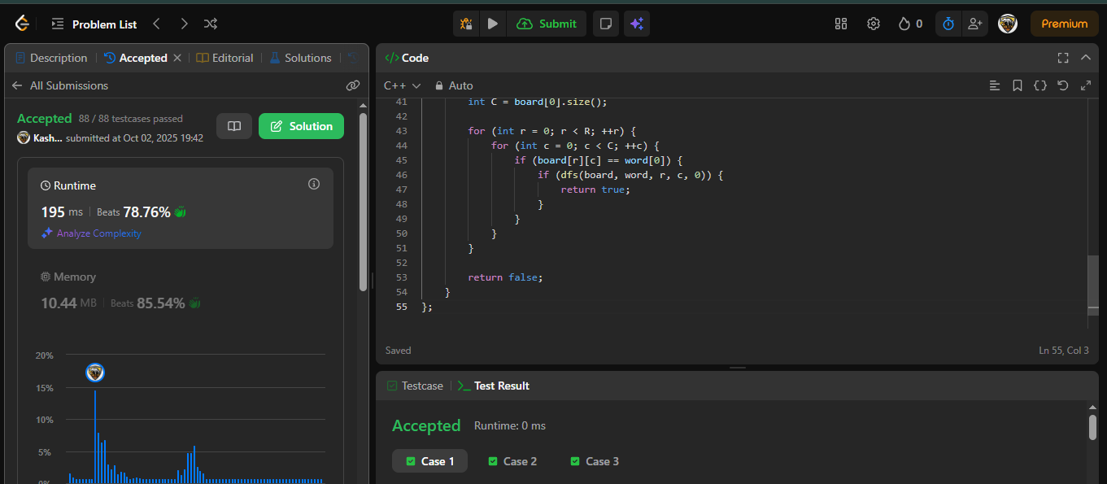

SOLUTION:

<https://leetcode.com/problems/word-search/submissions/1789294094/>

**COMBINATION SUM**

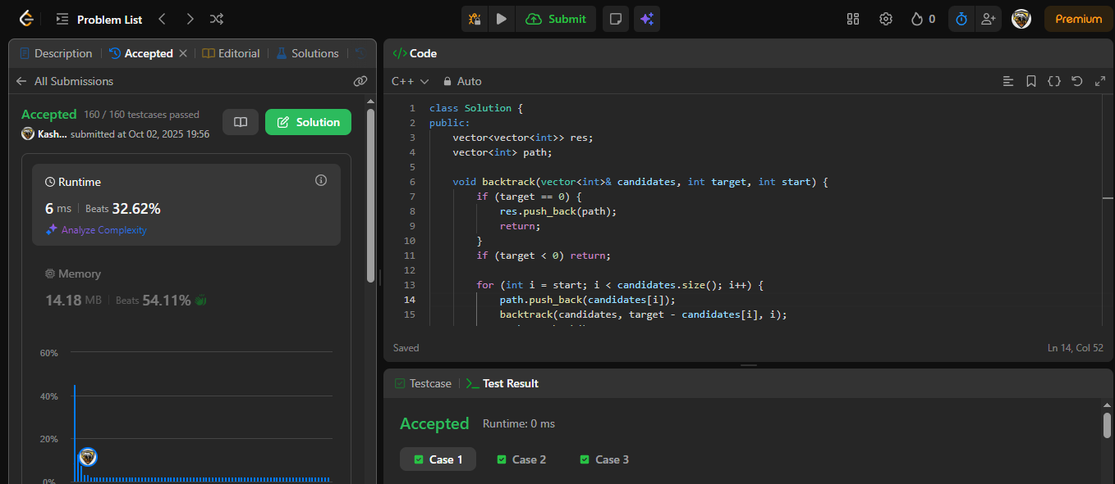

SOLUTION:

<https://leetcode.com/problems/combination-sum/submissions/1789305453/>