|  |  |
| --- | --- |
| **Documentation**  **Inquest**  **Faculty** = Miss Sana Sheeraz  **Coordinator**= Miss Fariha Alam  **Batch code** = 1807B1  **Curriculum**= 6673,  **Semester**= HDSE II,  C:\Users\asp\Desktop\123.png  APTECH North NAZIMABAD  http://www.aptechnn.com | group members & enrolment no.  **Khulaid Abdul Aziz**  **(Student1123301) Kashan Khan**  **(Student 1053833) Muhammad Waqas (Student1106854)**  **Muhammad Asab Zia (Student1121395)** |

**TABLE OF CONTENTS:**

**Acknowledgement** 3

Abstract or Declaration……………………………………………………………………………………………………………………………4

**PROJECT CERTIFICATION:** 5

**Introduction** 6

**Harware or Software:** 8

**Objective** 9

**PROJECT MAKING** 10

**Task sheet** 11

**WorkFlow** 12

**WEBSITE MAP:** 13

**Snapshots:** 15

**Logo**………………………………………………………………………………………………………………………………………….15

**Admin**……………………………………………………………………………………………………………………………………….16

**User Interface**...………………………………………………………………………………………………………………………. 25

ACKNOWLEDGEMENT

**W**

e are thankful to Almighty, ALLAH that by His grace we have been successful. We presenting on **Visual Studio Code** in your hands. We have tried our best to take all relevant important topics in consideration so that this project may become comprehensive.

This is our **FOURTH Semester Project**. We have tried our best & struggled for a better outlook to come. This project has been developed in **Visual Studio Code.** We choose to make Web Application for **INQUEST** as a project. We find easy to do coding in **Visual Studio Code.**

We earnestly hope that this project will provide all the necessarily information required for the user to fulfill their inspiration. However, suggestions for improvement of the project will be thankful received & acknowledge.

It was very great experience for us to make the web application in visual studio Code.

**Thanking Y****ou!**

**ABSTRACT**

The topic of our project was to develop a INQUEST

It’s made using PHP, HTML, CSS, Javascript and database with Mysql.

## **Declaration**

We are writing this to declare that all the work which is being written bellow in this Project Report entitled “--**INQUEST**--” is a veritable record of our own work submitted to the Aptech NN, Karachi, Pakistan during the year 2020 to 2021 in the partial fulfillment of semester IV (HDSEIl) project We also declare that we have not submitted the material being presented in this Project Report for the award of any other degree elsewhere

## 

# **PROJECT CERTIFICATION:**

# 

**INQUEST**

This is to certify that,

**Mr. Khulaid Abdul Aziz (Student1123301)**

**Mr. Kashan Khan (Student1053833)**

**Mr. Muhammad Waqas (Student1106854)**

**Mr. Muhammad Asab Zia (Student1121395)**

has successfully Designed & Developed **INQUEST.**

Date of Issue: **12-Jun-2020**

Date of Submission: 1**2-Jul-2020**

Authorized Signature**: Miss Sana Sheeraz**

# **introduction**

### Problem Statement

# **INQUEST**

**About Project**

**Introduction:**

It is usually the ‘how’ question that is the main focus of the Inquest. It could be

anything regarding Animals, Food, Physics, Science, Programming and so on.

Inquest is a platform that engages individuals to gain from one another. On

Inquest, people can ask questions and connect with others who contribute

unique insights and quality answers.

Our Aim is to help developers write their scripts more concise and functional, to

help explorers find out more about their findings, help coders to remove

malfunctions from their code, to make taste lovers find the best tastes throughout

the world, what’s going on in the universe? Can a cat see colors? Do we have

another planet to live on? In short, we aim to satisfy our user with the solution of

any matter they want to have.

Team Inquest wants a Web Solution where questions are asked, answered, and

edited by  Internet   users  in the form of opinions. A key test is to remove

undependable inquiries - those established upon false premises, or that mean to

create an impression instead of search for supportive answers. For that purpose,

Admin will be responsible to have a check on queries. Every time when a

question is added to the site, admin will get a notification on his/her dashboard so

he/she could review the post. All queries must show the given answers and their

count provided by users.

Module Description:

1. Admin Module

2. User Module

Admin:

a) Manage website information.

b) Review/Modify/Remove posted content by users.

c) Add/Modify /Remove Categories. (Such as Animals, Food, Physics,

Science, Programming, etc.)

d) View Feedback submitted by user.

User:

a) Register/Create Account.

b) Login to the system with his USERNAME/PASSWORD

c) Post/Update/Delete Queries in their respective category and also mark the

answer as correct if it satisfies the query.

d) Answer the queries posted by other users. (The user will get a notification if

someone added an answer to their question.)

e) Post feedback by filling proper feedback form.

Software & Hardware Requirements

## **Hardware Requirements:**

1. A minimum computer system that will help you access all the tools in the courses is a Pentium 166 or better.

128 Megabytes of RAM or better

**Software Requirements:**

* Notepad/HTML editor/visual studiocode/
* Php
* MySQL Sever 2000
* IE 5.0/ Netscape 6.0
* Visual Studio .Net / ASP
* IIS server
* .Net Framework
* Java Virtual Machine/ J2EE server
* j2sdk1.4.1_02 (or later).
* EJB Dev Kit
* Java enabled web server
* JSP / Servlets Dev. Kit

## **Objective**

The Objective of this program is to give a sample project to work on real life projects. These applications help you build a larger more robust application.

The objective is not to teach you topic but to provide you with a real life scenario and help you create basic applications using the tools.

You can revise these chapters before you start with the project.

These programs should be done in the Lab sessions with assistance of the faculty if required.

It is very essential that a student has a clear understanding of the subject.

Kindly get back to eProjects Team in case of any doubts regarding the application or its objectives.

# **PROJECTMAKING**

## Project Duration:

1. Analysis- 5 days
2. Design – 7 days
3. Development –10 days
4. Testing – 4days
5. Documentation -4days

|  |  |  |  |  |
| --- | --- | --- | --- | --- |
| Analysis | Design | Development | Testing | Documentation |

|  |  |  |  |  |  |  |  |  |  |  |  |  |  |  |  |  |  |  |  |  |  |  |  |  |  |  |  |  |  |
| --- | --- | --- | --- | --- | --- | --- | --- | --- | --- | --- | --- | --- | --- | --- | --- | --- | --- | --- | --- | --- | --- | --- | --- | --- | --- | --- | --- | --- | --- |
| 1 | 2 | 3 | 4 | 5 | 6 | 7 | 8 | 9 | 10 | 11 | 12 | 13 | 14 | 15 | 16 | 17 | 18 | 19 | 20 | 21 | 22 | 23 | 24 | 25 | 26 | 27 | 28 | 29 | 30 |

## **Task sheet**

|  |  |  |  |  |  |
| --- | --- | --- | --- | --- | --- |
| **No.** | **Task** | **Actual Start Date** | **Actual Days** | **Teammates Name** | **Status** |
| 1. | Analysis | 12hJun 2020 | 5 | Khulaid Abdul Aziz Kashan Khan Muhammad Waqas Muhammad Asab Zia | Completed |
| 2. | UI Designing | 17th Jun 2020 | 7 | Khulaid Abdul Aziz Kashan Khan Muhammad Waqas Muhammad Asab Zia | Completed |
| 3. | Development | 24st Jun 2020 | 10 | Khulaid Abdul Aziz Kashan Khan Muhammad Waqas Muhammad Asab Zia | Completed |
| 4. | Testing | 4th Jul 2020 | 4 | Khulaid Abdul Aziz Kashan Khan Muhammad Waqas Muhammad Asab Zia | Completed |
| 5. | Documentation | 8ndJul 2020 | 4 | Khulaid Abdul Aziz Kashan Khan Muhammad Waqas Muhammad Asab Zia | Completed |

# 

# **WORKFLOW**

## 

## **Submission Checklist**

|  |  |  |  |
| --- | --- | --- | --- |
| **S.NO** | **LIST OF ITEMS** | **Remarks** | **COMMENTS** |
| 1. | Do All Pages Linked together | **Yes** | Properly navigation provided |
| 2. | Database Connected | **Yes** | Using  PHPMYSQL |
| 3. | Page Colors as Per Common Guidelines | **Yes** | Color Theme related to topic were used |
| 4. | Documentation Included | **Yes** | All three files included |
| 5. | Project Zip File | **Yes** | Created using Zip File |

**Website Map**

There are two types of users in our website.

* 1. Admin
  2. Users

**Map of Admin Dashboard**

Admin Login

Admin Dashboard

User Details (Update, Delete or View)

Admin (Add, Update, Delete or View)

Answers (Update, Delete or View)

Category (Add, Update, Delete or View)

Logout

Feedback (Update, Delete or View)

Questions (Update, Delete or View)

**Map of Users Interface Without Login**

Home

Question (View)

Contact Us

Create Account

Login Area

**Map of User Interface after Login**

Home

View Question

Navigation

Questions

Contact

User

Ask Question

Answers

Logout

View User Profile

View User Question/Answer

## 

View User Feedback

Edit User Profile

**SNAPSHOT OF INQUEST**

**LOGO**



1. This is Inquest logo.

**ADMIN LOGIN**

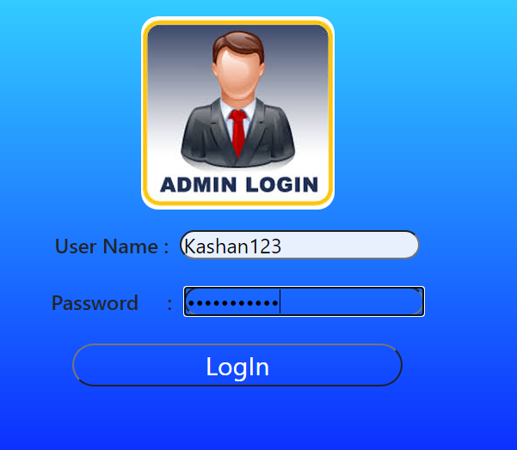

1. This is Admin login page.

2. Admin can access all details in Inquest.

**ADMIN DASHBOARD**

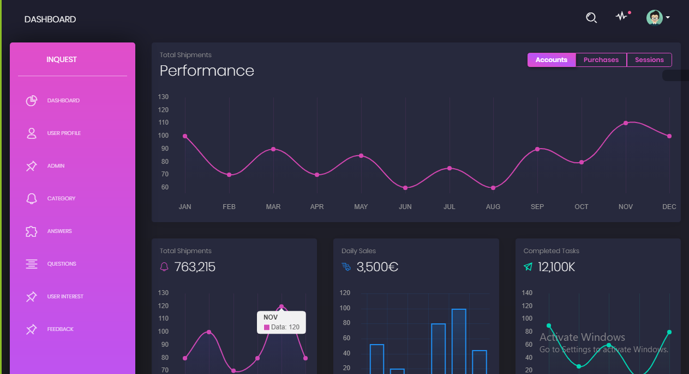

1. This is our Admin Dashboard page, we used side nav bar in header, and it contains many options like User Profile, Admin, Category etc . On this page Admin can access all the details in Inquest.
2. **User Profile:** When we press on the user profile , the new file will open as name as user profile where the admin can view, update and delete user profile.
3. **Admin:** When we press on the Admin , the new file will open as name as admin where the admin can view all admins, add new adin and update, delete Admin.
4. **Category:** When we press on the Category , the new file will open where the admin can add, update and delete category.
5. **Answers:** When we press on the answers, the new file will open where the admin can update and delete user answers.
6. **Questions:** When we press on the questions, the new file will open where the admin can update and delete user questions.
7. **User Feedback:** When we press on the feedback, the new file will open where the admin can update and delete user feedback.
8. Logout button took admin to the login page.

**USER DETAILS**

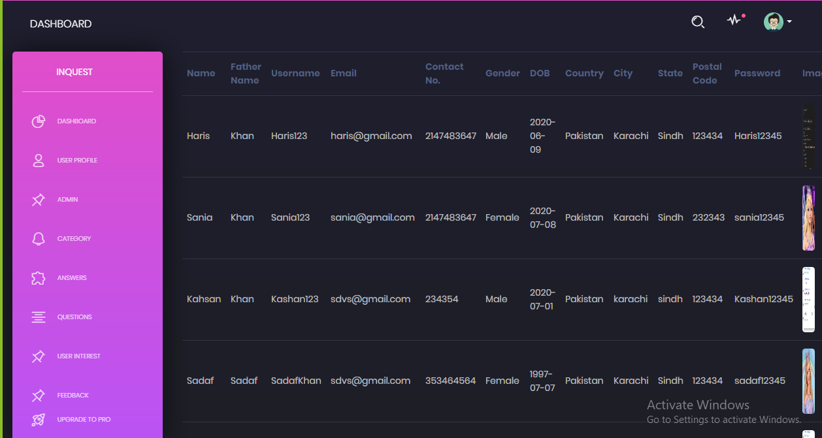

* This is our User Details Page.
* Admin can View User all details
* Admin can Update user details
* Admin can delete users

**ADMIN DETAILS**

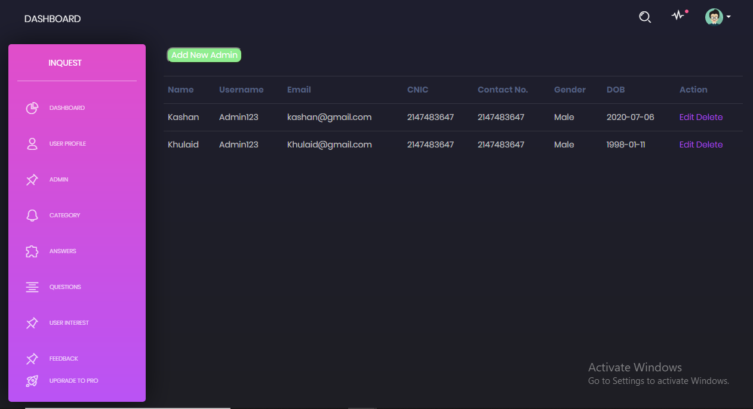

* This is our Admin details page
* Admin can View all Admin details
* Admin can Add new Admin
* Admin can Update Admin
* Admin can Delete Admin

**CATEGORY DETAILS**

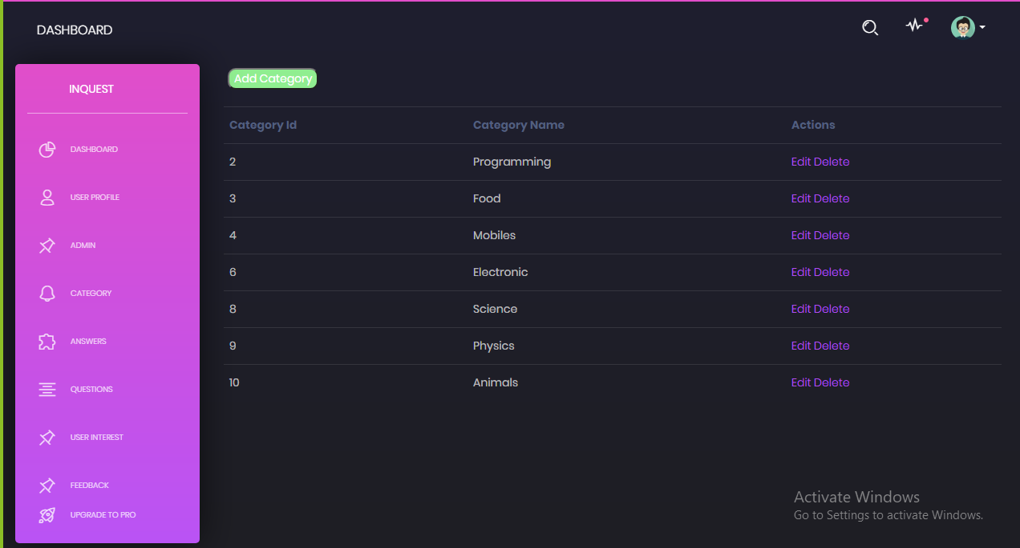

* This is our Category Details Page.
* Admin can View Category
* Admin can Add Category
* Admin can Update Category

**ANSWERS DETAILS**

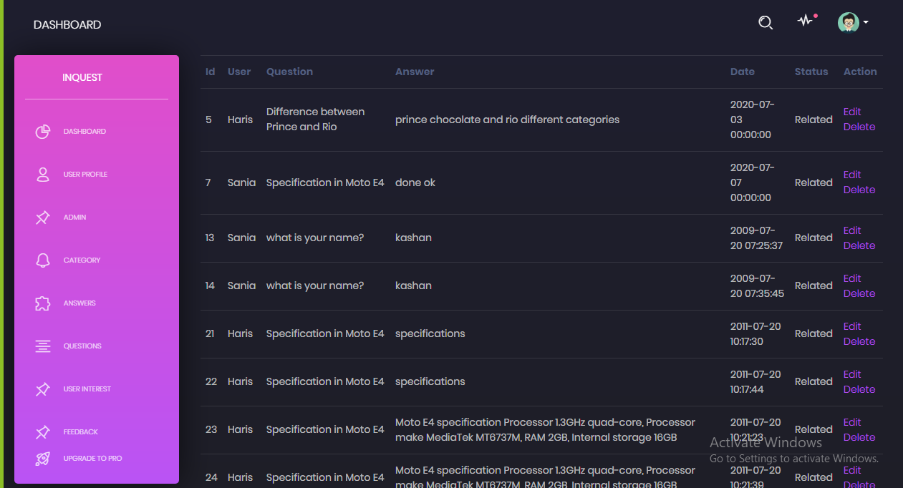

* This is our Answer details page
* Admin can View all Answers
* Admin can Update Answer
* Admin can Delete Answer

**QUESTION DETAILS**

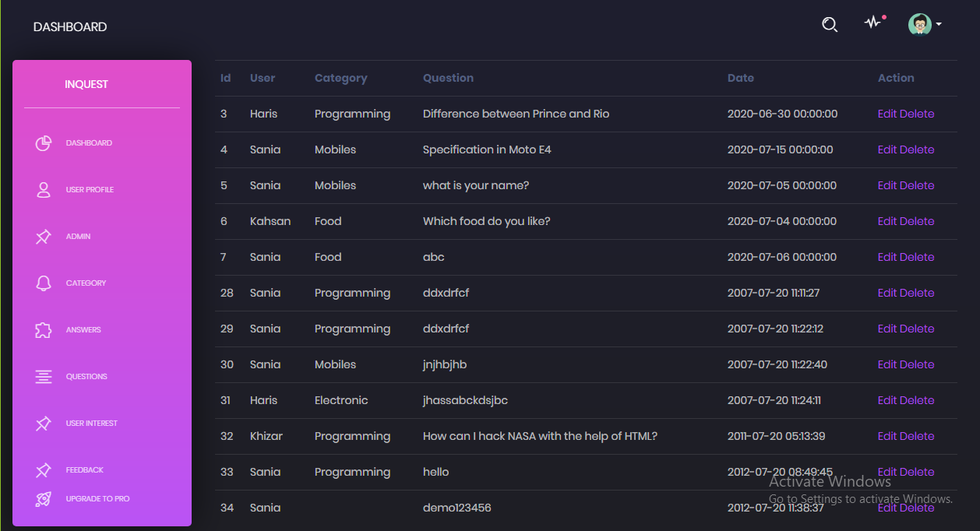

* This is our Question details page
* Admin can View all Questions
* Admin can Update Question
* Admin can Delete Question

**USER FEEDBACK**

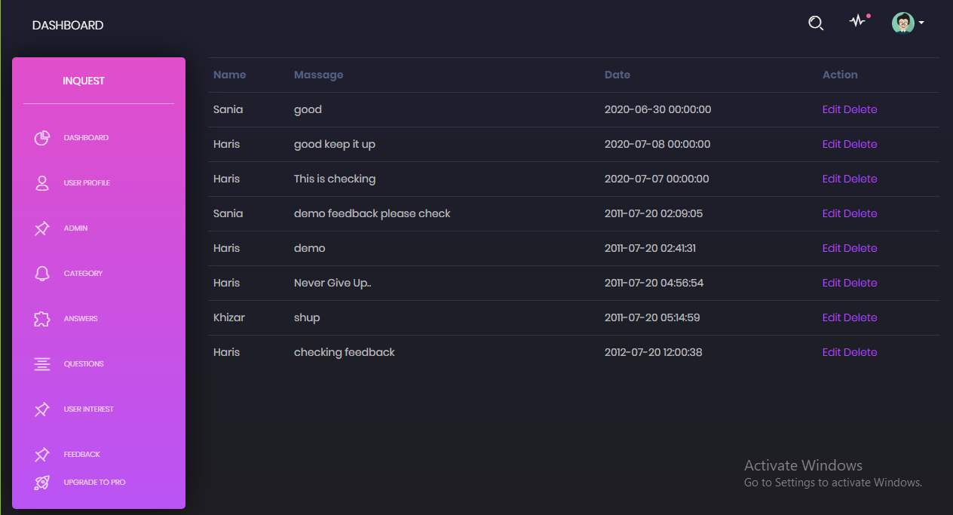

* This is our User Feedback page
* Admin can View all Feedbacks
* Admin can Update Feedback
* Admin can Delete Feedback

**USER INTERFACE**

**LOGIN AREA**

**LOGIN**

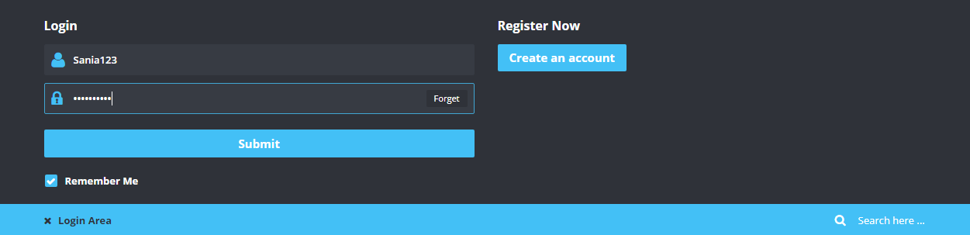

* This is our Login Area
* When you login from User you will able to access User Panel.
* When you click Create an Account.

**REGISTRATION FORM**

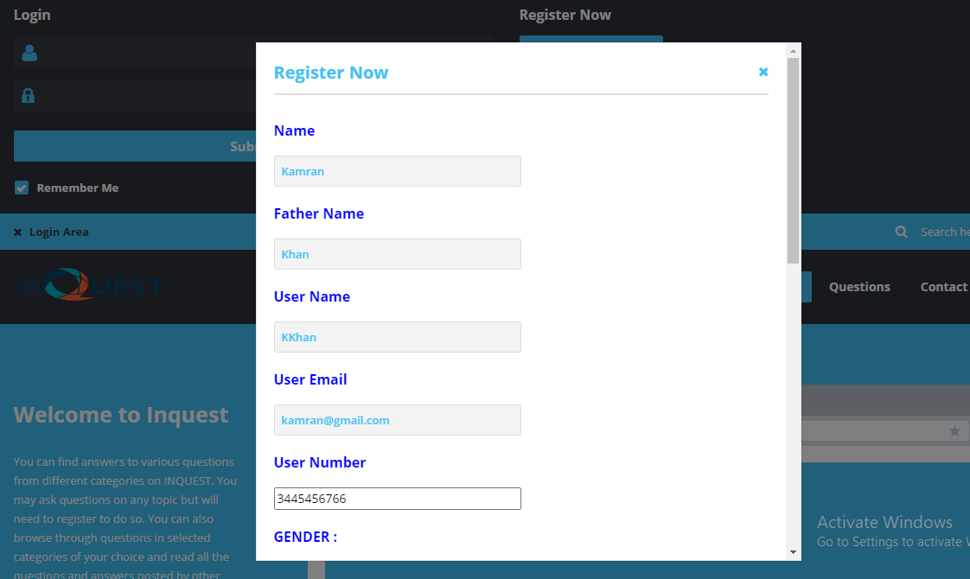

* This is Registration Form.
* User can create an account to fill this form.

**HOME PAGE**

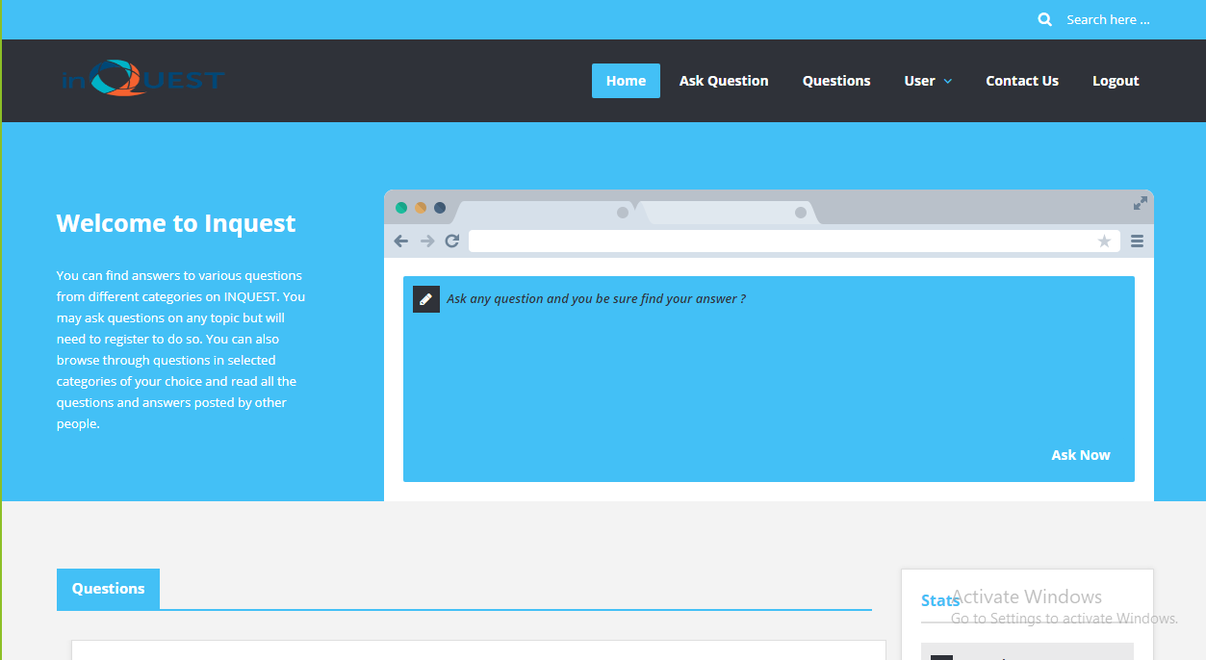

* This is our Home page.
* After login user can access many options
* User ask questions
* User view questions and reply all questions
* User see thier profile
* User can update their profile
* User can View their Feedbacks
* User can see our Contact information and give Feedback
* User want to logout so just clicking Logout Button.

**ASK QUESTION**

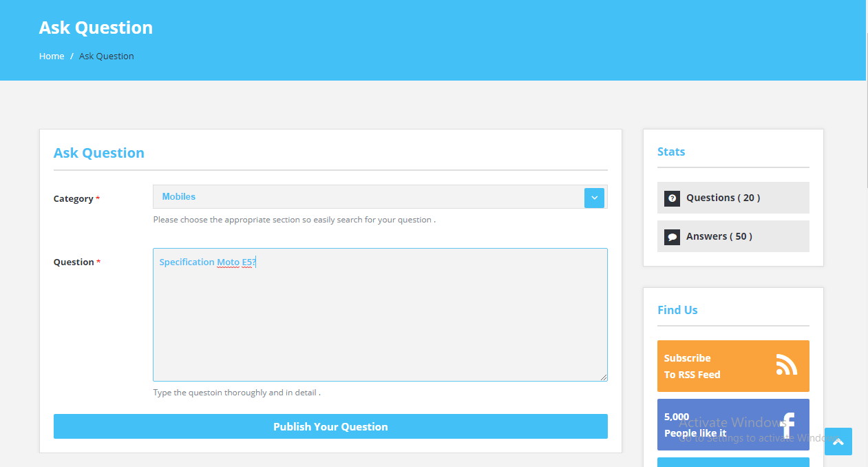

* This is our Ask Question page.
* User select category and than ask question according to category.

**View Question**

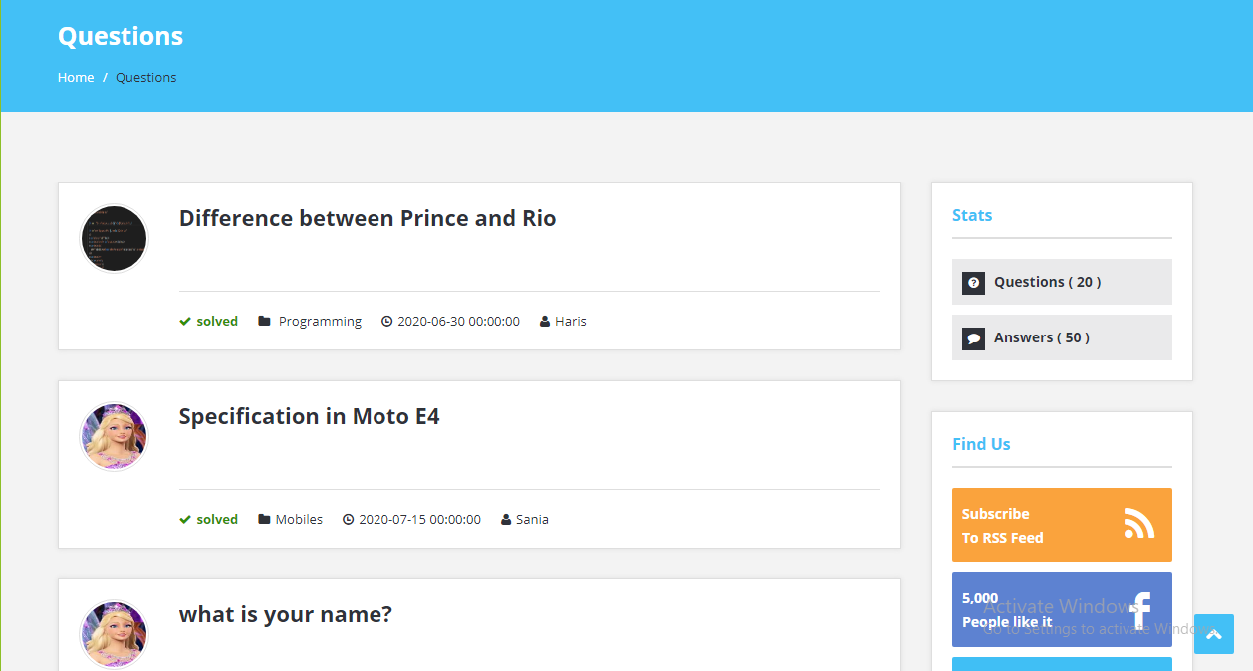

* This is our View Question page
* User can view all question to this page
* User select question to view answers selective question.

**ANSWERS**

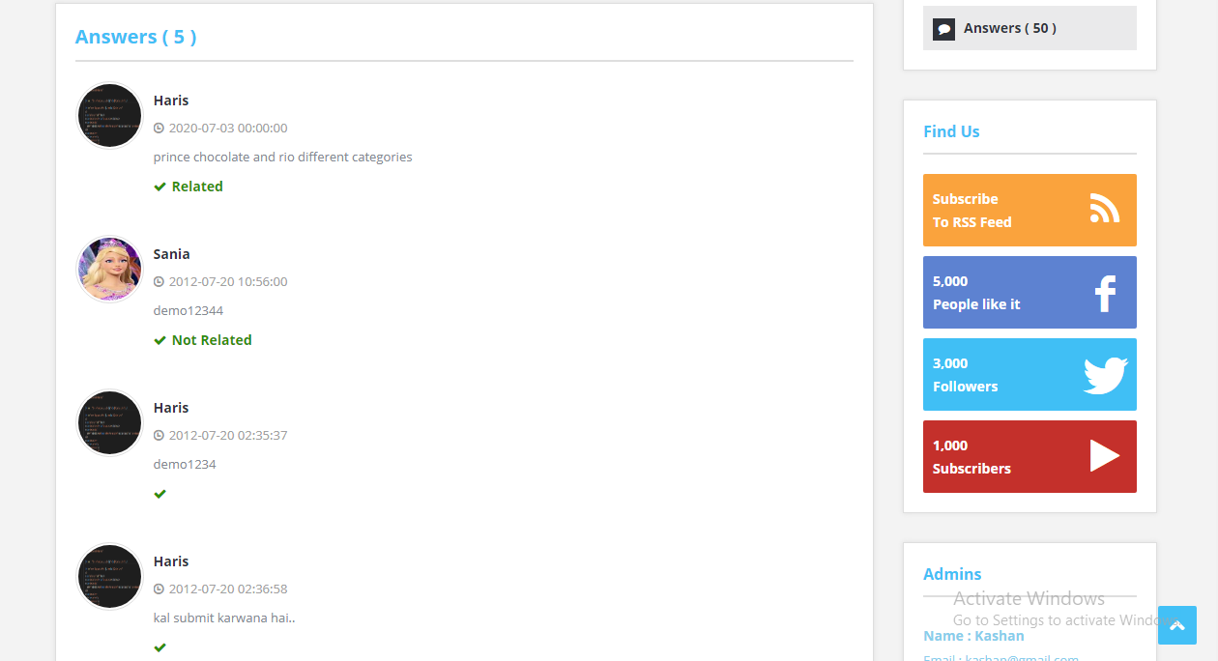

* This is our Answers page.
* User select question than move to this page.

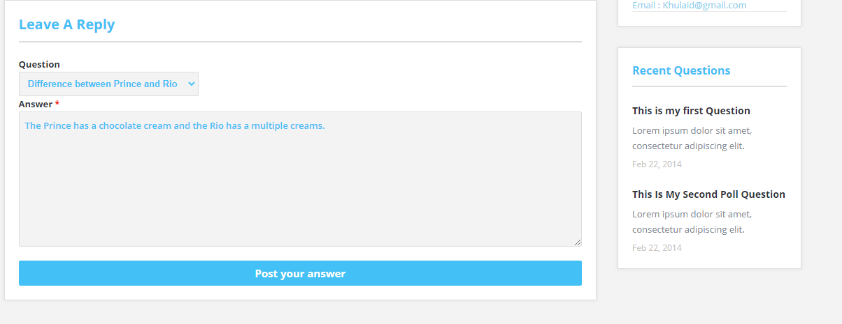

* This form also a part of Answer page
* User can give answer by this form.

**USER PROFILE**

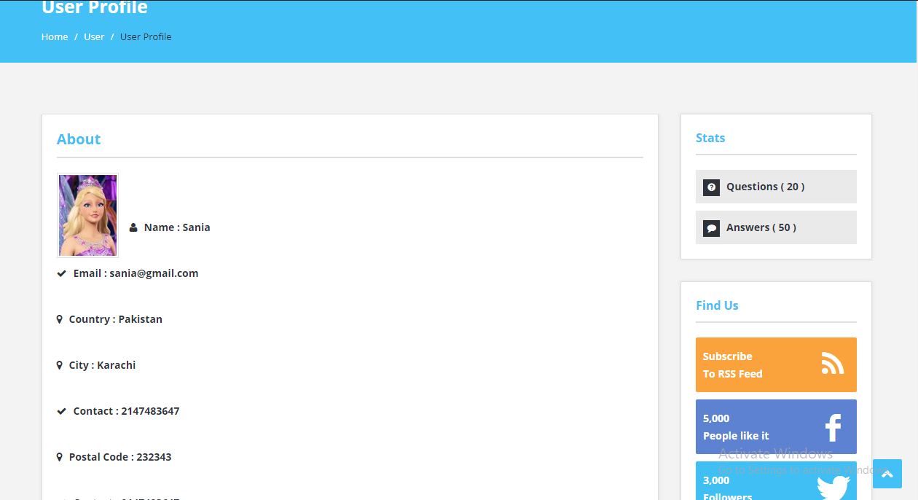

* This is our User Profile page
* User can view their profile to this page

**USER PROFILE UPDATE**

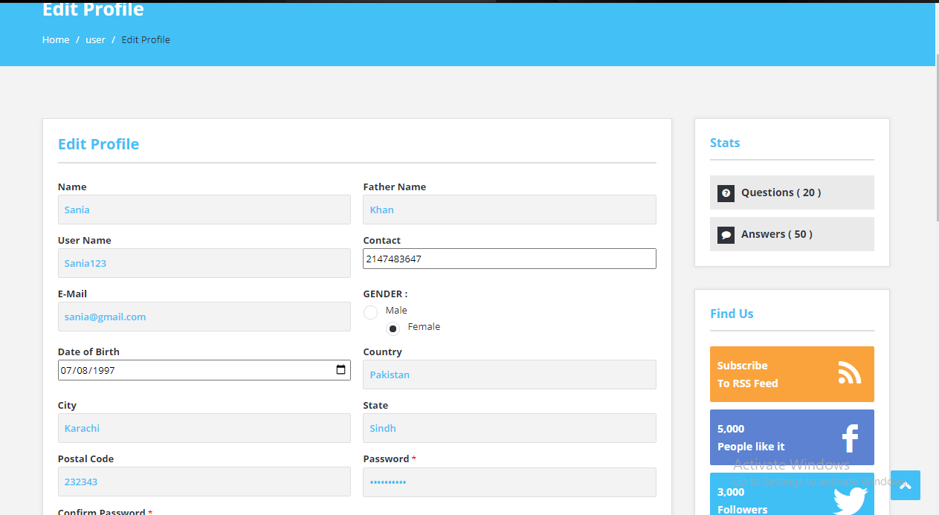

* This is our User Edit Profile page
* User can Edit their profile

**USER FEEDBACKS**

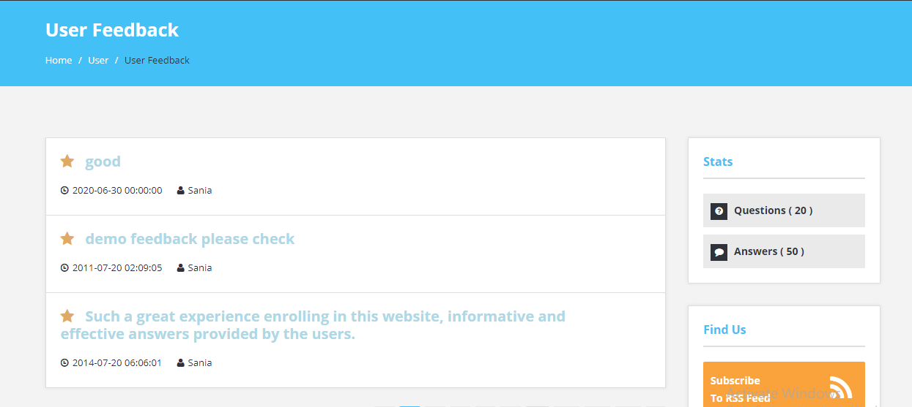

* This is our User Feedback page
* User can View their Feedback

**FEEDBACK**

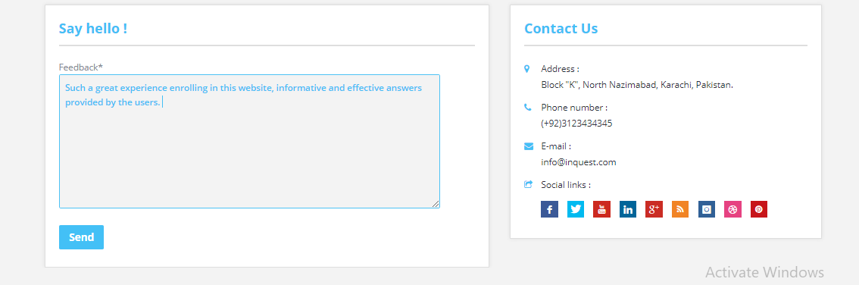

* This is our Feedback form
* It is compulsory to login our website to give feedback
* User can give Feedback by this form.

**CONTACT US**

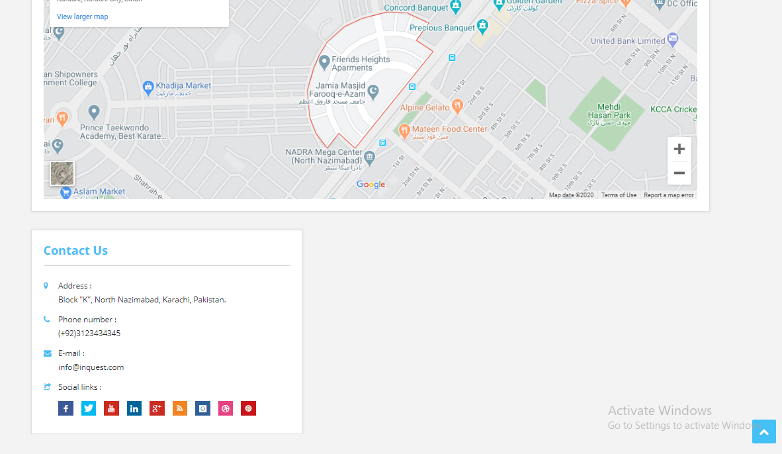

* This is our Contact page
* User find us through map location
* Contact us through Mail and Phone Number

