Name: Kashan Humayun

Sap id: 24773

Q1 Create a user Hospital management system (Username HMS).

create user HMS identified by 123;

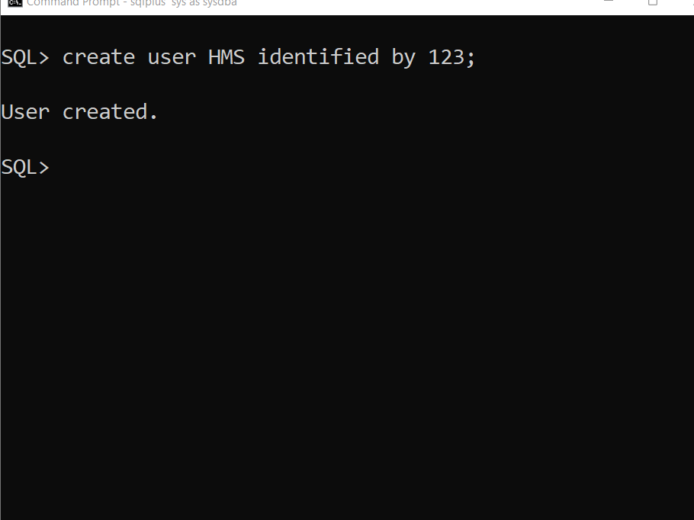

Q2 Give System level privileges to HMs.

grant create session,create table,create sequence,

create view, create procedure to HMS;

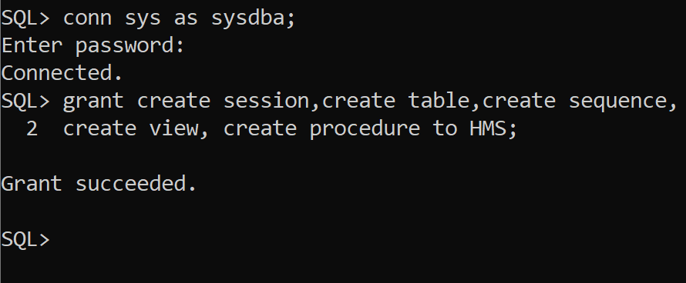

Q3 Create table hospital, patient, doctors.

create table Hospital(branch_id number(6) primary key,hospital_name varchar2(25));

create table Patient(patient_id number(6) primary key,patient_name varchar2(25));

create table Doctor(doctor_id number(6) primary key,doctor_name varchar2(25));

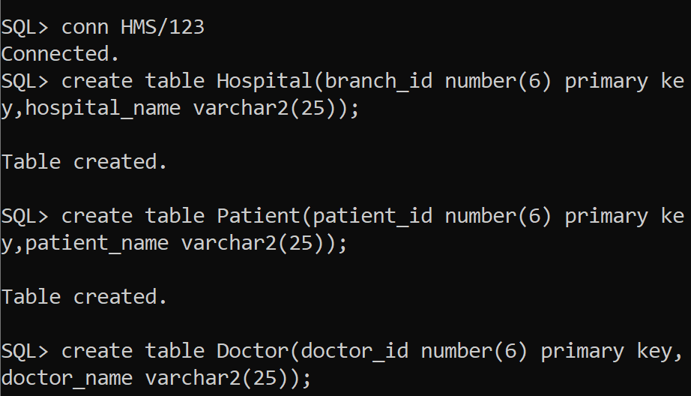

Q4 Assign object level privileges to hospital. Patient and doctors.

grant alter,insert,select on Hospital to HMS;

grant alter,insert,select on Doctor to HMS;

grant alter,insert,select on Patient to HMS;

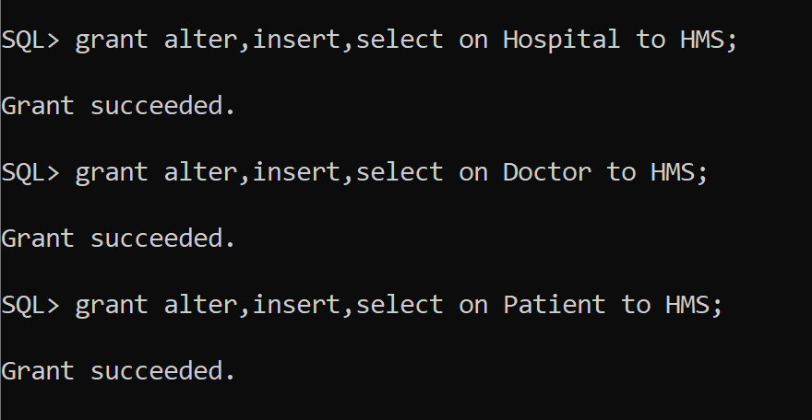

Q5 Revoke all system level privileges to hms .

revoke create table from HMS;

revoke create view, create sequence from HMS;

