Name**: Kashan Humayun**

Sap Id:**24773**

Semester**: 4th**

Program**: BSCS**

Subject: **Database Design Lab**

**Q1 You are required to read the lab manual and implement all the queries mentioned in the manual. (5 marks)**

**SELECT ALL:**

SELECT * FROM employees;

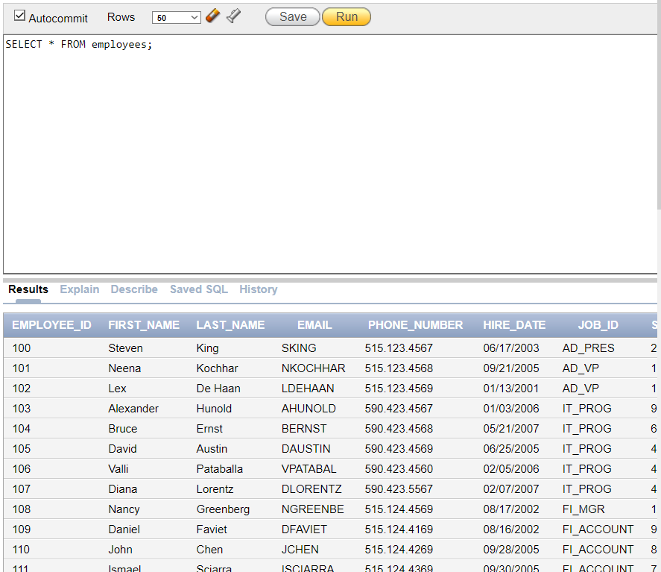

**Selecting specific Columns**:

SELECT department_id, department_name FROM departments;

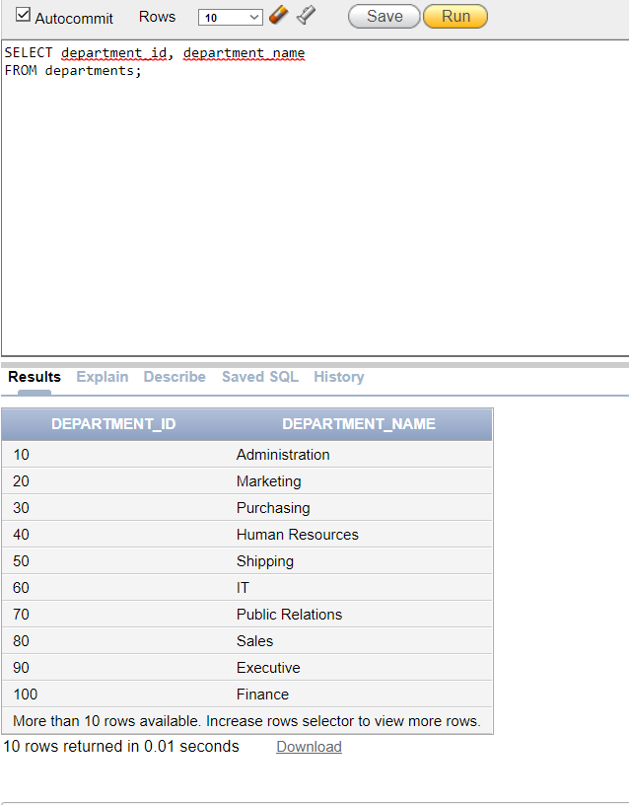

**Arithmetic expressions;**

SELECT Employee_ID, First_Name, Salary, 12*Salary+100 from employees;

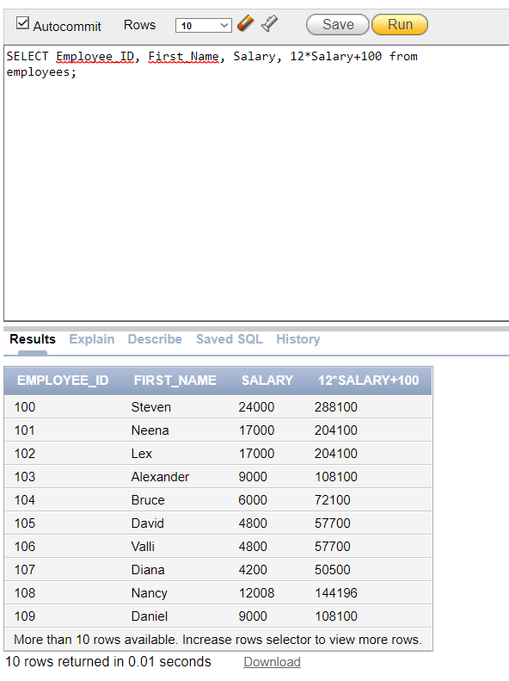

**SELECT Employee_ID, First_Name, Salary, 12*(Salary+100) from employees;**

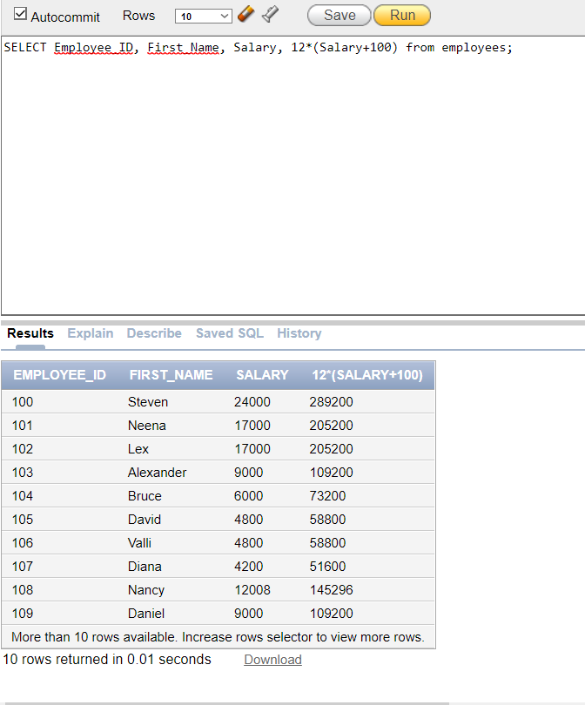

**Column Alias:**

SELECT first_name AS Name from employees;

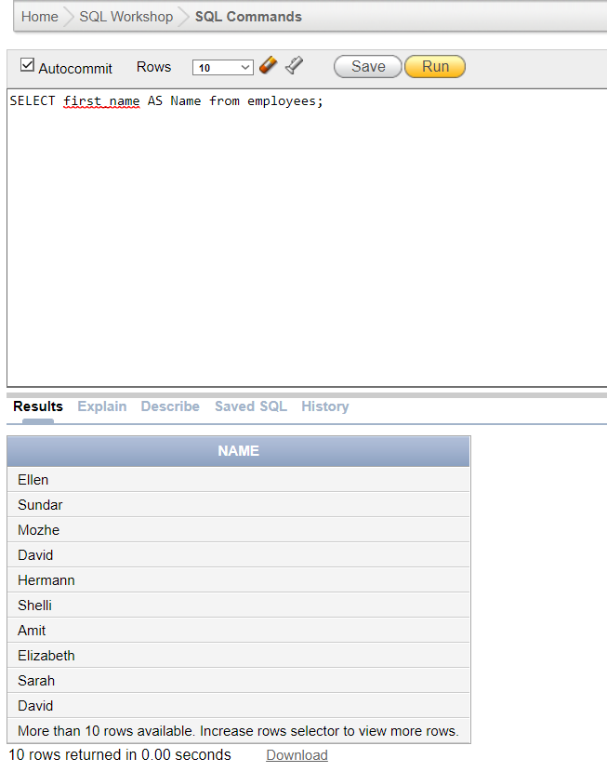

SELECT first_name “Name”, salary*12 “Annual Salary” from employees;

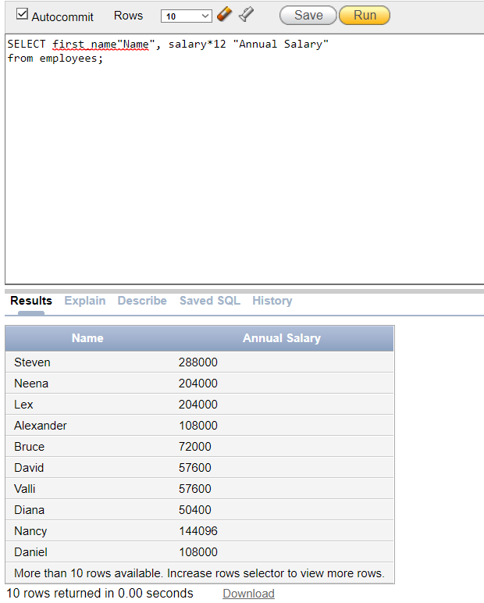

**Eliminating duplicate rows:**

SELECT DISTINCT department_id from employees;

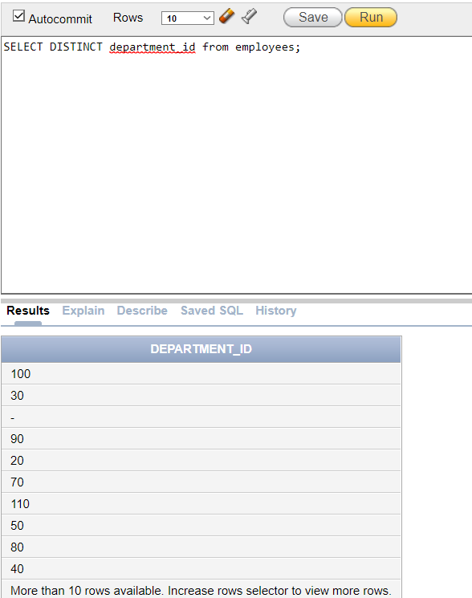

**Displaying table structure:**

DESCRIBE employees;

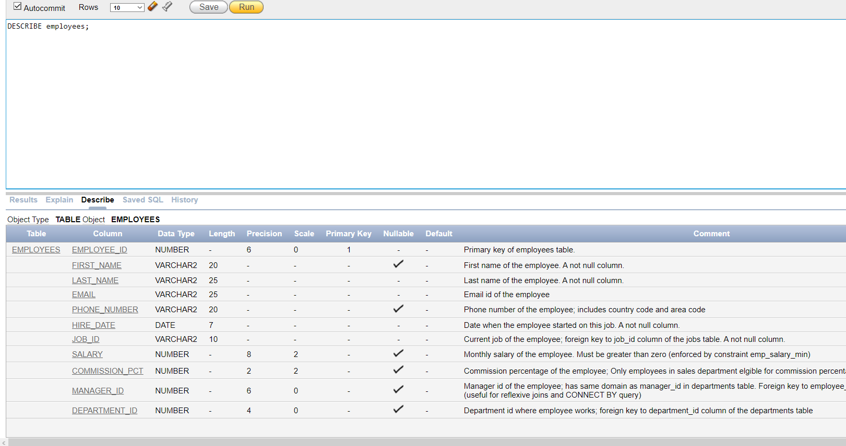

**Limiting rows selected:**

SELECT first_name, job_id, department_id FROM employees WHERE job_id='AD_PRES';

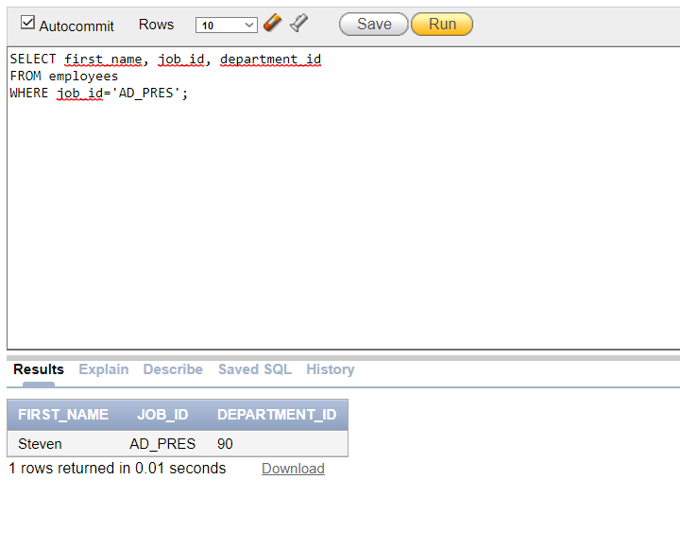

**Comparison operators:**

SELECT first_name, salary from employees where salary<=10000;

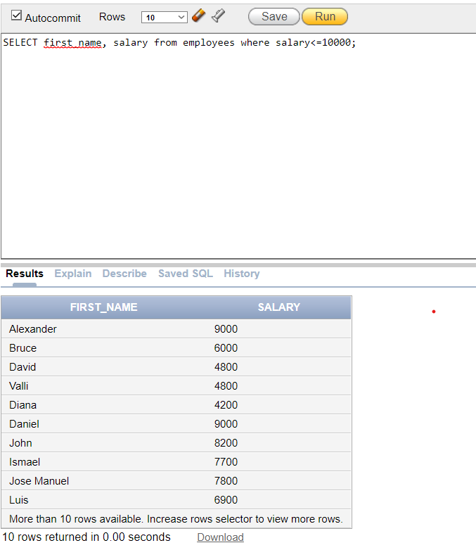

**SELECT first_name, salary from employees where salary between 1000 and 1500;**

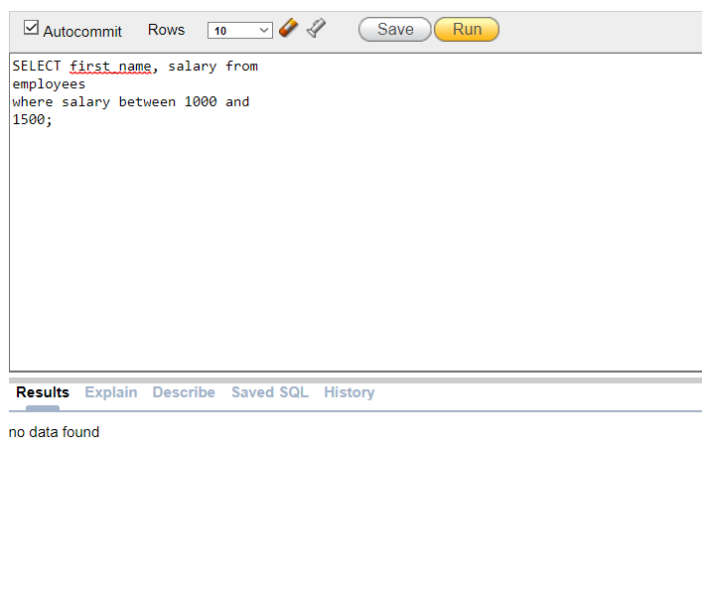

**SELECT employee_id,first_name, salary,manager_id from employees where manager_id in (100,102,103);**

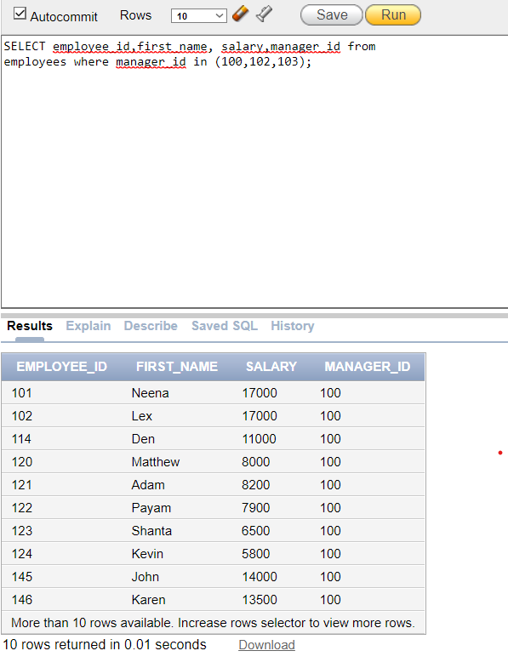

**SELECT first_name from employees where first_name like ‘S%’;**

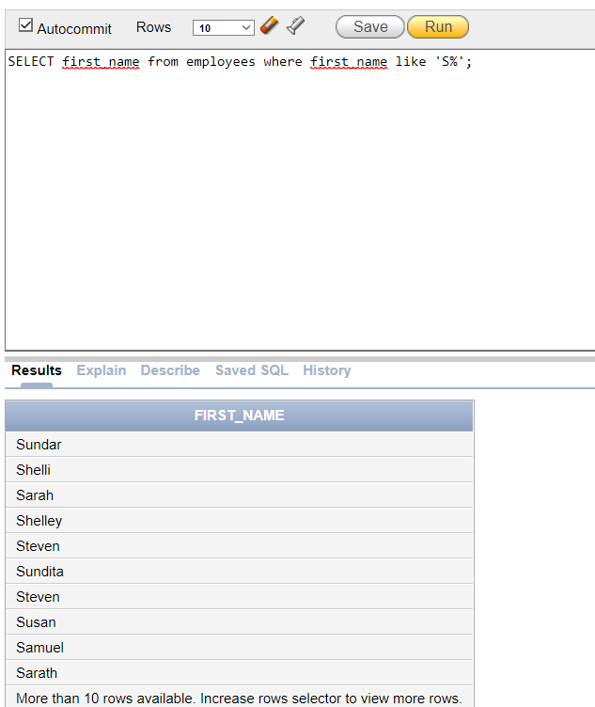

**SELECT first_name,manager_id from employees where manager_id is null;**

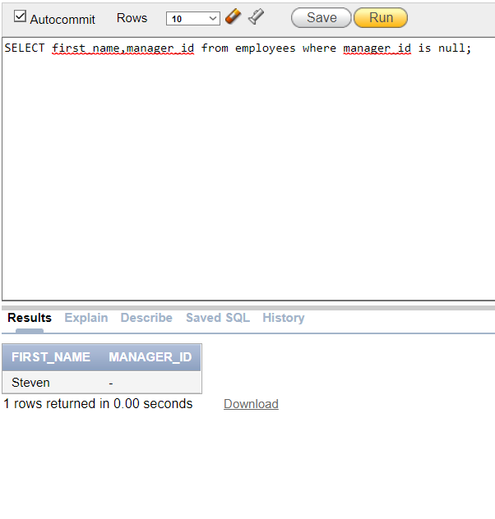

**Q2 Display all records whose first name contains ‘a’; (2 marks)**

Select first_name

From employees

Where first_name like ‘%a%’;

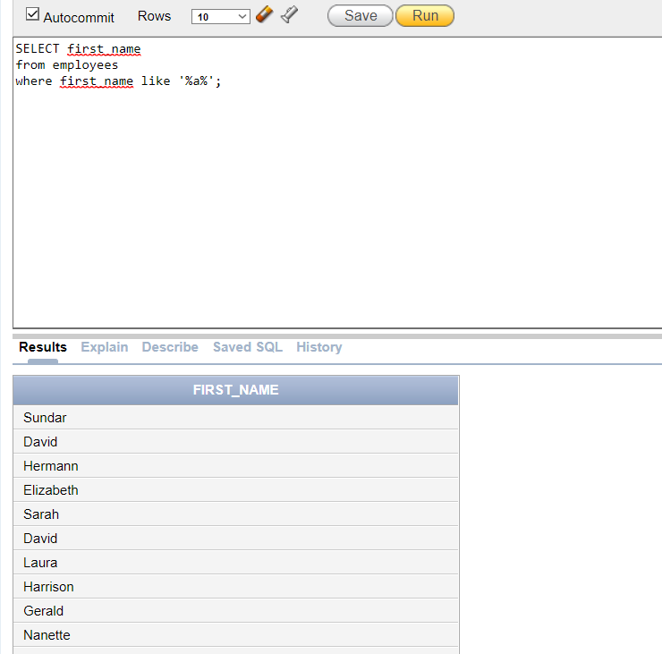

**Q3 Write a query to display employee number, salary and manager number of those employees Whose salary range 2000 to 8000 (3 marks)**

SELECT employee_id, salary, manager_id

from employees

where salary between 2000 and 8000;

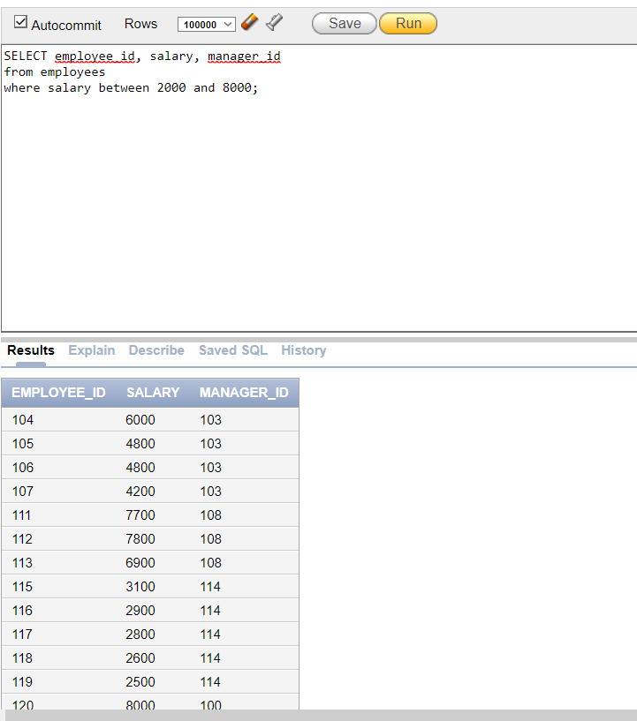

**Q4 Show all employee record whose salary in less than 5000. (2 marks)**

SELECT first_name, salary from employees

where salary<5000;

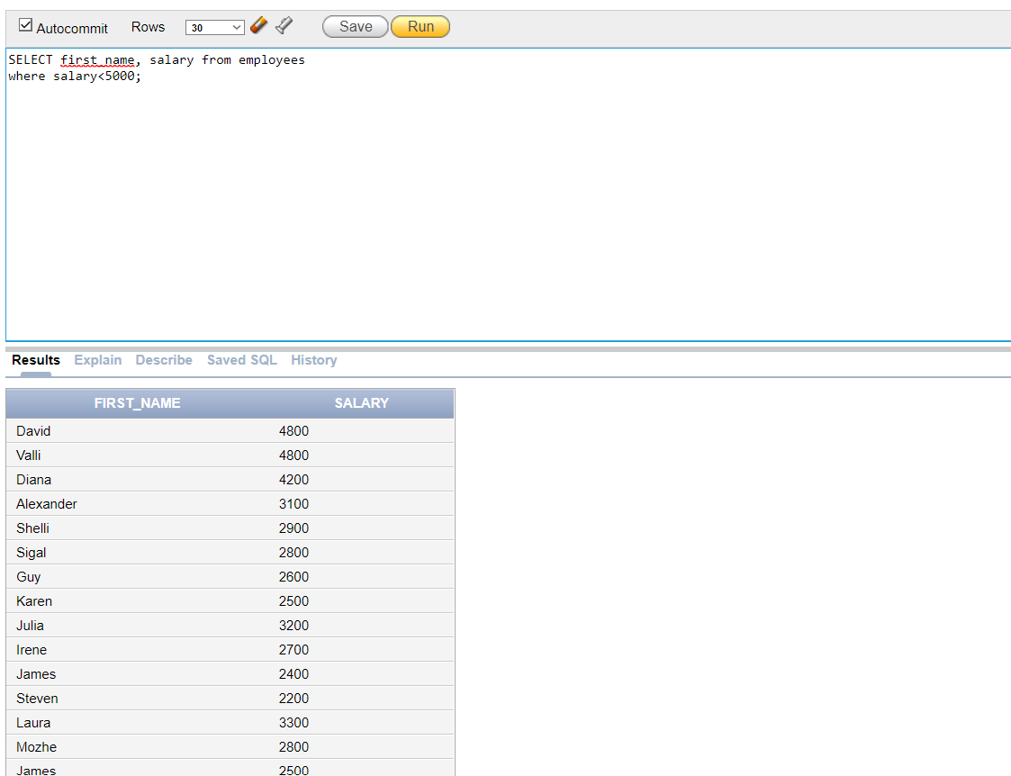

**Q5 Display job number, employee id and salary of those employee whose salary is 2000, 5000 and 8000 (3 marks).**

Select job_id,employee_id,salary

From employees

Where salary in(2000,5000,8000);

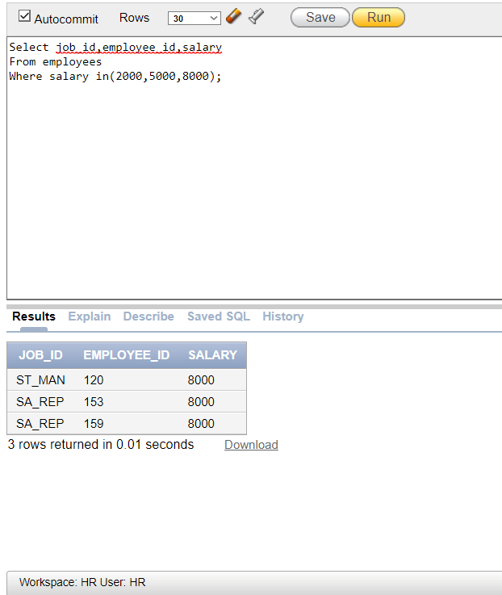

**(Q6): Show joining date of those employees whose department no is null.**

Select employee_id,first_name, hire_date, department_id

From employees

Where department_id is null;

