**Name: Kashan Humayun**

**Sap ID: 24773**

**Lab#5**

**Q1** Implement your Lab example here.

* SELECT e.employee_id, e.last_name, e.department_id, d.department_id, d.location_id FROM employees e JOIN departments d ON (e.department_id = d.department_id); 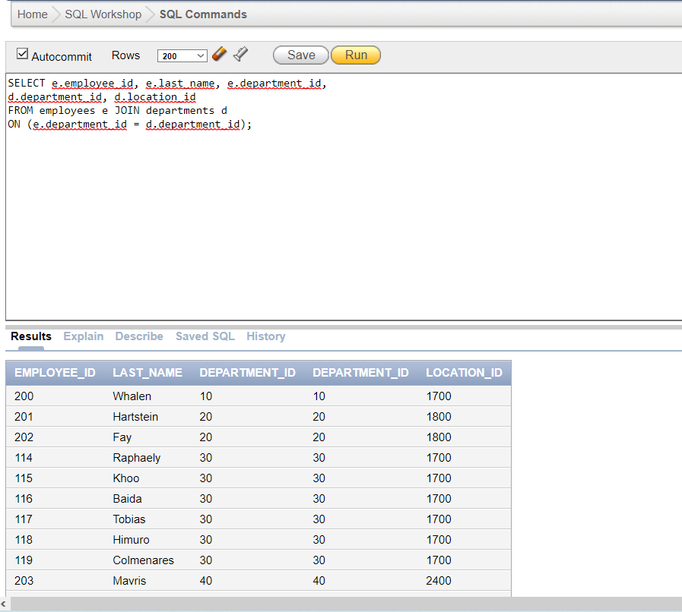
* SELECT e.last_name, e.department_id, d.department_name

FROM employees e

LEFT OUTER JOIN departments d

ON (e.department_id = d.department_id);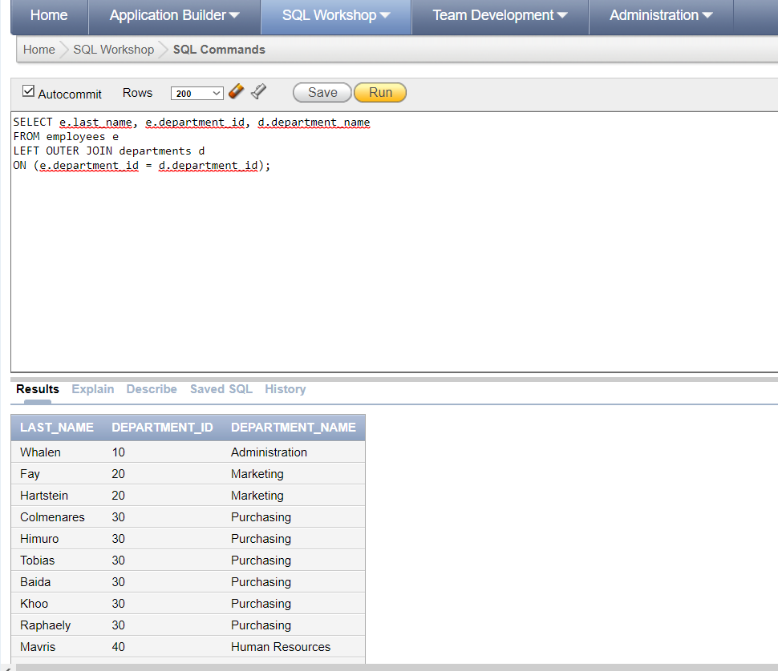

* SELECT e.last_name, e.department_id, d.department_name FROM employees e RIGHT OUTER JOIN departments d ON (e.department_id = d.department_id);

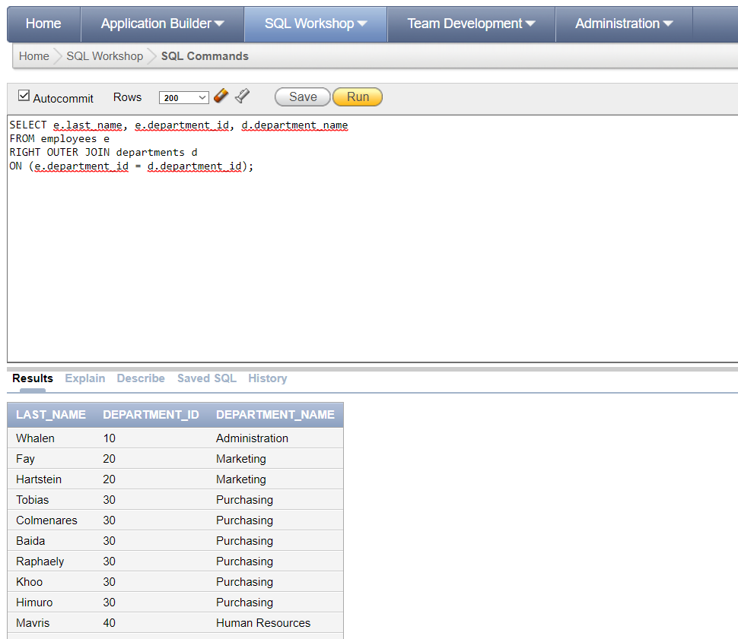

* select e.last_name,e.department_id,d.department_name

from employees e full outer join departments d

on(e.department_id=d.department_id)

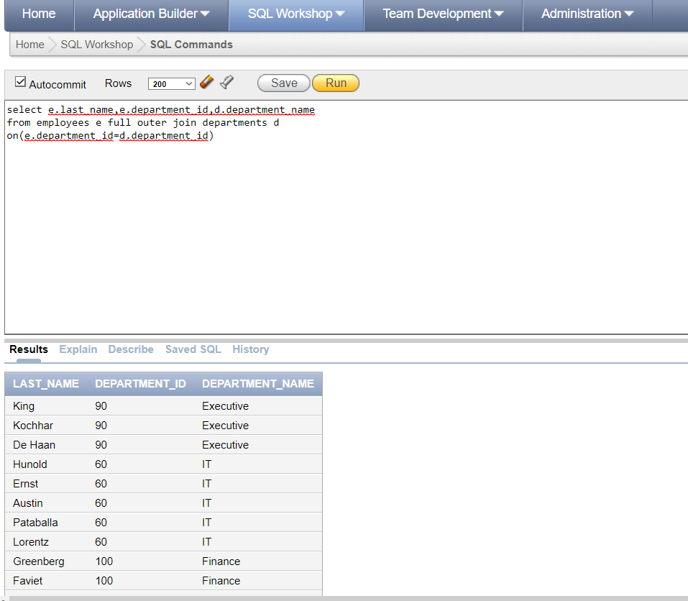

* select e.last_name,m.last_name

from employees e join employees m

on(e.manager_id=m.employee_id) 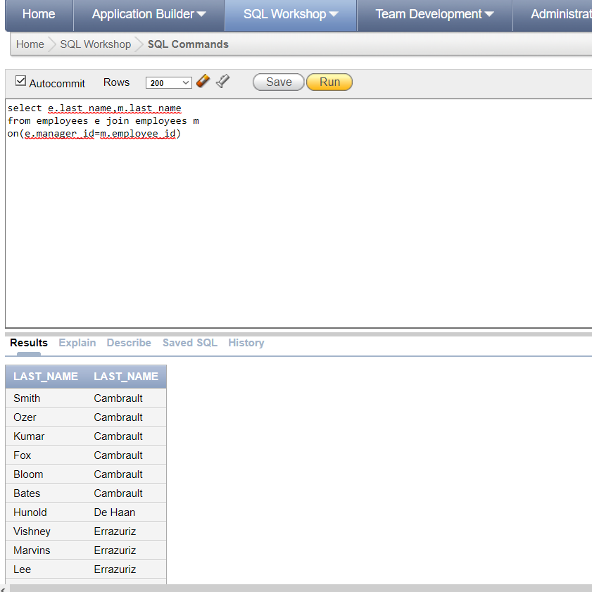

* SELECT e.employee_id, e.last_name, e.department_id,

d.department_id, d.location_id

FROM employees e JOIN departments d

ON (e.department_id = d.department_id)

AND e.manager_id = 149 ;

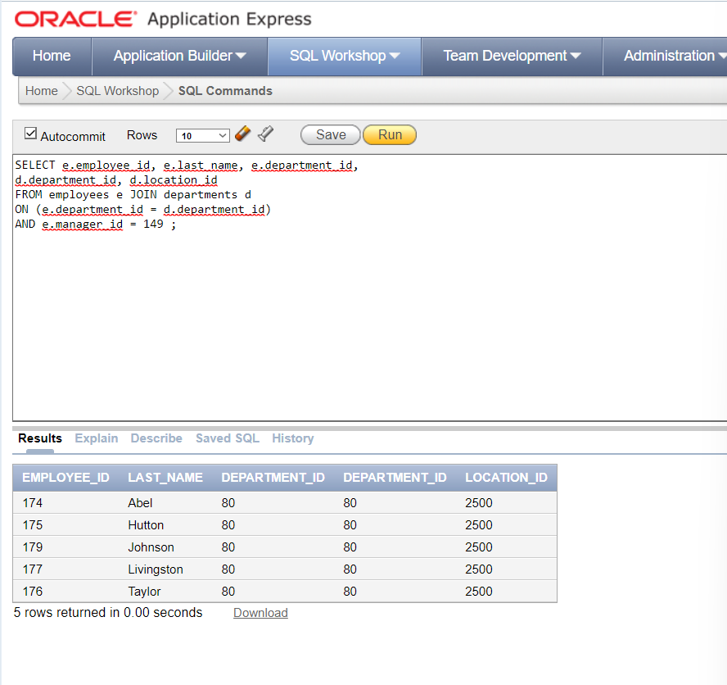

* SELECT employee_id, city, department_name FROM employees e JOIN departments d ON d.department_id = e.department_id JOIN locations l ON d.location_id = l.location_id;

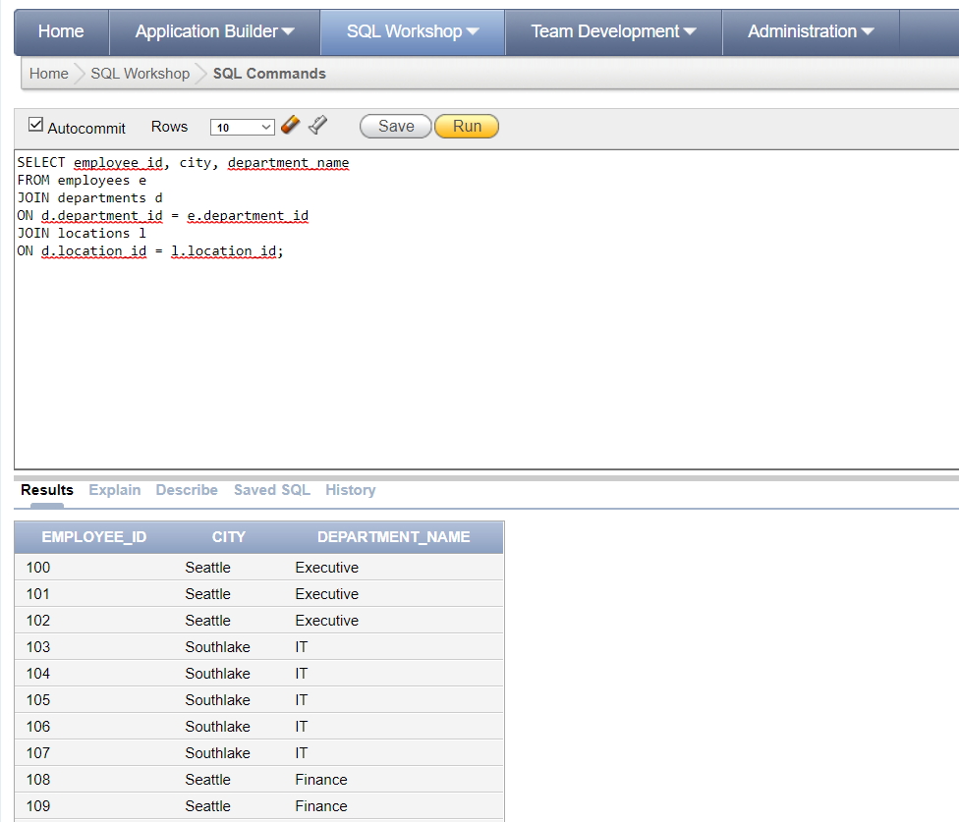

* SELECT last_name, department_name FROM employees CROSS JOIN departments;

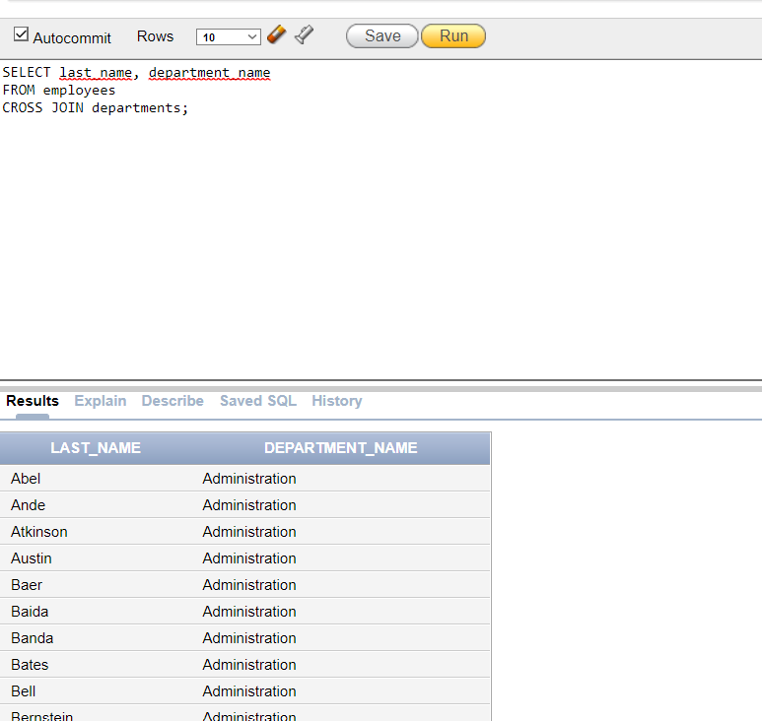

**Q2** Write a query that displays the job-title, employee last name, department id for all employees whose employee job-id is equal to job job-id.

* select e.job_id,e.last_name,e.department_id,j.job_id

from employees e join jobs j

on(e.job_id=j.job_id)

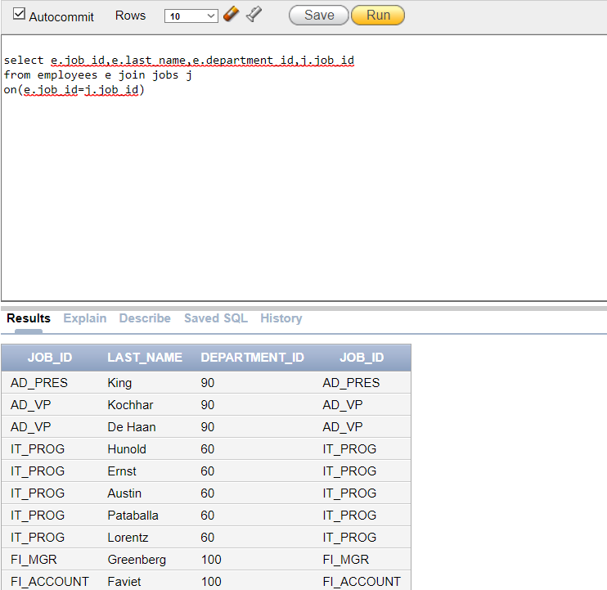

**Q3** Write a query to display employees’ last name and employee number along with their manager’s last name and manager number. Label the columns Employee, Emp#, Manager, and Mgr#, respectively.

* select e.last_name as Employee,e.employee_id as Emp#,m.last_name as Manager, m.manager_id as Mgr#

from employees e join employees m

on( e.manager_id=m.employee_id)

