|  |  |
| --- | --- |
| PROJECT introduction:  For all cricket lovers who miss their matches due to their busy schedule and need to search YouTube or different websites. What if you have an app that will help you to be up to date with cricket world and new upcoming players in every team. Also if you miss or wanted to know the latest cricket rankings then this is the perfect app that will make you up to date.  This project is developed using Visual Studio 2015 pro.  . | PROJECT  SUMISSION────CRICKET APPLICATION────SUBMIT TO SIR SAAD AKBAR────Course NameIntroduction to Software Development────Kashan siddiqui Roll Number B15158029  Class  BSSE 2nd Year |

**LOGIN MODULE:**

Login page requires username and password. The data you enter in both the text fields will then be checked at the back end code for login confirmation. At backend no external data base such as My SQL is used. Instead visual studio provides its own data base for such cases.

The data base automatically checks whether data present in data base or not. A pop up will come if you will enter wrong user name or password.

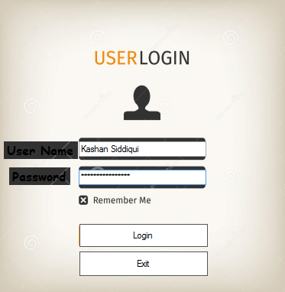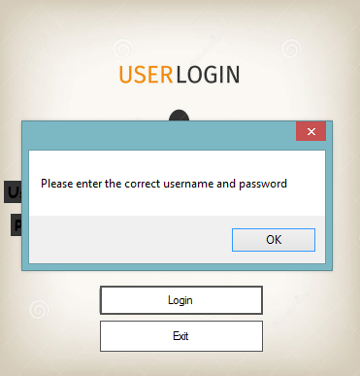

**LIVE SCORE:**

This app also shows live scores of ongoing matches. You can select one or more channels to view matches. It fetches the data from your selected links and display it on to your app. The data will be updated automatically.

This will be the first screen that will come after login.

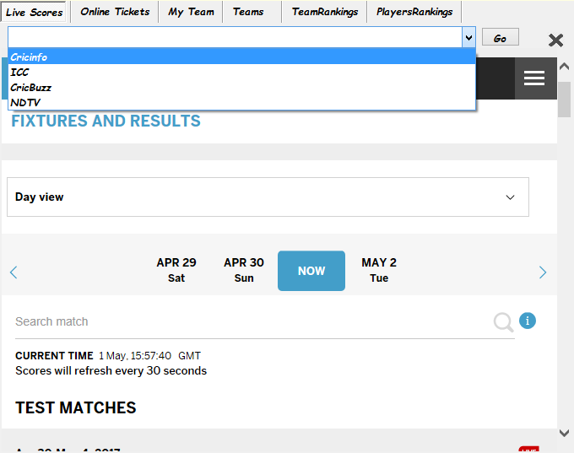

**Cricket Rankings:**

All types of rankings whether players ranking or teams ranking in all three formats of cricket will be shown in list along with the team players. This is also done by fetching data from net and also Filling is done here. You can select your own team and your own format.

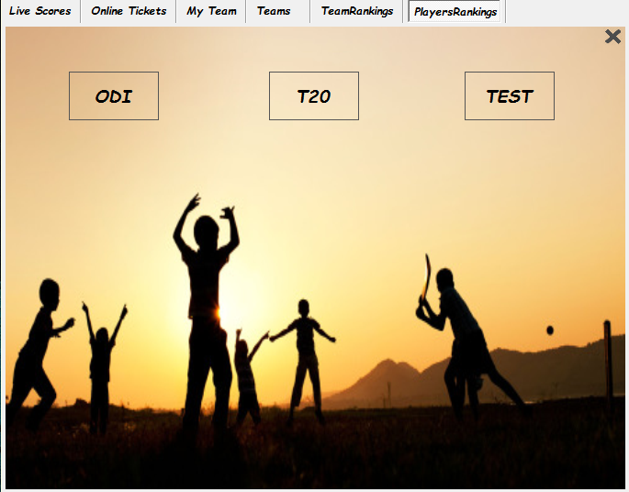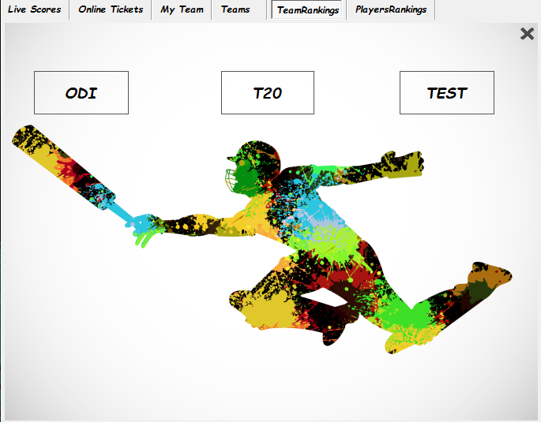

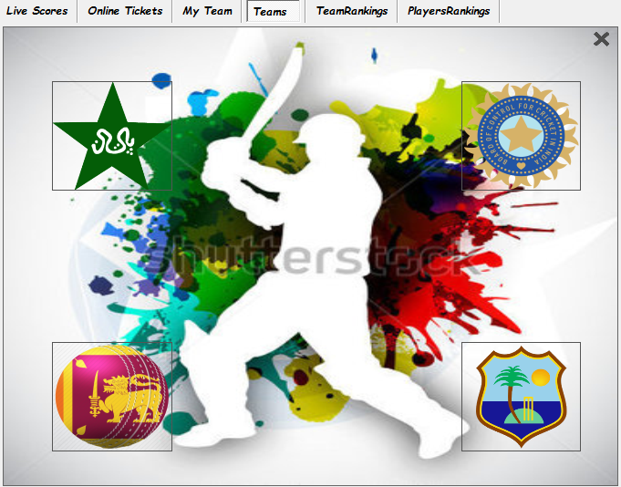

**Tickets Booking:**

Online ticket booking service from popular servers is also provided in this app. You can have ticket of any match around the world just by sitting at your chair.

Same procedure just selects your link then your match and pay online bill.

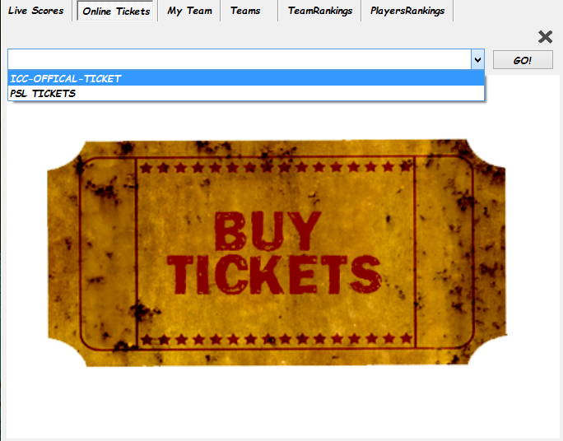

**CODE SNIPPETS OF DIFFERENT MODULES:**

* **DATA BASE:**

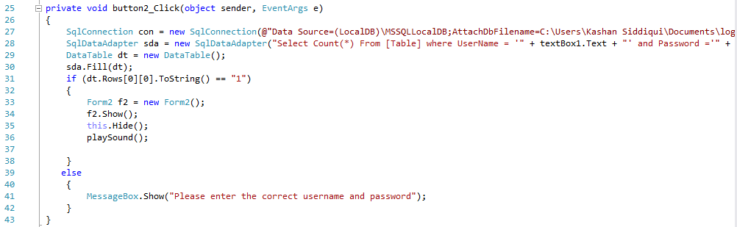Objects of SqlDataAdapter, SqlConnection and DataTable are created and path of your data base is given to 2 first objects. Then condition of if checks that username and password are correct or not then it further proceeds. If data does not match, then it will show the pop up box to enter correct data.

* **FILLING:**

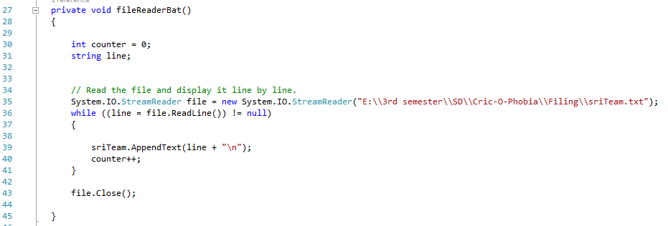File reader class use to read data from text file of given link and with this code it will show data on labels.

* **Sound Library:**

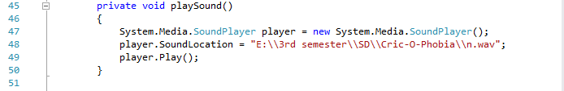Media sound player library object is created. It will take audio file and sound will start when you will have logged into this app. This is the built in library in java and play sound of your given link.

**FUTURE WORK:**

* Quiz will also be added related to cricket. For entertainment and knowledge purpose.
* GUI will be updated.
* API will also be added.
* Cricket game will also be added for entertainment.