**BCG: Financial Chatbot**

**Summary**

* **Data Collection & Analysis:** The data from the 10K annual reports was compiled into an **Excel sheet** and analysed using **Pandas**.
* **User Interface:** The user interacts through an **HTML form** (with an input field and a submit button) where they type queries.
* **Backend Processing:** A **Flask web app** was built that processes the query, extracts relevant information using **Pandas**, and sends the response to the user using **Jinja2 templates** to display it on the webpage. Refer the images attached at the bottom of the document, images provide you with a mini demonstration of how the web app looks like and how user is supposed to ask a query.
* **Basic queries that user can ask are as follows:**
  + - * + What are the Total Assets of Microsoft for the year 2021
        + What is the Cash Flow from Operating Activities of Tesla for the year 2022
        + What is the Total Liability of Microsoft for the year 2023
        + What is the Net Income of Tesla for the year 2023
        + What is the percent change in the Net Income of Apple for the year 2023
        + What is the percent change in the Net Income of Apple for the year 2022
        + What is the percent change in the Net Income of Tesla for the year 2023
        + What is the percent change in the Net Income of Tesla for the year 2022
        + What is the percent change in the Net Income of Microsoft for the year 2023
        + What is the percent change in the Net Income of Microsoft for the year 2022
        + What is the percent change in the Revenue of Apple for the year 2023
        + What is the percent change in the Revenue of Apple for the year 2022
        + What is the percent change in the Revenue of Tesla for the year 2023
        + What is the percent change in the Revenue of Tesla for the year 2022
        + What is the percent change in the Revenue of Microsoft for the year 2023
        + What is the percent change in the Revenue of Microsoft for the year 2022

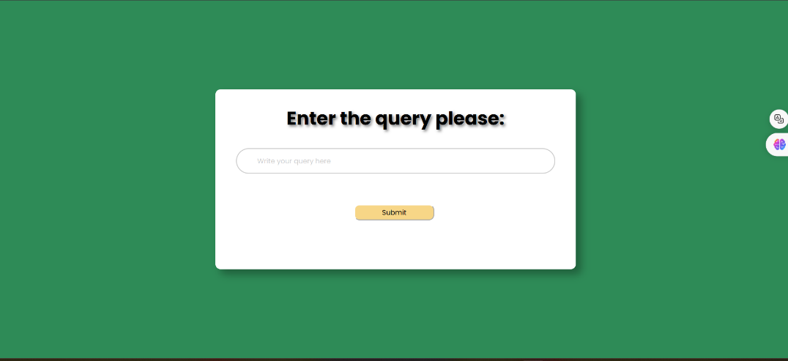

**Basic Form for the Chatbot**

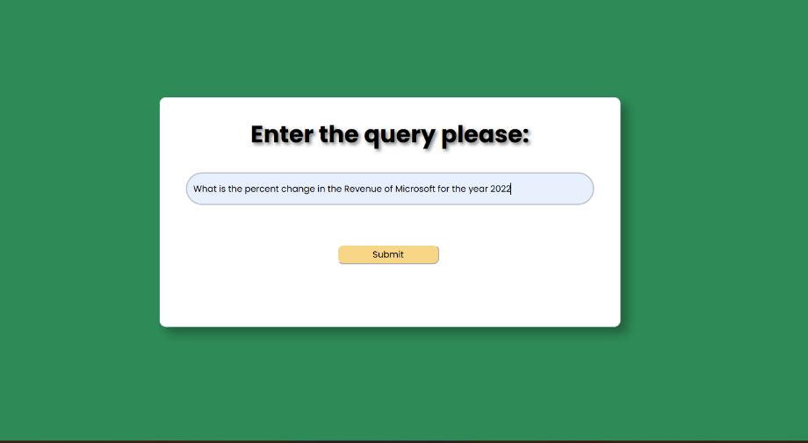

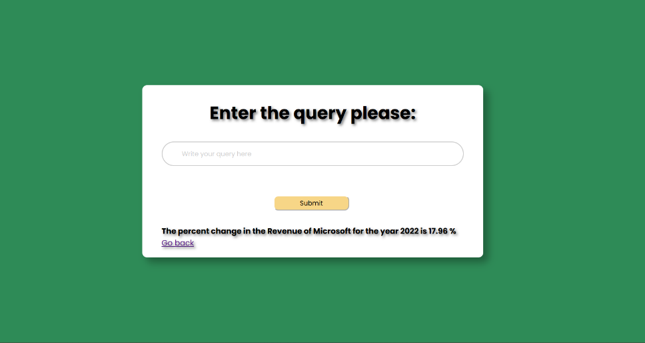**User can input the query in the text field**

**Response generated at the bottom of the div**

* **Limitations**: - Currently, the limitations of the Chatbot are huge since it is not generalized to the natural language (English) it is way more than specific to a certain number of queries, hence we have a smaller number of degrees of freedom to write the queries.

The HTML form created to accept user queries is somewhat less like a conversation and more like I/O interface, this interface can be enhanced to a typical conversation-based interface such as we have in ChatGPT or WhatsApp.