### Kashif Alam 02-131222-134

### Moula Bux 02-131222-058

### Smart Home Automation System: A Formal Report

The Smart Home Automation System is a mobile and web-based application that offers users a centralized platform to manage multiple smart devices. It addresses the common challenge of handling disconnected smart gadgets that often lack a cohesive and user-friendly interface. By offering a unified control point, the system simplifies and streamlines smart device management. This project is a focused initiative with clear start and end points, aimed at resolving specific business challenges through effective software engineering practices.

### 1. Project Definition

The core objective of the Smart Home Automation System is to address the issue of **fragmented control over smart devices**. Users often need multiple applications to manage different devices, leading to a complex and inefficient experience. The proposed solution is a **mobile application** that provides a single, centralized interface for controlling various smart devices, such as lights and thermostats, thereby offering an easy-to-use system.

### 2. Vision and Scope Document & SRS

#### Vision Statement

#### For homeowners facing difficulties in managing multiple disconnected smart devices, the Smart Home Automation System offers a mobile application that brings all device controls into one intuitive and centralized platform. Unlike existing scattered control solutions, this system delivers a smooth and cohesive user experience, streamlining smart device management and elevating the overall efficiency of home automation.

#### Software Requirements Specification (SRS)

The **SRS** serves as a detailed roadmap for the project8. It defines the system's behavior from a user's viewpoint, covering input, processing, output, and operational scenarios9.

**Functional Requirements (FR):**

These outline the core operations the system must perform:

* Users must be able to control smart lights (turn them on/off) and adjust thermostat settings.
* The system should enable users to manage multiple smart devices through a single application
* The application must process user commands and relay them accurately to the appropriate smart devices (e.g., lighting, thermostat).
* The system should retrieve and present the current status of all connected devices (e.g., whether a light is on or off, or the current room temperature).

**Non-Functional Requirements (NFR):**

These define the quality and performance standards of the system:

* Reliability: The system must perform actions and execute commands dependably, without crashes or malfunctions.
* Performance (Response Time): Actions like switching a light or adjusting the thermostat should be completed within one second.
* Security: Access must be restricted to authorized users only. Device identifiers and user credentials must be securely managed to prevent unauthorized control or data breaches.
* Usability: The application interface should be user-friendly and easily operable by individuals of all technical skill levels.

### 3. Diagrams

#### Context Diagram

#### Use Case Diagram

#### Sequence Diagram

#### Class Diagram

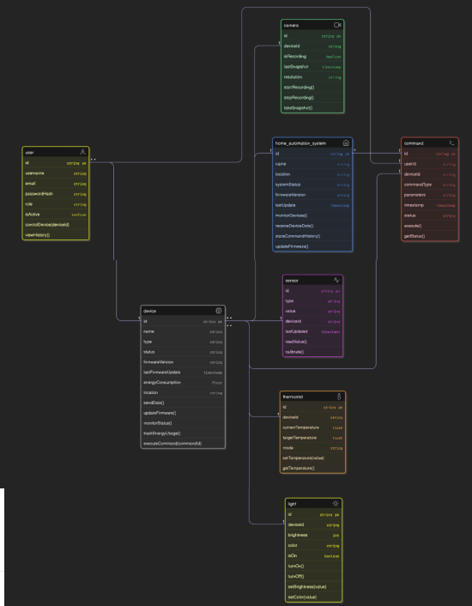

### 4. Prototyping

Prototyping is an essential step to visualize and refine the user interface and functionality.

#### Low-Fidelity Prototypes

Low-fidelity prototypes are basic, low-detail representations of the user interface. These models emphasize layout and core functionality rather than aesthetics or visual polish. Their simplicity allows for rapid creation and easy adjustments based on initial user feedback.

**Examples:**

* **Dashboard Sketch**  
  A rough sketch—either on paper or using a digital wireframing tool—representing the main dashboard screen. This includes basic placeholders for a navigation menu, a list of rooms, and a quick overview panel showing device statuses.
* 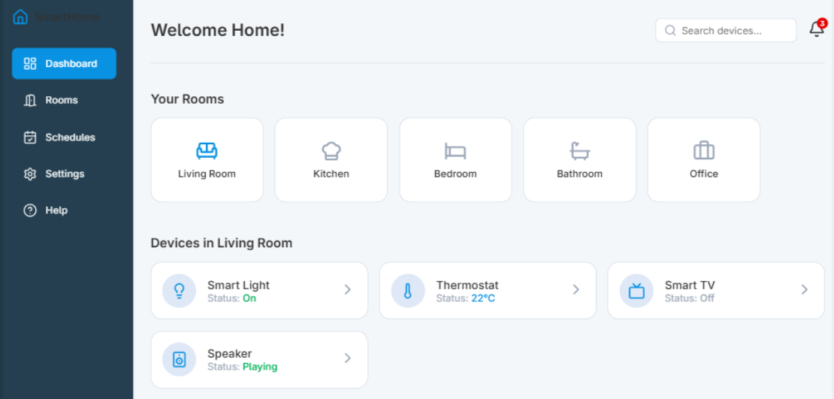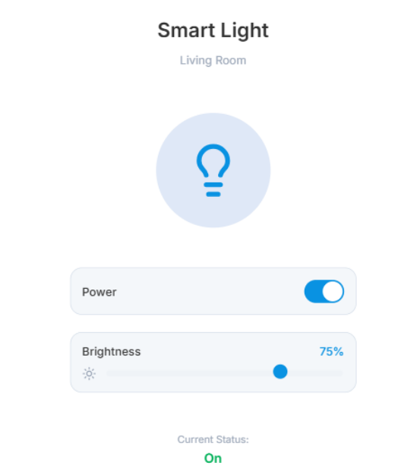**Device Control Sketch**  
  A simple wireframe focused on controlling an individual device, such as a smart light. It may include an on/off toggle switch and a brightness adjustment slider, showcasing essential interactions without any styling or graphical elements.

#### High-Fidelity Prototypes

High-fidelity prototypes are advanced, interactive models that closely replicate the final application in both appearance and functionality. These prototypes are used to evaluate the user experience with realistic visuals, interface elements, and interactive behaviors.

Compared to low-fidelity prototypes, high-fidelity versions are more polished and suitable for usability testing, stakeholder presentations, and final-stage feedback.

**Examples:**

* **Interactive Home Screen**  
  A detailed mock-up created using tools like **Figma** or **Visily**, featuring a complete color palette, icons, text, and realistic UI components. Users can interact with the interface—such as clicking on a room to view its associated devices—mimicking real app navigation.
* 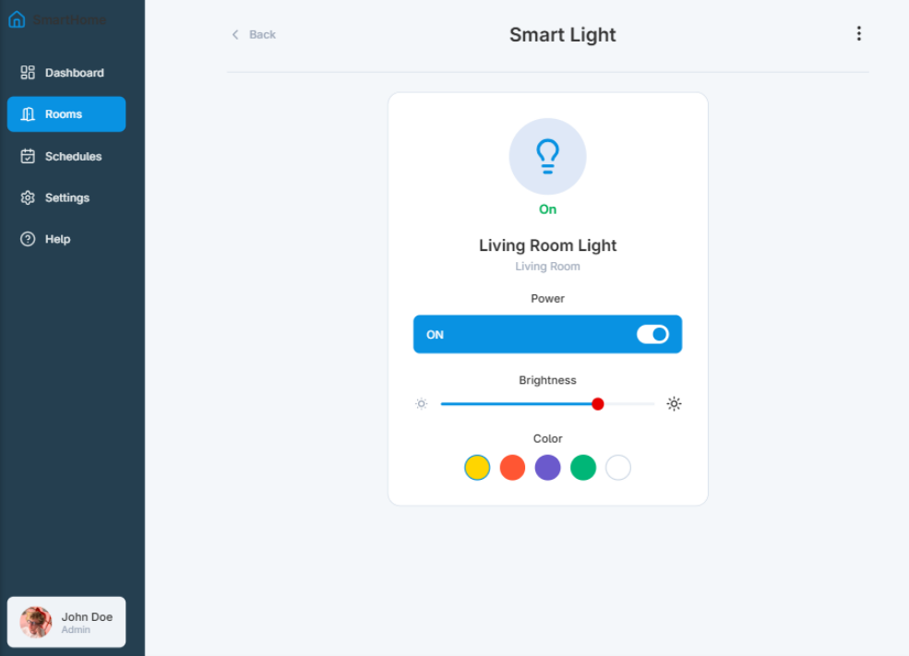**Interactive Device Control Screen**  
  A high-fidelity design of an individual device interface, such as for a smart light. This screen includes a sleek toggle switch and a responsive slider for brightness control. Visual feedback is integrated—for example, the light icon may change brightness or color in real time, providing an experience nearly identical to the final product.

