Assignment No. 1 Course: Operating System Lab

Section: 106354 Assigned By: UBAID ULLAH



FALL

2022

LAB

# ASSIGNMENT #. 1

**Course:**

## Operating System

Assigned By:

UBAID ULLAH

Points To Remember

1. Total Marks Of Assignment is 10.
2. If the code/answer is found copied, straight zero will be marked.

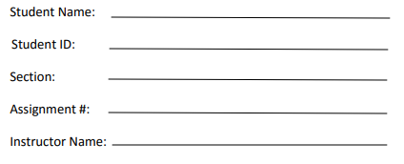

1. Straight zero will be marked for incorrect submissions.
2. Submit Your Assignment within due date.
3. Late submissions will not be considered.
4. Your file name should be like (OS_Assigment#1_StudentName_StudentID_Section)
5. File submitted answering to this assignment must contain:
   1. Code of the program along with the screen shots of the output.
   2. All work must be in a proper, quality, neat and clean way as with all work in this course, 10% of the grade is for quality of presentation.
6. Output must be in the formatted form.
7. Cover page of your file must contain:

*Question No.1*

1. **Write shell script that prompts the user to enter an 8-bit binary number and then convert it to equivalent decimal number.**
2. **Write a function to find the grade “A to F” of a given percentage by user using shell scripting.** (Marks=3.5+1)

*Question No. 2*

**Write a C program which dynamically allocates the memory to the pointer variable and inputs the following values from user:**

* 1. (55, 3, 71, 31, 39, 83, 415) in the allocated memory and print on the screen.
  2. Re-Allocate the memory to the pointer variable and now input the following values from user in the re-allocated memory (83, 23, 4, 3, 75, 55) and print them.
  3. And check the same values occurring before and after the re-allocation of the memory and store them in an array and then print the array on the screen.
  4. Also Count the same values and print the total number of same values.

(Marks=2)

*Question No. 3*

**Implement the following scheduling algorithms using C Language on given data:** (Marks=3.5)

### Shortest Job First

1. **Round Robin**
2. Key points to remember
   1. Your program must take input only once for the both algorithms from user.
   2. Then print the table for both algorithms, output table must contain the following.

### 1. Process ID, 2. Priority, 3. Burst Time, 4. Waiting Time, 5. Turnaround Time, 6. Avg Waiting_Time,

**7. Avg Turnaround_Time.**

* + - And then compare the **Avg Waiting_Time** and **Avg Turnaround_Time** at the end. And give your analysis which one is better according to their **Avg Waiting_Time** and **Avg Turnaround_Time.**
    - Use the following chart for Priorities and Burst Time for Processes.

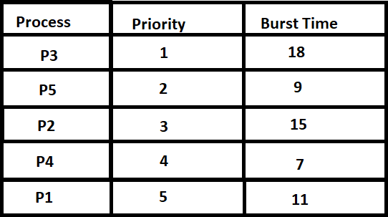

**Sample Output:**

Best Of Luck

