**Project**

**Home**

# Navigation bar

* + 1. Home
    2. Resource
    3. Test
    4. About us
    5. Contact

1. Home
2. Content area
   * 1. About machine learning
     2. About AI
     3. 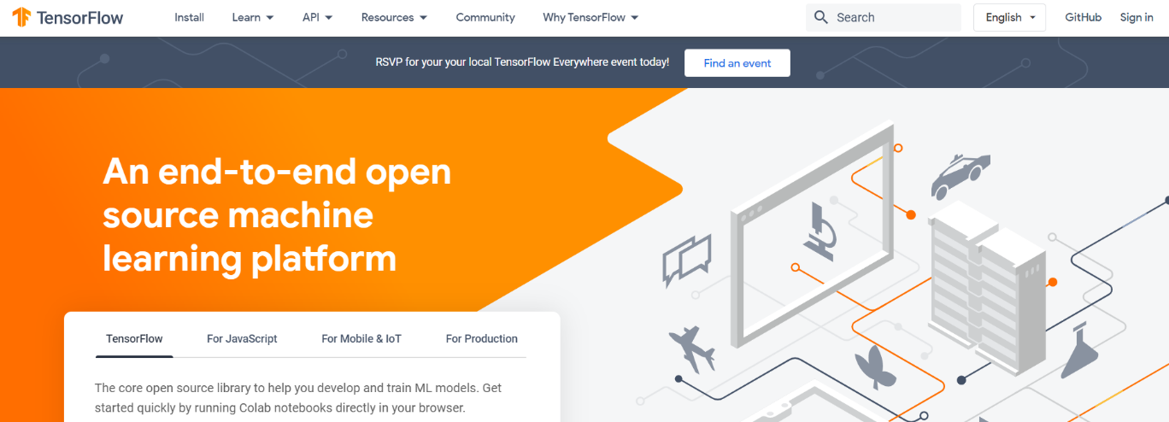Mission and Vision
3. Resources
   * 1. <https://www.tensorflow.org/>
     2. <https://www.coursera.org/>
     3. <https://online.stanford.edu/>
4. Test
   * 1. <http://www.asmarterwaytolearn.com/python/5.html>
     2. 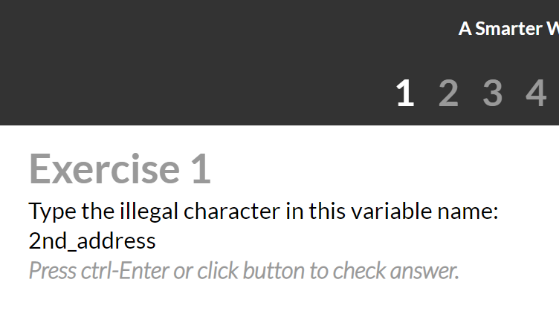MCQ’s based test with radio button of show result and go to next
5. About us
   * 1. 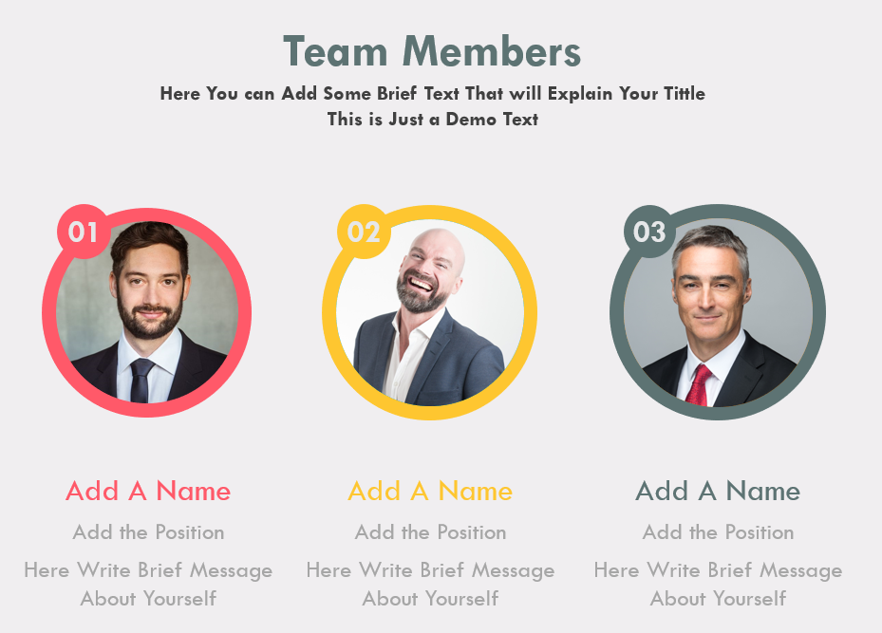team members
     2. About our website
6. Contact
   * 1. 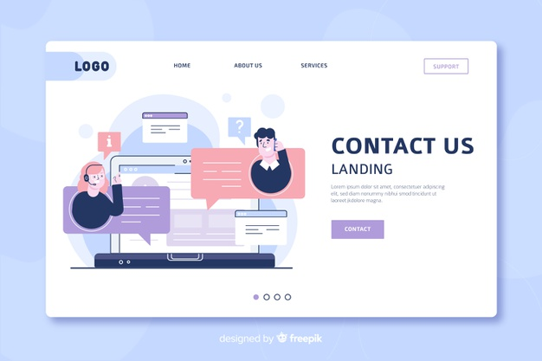contact form