Module 1: Introduction

Project Scenario and Overview

Introduction to the Commercial Space Age
The commercial space age is here, and several companies are making space travel more affordable and accessible.
Some major companies in the commercial space industry include:
- Virgin Galactic – Provides suborbital spaceflights.
- Rocket Lab – A small satellite launch provider.
- Blue Origin – Manufactures suborbital and orbital reusable rockets.
- SpaceX – One of the most successful commercial space companies.

SpaceX Accomplishments
Some of SpaceX's major accomplishments include:
- Sending spacecraft to the International Space Station (ISS).
- Developing Starlink, a satellite internet constellation that provides internet access through satellites.
- Sending manned missions to space.

Why SpaceX Launches Are Less Expensive
One reason SpaceX has achieved significant success is that its rocket launches are relatively inexpensive.
- A Falcon 9 launch is advertised at approximately $62 million.
- Other launch providers may charge more than $165 million per launch.
A major reason for these lower costs is that SpaceX can reuse the first stage of its rockets.
Therefore, if we can determine whether the first stage will successfully land, we can estimate the overall cost of a launch.

Understanding the Falcon 9 Rocket
To understand the scale of the Falcon 9 rocket, diagrams created by Forest Katsch at zlsadesign.com are used.
Forest Katsch is:
- A 3D artist
- A software engineer
- A creator of infographics related to spaceflight and spacecraft art
- A software developer

Components of Falcon 9

Payload
The payload is enclosed inside the fairings (protective shells that surround and protect the payload during launch).

Second Stage
The second stage helps bring the payload into orbit.

First Stage
The first stage performs most of the work during launch and is significantly larger than the second stage.
Characteristics of the first stage:
- Very large in size.
- Expensive to manufacture.
- Responsible for most of the rocket's thrust during launch.
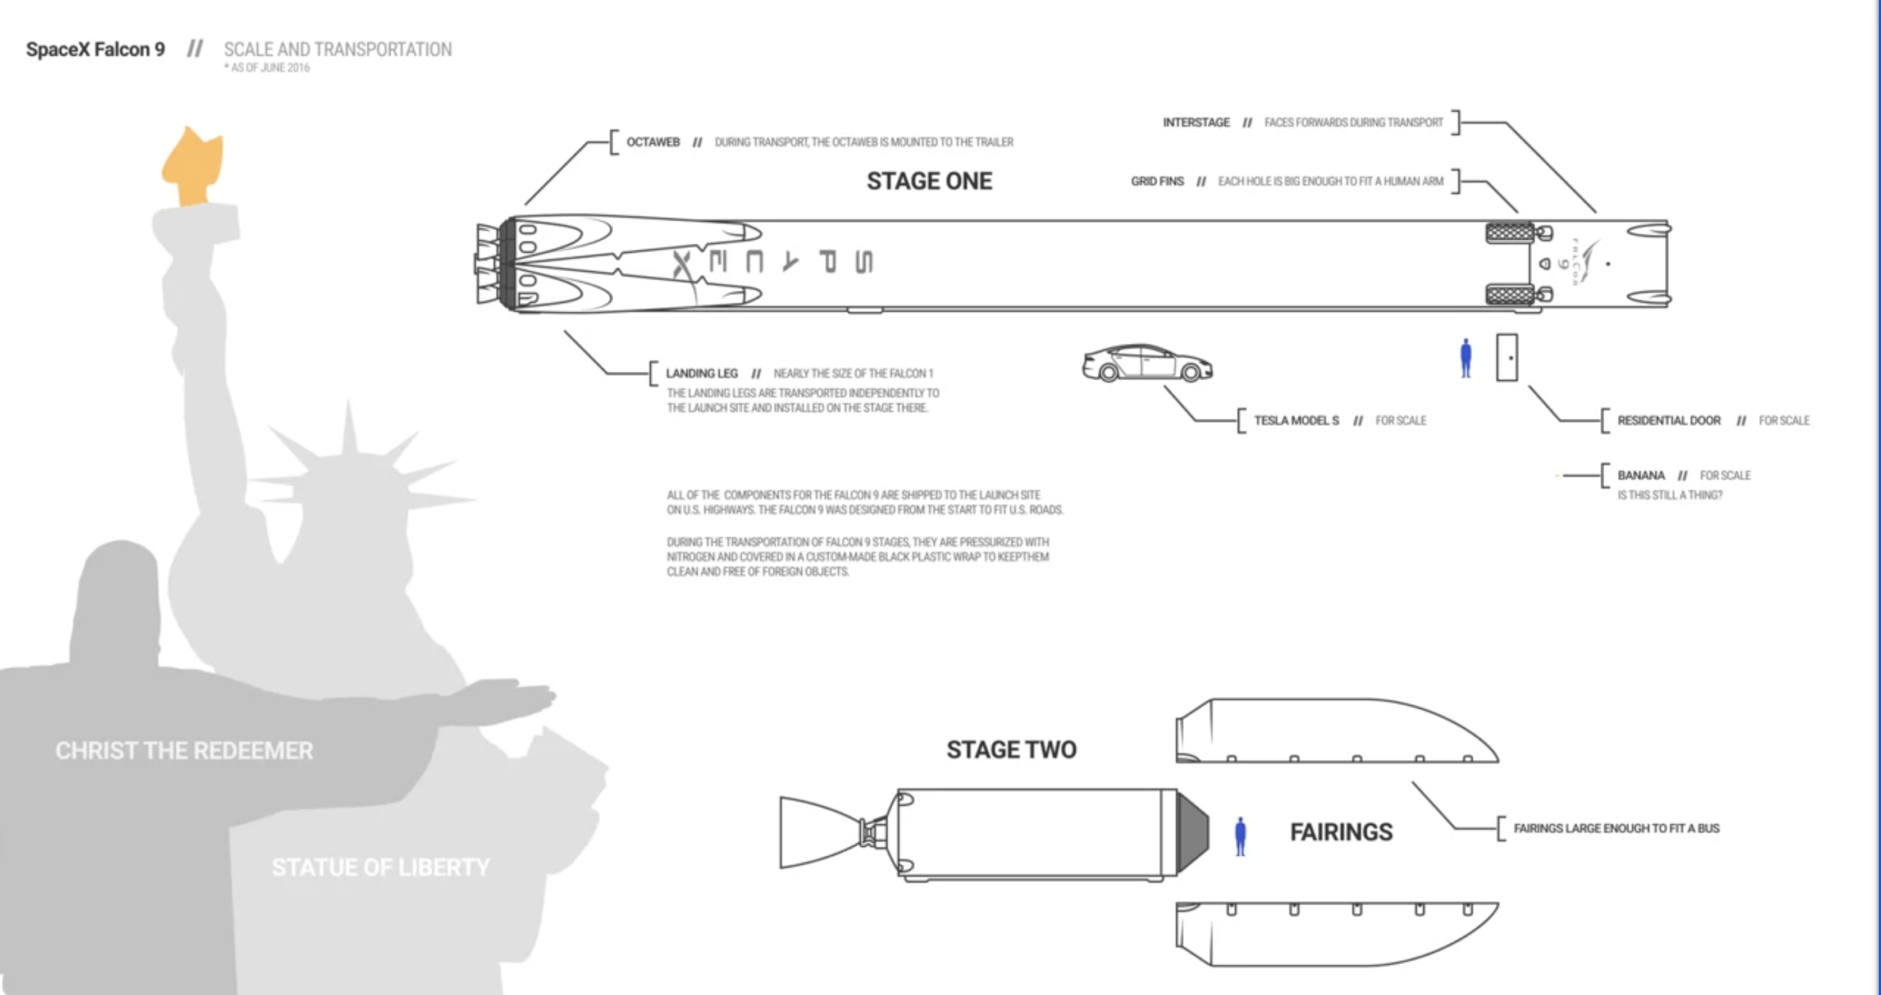

First Stage Recovery
Unlike many other rocket providers, SpaceX can recover the first stage of the Falcon 9 rocket.
However, the first stage does not always land successfully.
Possible outcomes include:
- Successful landing and recovery.
- Crashing during landing.
- Intentional sacrifice of the first stage because of mission requirements.
Mission parameters that may require sacrificing the first stage include:
- Payload requirements
- Target orbit
- Customer requirements

Capstone Project Scenario
In this capstone project, you will take the role of a Data Scientist working for a new rocket company called Space Y.
Space Y aims to compete with SpaceX and is founded by billionaire industrialist Allon Musk.

Project Objectives
Your responsibilities in this project include:

Determine the Price of Each Launch
You will gather information about SpaceX and estimate the cost of each rocket launch.

Create Dashboards
You will create dashboards to help your team understand and analyze launch data.

Predict First Stage Reusability
You will determine whether SpaceX will reuse the first stage of its rockets.
Instead of using rocket science principles to determine whether the first stage will land successfully, you will:
- Gather publicly available data.
- Train a machine learning model.
- Use the model to predict whether the Falcon 9 first stage will be reused.
The ability to predict first-stage recovery is important because it directly influences the cost of a rocket launch.

