Module 1: Data Science and Generative AI

Generative AI and Data Science

Learning Objectives
After studying this topic, we will be able to:
- Describe Generative AI.
- Explain how data scientists use Generative AI in data science.

What is Generative AI?
Generative AI is a subset of artificial intelligence that focuses on producing new data rather than just analyzing existing data.
It allows machines to create content, including:
- Images
- Music
- Language
- Computer code
- Other forms of content
These creations mimic content produced by people.

How Generative AI Operates
Deep learning models like Generative Adversarial Networks (GANs) and Variational Autoencoders (VAEs) are at the foundation of this technique.
These models create new instances that replicate the underlying distribution of the original data by learning patterns from enormous volumes of data.

Applications of Generative AI
Generative AI has found diverse applications across various industries.
Some examples include:
- Natural Language Processing (NLP): OpenAI's GPT-3 can generate human-like text, revolutionizing content creation and chatbots.
- Healthcare: Generative AI can synthesize medical images, aiding in the training of medical professionals.
- Art and Creativity: Generative AI can create unique and visually stunning artworks, generating endless creative visual compositions.
- Game Development: Game developers use Generative AI to generate realistic environments, characters, and game levels.
- Fashion: Generative AI assists in fashion by designing new styles and creating personalized shopping recommendations.

How Data Scientists Use Generative AI

Synthetic Data Generation
Training and testing a model takes lots of data.
Sometimes, the data we want to study does not have enough observations to build a model.
Interest in synthetic data as a tool for analysis and model creation has increased due to recent developments in Generative AI.
Data scientists can augment their datasets using Generative AI to create synthetic data.
It creates this data with similar properties as the real data, such as:
- Distribution
- Clustering
- Many other factors the AI learned about the real dataset
Data scientists can then use the synthetic data along with the real data for model training and testing.

Code Generation for Analytical Models
Data scientists, researchers, and analysts frequently find themselves confined by time when examining data patterns and insights.
Due to this restriction, they can only conceive, develop, and evaluate a small number of hypotheses, leaving many other possibilities untested.
With Generative AI, data scientists can leverage Generative AI to generate and test software code for constructing analytical models.
Coding automation has the potential to revolutionize the field of analytics, allowing the data scientist to focus on higher-level tasks such as:
- Identifying and clarifying the problem the models intend to solve.
- Evaluating hypotheses from a wider range of data sources.

Business Insights and Reporting
Generative AI can generate accurate business insights and comprehensive reports, making it possible to update these insights as the data evolves.
Furthermore, it can autonomously explore data to uncover hidden patterns and insights that might go unnoticed during manual analysis and enhance decision-making.

Real-World Example
IBM's Cognos Analytics, which provides AI-powered automation, enables us to unlock the full potential of our data with the help of its natural language AI assistant.
We describe the question we are looking to answer or the hypothesis we want to test, and it helps generate the insights we need.

Key Takeaways
- Generative AI is a subset of artificial intelligence that focuses on producing new data rather than analyzing existing data.
- It uses deep learning models such as Generative Adversarial Networks (GANs) and Variational Autoencoders (VAEs) to generate new data that follows the patterns of the original dataset.
- Generative AI has applications in natural language processing, healthcare, art, game development, and fashion.
- Data scientists use Generative AI to generate synthetic data for model training and testing when real-world data is limited.
- Generative AI helps automate software code generation for analytical models, allowing data scientists to focus on higher-level analytical tasks.
- It can generate business insights, produce comprehensive reports, and continuously update them as new data becomes available.
- AI-powered tools such as IBM Cognos Analytics assist in exploring data, uncovering hidden patterns, testing hypotheses, and improving decision-making.
- Generative AI augments data science efforts, enabling deeper insights, addressing data limitations, and improving the overall quality of data-driven outcomes.

Expert Viewpoints: How Generative AI Enhances Data Science Workflows

Introduction
In this topic, we explore expert perspectives on how Generative AI (Gen AI) is currently being used to enhance data science workflows. Experts discuss how Gen AI automates repetitive tasks, accelerates development, improves model performance, and supports various stages of the data science lifecycle.

How Generative AI Enhances Data Science Workflows
Generative AI helps streamline data science workflows by automating repetitive tasks.
Some key applications include:
- Creating synthetic data to balance datasets.
- Generating new features to improve model performance.
- Summarizing large documents.
- Translating languages.
- Automating repetitive processes so that data scientists can focus on more critical aspects of projects, such as analysis and decision-making.

Generative AI for Coding Tasks
One of the major applications of Generative AI in data science is assisting with coding tasks.
Certain foundation models (large AI models trained on vast amounts of data that can perform many different tasks) are capable of:
- Writing code.
- Debugging code.
- Translating code.
- Explaining code.
For example, certain models understand Python libraries such as:
- Pandas
- Scikit-learn
As a result, they help accelerate the development of data science scripts.
Instead of starting with a blank Jupyter Notebook from scratch, Generative AI can generate a boilerplate template (a reusable starting template containing the basic project structure) to help us begin quickly.

Data Preparation and Automation
Currently, Generative AI is widely used for numerous data preparation tasks.
These include:
- Generating synthetic data, especially when datasets involve privacy concerns.
- Automating data imputation(statistical process of replacing missing or inconsistent values in a dataset with estimated substitutions).
- Detecting outliers.
- Performing data normalization.

Automated Data Imputation
Generative AI models such as:
- Autoencoders
- GANs (Generative Adversarial Networks)
can generate plausible values for missing or corrupted data.
This eliminates the need for manual imputation techniques.

Popular Generative AI Tools

ChatGPT
When discussing Generative AI, ChatGPT is one of the most widely recognized tools.
It provides valuable assistance by:
- Answering questions.
- Generating code snippets.
- Brainstorming ideas.
- Supporting various technical tasks.

GitHub Copilot
GitHub Copilot is an AI-powered coding assistant developed by GitHub.
It helps by providing:
- Code suggestions.
- Auto-completion.
- Documentation assistance.
Its Visual Studio Code (VS Code) extension includes a chat window that helps us find suitable code solutions for development tasks.

Technical Documentation
Generative AI also accelerates the creation of technical documentation.
It can assist with:
- Cleaning up GitHub repositories.
- Writing one-page documents.
- Preparing playback presentations.
- Creating solution architectures.
By providing reference data, Generative AI can generate these materials much faster than creating them manually.

Feature Engineering
Generative AI supports feature engineering by generating additional features using existing data.
These newly generated features can improve the performance of machine learning models.

Visualization and Reporting
Generative AI helps with:
- Advanced visualizations.
- Report generation.
It enables data scientists to quickly create plots and visualizations without spending excessive time searching documentation or researching suitable visualization techniques on websites such as Stack Overflow.

Rapid Model Prototyping
Generative AI is also used to rapidly prototype machine learning models.
For example:
- We have a problem.
- We have its corresponding dataset.
- We use Generative AI to quickly iterate through multiple algorithms.
- We determine which algorithm is best suited for solving the problem on the available data.
This significantly reduces experimentation time.

Expert Examples of Using Generative AI in Data Science
Experts shared several real-world examples of how they use Generative AI in their daily work.

Data Extraction and Transformation
Generative AI is used throughout the data science workflow, including:
- Data extraction.
- Data transformation.
Since no amount of data is ever enough for every problem, Generative AI helps generate synthetic datasets that match project requirements.

Synthetic Data Generation
Experts have observed Generative AI being used to:
- Generate synthetic data when available data is limited.
- Create datasets tailored to specific problem statements.
- Address privacy concerns while maintaining useful training data.

Automated Report Generation
Generative AI can automatically generate reports from raw data, making it easier to present findings to stakeholders.

Documentation and Code Generation
Generative AI reduces time spent on routine tasks by automating:
- Documentation.
- Code generation.

Research Assistance
Previously, finding suitable research papers required spending considerable time searching platforms such as:
- Google Scholar
- arXiv
With the emergence of Generative AI, researchers now use it to identify the best resources for their research topics more efficiently.

Enterprise Knowledge Chatbots
One expert described implementing company-specific documents into a language model and deploying a chatbot.
As a result:
- Employees no longer spent long hours searching documents.
- They could retrieve specific information directly from a Generative AI-powered chatbot.

Computer Vision Applications
Generative AI is used for image synthesis in computer vision projects.
One example involves detecting manufacturing defects.
Benefits include:
- Expanding training datasets.
- Improving the performance of models that identify faults or irregularities in machines.

Design Optimization
Generative AI can assist in design optimization by:
- Generating new machine component designs.
- Optimizing performance.
- Reducing weight.
- Making materials more efficient.

Financial Services Applications
For financial services clients, Generative AI is extensively used for Natural Language Processing (NLP).
Examples include:
- Sentiment analysis.
- Entity extraction.
- Topic classification.
- Additional NLP tasks using Large Language Models (LLMs).

Document Understanding
Generative AI also supports computer vision-based document understanding.
Examples include:
- Reading bank statements and extracting key topics or values to populate databases.
- Reading Requests for Proposal (RFPs) (formal documents organizations use to request project proposals from vendors) and summarizing key concepts.
- Analyzing tables and graphs to extract key insights.

Machine Learning Code Generation
Generative AI can automatically generate machine learning code.
We simply describe the problem, such as:
- Classification.
- Regression.
- Using Scikit-learn.
- Using a neural network.
Generative AI then generates the complete shell code (the initial project code structure that provides a starting point for development).

Model Metadata
Generative AI is also useful for collecting model metadata (information that describes a machine learning model, such as its configuration, parameters, performance metrics, and training details).

Generative AI Tools for Data Scientists

Overview
Generative Artificial Intelligence (AI) has revolutionized data science by enabling the creation of new data samples that resemble the original dataset. From generating synthetic images to creating realistic text and simulating complex datasets, these tools serve various purposes in the hands of data scientists.
This topic explores the different tasks data scientists perform using generative AI tools, the purposes of these AI tools, and their applications across diverse domains.

Synthetic Data Generation
Tasks
- Creating artificial data samples that mimic real-world datasets.
Tools
- TensorFlow Probability
- PyTorch
- SDV (Synthetic Data Vault)
- GANs (Generative Adversarial Networks)
Purpose and Applications
- TensorFlow Probability and PyTorch enable probabilistic modeling.
- SDV provides a framework for generating synthetic data based on statistical models.
- GANs (Generative Adversarial Networks) are a well-known generative modeling technique that excels in creating realistic data samples.
- These tools are used in healthcare for creating synthetic patient records.
- They are used in finance for creating simulated financial transactions.
- They are also used for training machine learning models when the original data is scarce or sensitive.

Image Generation and Manipulation
Tasks
- Generating synthetic images.
- Modifying visual attributes.
- Creating new designs.
Tools
- StyleGAN
- DALL·E
- BigGAN
Purpose and Applications
- StyleGAN, a specialized implementation and extension of GANs, can create high-quality images.
- DALL·E can create images based on text descriptions.
- BigGAN can generate diverse and realistic images.
- These tools have applications in the art and design, content creation, fashion, and gaming industries.
- They enable the creation of unique images and enhance creative workflows.

Natural Language Generation
Tasks
- Generating human-like text.
- Creating stories, articles, or dialogue.
Tools
- OpenAI's GPT (Generative Pre-Trained Transformer) models
- Hugging Face's Transformers
Purpose and Applications
- GPT models can generate coherent and context-appropriate text.
- Transformers provide flexibility in text generation and fine-tuning specific tasks.
- Data professionals use these tools in:
  - Chatbots
  - Content generation
  - Automated summarization
  - Conversational AI
- These applications are widely used in media, customer service, and content creation.

Music and Audio Synthesis
Tasks
- Generating musical compositions.
- Synthesizing audio samples.
Tools
- Magenta
- Jukebox
- NSynth
Purpose and Applications
- Magenta can generate melodies, harmonies, and musical compositions using deep learning techniques.
- Jukebox can create new songs in various genres.
- NSynth can generate new sounds by combining existing ones.
- Artists use these tools in:
  - Music production
  - Gaming
  - Entertainment
- These tools help create original compositions, sound effects, and adaptive soundtracks.

Simulation and Data Augmentation
Tasks
- Simulating scenarios.
- Augmenting datasets for machine learning models.
Tools
- Unity ML-Agents
- NVIDIA's SimNet
- Augmentor
Purpose and Applications
- Unity ML-Agents can create intelligent agents for simulations.
- SimNet can simulate realistic data.
- Augmentor provides data augmentation techniques.
- Data professionals use these tools in:
  - Robotics
  - Gaming
  - Autonomous vehicles
  - Simulations
- These tools support training AI models and testing algorithms in different environments.

Content Generation
Tasks
- Creating human-like content such as:
  - Text
  - Images
  - Music
Tools
- OpenAI's GPT models
- DeepDream
- StyleGAN
Purpose and Applications
- GPT models excel in generating coherent text.
- DeepDream creates surreal images.
- StyleGAN ensures realistic image generation.
- Content creators use these tools in:
  - Content creation
  - Storytelling
  - Art
  - Entertainment industries

Anomaly Detection
Tasks
- Identifying outliers or anomalies in datasets.
Tools
- Autoencoders
- Isolation Forest
- GANs
Purpose and Applications
- Autoencoders can detect anomalies or outliers in the data.
- Isolation Forest can effectively handle anomaly detection in high-dimensional data.
- GANs can generate normal data distributions.
- Data professionals use these tools to detect:
  - Financial fraud
  - Manufacturing errors
  - Cybersecurity threats

Data Augmentation
Tasks
- Enhancing training datasets by generating variations of existing data.
Tools
- CycleGAN
- Augmentor
- Neural Style Transfer
Purpose and Applications
- CycleGAN can perform image-to-image translation.
- Augmentor can generate augmented images.
- Neural Style Transfer allows the artistic transformation of images based on the style of one image and the content of another.
- Data professionals use these tools in:
  - Computer vision
  - Medical imaging
  - Data augmentation for machine learning models

Human-Computer Interaction
Tasks
- Enabling human-like interactions through:
  - Chatbots
  - Assistants
  - Avatars
Tools
- Dialogflow
- Rasa
- RunwayML
Purpose and Applications
- Dialogflow and Rasa effectively build conversational AI.
- RunwayML is suited for creative coding.
- These tools are used in:
  - Customer service
  - Virtual assistants
  - Gaming industries
- They help enhance the user experience.

Conclusion
Generative AI tools allow data scientists to expand datasets, create new content, and simulate scenarios to push the boundaries of innovation and enable advancements across all industries.
These tools are constantly evolving, allowing data scientists to explore new possibilities and make significant discoveries in the field of artificial intelligence and data science.

Generative AI's Impact Across Industries

Learning Objectives
After studying this topic, we will be able to:
- Summarize the impact of Generative AI across industries.
- List the impact of Generative AI on the following industries:
  - Healthcare
  - Finance
  - Retail
  - Manufacturing
  - Media and Entertainment
  - Education
  - Transportation

Introduction
Generative AI is an impactful branch of Artificial Intelligence that has revolutionized the field of data science by opening up new ways to generate new data, insights, and solutions.
Using deep learning algorithms, data scientists train Generative AI models to create new data that is statistically similar to the original data. This generated data provides valuable insights and helps tackle complex problems across various industries.
The following sections explain the impact of Generative AI on healthcare, finance, retail, manufacturing, media and entertainment, education, and transportation.

Impact of Generative AI on Healthcare
Generative AI models have a significant impact on the healthcare industry because they can help:
- Discover new drugs.
- Analyze medical images.
- Personalize treatment plans.

Drug Discovery
By analyzing the molecular structure of known medications and their impact on biological targets, Generative AI models can predict new drug candidates with the required properties in a much shorter time.

Medical Image Analysis
Generative AI models can analyze medical images such as:
- X-rays
- MRIs (Magnetic Resonance Imaging)
- CT scans (Computed Tomography scans)
These models help detect possible abnormalities and support earlier detection of diseases.

Personalized Treatment
Generative AI models can predict the risk of developing certain diseases by analyzing:
- Lifestyle factors
- Medical history
- Genetic information
This improves the effectiveness of treatment and reduces adverse drug reactions (unwanted or harmful effects caused by medications).

Impact of Generative AI on Finance
The financial industry is embracing Generative AI models to:
- Manage risks.
- Detect fraud.
- Create better investment strategies.

Risk Management
Generative AI models can analyze:
- Market trends
- Historical data
- Economic indicators
They can also simulate various financial scenarios, such as:
- Market crashes
- Economic downturns
These simulations help assess potential risks and develop strategies to minimize losses.

Fraud Detection
Generative AI models can flag potentially fraudulent activities by:
- Analyzing transaction patterns.
- Identifying anomalies (unusual or unexpected patterns).
This helps prevent losses due to fraud.

Investment Strategies
Generative AI models can analyze financial data and investment patterns to help financial advisors recommend personalized and profitable investment portfolios for their clients.

Impact of Generative AI on Retail
The retail industry utilizes Generative AI models to:
- Enhance customer experience.
- Develop products.
- Optimize the supply chain.

Customer Experience
Generative AI models analyze:
- Customer behavior
- Purchase patterns
- Customer feedback
This enables retailers to personalize:
- Product recommendations
- Marketing campaigns
- Customer service interactions

Product Development
Generative AI models identify popular features and styles to help product designers create products that resonate with the target audience.

Supply Chain Optimization
Generative AI can:
- Predict demand patterns.
- Identify potential disruptions.
This capability helps retailers create effective inventory management strategies.

Impact of Generative AI on Manufacturing
The manufacturing industry is leveraging Generative AI models to:
- Optimize production processes.
- Improve product design.
- Enhance quality control.

Production Optimization
Generative AI can simulate various production scenarios and identify bottlenecks (points that slow down production) to help manufacturers:
- Increase production efficiency.
- Reduce waste.
- Minimize downtime.

Product Design
These models help design functional and cost-effective products by analyzing:
- Engineering data
- Material properties
- Manufacturing constraints

Quality Control
Generative AI models help manufacturers enhance quality control by:
- Analyzing product data.
- Identifying defects.
- Predicting potential failures.

Impact of Generative AI on Media and Entertainment
The media and entertainment industry is embracing Generative AI models to:
- Create new forms of content.
- Personalize user experiences.
- Enhance creative workflows.

Content Creation
These models can generate realistic:
- Images
- Videos
- Music
The entertainment industry can use this content in:
- Television shows
- Movies
- Video games

Personalized User Experience
Generative AI models analyze:
- User preferences
- Viewing history
- Demographic data
This helps:
- Recommend personalized content.
- Tailor advertisements.
- Create customized user interfaces.

Creative Assistance
Generative AI models assist:
- Writers
- Artists
- Musicians
They help by:
- Developing new ideas.
- Generating creative variations.
- Exploring uncharted territories in their respective fields.
This enables creators to produce original and engaging content for their audiences.

Impact of Generative AI on Education
The education sector is using Generative AI models to:
- Personalize learning experiences.
- Provide real-time feedback.
- Create adaptive learning materials.

Personalized Learning
Generative AI models analyze student data such as:
- Test scores
- Learning styles
- Individual needs
These models can:
- Create tailored learning plans.
- Recommend appropriate resources.
- Provide personalized feedback.

Real-Time Feedback
Generative AI models can:
- Assess student comprehension.
- Identify areas of difficulty.
- Provide real-time feedback.
This helps students identify their strengths and weaknesses.

Adaptive Learning Materials
Generative AI models can create customized learning materials that adapt to individual learning speeds, helping educators develop adaptive learning materials for their students.

Impact of Generative AI on Transportation
The transportation industry is exploring the potential of Generative AI models to:
- Improve traffic flow.
- Optimize transportation systems.
- Enhance safety.

Traffic Management
Generative AI models can predict traffic patterns based on:
- Historical data
- Real-time traffic sensors
- Weather forecasts
The models help:
- Optimize traffic signals.
- Adjust speed limits.
- Reroute traffic.
These capabilities help reduce traffic congestion.

Transportation System Optimization
Generative AI models analyze transportation networks, including:
- Public transit systems
- Road infrastructure
- Logistics networks
This helps identify potential bottlenecks and suggest improvements.

Transportation Safety
Generative AI models analyze:
- Accident data
- Patterns
- Risk factors
This helps:
- Reduce the number of accidents.
- Improve overall safety in the transportation sector.

Key Takeaways
- Generative AI can tackle complex problems across various industries.
- The healthcare industry uses Generative AI models to discover drugs, diagnose diseases, and personalize treatment plans.
- The financial industry uses these models to manage risks, detect fraud, and create better investment strategies.
- The retail industry utilizes Generative AI models to enhance customer experience, develop products, and optimize the supply chain.
- The manufacturing industry leverages these models to optimize production processes, improve product design, and enhance quality control.
- The media and entertainment industry embraces these models to create new content, personalize user experiences, and enhance creative workflows.
- The education sector uses Generative AI models to personalize learning experiences, provide real-time feedback, and create adaptive learning materials.
- The transportation industry is exploring these models to improve traffic flow, optimize transportation systems, and enhance safety.

Skills Data Professionals Should Develop to Effectively Leverage Generative AI (GenAI)

Introduction
To effectively leverage or use Generative AI (GenAI) in projects, data professionals should focus on developing a combination of technical, analytical, and soft skills. Building expertise across programming, machine learning, deep learning, prompt engineering, AI workflows, deployment, and ethical decision-making enables us to successfully develop and implement AI solutions in real-world projects.

Programming Skills
Programming forms the foundation for working with Generative AI.
- Learn programming languages, especially Python, as it is the best choice for most AI and Data Science-related frameworks.
- Develop proficiency in R, which is also widely used for working with Generative AI tools.

Machine Learning Fundamentals
A strong understanding of Machine Learning is essential before working with Generative AI.
We should develop knowledge of:
- Machine Learning algorithms and how to implement them.
- Regression.
- Classification.
- AI model training.
- Data manipulation.
- Evaluating AI-generated outcomes.
To implement Machine Learning models, we should gain experience with frameworks such as:
- TensorFlow
- PyTorch
- Keras

Mathematical Foundations
Understanding the mathematical concepts behind AI helps us better understand how Generative AI models work.
Important topics include:
- Linear Algebra.
- Matrix Computations.

Deep Learning Foundations
Before learning modern Generative AI models, we should understand the deep learning architectures that paved the way for them.
Key concepts include:
- Recurrent Neural Networks (RNNs)
- Convolutional Neural Networks (CNNs)
- Attention Mechanism
- Natural Language Processing (NLP) concepts

Generative AI Model Architectures
We should become familiar with the major model architectures associated with Generative AI, including:
- Transformers
- Encoder Models
- Decoder Models
- Embeddings (numerical representations of data that capture semantic meaning)
- Diffusion Models
- GANs (Generative Adversarial Networks)
Understanding these architectures provides a solid foundation for learning the complete Generative AI ecosystem.

Understanding How GenAI Works
The first and foremost requirement is understanding how Generative AI works.
We should understand:
- How GenAI is trained.
- What kind of data it is trained on.
- Its strengths.
- Its limitations.
- Where GenAI should be used.
- Where GenAI should not be used.
This knowledge helps us make informed decisions about when and how to apply Generative AI effectively.

Prompt Engineering
Prompt Engineering is one of the most important skills for working with Generative AI.
Each model has different best practices for prompting, so we should learn how to effectively communicate with different AI models to obtain the desired output.
Important Prompt Engineering concepts include:
- Prompt Engineering.
- Few-shot Prompting (providing a few examples within the prompt to guide the model).
- Creating memory for chatbots.
- Chaining prompts using LangChain (a framework for connecting multiple prompts, tools, and AI components into workflows).
As of now, prompt engineering is the primary medium of communication with Generative AI models.
Remember:
With GenAI, it's not about doing, it's about getting your work done.

Advanced AI Workflows
After mastering the fundamentals, we should explore advanced AI techniques, including:
- Retrieval-Augmented Generation (RAG) (combining external knowledge retrieval with AI-generated responses).
- Embeddings.
- Agentic Workflows (AI systems capable of planning and performing tasks autonomously).

Model Fine-Tuning
Develop skills in improving foundation models through various tuning techniques.
Important topics include:
- Prompt Tuning.
- Fine-Tuning.
- PEFT (Parameter-Efficient Fine-Tuning).
- Instruction Tuning of a Base Model.

AI Libraries and Frameworks
Develop practical experience with widely used AI libraries and frameworks, including:
- TensorFlow
- PyTorch
- Keras
- Hugging Face
- Scikit-learn
- LangChain

Data Visualization Skills
Data visualization helps us interpret AI-generated results more effectively.
Useful visualization tools include:
- Matplotlib
- Plotly
- Cmode

Model Deployment
Beyond model development, we should learn how to deploy AI solutions.
Important deployment technologies include:
- Docker
- Kubernetes
- Cloud Platforms

Evaluating AI-Generated Solutions
Data professionals should develop the ability to quickly evaluate:
- AI-generated code.
- AI-generated solutions.
The faster we evaluate outputs, the more iterations we can perform, leading to better and more refined solutions.

Essential Soft Skills
Technical expertise alone is not enough. Successful AI professionals should also develop strong soft skills, including:
- Problem Solving.
- Adaptability.
- Ethical Decision-Making.
These skills play a significant role in implementing AI successfully in real-world applications.

Key Takeaways
To effectively leverage Generative AI in projects, we should develop expertise in the following areas:
- Python and R programming.
- Machine Learning algorithms.
- Linear Algebra and Matrix Computations.
- Deep Learning fundamentals.
- Transformers, Encoder Models, Decoder Models, Embeddings, Diffusion Models, and GANs.
- Understanding how GenAI works, including its strengths and limitations.
- Prompt Engineering and advanced prompting techniques.
- LangChain and chatbot memory creation.
- Retrieval-Augmented Generation (RAG).
- Agentic Workflows.
- Prompt Tuning, Fine-Tuning, PEFT, and Instruction Tuning.
- TensorFlow, PyTorch, Keras, Hugging Face, and Scikit-learn.
- Data Visualization using Matplotlib, Cmode, and Plotly.
- Model deployment using Docker, Kubernetes, and Cloud Platforms.
- Rapid evaluation of AI-generated code and solutions.
- Problem Solving, Adaptability, and Ethical Decision-Making.

Leveraging Generative AI in the Data Science Life Cycle

Learning Objectives
After completing this topic, we will be able to:
- List the five phases of the data science life cycle.
- Discuss how Generative AI provides innovative tools to improve every phase of the data science life cycle.

Introduction
The data science life cycle is a structured approach to delivering knowledge and insights from data. It is a series of interconnected phases that transform raw data into actionable insights.
Generative AI is a branch of artificial intelligence that generates new data. It has proven to be a transformative force in the data science life cycle by providing data scientists with powerful tools to analyze data, uncover hidden insights, and develop innovative solutions.
The data science life cycle comprises the following five phases:
- Problem Definition and Business Understanding
- Data Acquisition and Preparation
- Model Development and Training
- Model Evaluation and Refinement
- Model Deployment and Monitoring
Generative AI has revolutionized the data science life cycle by providing innovative tools to improve every process phase.

Problem Definition and Business Understanding
The Problem Definition and Business Understanding phase involves clearly defining the problem and understanding the business context of the data.
In this phase, Generative AI can:
- Generate new ideas and solutions by mimicking existing product descriptions, marketing campaigns, or successful solutions in other industries.
- Generate synthetic customer profiles (artificially created customer data that resembles real customer characteristics) to understand diverse needs and preferences, informing product development and targeted marketing strategies.
- Simulate economic conditions, competitor actions, and market trends to assess opportunities and potential risks before investing in data gathering or model development.

Real-World Example
A pharmaceutical company uses Generative AI to analyze synthetic patient profiles and generate potential drug targets for rare diseases.

Data Acquisition and Preparation
The Data Acquisition and Preparation phase includes gathering accurate and consistent data from various sources and running preprocessing steps for preparing data for modeling and analysis.
In this phase, Generative AI can:
- Fill in missing values in datasets to improve data quality and model training accuracy.
- Augment data by generating synthetic data points to:
  - Balance skewed datasets.
  - Expand training datasets.
  - Improve model generalizability (the ability of a model to perform well on unseen data) to unseen scenarios.
- Detect anomalies by training generative models on standard data patterns to identify outliers (data points that differ significantly from the rest of the data) and potential security threats in real-time data streams.

Real-World Example
A manufacturing company uses Generative AI to fill in missing sensor data on production lines for predictive maintenance and anomaly detection.

Model Development and Training
The Model Development and Training phase includes selecting and training appropriate machine learning algorithms to generate insights and patterns from the data.
In this phase, Generative AI can:
- Perform feature engineering by generating diverse and representative features to address feature scarcity and improve model performance.
- Explore many hyperparameter combinations and accelerate model optimization efficiently.
- Generate textual explanations or visual representations of complex model predictions, improving interpretability (making model decisions easier to understand) and trust in AI-driven decisions.

Real-World Example
A financial institution uses Generative AI to explore different feature combinations and optimize a fraud detection model with higher accuracy and explainability.

Model Evaluation and Refinement
The Model Evaluation and Refinement phase involves evaluating the performance of trained models to identify areas for improvement and ensure their generalizability.
In this phase, Generative AI can:
- Generate adversarial or edge cases (challenging or unusual test cases designed to expose model weaknesses) to test the model's robustness against malicious attacks or unusual scenarios.
- Train a generative model to mimic model uncertainty, highlighting cases where predictions are unreliable and require further scrutiny.
- Perform counterfactual reasoning (evaluating "what if" scenarios by changing one or more variables) by modeling existing data points to assess the impact of different variables on model predictions and refine decision-making strategies.

Real-World Example
A self-driving car company uses Generative AI to test its models against extreme weather conditions and assess potential risks before real-world deployment.

Model Deployment and Monitoring
The Model Deployment and Monitoring phase includes integrating trained models into real-world applications or systems and continuously monitoring their performance.
In this phase, Generative AI can:
- Continuously monitor real-time data using a generative AI model trained on the initial training data to detect data drift (changes in the statistical properties of incoming data over time) and trigger model retraining when necessary.
- Provide personalized experiences by generating dynamic content or recommendations tailored to individual user preferences or contexts, enriching user experience and engagement.
- Perform A/B testing by generating variations of marketing campaigns or product features and testing them on small subgroups of users before wider rollout, optimizing performance based on real-time feedback.

Real-World Example
A streaming service uses Generative AI to recommend personalized content to each user based on their unique viewing histories and preferences.

Summary
The data science life cycle comprises the following five phases:
- Problem Definition and Business Understanding
- Data Acquisition and Preparation
- Model Development and Training
- Model Evaluation and Refinement
- Model Deployment and Monitoring

How Generative AI Enhances Each Phase
Data Science Life Cycle Phase | How Generative AI Helps
Problem Definition and Business Understanding | Idea generation, customer segmentation, simulation scenarios
Data Acquisition and Preparation | Missing data imputation, data augmentation, anomaly detection
Model Development and Training | Feature engineering, AutoML exploration, hyperparameter tuning, improved interpretability
Model Evaluation and Refinement | Stress testing, uncertainty estimation, counterfactual reasoning (what-if scenario analysis)
Model Deployment and Monitoring | Data drift detection, personalized experiences, A/B testing

Types of Generative AI Models

Learning Objectives
After completing this topic, we will be able to:
- List the four common types of generative AI models.
- Discuss the strengths of each generative AI model.
- Explain the applications of each model in data science.

Introduction
Generative AI models represent a fascinating domain within the field of machine learning. Data scientists can use these models to create new content, including text, images, audio, and other data types.
The four common types of generative AI models are:
- Generative Adversarial Networks (GANs)
- Variational Autoencoders (VAEs)
- Autoregressive Models
- Flow-Based Models
The following sections discuss each model, its strengths, applications, and real-world examples.

Generative Adversarial Networks (GANs)
Generative Adversarial Networks (GANs) are renowned for their ability to imitate and transcend reality.
A GAN consists of two neural networks:
- Generator – Produces increasingly realistic data.
- Discriminator – Distinguishes between real and fake samples.
This process drives the generator to continually refine its outputs, creating remarkably authentic data.

Strengths of GANs
- Generate highly realistic and diverse data that is often indistinguishable from genuine data.
- Generate complex data across multiple modalities, including:
  - Images
  - Videos
  - Music

Applications of GANs
GANs are widely used for:
- Generating new images.
- Editing existing images.
- Enhancing image quality.
- Composing original music.
- Personalizing playlists.
- Generating text.
- Producing creative content.
- Translating languages.
- Summarizing text.
- Data augmentation (expanding limited datasets for training other machine learning models).

Example
StyleGAN is a notable GAN architecture specifically designed for generating high-fidelity images of faces with diverse styles and attributes.

Variational Autoencoders (VAEs)
Variational Autoencoders (VAEs) discover the underlying patterns that govern data organization.
They encode data into a latent representation (a compressed representation that captures the essential characteristics of the original data) and preserve the inherent structure of the original data.
This latent representation serves as the foundation for generating new data samples.

Strengths of VAEs
- Discover the underlying structure of data.
- Generate new samples that follow inherent patterns.
- Efficient and scalable for handling large datasets.
- Effective for anomaly detection by identifying outliers and unexpected patterns.
- Compress datasets without compromising information content.

Applications of VAEs
VAEs are commonly used for:
- Anomaly detection.
- Data compression.
- Collaborative filtering (recommending products, movies, or music based on user preferences).
- Image style transfer (transforming the style of one image into another).

Example
VAEGAN is a hybrid model that combines VAEs and GANs to generate high-quality and diverse images of faces.

Autoregressive Models
Autoregressive models are sequential data champions.
These models excel at handling sequential data such as:
- Text
- Time series
They generate data one element at a time by predicting the next element based on previously generated elements, enabling the creation of coherent and consistent sequences.

Strengths of Autoregressive Models
- Simple and interpretable, making them easier to understand and debug.
- Highly effective for sequential data.
- Produce coherent and grammatically correct sequences.

Applications of Autoregressive Models
Autoregressive models are commonly used for:
- Generating poetry.
- Generating scripts.
- Generating emails.
- Converting text into natural-sounding speech.
- Time series forecasting (predicting future trends and patterns in time-dependent data).
- Machine translation with fluent and accurate language generation.

Example
Generative Pre-trained Transformers (GPTs) are prominent autoregressive models that:
- Generate human-quality text.
- Translate languages.
- Produce diverse creative content.

Flow-Based Models
Flow-based models unveil the probability landscape of data.
These models directly model the probability distribution (the mathematical representation of how data values are distributed) of data, enabling efficient sampling and generation.
They transform complex data into more straightforward representations while generating new data that follows the original probability distribution.

Strengths of Flow-Based Models
- Directly model probability distributions.
- Enable efficient sampling and data generation.
- Offer flexible and adaptable architectures that can be tailored to specific data characteristics and task requirements.

Applications of Flow-Based Models
Flow-based models are widely used for:
- Generating high-quality images with realistic details and textures.
- Simulating synthetic data.
- Identifying unusual patterns in data distribution that may indicate fraudulent activity.
- Density estimation (estimating the probability density function to gain insights into data distribution).

Example
RealNVP is a well-known flow-based model that generates high-quality images of human faces.

Summary
The four common generative AI models are:
Model | Major Strengths | Common Applications | Example
Generative Adversarial Networks (GANs) | Highly realistic and diverse data generation | Image generation, image editing, image enhancement, music generation, text generation, language translation, text summarization, data augmentation | StyleGAN
Variational Autoencoders (VAEs) | Discover underlying data structure, scalable, efficient, anomaly detection, data compression | Anomaly detection, data compression, collaborative filtering, image style transfer | VAEGAN
Autoregressive Models | Effective for sequential data, simple, interpretable | Text generation, speech synthesis, time series forecasting, machine translation | Generative Pre-trained Transformers (GPTs)
Flow-Based Models | Direct probability modeling, efficient sampling, flexible architecture | Image generation, synthetic data generation, anomaly detection, density estimation | RealNVP

Key Takeaways
- Generative AI models create new content such as text, images, audio, and other data types.
- GANs excel at image, music, and text generation, as well as data augmentation.
- VAEs are effective for anomaly detection, data compression, collaborative filtering, and style transfer.
- Autoregressive models are well suited for text generation, speech synthesis, time series forecasting, and machine translation.
- Flow-based models are suitable for image generation, synthetic data generation, anomaly detection, and density estimation.

Guide to Choosing a Generative AI Model Type

Types of Generative AI Models
Model | Key Features | Applications
Generative Adversarial Networks (GANs) | - Two competing neural networks: generator and discriminator.  - The generator learns to create realistic data, while the discriminator learns to distinguish real from fake.  - The adversarial training process continuously improves both networks.  - Can be challenging to train and achieve stable results. | - Image generation: faces, landscapes, objects  - Text generation: poems, code, scripts  - Video generation: realistic videos, animation  - Drug discovery: generate molecules with intended properties  - Music generation: composing new songs
Variational Autoencoders (VAEs) | - Encode input data into a lower-dimensional latent space.  - Learn a probability distribution over the latent space.  - Decode samples from the latent space to generate new data points.  - Focus on learning a meaningful representation of the data. | - Image compression: efficiently stores and transmits images  - Anomaly detection: identify unusual data points  - Dimensionality reduction: compress high-dimensional data  - Text summarization: generate concise summaries of text documents
Autoregressive Models | - Generate data point by point, conditioned on previously generated points.  - Use recurrent neural networks (RNNs) or transformers to capture long-term dependencies.  - Can be computationally expensive for long sequences. | - Text generation: realistic and coherent text sequences  - Music generation: generating music that follows genre and style  - Time series forecasting: predicting future values of a time series  - Image inpainting: filling in missing parts of an image
Diffusion Models | - Start with simple noise and gradually de-noise it into realistic data.  - Use a U-Net architecture (a neural network architecture designed for image segmentation and generation) with skip connections (connections that preserve important information by bypassing intermediate layers).  - Can be more stable and easier to train than GANs, but often slower. | - Image generation: high-quality and diverse images  - Text generation: coherent and grammatically correct text  - Audio generation: realistic and musical audio  - Inpainting and denoising: improving the quality of images or audio
Flow-based Models | - Transform a simple distribution (Gaussian (a normal probability distribution)) into a complex one using invertible transformations (transformations that can be reversed without losing information).  - Learn the parameters of these transformations from the data.  - Can be efficient and accurate for high-dimensional data, but training can be challenging. | - Image generation: realistic and diverse images  - Density estimation: modeling the probability distribution of data  - Dimensionality reduction: compress high-dimensional data  - Anomaly detection: identify unusual data points

Comparison of Models on Different Considerations
Feature | GANs | VAEs | Autoregressive Models | Diffusion Models | Flow-based Models
Data Type | Images, text, audio | Images, text, continuous data | Images, text, sequences | Images, text | Images, continuous data
Task Objective | High-fidelity generation, data augmentation | Encoding/decoding, representation learning | Sequence generation, text-to-image translation | Image generation, editing, inpainting | Image generation, conditional generation
Quality of Samples | High-fidelity, diverse | Often blurry, less realistic | Sharp, high-resolution | High-fidelity, diverse | High-fidelity, controllable
Control over Generation | Limited | Moderate | High | Moderate | High
Training Complexity | High | Moderate | High | Moderate | High
Interpretability | Low | Moderate | High | Moderate | Low

Case Study: Successful Implementation of Generative AI

Introduction
StreamCraft, a rapidly growing online streaming platform, faced a critical challenge: user engagement was plateauing. Traditional recommendation engines struggled to break through the "filter bubble" (a situation in which users repeatedly receive similar content based on their previous preferences), thereby offering predictable content and failing to entice viewers to explore new genres or hidden gems.
To address this challenge, StreamCraft decided to integrate Generative AI (GAI) into its data science workflow at every stage of the content discovery process.

Data Ingestion and Preprocessing

Text Analysis with Generative Pre-trained Transformers (GPTs)
GPTs were used to analyze movie descriptions, reviews, and social media mentions, extracting hidden semantic relationships and identifying emotional tones. This enriched metadata, allowing StreamCraft to categorize content beyond genre labels while capturing nuanced themes and moods.

Automatic Genre and Subgenre Tagging
GPTs further enabled the creation of dynamic genre tags that evolved with the content landscape. This allowed StreamCraft to identify emerging trends and niche subgenres, catering to specific viewer preferences.

AI-Powered Anomaly Detection
StreamCraft employed GAI to identify and flag unusual patterns in user behavior and content engagement. This facilitated proactive intervention against fraudulent activity or potential technical glitches, ensuring a smooth user experience.

Feature Engineering and Model Training

Generative Adversarial Networks (GANs)
Generative Adversarial Networks (GANs) were used to create synthetic user profiles, mimicking the behavior of actual viewers with specific interests. This expanded the training data, enabling the recommendation engine to learn from a wider range of preferences and make more accurate predictions.

Counterfactual Reasoning
GAI models were trained to predict what users would watch under hypothetical scenarios, simulating their response to different content offerings. This allowed StreamCraft to test various recommendation strategies and optimize content placement without impacting real users.

Explainable AI (XAI) for Model Interpretability
StreamCraft implemented Explainable AI (XAI) techniques to understand the reasoning behind the recommendations generated by their GAI models. This enhanced transparency, allowing for trust-building with users and enabling targeted improvements to the recommendation system.

Deployment and Monitoring

Adaptive Content Recommendations
StreamCraft's GAI-powered engine delivered dynamic, context-aware recommendations, adapting to real-time user behavior and external factors such as trending topics or seasonal events. This personalized experience kept viewers engaged and encouraged exploration beyond their usual preferences.

A/B Testing with Generative Models
GAI facilitated rapid testing of different recommendation algorithms and content layouts. StreamCraft could generate multiple versions of its user interface and test them with simulated user data, identifying the most effective layouts and content combinations before deploying them to real users.

Continuous Feedback Loop
StreamCraft incorporated user feedback into its GAI models, allowing the system to learn and adapt over time. This ensured the recommendations remained relevant and user-centric, creating a virtuous cycle of improved engagement and retention.

Conclusion
StreamCraft's GAI implementation resulted in a significant increase in user engagement:
- Viewership time per user grew by 25%.
- Discovery of new content genres increased by 30%.
- The platform experienced a 15% reduction in churn (the percentage of users who stopped using it), indicating a stronger relationship with its viewers.
This success story showcases the transformative potential of Generative AI (GAI) in the online streaming industry, paving the way for personalized, dynamic, and ultimately more engaging experiences for viewers.

Explore a Simple Generative Tool

Learning Objectives
After completing these exercises, we will be able to:
- Sign up for the DataRobot platform.
- Add a dataset to a use case.
- Build and explore machine learning models using DataRobot.

Introduction
Generative AI tools simplify many aspects of data science and machine learning by automating data preparation, model building, prediction, and analysis. In this topic, we explore the DataRobot platform to understand how automated machine learning (AutoML) can streamline the model development workflow.

Exercise 1: Sign Up in DataRobot

Step
- Sign up for the DataRobot platform.
Note: DataRobot requires a work email address for registration. Alternatively, we can create a GitHub account using a Gmail address and use GitHub credentials to sign in to DataRobot. Also, we can choose the Sign in with Google method to sign in to the platform.
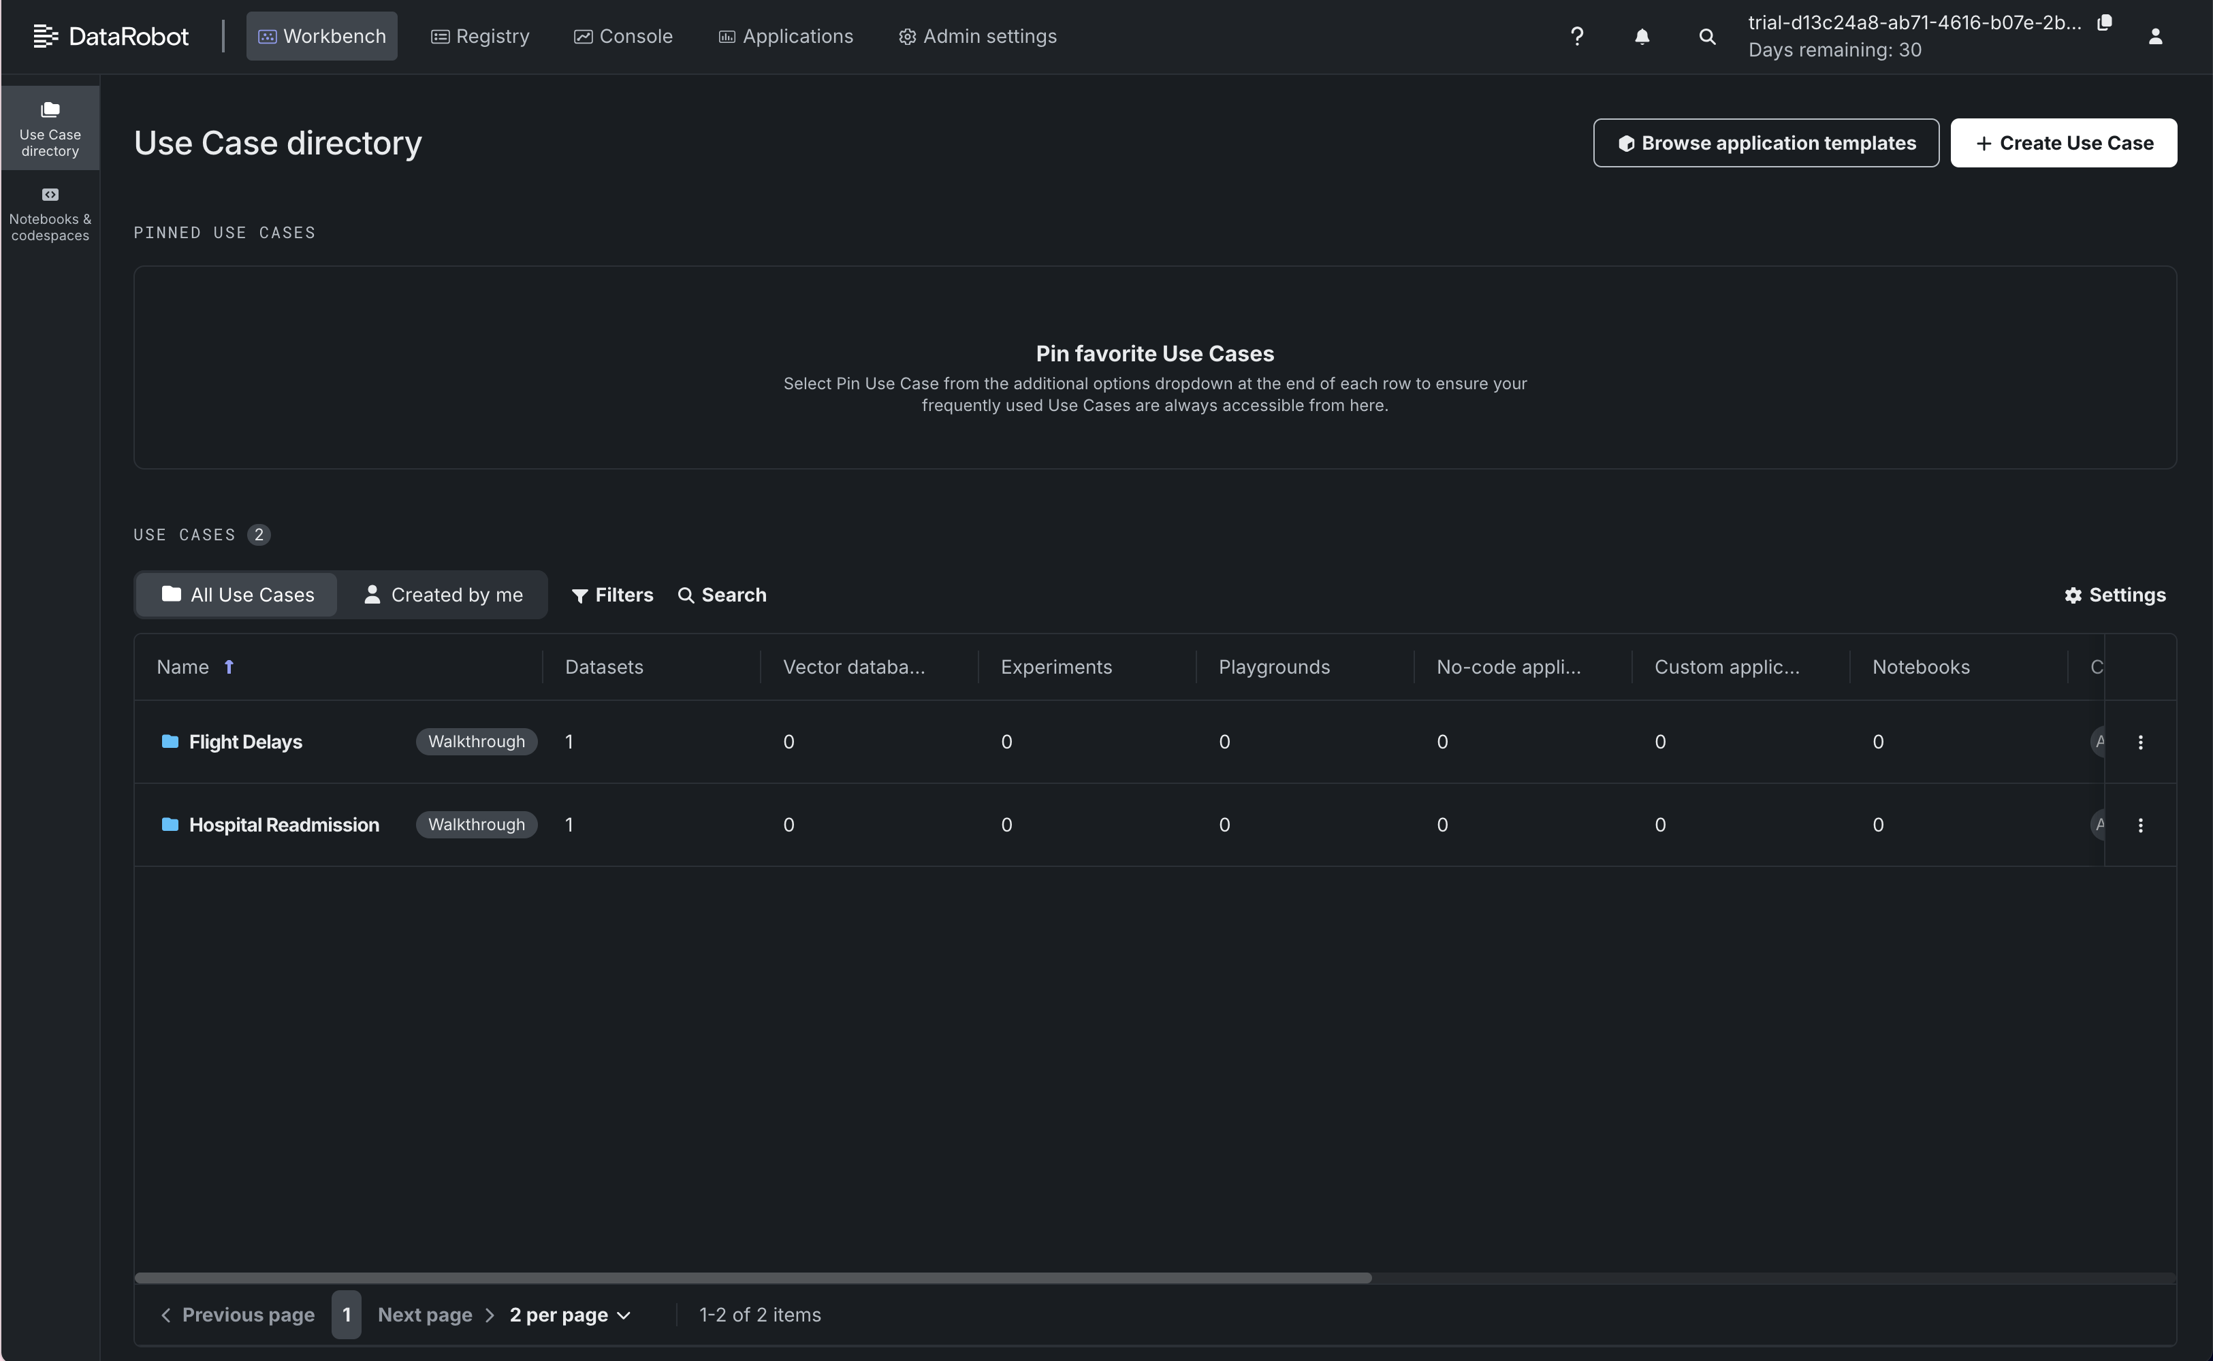

Exercise 2: Add a Dataset
In this exercise, we create a new use case and add a dataset for model development.

Steps
- Open Workbench.
- Create a new Use Case.
- Browse the available datasets.
- Select the sample dataset HOSPITAL_READMISSION_DATA.
- Preview the dataset and its features.
- Add the dataset to the use case.
- Explore the dataset features using the All Features menu.
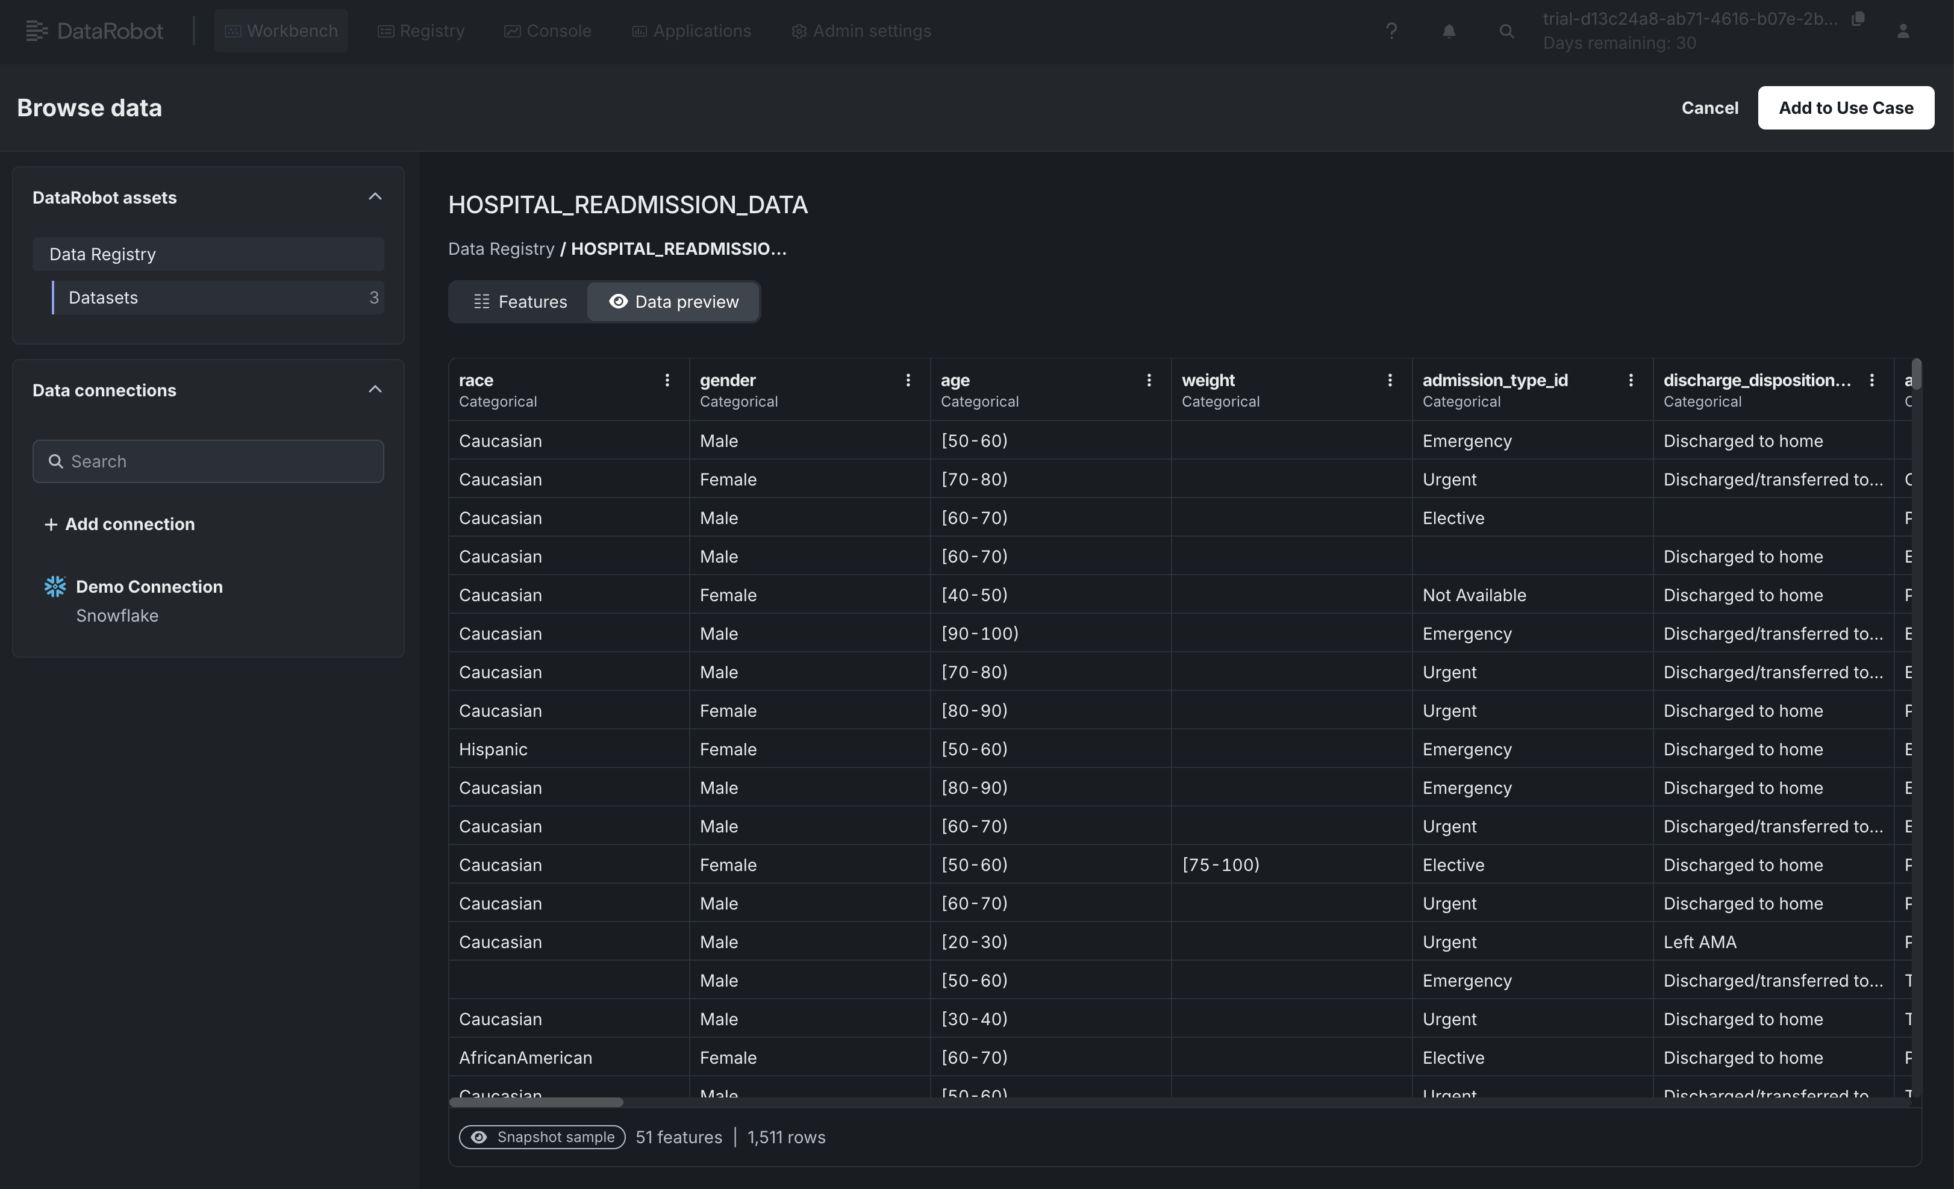
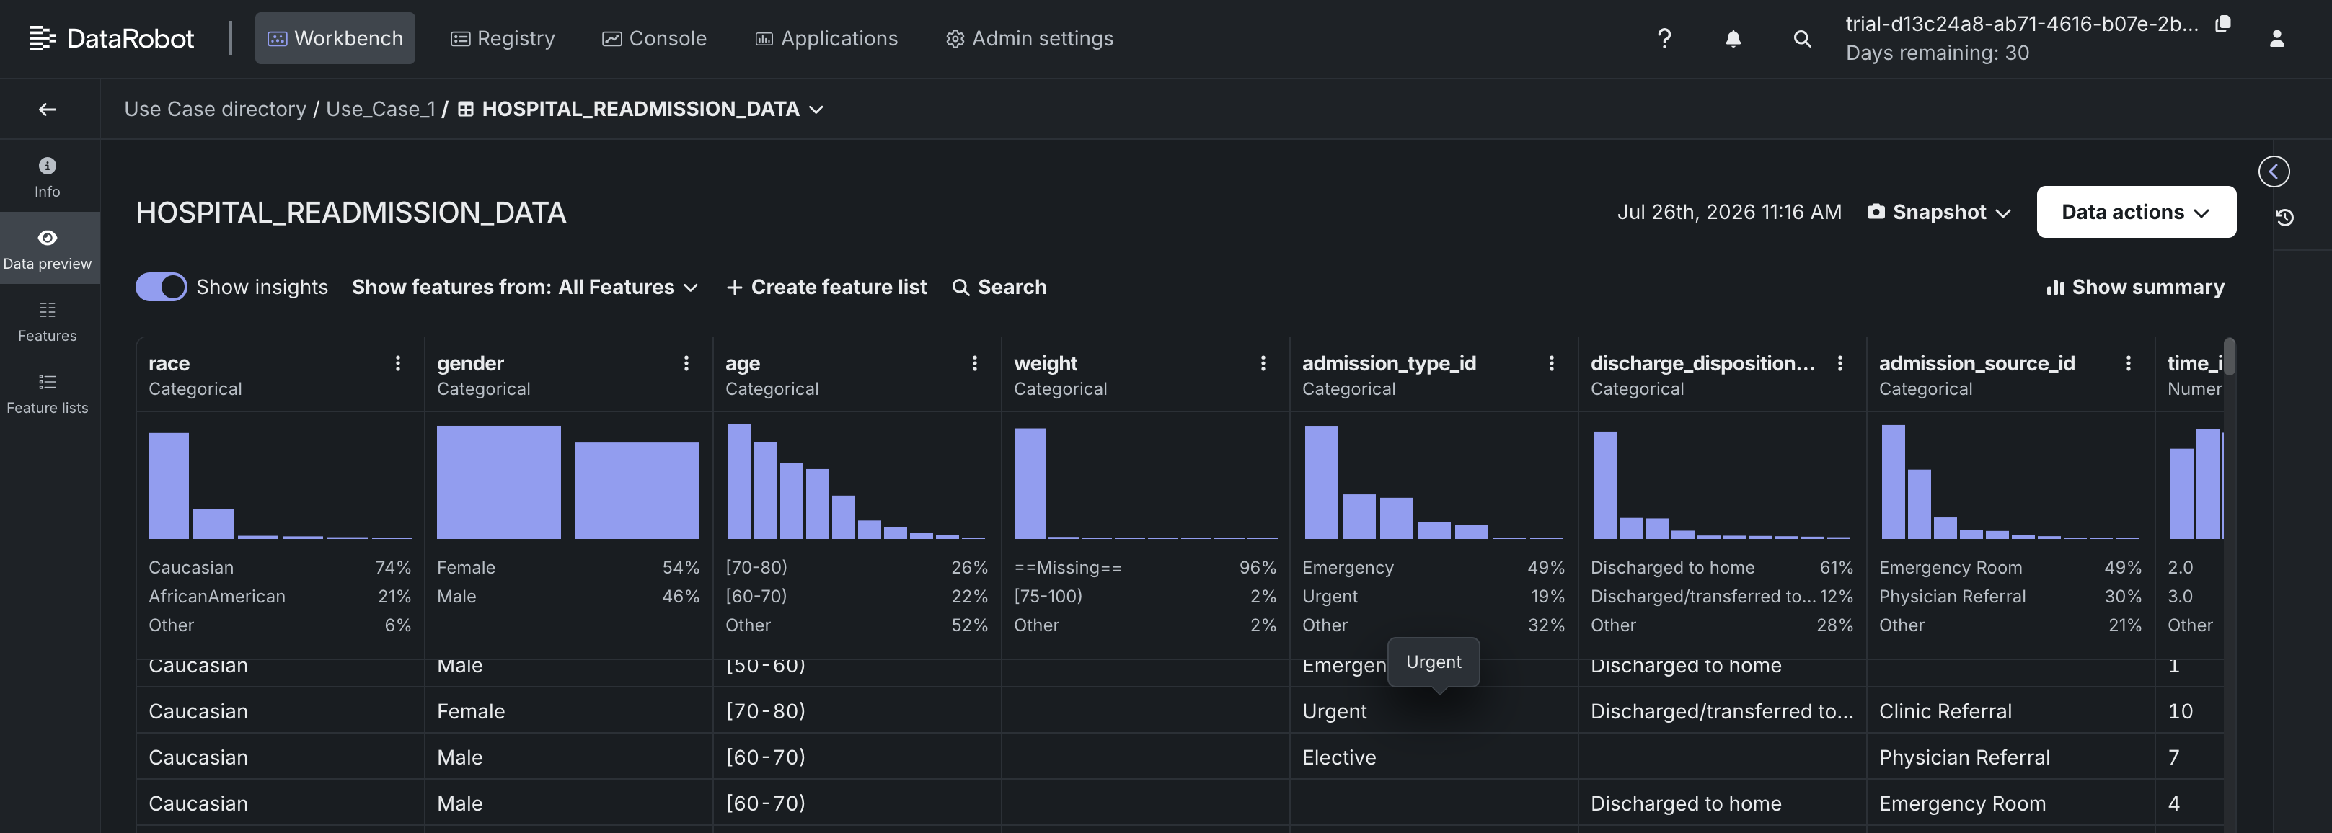

Exercise 3: Work on Data Modeling
In this exercise, we build a machine learning model using the uploaded dataset and explore the generated results. 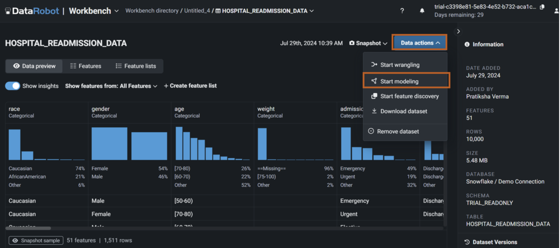
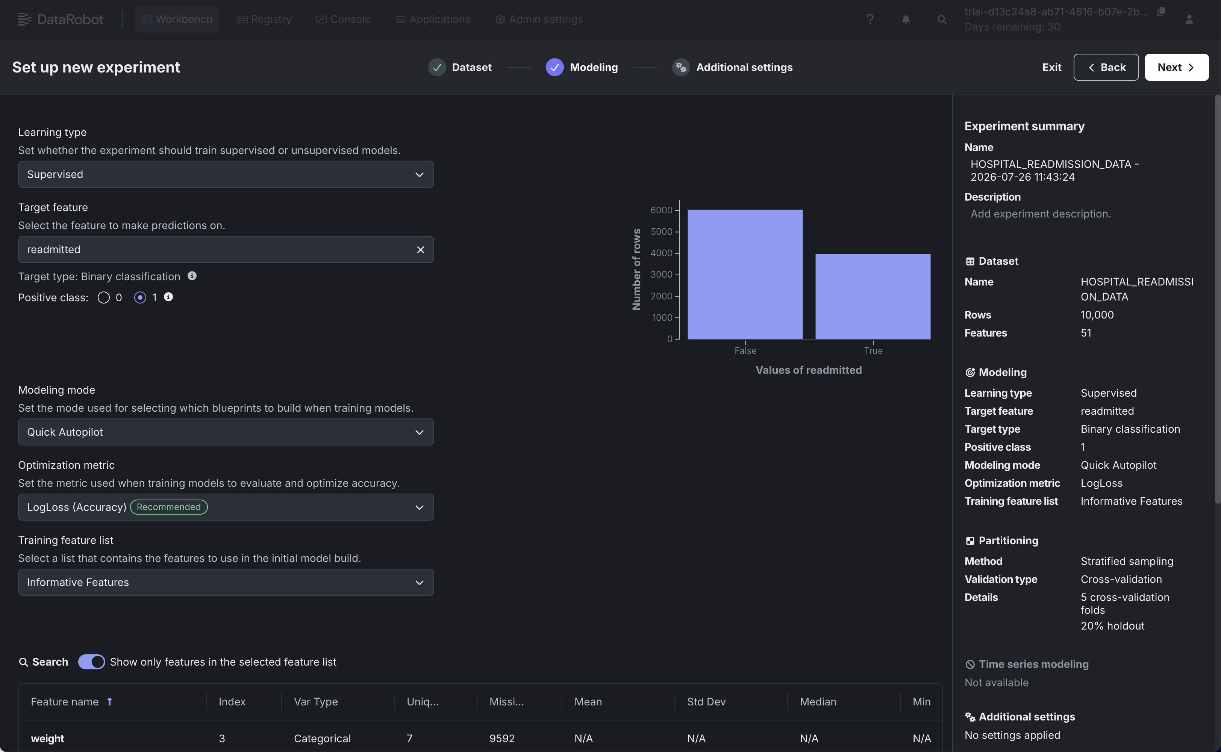

Steps
- Select Modeling from Data Actions.
- Prepare the dataset for modeling.
- Select readmitted as the target feature.
- Configure additional model settings if required.
- Start the modeling process.
- Review the generated models after training is complete.
- Explore the Model Overview, including:
  - Blueprint
  - Feature Impact
  - Other model insights
- Generate predictions using unseen or test data.
- Generate and download the compliance report for the selected model.
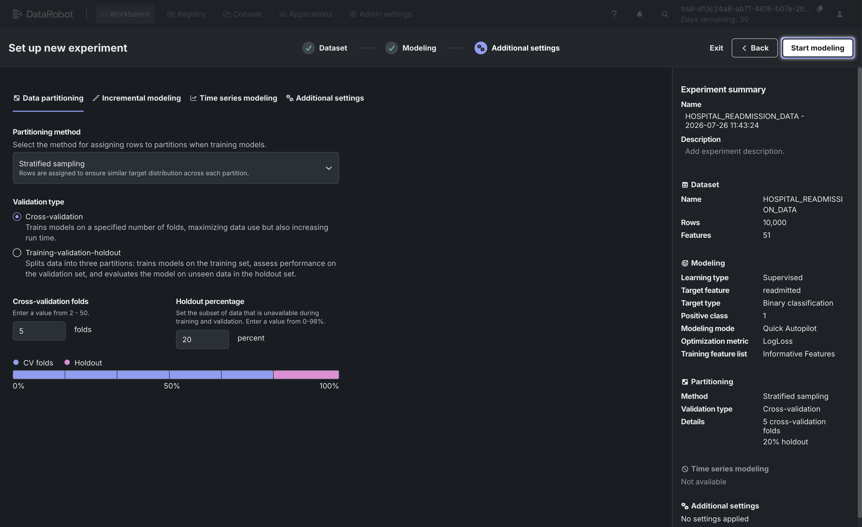
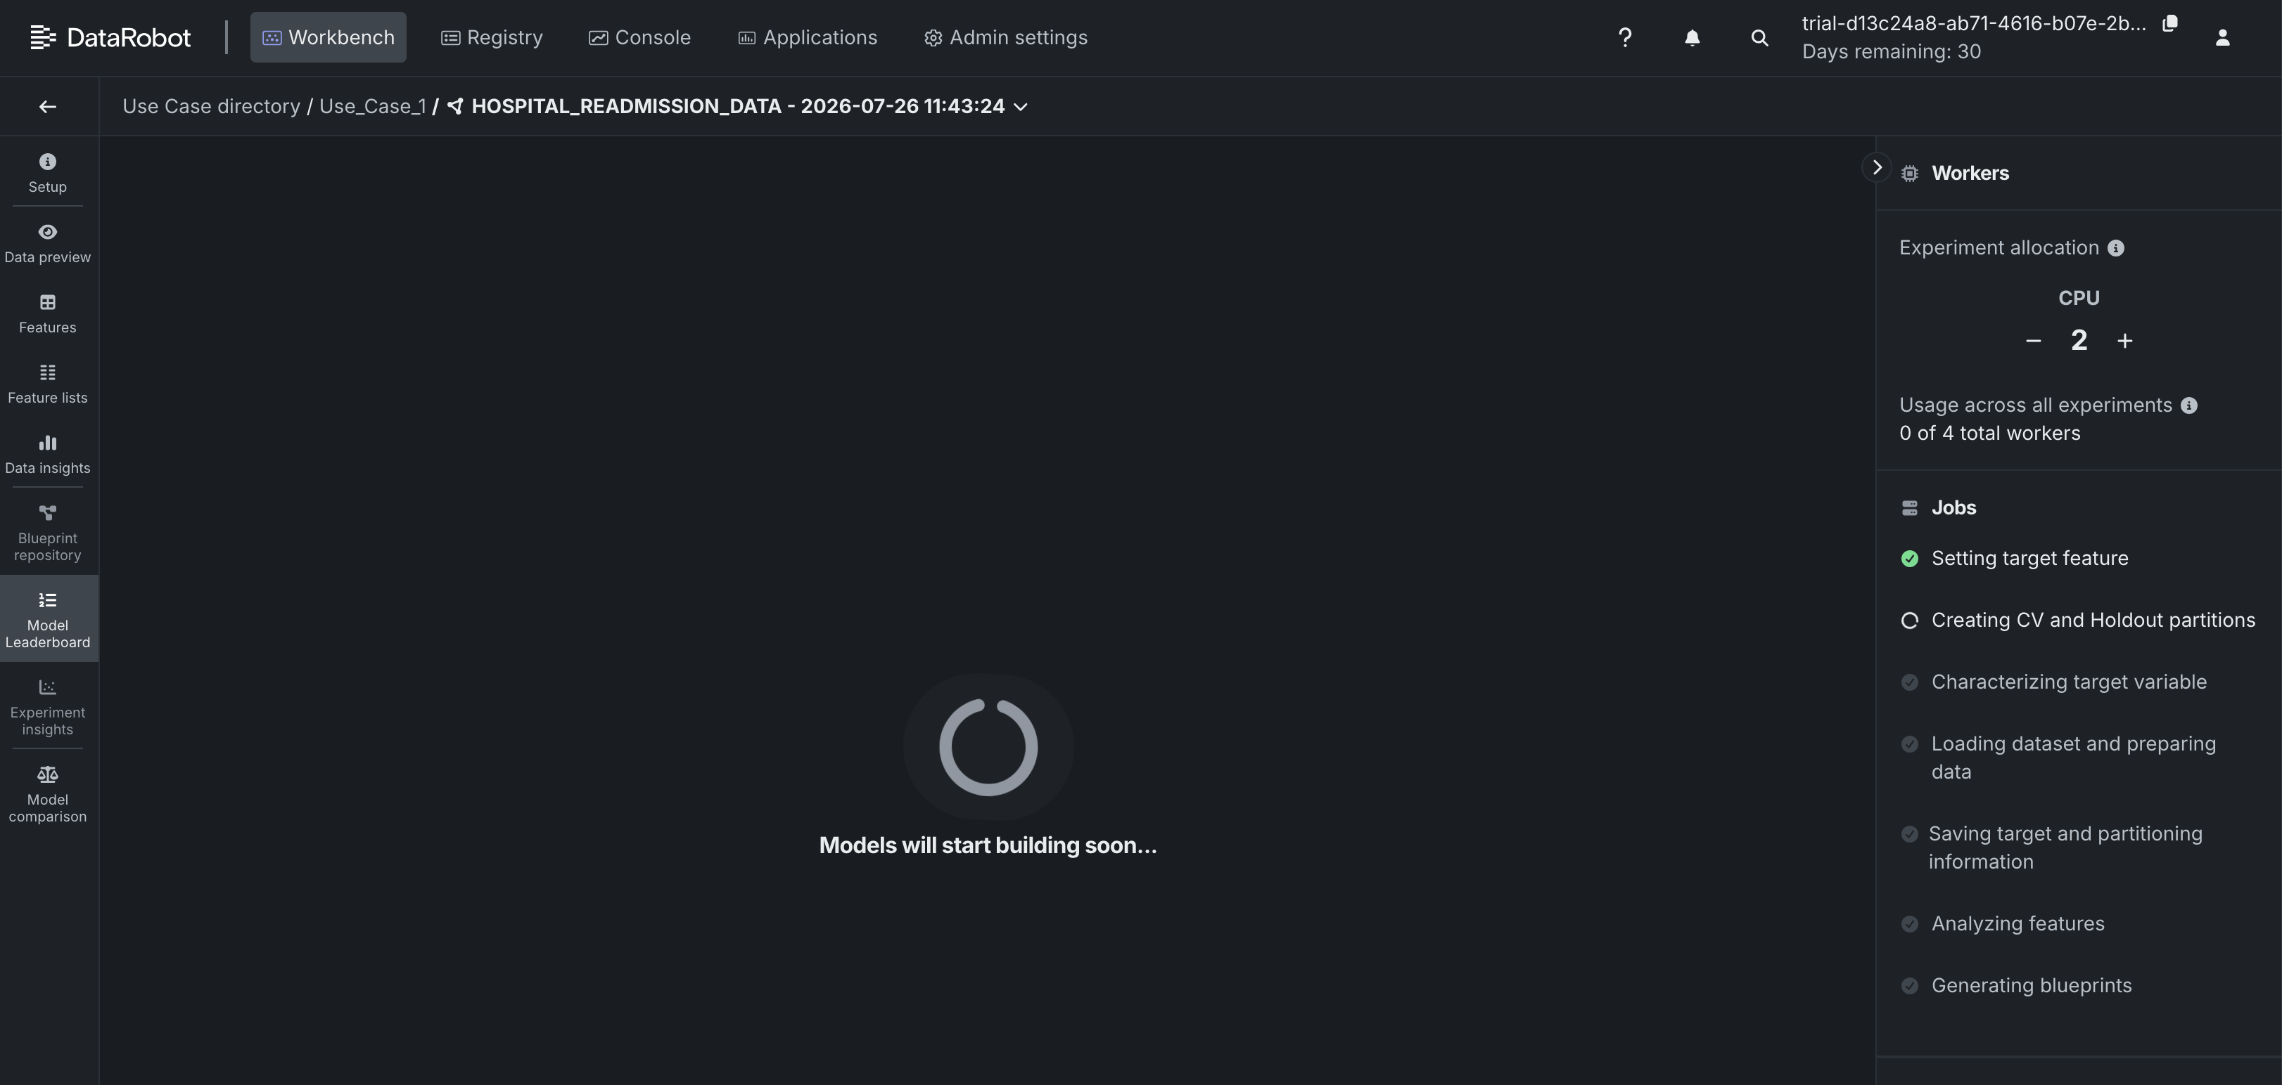

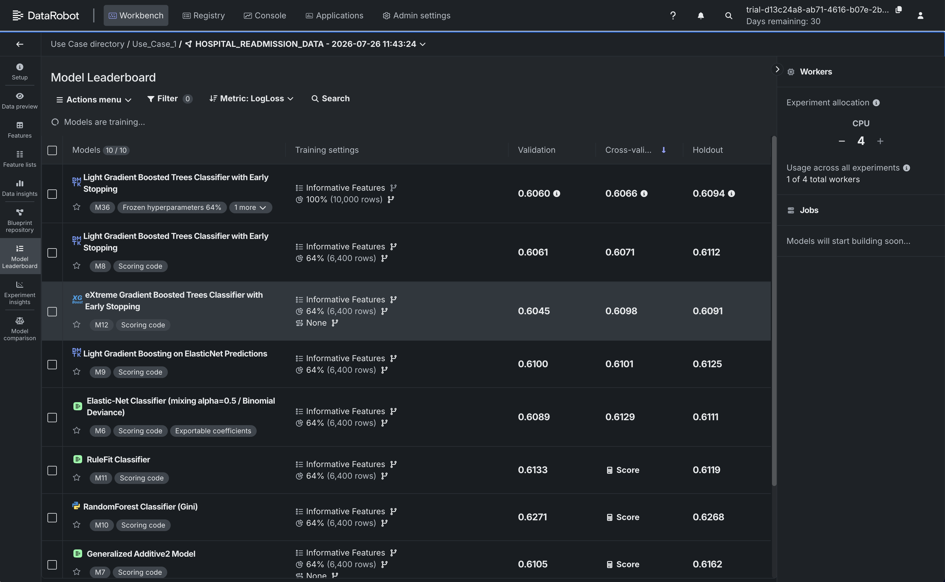

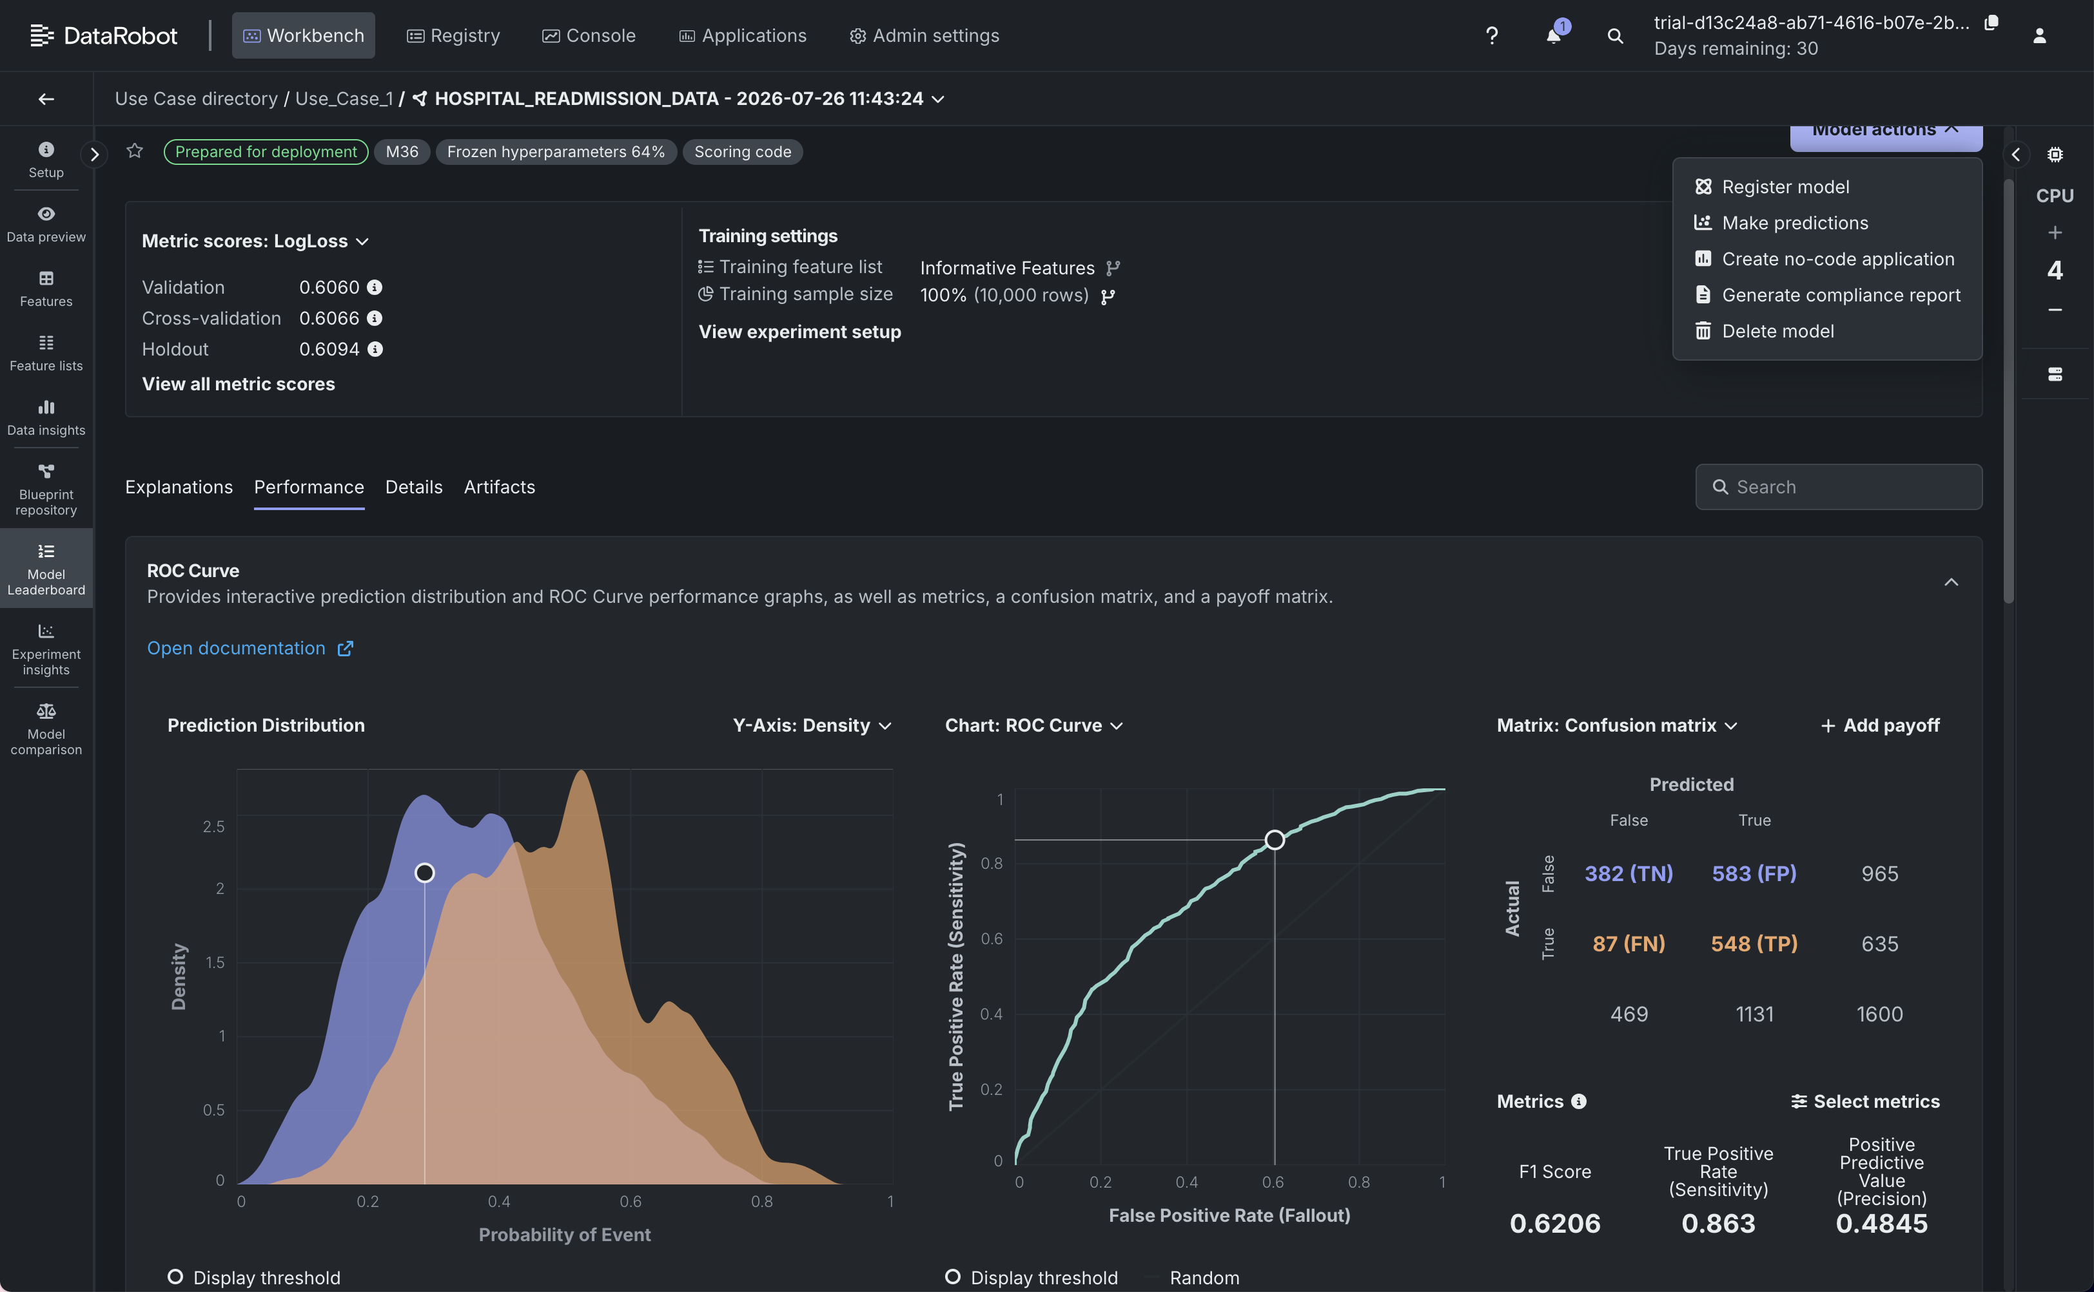
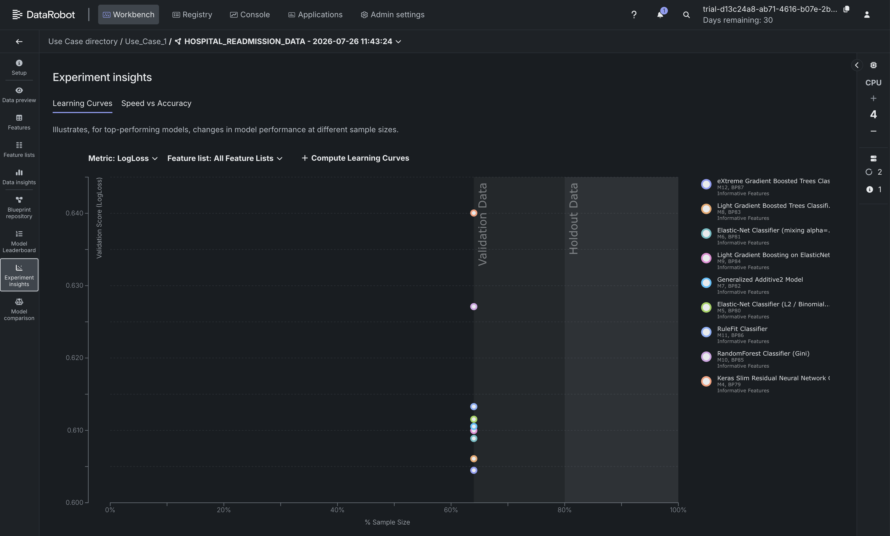

Summary
These exercises demonstrated the basic workflow of using DataRobot for automated machine learning. We explored how to:
- Create a DataRobot account.
- Create a new use case.
- Add a dataset.
- Build machine learning models.
- Analyze model insights.
- Generate predictions.
- Produce compliance reports using the DataRobot platform.

Generative AI Tools for Data Scientists

Overview
Generative AI provides a wide range of tools that help data scientists automate repetitive tasks, improve productivity, accelerate machine learning workflows, and focus on higher-level problem-solving. These tools can be broadly categorized into open-source tools and proprietary tools.

Claude AI by Anthropic
One of the recommended generative AI tools is Claude AI by Anthropic. It can be used for a variety of data science and programming tasks, including:
- Understanding and debugging code found on Stack Overflow or in repositories shared by peers.
- Creating sample synthetic data for experimenting with new data science models.
- Automating repetitive tasks, such as extracting only a few email addresses from a list of 100 emails in just a few seconds.

Categories of Generative AI Tools
There are two types of tools that we can use:
- Open-source tools
- Proprietary tools

Open-Source Generative AI Tools

Hugging Face Transformers
Hugging Face Transformers offers a wide variety of libraries of pre-trained models for:
- Text generation
- Translation
- Summarization
- Building applications powered by large language models (LLMs)
It supports models such as:
- OpenAI's ChatGPT
- LLaMA
- Mistral

Databricks with GenAI
Databricks provides many AI and data science products, including:
- Vector Search
- AutoML (Automated Machine Learning)

LangChain
LangChain helps build pipelines for text-based workflows, including:
- Summarization
- Retrieval-Augmented Generation (RAG) (a technique that combines information retrieval with large language models to generate more accurate and context-aware responses)

Hugging Face Datasets
Hugging Face Datasets is useful for:
- Data processing
- Data labeling

Label Studio
Label Studio is a tool used for data labeling and annotation.

DAML (Data Annotation for Machine Learning)
DAML stands for Data Annotation for Machine Learning and is useful for data processing and labeling tasks.

Albumentations
Albumentations is an open-source library commonly used for:
- Data augmentation (techniques used to increase the diversity of training data by creating modified versions of existing data)

Pandas Profiling
Pandas Profiling is useful for:
- Exploratory Data Analysis (EDA) (the process of analyzing datasets to summarize their main characteristics before building models)

TensorFlow
TensorFlow is essential for:
- Machine learning model development
- Model evaluation
- Model monitoring

PyTorch
PyTorch is widely used for:
- Machine learning modeling
- Model evaluation
- Model monitoring

MLflow
MLflow is essential for:
- Managing machine learning workflows
- Evaluating models
- Monitoring machine learning models

Proprietary Generative AI Tools

OpenAI GPT Models
OpenAI's GPT models are useful for:
- Generating insights from unstructured data
- Writing code
- Automating various data science tasks

ChatGPT
OpenAI's ChatGPT is described as a powerhouse for generating human-like text and can be fine-tuned for specific tasks.

Microsoft Copilot
Microsoft Copilot is very helpful for:
- Coding
- Productivity tasks
- Integrating with GitHub
- Assisting in writing code
- Assisting in documentation

GitHub Copilot
GitHub Copilot is recommended as a coding assistant because it:
- Helps develop applications
- Is trained on a diverse and large set of programming languages
- Integrates well with IDEs such as Visual Studio Code (VS Code)

IBM watsonx Code Assistant
IBM watsonx Code Assistant is recommended because it:
- Supports multiple programming languages
- Integrates well with IDEs such as VS Code
- Assists developers in writing code efficiently

Tableau GPT
Tableau GPT integrates generative AI to:
- Automatically create dashboards
- Suggest visualizations based on user queries

Power BI Copilot
Power BI Copilot leverages AI to:
- Build interactive visualizations directly from text prompts

DataRobot
DataRobot provides:
- Automated model building
- AI-powered feature impact analysis
- AI-driven insights

Cloud-Based AI Platforms
Cloud providers also offer proprietary AI platforms for machine learning development, including:
- Microsoft Azure Machine Learning Studio
- Google's Vertex AI
- AWS SageMaker

Additional AI Tools

Google's BOT Model
Google's BOT model is widely used for:
- Natural Language Processing (NLP)

HTU.ai
HTU.ai is an AutoML tool that integrates generative AI to:
- Speed up the model training process
- Assist with model fine-tuning

Key Takeaways
Generative AI tools help data scientists:
- Understand and debug code more efficiently.
- Generate synthetic data for experimentation.
- Automate repetitive tasks.
- Build applications using large language models.
- Perform data processing and data labeling.
- Conduct data augmentation and exploratory data analysis.
- Develop, evaluate, and monitor machine learning models.
- Build dashboards and interactive visualizations.
- Improve coding productivity with AI-powered coding assistants.
- Accelerate model training and fine-tuning using AutoML.
- Focus more on higher-level tasks by reducing manual effort.

Generative AI as a Useful Tool for Data Generation and Augmentation

Learning Objectives
After completing this topic, we will be able to:
- Explain how Generative AI is a useful tool for data generation and augmentation.
- Generate synthetic data using a Generative AI-based tool.
- Augment data using a Generative AI-based tool.

Introduction
Data augmentation is a powerful technique for improving the performance of machine learning models, especially when the training datasets are small or imbalanced.
It is the process of artificially increasing the size of a training dataset by creating modified data from the existing one.
Since data can be categorized into three categories—structured data, semi-structured data, and unstructured data—there are many ways to generate these categories of data or augment them.
Generative AI provides several tools that can be leveraged for data generation and augmentation across these different data types.

Generative AI for Different Types of Data

Structured Data
Structured data, often saved in tabular formats, serves as a foundation for many machine learning systems.
CTGAN (Conditional Generative Adversarial Network) and Synthetic Data Vault (SDV) are examples of Generative AI techniques that excel in augmenting structured datasets.
These tools generate synthetic data that mimics the statistical traits and correlations seen in the original data.
They are especially useful for:
- Handling data imbalances.
- Filling missing values.
- Addressing privacy problems.

Semi-Structured Data
Semi-structured data, such as text and code, poses unique challenges for data augmentation.
Generative AI tools such as GPT and Copilot can effectively augment semi-structured datasets by generating realistic text descriptions and code snippets.
This enhances the performance of machine learning models in:
- Natural Language Processing (NLP).
- Code generation tasks.

Unstructured Data
Unstructured data, including images and audio, is often difficult to augment because of its inherent complexity.
Generative AI tools such as StyleGAN2 and BigGAN have demonstrated remarkable capabilities in augmenting image datasets by generating high-resolution, realistic images.
Generative AI can also augment audio datasets by synthesizing new audio samples. An example is SoundGAN by NVIDIA.

Data Generation Using Universal Data
The Universal Data website can be used to generate synthetic datasets.
Website:
generate.universaldata.io

Example Prompt
Patient dataset for the symptoms of diabetes
The process is as follows:
- Type the prompt.
- Skip specifying the fields (optional).
- Generate the data.
- Wait for the prompt to be processed.
- View the generated dataset.
- Copy or download the generated data.
- Selecting Download saves the dataset as a CSV file.
Generative AI tools may have different ways of creating datasets. Some may be efficient, while others may require additional work.
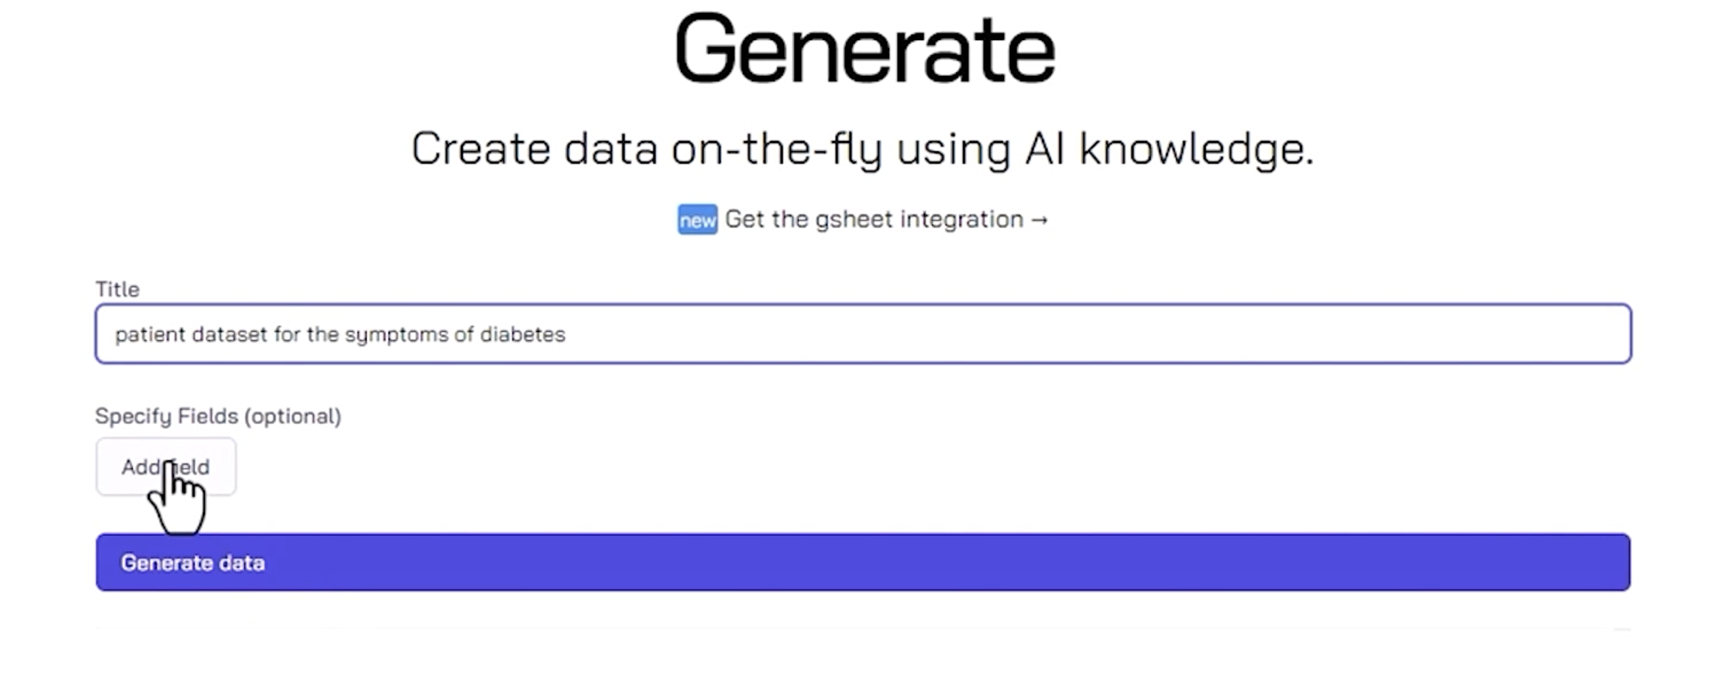

Data Generation Using ChatGPT
Another approach is to use ChatGPT, available free of charge, while specifying the required dataset attributes.

Example Prompt
Create a dataset with attributes as temperature in Fahrenheit, temperature category, humidity in percentage, wind speed in miles per hour, wind direction, visibility, windchill, precipitation, fog, rain, and snow as categorical type in yes or no categories, month, year, and specify the data has to be created for 100 observations in a CSV format.
After submitting the prompt:
- A sample dataset is generated.
- We can modify the values and attributes according to our needs.
- We can copy the generated code and run it in a Jupyter Notebook.
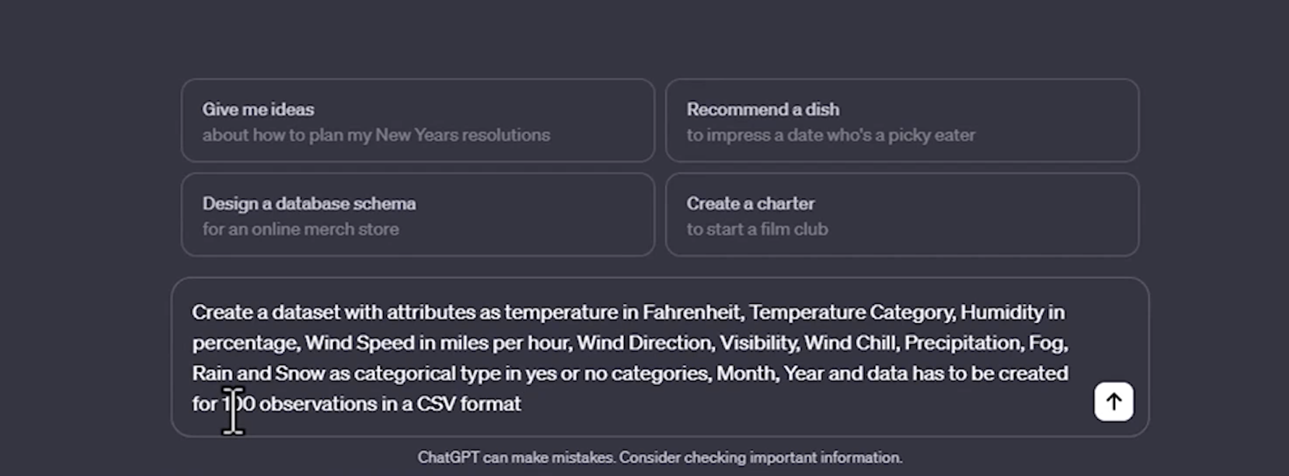

Data Generation Using BARD
The same prompt can also be used with BARD.
Website:
bard.google.com
Steps:
- Open a new session.
- Submit the same prompt.
- Review the generated dataset.
- Review the additional draft versions generated by the tool.
- Copy the generated data for further use.
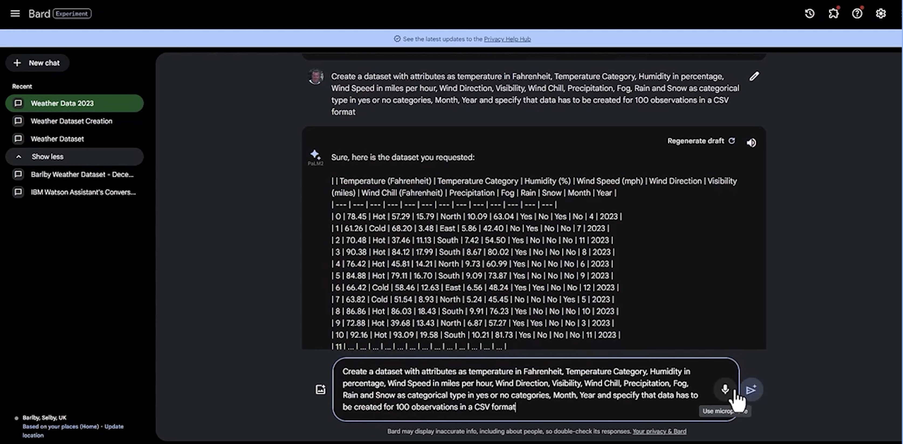

Data Generation Using MostlyAI
Another approach is to upload an existing dataset and generate synthetic data.
Website:
synthetic.mostly.ai

Steps
- Open the Upload Files tab.
- Upload the Daily Car Sales dataset.
- Click Proceed.
- Select a training goal.
Available training goals include:
- Accuracy
- Speed
- Turbo
Each option prioritizes one objective over another, causing the training size and the number of training epochs to change accordingly.
Next:
- Click Create Synthetic Dataset.
- Wait while the training epochs are executed.
- The job status changes from Pending to In Progress.
- Select the status link to monitor progress.
- Once completed, review the augmented dataset.
The generated dataset contains the same number of samples as the original dataset.
The synthetic dataset can then be downloaded and used for model training.
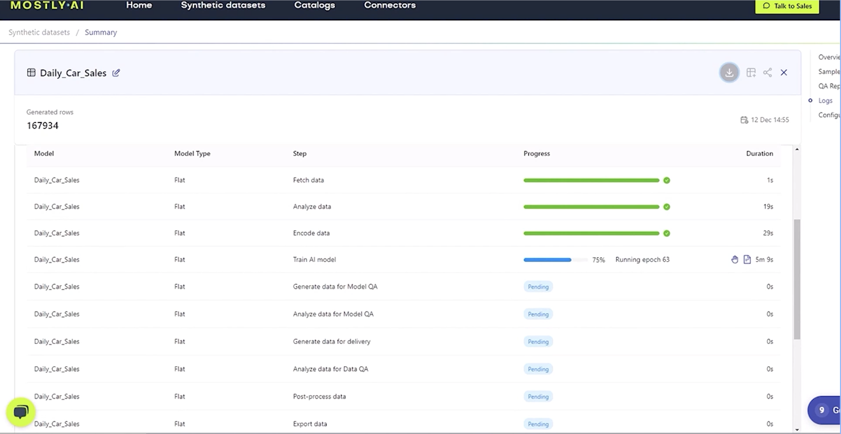

Data Generation Using CTGAN in Google Colaboratory
Another method is to generate synthetic data programmatically.
Website:
collab.research.google.com

Dataset Used
For this demonstration, we use the sample dataset:
- CaliforniaHousingTrain.csv
The dataset can be accessed from:
- Files
- Sample Data

Steps
- Install the CTGAN module.
- Install Table Evaluator.
- Import the sample CSV file into the notebook using Pandas.
- Import the CTGAN library.
- Fit the CTGAN model on the dataset.
- If the dataset contains categorical features, pass them as a list to the fit() function.
- Run the training process for 200 epochs.
- Save the generated samples.
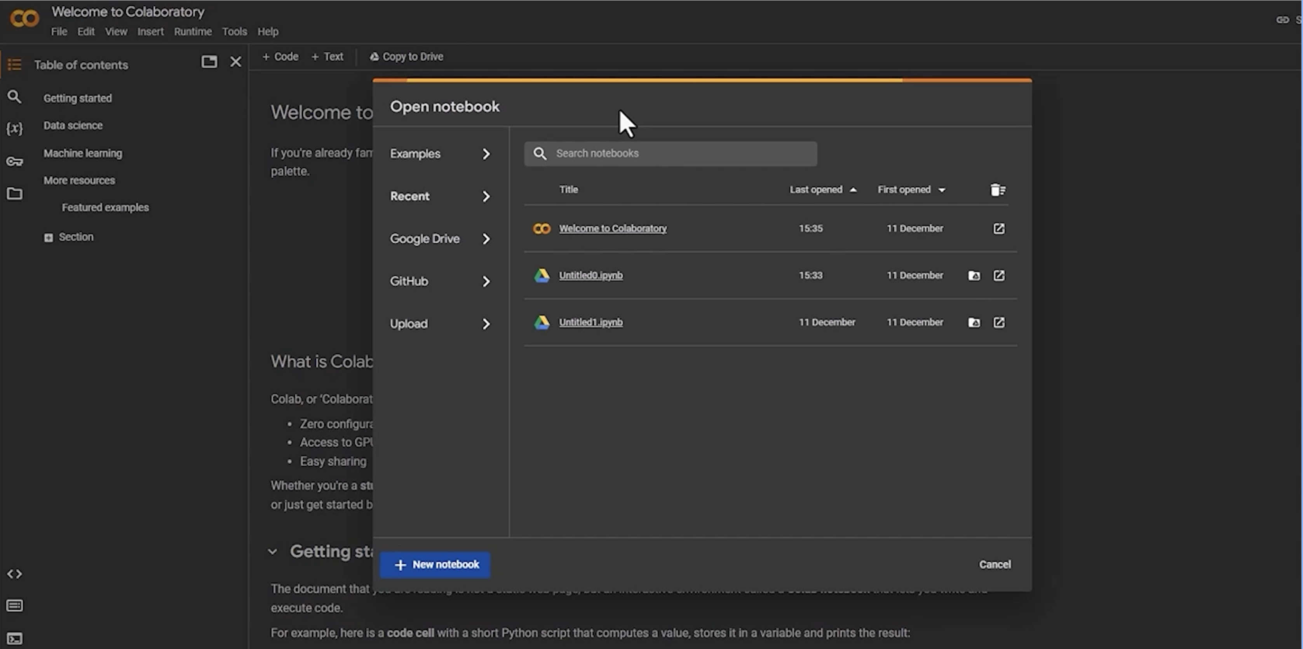
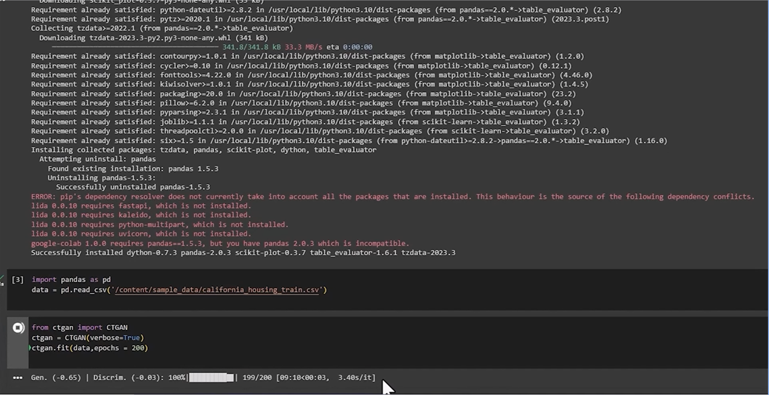

Evaluating the Generated Data
To evaluate how closely the generated data matches the original data:
- Import Table Evaluator.
- Print the shapes of the original dataset and the generated dataset.
- Compare the fake data with the original data.
- Generate evaluation visualizations.
The evaluation visualizations show that the generated synthetic data is fairly similar to the original real data.
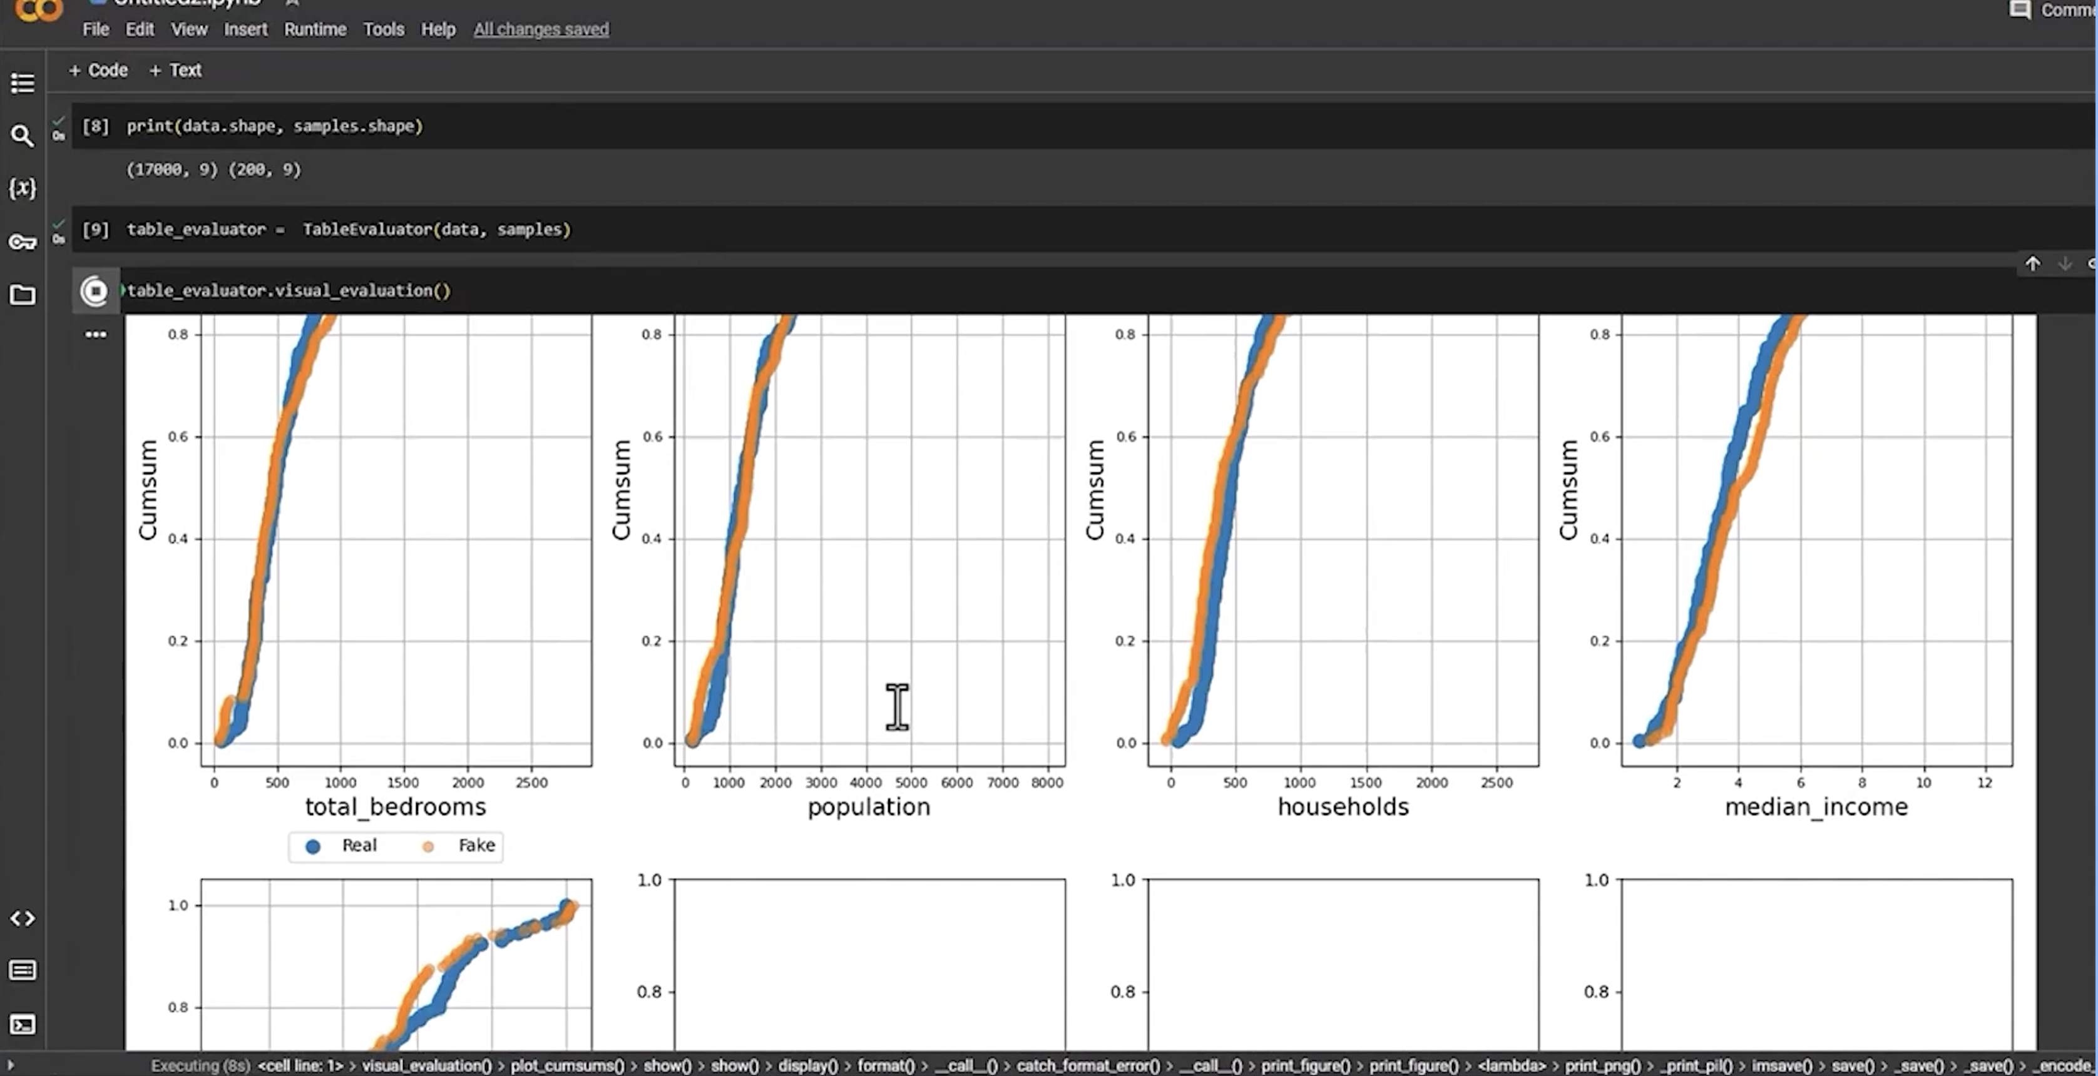

Key Takeaways
- Data augmentation is the process of artificially increasing the size of a training dataset by creating modified data from existing data.
- CTGAN and Synthetic Data Vault (SDV) are Generative AI techniques that excel in augmenting structured datasets.
- GPT and Copilot effectively augment semi-structured datasets by generating realistic text and code.
- StyleGAN2 and BigGAN augment image datasets by generating realistic, high-resolution images.
- SoundGAN by NVIDIA synthesizes new audio samples for augmenting audio datasets.
- Generative AI tools can generate synthetic datasets that help address data imbalance, missing values, and privacy concerns while improving machine learning model performance.

Generative AI for Data Generation and Augmentation

Learning Objectives
After completing these exercises, we will be able to:
- Understand the concept of synthetic data generation using Generative AI.
- Use tools such as iLoveCSV and Tonic Fabricate to generate synthetic data.
- Augment an existing CSV dataset while preserving its statistical characteristics.
- Explore how Generative AI enhances datasets for analysis, modeling, and other downstream data science tasks.

Introduction
One of the major advantages of Generative AI is its ability to generate realistic synthetic data. Synthetic data is created using pretrained generative models that generate new data samples or perform transfer learning on existing datasets.
These synthetic samples preserve the statistical distribution and interpretability of the original data while increasing the dataset size for machine learning and data analysis tasks.
In this topic, we explore how Generative AI can generate synthetic data samples and augment an existing dataset using two different tools.

Insurance Dataset Overview
The exercises use an Insurance Dataset containing insurance records. This dataset is a cleaned version of the original dataset, where errors, missing values, and inconsistencies have already been removed to ensure data quality.

Exercise 1: Data Augmentation Using iLoveCSV
The iLoveCSV tool provides a graphical interface for generating synthetic data while preserving the statistical properties of the original dataset.

Procedure
- Open the iLoveCSV website.
- Create an account or sign in.
- Upload the Insurance Dataset.
- Open the Data Augmentation tool under the AI and Machine Learning section.

Data Augmentation
Statistical augmentation generates synthetic rows based on the existing dataset while maintaining its statistical characteristics.
- Set the Augmentation Factor according to the required dataset size (for example, 1×).
- Execute the augmentation process.
- Download the generated synthetic dataset.
Note:
Using a 1× augmentation factor doubles the dataset size. For example, the resulting dataset contains 2,676 rows, providing additional synthetic samples suitable for data science and machine learning applications.
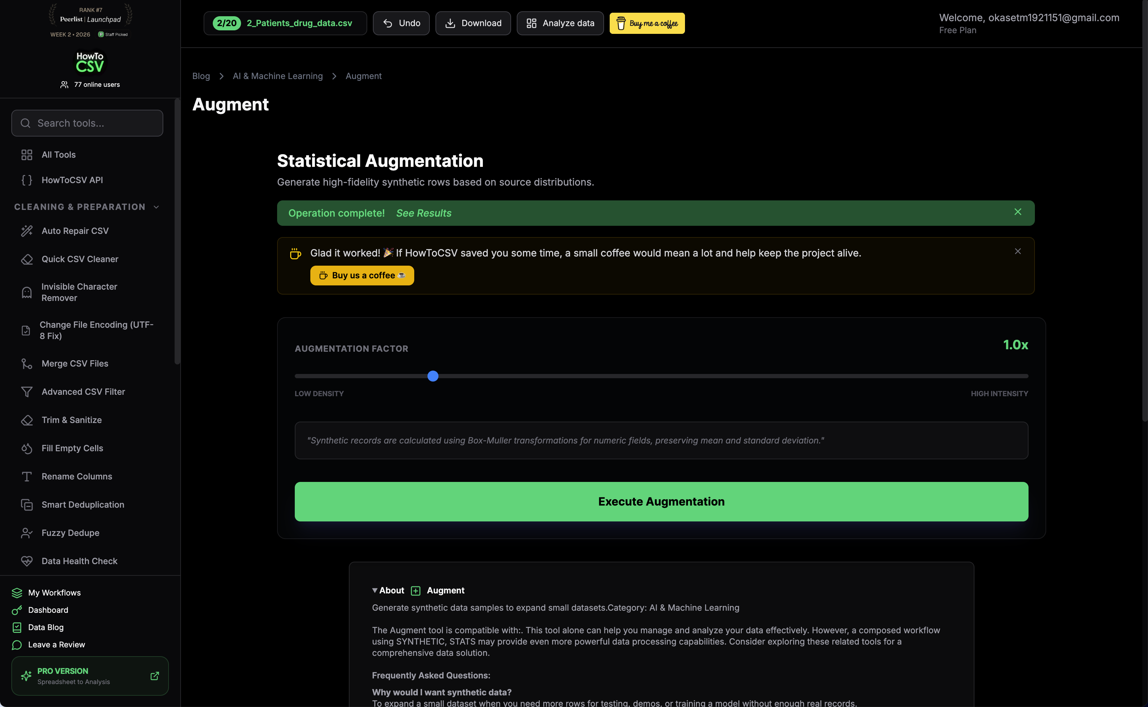

Exercise 2: Data Augmentation Using Tonic Fabricate
Tonic Fabricate is a prompt-based Generative AI tool that creates synthetic datasets while preserving schema, feature relationships, and statistical consistency.

Procedure
- Open the Tonic Fabricate website.
- Create an account or sign in.
- Upload the Dataset.

Prompt for Synthetic Data Generation
Generate a synthetic dataset based on the uploaded data file. Preserve the original schema, column names, and data types. Maintain realistic distributions for key fields, for example like age, premium, policy type, claim amount, and tenure etc. Ensure logical relationships between variables (for example, higher age may correlate with higher premiums, and claim amounts should align with policy coverage). Avoid duplicates and unrealistic values. Generate clean, high-quality data suitable for analysis, ensuring synthetic data is statistically consistent with the source dataset and achieving approximately 80% similarity/accuracy. Create a dataset that is 1× the size of the original while introducing meaningful variations.
Note:
Synthetic data generation may take some time depending on the dataset size and complexity.

Download the Synthetic Dataset
Once the generation process is complete, download the generated CSV dataset for further analysis or machine learning tasks.
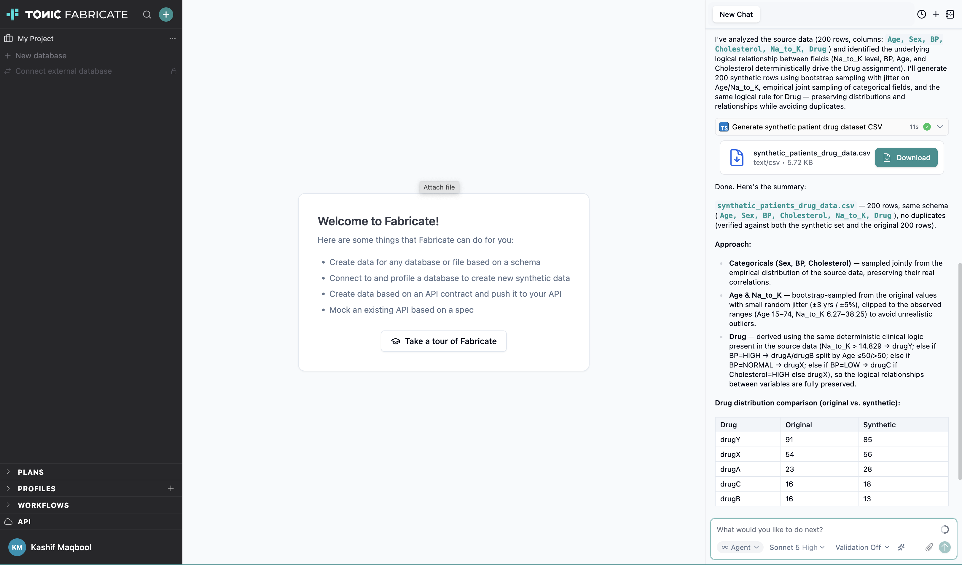

Analyze the Generated Report
Generative AI can also generate a detailed report describing how the synthetic dataset was created.

Prompt for Report Generation
Provide a detailed report on the model used for generating the synthetic data. Include information about the modeling approach, data distribution handling, and feature relationships learned. Also include performance metrics such as accuracy, AUC (Area Under the Curve), and any validation metrics used to assess the quality and similarity of the synthetic data relative to the original dataset. Present the report in a clear and structured format suitable for analysis.

Summary
These exercises demonstrated how Generative AI can generate and augment synthetic datasets while preserving the statistical properties of the original data.
We explored two different approaches:
- iLoveCSV for statistical data augmentation through a graphical interface.
- Tonic Fabricate for prompt-based synthetic data generation.
Together, these exercises illustrate how synthetic data can:
- Improve data availability.
- Support machine learning workflows.
- Enhance downstream data analysis.
- Maintain realistic feature distributions and relationships.

Generative AI for Data Preparation and Data Querying

Learning Objectives
After studying this topic, we will be able to:
- Summarize the challenges in data preparation and querying.
- List the Generative AI models that can help tackle these challenges.

Introduction
Generative AI models are instrumental in tackling data preparation and querying challenges. They excel in:
- Imputing (filling in) missing values.
- Detecting outliers.
- Reducing noise in datasets.
- Handling data translation tasks.
- Enabling natural language interactions in querying systems.
- Recommending queries.
- Optimizing query performance.
These capabilities enhance overall efficiency, improve accessibility, and help extract valuable insights from complex data.

Generative AI for Data Preparation

Handling Missing Values
Missing values are a pervasive (widely occurring) dataset issue and can pose significant challenges to data analysis and modeling.
Traditional imputation methods, such as:
- Mean imputation
- Median imputation
often lead to inaccurate results because they fail to capture the underlying data distribution and relationships between variables.
Generative AI models, particularly Variational Autoencoders (VAEs), offer a promising solution by learning the intricate (complex) patterns within the data and generating plausible (realistic) values that align with the observed data.

Detecting Outliers
Outliers are data points that significantly deviate from the expected pattern. They can distort statistical analysis and lead to erroneous (incorrect) conclusions.
Generative AI models, notably Generative Adversarial Networks (GANs), excel at outlier detection by learning the boundaries of the standard data distributions.
GANs consist of two competing neural networks:
- Generator – Strives to produce data that resembles the real data.
- Discriminator – Attempts to distinguish between real and generated data.
This adversarial process enables GANs to identify outliers.

Noise Reduction
Noise refers to unwanted random fluctuations that obscure the underlying patterns in a dataset. It can hinder data analysis and impede the extraction of meaningful insights.
Generative AI models, particularly Autoencoders, demonstrate remarkable capabilities in noise reduction.
Autoencoders learn the latent code (a compressed representation that captures the essential information of the data). This compressed representation encapsulates the core information while discarding the noise.
As a result, Autoencoders capture the essential features while removing unnecessary noise.

Data Translation
Data translation is the process of converting data from one format to another. It plays a crucial role in data exchange and communication, and inaccurate conversion can lead to inaccurate predictions.
Generative AI models, especially Neural Machine Translation (NMT), have emerged as powerful tools for data translation.
NMT utilizes Recurrent Neural Networks (RNNs) to learn the complex relationships between languages.
RNNs are proficient at accurately translating text from one language to another.
The capabilities of NMT extend beyond language translation and include:
- Text-to-speech translation
- Image-to-text translation

Generative AI for Data Querying

Natural Language Querying
Natural language querying has revolutionized data exploration by enabling users to interact with data using natural language rather than complex SQL statements.
Generative AI models, particularly Large Language Models (LLMs), act as intelligent intermediaries between users and data.
LLMs can:
- Interpret the nuances of natural language, including context, intent, and relationships between words.
- Translate natural language accurately into equivalent executable SQL statements.

Query Recommendation
Query recommendations suggest relevant queries to users based on their past questions and search context.
This enhances data exploration by guiding users toward insightful queries.
Generative AI models such as Recurrent Neural Networks (RNNs) excel at query recommendation.
RNNs model the sequential nature of users' queries by capturing the temporal relationship between questions, enabling them to predict the next logical query based on the user's current query and search history.

Query Optimization
Query optimization is the process of improving the performance of database queries to ensure efficient data retrieval.
Generative AI models, particularly Graph Neural Networks (GNNs), demonstrate remarkable capabilities in query optimization.
GNNs represent data as a graph where:
- Data entities are represented as nodes.
- Relationships between entities are represented as edges.
This graph representation allows GNNs to understand the intricate connections between data entities, enabling them to identify the most efficient query execution plans that minimize query execution time.

Summary
In this topic, we learned that Generative AI models are instrumental in tackling several data preparation and querying challenges.
Key takeaways include:
- Variational Autoencoders (VAEs) are highly effective for imputing missing values.
- Generative Adversarial Networks (GANs) excel at outlier detection by learning the boundaries of standard data distributions.
- Autoencoders demonstrate remarkable capabilities in noise reduction.
- Neural Machine Translation (NMT) has emerged as a powerful tool for data translation.
- Large Language Models (LLMs) are highly effective at interpreting natural language queries and translating them into equivalent SQL statements.
- Recurrent Neural Networks (RNNs) excel at query recommendation by modeling the sequential nature of users' queries.
- Graph Neural Networks (GNNs) demonstrate remarkable capabilities in query optimization.

Generative AI for Streamlining the Data Preparation Process

Learning Objectives
After studying this topic, we will be able to:
- Explain how Generative AI streamlines the data preparation process.
- Describe how Generative AI assists in data cleaning, transformation, normalization, and augmentation.
- Understand the role of Generative AI in generating and optimizing complex data queries.
- Identify the potential pitfalls and limitations of using Generative AI during data preparation.

How Generative AI Streamlines Data Preparation
One game-changing technology that has significantly transformed the data preparation process is Generative AI. It automates several time-consuming tasks involved in preparing data for analysis and machine learning.
Generative AI can:
- Automate data cleaning by identifying and filling missing values.
- Correct errors in datasets.
- Remove duplicate records.
- Save a significant amount of manual effort and time.

ChatCSV for Data Cleaning
One example is the ChatCSV Generative AI tool.
It can:
- Swiftly identify missing values in a dataset.
- Provide recommendations for replacing missing values.

Data Integration and Table Merging
Data preparation often involves merging multiple data tables to consolidate information and extract meaningful insights.
Generative AI simplifies this process by:
- Offering intuitive interfaces to join tables.
- Allowing users to define key columns.
- Helping users choose the appropriate type of join.
For example, Tamato.ai can assist with this process.

Natural Language to SQL
Generative AI helps automate the retrieval of data from databases using natural language.
Instead of writing complex SQL queries manually:
- We can provide a natural language prompt.
- A Large Language Model (LLM) transforms the prompt into an SQL query.
- The appropriate data is then retrieved automatically.

Knowledge-Augmented Foundation Models
If a foundation model is augmented with an extensive knowledge base, such as internal documentation, the model can effectively:
- Locate the required information.
- Retrieve relevant information from large databases.
- Reduce the time required for manual searching.

Data Cleaning and Data Quality Improvement
Generative AI can greatly streamline the data preparation process by automating tasks such as:
- Data cleaning
- Data transformation
- Data augmentation
For example, AI can:
- Correct formatting inconsistencies.
- Generate synthetic data to fill data gaps.
This significantly reduces manual effort.
Generative AI can also perform data cleaning tasks such as:
- Correcting typos.
- Fixing formatting issues.
- Handling datetime field inconsistencies.
- Identifying outliers.
- Handling missing data.
Handling missing values in numerical columns is relatively straightforward, whereas handling missing values in categorical columns is more challenging. Generative AI can make this process easier.

Data Normalization and Transformation
Generative AI can automate data normalization by:
- Scaling data.
- Transforming data into a standard format.
- Ensuring consistency across datasets.
It can also assist with data transformations such as:
- Standardizing data.
- Normalizing data.
- Encoding data using one-hot encoding.
- Applying other encoding techniques.
These transformations prepare the data for:
- Data analysis.
- Building machine learning models.

Potential Pitfalls of Generative AI
Although Generative AI offers many advantages, it also has several limitations and risks.

Lack of Domain Understanding
Generative AI may not understand domain-specific relationships within the data.
As a result, it may:
- Generate inappropriate transformations.
- Produce misleading outputs.

False Sense of Data Quality
AI-generated transformations can create a false sense of data quality by potentially overlooking:
- Edge cases.
- Hidden errors.

Overfitting Noise
Generative AI can overfit the noise present in data, which can negatively affect feature engineering.

Bias in Generated Data
We need to be very careful about the bias that Generative AI can introduce into generated data.
If the AI has been trained on biased data, it can:
- Produce skewed results.
- Perpetuate existing inequalities.

Importance of Human Oversight
Generative AI should not be considered a 100% automated system.
Human oversight is necessary at every step.
We should think of Generative AI as a tool that makes experts much more productive, rather than expecting a novice to use it to perform complex data science tasks independently.
Even though Generative AI can automate many tasks, oversight is still required to ensure:
- Data quality.
- Data accuracy.
Errors introduced during the data preparation stage can lead to poor machine learning model performance.

Generative AI for Complex Data Queries
Generative AI is highly effective in generating and optimizing complex data queries.
It accomplishes this by:
- Understanding patterns in data.
- Learning from previous query structures.
Compared to traditional methods that rely on manual coding and query tuning, AI-powered tools can:
- Suggest optimized SQL queries.
- Automatically construct queries for improved performance.
Since Generative AI models are trained on large amounts of internet data, they gain the ability to:
- Write complex code.
- Generate SQL queries.
- Suggest code completions.
- Handle complex programming tasks.
- Optimize queries.
Generative AI can also:
- Analyze existing data.
- Recommend indexes.
- Calculate execution times.
- Support speech-to-text functionality.
- Support text-to-SQL by using tailored prompts.
Natural language enables users to move from a simple request to retrieving the appropriate data without manually writing complex programs to pull and clean the data.
Additionally, techniques such as:
- Few-shot prompting.
- Retrieval-Augmented Generation (RAG) (enhancing responses by retrieving relevant external information before generating an answer).
- Agentic workflows (AI systems that autonomously plan and perform multi-step tasks to achieve a goal).
can further improve the quality of generated queries.

Gen SQL
A recent Generative AI tool known as Gen SQL has been introduced.
This tool enables database users to:
- Perform complicated statistical analyses.
- Make predictions.
- Detect anomalies.
- Estimate missing values.
- Fix errors.
- Generate synthetic data.
These tasks can be performed with just a few keystrokes.
Gen SQL is especially helpful for traditional database users and individuals who do not have SQL or other query language knowledge, making database querying much simpler and more accessible.

Key Takeaways
- Generative AI automates data cleaning, transformation, augmentation, and normalization.
- Tools such as ChatCSV help identify and replace missing values.
- Tamato.ai simplifies table joining and data integration.
- Large Language Models (LLMs) can convert natural language prompts into SQL queries.
- Knowledge-augmented foundation models can efficiently retrieve information from large internal knowledge bases.
- Generative AI supports standardization, one-hot encoding, outlier detection, typo correction, and synthetic data generation.
- Human oversight remains essential because AI may introduce bias, overlook edge cases, or generate inappropriate transformations.
- Generative AI significantly improves SQL generation and query optimization through natural language interfaces.
- Techniques such as Few-shot Prompting, Retrieval-Augmented Generation (RAG), and Agentic Workflows further enhance query quality.
- Gen SQL simplifies statistical analysis and complex database operations for users with little or no SQL expertise.

Generative AI for Data Preparation

Learning Objectives
After completing this topic, we will be able to:
- Replace missing values in data.
- Find outliers in data.
- Merge multiple data tables by using a join.
- Filter data.
- Use an AI assistant to analyze data.
- Create an if-then rule for data preparation.

Introduction to Data Preparation
Data preparation is a crucial step in the process of data analytics, which involves cleaning, transforming, and organizing raw data to make it suitable for further analysis and modeling.
This step ensures that the data is:
- Accurate
- Reliable
- Consistent
Generative AI makes data preparation easier and quicker for data professionals by automating many common data cleaning and transformation tasks.

Demonstration 1: Data Preparation Using ChatCSV
The first demonstration uses the ChatCSV generative AI tool, which is a web-based tool that acts as a personal data analyst assistant. It enables us to attach any CSV file to a chat session and ask questions about the data.

Uploading the Dataset
We begin by initiating a chat and attaching the dataset:
- Dataset: Daily_Car_Sales.csv
Once the dataset is uploaded, the GPT model displays:
- A description of the dataset.
- Basic information about the dataset.
- Information on columns containing missing values.
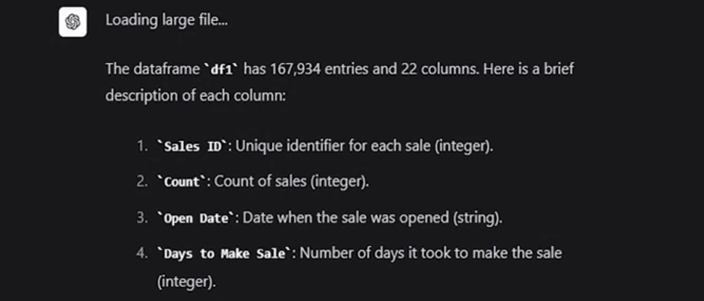

Replacing Missing Values
To handle missing values, we enter the following prompt:
Replace missing values of temperature F with the mean of temperature F.
The generative AI tool quickly updates the dataset by replacing the missing values in the Temperature F column with the average (mean) temperature.
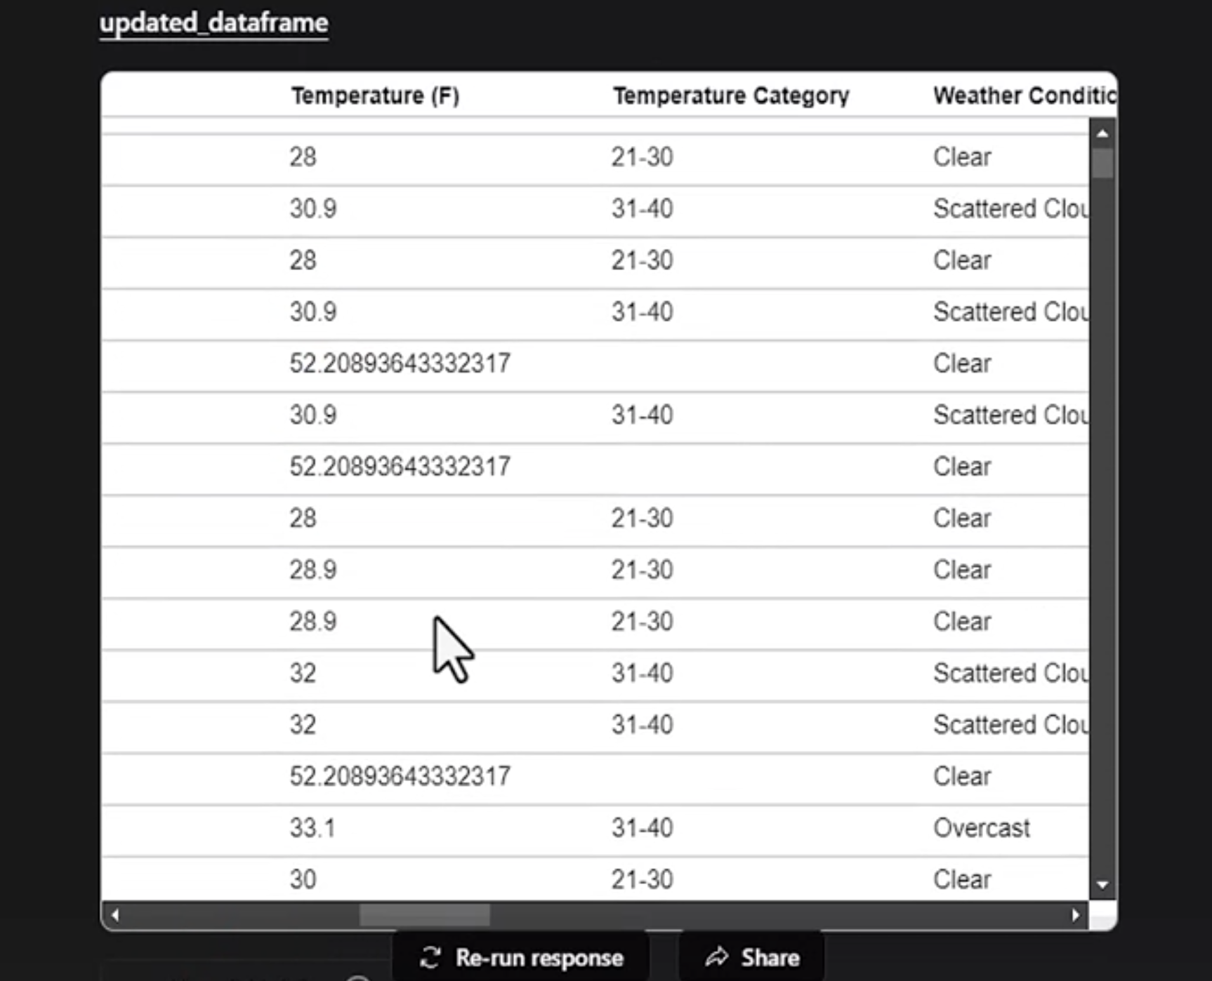

Finding Outliers
Next, we identify outliers in the dataset.
The GPT model automatically produces box plots (a visualization used to identify data distribution and outliers) for each column.
From these box plots, we observe:
- Several columns contain outliers.
- Outliers are represented by black dots.
This demonstrates how Generative AI simplifies common data preparation tasks.
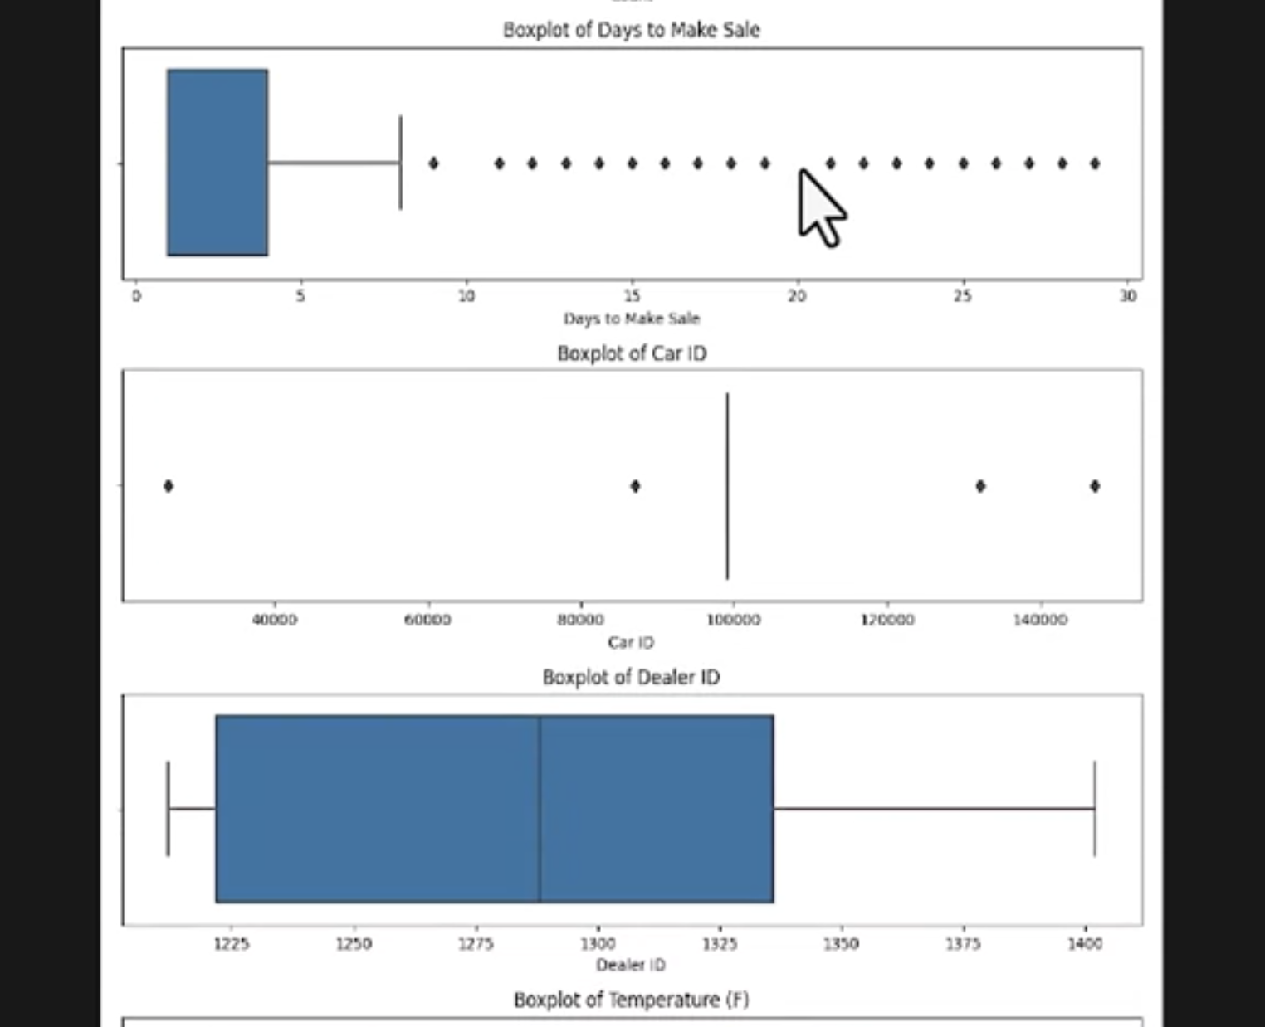

Demonstration 2: Data Preparation Using Tomat.AI
The second demonstration uses the Tomat.AI Community Edition, which allows us to explore and analyze data without limitations.

Uploading the Dataset
To begin:
- Upload the CSV file by dragging and dropping it or browsing for it.
- Click Add to Catalog in the upper-right corner.
After uploading, we enter the Explorer view, where statistics for every column are displayed in the right-hand pane.

Calculating Average Values
To calculate the average temperature for each weather condition:
- Group the data by Weather Condition.
- Select the Temperature F column as the value.
- Choose Average as the aggregation method.
After closing the dialog box, the updated table displays the average temperature for each weather condition.

Creating a Data Flow
Next, we convert the prepared data into a Flow for additional transformations.

Merging Multiple Tables
We upload another dataset:
- Dataset: Dealer_ID_Names.csv
After uploading the file:
- Click Create to save the changes.
- Select Join.
- Connect both table icons to the Join node.
Configure the join as follows:
- Join Type: Left Join
- Join Key (Table 1): Dealer ID
- Join Key (Table 2): Dealer ID
Then create the join.

Filtering Data
We can also filter the data.
For example, we apply a filter where:
- Weather Condition = Scattered Clouds
After applying the filter, only rows containing Scattered Clouds remain visible.

Using the AI Assistant
The AI Assistant provides automatic suggestions for improving the dataset, including:
- Handling missing values.
- Other recommendations for different tables in the dataset.
We can also ask the AI Assistant specific questions.
Example:
How should we deal with missing values in the temperature column?
One suggested solution is to replace missing values with a constant value, such as the average.

Creating an If-Then Rule
To replace missing temperature values with the average value:
- Select If..Then from the New menu.
- Select the Is Missing condition for the Temperature F column.
- If the value is missing, assign the average temperature.
- Otherwise, keep the existing temperature value.
Finally:
- Overwrite the Temperature column.
- Create the rule.
An If node is then connected to the Join and Filter nodes in the data flow.
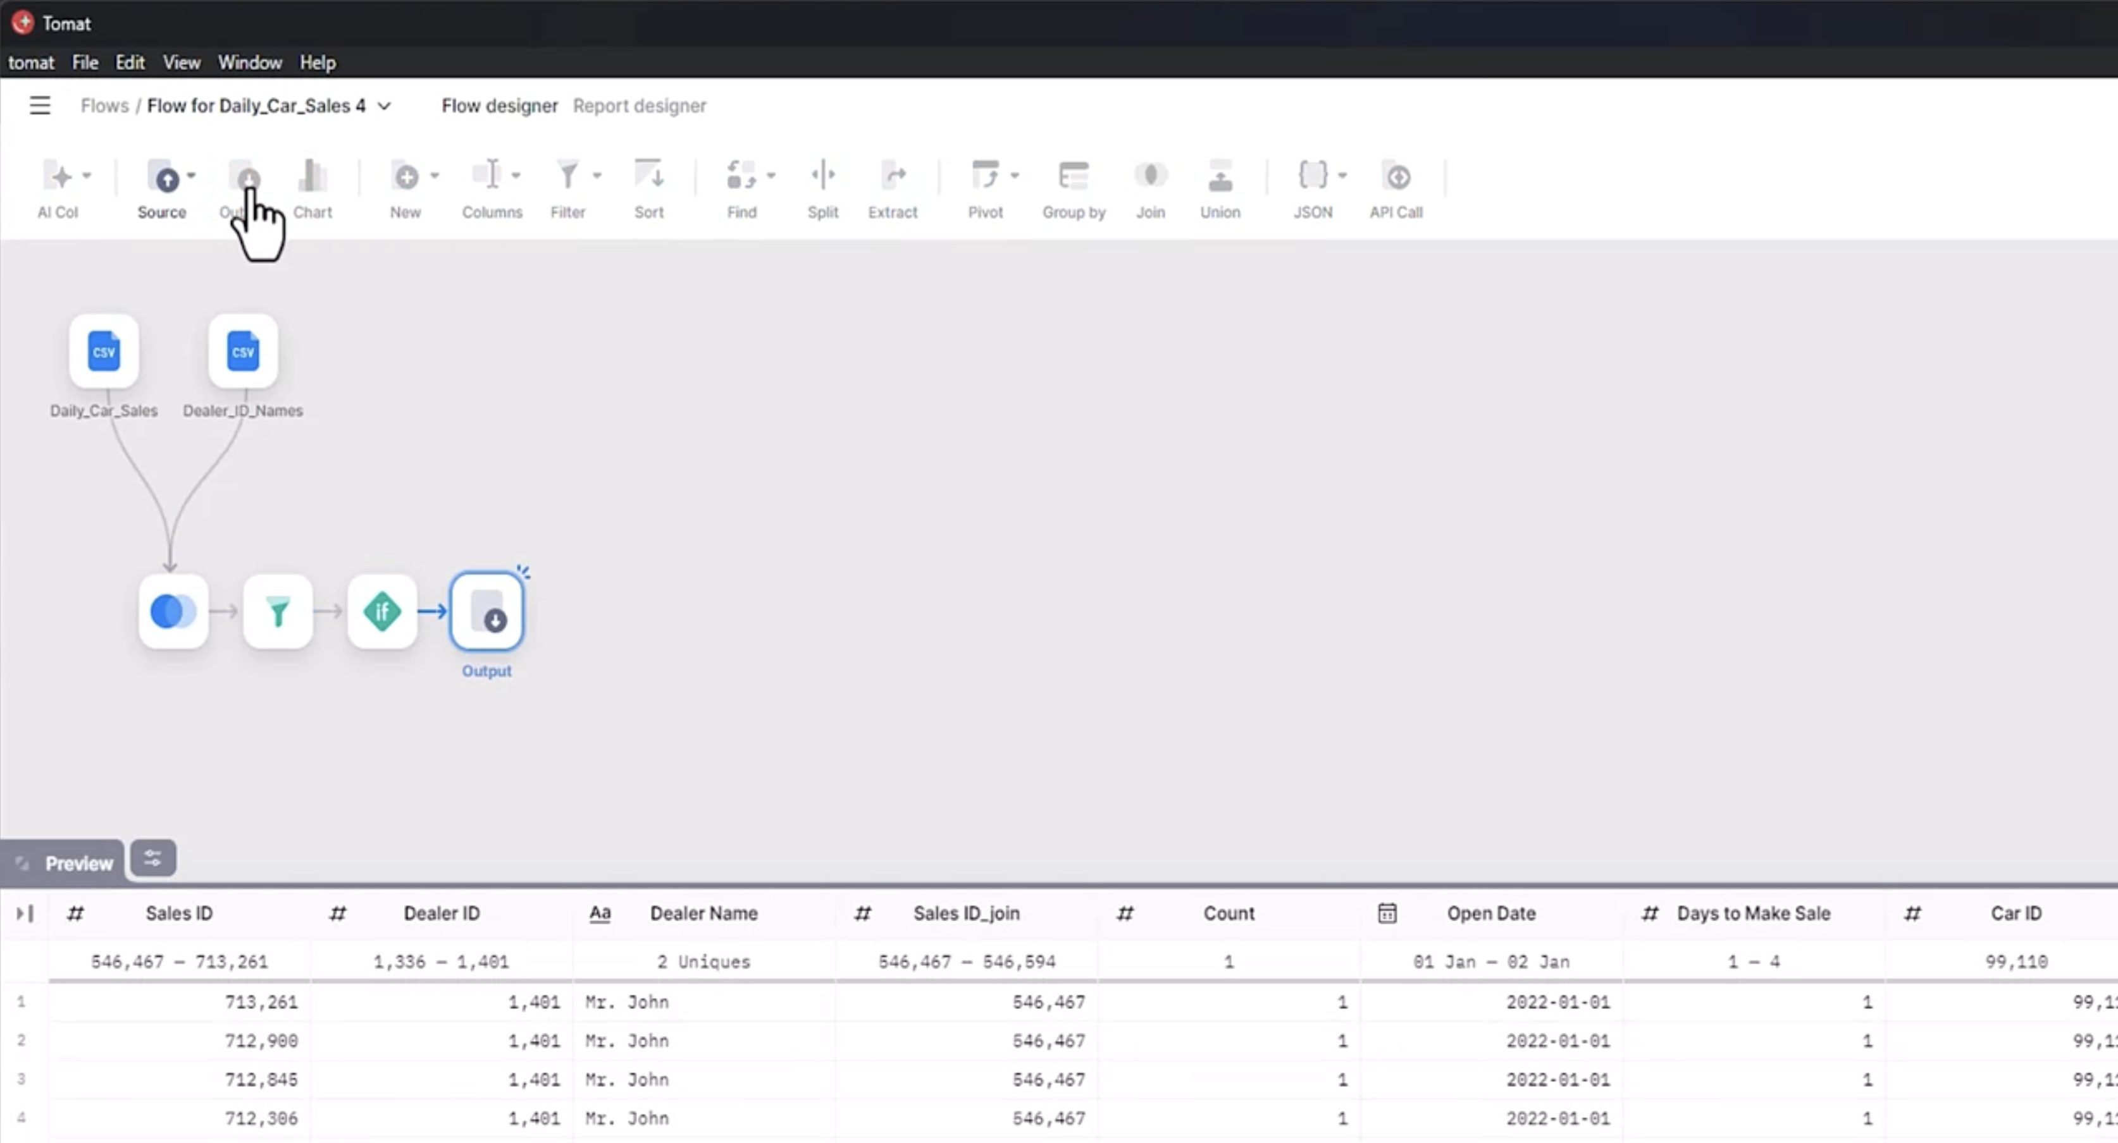

Exporting the Prepared Dataset
To generate the processed CSV file:
- Add a Local File output.
- Specify the output location.
- Name the file:
prepared data
Once the flow is complete:
- Click the Run Job icon.
- Wait for the processing to finish.
After completion, a CSV file containing the prepared data is generated.

Key Takeaways
In this topic, we learned that Generative AI can simplify several data preparation tasks, including:
- Replacing missing values in data.
- Managing outliers in data.
- Finding average values for each data category.
- Applying filters.
- Merging multiple data tables using joins.
- Deleting columns.
- Creating if-then rules for data transformation.
- Generating a CSV file containing processed data.

Generative AI for Data Preparation

Learning Objectives
After completing these exercises, we will be able to:
- Handle missing values in a dataset.
- Correct the data types of dataset attributes.
- Perform standardization and normalization on selected attributes.
- Convert categorical data into numerical indicator variables.

Introduction
Data preparation is one of the first steps in a data science workflow. It involves cleaning and transforming data before analysis, including handling missing values, correcting data types, standardizing and normalizing numerical attributes, and converting categorical variables into numerical representations.
In these exercises, we use Generative AI to generate Python code that performs these common data preparation tasks on a real-world dataset.

Exercise 1: Import the Dataset

Prompt
Generate plain basic Python code without using definition or exceptions or if else statements. Response should be concise.
Write a Python code that can perform the following task:
- Read the CSV file, located on a given file path, into a Pandas DataFrame, assuming that the first rows of the file are the headers for the data.

Exercise 2: Handle Missing Data

Identify Missing Values

Prompt
Write a Python code that identifies the columns with missing values in a Pandas DataFrame and gives missing value counts per column.
The dataset contains missing values in the following attributes:
- Screen_Size_cm (categorical attribute)
- Weight_kg (continuous attribute)

Guidelines
- Replace missing values in categorical attributes with the most frequent value.
- Replace missing values in continuous attributes with the mean value.
- If the target column contains missing values, the corresponding row may need to be removed.

Replace Missing Values

Prompt
Write Python code to replace the missing values in a Pandas DataFrame, according to the following guidelines:
- For the categorical attribute "Screen_Size_cm", replace the missing values with the most frequent value in the column.
- For the continuous attribute "Weight_kg", replace the missing values with the mean value of the entries in the column.

Exercise 3: Modify Data Types

Prompt
Write a Python code snippet to change the data type of the attributes "Screen_Size_cm" and "Weight_kg" of a DataFrame to float.

Exercise 4: Standardization and Normalization
The dataset contains attributes that should be converted into standard measurement units.

Convert Measurement Units
Convert:
- Screen_Size_cm to Screen_Size_inch
- Weight_kg to Weight_pounds

Prompt
Write a Python code to modify the contents under the following attributes of the DataFrame as required:
- Data under "Screen_Size_cm" is assumed to be in centimeters. Convert this data into inches. Modify the name of the attribute to "Screen_Size_inch".
- Data under "Weight_kg" is assumed to be in kilograms. Convert this data into pounds. Modify the name of the attribute to "Weight_pounds".

Normalize CPU Frequency
The CPU_frequency attribute should be normalized with respect to its maximum value, and the original attribute should be updated instead of creating a new one.

Prompt
Write Python code to normalize the content under the attribute "CPU_frequency" in a DataFrame df with respect to its maximum value. Make changes to the original data, and do not create a new attribute.

Exercise 5: Convert Categorical Data to Numerical Data
For predictive modeling, categorical variables should be converted into indicator (one-hot encoded) variables. After creating the indicator variables, the original categorical attribute should be removed.

Prompt
Write Python code to perform the following tasks:
- Convert the DataFrame df attribute "Screen" into indicator variables, saved as df1, with the naming convention "Screen_".
- Append df1 to the original DataFrame df.
- Drop the original "Screen" attribute from the DataFrame df.

Practice Exercises
- Create a prompt to generate Python code that converts the values under Price from USD to Euros.
- Modify the normalization prompt to perform Min-Max Normalization on the CPU_frequency attribute.

Summary
Through these exercises, we learned how to use Generative AI to generate Python code for common data preparation tasks, including:
- Handling missing values.
- Modifying attribute data types.
- Performing standardization and normalization.
- Converting categorical attributes into numerical indicator variables.

Generative AI for Querying Databases

Learning Objectives
After completing this topic, we will be able to:
- Demonstrate how we can quickly and easily extract insights from massive datasets using Generative AI.
- Use Generative AI tools to understand natural language queries.
- Convert natural language queries into SQL commands.

Introduction
Querying a database involves retrieving or manipulating data stored in a database.
A database refers to an organized collection of data, and queries refer to the primary means of interacting with this collection and extracting information from the database.
Structured Query Language (SQL) is the most common and standardized query language for interacting with relational databases. SQL queries consist of commands that specify:
- The data to be retrieved.
- The conditions to be applied.
- The sequence in which to display the data.
Generative AI has changed the way we interact with databases. By enabling users to query databases using natural language, Generative AI makes it easier to access and understand data. This capability can profoundly impact a wide range of industries, including:
- Finance
- Healthcare
- Education

Extracting Insights from Massive Datasets Using Generative AI
Traditionally, data professionals would spend hours crafting SQL queries to navigate through complex database structures.
This demonstration uses SQL through AI, a Generative AI model designed to understand natural language queries and convert them into SQL commands.

Setting Up the Database
To begin:
- Log in to the platform.
- Upload the Boston Housing Price dataset that we want to query.
- Give the dataset a name.
- Save the dataset.
Once the dataset is saved, we can begin querying the data.
The tool allows us to generate queries for multiple database management systems and languages, including:
- SQL
- MongoDB
- Other supported database systems
For this demonstration, SQL is selected.


Generating SQL Queries Using Natural Language

Viewing Column Names
Select the dataset and enter the following prompt:
What are the column names?
Within seconds, the SQL query is generated, which can then be copied and used in an application.

Counting the Number of Rows
Enter a new prompt requesting the count of rows in the dataset.
The generated SQL query is:
SELECT COUNT(*)
FROM Boston_house_prices;

Finding the Average Age
To determine the average age in the database, the generated SQL query is:
SELECT AVG(age)
FROM Boston_house_prices;

Finding Rows Based on a Tax Range
To find all rows where tax is between 210 and 250, the generated SQL query is:
SELECT *
FROM Boston_house_prices
WHERE tax >= 210
AND tax <= 250;

Replacing Zero Values in the ZN Column
To replace all zero values in the ZN column with a constant value of 5, the generated SQL query is:
UPDATE Boston_house_prices
SET ZN = 5
WHERE ZN = 0;

Sorting the Table by the MEDV Column
To sort the table in ascending order based on the MEDV column, the generated SQL query is:
SELECT *
FROM Boston_house_prices
ORDER BY MEDV ASC;

Inserting New Rows
The tool can also generate SQL statements for inserting new rows.
The generated response may not always be exactly as expected. We need to replace the NULL values with the actual values required for each field before executing the query.

Generating a Condition-Based Query
To find rows where:
- RAD = 5
- AGE is between 50 and 55
The generated SQL query is:
SELECT *
FROM Boston_house_prices
WHERE RAD = 5
AND AGE BETWEEN 50 AND 55;

Creating a Sub-Table
To create a sub-table where:
- CHAS = 1
- RAD = 4
The generated SQL statement is:
SELECT *
FROM Boston_house_prices
WHERE CHAS = 1
AND RAD = 4;

Importance of Querying Databases
Querying databases is an essential part of working with data.
By understanding how to write SQL queries, we can effectively retrieve and manipulate data to:
- Gain valuable insights.
- Analyze datasets efficiently.
- Make informed decisions.
Generative AI plays a vital role in query generation through a simple natural language processing (NLP) interface, saving both time and effort.

Key Takeaways
In this topic, we learned that Generative AI can generate SQL queries from natural language prompts, allowing us to:
- Query specific data from a dataset, such as column names, row counts, and average age.
- Find specific rows using filtering conditions.
- Replace values in a column.
- Sort a table in ascending order.
- Insert new rows.
- Generate condition-based queries.
- Create sub-tables using SQL statements.

Generative AI for Querying Databases

Learning Objectives
After completing these exercises, we will be able to:
- Use Generative AI to create efficient SQL queries for a dataset.

Introduction
Processed data stored in database tables can be accessed using SQL queries. Writing efficient queries is an essential skill for data professionals. In these exercises, we use Generative AI to generate optimized SQL queries by providing sufficient context about the dataset and its attributes.

Exercise 1: Provide Context to the Generative AI Model
Before generating SQL queries, we provide the model with a detailed description of the dataset and its attributes so it can generate accurate and optimized queries.

Prompt Instructions
We have a Heart Disease Prediction dataset with a single table that contains the following attributes.
Attribute | Description
age | Age in years
gender | Gender (1 = male; 0 = female)
cp | Chest pain type
trestbps | Resting blood pressure (mm Hg)
chol | Serum cholesterol (mg/dl)
fbs | Fasting blood sugar > 120 mg/dl (1 = true; 0 = false)
restecg | Resting electrocardiographic results
thalach | Maximum heart rate achieved
exang | Exercise-induced angina (1 = yes; 0 = no)
oldpeak | ST depression induced by exercise relative to rest
slope | Slope of the peak exercise ST segment
ca | Number of major vessels (0–3) colored by fluoroscopy
thal | Thallium stress test result
num | Target attribute (Heart disease status)

Attribute Value Definitions

Chest Pain Type (cp)
Value | Description
1 | Typical angina
2 | Atypical angina
3 | Non-anginal pain
4 | Asymptomatic

Resting Electrocardiographic Results (restecg)
Value | Description
0 | Normal
1 | ST-T wave abnormality
2 | Left ventricular hypertrophy

Slope of Peak Exercise ST Segment (slope)
Value | Description
1 | Upsloping
2 | Flat
3 | Downsloping

Thallium Stress Test (thal)
Value | Description
3 | Normal
6 | Fixed defect
7 | Reversible defect

Target Attribute (num)
Value | Description
0 | <50% diameter narrowing
1 | >50% diameter narrowing

Exercise 2: Generate SQL Queries Using Prompts

Age Distribution
Prompt
Write an SQL query to find the minimum, maximum, and average age of patients in the dataset.
SELECT
MIN(age) AS min_age,
MAX(age) AS max_age,
AVG(age) AS avg_age
FROM heart_disease_prediction_dataset;

Gender Analysis
Prompt
Write an SQL query to count the number of male and female patients in the dataset.
SELECT
SUM(CASE WHEN gender = 1 THEN 1 ELSE 0 END) AS male_count,
SUM(CASE WHEN gender = 0 THEN 1 ELSE 0 END) AS female_count
FROM heart_disease_prediction_dataset;

Chest Pain Type Frequency
Prompt
Write an SQL query to determine the frequency of each type of chest pain (typical angina, atypical angina, non-anginal pain, and asymptomatic) among patients.
SELECT
CASE cp
WHEN 1 THEN 'typical_angina'
WHEN 2 THEN 'atypical_angina'
WHEN 3 THEN 'non_anginal_pain'
WHEN 4 THEN 'asymptomatic'
ELSE 'unknown'
END AS chest_pain_type,
COUNT(*) AS frequency
FROM your_table_name
GROUP BY
CASE cp
WHEN 1 THEN 'typical_angina'
WHEN 2 THEN 'atypical_angina'
WHEN 3 THEN 'non_anginal_pain'
WHEN 4 THEN 'asymptomatic'
ELSE 'unknown'
END
ORDER BY frequency DESC;

Age Group Analysis and Target Variable
Prompt
Write an SQL query to investigate the distribution of the target variable (presence or absence of heart disease) within different age groups (e.g., 20–30, 30–40, etc.).
SELECT
CASE
WHEN age IS NULL THEN 'Unknown'
WHEN age >= 20 AND age < 30 THEN '20-29'
WHEN age >= 30 AND age < 40 THEN '30-39'
WHEN age >= 40 AND age < 50 THEN '40-49'
WHEN age >= 50 AND age < 60 THEN '50-59'
WHEN age >= 60 AND age < 70 THEN '60-69'
WHEN age >= 70 AND age < 80 THEN '70-79'
ELSE '80+'
END AS age_group,
num AS heart_disease_status,
COUNT(*) AS count
FROM your_table_name
GROUP BY
CASE
WHEN age IS NULL THEN 'Unknown'
WHEN age >= 20 AND age < 30 THEN '20-29'
WHEN age >= 30 AND age < 40 THEN '30-39'
WHEN age >= 40 AND age < 50 THEN '40-49'
WHEN age >= 50 AND age < 60 THEN '50-59'
WHEN age >= 60 AND age < 70 THEN '60-69'
WHEN age >= 70 AND age < 80 THEN '70-79'
ELSE '80+'
END,
num
ORDER BY age_group, heart_disease_status;

Practice Exercises
Practice the following SQL exercises using Generative AI.
- Cholesterol Range
  - Find the range of cholesterol levels among patients (minimum and maximum).
- Age Range and Gender Analysis
  - Determine the age range (youngest and oldest) for male and female patients separately.
- Age Group Analysis and Target Variable
  - Investigate the distribution of the target variable (presence or absence of heart disease) within different age groups (e.g., 20–30, 30–40, etc.).
- Maximum Heart Rate by Age Group
  - Find the maximum heart rate achieved during exercise for different age groups (e.g., 30–40, 40–50, etc.).
- Percentage of Patients with High Blood Sugar
  - Calculate the percentage of patients with fasting blood sugar greater than 120 mg/dl.
- Ratio of Patients with Resting Electrocardiographic Abnormality
  - Find the ratio of patients with abnormal resting electrocardiographic results to those with normal results.
- Number of Patients with Reversible Thalassemia
  - Count the number of patients with reversible thalassemia detected by thallium stress testing.
- Average Age of Patients with Chest Pain
  - Calculate the average age of patients who experienced chest pain during diagnosis.
- Distribution of Patients by Number of Major Vessels
  - Investigate the distribution of patients based on the number of major vessels colored by fluoroscopy (0–3).

Summary
Through these exercises, we learned how to use Generative AI to generate efficient SQL queries for retrieving information from a database.
We also learned that providing detailed context about the dataset and its attributes enables the model to generate accurate, optimized, and ready-to-use SQL queries.

Module 1 Summary: Data Science and Generative AI

Module Completion
At this point, we know that:
- The four common AI models are:
  - Generative Adversarial Networks (GANs)
  - Variational Autoencoders (VAEs)
  - Autoregressive Models
  - Flow-based Models
- Generative Adversarial Networks (GANs) are particularly effective for data augmentation.
- Variational Autoencoders (VAEs) are well suited for:
  - Anomaly detection
  - Data compression
  - Collaborative filtering
  - Style transfer
- Autoregressive Models are commonly used for:
  - Text generation
  - Speech synthesis
  - Time series forecasting
  - Machine translation
- Flow-based Models are suitable for:
  - Image generation
  - Data generation
  - Density estimation
- Generative AI can tackle complex problems across a wide range of industries.
- Generative AI models are instrumental in addressing several data preparation and querying challenges, including:
  - Imputation of missing values
  - Detecting outliers
  - Reducing noise
  - Translating natural language queries into equivalent SQL statements

Module 1 Cheatsheet: Data Science and Generative AI

Popular Generative AI Tools
Name of Model | Usage | Link
Data Robot | A simple tool useful for data analysis and model building operations. | https://www.datarobot.com/
Mostly.AI | Synthetic data generation. | https://mostly.ai/
ChatGPT | GPT-based model used for text and code generation based on natural language queries. | https://openai.com/chatgpt
DB Sensei | Generate SQL queries for databases using natural language queries. | https://dbsensei.com/

Important Prompts for Data Preparation
Task | Prompt
Read a CSV data file and load it to a data frame. | Write a Python code that can perform the following tasks  Read the CSV file, located on a given file path, into a Pandas data frame, assuming that the first rows of the file are the headers for the data.
Data cleaning: Identify and replace missing values per the following guidelines. | Write a Python code to perform the following tasks:  - Identify the attributes with missing values.  - Segregate these attributes into categorical and continuous valued attributes.  - Drop the entire row if the value is missing in the target variable.  - If the value is missing in a categorical attribute, replace the missing values with the most frequent value in the column.  - If the value is missing in a continuous value attribute, replace the missing values with the mean value of the entries in the column.
Data Normalization: Normalize an attribute to its maximum value. | Write a Python code to normalize the content under a given attribute in a data frame df to its maximum value. Make changes to the original data, and do not create a new attribute.
Converting categorical variables into indicator variables | Write a Python code to perform the following tasks:  - Convert a data frame df attribute into indicator variables, saved as df1, with the naming convention Name_<unique value of the attribute>.  - Append df1 into the original data frame df.3. Drop the original attribute from the data frame df.

Module 2: Use of Generative AI for Data Science

Generative AI for Drawing Data Insights

Learning Objectives
After completing this topic, we will be able to:
- Use generative AI to create Python code that performs various operations relevant to drawing insights from a given dataset.
- Use hal9's free plan to generate statistical data analysis.
- Find missing values in a dataset using generative AI tools.

Using Generative AI to Generate Python Code for Data Analysis
Assume that our cleaned data is available in a CSV file. We can then use a generative AI model like GPT-3.5 to create Python code that generates the analysis we require.
For example, a simple prompt for the tool would be:
Create a Python code to generate the statistical description of cleaned data available in a CSV file.
The response of the model would generate valid Python code that uses the pandas library to produce statistical descriptions of the dataset using the describe() function.

Enhancing Data Analysis with Advanced Statistical Insights
The same prompt can be enhanced to include more advanced aspects for creating data insights.
For example, we can use the following prompt:
Create a Python code to perform univariate, bivariate, and multivariate analysis of data available in a CSV file.
The generated code will produce a detailed statistical description of the data.
It will perform:
- Univariate analysis for any selected attribute.
- Bivariate analysis for any pair of attributes.
- Multivariate analysis by generating a pair plot (an ensemble plot consisting of bivariate analysis of all pairs of data attributes).

Extending the Analysis with Feature Selection and Feature Engineering
We can further extend the generated code by asking the model to include additional data analysis tasks.
For example, if we want to select the five best features that have the strongest relationship with the target attribute and engineer new features, we can continue the conversation using the following prompt:
In the code above, add the aspects of selecting the five best features that fit the target attribute as well as the aspect of engineering new features for the same.
The generated code will:
- Use the SelectBest method from the scikit-learn library to identify the five best features for the dataset.
- Create new polynomial features using the PolynomialFeatures method from the scikit-learn library.

Using hal9 to Generate Data Insights
Another way to generate insights quickly and effectively is by using hal9's free plan.
For this demonstration, the dataset used is student-mat.csv, which contains student performance data collected from:
- School reports
- Questionnaires
The dataset includes:
- Student grades
- Demographic information
- Social features
- School-related features
After uploading the dataset and selecting Create, the platform suggests prompts that can be used to generate insights.

Distribution of Student Ages Across Schools
One suggested analysis is to determine the distribution of student ages across schools.
The generated output is a graphical representation of the age distribution.
For example:
- School GP has 57 students aged 18.
- School MS has 25 students aged 18.
The generated responses can also be saved for future use.

Finding Missing Values
Another useful analysis is checking for missing values in the dataset.
The generated response includes:
- Sample rows from the dataset.
- A tabular summary of column names.
- The count of missing values for each column.
In this demonstration, the output shows that no values are missing.

Generating Statistical Insights
The platform can also generate statistical insights for the complete dataset.
The statistical summary includes the following for quantitative columns:
- Count
- Mean
- Standard Deviation (STD)
- Minimum value (Min)
- Quartiles (25%, 50%, and 75%)
- Maximum value (Max)
For categorical columns, it provides:
- Unique values
- Count of each unique value
For example, the school attribute contains the unique values:
- GP
- MS

Key Takeaways
- Generative AI tools can generate Python code to perform various operations for drawing insights from a dataset.
- We can enhance generated code to perform univariate, bivariate, and multivariate analysis.
- We can extend the generated code by adding feature selection and feature engineering capabilities.
- The SelectBest method in scikit-learn can be used to identify the five best features related to the target attribute.
- The PolynomialFeatures method in scikit-learn can be used to engineer new polynomial features.
- hal9's free plan can generate statistical representations of datasets and identify missing values.
- Statistical summaries include descriptive statistics for quantitative columns and unique value counts for categorical columns.

