
Table of Content
1 Fundamentals of Deep Learning and Neural Networks with Keras 16
1.1 Biological Inspiration Behind Neural Networks 16
1.2 Artificial Neural Networks 16
1.3 Forward Propagation 16
1.4 Learning Process in Neural Networks 16
1.5 Deep Learning Libraries 17
1.5.1 Keras Library 17
1.5.2 Types of Neural Networks 17
1.5.3 Advanced Deep Learning Models 17
1.5.4 Convolutional Neural Networks (CNNs) 17
1.5.5 Recurrent Neural Networks (RNNs) 18
1.5.6 Transformers 18
1.5.7 Autoencoders 18
2 Introduction to Deep Learning 18
2.1 Overview 18
2.2 Deep Learning Applications 19
2.2.1 Color Restoration 19
2.2.2 Speech Enactment 19
2.2.3 Automatic Handwriting Generation 20
2.3 Additional Deep Learning Applications 21
2.3.1 Automatic Machine Translation 21
2.3.2 Sound Generation for Silent Movies 21
2.3.3 Object Classification and Detection 21
2.3.4 Self-Driving Cars 21
2.3.5 Chatbots 21
2.3.6 Text-to-Image Generators 22
2.4 Neural Networks as the Foundation of Deep Learning 22
2.4.1 Neural Networks 22
2.5 Types Mentioned in This Lecture 22
2.5.1 Convolutional Neural Networks (CNNs) 22
2.5.2 Recurrent Neural Networks (RNNs) 22
2.6 Key Takeaways 22
2.6.1 Important Points 22
2.7 Major Applications Covered 23
2.7.1 Image and Vision Applications 23
2.7.2 Audio and Video Applications 23
2.7.3 Language Applications 23
2.7.4 Creative Applications 23
2.7.5 Autonomous Systems 23
2.8 Conclusion 23
3 Neurons and Neural Networks 23
3.1 Introduction to Neurons and Neural Networks 23
3.2 Structure of a Biological Neuron 24
3.2.1 Soma 24
3.2.2 Dendrites 24
3.2.3 Axon 24
3.2.4 Synapses (Terminal Buttons) 24
3.3 How Information Flows Through a Neuron 25
3.3.1 Step 1: Receiving Information 25
3.3.2 Step 2: Sending Information to the Soma 25
3.3.3 Step 3: Processing Information 25
3.3.4 Step 4: Passing Information Through the Axon 25
3.3.5 Step 5: Communicating with Other Neurons 26
3.4 Learning in the Brain 26
3.4.1 Key Concepts of Biological Learning 26
3.5 Artificial Neurons 26
3.5.1 Components of an Artificial Neuron 26
3.5.2 Similarities Between Biological and Artificial Neurons 26
3.5.3 Neural Connections 26
3.6 Deep Learning and Brain Inspiration 27
3.7 Summary 27
3.7.1 Important Terms 27
3.7.2 Key Points 27
4 Artificial Neural Networks 27
4.1 Introduction to Artificial Neural Networks 27
4.2 Perceptron (Artificial Neuron) 28
4.3 Structure of a Neural Network 28
4.3.1 Input Layer 28
4.3.2 Hidden Layers 28
4.3.3 Output Layer 28
4.4 Main Topics in Neural Networks 28
4.5 Forward Propagation 29
4.6 Mathematical Formulation of a Neuron 29
4.6.1 Linear Combination Formula 29
4.6.2 Important Notation 29
4.7 Importance of Activation Functions 30
4.7.1 Sigmoid Activation Function 30
4.7.2 Behavior of the Sigmoid Function 30
4.8 Role of Activation Functions 30
4.8.1 Key Takeaway 30
4.9 Example: Forward Propagation with One Neuron 31
4.9.1 Given Values 31
4.9.2 Step 1: Compute the Linear Combination 31
4.9.3 Step 2: Apply the Sigmoid Activation Function 31
4.10 Example: Neural Network with Two Neurons 31
4.10.1 Process 32
4.10.2 Final Output 32
4.11 How Neural Networks Make Predictions 32
4.12 Summary 32
4.12.1 Neural Network Layers 32
4.12.2 Important Concepts 33
4.12.3 Final Takeaway 33
5 Deep Learning and Artificial Neural Networks — Lesson Summary 33
5.1 Introduction to Deep Learning 33
5.2 Applications of Deep Learning 33
5.2.1 Color Restoration Applications 33
5.2.2 Speech Enactment Applications 33
5.2.3 Handwriting Generation Applications 34
5.3 Biological Inspiration Behind Deep Learning 34
5.4 Structure of a Biological Neuron 34
5.4.1 Soma 34
5.4.2 Dendrites 34
5.4.3 Axon 34
5.4.4 Synapses 34
5.5 Information Processing in Biological Neurons 35
5.6 Learning Mechanism in the Brain 35
5.7 Artificial Neurons 35
5.8 Neural Network Layers 35
5.8.1 Input Layer 35
5.8.2 Hidden Layers 35
5.8.3 Output Layer 35
5.9 Forward Propagation 35
5.10 Weights and Biases in Neural Networks 36
5.11 Key Takeaways 36
6 Gradient Descent 36
6.1 Introduction to Gradient Descent 36
6.2 Problem Setup: Dataset and Objective 36
6.3 Cost (Loss) Function 37
6.3.1 Purpose of the Cost Function 37
6.4 Shape of the Cost Function 37
6.5 Why Optimization is Needed 37
6.6 Gradient Descent Algorithm 38
6.6.1 Core Idea 38
6.7 Initialization 38
6.8 Gradient Calculation 39
6.9 Weight Update Rule 39
6.10 Iterative Process 39
6.10.1 Stopping Condition 40
6.11 Learning Rate 40
6.11.1 Large Learning Rate 40
6.11.2 Small Learning Rate 40
6.11.3 Key Insight 40
6.12 Example: Gradient Descent Iterations (Learning Rate = 0.4) 40
6.12.1 Initial State 40
6.12.2 Observation 40
6.13 First Iteration 41
6.14 Second Iteration 41
6.15 Third Iteration 41
6.16 Fourth Iteration 41
6.17 Key Insight from Iterations 41
6.18 Direction of Movement 41
6.19 Key Takeaways 42
7 Neural Network Training and Backpropagation 42
7.1 Introduction to Neural Network Training 42
7.2 Supervised Learning 42
7.2.1 Definition 43
7.2.2 Training Objective 43
7.3 Neural Network Training Process 43
7.4 Forward Propagation Review 43
7.4.1 Forward Propagation Steps 43
7.5 Error (Loss) Function 43
7.5.1 Squared Error Function 44
7.6 Mean Squared Error (MSE) 44
7.6.1 Mean Squared Error Formula 44
7.7 Backpropagation 44
7.7.1 Purpose of Backpropagation 44
7.8 Updating Weights Using Gradient Descent 44
7.8.1 General Weight Update Rule 44
7.9 Chain Rule in Backpropagation 45
7.10 Updating Weight $w2$ 45
7.10.1 Dependency Chain 45
7.10.2 Chain Rule Expression 45
7.10.3 Individual Derivatives 46
7.10.4 Final Gradient Expression for $w2$ 46
7.11 Updating Bias $b2$ 46
7.11.1 Important Difference 46
7.12 Updating Weight $w1$ 47
7.12.1 Dependency Chain 47
7.12.2 Chain Rule Expression 47
7.12.3 Individual Derivatives 47
7.12.4 Final Gradient Expression for $w1$ 48
7.13 Updating Bias $b1$ 48
7.14 Example of Backpropagation 48
7.15 Initial Network Parameters 48
7.16 Forward Propagation Results 48
7.16.1 Hidden Layer 48
7.16.2 Output Layer 48
7.17 Ground Truth 49
7.18 Error Computation 49
7.19 Training Iterations (Epochs) 49
7.20 Learning Rate 49
7.21 First Iteration Updates 50
7.21.1 Updating $w2$ 50
7.22 Updating $b2$ 50
7.23 Updating $w1$ 50
7.24 Updating $b1$ 51
7.25 Repeating the Training Process 51
7.26 Complete Neural Network Training Algorithm 51
7.26.1 Step 1 — Initialize Parameters 51
7.27 Step 2 — Forward Propagation 51
7.28 Step 3 — Compute Error 51
7.29 Step 4 — Backpropagation 52
7.30 Step 5 — Update Parameters 52
7.31 Step 6 — Repeat 52
7.32 Key Concepts Summary 52
7.32.1 Forward Propagation 52
7.32.2 Backpropagation 52
7.32.3 Gradient Descent 52
7.32.4 Learning Rate 52
7.32.5 Epoch 53
7.33 Final Takeaways 53
8 Vanishing Gradient Problem 53
8.1 Introduction to the Vanishing Gradient Problem 53
8.2 Background 53
8.3 Sigmoid Activation Function 53
8.3.1 Characteristics of the Sigmoid Function 53
8.4 Understanding the Vanishing Gradient Problem 54
8.4.1 Problem Observation 54
8.5 Why Gradients Vanish 54
8.5.1 Example 54
8.6 Backpropagation and Gradient Shrinking 54
8.6.1 Result 55
8.7 Effect on Neural Network Training 55
8.7.1 Earlier Layers Learn Very Slowly 55
8.7.2 Training Becomes Inefficient 55
8.7.3 Compromised Performance 55
8.8 Why Sigmoid Functions Are Avoided 56
8.8.1 Main Reason 56
8.9 Key Characteristics of the Vanishing Gradient Problem 56
8.9.1 Small Gradients 56
8.9.2 Slow Learning in Early Layers 56
8.9.3 Training Instability 56
8.9.4 Reduced Accuracy 56
8.9.5 Mathematical Insight 56
8.10 Summary of the Vanishing Gradient Process 57
8.11 Key Takeaways 57
9 Activation Functions in Neural Networks 57
9.1 Introduction to Activation Functions 57
9.2 Role of Activation Functions 57
9.3 Types of Activation Functions 57
9.4 Sigmoid Activation Function 58
9.4.1 Formula 58
9.4.2 Characteristics of the Sigmoid Function 58
9.4.3 Advantages 58
9.4.4 Limitations of the Sigmoid Function 58
9.5 Hyperbolic Tangent (tanh) Function 59
9.5.1 Formula 59
9.5.2 Characteristics of tanh 59
9.5.3 Advantages 60
9.5.4 Limitations 60
9.6 ReLU (Rectified Linear Unit) 60
9.6.1 Formula 60
9.6.2 Behavior of ReLU 60
9.6.3 Example 60
9.7 Advantages of ReLU 61
9.7.1 Sparse Activation 61
9.7.2 Helps Overcome the Vanishing Gradient Problem 61
9.7.3 Computational Efficiency 61
9.8 Leaky ReLU 62
9.8.1 Formula 62
9.8.2 Advantage 62
9.9 Softmax Function 62
9.9.1 Purpose of Softmax 62
9.9.2 Example 63
9.9.3 Why Softmax is Useful 63
9.9.4 Softmax Formula 63
9.10 Comparison of Common Activation Functions 63
9.11 Modern Recommendations 63
9.11.1 Hidden Layers 63
9.11.2 Output Layer 64
9.12 Important Observations 64
9.12.1 Sigmoid and tanh 64
9.12.2 ReLU 64
9.12.3 Softmax 64
9.13 Best Practice for Building Models 64
9.14 Key Concepts Summary 64
9.14.1 Activation Functions 64
9.14.2 Sigmoid Function 65
9.14.3 tanh Function 65
9.14.4 ReLU Function 65
9.14.5 Softmax Function 65
9.15 Final Takeaways 65
10 Module 2 Summary: Basics of Deep Learning 65
10.1 Introduction 65
10.2 Gradient Descent 66
10.2.1 Key Characteristics 66
10.2.2 Gradient Descent Update Rule 66
10.3 Learning Rate 66
10.3.1 Large Learning Rate 66
10.3.2 Small Learning Rate 66
10.3.3 Important Observation 67
10.4 Neural Network Training Process 67
10.4.1 Initialization 67
10.4.2 Training Loop 67
10.5 Forward Propagation 67
10.5.1 Process 67
10.6 Backpropagation 68
10.6.1 Purpose 68
10.6.2 Process 68
10.7 Vanishing Gradient Problem 68
10.7.1 Main Cause 68
10.7.2 Why It Happens 68
10.8 Impact of Vanishing Gradients 68
10.8.1 Slow Learning in Early Layers 68
10.8.2 Increased Training Time 69
10.8.3 Reduced Prediction Accuracy 69
10.9 Why Sigmoid Activation Functions Are Avoided 69
10.10 Activation Functions 69
10.10.1 Purpose of Activation Functions 69
10.11 Common Activation Functions 69
10.11.1 Sigmoid Function 69
10.11.2 Characteristics 69
10.12 Hyperbolic Tangent (Tanh) Function 70
10.12.1 Characteristics 70
10.13 ReLU Function 70
10.13.1 Advantages of ReLU 70
10.14 Softmax Function 70
10.14.1 Purpose 70
10.14.2 Softmax Formula 70
10.14.3 Usage 70
10.15 Key Takeaways 71
10.15.1 Gradient Descent 71
10.15.2 Learning Rate 71
10.15.3 Neural Network Training 71
10.15.4 Vanishing Gradient Problem 71
10.15.5 Activation Functions 71
10.15.6 ReLU 71
10.15.7 Softmax 71
11 Deep Learning Libraries 72
11.1 Introduction to Deep Learning Libraries 72
11.2 Overview of Popular Deep Learning Libraries 72
11.3 Theano 72
11.3.1 Introduction 72
11.3.2 Key Features 72
11.3.3 Decline in Popularity 73
11.4 TensorFlow 73
11.4.1 Introduction 73
11.4.2 Popularity of TensorFlow 73
11.4.3 Strengths of TensorFlow 74
11.4.4 Limitations of TensorFlow 74
11.5 PyTorch 74
11.5.1 Introduction 74
11.5.2 Relationship with Torch 74
11.5.3 Features of PyTorch 75
11.5.4 Growing Popularity of PyTorch 75
11.5.5 Why Researchers Prefer PyTorch 75
11.5.6 Limitations of PyTorch 75
11.6 Keras 75
11.6.1 Introduction 75
11.6.2 Main Purpose of Keras 76
11.6.3 Key Advantages of Keras 76
11.6.4 Backend Support in Keras 76
11.6.5 Support and Ecosystem 76
11.7 TensorFlow vs PyTorch vs Keras 77
11.7.1 TensorFlow 77
11.7.2 PyTorch 77
11.7.3 Keras 77
11.8 Choosing the Right Library 77
11.8.1 Use Keras If 78
11.8.2 Use TensorFlow If 78
11.8.3 Use PyTorch If 78
11.9 Important Takeaways 78
11.9.1 TensorFlow 78
11.9.2 PyTorch 78
11.9.3 Keras 78
11.9.4 General Observation 78
11.10 Final Summary 79
12 Regression Models with Keras 79
12.1 Learning Objectives 79
12.2 Introduction to Regression Models in Keras 79
12.3 Regression Example: Concrete Compressive Strength Dataset 79
12.3.1 Example Concrete Sample 80
12.4 Goal of the Neural Network 80
12.4.1 Network Architecture 80
12.4.2 Important Note 81
12.5 Dense Neural Networks 81
12.5.1 Dense Network 81
12.6 Preparing Data for Keras 81
12.6.1 Predictor Variables 82
12.6.2 Target Variable 82
12.6.3 Example 82
12.7 Importing Keras Libraries 82
12.7.1 Import Sequential Model 82
12.8 Sequential Model 82
12.8.1 Keras Provides Two Main Model Types 82
12.9 Creating the Neural Network 82
12.9.1 Adding Layers to the Model 82
12.9.2 Add Hidden Layers 83
12.9.3 ReLU Activation Function 83
12.9.4 Creating the Output Layer 83
12.9.5 Compiling the Model 83
12.9.6 Compile the Model 83
12.9.7 Training the Model 84
12.9.8 Making Predictions 84
12.10 Complete Keras Regression Model Example 84
12.11 Key Takeaways 85
13 Classification Models with Keras 85
13.1 Introduction to Classification Models 85
13.1.1 Example Scenario 85
13.2 Car Dataset Overview 85
13.2.1 Features in the Dataset 85
13.2.2 Example Data Point 86
13.3 Neural Network Architecture 86
13.3.1 Network Structure 87
13.4 Predictors and Target 87
13.4.1 Predictors 87
13.4.2 Target 87
13.5 Transforming the Target Variable 87
13.5.1 Example Transformation 87
13.5.2 Using to_categorical() 87
13.6 Building the Classification Model in Keras 88
13.6.1 Importing Required Libraries 88
13.7 Creating the Neural Network 88
13.7.1 Initializing the Model 88
13.7.2 Adding Hidden Layers 88
13.7.3 Adding the Output Layer 88
13.8 Why Use Softmax? 88
13.9 Compiling the Model 88
13.9.1 Training the Model 88
13.9.2 Epochs 89
13.9.3 Making Predictions 89
13.10 Example Prediction Analysis 89
13.10.1 Second Car 89
13.10.2 Last Three Cars 90
13.11 Evaluation Metric: Accuracy 90
13.11.1 Accuracy Formula 90
13.12 Key Concepts Learned 90
13.12.1 Classification Problems 90
13.12.2 Dataset Structure 90
13.12.3 Target Encoding 90
13.12.4 Neural Network Design 90
13.12.5 Loss Function 91
13.12.6 Prediction Output 91
13.13 Complete Keras Classification Model Example 91
13.14 Summary 92
14 Module 3 Summary: Keras and Deep Learning Libraries 92
14.1 Introduction to Deep Learning Libraries 92
14.2 TensorFlow 92
14.2.1 Overview 92
14.2.2 Key Features 92
14.3 PyTorch 92
14.3.1 Overview 92
14.3.2 Key Features 92
14.3.3 Limitation 93
14.4 Keras 93
14.4.1 Overview 93
14.4.2 Advantages of Keras 93
14.4.3 Backend Support 93
14.5 Data Preparation for Keras 93
14.5.1 Dataset Structure 93
14.6 Classification Problems in Keras 93
14.6.1 Target Variable Transformation 93
14.6.2 Using to_categorical 93
14.7 Building Neural Networks with Keras 94
14.7.1 Example Workflow 94
14.8 Key Takeaways 94
15 Shallow vs Deep Neural Networks 94
15.1 Introduction 94
15.2 Shallow Neural Networks 95
15.2.1 Definition 95
15.2.2 Characteristics of Shallow Neural Networks 95
15.2.3 Input Type 95
15.3 Deep Neural Networks 95
15.3.1 Definition 95
15.3.2 Characteristics of Deep Neural Networks 95
15.3.3 Input Type 95
15.4 Difference Between Shallow and Deep Neural Networks 96
15.5 Reasons Behind the Deep Learning Boom 96
15.6 Advancements in Deep Learning Techniques 96
15.6.1 ReLU Activation Function 96
15.6.2 Vanishing Gradient Problem 96
15.7 Availability of Large Amounts of Data 96
15.7.1 Why Large Data is Important 97
15.7.2 Comparison with Traditional Machine Learning 97
15.7.3 Modern Data Availability 97
15.8 Increased Computational Power 97
15.8.1 Role of GPUs 97
15.8.2 Faster Experimentation 97
15.9 Main Factors Responsible for Deep Learning Growth 98
15.10 Key Takeaways 98
16 Convolutional Neural Networks (CNNs) 98
16.1 What are Convolutional Neural Networks? 98
16.1.1 Difference Between Neural Networks and CNNs 98
16.1.2 Applications of CNNs 99
16.2 Architecture of a Convolutional Neural Network 99
16.2.1 Typical CNN Architecture 99
16.2.2 Input to a CNN 99
16.2.3 Convolutional Layer 100
16.2.4 ReLU Activation Layer 101
16.2.5 Pooling Layer 101
16.2.6 Fully Connected Layer 103
16.2.7 Output Vector 103
16.3 Building a CNN Using Keras 103
16.3.1 Step 1: Create the Model 103
16.3.2 Step 2: Define Input Shape 103
16.3.3 Step 3: Add Convolutional Layer 103
16.3.4 Step 4: Add Pooling Layer 104
16.3.5 Step 5: Add Additional Convolutional and Pooling Layers 104
16.4 Flattening and Fully Connected Layers 104
16.4.1 Flatten Layer 104
16.4.2 Dense Layer 104
16.4.3 Output Layer 104
16.5 Summary 105
16.5.1 CNN Fundamentals 105
16.5.2 CNN Input Shapes 105
16.5.3 Convolutional Layer 105
16.5.4 ReLU Activation 105
16.5.5 Pooling Layer 105
16.5.6 Fully Connected Layer 105
16.5.7 Keras Implementation 105
16.6 Conclusion 106
17 Recurrent Neural Networks (RNNs) 106
17.1 Introduction to Recurrent Neural Networks 106
17.1.1 Problem with Traditional Neural Networks 106
17.2 What are Recurrent Neural Networks (RNNs)? 106
17.3 Architecture of a Recurrent Neural Network 107
17.3.1 Time Step t = 0 107
17.3.2 Time Step t = 1 107
17.4 Key Feature of RNNs 107
17.5 Applications of Recurrent Neural Networks 108
17.6 Long Short-Term Memory (LSTM) 108
17.6.1 Introduction to LSTM 108
17.7 Applications of LSTM Models 108
17.7.1 Image Generation 108
17.7.2 Handwriting Generation 108
17.7.3 Automatic Image Captioning 108
17.7.4 Automatic Video Description 108
17.8 Summary 109
18 Transformers 109
18.1 Introduction to Transformers 109
18.2 Key Applications and Transformer Models 109
18.3 Attention Mechanism Overview 109
18.4 Self-Attention Mechanism in Transformers 110
18.4.1 1. Query, Key, and Value (Q, K, V) 110
18.4.2 2. Attention Scores 110
18.4.3 3. Weighted Sum (Context Vector) 110
18.5 Example: Self-Attention with “The Dog Runs” 110
18.5.1 Attention Computation Process 110
18.5.2 Result 111
18.6 Cross-Attention Mechanism (Text-to-Image Generation) 111
18.6.1 What is Cross-Attention? 111
18.6.2 Process in Text-to-Image Models 111
18.6.3 Key Idea 111
18.6.4 Contextual Embeddings 112
Sentence 1 112
Sentence 2 112
18.7 Advantages of Transformers Compared to RNNs 113
18.7.1 RNN Limitations 113
18.8 Limitations of Transformers 113
18.9 Summary and Key Takeaways 113
19 Autoencoders 113
19.1 Introduction to Autoencoders 113
19.2 What Are Autoencoders? 114
19.3 Characteristics of Autoencoders 114
19.3.1 Data-Specific Nature 114
19.4 Applications of Autoencoders 114
19.5 Architecture of an Autoencoder 114
19.5.1 Encoder 114
19.5.2 Decoder 115
19.6 How Autoencoders Work 115
19.6.1 Key Idea 115
19.6.2 Importance of Nonlinear Activation Functions 115
19.7 Restricted Boltzmann Machines (RBMs) 115
19.7.1 Definition 115
19.8 Applications of Restricted Boltzmann Machines 116
19.8.1 Fixing Imbalanced Data Sets 116
19.8.2 Estimating Missing Values 116
19.8.3 Automatic Feature Extraction 116
19.9 Summary 116
19.9.1 Autoencoders 116
19.9.2 Autoencoder Workflow 116
19.9.3 Restricted Boltzmann Machines (RBMs) 116
20 Using Pretrained Models as Feature Extractors in Keras 117
20.1 Introduction to Pretrained Models 117
20.2 Using Pretrained Models as Feature Extractors 117
20.2.1 Common Downstream Tasks 117
20.3 Benefits of Using Pretrained Models 118
20.3.1 No Additional Training Required 118
20.3.2 Efficient Feature Extraction 118
20.3.3 Suitable for Limited Resources 118
20.4 Example: Using VGG16 for Feature Extraction in Keras 118
20.4.1 Step 1: Create Sample Dataset 118
20.4.2 Step 2: Load the Pretrained Model 118
20.5 Model Architecture 119
20.5.1 Flatten Layer 119
20.5.2 Dense Layer 119
20.5.3 Output Layer 119
20.6 Model Compilation 119
20.7 Image Preprocessing 119
20.7.1 ImageDataGenerator 119
20.8 Loading Data Using flow_from_directory 120
20.9 Training the Model 120
20.9.1 Training Details 120
20.10 Fine-Tuning Pretrained Models 120
20.11 Transfer Learning 120
20.12 How Fine-Tuning Improves Performance 121
20.13 Key Takeaways 121
20.13.1 Pretrained Models 121
20.13.2 Feature Extraction 121
20.13.3 Fine-Tuning 121
20.13.4 Transfer Learning 121
20.13.5 Advantages 121
20.14 Summary 122
21 Module 4 Summary: Deep Learning Models 122
21.1 Introduction 122
21.2 Shallow Neural Networks vs Deep Neural Networks 122
21.2.1 Shallow Neural Networks 122
21.2.2 Deep Neural Networks 122
21.2.3 Reasons for the Growth of Deep Learning 122
21.3 Convolutional Neural Networks (CNNs) 123
21.3.1 Overview 123
21.3.2 Applications of CNNs 123
21.3.3 Input Structure in CNNs 123
21.4 Convolutional Layer 123
21.4.1 Filters and Convolution 123
21.4.2 ReLU Activation Function 123
21.5 Pooling Layer 124
21.5.1 Purpose of Pooling 124
21.5.2 Types of Pooling 124
21.6 Fully Connected Layer 124
21.6.1 Flattening 124
21.6.2 Dense Connections 124
21.7 Recurrent Neural Networks (RNNs) 124
21.7.1 Overview 124
21.7.2 Applications of RNNs 124
21.8 Long Short-Term Memory Networks (LSTMs) 125
21.8.1 Overview 125
21.8.2 Applications of LSTMs 125
21.9 Autoencoders 125
21.9.1 Overview 125
21.9.2 Characteristics of Autoencoders 125
21.9.3 Applications of Autoencoders 125
21.10 Autoencoder Architecture 125
21.10.1 Encoder 125
21.10.2 Decoder 126
21.10.3 Example Workflow 126
21.11 Restricted Boltzmann Machines (RBMs) 126
21.11.1 Overview 126
21.11.2 Applications of RBMs 126
21.12 Key Takeaways 126

Module 1: Introduction to Deep Learning and Neural Networks

Fundamentals of Deep Learning and Neural Networks with Keras

Biological Inspiration Behind Neural Networks
The module briefly introduces:
- Neurons in the human brain
- Biological neural networks
This helps in understanding how Artificial Neural Networks were inspired by the human brain.

Artificial Neural Networks
The course introduces the concepts associated with Artificial Neural Networks and explains how they function.

Forward Propagation
One of the first concepts covered is:
- Forward Propagation
This process explains how data moves through a neural network from input to output.

Learning Process in Neural Networks
The course also explains how Artificial Neural Networks learn from data.
Topics include:
- Gradient Descent
- Backpropagation
- Vanishing Gradient Problem
- Activation Functions

Deep Learning Libraries
The course introduces some of the most popular Deep Learning libraries, including:
- TensorFlow
- PyTorch
- Keras

Keras Library
Learners will use the Keras library to build models for:
- Regression
- Classification

Types of Neural Networks
The course compares:
- Shallow Neural Networks
- Deep Neural Networks
It also introduces:
- Supervised Deep Neural Networks
- Unsupervised Deep Neural Networks

Advanced Deep Learning Models
The course provides foundational knowledge of several advanced Deep Learning architectures.

Convolutional Neural Networks (CNNs)
Learners will understand the fundamentals of:
- Convolutional Neural Networks
The course also includes practical implementation using Keras.

Recurrent Neural Networks (RNNs)
The course introduces:
- Recurrent Neural Networks
These networks are commonly used for sequential and time-series data.

Transformers
Learners will study the fundamentals of:
- Transformers
These architectures are widely used in Natural Language Processing and Generative AI systems.

Autoencoders
The course also introduces:
- Autoencoders
These are neural networks used for representation learning and data compression.
- Fundamental Deep Learning concepts
- Neural Network architectures
- Popular Deep Learning libraries
- Model implementation using Keras

Introduction to Deep Learning

Overview
Deep learning is currently one of the hottest and most influential fields in data science. Over the last decade, deep learning has enabled the development of applications that were once considered nearly impossible. The rapid advancement of neural network architectures and computational power has led to remarkable breakthroughs across computer vision, speech processing, natural language processing, and artificial intelligence.
This lecture introduces several modern applications of deep learning and explains how neural networks form the foundation of these technologies.

Deep Learning Applications

Color Restoration

Introduction
One fascinating application of deep learning is automatic color restoration. In this task, a grayscale image is automatically converted into a colored image.

How It Works
Researchers in Japan developed a system using Convolutional Neural Networks (CNNs) that can:
- Analyze grayscale images
- Predict realistic colors
- Generate fully colored versions of black-and-white images

Significance
This application demonstrates how deep learning models can understand image content and generate visually realistic outputs automatically.

Speech Enactment

Introduction
Speech enactment is another advanced deep learning application in which:
- Audio is synthesized with video
- Lip movements are synchronized with speech
- Videos can appear completely realistic, even when generated artificially

Previous Challenges
Earlier systems attempting this task often produced results that appeared unnatural or uncanny.

Breakthrough Research
Researchers at the University of Washington developed a highly realistic system using:
- Recurrent Neural Networks (RNNs)
- Large video datasets
- Training data focused on a single individual
Their case study used videos of former U.S. President Barack Obama.

System Capabilities
The system can:
- Synchronize lip movements with synthesized audio
- Generate realistic speaking videos
- Extract audio from one video
- Apply that audio to another video while synchronizing lip movements

Example Demonstration
The system successfully generated realistic videos in which:
- Audio from one speech was synchronized with video from another speech
- Lip movements matched the spoken words accurately
- Many viewers could not distinguish the generated video from a real one

Importance
This application highlights the power of deep learning in:
- Video synthesis
- Facial motion generation
- Audio-visual synchronization
- Human-like media generation

Automatic Handwriting Generation

Introduction
Another fascinating application of deep learning is handwriting generation.

Research Contribution
Alex Graves at the University of Toronto developed an algorithm using Recurrent Neural Networks (RNNs) capable of generating realistic cursive handwriting.

Features of the System
The system allows users to:
- Input custom text
- Generate realistic handwritten output
- Select different handwriting styles
- Randomly generate handwriting styles automatically

Importance
This demonstrates how neural networks can learn:
- Writing patterns
- Pen movement dynamics
- Human handwriting styles
The generated handwriting closely resembles natural human cursive writing.

Additional Deep Learning Applications

Automatic Machine Translation
Deep learning models can automatically translate text between languages. Convolutional neural networks and other neural architectures are used to:
- Detect text in images
- Translate the detected text
- Display translations in real time

Sound Generation for Silent Movies
Deep learning can automatically add sounds to silent videos by:
- Analyzing visual scenes
- Searching databases of pre-recorded sounds
- Selecting audio that best matches the visual content

Object Classification and Detection
Deep learning is widely used for:
- Identifying objects in images
- Detecting multiple objects simultaneously
- Image recognition tasks
These applications are fundamental in computer vision systems.

Self-Driving Cars
Deep learning enables autonomous vehicles to:
- Detect roads and lanes
- Recognize traffic signs
- Identify pedestrians and obstacles
- Make driving decisions automatically

Chatbots
Modern chatbots use deep learning to:
- Understand human language
- Generate natural responses
- Simulate a human conversation

Text-to-Image Generators
Deep learning models can generate images directly from textual descriptions. These systems learn relationships between:
- Language
- Visual objects
- Artistic styles
- Scene composition

Neural Networks as the Foundation of Deep Learning

Neural Networks
Deep learning systems are built upon neural networks, which are computational models inspired by the human brain.

Types Mentioned in This Lecture

Convolutional Neural Networks (CNNs)
Used primarily for:
- Image processing
- Computer vision tasks
- Color restoration
- Object detection
- Image translation

Recurrent Neural Networks (RNNs)
Used primarily for:
- Sequential data processing
- Speech synthesis
- Handwriting generation
- Video and audio synchronization

Key Takeaways

Important Points
- Deep learning is one of the fastest-growing fields in data science.
- Neural networks are the foundation of deep learning applications.
- Convolutional Neural Networks are heavily used in image-related tasks.
- Recurrent Neural Networks are effective for sequence-based applications.
- Deep learning enables realistic media generation and intelligent automation.

Major Applications Covered

Image and Vision Applications
- Color restoration
- Object classification
- Object detection
- Text-to-image generation

Audio and Video Applications
- Speech enactment
- Lip synchronization
- Sound generation for silent videos

Language Applications
- Machine translation
- Chatbots

Creative Applications
- Automatic handwriting generation

Autonomous Systems
- Self-driving cars

Conclusion
Deep learning has transformed modern artificial intelligence by enabling machines to perform tasks that once required human intelligence. From image coloring and speech synchronization to handwriting generation and autonomous driving, deep learning continues to drive innovation across numerous industries.
As neural network architectures improve, the range and quality of deep learning applications will expand rapidly.

Neurons and Neural Networks

Introduction to Neurons and Neural Networks
Deep learning algorithms are largely inspired by the way neurons and neural networks function and process information in the brain.
One of the earliest drawings of a neuron was created in 1899 by Santiago Ramon y Cajal, who is now known as the father of modern neuroscience. His drawing was based on observations of a pigeon’s brain under a microscope.
According to his observations:
- Neurons have large central bodies
- Long arms extend outward from the body
- These arms branch off and connect with other neurons
- Neural networks in the brain contain hundreds of thousands of tightly packed neurons
This biological structure inspired the design of artificial neural networks used in deep learning.

Structure of a Biological Neuron

Soma
The main body of the neuron is called the soma.

Functions of the Soma
- Contains the nucleus of the neuron
- Acts as the central processing area
- Receives information from dendrites
- Processes incoming electrical impulses

Dendrites
Dendrites are the extensive network of branches extending from the soma.

Functions of Dendrites
- Receive electrical impulses or signals
- Carry information from:
  - Sensors
  - Synapses of adjoining neurons
- Transfer the received information to the soma

Axon
The long arm extending from the soma is called the axon.

Functions of the Axon
- Carries processed information away from the soma
- Transfers signals to other neurons
- Connects the neuron to other neurons

Synapses (Terminal Buttons)
The whisker-like endings at the end of the axon are called:
- Terminal buttons
- Synapses

Functions of Synapses
- Deliver output signals to other neurons
- Allow communication between neurons
- Pass processed information to thousands of connected neurons
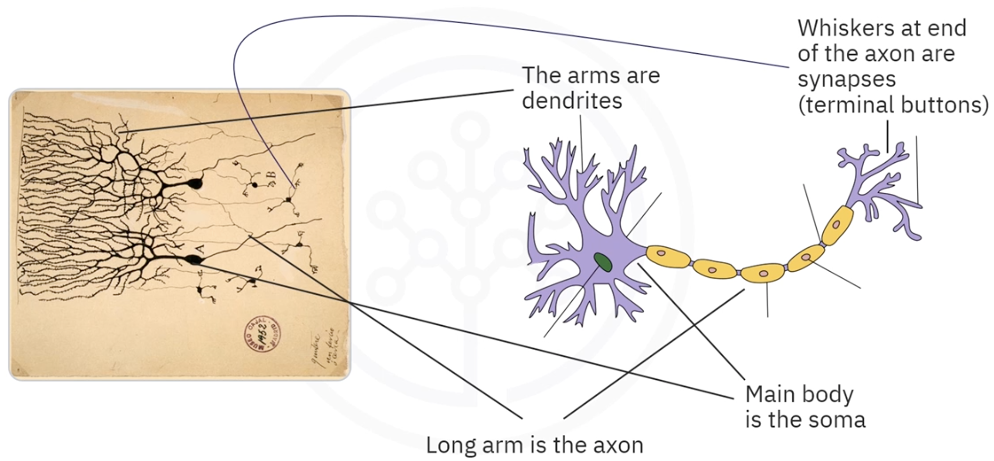

How Information Flows Through a Neuron

Step 1: Receiving Information
- Dendrites receive electrical impulses
- Information comes from nearby neurons or external sensors

Step 2: Sending Information to the Soma
- Dendrites carry the received impulses to the soma

Step 3: Processing Information
Inside the nucleus and soma:
- Electrical impulses are combined
- Information is processed
- A decision/output signal is generated

Step 4: Passing Information Through the Axon
- The processed information moves through the axon

Step 5: Communicating with Other Neurons
- Synapses transmit the output signal
- The output of one neuron becomes the input to many other neurons

Learning in the Brain
Learning occurs in the brain through repeated activation of neural connections.

Key Concepts of Biological Learning
- Some neural connections are activated more frequently than others
- Frequently used connections become stronger over time
- Stronger neural connections are more likely to produce desired outcomes
- Reinforced connections improve learning efficiency
This strengthening process is the biological inspiration behind learning in artificial neural networks.

Artificial Neurons
Artificial neurons are designed to behave similarly to biological neurons.

Components of an Artificial Neuron
Artificial neurons also contain structures analogous to:
- Soma
- Dendrites
- Axon

Similarities Between Biological and Artificial Neurons
Biological Neuron | Artificial Neuron
Receives inputs through dendrites | Receives input data
Processes information in the soma | Processes data mathematically
Sends outputs through the axon | Produces output to other neurons
Learns by strengthening connections | Learns by adjusting weights

Neural Connections
- Artificial neurons can connect to many other neurons
- Outputs from one neuron become inputs to other neurons
- This interconnected structure forms an artificial neural network

Deep Learning and Brain Inspiration
Deep learning systems are inspired by:
- Biological neurons
- Neural communication mechanisms
- Brain learning processes
- Strengthening of neural connections
Artificial neural networks imitate these biological processes to learn patterns from data and make predictions.

Summary

Important Terms
Term | Description
Soma | Main body of the neuron containing the nucleus
Dendrites | Branch-like structures that receive signals
Axon | Long structure that carries processed signals
Synapses | End points that transfer signals to other neurons

Key Points
- Deep learning is inspired by biological neural networks
- Neurons communicate using electrical impulses
- Dendrites receive information
- The soma processes information
- The axon carries processed information
- Synapses transfer outputs to other neurons
- Learning occurs by strengthening frequently used neural connections
- Artificial neurons mimic biological neuron behavior

Artificial Neural Networks

Introduction to Artificial Neural Networks
Artificial Neural Networks (ANNs) are inspired by the structure and functioning of biological neurons in the human brain. Artificial neurons are designed to mimic the behavior of real neurons by receiving inputs, processing them, and producing outputs.
One of the earliest artificial neurons was designed to:
- Accept binary inputs
- Produce a binary output
An artificial neuron is also known as a Perceptron.

Perceptron (Artificial Neuron)
A perceptron performs the following operations:
- Calculates the weighted sum of inputs
- Compares the result with a threshold
- Produces an output:
  - 1 if the sum exceeds the threshold
  - 0 otherwise
A perceptron is the fundamental building block of artificial neural networks.

Structure of a Neural Network
In a neural network, multiple perceptrons are arranged into layers.

Input Layer
The first layer that feeds data into the network is called the Input Layer.

Hidden Layers
The layers between the input and output layers are called Hidden Layers.

Output Layer
The layer responsible for generating the final output is called the Output Layer.
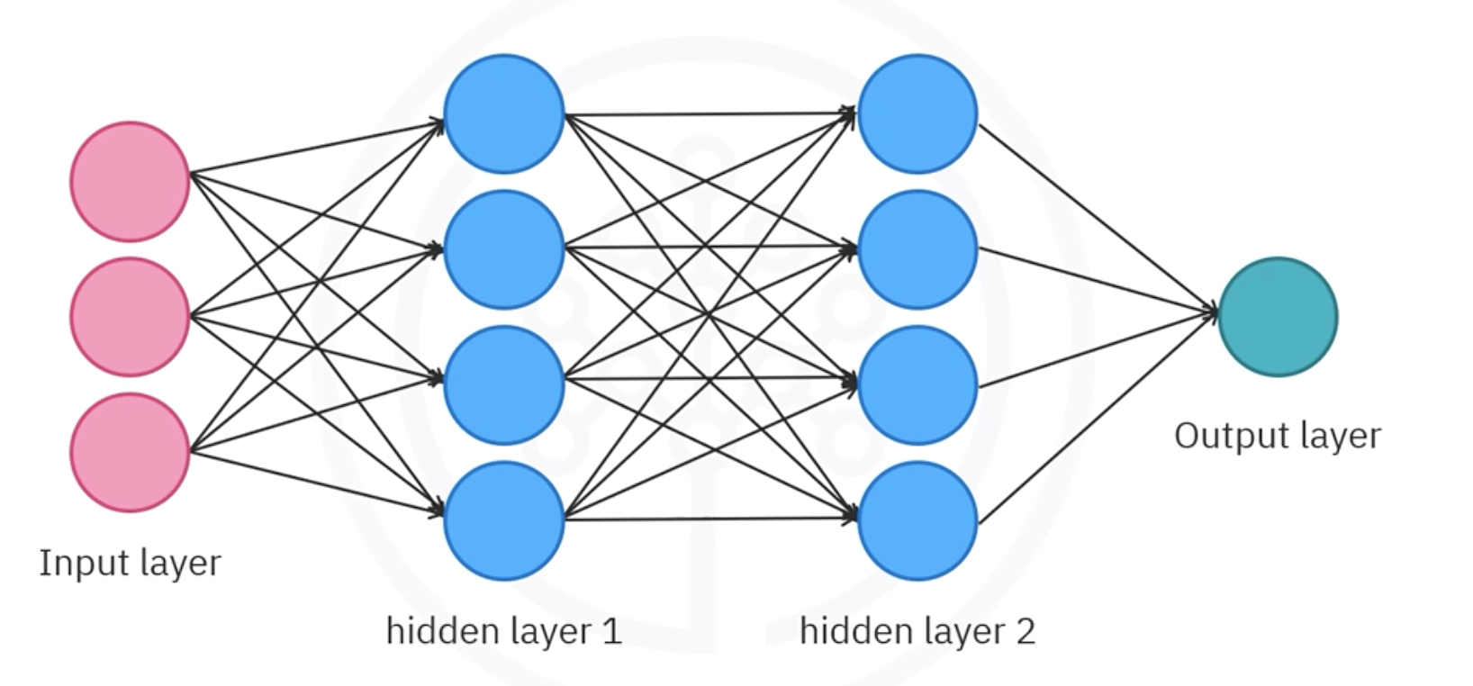

Main Topics in Neural Networks
When working with neural networks, three major concepts are commonly discussed:
- Forward Propagation
- Backpropagation
- Activation Functions
This lecture primarily focuses on Forward Propagation.

Forward Propagation
Forward propagation is the process through which data moves through the layers of a neural network:
- Data flows from the input layer
- Passes through hidden layers
- Reaches the output layer
The flow of information occurs through connections between neurons.

Mathematical Formulation of a Neuron
Consider a neuron with two inputs:
- $x_{1}$
- $x_{2}$
Each input is associated with a weight:
- $w_{1}$
- $w_{2}$
The neuron computes a weighted sum of the inputs and adds a bias term.

Linear Combination Formula
The linear combination is represented as:
$$z=w_{1}x_{1}+w_{2}x_{2}+b$$
Where:
- $z$= linear combination of inputs and weights
- $b$= bias
- $a$= output of the neuron

Important Notation
Throughout neural network discussions:
- $'z$’ always represents the linear combination
- $'a'$ always represents the neuron’s output

Importance of Activation Functions
Simply producing a weighted sum limits the capability of neural networks.
To solve complex problems, neural networks apply a nonlinear transformation using an Activation Function.

Sigmoid Activation Function
One of the most popular activation functions is the Sigmoid Function.
$$a=σ(z)=\frac{1}{1+e^{-z}}$$

Behavior of the Sigmoid Function
- If $z$is a very large positive number:
  - Output approaches 1
- If $z$ is a very large negative number:
  - Output approaches 0
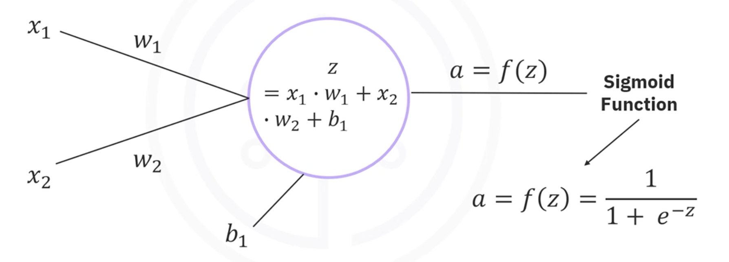

Role of Activation Functions
Activation functions determine whether a neuron should be activated.
They help the network decide:
- Which information is relevant
- Which information should be ignored

Key Takeaway
Without activation functions, a neural network behaves similarly to a linear regression model.
Activation functions enable neural networks to perform complex nonlinear tasks such as:
- Image classification
- Language translation
- Pattern recognition

Example: Forward Propagation with One Neuron
Consider a neural network with:
- One input neuron
- One perceptron

Given Values
Parameter | Value
$$x_{1}$$ | 0.1
$$w_{1}$$ | 0.15
$$b_{1}$$ | 0.4

Step 1: Compute the Linear Combination
Using the formula:
$$z=w_{1}x_{1}+b_{1}$$
Substituting the values:
$$z=(0.15)(0.1)+0.4 \\ z=0.015+0.4 \\ z=0.415$$

Step 2: Apply the Sigmoid Activation Function
$$a=σ(0.415)$$
Output:
$$a=0.6023$$
Therefore, the neuron outputs:
$$0.6023$$

Example: Neural Network with Two Neurons
In a network with two neurons:
- The output of the first neuron becomes the input to the second neuron

Process
The second neuron:
- Takes $a_{1}$as input
- Multiply it by weight $w_{2}$
- Adds bias $b_{2}$
- Applies the sigmoid activation function

Final Output
The final predicted output becomes:
$$0.7153$$
This is the predicted value for the original input:
$$x_{1}=0.1$$
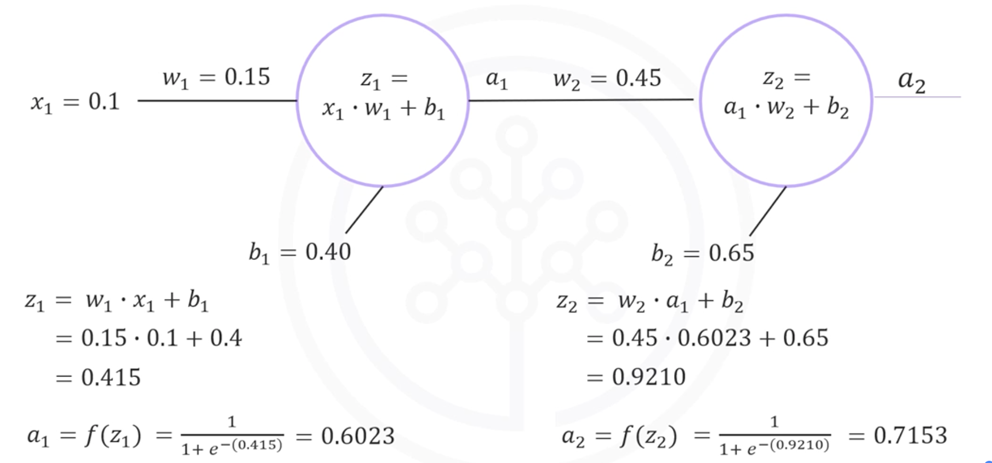

How Neural Networks Make Predictions
Regardless of how large or complex a neural network becomes, the prediction process follows the same sequence:
- Compute weighted sums
- Add biases
- Apply activation functions
- Pass outputs to the next layer
- Generate final prediction

Summary

Neural Network Layers
Layer Type | Description
Input Layer | Feeds input data into the network
Hidden Layer | Intermediate processing layers
Output Layer | Produces the final output

Important Concepts
Concept | Description
Forward Propagation | Process of passing data from input to output
Weights | Control the influence of inputs
Bias | Constant added to the weighted sum
Activation Function | Applies nonlinear transformation
Sigmoid Function | Common activation function producing values between 0 and 1

Final Takeaway
Given:
- Inputs
- Weights
- Biases
- Activation functions
You should be able to compute the output of a neural network for any input using forward propagation.

Deep Learning and Artificial Neural Networks — Lesson Summary

Introduction to Deep Learning
Deep learning is one of the hottest and most important subjects in data science. It enables machines to learn complex patterns and perform tasks that traditionally required human intelligence.

Applications of Deep Learning

Color Restoration Applications
Color restoration systems can automatically convert grayscale images into fully colored images.

Speech Enactment Applications
Speech enactment applications can:
- Synthesize audio clips with lip movements in videos
- Extract audio from one video
- Synchronize lip movements with audio from another video

Handwriting Generation Applications
Handwriting generation systems can rewrite provided text in highly realistic cursive handwriting across a wide variety of writing styles.

Biological Inspiration Behind Deep Learning
Deep learning algorithms are largely inspired by the way biological neurons and neural networks function in the human brain.

Structure of a Biological Neuron

Soma
The main body of a neuron is called the Soma.

Dendrites
The extensive network of arm-like structures extending from the soma are called Dendrites.
Functions of dendrites:
- Receive electrical impulses
- Carry information from neighboring neurons
- Transfer impulses to the soma

Axon
The long extension projecting from the soma is called the Axon.
Function of the axon:
- Carries processed information away from the neuron

Synapses
The whisker-like endings at the end of the axon are called Synapses.
Functions of synapses:
- Transmit signals to adjoining neurons
- Allow communication between neurons

Information Processing in Biological Neurons
The processing workflow inside a neuron is as follows:
- Dendrites receive electrical impulses
- Signals are passed to the soma
- The nucleus processes and combines the impulses
- The processed information is transferred to the axon
- The axon carries information to the synapses
- The output becomes input for thousands of other neurons

Learning Mechanism in the Brain
Learning in the human brain occurs through repeated activation of certain neural connections.
Repeated activation strengthens and reinforces these neural pathways over time.

Artificial Neurons
Artificial neurons are designed to behave similarly to biological neurons.
They form the fundamental building blocks of artificial neural networks.

Neural Network Layers

Input Layer
The first layer that feeds input data into the neural network is called the Input Layer.

Hidden Layers
The intermediate layers between the input and output layers are called Hidden Layers.

Output Layer
The layer responsible for generating the final network output is called the Output Layer.

Forward Propagation
Forward propagation is the process through which data moves through the layers of a neural network:
- From the input layer
- Through hidden layers
- To the output layer
This process enables the network to generate predictions or outputs.

Weights and Biases in Neural Networks
Neural networks use:
- Weights
- Biases
to process input data and compute outputs.
Given a neural network with known weights and biases, it is possible to compute the output for any given input.

Key Takeaways
Concept | Description
Deep Learning | A major field in data science inspired by the human brain
Artificial Neuron | Computational model inspired by biological neurons
Dendrites | Receive information from other neurons
Soma | Main body of the neuron
Axon | Transfers processed information
Synapses | Connect neurons for communication
Input Layer | Receives input data
Hidden Layers | Perform intermediate computations
Output Layer | Produces final predictions
Forward Propagation | Flow of data through the network
Weights and Biases | Parameters used to compute outputs

Module 2: Basics of Deep Learning

Gradient Descent

Introduction to Gradient Descent
Before learning how neural networks optimize weights and biases, it is important to understand Gradient Descent. Gradient Descent is an iterative optimization technique used to minimize a function, especially in machine learning models.

Problem Setup: Dataset and Objective
Consider a simple dataset shown as a scatterplot.
For simplicity:
- The dataset is constructed such that
z = 2x
We want to find a weight value w such that a line:
- z = wx
best fits the data.
The goal is to determine the optimal value of w that minimizes prediction error.

Cost (Loss) Function
To measure how well a chosen value of w fits the data, we define a cost function:
Cost Function (J):
- It computes the difference between actual values (z) and predicted values (wx)
- It squares these differences
- It sums them across all data points
Mathematically:
J(w) = Σ (z − wx)²

Purpose of the Cost Function
- Measures prediction error
- Helps evaluate model performance
- The smaller the value, the better the fit
The best value of w is the one that minimizes J(w).

Shape of the Cost Function
The cost function in this example has a special property:
- It forms a parabola
- It has a single global minimum
- It has a unique optimal solution
For this dataset:
- The minimum occurs at: w = 2
- This produces the perfect model: z = 2x
At this point, the line fits all data points exactly.

Why Optimization is Needed
In real-world problems:
- There are multiple variables (features)
- There are many weights to optimize
- The cost function cannot be visualized easily
Therefore, we need an automatic method to find the minimum.
This method is called Gradient Descent.
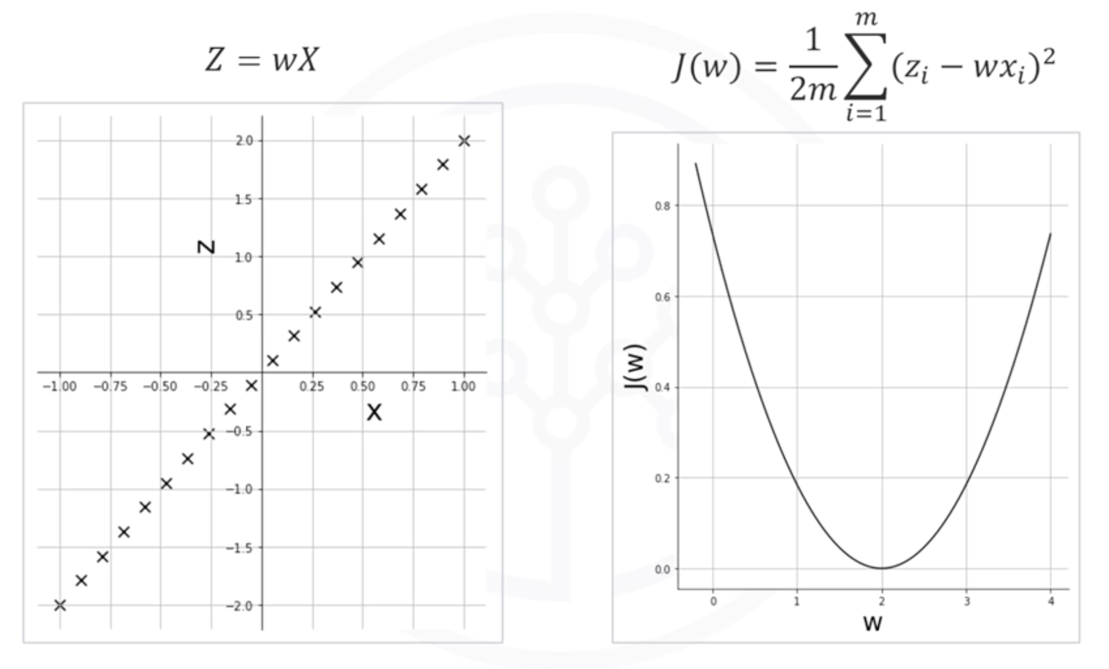

Gradient Descent Algorithm
Gradient Descent is an iterative optimization algorithm used to find the minimum of a function.

Core Idea
At each step:
- Compute the gradient (slope) of the cost function
- Move in the direction opposite to the gradient
- Repeat until reaching the minimum

Initialization
The process starts by choosing a random initial value of w:
Example:
- w₀ = 0.2
This is the starting point of optimization.

Gradient Calculation
At each step:
- Compute the slope of the cost function at the current value of w
- This slope is called the gradient
The gradient indicates:
- Direction of steepest increase
So we move in the opposite direction to reduce error.

Weight Update Rule
The weight is updated using:
w₁ = w₀ − η × gradient
Where:
- w₀ = current weight
- w₁ = updated weight
- η = learning rate
- gradient = slope of the cost function
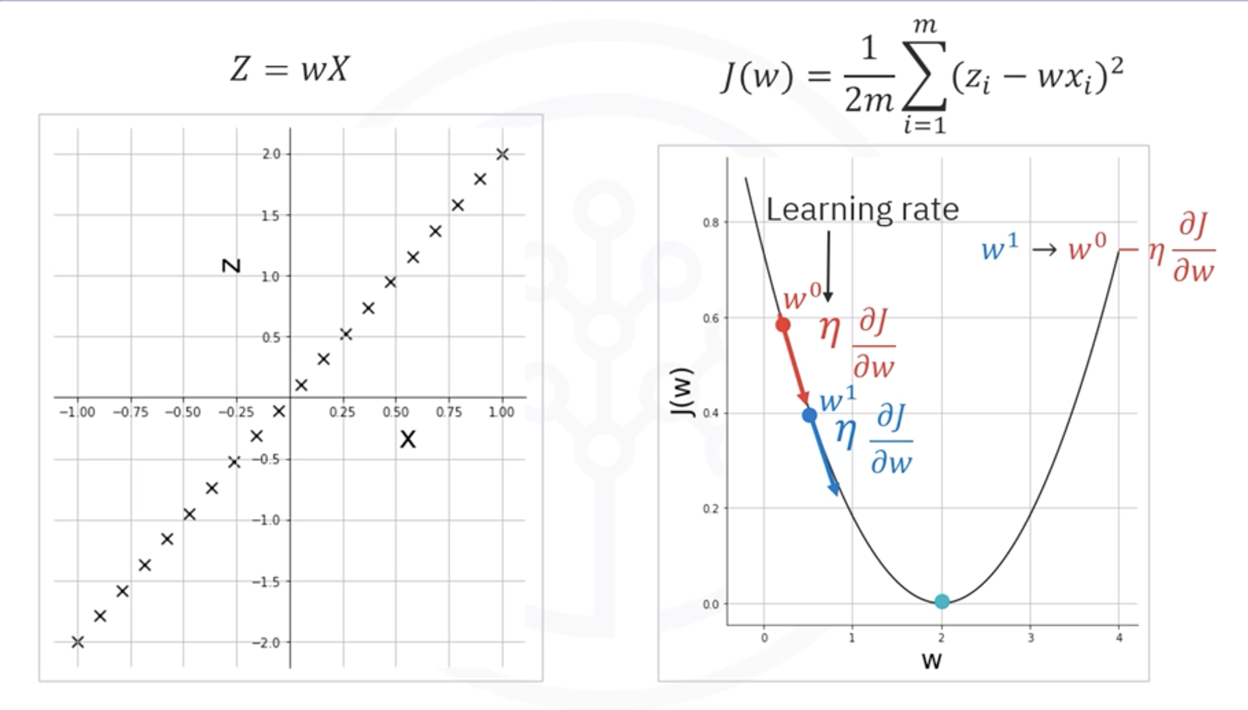

Iterative Process
Gradient Descent repeats the following steps:
- Compute the gradient at the current point
- Update the weight using the rule
- Move closer to the minimum
- Repeat until convergence

Stopping Condition
The algorithm stops when:
- It reaches the minimum, OR
- The change becomes very small (below a threshold)

Learning Rate
The learning rate (η) controls the step size during updates.

Large Learning Rate
- Takes large steps
- May overshoot the minimum
- Can miss the optimal solution

Small Learning Rate
- Takes very small steps
- Requires many iterations
- Slow convergence

Key Insight
Choosing the learning rate is critical for successful optimization.

Example: Gradient Descent Iterations (Learning Rate = 0.4)

Initial State
- w = 0
- z = 0
This produces a horizontal line.

Observation
- The line is a poor fit
- The cost is very high

First Iteration
- The gradient is very steep at w = 0
- Large update step occurs
- w moves closer to 2
Result:
- Significant reduction in cost
- Better fitting line

Second Iteration
- Slope becomes less steep
- Step size becomes smaller
- w continues moving toward 2
Result:
- Cost decreases further
- Fit improves

Third Iteration
- Gradient continues to reduce
- Smaller updates occur
- w approaches optimal value

Fourth Iteration
- w is very close to 2
- Line nearly fits the data perfectly
Final observation:
- Model is almost fully optimized

Key Insight from Iterations
Each update follows this principle:
- Move opposite to the gradient direction
- Reduce cost step by step
- Converge gradually toward the minimum

Direction of Movement
- If w is to the right of the minimum → gradient is positive → move left
- If w is to the left of the minimum → gradient is negative → move right
Thus, Gradient Descent always moves toward the minimum.
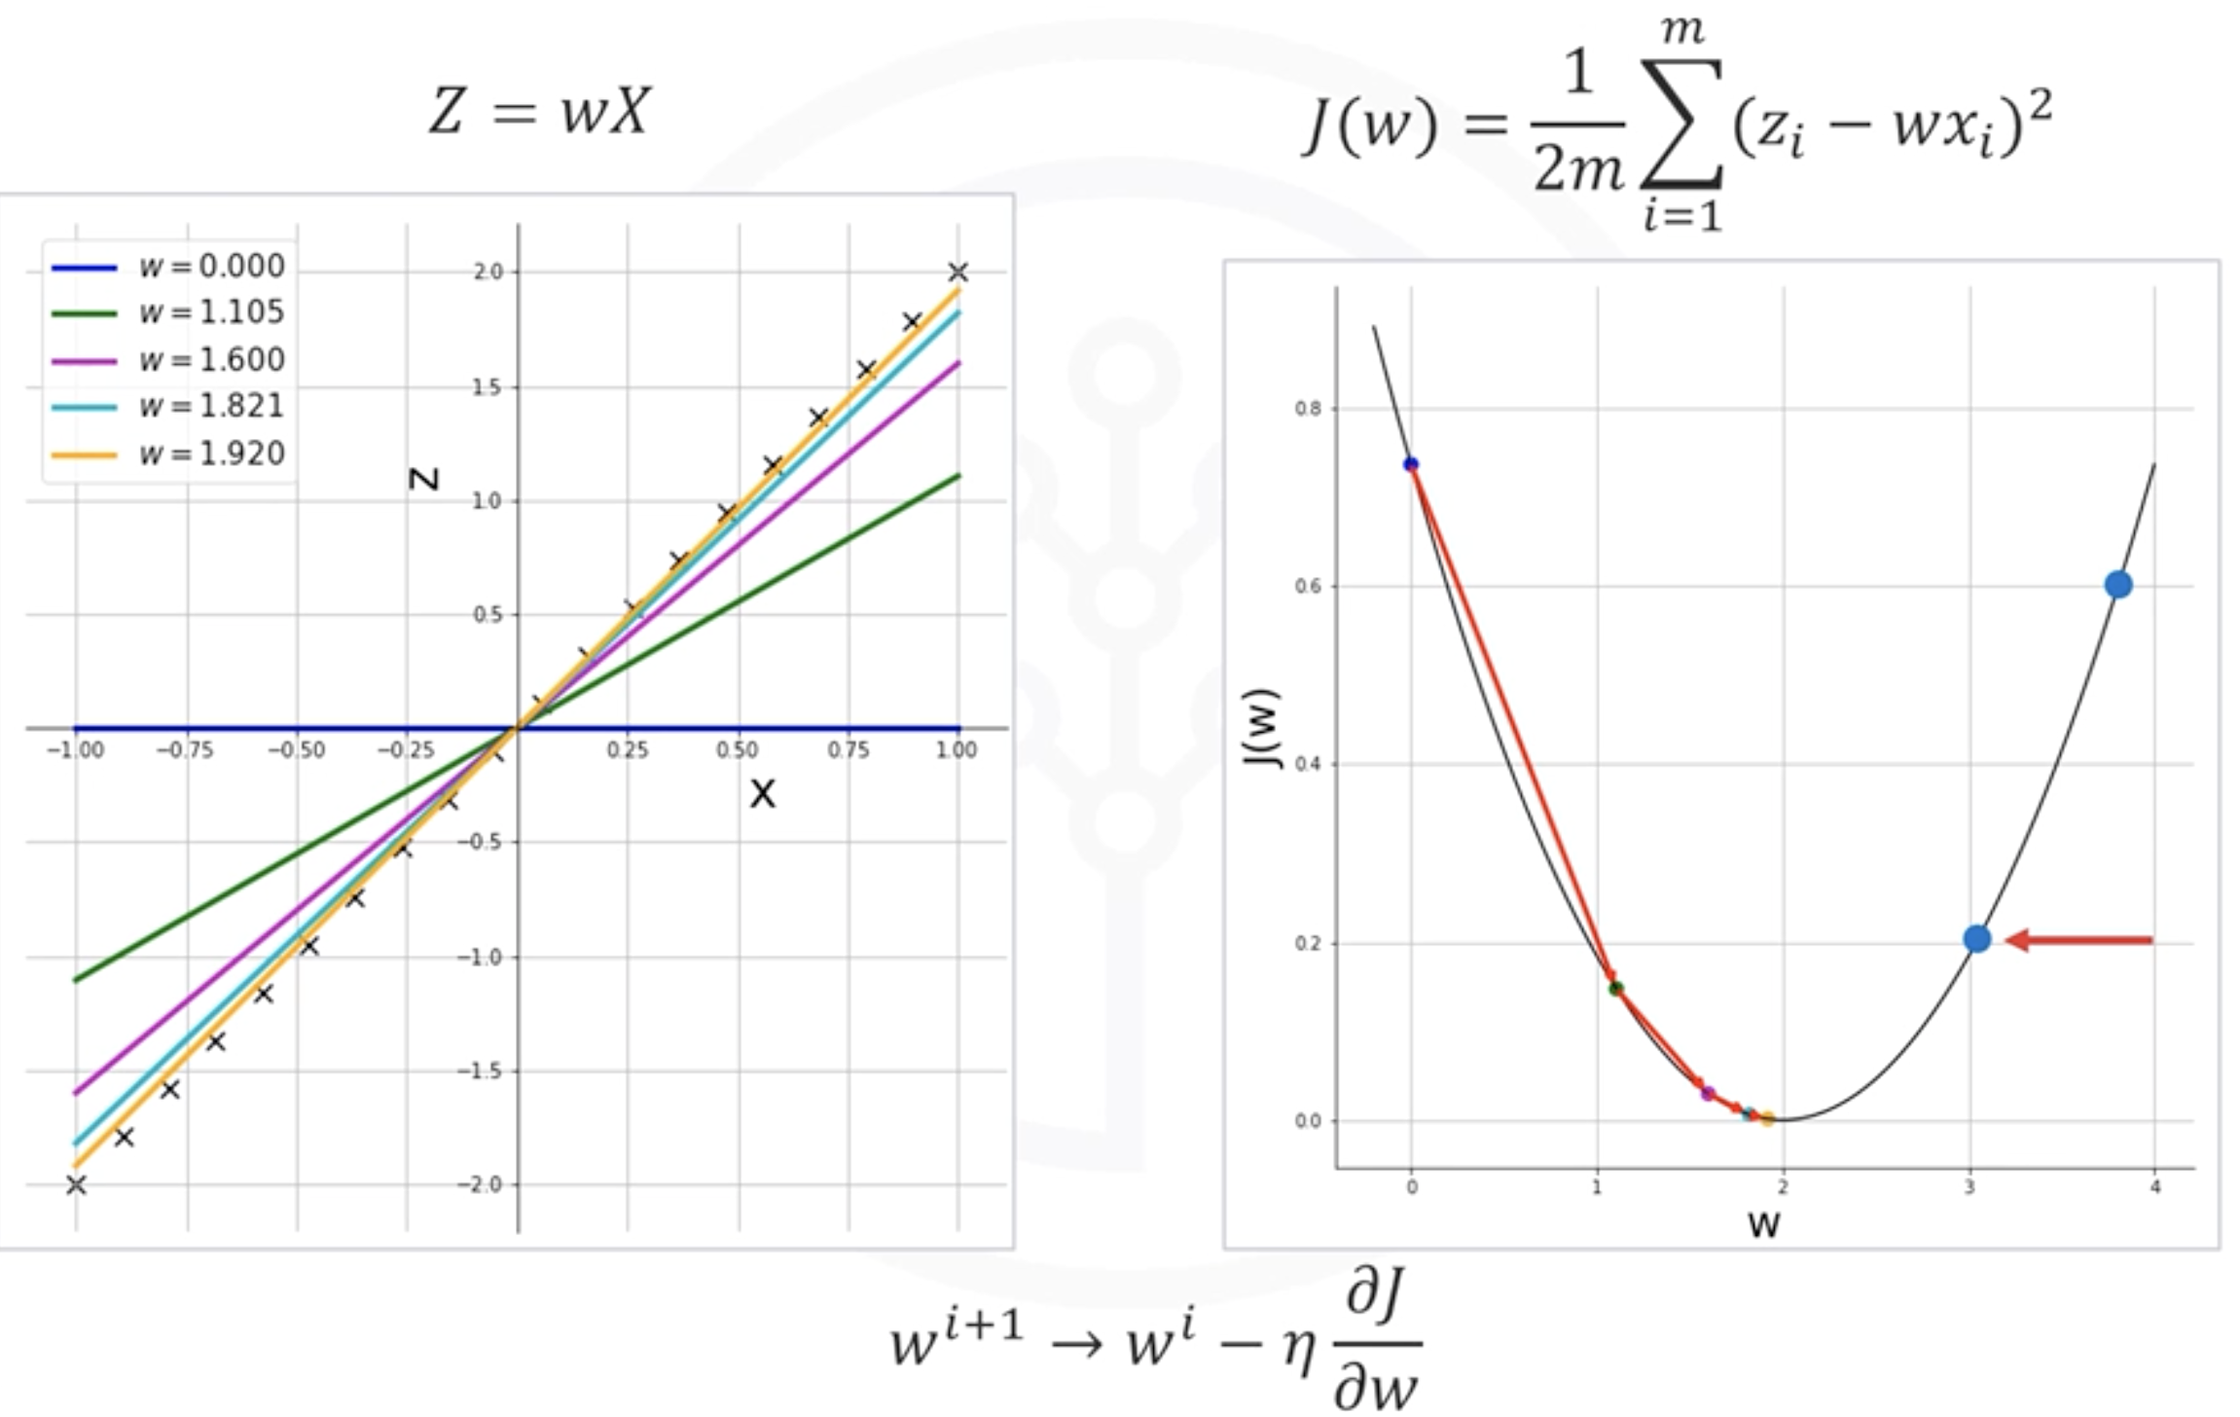

Key Takeaways
- Gradient Descent is an iterative optimization algorithm
- It minimizes a cost function step by step
- The cost function measures prediction error
- The gradient determines the direction of movement
- The learning rate controls the step size
- Proper learning rate selection is essential for convergence
- Repeated iterations gradually improve model fit until optimal performance is reached

Neural Network Training and Backpropagation

Introduction to Neural Network Training
Neural networks learn by training and optimizing their weights and biases. During training, the network adjusts these parameters to minimize prediction error and improve accuracy.

Supervised Learning
Neural network training is commonly performed using supervised learning.

Definition
In supervised learning:
- Each input data point has a corresponding label or ground truth
- The network learns by comparing predictions with actual values

Training Objective
The goal is to minimize the difference between:
- Predicted output
- Ground truth (target output)

Neural Network Training Process
Training begins when:
- The network prediction does not match the ground truth
The network then:
- Computes the prediction error
- Propagates the error backward
- Updates weights and biases
- Repeats the process iteratively

Forward Propagation Review
Before training, the network performs forward propagation.

Forward Propagation Steps
- Input passes through neurons
- Weighted sums are calculated
- Activation functions are applied
- Final prediction is generated
The predicted output is represented as:
$$a_{2}$$
The ground truth is represented as:
$$T$$

Error (Loss) Function
The network calculates the error between:
- Ground truth $T$
- Predicted value $a_{2}$

Squared Error Function
$$E=\frac{1}{2}(T-a_{2})^{2}$$
This error function represents the cost or loss function.

Mean Squared Error (MSE)
In real-world training:
- Networks are trained on thousands of data points
- Error is averaged across all samples

Mean Squared Error Formula
$$MSE=\frac{1}{N}∑(T-a_{2})^{2}$$
Where:
- $N$= number of training samples

Backpropagation
Backpropagation is the process of propagating the error backward through the network to update weights and biases.

Purpose of Backpropagation
Backpropagation helps:
- Compute gradients
- Determine how much each weight contributed to the error
- Update weights to minimize loss

Updating Weights Using Gradient Descent
Weights are updated using Gradient Descent.

General Weight Update Rule
$$w_{new}=w_{old}-η\frac{∂E}{∂w}$$
Where:
- $η$= learning rate
- $\frac{∂E}{∂w}$= gradient of error with respect to weight
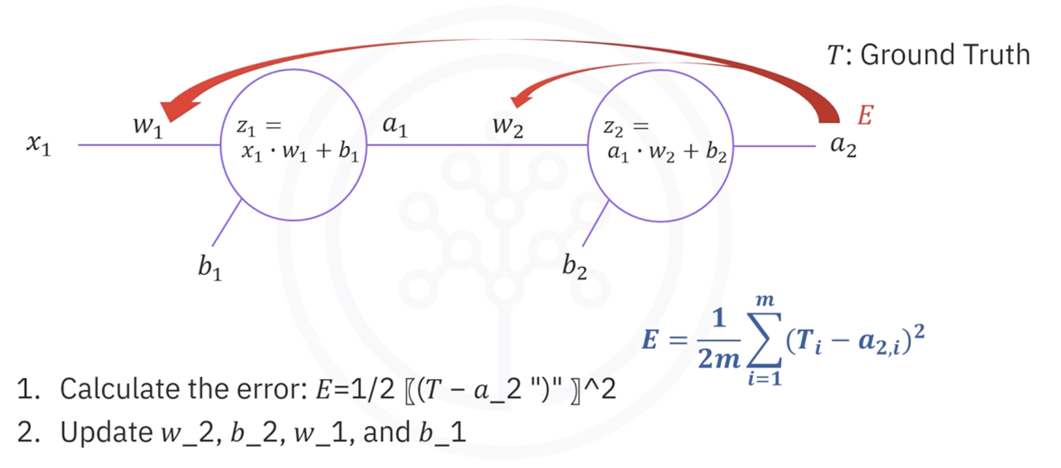

Chain Rule in Backpropagation
The error is not directly dependent on all weights.
Therefore, we use the Chain Rule from calculus.

Updating Weight $w_{2}$

Dependency Chain
The error depends on:
$$E→a_{2}→z_{2}→w_{2}$$

Chain Rule Expression
$$\frac{∂E}{∂w_{2}}=\frac{∂E}{∂a_{2}}⋅\frac{∂a_{2}}{∂z_{2}}⋅\frac{∂z_{2}}{∂w_{2}}$$
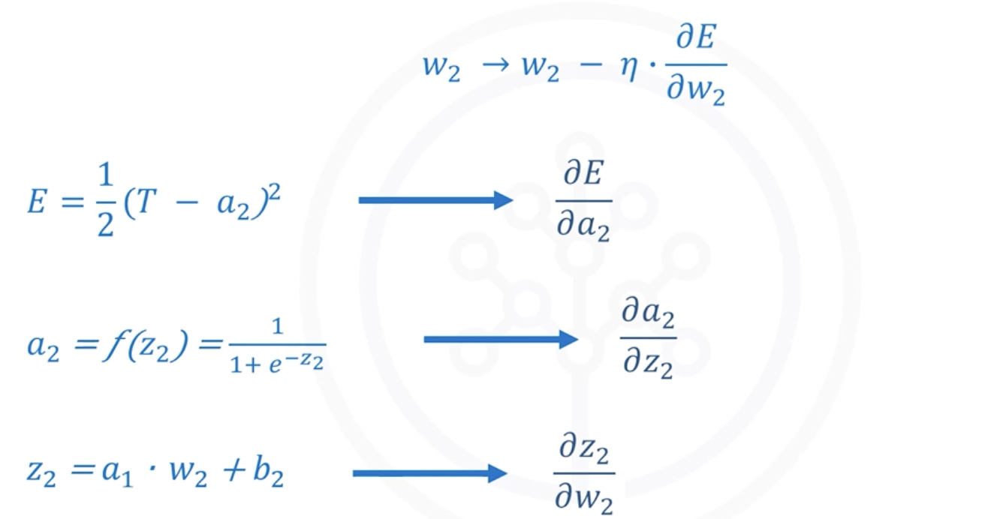

Individual Derivatives

Derivative of Error with Respect to $a_{2}$
$$\frac{∂E}{∂a_{2}}=-(T-a_{2})$$

Derivative of Activation with Respect to $z_{2}$
$$\frac{∂a_{2}}{∂z_{2}}=a_{2}(1-a_{2})$$

Derivative of $z_{2}$with Respect to $w_{2}$
$$\frac{∂z_{2}}{∂w_{2}}=a_{1}$$

Final Gradient Expression for $w_{2}$
$$\frac{∂E}{∂w_{2}}=-(T-a_{2})⋅a_{2}(1-a_{2})⋅a_{1}$$

Updating Bias $b_{2}$
The update process for $b_{2}$ is similar.

Important Difference
$$\frac{∂z_{2}}{∂b_{2}}=1$$
Instead of:
$$\frac{∂z_{2}}{∂w_{2}}=a_{1}$$
So,
$$\frac{∂E}{∂b_{2}}=-(T-a_{2})⋅a_{2}(1-a_{2})⋅1$$

Updating Weight $w_{1}$

Dependency Chain
The error depends on:
$$E→a_{2}→z_{2}→a_{1}→z_{1}→w_{1}$$

Chain Rule Expression
$$\frac{∂E}{∂w_{1}}=\frac{∂E}{∂a_{2}}⋅\frac{∂a_{2}}{∂z_{2}}⋅\frac{∂z_{2}}{∂a_{1}}⋅\frac{∂a_{1}}{∂z_{1}}⋅\frac{∂z_{1}}{∂w_{1}}$$

Individual Derivatives

Output Error Derivative
$$\frac{∂E}{∂a_{2}}=-(T-a_{2})$$

Activation Derivative at Output Layer
$$\frac{∂a_{2}}{∂z_{2}}=a_{2}(1-a_{2})$$

Derivative of $z_{2}$with Respect to $a_{1}$
$$\frac{∂z_{2}}{∂a_{1}}=w_{2}$$

Hidden Layer Activation Derivative
$$\frac{∂a_{1}}{∂z_{1}}=a_{1}(1-a_{1})$$

Derivative of $z_{1}$with Respect to $w_{1}$
$$\frac{∂z_{1}}{∂w_{1}}=x_{1}$$

Final Gradient Expression for $w_{1}$
$$\frac{∂E}{∂w_{1}}=-(T-a_{2})⋅a_{2}(1-a_{2})⋅w_{2}⋅a_{1}(1-a_{1})⋅x_{1}$$

Updating Bias $b_{1}$
The same backpropagation approach is used to compute the update rule for $b_{1}$.
So,
$$\frac{∂E}{∂b_{1}}=-(T-a_{2})⋅a_{2}(1-a_{2})⋅w_{2}⋅a_{1}(1-a_{1})⋅1$$

Example of Backpropagation

Initial Network Parameters
Consider a neural network with:
- Two neurons
- One input
- Initial weights and biases

Forward Propagation Results
After forward propagation:

Hidden Layer
$$z_{1}=0.415 \\ a_{1}=0.6023$$

Output Layer
$$z_{2}=0.9210 \\ a_{2}=0.7153$$
The predicted output is:
$$0.7153$$
For input:
$$x=0.1$$

Ground Truth
Assume the actual target value is:
$$T=0.25$$
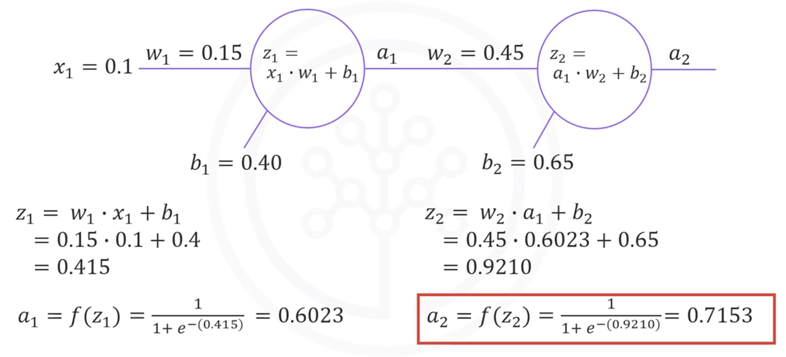

Error Computation
The network first computes the error between:
- Predicted value
- Ground truth

Training Iterations (Epochs)
The network updates weights and biases for:
- A predefined number of epochs (e.g., 1000)
- Or until the error becomes very small
Example threshold:
$$0.001$$

Learning Rate
Assume:
$$η=0.4$$

First Iteration Updates

Updating $w_{2}$
Calculated gradient:
$$\frac{∂E}{∂w_{2}}=0.05706$$
Updated weight:
$$w_{2}=0.427$$
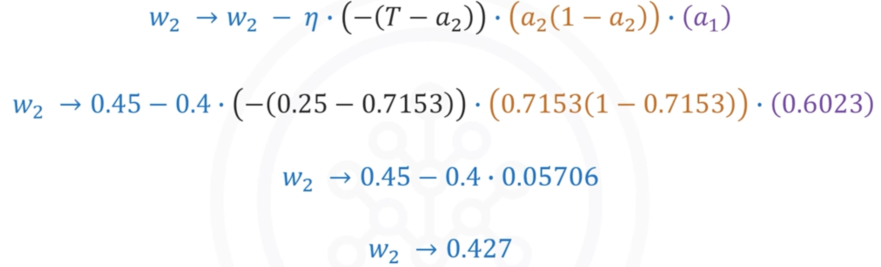

Updating $b_{2}$
Calculated gradient:
$$\frac{∂E}{∂b_{2}}=0.0948$$
Updated bias:
$$b_{2}=0.612$$

Updating $w_{1}$
Calculated gradient:
$$\frac{∂E}{∂w_{1}}=0.001021$$
Updated weight:
$$w_{1}=0.1496$$

Updating $b_{1}$
Calculated gradient:
$$\frac{∂E}{∂b_{1}}=0.01021$$
Updated bias:
$$b_{1}=0.3959$$
This completes one iteration (epoch) of training.

Repeating the Training Process
After updating the parameters:
- Perform forward propagation again
- Compute the new prediction
- Calculate new error
- Apply backpropagation
- Update weights and biases again
This cycle repeats continuously.

Complete Neural Network Training Algorithm

Step 1 — Initialize Parameters
Initialize:
- Weights
- Biases
Using random values.

Step 2 — Forward Propagation
Compute network predictions using forward propagation.

Step 3 — Compute Error
Calculate the difference between:
- Predicted output
- Ground truth

Step 4 — Backpropagation
Propagate the error backward through the network.

Step 5 — Update Parameters
Update:
- Weights
- Biases
Using Gradient Descent.

Step 6 — Repeat
Repeat all steps until:
- Maximum epochs are reached
- Or an error falls below a threshold

Key Concepts Summary

Forward Propagation
Forward propagation:
- Computes predictions
- Passes information from input to the output layer

Backpropagation
Backpropagation:
- Propagates error backward
- Computes gradients
- Helps optimize parameters

Gradient Descent
Gradient Descent:
- Minimizes error
- Updates weights iteratively

Learning Rate
The learning rate:
- Controls update size
- Affects convergence speed

Epoch
An epoch is:
- One complete training cycle
- One forward pass plus one backward pass

Final Takeaways
- Neural networks learn by minimizing prediction error.
- Training uses supervised learning with labeled data.
- Forward propagation computes predictions.
- Backpropagation computes gradients using the Chain Rule.
- Gradient Descent updates weights and biases.
- Training repeats iteratively until convergence.
- Proper selection of the learning rate is essential for stable learning.

Vanishing Gradient Problem

Introduction to the Vanishing Gradient Problem
The Vanishing Gradient Problem is one of the major challenges encountered during the training of deep neural networks.

Background
Early neural networks commonly used the sigmoid activation function.
Although sigmoid functions helped introduce non-linearity into neural networks, they also created a serious optimization issue known as the Vanishing Gradient Problem.
This problem significantly slowed the development and success of deep neural networks.

Sigmoid Activation Function
The sigmoid activation function produces outputs between 0 and 1.
The sigmoid equation is:
$$σ(x)=\frac{1}{1+e^{-x}}$$

Characteristics of the Sigmoid Function
- Output values always lie between 0 and 1
- Smooth and differentiable
- Commonly used in early neural networks
However, despite these advantages, sigmoid functions create very small gradients during backpropagation.

Understanding the Vanishing Gradient Problem
During training, neural networks use backpropagation to update weights.
Backpropagation computes gradients of the error with respect to each weight in the network.

Problem Observation
In a simple network with only two neurons:
- Gradients already become very small
- Earlier layer gradients are even smaller
Especially:
- The gradient of the error with respect to $W_{1}$becomes extremely small

Why Gradients Vanish
Because sigmoid outputs are between 0 and 1:
$$0<σ(x)<1$$
During backpropagation:
- Many small values are multiplied together
- Multiplying numbers less than 1 repeatedly causes the result to shrink rapidly

Example
$$0.5×0.5×0.5×0.5=0.0625$$
As multiplication continues across many layers:
- Gradients become extremely close to zero
- Weight updates become negligible

Backpropagation and Gradient Shrinking
Backpropagation works layer by layer from the output layer toward earlier layers.
The gradient at each layer depends on:
- The gradient from the next layer
- The derivative of the activation function
For sigmoid activation:
- Derivatives are small
- Repeated multiplication reduces gradients further

Result
Gradients progressively decrease as we move backward through the network.

Effect on Neural Network Training

Earlier Layers Learn Very Slowly
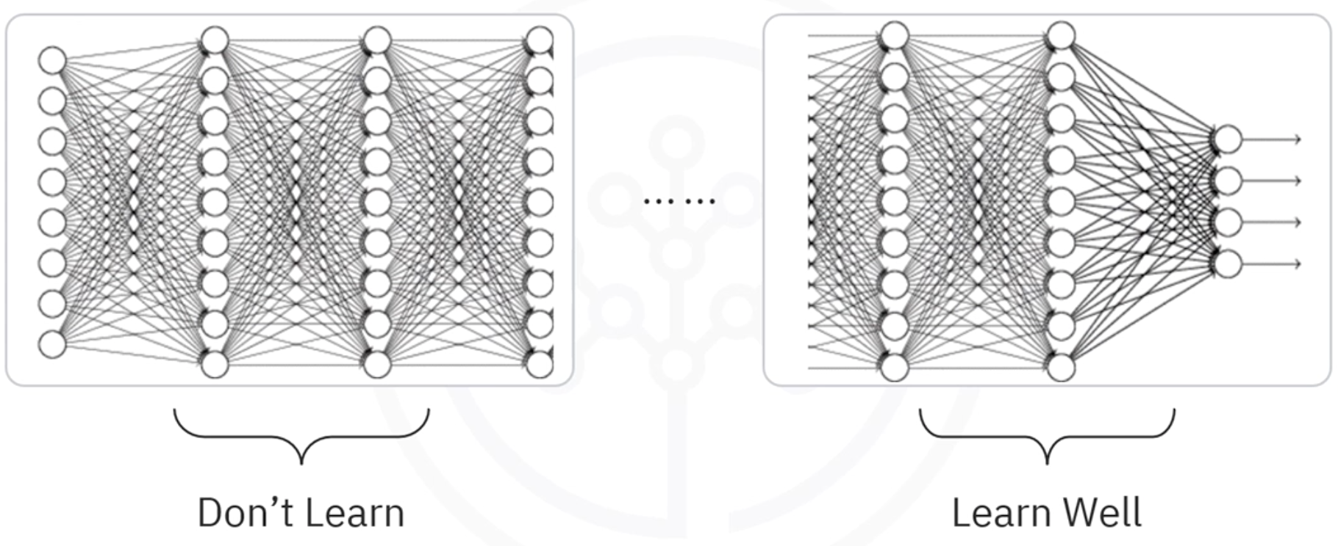
Because gradients become tiny:
- Weight updates in early layers are extremely small
- Earlier layers learn much more slowly than later layers

Training Becomes Inefficient
This leads to:
- Long training times
- Poor convergence
- Reduced prediction accuracy

Compromised Performance
Since earlier layers fail to learn properly:
- Feature extraction becomes weak
- Overall model performance suffers

Why Sigmoid Functions Are Avoided
Modern deep learning models generally avoid using sigmoid activation functions in hidden layers because they are prone to vanishing gradients.

Main Reason
Sigmoid functions:
- Produce outputs between 0 and 1
- Cause gradients to shrink during backpropagation
- Slow down learning in deep networks

Key Characteristics of the Vanishing Gradient Problem

Small Gradients
Gradients become extremely small during backpropagation.

Slow Learning in Early Layers
Neurons in earlier layers update their weights very slowly.

Training Instability
Training deep networks becomes difficult and inefficient.

Reduced Accuracy
The model may fail to learn useful features effectively.

Mathematical Insight
The derivative of the sigmoid activation function is:
$$σ^{'}(x)=σ(x)(1-σ(x))$$
Since:
$$0<σ(x)<1$$
The derivative is always small.
This contributes directly to shrinking gradients during backpropagation.

Summary of the Vanishing Gradient Process
- The sigmoid activation function produces outputs between 0 and 1.
- During backpropagation, gradients are multiplied layer by layer.
- Repeated multiplication of small values causes gradients to shrink rapidly.
- Earlier layers receive extremely tiny gradients.
- Weight updates become very small.
- Training becomes slow and less effective.

Key Takeaways
- The Vanishing Gradient Problem occurs when gradients become extremely small during backpropagation.
- Sigmoid activation functions are highly prone to this problem.
- Repeated multiplication of values less than 1 causes gradients to shrink.
- Earlier layers in deep neural networks learn very slowly.
- Training becomes inefficient, and prediction accuracy decreases.

Activation Functions in Neural Networks

Introduction to Activation Functions
Activation functions play a major role in the learning process of neural networks. They determine whether a neuron should be activated and help neural networks learn complex nonlinear relationships in data.

Role of Activation Functions
In a neural network:
- Each neuron computes a weighted sum of inputs
- The activation function transforms this value into an output
- This transformation introduces nonlinearity into the network
Without activation functions, neural networks would behave like simple linear models and would not be able to learn complex patterns.

Types of Activation Functions
There are several activation functions used in neural networks, including:
- Binary Step Function
- Linear (Identity) Function
- Sigmoid (Logistic) Function
- Hyperbolic Tangent (tanh) Function
- Rectified Linear Unit (ReLU)
- Leaky ReLU
- Softmax Function
The most commonly discussed and widely used activation functions are:
- Sigmoid
- Hyperbolic Tangent (tanh)
- ReLU
- Softmax

Sigmoid Activation Function
The Sigmoid function is also called the Logistic function.

Formula
$$a=\frac{1}{1+e^{-z}}$$

Characteristics of the Sigmoid Function
- Output values range between 0 and 1
- At $z=0$ the output is:
$$a=0.5$$
- Large positive values of $z$ produce outputs close to 1
- Large negative values of $z$ produce outputs close to 0

Advantages
- Smooth and differentiable
- Produces probability-like outputs
- Historically popular in neural networks

Limitations of the Sigmoid Function

Vanishing Gradient Problem
The Sigmoid function becomes flat for large positive or negative values.
Typically:
- Flat near $z>3$
- Flat near $z<-3$
In these regions:
- Gradients become extremely small
- Weight updates become negligible
- The network learns very slowly or stops learning
This issue is called the vanishing gradient problem.

Lack of Symmetry
The Sigmoid function outputs values only between:
$$0\text{ to }1$$
This means:
- Outputs are always positive
- The function is not symmetric around the origin
- Neurons in the next layer receive activations of the same sign
This can negatively affect optimization.
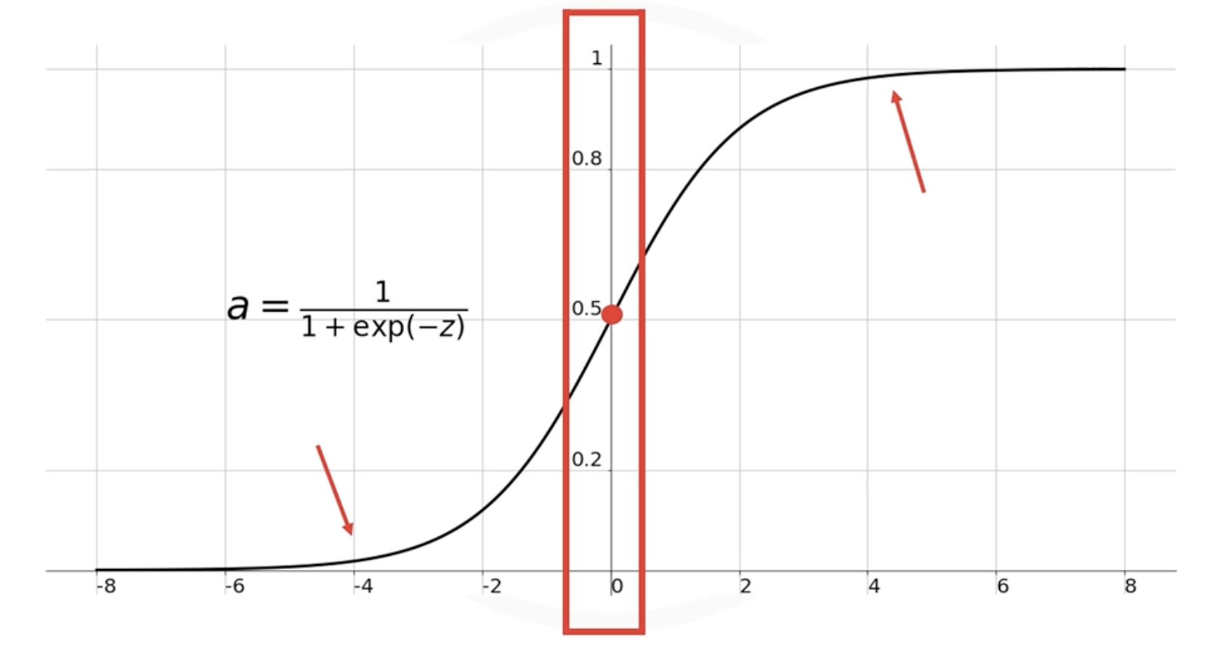

Hyperbolic Tangent (tanh) Function
The hyperbolic tangent function is very similar to the Sigmoid function.

Formula
$$a=tanh⁡(z)$$

Characteristics of tanh
- Output values range between:
$$-1\text{ to }1$$
- Symmetrical around the origin
- Scaled version of the Sigmoid function

Advantages
- Outputs include both positive and negative values
- Better symmetry improves optimization
- Often performs better than Sigmoid

Limitations
Although tanh solves the symmetry issue, it still suffers from:
- Vanishing gradient problem
- Slow learning in very deep neural networks
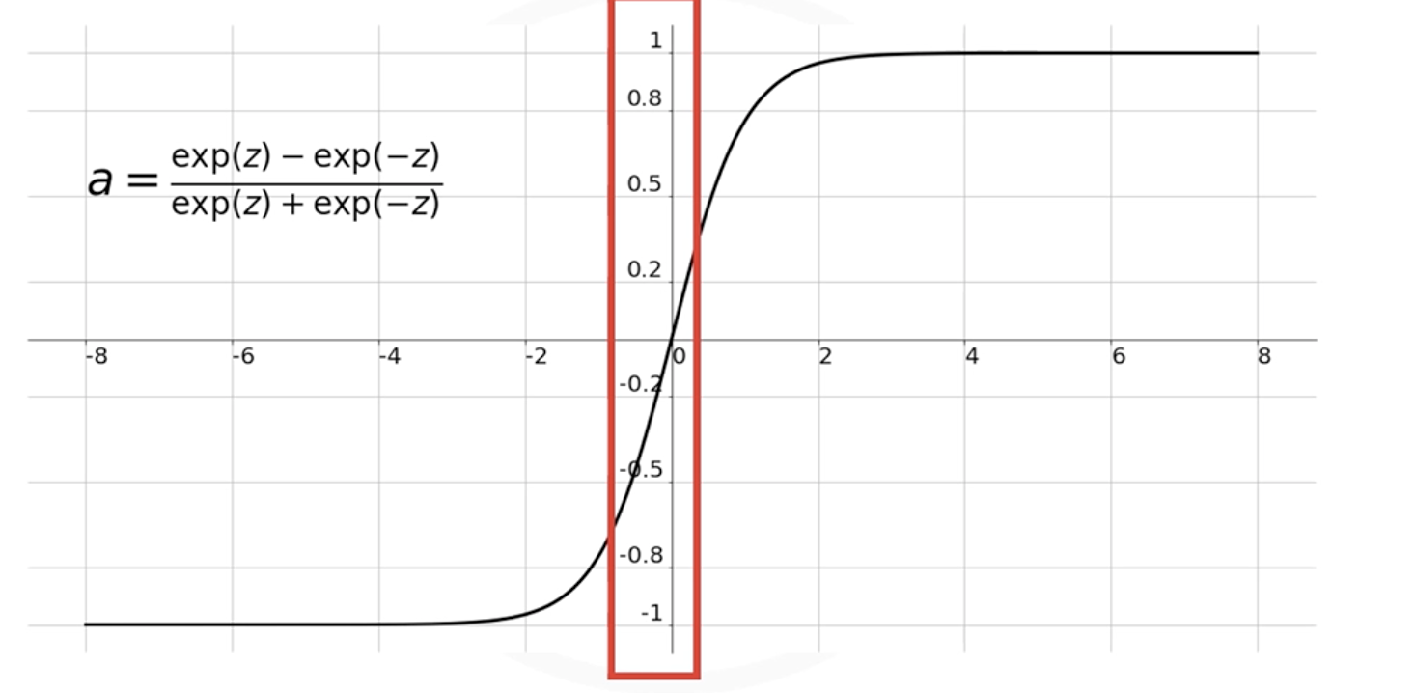

ReLU (Rectified Linear Unit)
The Rectified Linear Unit (ReLU) is the most widely used activation function in modern deep learning.

Formula
$$a=max⁡(0,z)$$

Behavior of ReLU
- If input is positive → output equals input
- If input is negative → output becomes zero

Example
Input $z$ | Output $a$
-5 | 0
-1 | 0
0 | 0
3 | 3
7 | 7

Advantages of ReLU

Sparse Activation
ReLU does not activate all neurons simultaneously.
If input is negative:
$$a=0$$
This means:
- Some neurons remain inactive
- The network becomes sparse
- Computation becomes more efficient

Helps Overcome the Vanishing Gradient Problem
One of the major reasons for ReLU’s popularity is that it significantly reduces the vanishing gradient problem.
This advancement played a major role in the success of deep learning.

Computational Efficiency
ReLU is:
- Simple
- Fast to compute
- Efficient for large neural networks
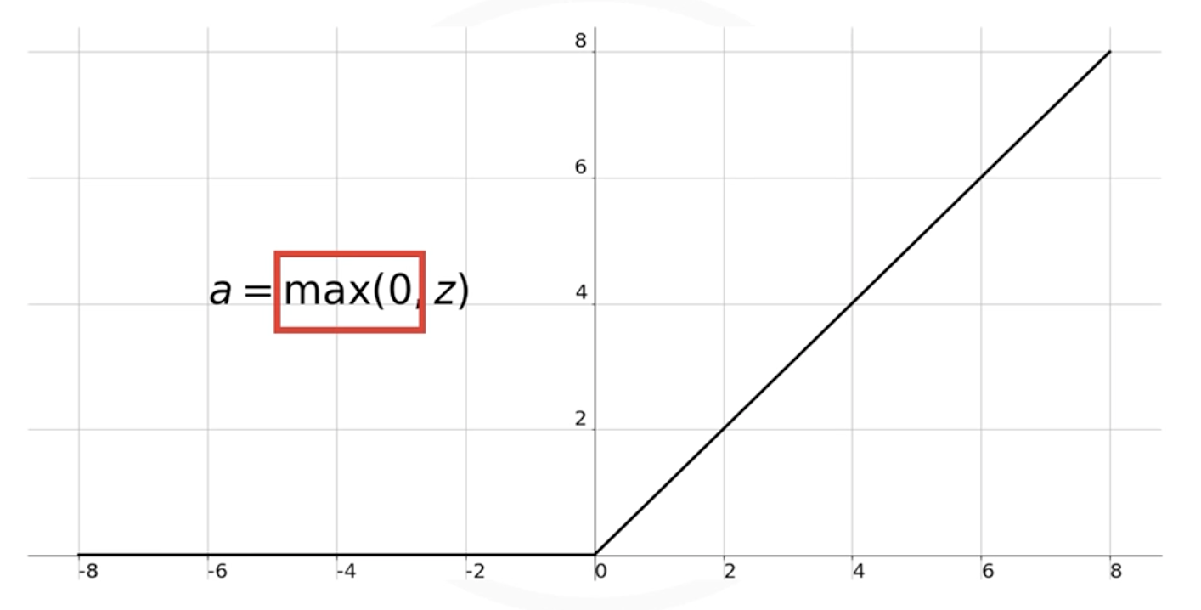

Leaky ReLU
Leaky ReLU is a variation of ReLU designed to address the “dying ReLU” problem.
Instead of outputting zero for all negative inputs, it outputs a small negative value.

Formula
$$a=max⁡(0.01z,z)$$

Advantage
- Prevents neurons from permanently becoming inactive
- Maintains small gradients for negative inputs

Softmax Function
The Softmax function is commonly used in classification problems.
It is typically applied in the output layer of a neural network.

Purpose of Softmax
Softmax converts raw output values into probabilities.
The probabilities:
- Range between 0 and 1
- Sum to 1
- Represent the likelihood of each class

Example
Suppose the output layer produces:
[1.6, 0.55, 0.98]
After applying Softmax:
[0.51, 0.18, 0.31]
These values represent class probabilities.

Why Softmax is Useful
Softmax makes it easier to:
- Classify data points
- Determine predicted categories
- Interpret neural network outputs

Softmax Formula
$$a_{i}=\frac{e^{z_{i}}}{{∑_{k=1}^{m} e}^{z_{j}}}$$

Comparison of Common Activation Functions
Activation Function | Output Range | Advantages | Limitations | Common Usage
Sigmoid | 0 to 1 | Smooth, probabilistic output | Vanishing gradients, not zero-centered | Binary classification output
tanh | -1 to 1 | Zero-centered outputs | Vanishing gradients | Sometimes hidden layers
ReLU | 0 to ∞ | Fast, efficient, reduces vanishing gradients | Can cause dead neurons | Hidden layers
Leaky ReLU | Small negative to ∞ | Prevents dead neurons | Slightly more complex | Hidden layers
Softmax | 0 to 1 probabilities | Multi-class classification | Used only in output layer | Output layer

Modern Recommendations

Hidden Layers
The ReLU function is most commonly used in hidden layers because:
- It is computationally efficient
- It reduces vanishing gradients
- It improves deep network training

Output Layer
The activation function used in the output layer depends on the problem type:
Problem Type | Recommended Activation
Binary Classification | Sigmoid
Multi-Class Classification | Softmax
Regression | Linear Activation

Important Observations

Sigmoid and tanh
These functions:
- Were widely used in older neural networks
- Are avoided in many deep learning applications today
- Can cause vanishing gradient problems

ReLU
ReLU:
- Is the most popular activation function today
- Is mainly used in hidden layers
- Improved deep learning performance significantly

Softmax
Softmax:
- Is mainly used in output layers
- Produces probabilities for classification tasks

Best Practice for Building Models
When designing a neural network:
- Start with ReLU in hidden layers
- Evaluate model performance
- Switch to other activation functions only if needed
ReLU is usually the default starting choice for deep learning models.

Key Concepts Summary

Activation Functions
Activation functions:
- Introduce nonlinearity
- Control neuron activation
- Enable neural networks to learn complex patterns

Sigmoid Function
- Outputs values between 0 and 1
- Suffers from vanishing gradients
- Not zero-centered

tanh Function
- Outputs values between -1 and 1
- Symmetric around the origin
- Still suffers from vanishing gradients

ReLU Function
- Most widely used activation function
- Efficient and sparse
- Helps overcome vanishing gradients

Softmax Function
- Converts outputs into probabilities
- Used for classification problems
- Typically placed in the output layer

Final Takeaways
- Activation functions are essential in neural networks.
- Different activation functions serve different purposes.
- Sigmoid and tanh are less commonly used in deep networks due to vanishing gradients.
- ReLU is the most widely used activation function in hidden layers.
- Softmax is commonly used in output layers for classification tasks.
- Choosing the right activation function significantly impacts neural network performance.

Module 2 Summary: Basics of Deep Learning

Introduction
This module introduced the foundational concepts of Deep Learning, including:
- Gradient Descent
- Learning Rates
- Neural Network Training
- Forward and Backpropagation
- Vanishing Gradient Problem
- Activation Functions
These concepts form the basis of how neural networks learn and optimize their parameters.

Gradient Descent
Gradient Descent is an iterative optimization algorithm used to find the minimum value of a function.

Key Characteristics
- It minimizes the cost (loss) function
- It updates weights iteratively
- It helps neural networks learn optimal parameters

Gradient Descent Update Rule
$$w_{new}=w_{old}-η\frac{dJ}{dw}$$
Where:
- $w_{old}$= current weight
- $w_{new}$= updated weight
- $η$= learning rate
- $\frac{dJ}{dw}$= gradient of the cost function

Learning Rate
The learning rate controls the size of the update step during optimization.

Large Learning Rate
A large learning rate:
- Produces large update steps
- Can overshoot the minimum point
- May prevent convergence

Small Learning Rate
A small learning rate:
- Produces very small update steps
- Makes training extremely slow
- Requires more iterations to converge

Important Observation
Choosing the proper learning rate is critical for successful training.

Neural Network Training Process
Neural networks learn by optimizing weights and biases.

Initialization
Initially:
- Weights and biases are assigned random values

Training Loop
The following steps are repeated iteratively:

Step 1: Forward Propagation
The network computes predictions using current weights and biases.

Step 2: Error Calculation
The predicted output is compared with the ground truth.
The error or loss is computed.

Step 3: Backpropagation
Weights and biases are updated using gradients computed from the error.

Step 4: Repeat
The process continues until:
- The maximum number of epochs is reached
- Or the error becomes smaller than a predefined threshold

Forward Propagation
Forward propagation is the process by which input data passes through the network to generate predictions.

Process
- Inputs move layer by layer through the network
- Each neuron performs computations
- Activation functions are applied
- Final predictions are generated at the output layer

Backpropagation
Backpropagation is the process used to update weights and biases.

Purpose
- Minimize prediction error
- Compute gradients efficiently
- Improve network performance iteratively

Process
- Error gradients are propagated backward through the network
- Gradients determine how weights should change
- Weights are updated using Gradient Descent

Vanishing Gradient Problem
The vanishing gradient problem is a major issue in deep neural networks.

Main Cause
The problem is mainly caused by sigmoid-like activation functions.

Why It Happens
During backpropagation:
- Gradients are repeatedly multiplied
- These values are often less than one
- Gradients become smaller and smaller as they move backward
As a result:
- Earlier layers receive extremely small gradients
- Learning becomes very slow

Impact of Vanishing Gradients

Slow Learning in Early Layers
Neurons in earlier layers:
- Learn much more slowly
- Receive tiny gradient updates

Increased Training Time
Because earlier layers train slowly:
- Overall, training takes much longer

Reduced Prediction Accuracy
Poor learning in earlier layers:
- Reduces model effectiveness
- Compromises prediction accuracy

Why Sigmoid Activation Functions Are Avoided
Sigmoid activation functions are prone to vanishing gradient problems.
Therefore:
- They are rarely used in hidden layers of deep neural networks today

Activation Functions
Activation functions play a major role in neural network training.

Purpose of Activation Functions
They:
- Introduce non-linearity into the network
- Allow neural networks to learn complex patterns
- Control neuron activation

Common Activation Functions

Sigmoid Function
The sigmoid function maps values between 0 and 1.
$$σ(x)=\frac{1}{1+e^{-x}}$$

Characteristics
- Produces probabilities
- Suffers from vanishing gradients
- Not preferred for deep hidden layers

Hyperbolic Tangent (Tanh) Function
The tanh function is a scaled version of the sigmoid function.
$$tanh(x)=\frac{e^{x}-e^{-x}}{e^{x}+e^{-x}}$$

Characteristics
- Symmetrical around the origin
- Outputs values between -1 and 1
- Often performs better than sigmoid

ReLU Function
The Rectified Linear Unit (ReLU) is the most widely used activation function in modern neural networks.
$$ReLU(x)=max(0,x)$$

Advantages of ReLU
- Computationally efficient
- Helps reduce vanishing gradients
- Does not activate all neurons simultaneously
- Enables faster training

Softmax Function
The Softmax function is commonly used in the output layer of classification networks.

Purpose
It converts outputs into probabilities representing class membership.

Softmax Formula
$$a_{i}=\frac{e^{z_{i}}}{{∑_{k=1}^{m} e}^{z_{j}}}$$

Usage
- Multi-class classification problems
- Probability distribution generation
- Final output layer of classifiers

Key Takeaways

Gradient Descent
- Iterative optimization algorithm
- Used to minimize loss functions

Learning Rate
- Controls update step size
- Must be carefully selected

Neural Network Training
Training involves:
- Forward propagation
- Error calculation
- Backpropagation
- Iterative optimization

Vanishing Gradient Problem
- Mainly caused by sigmoid-like activation functions
- Makes early layers learn slowly
- Increases training time

Activation Functions
Activation functions:
- Add non-linearity
- Improve learning capability
- Influence network performance significantly

ReLU
- Most widely used activation function today
- Efficient and effective for deep networks

Softmax
- Used for classification outputs
- Produces probability distributions for classes

Module 3: Keras and Deep Learning Libraries

Deep Learning Libraries

Introduction to Deep Learning Libraries
Before building deep learning networks, it is important to understand the major deep learning libraries and frameworks available today.
These libraries provide tools and APIs that simplify the process of:
- Building neural networks
- Training deep learning models
- Running computations efficiently on GPUs
- Deploying models into production environments

Overview of Popular Deep Learning Libraries
The most popular deep learning libraries in descending order are:
- TensorFlow
- PyTorch
- Keras
Another historically important library is:
- Theano
However, Theano is no longer widely used.

Theano

Introduction
Theano was developed by the Montreal Institute for Learning Algorithms (MILA).
Before TensorFlow and PyTorch became dominant, Theano was one of the major deep learning libraries used for research and development.

Key Features
- Supported deep learning computations
- Enabled GPU acceleration
- Widely used in early deep learning research

Decline in Popularity
Theano gradually lost popularity because:
- The developers could not continuously maintain and support the library
- Newer libraries, such as TensorFlow and PyTorch, have become more advanced and widely adopted
As a result, modern deep learning courses and projects rarely use Theano.

TensorFlow

Introduction
TensorFlow is the most popular deep learning library for production-level deep learning systems.
It was:
- Developed by Google
- Released publicly in 2015
TensorFlow is still actively used by Google for:
- Research purposes
- Production systems

Popularity of TensorFlow
TensorFlow has a very large community.
Its popularity can be observed through:
- Large number of GitHub forks
- High number of commits
- Many pull requests
- Extensive documentation and tutorials

Why TensorFlow is Popular
TensorFlow is widely used because it provides:
- Scalable deep learning solutions
- GPU and TPU support
- Production-ready deployment tools
- Strong ecosystem support

Strengths of TensorFlow

Major Advantages
- Highly scalable
- Suitable for production environments
- Strong community support
- Extensive tooling and deployment options
- Backed by Google

Common Use Cases
TensorFlow is commonly used for:
- Production AI systems
- Enterprise-level machine learning applications
- Large-scale neural networks
- Cloud deployment

Limitations of TensorFlow
Despite its popularity, TensorFlow:
- Has a steep learning curve
- Can be difficult for beginners
- Requires understanding of complex concepts

PyTorch

Introduction
PyTorch is another highly popular deep learning library.
It is derived from the Torch framework, which was originally written in Lua.
PyTorch was:
- Released in 2016
- Supported by Facebook (now Meta)

Relationship with Torch
PyTorch is not simply a wrapper around Torch.
Instead:
- It was rewritten specifically for Python
- Designed to feel native and fast
- Optimized for modern deep learning development

Features of PyTorch
PyTorch provides:
- Strong GPU support
- Dynamic computational graphs
- Flexibility for custom deep learning operations
- Easy debugging and experimentation

Growing Popularity of PyTorch
PyTorch has gained immense popularity, especially in:
- Academic research
- Experimental deep learning
- Custom neural network architectures
It is increasingly preferred over TensorFlow for research applications.

Why Researchers Prefer PyTorch
Researchers favor PyTorch because it:
- Offers greater flexibility
- Makes experimentation easier
- Simplifies custom expression optimization
- Provides intuitive debugging

Limitations of PyTorch
Like TensorFlow, PyTorch:
- Has a steep learning curve
- Can be difficult for beginners
- Requires a deeper understanding of neural networks

Keras

Introduction
Keras is a high-level API for building deep learning models.
It is widely known for:
- Simplicity
- Ease of use
- Fast model development

Main Purpose of Keras
Keras simplifies the process of building deep learning networks.
It allows developers to:
- Build models quickly
- Write less code
- Focus on experimentation rather than implementation complexity

Key Advantages of Keras

Ease of Use
Keras is beginner-friendly because of its:
- Clean syntax
- Simple API
- Minimal code requirements

Fast Development
Very complex neural networks can be built using only a few lines of code.

Rapid Prototyping
Keras is ideal for:
- Beginners
- Educational purposes
- Fast experimentation
- Quick model prototyping

Backend Support in Keras
Keras typically runs on top of low-level deep learning libraries such as TensorFlow.
This means:
- TensorFlow must usually be installed first
- Keras uses TensorFlow as its backend engine
When importing Keras, the backend being used is often displayed explicitly.

Support and Ecosystem
Keras is also supported by Google and integrates closely with TensorFlow.

TensorFlow vs PyTorch vs Keras

TensorFlow

Best For
- Production systems
- Large-scale deployment
- Enterprise AI applications

Characteristics
- Powerful
- Scalable
- Complex
- Large ecosystem

PyTorch

Best For
- Academic research
- Experimentation
- Custom neural network architectures

Characteristics
- Flexible
- Research-friendly
- Dynamic
- Easy experimentation

Keras

Best For
- Beginners
- Rapid development
- Quick prototyping

Characteristics
- Simple
- High-level
- Easy to learn
- Minimal coding required

Choosing the Right Library
The choice of library depends on your goals.

Use Keras If
- You are new to deep learning
- You want rapid development
- You prefer simplicity
- You want to build models quickly

Use TensorFlow If
- You need production deployment
- You require scalability
- You want enterprise-level tools

Use PyTorch If
- You are conducting research
- You need flexibility
- You want detailed control over computations
- You are optimizing custom expressions

Important Takeaways

TensorFlow
- Most popular production deep learning library
- Developed by Google
- Large community and ecosystem
- Widely used in industry

PyTorch
- Based on the Torch framework
- Supported by Meta (Facebook)
- Popular in academic research
- Excellent for custom deep learning applications

Keras
- High-level deep learning API
- Extremely beginner-friendly
- Enables rapid development
- Runs on top of TensorFlow

General Observation
- TensorFlow and PyTorch are powerful but more difficult to learn
- Keras is much easier for beginners and has fast development

Final Summary
- TensorFlow, PyTorch, and Keras are the most widely used deep learning libraries.
- TensorFlow dominates production-level AI development.
- PyTorch is highly preferred in academic and research environments.
- Keras provides the easiest entry point for beginners.
- Keras simplifies deep learning development using a clean and minimal syntax.
- TensorFlow and PyTorch provide more flexibility and control but require greater expertise.

Regression Models with Keras

Learning Objectives
After reading this topic, we will be able to:
- Prepare data in the correct format for Keras models
- Split a dataset into:
  - Predictor variables
  - Target variable
- Build a simple neural network model using Keras
- Train a regression model using only a few lines of code
- Use the trained model to make predictions

Introduction to Regression Models in Keras
In this lesson, we learn how to use the Keras library to build deep learning models for regression problems.
A regression problem is a type of machine learning problem where the goal is to predict a continuous numerical value.

Regression Example: Concrete Compressive Strength Dataset
The example dataset contains information about the compressive strength of concrete samples.
The dataset includes different material quantities used in concrete mixtures, such as:
- Cement
- Blast furnace slag
- Fly ash
- Water
- Superplasticizer
- Coarse aggregate
- Fine aggregate
The target variable is:
- Compressive strength (measured in megapascals)

Example Concrete Sample
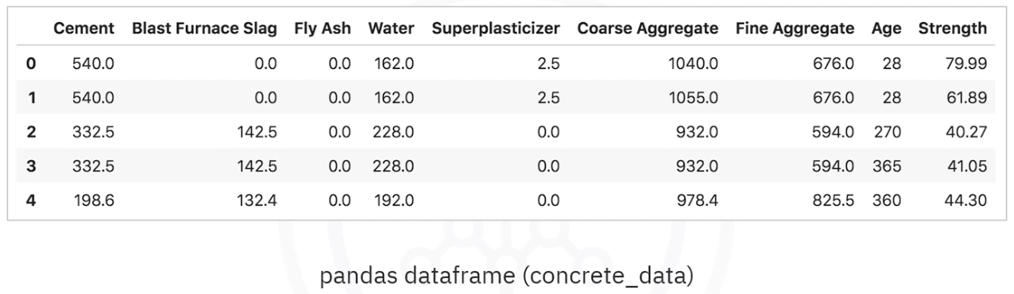

Goal of the Neural Network
The goal is to create a deep neural network that can automatically predict the compressive strength of concrete based on the ingredient quantities.

Network Architecture
The neural network contains:
- Input Layer:
  - Takes 8 input features
- Hidden Layer 1:
  - 5 neurons
- Hidden Layer 2:
  - 5 neurons
- Output Layer:
  - 1 neuron
  - Outputs predicted compressive strength
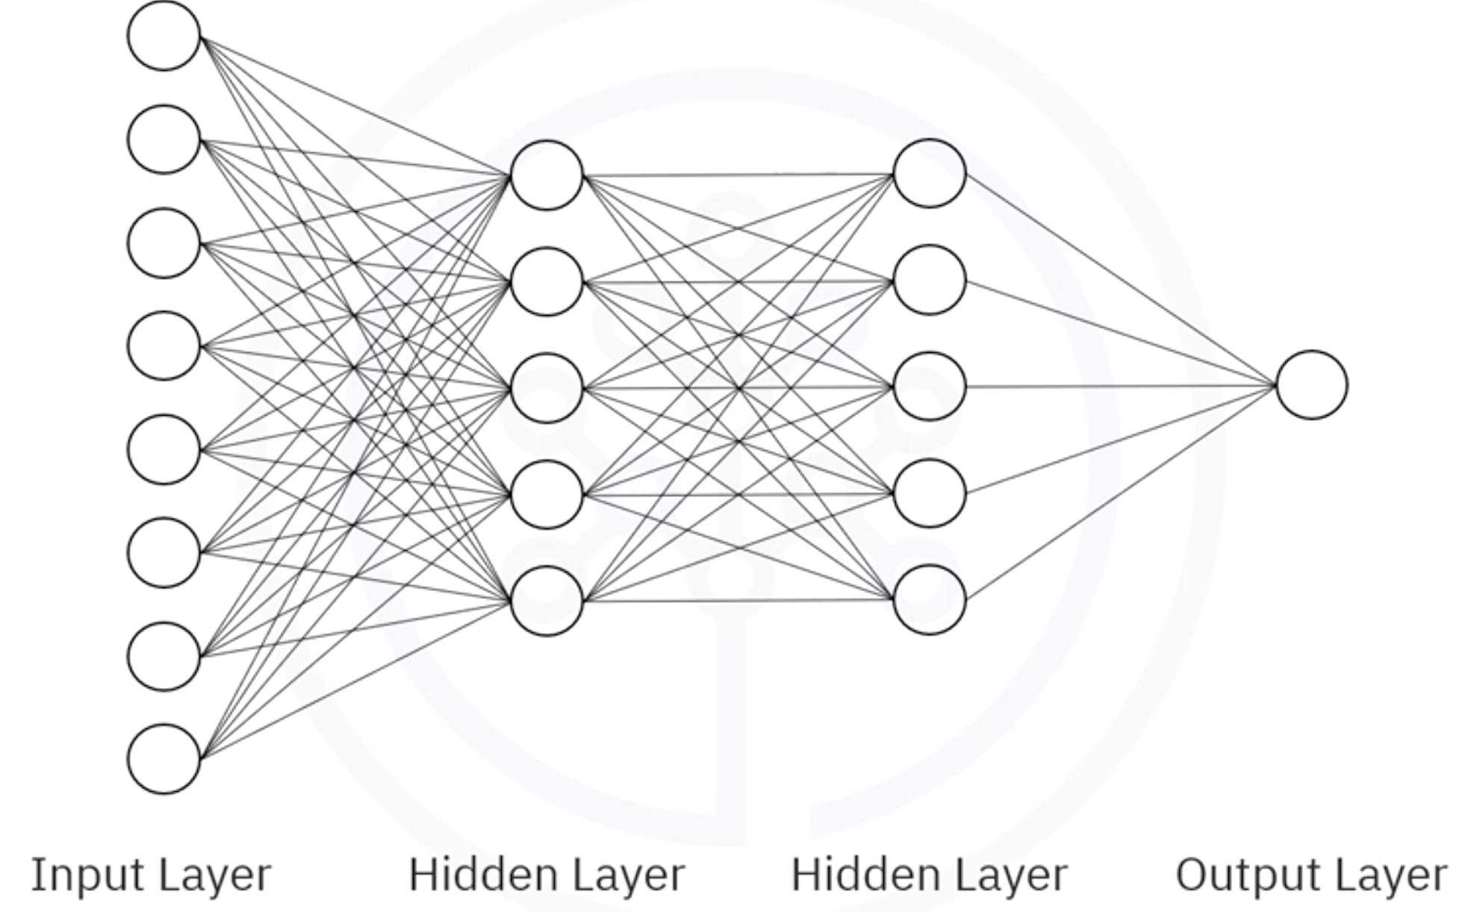

Important Note
In real-world applications, hidden layers usually contain many more neurons, such as:
- 50 neurons
- 100 neurons
A smaller network is used here only for simplicity.

Dense Neural Networks
In this architecture:
- Every neuron in one layer is connected to every neuron in the next layer
Such a network is called a:

Dense Network
Dense layers are among the most commonly used layer types in deep learning.

Preparing Data for Keras
Before using Keras, the dataset must be prepared correctly.
The dataset is split into:
DataFrame | Purpose
Predictors | Input features
Target | Output variable

Predictor Variables
The predictors contain all input columns.

Target Variable
The target contains the compressive strength column.

Example
predictors = concrete_data.drop('Strength', axis=1)
target = concrete_data['Strength']

Importing Keras Libraries
The first step is importing Keras and the Sequential model.

Import Sequential Model
from keras.models import Sequential

Sequential Model
The Sequential model is used because the network is a linear stack of layers.
This is the most common type of neural network architecture.

Keras Provides Two Main Model Types
Model Type | Description
Sequential Model | Used for linear stack architectures
Functional API Model | Used for more complex architectures
For most standard problems, the Sequential model is sufficient.

Creating the Neural Network
To create the model:
model = Sequential()

Adding Layers to the Model
To create layers, import the Dense layer type.

Import Dense Layer
from keras.layers import Dense

Add Hidden Layers
model.add(Dense(5, activation='relu', input_shape=(8,)))
model.add(Dense(5, activation='relu'))

Explanation
Parameter | Description
5 | Number of neurons
activation='relu' | Activation function
input_shape=(8,) | Number of input features

ReLU Activation Function
The ReLU activation function is commonly recommended for hidden layers.

Why ReLU?
- Computationally efficient
- Helps reduce vanishing gradient problems
- Works well in deep learning applications

Creating the Output Layer
The output layer contains one neuron because this is a regression problem with one numerical output.
model.add(Dense(1))

Compiling the Model
Before training, the model must be compiled.
Compilation defines:
- Optimizer
- Loss function

Compile the Model
model.compile(optimizer='adam', loss='mean_squared_error')

Loss Function
The loss function used is:

Mean Squared Error (MSE)
Mean Squared Error measures the difference between:
- Predicted values
- Actual values
It is one of the most common loss functions for regression problems.

Optimizer
The optimizer used is:

Adam Optimizer
Adam is more efficient than standard gradient descent in many deep learning applications.

Advantages of Adam
- Faster convergence
- Adaptive learning rates
- No need to manually specify the learning rate
This simplifies model optimization.

Training the Model
The model is trained using the fit() method.

Example
model.fit(predictors, target, epochs=50)

Parameters
Parameter | Description
predictors | Input features
target | Ground truth values
epochs | Number of training iterations

Making Predictions
After training, predictions can be generated using the predict() method.

Example
predictions = model.predict(new_data)

Complete Keras Regression Model Example
from keras.models import Sequential
from keras.layers import Dense
# Define predictors and target
predictors = concrete_data.drop('Strength', axis=1)
target = concrete_data['Strength']
# Build model
model = Sequential()
model.add(Dense(5, activation='relu', input_shape=(8,)))
model.add(Dense(5, activation='relu'))
model.add(Dense(1))
# Compile model
model.compile(optimizer='adam', loss='mean_squared_error')
# Train model
model.fit(predictors, target, epochs=50)
# Make predictions
predictions = model.predict(predictors)

Key Takeaways
- Keras makes building neural networks very simple
- Data must be prepared properly before training
- Regression problems predict continuous numerical values
- Dense networks connect every neuron between layers
- Sequential models are used for linear layer stacks
- ReLU is commonly used for hidden layers
- Mean Squared Error is commonly used for regression loss
- Adam is a powerful and efficient optimizer
- Neural networks in Keras can be built and trained with only a few lines of code

Classification Models with Keras

Introduction to Classification Models
In this lesson, we learn how to use the Keras library to build neural network models for classification problems.
Classification models are used when the target variable belongs to multiple categories or classes instead of predicting a continuous numerical value.

Example Scenario
Suppose we want to build a model that helps determine whether purchasing a particular car is a good decision based on:
- The price of the car
- The maintenance cost
- The number of people the car can accommodate

Car Dataset Overview
The dataset used in this example is called car_data.
The dataset has already been cleaned and transformed using one-hot encoding.

Features in the Dataset

Car Price Categories
The price of the car can be:
- High
- Medium
- Low

Maintenance Cost Categories
The maintenance cost can also be:
- High
- Medium
- Low

Passenger Capacity
The car can accommodate:
- Two people
- More than two people

Example Data Point
For the first car in the dataset:
- The car is expensive
- Maintenance cost is high
- The car can only fit two people
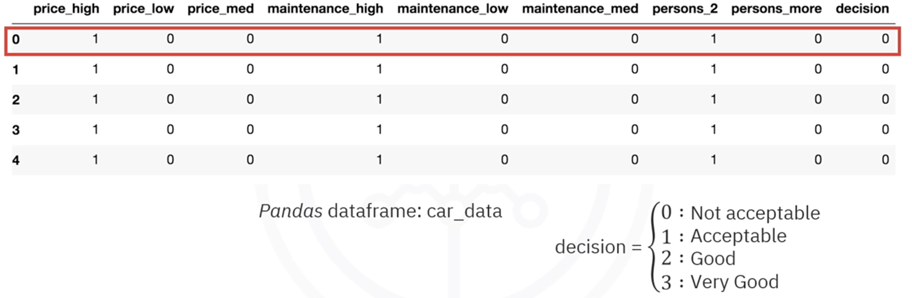
The target output (decision) is:
Decision Value | Meaning
0 | Bad choice / Not acceptable
1 | Acceptable
2 | Good decision
3 | Very good decision

Neural Network Architecture
The classification model uses a neural network architecture similar to the regression model discussed previously.

Network Structure
- Input Layer:
  - 8 input features (predictors)
- Hidden Layers:
  - 2 hidden layers
  - Each hidden layer contains 5 neurons
- Output Layer:
  - 4 neurons
  - One neuron for each target category

Predictors and Target
The dataset is divided into:

Predictors
The input variables/features used to make predictions.
Examples:
- Car price
- Maintenance cost
- Passenger capacity

Target
The output variable represents the decision category.

Transforming the Target Variable
For classification problems in Keras, the target column cannot be used directly.
The target values must first be transformed into binary arrays using one-hot encoding style formatting.

Example Transformation
Original Target | Binary Representation
0 | [1, 0, 0, 0]
1 | [0, 1, 0, 0]
2 | [0, 0, 1, 0]
3 | [0, 0, 0, 1]

Using to_categorical()
Keras provides the to_categorical() function to perform this transformation.
from keras.utils import to_categorical
Because the target variable has 4 categories, the output layer must contain 4 neurons.

Building the Classification Model in Keras

Importing Required Libraries
from keras.models import Sequential
from keras.layers import Dense
from keras.utils import to_categorical

Creating the Neural Network

Initializing the Model
model = Sequential()

Adding Hidden Layers
Two hidden layers are added using the ReLU activation function.
model.add(Dense(5, activation='relu', input_shape=(8,)))
model.add(Dense(5, activation='relu'))

Adding the Output Layer
The output layer contains 4 neurons and uses the Softmax activation function.
model.add(Dense(4, activation='softmax'))

Why Use Softmax?
The Softmax activation function ensures that:
- The output probabilities sum to 1
- Each output neuron represents the probability of belonging to a specific class
This makes Softmax ideal for multi-class classification problems.

Compiling the Model
For classification problems, we use:
- categorical_crossentropy as the loss function
- accuracy as the evaluation metric
model.compile(
optimizer='adam',
loss='categorical_crossentropy',
metrics=['accuracy']
)

Training the Model
The model is trained using the fit() method.
This time, the number of epochs is explicitly specified.
model.fit(X, y, epochs=50)

Epochs
An epoch represents one complete pass of the training dataset through the neural network.
More epochs generally allow the model to learn better patterns from the data.

Making Predictions
Predictions are made using the predict() method.
predictions = model.predict(X_test)

Understanding Prediction Output
The output of the prediction method is a probability distribution across all classes.

Example Prediction Output
Class | Probability
0 | 0.99
1 | 0.01
2 | 0.00
3 | 0.00

Interpretation
- The probabilities sum to 1
- The class with the highest probability becomes the predicted class
- Higher probabilities indicate higher confidence

Example Prediction Analysis
First Car
Prediction:
- Probability for class 0 ≈ 0.99
Interpretation:
- The model is highly confident that purchasing the car is not acceptable

Second Car
Prediction:
- Probability for class 0 ≈ 0.99
Interpretation:
- The model again predicts the purchase is not acceptable

Last Three Cars
Prediction:
- Probability for class 1 is slightly higher than class 0
Interpretation:
- The model leans toward accepting the purchase
- However, confidence is lower because probabilities are very close

Evaluation Metric: Accuracy
Accuracy is used to measure the performance of the classification model.

Accuracy Formula
$$\text{Accuracy}=\frac{\text{Correct Predictions}}{\text{Total Predictions}}$$
Keras provides accuracy as a built-in evaluation metric.
Custom evaluation metrics can also be defined if needed.

Key Concepts Learned

Classification Problems
- Classification models predict categories/classes
- Datasets can be split into categories

Dataset Structure
A dataset is divided into:
- Predictors (features)
- Target (output variable)

Target Encoding
For Keras classification problems:
- Target variables must be transformed into binary arrays
- to_categorical() is used for this transformation

Neural Network Design
The classification model contains:
- Input layer
- Hidden layers
- Output layer with Softmax activation

Loss Function
Classification models commonly use:
categorical_crossentropy
instead of:
mean_squared_error
which is typically used for regression problems.

Prediction Output
- Predictions are probabilities
- Probabilities sum to 1
- The highest probability determines the predicted class

Complete Keras Classification Model Example
from keras.models import Sequential
from keras.layers import Dense
from keras.utils import to_categorical
# Convert target column
y = to_categorical(y)
# Build model
model = Sequential()
# Hidden layers
model.add(Dense(5, activation='relu', input_shape=(8,)))
model.add(Dense(5, activation='relu'))
# Output layer
model.add(Dense(4, activation='softmax'))
# Compile model
model.compile(
optimizer='adam',
loss='categorical_crossentropy',
metrics=['accuracy']
)
# Train model
model.fit(X, y, epochs=50)
# Make predictions
predictions = model.predict(X_test)

Summary
In this lesson, we’ve learned:
- How classification models work in Keras
- How datasets are divided into predictors and targets
- How to convert target values into binary arrays using to_categorical()
- How to build a neural network for classification
- How to use Softmax activation for multi-class outputs
- How to compile, train, and evaluate a classification model
- How to interpret prediction probabilities from the model

Module 3 Summary: Keras and Deep Learning Libraries

Introduction to Deep Learning Libraries
The most popular deep learning libraries are:
- TensorFlow
- PyTorch
- Keras
These libraries are widely used for building, training, and deploying deep learning models.

TensorFlow

Overview
TensorFlow is one of the most widely used deep learning libraries.

Key Features
- Used extensively in the production of deep learning models
- Supported by a very large developer and research community
- Suitable for large-scale machine learning and deep learning applications

PyTorch

Overview
PyTorch is based on the Torch framework written in Lua.

Key Features
- Supports machine learning algorithms running on GPUs
- Highly preferred in academic and research environments
- Popular among researchers due to its flexibility and dynamic computation graph

Limitation
- Similar to TensorFlow, PyTorch has a steep learning curve and can be difficult for beginners to use

Keras

Overview
Keras is a high-level API designed for building deep learning models quickly and easily.

Advantages of Keras
- Easy to use
- Simple and clean syntax
- Facilitates fast development
- Requires only a few lines of code to create complex neural networks

Backend Support
Keras normally runs on top of low-level deep learning libraries such as TensorFlow.

Data Preparation for Keras
Before using Keras, data must be properly prepared and organized in the correct format.

Dataset Structure
A dataset is typically divided into:
- Predictors (Input Features)
- Target (Output Label)

Classification Problems in Keras

Target Variable Transformation
When solving classification problems using Keras, the target column must be transformed into an array of binary values.

Using to_categorical
The to_categorical function from the Keras utilities package is used to convert dataset labels into binary class matrices.

Example
from tensorflow.keras.utils import to_categorical
binary_targets = to_categorical(target_column)

Building Neural Networks with Keras
Keras allows developers to build and train neural networks with only a few lines of code.

Example Workflow
from tensorflow.keras.models import Sequential
from tensorflow.keras.layers import Dense
model = Sequential()
model.add(Dense(10, activation='relu', input_shape=(5,)))
model.add(Dense(3, activation='softmax'))
model.compile(optimizer='adam',
loss='categorical_crossentropy',
metrics=['accuracy'])
model.fit(X_train, y_train, epochs=10)

Key Takeaways
- TensorFlow, PyTorch, and Keras are the most popular deep learning libraries
- TensorFlow is widely used in production environments
- PyTorch is preferred in academic research settings
- Both TensorFlow and PyTorch can be difficult for beginners
- Keras simplifies deep learning development with easy syntax
- Keras can build complex neural networks with very little code
- Proper data preparation is essential before using Keras
- Datasets are divided into predictors and targets
- Classification targets must be converted into binary arrays
- The to_categorical function is used for target transformation
- Keras can be used to build classification models efficiently

Module 4: Deep Learning Models

Shallow vs Deep Neural Networks

Introduction
Neural networks can generally be categorized into two types:
- Shallow Neural Networks
- Deep Neural Networks
Understanding shallow neural networks is important because they serve as the foundation for understanding more complex deep neural networks.

Shallow Neural Networks

Definition
There is no strict universal definition of a shallow neural network, but generally:
- A neural network with one or two hidden layers is considered a shallow neural network.

Characteristics of Shallow Neural Networks
- Simpler architecture
- Easier to understand and implement
- Typically, take input data in the form of vectors
- Limited ability to automatically extract complex features

Input Type
Shallow neural networks usually require:
- Structured numerical input
- Preprocessed feature vectors
They generally cannot directly process raw data, such as:
- Images
- Audio
- Text

Deep Neural Networks

Definition
A neural network is considered a deep neural network when it contains:
- Three or more hidden layers
- A large number of neurons in each layer

Characteristics of Deep Neural Networks
- Complex architecture
- Better capability to learn intricate patterns
- Able to automatically extract features from raw data
- Suitable for advanced artificial intelligence applications

Input Type
Deep neural networks can directly process raw data, including:
- Images
- Text
- Audio
- Video
This automatic feature extraction capability is one of the biggest advantages of deep learning.

Difference Between Shallow and Deep Neural Networks
Feature | Shallow Neural Network | Deep Neural Network
Number of Hidden Layers | 1–2 hidden layers | 3 or more hidden layers
Complexity | Simpler | More complex
Feature Extraction | Requires manual feature engineering | Automatically extracts features
Input Type | Vector-based input | Raw data input
Learning Capability | Limited for complex tasks | Excellent for complex tasks
Computational Requirement | Lower | Higher

Reasons Behind the Deep Learning Boom
Deep learning has existed for many years, but its rapid growth and success occurred due to three major factors.

Advancements in Deep Learning Techniques

ReLU Activation Function
One major breakthrough was the introduction of the ReLU (Rectified Linear Unit) activation function.
Benefits of ReLU:
- Helped overcome the vanishing gradient problem
- Made training deep neural networks easier
- Enabled the creation of very deep architectures

Vanishing Gradient Problem
Earlier activation functions caused gradients to become extremely small during backpropagation, making deep networks difficult to train.
ReLU significantly reduced this issue.

Availability of Large Amounts of Data
Deep neural networks perform best when trained on massive datasets.

Why Large Data is Important
- Neural networks learn training data extremely well
- Small datasets can lead to overfitting
- More data improves generalization performance

Comparison with Traditional Machine Learning
Traditional machine learning algorithms:
- Improve only up to a certain point with more data
- Eventually, stop gaining significant performance improvements
Deep learning algorithms:
- Continue improving as more data becomes available
- Benefit greatly from massive datasets

Modern Data Availability
Today, huge amounts of data are easily available from:
- Internet platforms
- Social media
- Sensors
- Mobile devices
- Online services
This has accelerated deep learning research and applications.

Increased Computational Power

Role of GPUs
Modern GPUs (Graphics Processing Units) provide enormous computational power.
Benefits include:
- Faster neural network training
- Ability to process massive datasets
- Reduced training time from weeks to hours

Faster Experimentation
Researchers and developers can now:
- Test multiple architectures quickly
- Experiment with different prototypes
- Improve models in shorter development cycles

Main Factors Responsible for Deep Learning Growth
The deep learning boom can mainly be attributed to:
- Advancements in deep learning techniques
- Availability of large datasets
- Increased computational power through GPUs

Key Takeaways
- A neural network with one or two hidden layers is considered shallow.
- A neural network with many hidden layers is considered deep.
- Shallow neural networks primarily take vector inputs.
- Deep neural networks can process raw data such as images and text.
- ReLU activation helped solve the vanishing gradient problem.
- Deep learning benefits significantly from large datasets.
- GPUs made training deep neural networks much faster and more practical.
- These advancements collectively led to the rapid growth of deep learning applications.

Convolutional Neural Networks (CNNs)

What are Convolutional Neural Networks?
Convolutional Neural Networks (CNNs) are a specialized type of neural network designed primarily for processing image data.
CNNs are similar to traditional neural networks because:
- They are composed of neurons
- They use weights and biases
- They optimize parameters during training
- Each neuron computes a dot product between inputs and weights
- Activation functions such as ReLU are commonly used

Difference Between Neural Networks and CNNs
The major difference is that CNNs make the explicit assumption that the inputs are images.
This assumption allows CNNs to:
- Incorporate image-specific properties into the architecture
- Make forward propagation more efficient
- Reduce the number of parameters significantly
- Improve performance for computer vision tasks

Applications of CNNs
CNNs are best suited for:
- Image recognition
- Object detection
- Computer vision applications
- Image classification

Architecture of a Convolutional Neural Network

Typical CNN Architecture
A typical convolutional neural network consists of:
- Convolutional Layers
- ReLU Activation Layers
- Pooling Layers
- Fully Connected Layers
- Output Layer
These layers work together to extract features from images and perform classification tasks.
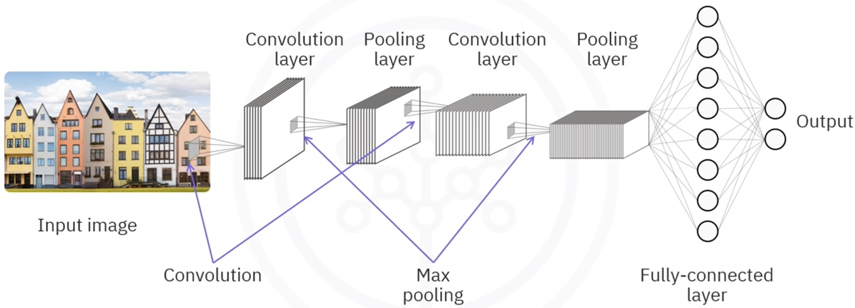

Input to a CNN

Image Representation
Traditional neural networks usually accept an n-by-1 vector as input.
CNNs, however, accept image data in the following forms:

Grayscale Images
- Input shape: n-by-m-by-1

Colored Images
- Input shape: n-by-m-by-3
- The number 3 represents:
  - Red channel
  - Green channel
  - Blue channel

Convolutional Layer

Purpose of the Convolutional Layer
The convolutional layer is responsible for extracting features from images.

Filters in CNNs
In a convolutional layer:
- Filters (also called kernels) are defined
- Convolution operations are performed between filters and images
- Each filter scans across the image

Convolution Process
The convolution process involves:
- Sliding the filter across the image
- Computing the dot product between:
  - Filter values
  - Overlapping pixel values
- Storing the result in an output matrix
- Repeating the process until the entire image is covered

Stride
Stride refers to the number of cells the filter moves each time.
- Stride of 1 → filter moves one cell at a time
- Larger strides reduce output dimensions

Multiple Filters
CNNs can use multiple filters.
Advantages of multiple filters:
- Better feature extraction
- Better preservation of spatial information(the information about where things are located and how they are arranged in space(picture or video))
- Ability to learn different image patterns
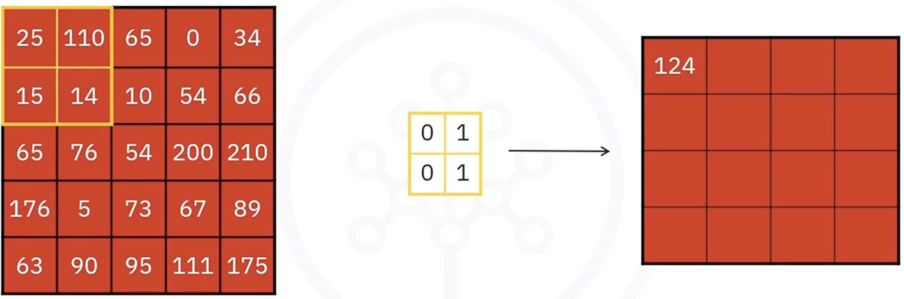

Why Use Convolution?
Instead of flattening( e.g., turning a 28 * 28 picture into a long 1D list like ($28×28=784\text{ values}$)) images directly into vectors, convolution is used because:
- Flattening creates a massive number of parameters
- Training becomes computationally expensive
- More parameters increase the risk of overfitting
- Convolution reduces parameter count efficiently

ReLU Activation Layer

Role of ReLU in CNNs
Convolutional layers are usually followed by ReLU activation functions.

ReLU Behavior
- Positive values are preserved
- Negative values are converted to zero

Benefits of ReLU
- Introduces non-linearity
- Helps networks learn complex patterns
- Improves training efficiency

Pooling Layer

Purpose of Pooling
Pooling layers reduce the spatial dimensions of data propagating through the network.
Benefits include:
- Reduced computational complexity
- Reduced memory usage
- Better generalization
- Reduced overfitting

Types of Pooling

Max Pooling
Max pooling selects the maximum value from each scanned region.
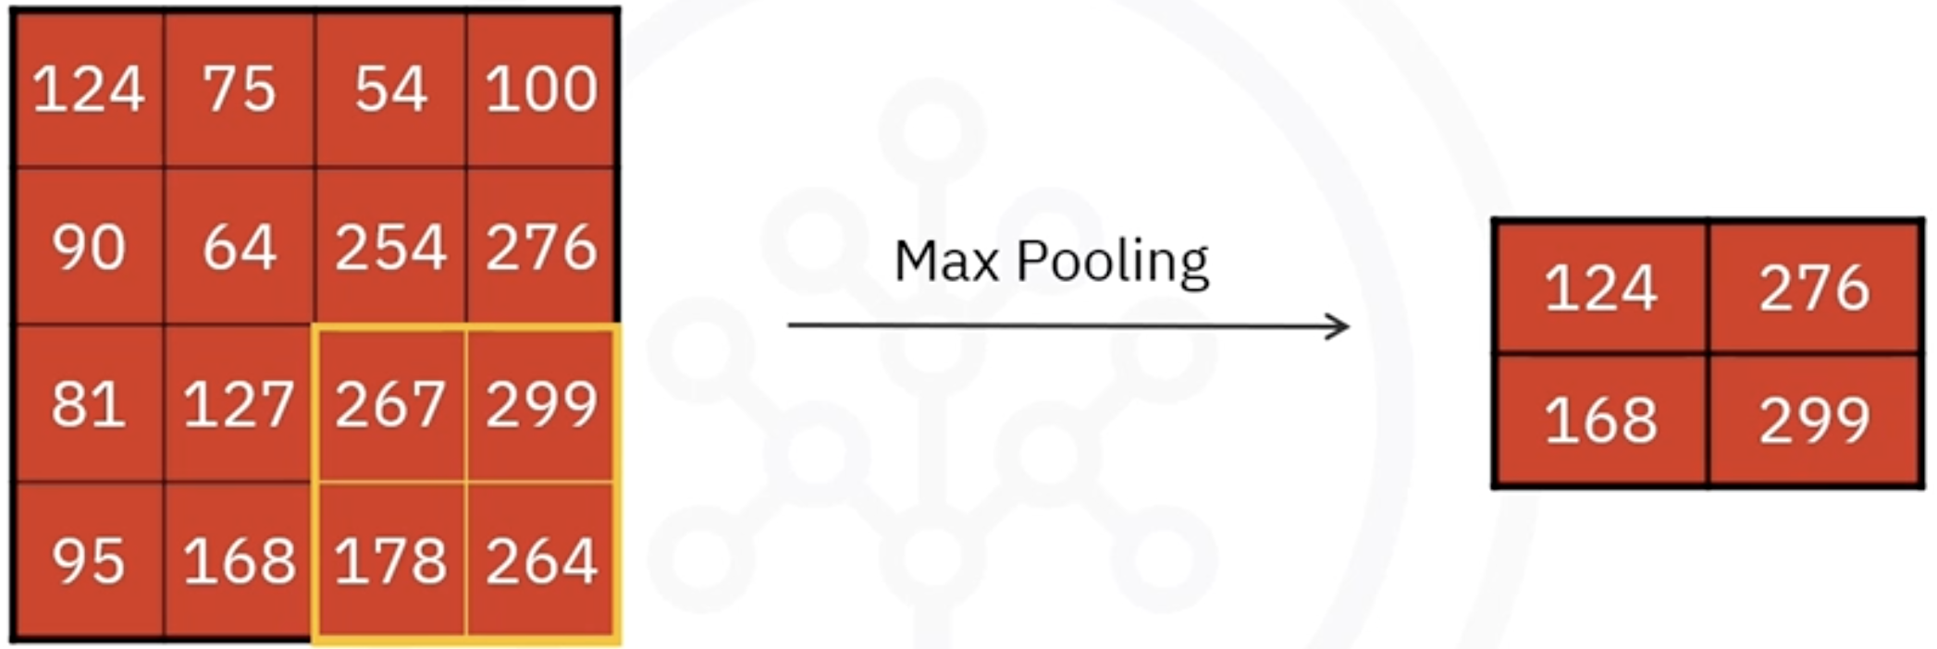
Characteristics:
- Most commonly used pooling method
- Preserves the most important features
- Usually uses larger strides

Average Pooling
Average pooling computes the average value of each scanned region.
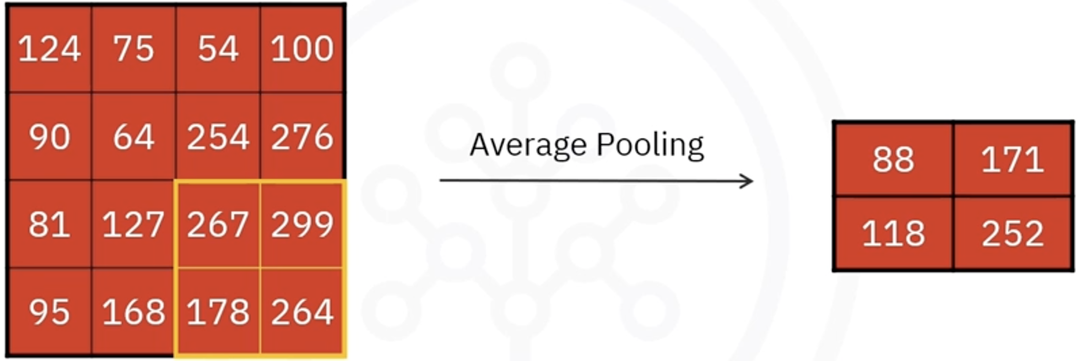

Spatial Variance
Max pooling provides spatial variance.
This helps CNNs recognize objects even when:
- The object position changes
- The object’s appearance slightly varies

Fully Connected Layer

Purpose of Fully Connected Layers
The fully connected layer performs the final classification.

Flattening
Before entering the fully connected layer:
- The output from previous layers is flattened into a vector

Dense Connections
In fully connected layers:
- Every neuron connects to every neuron in the next layer

Output Vector
The output layer generates an n-dimensional vector where:
- n = number of classes

Example
For digit classification:
- n = 10
- Represents digits 0 through 9

Building a CNN Using Keras

Step 1: Create the Model
Use the Sequential constructor to create the model.
from tensorflow.keras.models import Sequential

model = Sequential()

Step 2: Define Input Shape
For 128 × 128 RGB images:
input_shape = (128, 128, 3)

Step 3: Add Convolutional Layer
from tensorflow.keras.layers import Conv2D

model.add(Conv2D(
filters=16,
kernel_size=(2, 2),
strides=(1, 1),
activation='relu',
input_shape=(128, 128, 3)
))

Explanation
- 16 filters
- Filter size: 2 × 2
- Stride: 1 × 1
- Activation: ReLU

Step 4: Add Pooling Layer
from tensorflow.keras.layers import MaxPooling2D

model.add(MaxPooling2D(
pool_size=(2, 2),
strides=2
))

Explanation
- Pool size: 2 × 2
- Stride: 2
- Uses max pooling

Step 5: Add Additional Convolutional and Pooling Layers
model.add(Conv2D(
filters=32,
kernel_size=(2, 2),
activation='relu'
))

model.add(MaxPooling2D(
pool_size=(2, 2)
))

Note
The second convolutional layer uses more filters than the first layer.

Flattening and Fully Connected Layers

Flatten Layer
from tensorflow.keras.layers import Flatten

model.add(Flatten())

Dense Layer
from tensorflow.keras.layers import Dense

model.add(Dense(100, activation='relu'))

Output Layer
model.add(Dense(num_classes, activation='softmax'))

Purpose of Softmax
Softmax converts outputs into probabilities.

Summary

CNN Fundamentals
- CNNs assume that inputs are images
- CNNs are highly effective for computer vision tasks
- CNNs reduce the number of parameters compared to traditional neural networks

CNN Input Shapes
- Grayscale images: n-by-m-by-1
- Colored images: n-by-m-by-3

Convolutional Layer
- Uses filters to extract features
- Performs convolution operations
- Usually followed by ReLU activation

ReLU Activation
- Keeps positive values
- Converts negative values to zero

Pooling Layer
- Reduces spatial dimensions
- Common types:
  - Max pooling
  - Average pooling

Fully Connected Layer
- Flattens extracted features
- Connects neurons densely
- Produces final classification output

Keras Implementation
- CNNs can be built using Keras Sequential models
- Common layers include:
  - Conv2D
  - MaxPooling2D
  - Flatten
  - Dense

Conclusion
Convolutional Neural Networks are powerful deep learning models specifically designed for image processing tasks. By using convolution, pooling, and fully connected layers, CNNs efficiently extract features from images and perform accurate classification and recognition tasks.

Recurrent Neural Networks (RNNs)

Introduction to Recurrent Neural Networks
Recurrent Neural Networks (RNNs) are another type of supervised deep learning model designed to process sequential and time-dependent data.
Traditional neural networks and many deep learning models treat each data point as an independent instance. However, in many real-world applications, data points are connected and depend on previous information.

Problem with Traditional Neural Networks
Traditional neural networks are not suitable for tasks where:
- Data occurs in sequences
- Previous information affects future predictions
- Temporal relationships are important
For example, when analyzing scenes in a movie, the scenes cannot be treated as completely independent because each scene is connected to previous scenes.
Because of this limitation, traditional deep learning models are often unsuitable for sequential data analysis.

What are Recurrent Neural Networks (RNNs)?
Recurrent Neural Networks (RNNs) are neural networks that contain loops, allowing information from previous inputs to influence future outputs.
Unlike traditional neural networks, RNNs:
- Accept a new input at each time step
- Also use the output from the previous time step as an additional input
This enables the network to remember previous information and learn temporal patterns in data.

Architecture of a Recurrent Neural Network
The architecture of an RNN works across different time steps.

Time Step t = 0
At the initial time step:
- The network receives input $x_{0}$
- The network produces output $a_{0}$

Time Step t = 1
At the next time step:
- The network receives a new input $x_{1}$
- The previous output $a_{0}$is also fed back into the network
- The previous output is weighted using weights such as $w_{01}$
This process continues across multiple time steps, allowing the network to preserve contextual information from earlier inputs.
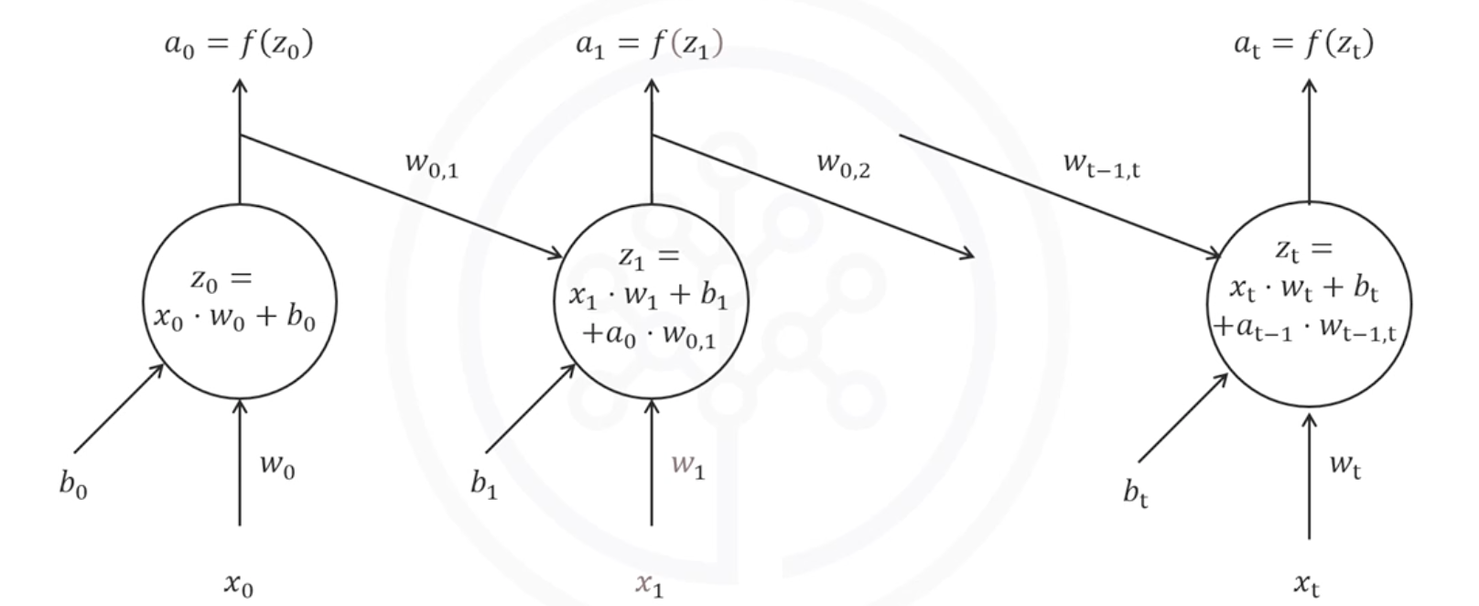

Key Feature of RNNs
The major strength of RNNs is their ability to model sequential and temporal data.
RNNs take into account:
- Order of data
- Sequence patterns
- Time dependencies
This gives RNNs a temporal dimension that traditional neural networks lack.

Applications of Recurrent Neural Networks
RNNs are highly effective for modeling patterns and sequences in data such as:
- Text
- Genomes
- Handwriting
- Stock market data

Long Short-Term Memory (LSTM)

Introduction to LSTM
A very popular type of recurrent neural network is the Long Short-Term Memory (LSTM) model.
LSTMs are specifically designed to better remember information over long sequences.

Applications of LSTM Models
LSTM models have been successfully used in many advanced applications.

Image Generation
LSTM-based models can:
- Learn from large image datasets
- Generate completely new images

Handwriting Generation
LSTMs can generate handwriting patterns that resemble human writing.

Automatic Image Captioning
LSTM models can automatically:
- Analyze images
- Generate descriptive captions for images

Automatic Video Description
LSTMs are also used to:
- Understand video sequences
- Automatically describe video content

Summary
In this lesson, you learned the following concepts:
- Traditional neural networks treat data points as independent instances
- Recurrent Neural Networks (RNNs) use loops to incorporate previous outputs into future computations
- RNNs are designed for sequential and temporal data
- RNNs are effective for applications involving text, genomes, handwriting, and stock market analysis
- Long Short-Term Memory (LSTM) is a popular type of RNN
- LSTMs are widely used for image generation, handwriting generation, automatic image captioning, and video description systems

Transformers

Introduction to Transformers
Transformers are a type of neural network architecture that has revolutionized natural language processing (NLP) and beyond. They are widely used in deep learning models that power AI tools such as ChatGPT and Gemini.
Unlike traditional recurrent neural networks (RNNs) and convolutional neural networks (CNNs), transformers excel at capturing long-range dependencies in sequential data. This makes them highly effective for tasks such as:
- Machine translation
- Text summarization
- Question answering
- Text-to-image generation

Key Applications and Transformer Models
Different types of transformer-based models include:
- Generative pre-trained models used in ChatGPT
- Bidirectional transformers (BERT) are used in Google Search and Google Translate
- Image transformers used in applications such as Adobe Photoshop

Attention Mechanism Overview
The key innovation in transformers is the attention mechanism.
This mechanism allows the model to:
- Weigh the importance of different parts of an input sequence
- Focus on relevant tokens while processing data
- Capture long-range dependencies effectively

Self-Attention Mechanism in Transformers
The self-attention mechanism is used to process textual data and consists of three main components:

1. Query, Key, and Value (Q, K, V)
For each input token, three vectors are generated:
- Query (Q): Represents the word we are focusing on
- Key (K): Represents all other words in the sequence
- Value (V): Contains the information passed to the next layer

2. Attention Scores
- The query vector of a token is compared with the key vectors of all other tokens using a dot product
- This produces attention scores that indicate how relevant each token is to the current token

3. Weighted Sum (Context Vector)
- Attention scores are normalized (using softmax)
- A weighted sum of value vectors is computed
- This produces a context-aware representation of each token

Example: Self-Attention with “The Dog Runs”
To understand self-attention:
- Input sentence: “The dog runs.”
- Each word is converted into an embedding vector
- Positional encoding is added to preserve word order
- Q, K, and V vectors are generated for each word

Attention Computation Process
- Compute the dot product between the query and key vectors
- Form an attention score matrix
- Scale scores and apply softmax to convert them into probabilities
- Compute the weighted sum of value vectors
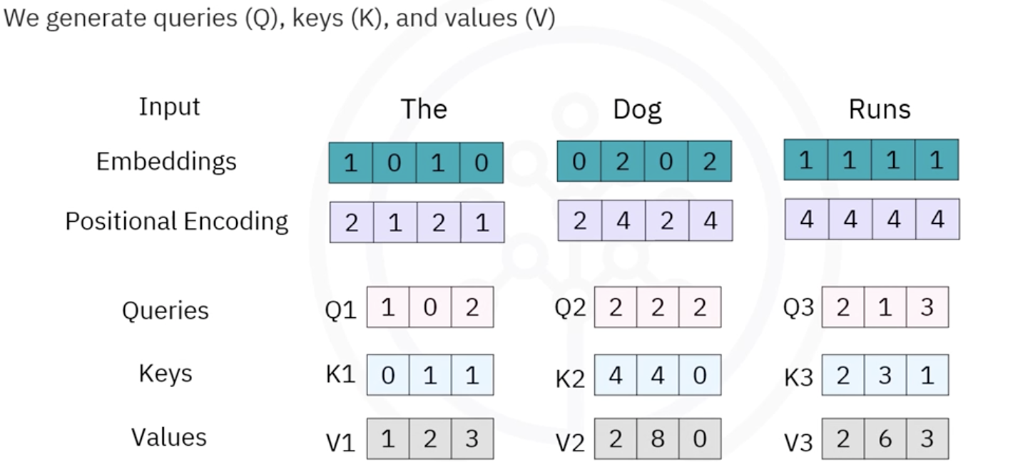

Result
- Each word becomes contextually enriched
- The output is a new contextualized vector representation of the sentence

Cross-Attention Mechanism (Text-to-Image Generation)
Transformers are also used for text-to-image generation through cross-attention.

What is Cross-Attention?
Cross-attention allows one type of data (e.g., text) to influence the generation of another type of data (e.g., images).

Process in Text-to-Image Models
Given a prompt such as:
“A two-story house with a red roof and a garden in front”
The process is as follows:
- The text is processed using self-attention to produce contextual embeddings(Numerical representations) because transformers don’t understand words like humans.
- These embeddings are passed through a transformer encoder to generate query representations (Q)
- An image generation model (e.g., DALL·E) uses cross-attention based on these queries
- The model generates images autoregressively, predicting one part at a time

Key Idea
- The model does not retrieve an existing image
- Instead, it synthesizes a new image based on learned understanding
- It can create novel and imaginative outputs (e.g., a turtle driving a car, or a horse with bamboo-like legs)
- Multiple variations of the same prompt can be generated

Contextual Embeddings
A neural network cannot directly understand words like humans do.
So each word is converted into a vector (a list of numbers).
Example:
"cat" → [0.21, -0.44, 0.91, ...]
Transformers solve this problem using:

Contextual Embeddings
Now the embedding depends on the surrounding words.
So:
bank(finance) ≠ bank(river)
The transformer creates different representations based on context.

Example

Sentence 1
“I deposited money in the bank.”
The word bank becomes associated with:
- money
- deposited
- finance

Sentence 2
“The fisherman sat on the bank.”
Now, the bank becomes associated with:
- fisherman
- river
- water
So the embedding changes dynamically.

Advantages of Transformers Compared to RNNs
Transformers offer several advantages over RNNs:
- Parallel processing of data significantly speeds up training
- Better at capturing long-range dependencies
- Avoid issues like vanishing gradients
- More effective for large-scale NLP tasks

RNN Limitations
- Process data sequentially (slow training)
- Struggle with long-term dependencies
- Limited ability to scale efficiently

Limitations of Transformers
Despite their success, transformers have some limitations:
- Require very large datasets for training
- High computational and memory requirements
- Inherent biases present in training data
- May struggle with generalization outside training distribution

Summary and Key Takeaways
Transformers are a powerful neural network architecture that has transformed modern AI and NLP.
Key points:
- They are based on the attention mechanism
- Self-attention uses Query, Key, and Value vectors to compute context
- Cross-attention enables text-to-image generation
- They outperform RNNs in scalability and performance
- They are widely used in applications like translation, summarization, and generative AI
- They require large datasets and can inherit bias from the data
Transformers remain one of the most important breakthroughs in modern deep learning and are central to many AI systems used today.

Autoencoders

Introduction to Autoencoders
So far, two supervised deep learning models have been discussed:
- Convolutional Neural Networks (CNNs)
- Recurrent Neural Networks (RNNs)
Autoencoders are different because they belong to the category of unsupervised deep learning models.

What Are Autoencoders?
Autoencoding is a data compression algorithm in which:
- The compression function is learned automatically from data
- The decompression function is also learned automatically from data
- No manual engineering by humans is required
Autoencoders are built using neural networks.

Characteristics of Autoencoders

Data-Specific Nature
Autoencoders are data-specific, meaning they only perform well on data similar to the data they were trained on.
For example:
- An autoencoder trained on images of cars will effectively compress car images
- The same autoencoder will perform poorly on images of buildings because it has learned vehicle-specific features

Applications of Autoencoders
Autoencoders have several important applications, including:
- Data denoising
- Dimensionality reduction
- Data visualization

Architecture of an Autoencoder
An autoencoder typically consists of two major components:

Encoder
The encoder:
- Accepts the input data (such as an image)
- Learns the optimal compressed representation of the input

Decoder
The decoder:
- Uses the compressed representation
- Reconstructs or restores the original input image
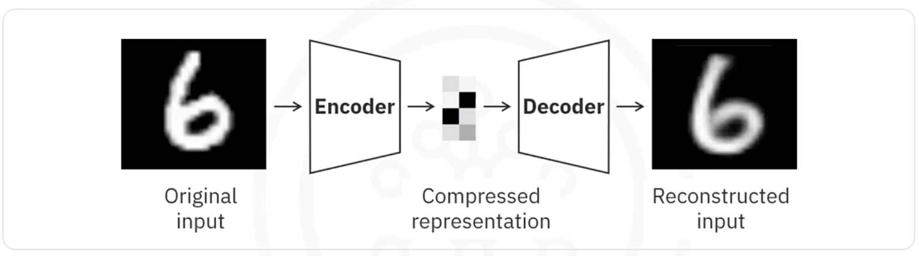

How Autoencoders Work
Autoencoders are unsupervised neural networks that use backpropagation during training.

Key Idea
The target output is set to be the same as the input.
In other words, the network attempts to learn an approximation of the identity function.

Importance of Nonlinear Activation Functions
Because neural networks use nonlinear activation functions, autoencoders can learn complex data projections.
This makes them more powerful than techniques such as:
- Principal Component Analysis (PCA)
PCA and similar traditional methods can only handle linear transformations, whereas autoencoders can capture nonlinear relationships in data.

Restricted Boltzmann Machines (RBMs)

Definition
Restricted Boltzmann Machines (RBMs) are a popular type of autoencoder.
RBMs have been successfully applied in several machine learning tasks.

Applications of Restricted Boltzmann Machines

Fixing Imbalanced Data Sets
RBMs can help balance imbalanced datasets because they learn the distribution of the input data.
They can:
- Learn the characteristics of the minority class
- Generate additional samples for the minority class
- Transform an imbalanced dataset into a balanced dataset

Estimating Missing Values
RBMs can estimate missing values in different features of a dataset.

Automatic Feature Extraction
RBMs are also widely used for:
- Automatic feature extraction
- Especially for unstructured data

Summary

Autoencoders
- Autoencoding is a data compression algorithm
- Compression and decompression functions are learned automatically from data
- Autoencoders are data-specific
- Applications include:
  - Data denoising
  - Dimensionality reduction
  - Data visualization

Autoencoder Workflow
An autoencoder:
- Takes an input (such as an image)
- Uses an encoder to create a compressed representation
- Uses a decoder to reconstruct the original input

Restricted Boltzmann Machines (RBMs)
- RBMs are a popular type of autoencoder
- Applications include:
  - Fixing imbalanced datasets
  - Estimating missing values
  - Automatic feature extraction for unstructured data

Using Pretrained Models as Feature Extractors in Keras

Introduction to Pretrained Models
Pretrained models are neural network models that have already been trained on very large datasets such as ImageNet. These models learn useful and general-purpose features that can later be reused for new tasks.
Instead of training a deep neural network from scratch, we can reuse these pretrained models to extract meaningful features from new data.
Common pretrained models include:
- VGG16
- ResNet
These models are widely used because they can capture rich visual patterns such as:
- Edges
- Shapes
- Textures
- Object parts
- High-level image representations

Using Pretrained Models as Feature Extractors
Using a pretrained model as a feature extractor means:
- Keeping the pretrained weights unchanged
- Using the model to extract high-level features from images
- Applying these extracted features to downstream tasks
The pretrained model acts as a fixed feature extractor without additional retraining.

Common Downstream Tasks
Extracted features can be used for:
- Clustering
- Visualization
- Dimensionality Reduction
- Image Classification
- Feeding features into traditional machine learning models

Benefits of Using Pretrained Models

No Additional Training Required
The pretrained model is used directly without retraining.
Benefits include:
- Faster implementation
- Reduced training time
- Lower computational cost

Efficient Feature Extraction
The convolutional layers in pretrained models learn hierarchical representations of images.
These learned representations are highly effective for:
- Feature extraction
- Pattern recognition
- Visual understanding tasks

Suitable for Limited Resources
This approach is useful when:
- Computational resources are limited
- The dataset is small
- Training a deep neural network from scratch is impractical

Example: Using VGG16 for Feature Extraction in Keras
This example demonstrates how to use a pretrained model in Keras for feature extraction.

Step 1: Create Sample Dataset
The following steps are used to generate sample image data:
- Create directories for two classes:
  - Class One
  - Class Two
- Define a function to generate random images
- Save generated images into their respective directories
- Use these images as input data for the pretrained model

Step 2: Load the Pretrained Model
Load the pretrained VGG16 model trained on ImageNet.
Key configuration:
- Exclude the top fully connected layers
- Use an input shape of:
(224, 224, 3)
This allows the model to act purely as a feature extractor.

Model Architecture

Flatten Layer
The Flatten() layer converts multidimensional feature maps into a one-dimensional vector.
Flatten()

Dense Layer
Adds a fully connected layer with:
- 256 units
- ReLU activation
Dense(256, activation='relu')

Output Layer
Adds a final output layer with:
- 1 unit
- Sigmoid activation
Dense(1, activation='sigmoid')

Model Compilation
The model is compiled using:
- Adam optimizer
- Binary cross-entropy loss function
model.compile(
optimizer='adam',
loss='binary_crossentropy',
metrics=['accuracy']
)

Image Preprocessing

ImageDataGenerator
ImageDataGenerator rescales pixel values from:
0–255 → 0–1
Example:
ImageDataGenerator(rescale=1./255)

Loading Data Using flow_from_directory
The flow_from_directory() method:
- Loads training images from directories
- Resizes images to 224 × 224
- Processes images in batches
- Assigns binary labels
Example configuration:
train_generator.flow_from_directory(
'sample_data',
target_size=(224, 224),
batch_size=32,
class_mode='binary'
)

Training the Model
The model is trained using:
model.fit(train_generator, epochs=10)

Training Details
- The dataset is processed in batches
- Training occurs for 10 epochs
- Extracted features are used for classification

Fine-Tuning Pretrained Models
Fine-tuning is an advanced form of transfer learning.
It involves:
- Unfreezing some top layers of the pretrained model
- Training these layers together with the newly added layers
This allows the model to better adapt to the new dataset.

Transfer Learning
Transfer learning refers to adapting a pretrained model for a new but related task.
Benefits include:
- Better performance
- Reduced training data requirements
- Faster convergence
- Improved accuracy
This is especially useful when:
- The new dataset is small
- The new task is related to the original task
- Training from scratch is expensive

How Fine-Tuning Improves Performance
Fine-tuning helps the model:
- Adjust pretrained weights
- Learn task-specific features
- Improve generalization on new data
Performance improvements are significant when:
- The new dataset differs from the original dataset
- The new task is similar but not identical

Key Takeaways

Pretrained Models
Pretrained models provide powerful feature extraction capabilities learned from large datasets.

Feature Extraction
You can use pretrained models directly without retraining to extract useful image features.

Fine-Tuning
Fine-tuning improves performance by adapting pretrained weights to a new task.

Transfer Learning
Transfer learning enables high performance even when limited training data is available.

Advantages
Using pretrained models offers:
- Faster development
- Lower computational requirements
- Better accuracy with smaller datasets
- Reduced training time

Summary
In this lesson, you learned:
- What pretrained models are
- How to use pretrained models as feature extractors
- How feature extraction works in Keras
- How to use VGG16 for downstream tasks
- The role of transfer learning and fine-tuning
- The advantages of leveraging pretrained models trained on ImageNet
By leveraging pretrained models, you can significantly improve model performance while reducing the amount of required training data and computational resources.

Module 4 Summary: Deep Learning Models

Introduction
This module covered the fundamentals of deep learning models, including neural networks, convolutional neural networks (CNNs), recurrent neural networks (RNNs), long short-term memory networks (LSTMs), and autoencoders. It also explored their architectures, working principles, and practical applications.

Shallow Neural Networks vs Deep Neural Networks

Shallow Neural Networks
- A neural network with only one hidden layer is called a shallow neural network.
- Shallow neural networks generally accept only vector inputs.

Deep Neural Networks
- A neural network with many hidden layers and a large number of neurons in each layer is called a deep neural network.
- Deep neural networks can directly process raw data, including:
  - Images
  - Text
  - Audio

Reasons for the Growth of Deep Learning
The rapid advancement of deep learning can be attributed to three major factors:
- Advancements in deep learning research
- Availability of massive datasets
- Increased computational power

Convolutional Neural Networks (CNNs)

Overview
Convolutional Neural Networks (CNNs) are specialized neural networks designed primarily for image-related tasks.
CNNs assume that the input data consists of images.

Applications of CNNs
CNNs are highly effective for:
- Image recognition
- Object detection
- Computer vision applications

Input Structure in CNNs
The input to a CNN is typically:
- (n × m × 1) for grayscale images
- (n × m × 3) for colored images
Where:
- n = image height
- m = image width
- 1 or 3 = number of color channels

Convolutional Layer

Filters and Convolution
- In the convolutional layer, filters are defined.
- Convolution operations are performed between the filters and the image data.

ReLU Activation Function
CNNs commonly use the ReLU activation function.

Purpose of ReLU
- Passes positive values
- Converts negative values to 0
This helps introduce non-linearity into the model.

Pooling Layer

Purpose of Pooling
Pooling layers reduce the spatial dimensions of the data flowing through the network.
Benefits include:
- Reduced computational cost
- Reduced overfitting
- Faster processing

Types of Pooling

Max Pooling
- Selects the maximum value from a region

Average Pooling
- Computes the average value from a region

Fully Connected Layer

Flattening
- The output from the final convolutional layer is flattened into a vector.

Dense Connections
- Every node in the current layer is connected to every node in the next layer.
This layer is mainly responsible for final prediction and classification tasks.

Recurrent Neural Networks (RNNs)

Overview
Traditional neural networks treat data points as independent instances.
RNNs differ because they:
- Take the current input
- Also use the output from the previous time step
This allows them to model sequential data effectively.

Applications of RNNs
RNNs are useful for:
- Text processing
- Genome analysis
- Handwriting recognition
- Stock market prediction

Long Short-Term Memory Networks (LSTMs)

Overview
LSTMs are a popular type of RNN designed to better handle long-term dependencies.

Applications of LSTMs
LSTMs are commonly used in:
- Image generation
- Handwriting generation
- Automatic image captioning
- Automatic video description generation

Autoencoders

Overview
Autoencoding is a data compression technique where:
- Compression and decompression functions are automatically learned from data.

Characteristics of Autoencoders
- Autoencoders are highly data-specific.
- They learn efficient representations of input data.

Applications of Autoencoders
Common applications include:
- Data denoising
- Dimensionality reduction
- Data visualization

Autoencoder Architecture

Encoder
- Compresses the input into an optimal lower-dimensional representation.

Decoder
- Reconstructs the original input from the compressed representation.

Example Workflow
For image data:
- The image is provided as input.
- The encoder compresses the image.
- The decoder reconstructs the original image.

Restricted Boltzmann Machines (RBMs)

Overview
Restricted Boltzmann Machines are a popular type of autoencoder-related model.

Applications of RBMs
RBMs are useful for:
- Handling imbalanced datasets
- Estimating missing dataset values
- Automatic feature extraction

Key Takeaways
- Shallow neural networks contain one hidden layer, while deep neural networks contain many hidden layers.
- CNNs are designed for image processing tasks.
- Pooling layers reduce dimensionality and computational complexity.
- RNNs and LSTMs are ideal for sequential and time-dependent data.
- Autoencoders learn compressed representations of data.
- RBMs help with feature extraction and handling incomplete datasets.

