Module 1: Python Coding Practices and Packaging Concepts

Python with Flask for Large-Scale Projects

Introduction
Python with Flask is a lightweight and flexible web application framework. It's known for its simplicity, minimalism, and ease of use. It is designed as a micro-framework providing a lightweight structure that facilitates developers in building a web application quickly and easily without compromising on efficiency and the ability to scale up from small-scale projects to larger, more complex applications.

Python with Flask for Large-Scale Development
Flask is a good choice for smaller, simpler applications. However, 'micro' has more to do with what Flask is, rather than limiting its scalability potential. Flask can handle large-scale systems and more complex applications when you focus on specific requirements and constraints, plan carefully, design well, and keep the architecture modular, but it may take more effort to manage and scale than more robust, feature-rich frameworks.
Its rich and robust ecosystem provides developers with tools, libraries, and functionalities to handle web development tasks such as routing, request handling, template rendering, and similar tasks. Caching, load-balancing, replication, and storing your data in a scalable manner can help achieve optimal results.
When building a large-scale application using Flask or when growing your codebase or scaling your application, the following techniques can be considered:
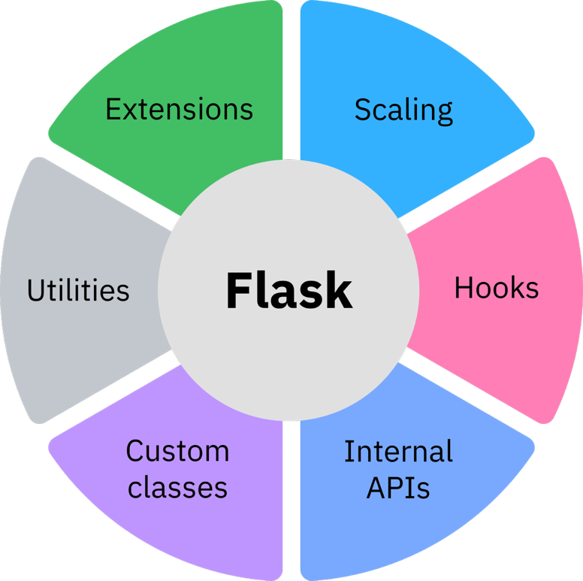

Key Flask Capabilities

Extensibility and Integration
Flask is extensible, and developers can add or remove features, enabling customization. Flask integrates seamlessly with other Python libraries and frameworks, letting developers combine its features with other tools and technologies to enhance its capabilities.

Transparent Documentation
Flask's documentation is transparent, allowing developers to find extension points, hooks, overrides, and signals as per requirement.

Custom Implementation
Out-of-the-box customizations and custom classes can be used for things like the request and response objects. The Flask class has many methods designed for subclassing. You can quickly add or customize behavior by subclassing Flask and using that subclass wherever you instantiate an application class.

Scaling Considerations
You can use scaling in such a way that if you double the number of servers, you get about twice the performance. One specific technical consideration regarding scaling in Flask is the use of context local proxies. They depend on context, which in Flask is defined as being either a thread, process, or greenlet. If your server uses some kind of concurrency that is not based on threads or greenlets, older versions of Flask could not support these global proxies. Modern Flask uses contextvars, which also work with asyncio.

Modular Development
Look for ways in which your project can be refactored into a collection of utilities and Flask extensions. Explore the many extensions in the community and look for patterns to build your own extensions if you do not find the tools you need. The best way to improve the tools for larger applications is getting feedback from users.

Real-World Applications
Today, Python with Flask has become a popular choice among big names for its simplicity, flexibility, versatility, and ease of learning and use. Its minimalistic design and customizable nature make it adaptable, effective, and reliable for large-scale web development requirements in diverse industries and sectors.
Several prominent companies, including Netflix, Reddit, Lyft, LinkedIn, Pinterest, and Uber, leverage Python with Flask in their technology stacks for specific backend services or functionalities. Python Flask benefits big companies for diverse purposes such as API development, backend services, rapid development, and prototyping, while its extensibility facilitates the addition of functionalities within their infrastructure. This suggests that it can be part of scalable architectures when combined with appropriate strategies and tools.

Application Development Lifecycle

Introduction
Every application goes through different phases before it is ready for users. For example, imagine a customer requests an application to help their employees track their daily tasks. Now, consider a scenario where a customer wants a web app to manage hotel reservations, from creation to customer check-out.
In either scenario, we cannot start building the application immediately when the customer makes a request. We need to perform certain activities like analyzing requirements, planning, and coding before the application is ready for users.
Regardless of the application type, every application will go through different phases, called the application development lifecycle.

Application Development Lifecycle
We can divide the application development lifecycle into seven phases:
- Requirement gathering
- Analysis
- Design
- Code and test
- User and system testing
- Production
- Maintenance

Requirement Gathering
Requirement gathering is the first phase in the application development process.
In the requirement gathering phase, we will capture the requirements across all aspects of the application, including:
- User requirements
- Business requirements
- Technical requirements

User Requirements
For the hotel reservation app, a user requirement may be that users must be able to view the different rooms and amenities available.

Business Requirements
Determining the right charge for different rooms and amenities may be a business requirement.

Technical Requirements
A technical requirement might be that the app must run on all browsers and mobile devices.
The goal should be to capture as many requirements as possible, even if it seems redundant or trivial.
We must also identify any constraints of design and viability of the business model.
For example, for the hotel reservation app, one constraint is that the server needs to keep the status of room availability updated at all times, which has an associated cost. Therefore, to keep the business viable, a minor convenience fee is added to the final payment.
After gathering the requirements and constraints, we must analyze each to create a possible solution for the application’s design.

Analysis and Design
During analysis and design, there might be multiple rounds of verification and revision to create a model solution that meets all the specified requirements.
Across the analysis and design phases of application development, we must maintain proper documentation with records of all updates in the design. This documentation should be clear and concise as used during the code and test phase.
The final proposed design and the specified requirements are passed on to the code and test phase.

Code and Test
During the code and test phase, the team uses the programming requirements specified in the design documentation to code, test, revise, and test the application programs until the code meets all documented requirements.

Unit Testing
The tests we conduct for the unit code is called unit testing.
Conduct the unit testing at the programming level to ensure we meet all required specifications.
After the unit testing, we can generate an acceptable application version.

User and System Testing
The new version of the application is then run through a series of user and system level tests.

User Testing
The user tests verify the functionality from a user’s point of view.

Integration Testing
We will need to execute several system-level tests, including integration and performance testing.
Integration tests verify that all involved programs continue functioning as expected after integration.
Integration testing also verifies that the application functions within a larger framework.

Performance Testing
Performance testing helps evaluate the speed, scalability, and stability of the application based on varying workloads.

Production
After testing, we can generate a new application version and send it to production.
Once in production, end users can access and use it. We must ensure that the application functions accurately and is available to users.
When the application is in the production phase, it must remain in a steady state.
In a steady state, we should not make any changes to the application. However, this is not always possible.
For example, we might need to make changes to the application in case of an error. These changes are tightly controlled and heavily tested before being implemented into production.

Maintenance
The last phase in the application development lifecycle is maintenance.
The application might need an upgrade, or we might need to add new features. In this case, the new features must go through all previous phases before being integrated into the application version deployed in production.

Coding Application Functionalities in Multiple Files
Every app usually has multiple functionalities, and the requirements for each functionality might vary.
The best practice is to code each functionality in separate file.
We can then create a central program, which runs the application and calls the individual files to perform specific functions.
This approach to organizing code makes code maintenance efficient and easy.
Having multiple files also helps when we need to add new functionality to an existing application.
When we write the code for new functionality in a separate file, only the file will go through the entire design and verification process before being integrated into the running application.

Application Development Lifecycle Summary
The application development lifecycle has seven phases, including:
- Requirement gathering: Where we collect user, business, and technical requirements for the app.
- Analysis: Where we analyze the requirements.
- Design: Where we design the complete solution.
- Code and test: Where we build and test the different components of the app.
- User and system test: Where users test the app for usability, and we perform system integration testing and performance testing.
- Production: Where the application is available to all end users.
- Maintenance: Where we upgrade or fix any user or system issues.
For efficient coding, always use a central program to call the individual files and functions to perform different actions.

Application Development Lifecycle

Introduction
The application development lifecycle describes the different phases an application goes through from the initial customer request to production and maintenance.
Consider two scenarios:
- A customer requests an application to help their employees track their daily tasks.
- A customer wants a web app to manage hotel reservations, from creation to customer check-out.
In either scenario, we cannot start building the application immediately when the customer makes a request. We need to perform certain activities like analyzing requirements, planning, and coding before the application is ready for users.
Regardless of the application type, every application will go through different phases, called the application development lifecycle.
The application development lifecycle can be divided into seven phases:
- Requirement gathering
- Analysis
- Design
- Code and test
- User and system testing
- Production
- Maintenance

Application Development Lifecycle Phases

Requirement Gathering
Requirement gathering is the first phase in the application development process.
In the requirement gathering phase, we capture the requirements across all aspects of the application, including:
- User requirements
- Business requirements
- Technical requirements
For example, consider the hotel reservation app:
- A user requirement may be that users must be able to view the different rooms and amenities available.
- Determining the right charge for different rooms and amenities may be a business requirement.
- A technical requirement might be that the app must run on all browsers and mobile devices.
The goal should be to capture as many requirements as possible, even if they seem redundant or trivial.
We must also identify any constraints of design and viability of the business model. For example, for the hotel reservation app, one constraint is that the server needs to keep the status of room availability updated at all times, which has an associated cost. Therefore, to keep the business viable, a minor convenience fee is added to the final payment.

Analysis and Design
After gathering the requirements and constraints, we must analyze each to create a possible solution for the application’s design.
During analysis and design, there might be multiple rounds of verification and revision to create a model solution that meets all the specified requirements.
Across the analysis and design phases of application development, we must maintain proper documentation with records of all updates in the design. This documentation should be clear and concise as used during the code and test phase.
The final proposed design and the specified requirements are passed on to the code and test phase.

Code and Test
During the code and test phase, the team uses the programming requirements specified in the design documentation to code, test, revise, and test the application programs until the code meets all documented requirements.
The tests conducted for the unit code are called unit testing.
We conduct unit testing at the programming level to ensure we meet all required specifications. After the unit testing, we can generate an acceptable application version.

User and System Testing
The new version of the application is then run through a series of user and system-level tests.
The user tests verify the functionality from a user’s point of view.
In addition, we need to execute several system-level tests, including:
- Integration testing: Integration tests verify that all involved programs continue functioning as expected after integration. Integration testing also verifies that the application functions within a larger framework.
- Performance testing: Performance testing helps evaluate the speed, scalability, and stability of the application based on varying workloads.

Production
After testing, we can generate a new application version and send it to production.
Once in production, end users can access and use it. We must ensure that the application functions accurately and is available to users.
When the application is in the production phase, it must remain in a steady state. In a steady state, we should not make any changes to the application.
However, this is not always possible. For example, we might need to make changes to the application in case of an error. These changes are tightly controlled and heavily tested before being implemented into production.

Maintenance
The last phase in the application development lifecycle is maintenance.
The application might need an upgrade, or we might need to add new features. In this case, the new features must go through all previous phases before being integrated into the application version deployed in production.

Coding Applications Using Multiple Files
Every app usually has multiple functionalities, and the requirements for each functionality might vary.
The best practice is to code each functionality in a separate file. We can then create a central program, which runs the application and calls the individual files to perform specific functions.
This approach to organizing code makes code maintenance efficient and easy.
Having multiple files also helps when we need to add new functionality to an existing application. When we write the code for new functionality in a separate file, only the file goes through the entire design and verification process before being integrated into the running application.

Key Takeaways
The application development lifecycle has seven phases:
- Requirement gathering: We collect user, business, and technical requirements for the app.
- Analysis: We analyze the requirements.
- Design: We design the complete solution.
- Code and test: We build and test the different components of the app.
- User and system test: Users test the app for usability, and we perform system integration testing and performance testing.
- Production: The application is available to all end users.
- Maintenance: We upgrade or fix any user or system issues.
For efficient coding, always use a central program to call the individual files and functions for performing different actions.

