Module 1

Introduction to Python

Users of Python
Python is widely used by professionals across different fields because of its clear and readable syntax.

Experienced Programmers
- Can develop the same programs from other languages with less code.

Beginners
- Python is an excellent starting language due to its large global community and wealth of documentation.

Benefits of Using Python
Python is a powerful, high-level, general-purpose programming language. It offers:
- A large standard library with tools for:
  - Databases
  - Automation
  - Web scraping
  - Text processing
  - Image processing
  - Machine learning
  - Data analytics
- Applications across:
  - Data Science
  - Artificial Intelligence and Machine Learning
  - Web Development
  - Internet of Things (IoT)
- A strong global community and support from the Python Software Foundation.

Popularity of Python
Python has become the most widely used and popular programming language in the data science industry:
- 2019 Kaggle Survey: 75% of over 10,000 respondents reported using Python regularly.
- Glassdoor (2019): More than 75% of data science job listings included Python.
- Over 80% of data professionals worldwide reported using Python in 2019 surveys.

Organizations Using Python
Major organizations that rely on Python include:
- IBM
- Wikipedia
- Google
- Yahoo!
- CERN
- NASA
- Facebook
- Amazon
- Instagram
- Spotify
- Reddit

Python in Data Science and AI
Python’s rich ecosystem of libraries supports advanced applications:

Scientific Computing Libraries
- Pandas
- NumPy
- SciPy
- Matplotlib

Artificial Intelligence and Machine Learning
- TensorFlow
- PyTorch
- Keras
- Scikit-learn

Natural Language Processing
- Natural Language Toolkit (NLTK)

Diversity and Inclusion in the Python Community
Python’s community is known for its commitment to diversity and inclusion:
- Python Software Foundation
- PyLadies

Table of Contents
1 Introduction to Python 1
1.1 Users of Python 1
1.1.1 Experienced Programmers 1
1.1.2 Beginners 1
1.2 Benefits of Using Python 1
1.3 Popularity of Python 1
1.3.1 Organizations Using Python 2
1.4 Python in Data Science and AI 2
1.4.1 Scientific Computing Libraries 2
1.4.2 Artificial Intelligence and Machine Learning 2
1.4.3 Natural Language Processing 2
1.5 Diversity and Inclusion in the Python Community 2
2 Course Overview 14
2.1 Course Content 14
2.1.1 Module 1: Python Basics 14
2.1.2 Module 2: Python Data Structures 14
2.1.3 Module 3: Python Programming Fundamentals 14
2.1.4 Module 4: Working with Data in Python 14
2.1.5 Module 5: APIs and Data Collection 15
3 Getting Started with Jupyter 15
3.1 Introduction 15
3.2 Launching a Notebook 15
3.2.1 Running Your First Cell 15
3.3 Working with Cells 15
3.3.1 Inserting a Cell 15
3.3.2 Deleting a Cell 15
3.3.3 Moving Cells 16
3.4 Working with Multiple Notebooks 16
3.4.1 Example 16
3.5 Presenting with Jupyter 16
3.6 Shutting Down Notebooks 16
3.7 Summary 16
4 Module 1 Summary: Python Basics 17
4.1 Data Types in Python 17
4.1.1 Typecasting 17
4.2 Expressions and Operations 17
4.3 Variables 17
4.4 String Operations 17
4.5 Key Takeaways 18
5 Lists and Tuples 18
5.1 Compound Data Types 18
5.2 Tuples 18
5.2.1 Definition 18
5.2.2 Accessing Elements 18
5.2.3 Operations on Tuples 19
5.2.4 Immutability 19
5.2.5 Functions with Tuples 19
5.2.6 Nesting and Indexing 19
5.3 Lists 19
5.3.1 Definition 19
5.3.2 Accessing Elements 19
5.3.3 Operations on Lists 19
5.3.4 Mutability 19
5.3.5 Conversion 20
5.4 Summary 20
6 Dictionaries 20
6.1 Definition 20
6.2 Structure 21
6.3 Example 21
6.4 Accessing Values 21
6.5 Modifying Dictionaries 21
6.6 Checking Membership 21
6.7 Dictionary Methods 21
6.8 Visualization 21
6.9 Summary 22
7 Sets 22
7.1 Definition 22
7.2 Creating Sets 22
7.3 Basic Set Operations 22
7.3.1 Adding Elements 22
7.3.2 Removing Elements 22
7.3.3 Membership Test 22
7.4 Mathematical Set Operations 23
7.4.1 Intersection 23
7.4.2 Union 23
7.4.3 Subset 23
7.5 Visualization with Venn Diagrams 23
7.6 Summary 23
8 Module 2 Summary: Python Data Structures 23
8.1 Tuples 23
8.2 Lists 23
8.3 Dictionaries 24
8.4 Sets 24
8.5 Summary 24
9 Exploring Python Functions 24
9.1 Objectives 24
9.2 Introduction to Functions 25
9.3 Purpose of Functions 25
9.4 Benefits of Using Functions 25
9.5 How Functions Work 25
9.5.1 Inputs (Parameters) 25
9.5.2 Performing Tasks 25
9.5.3 Producing Outputs 25
9.6 Python’s Built-in Functions 26
9.6.1 Common Examples 26
9.7 Defining Your Own Functions 26
9.7.1 Example with Parameters 26
9.7.2 Docstrings 26
9.7.3 Return Statement 26
9.8 Understanding Scopes and Variables 26
9.9 Using Functions with Loops 27
9.9.1 Example with Loop and Function 27
9.10 Modifying Data Structures with Functions 27
9.10.1 Adding and Removing Elements in a List 27
10 Exception Handling in Python 27
10.1 Objectives 27
10.2 What Are Exceptions? 28
10.3 Errors vs. Exceptions 28
10.4 Common Exceptions in Python 28
10.4.1 ZeroDivisionError 28
10.4.2 ValueError 28
10.4.3 FileNotFoundError 28
10.4.4 IndexError 29
10.4.5 KeyError 29
10.4.6 TypeError 29
10.4.7 AttributeError 29
10.4.8 ImportError 29
10.5 Handling Exceptions 29
10.5.1 How It Works 29
10.5.2 Example: Division by Zero 29
11 Objects and Classes in Python 30
11.1 Objectives 30
11.2 Introduction to Objects 30
11.2.1 Characteristics of an Object 30
11.2.2 Examples of Objects 30
11.3 Classes and Methods 30
11.4 Creating Your Own Classes 31
11.4.1 Circle Class Example 31
11.4.2 Rectangle Class Example 31
11.4.3 Class Definition 31
11.4.4 Creating Objects from a Class 31
11.5 Constructors and the __init__ Method 31
11.6 Accessing and Modifying Attributes 32
11.7 Methods in Classes 32
11.7.1 Example: Adding to Radius 32
11.7.2 Using the Method 32
11.8 Drawing Methods 32
11.9 Summary 32
12 Module 3 Summary: Python Programming Fundamentals 32
12.1 Conditional Statements 32
12.2 Loops 33
12.3 Functions 33
12.4 Variable Scope 33
12.5 Exception Handling 33
12.6 Objects and Classes 34
13 Reading a File with Open() 34
13.1 Introduction 34
13.2 Objectives 34
13.3 Plain Text Files 34
13.4 Opening the File 35
13.4.1 1. Using Python’s open() Function 35
13.4.2 2. Using the with Statement 35
13.5 Reading Operations 35
13.5.1 1. Reading the Entire Content 35
13.5.2 2. Reading the Content Line by Line 36
13.5.3 3. Reading Specific Characters 36
13.6 Conclusion 37
14 Writing on a File with Open() 37
14.1 Objective 37
14.2 Writing to a File 37
14.2.1 Code Explanation 37
14.3 Writing Multiple Lines to a File Using a List and Loop 38
14.3.1 Code Explanation 38
14.4 Appending Data to an Existing File 38
14.4.1 Code Explanation 38
14.5 Copying Contents from One File to Another 38
14.5.1 Code Explanation 39
14.6 File Modes in Python 39
14.7 Conclusion 40
15 Introduction to Pandas for Data Analysis 40
15.1 Objectives 40
15.2 What is Pandas? 40
15.2.1 Key Features of Pandas 40
15.3 Importing Pandas 41
15.4 Data Loading 41
15.5 What is a Series? 41
15.5.1 Accessing Elements in a Series 41
15.5.2 Series Attributes and Methods 42
15.6 What is a DataFrame? 42
15.6.1 Creating DataFrames from Dictionaries 42
15.6.2 Column Selection 42
15.6.3 Accessing Rows 42
15.6.4 Slicing 42
15.6.5 Finding Unique Elements 43
15.6.6 Conditional Filtering 43
15.6.7 Saving DataFrames 43
15.7 DataFrame Attributes and Methods 43
15.8 Conclusion 43
16 Beginner's Guide to NumPy 43
16.1 Objectives 43
16.2 What is NumPy? 44
16.2.1 Key Aspects of NumPy in Python 44
16.3 Installation 44
16.4 Creating NumPy Arrays 44
16.4.1 Creating a 1D Array 44
16.4.2 Creating a 2D Array 44
16.5 Array Attributes 45
16.6 Indexing and Slicing 45
16.7 Basic Operations 45
16.7.1 Array Addition 45
16.7.2 Scalar Multiplication 45
16.7.3 Element-wise Multiplication (Hadamard Product) 45
16.7.4 Matrix Multiplication 45
16.8 Operations with NumPy 46
16.9 Conclusion 46
17 Some Context on APIs 46
17.1 What are APIs? 46
17.2 Importance of APIs 47
17.2.1 Benefits of APIs 47
17.3 Applications of APIs 47
17.3.1 Social Media Platforms 47
17.3.2 E-Commerce Websites 47
17.3.3 Weather Applications 47
17.3.4 Maps and Navigation Applications 47
17.3.5 Payment Gateways 48
17.3.6 Messaging Applications 48
17.4 Conclusion 48
18 Module 4 Summary: Working with Data in Python 48
18.1 File Handling in Python 48
18.1.1 File Modes 48
18.1.2 Key Functions and Concepts 48
18.2 Pandas: Data Manipulation and Analysis 48
18.2.1 Importing and Aliasing 48
18.2.2 Working with DataFrames 49
18.3 NumPy: Numerical and Matrix Operations 49
18.3.1 Key Concepts 49
18.3.2 Array Attributes and Methods 49
18.4 Vector and Matrix Operations in NumPy 49
18.4.1 Vector Operations 49
18.4.2 Visualization with Matplotlib 49
18.5 Two-Dimensional Arrays in NumPy 50
18.6 Summary 50
19 Application Program Interfaces (APIs) 50
19.1 Introduction 50
19.2 What is an API? 50
19.3 APIs in Python 50
19.3.1 Pandas API 50
19.4 REST APIs 51
19.4.1 REST API Terminology 51
19.4.2 HTTP and JSON Communication 51
19.5 Example: PyCoinGecko API 51
19.5.1 Steps to Use PyCoinGecko 51
19.5.2 Data Conversion and Processing 52
19.5.3 Candlestick Chart Creation 52
19.6 Summary 52
20 HTTP Protocol 52
20.1 Introduction 52
20.2 Overview of HTTP 52
20.2.1 Example: Web Server Resources 53
20.3 Uniform Resource Locator (URL) 53
20.4 HTTP Request and Response 53
20.4.1 Request Message 53
20.4.2 Response Message 53
20.5 HTTP Status Codes 54
20.6 HTTP Methods 54
20.7 Summary 54
21 Working with the HTTP Protocol using the Requests Library 54
21.1 Introduction 54
21.2 Overview of the Requests Library 55
21.3 Exploring the Response Object 55
21.3.1 Checking Status Code 55
21.3.2 Viewing Request Headers 55
21.3.3 Viewing Request Body 55
21.3.4 Viewing Response Headers 55
21.3.5 Checking Encoding and Response Text 56
21.4 GET Requests with Parameters 56
21.4.1 Structure of a Query String 56
21.4.2 Sending GET Request in Python 56
21.5 POST Requests 57
21.5.1 Differences Between GET and POST 57
21.5.2 Comparing URLs and Bodies 57
21.6 Summary 57
22 Web Scraping and HTML Basics 57
22.1 Objectives 57
22.2 Introduction to Web Scraping 58
22.3 How Web Scraping Works 58
22.3.1 HTTP Request 58
22.3.2 Web Page Retrieval 58
22.3.3 HTML Parsing 58
22.3.4 Data Extraction 58
22.3.5 Data Transformation 58
22.3.6 Storage 58
22.3.7 Automation 58
22.4 Document Tree 59
22.4.1 HTML Structure 59
22.4.2 Composition of an HTML Tag 59
22.4.3 HTML Document Tree 59
22.5 HTML Tables 60
22.6 Web Scraping with Python 61
22.7 Navigating the HTML Structure 61
22.8 Custom Data Extraction 61
22.9 Using BeautifulSoup for HTML Parsing 61
22.10 Using Pandas read_html for Table Extraction 61
22.11 Conclusion 62
23 Introduction to HTML for Web Scraping 62
23.1 Overview 62
23.2 Objectives 62
23.3 Introduction to HTML for Web Scraping 62
23.4 Basic HTML Structure 62
23.4.1 Common HTML Elements 62
23.4.2 Example 63
23.5 Composition of an HTML Tag 63
23.5.1 Tag Structure 63
23.5.2 Example: Anchor Tag 63
23.6 HTML Document Tree 63
23.6.1 Parent and Child Relationships 63
23.7 HTML Tables 64
23.7.1 Table Elements 64
23.7.2 Example Structure 64
23.8 Inspecting and Extracting HTML 64
23.9 Summary 64
24 Web Scraping 65
24.1 Overview 65
24.2 Objectives 65
24.3 Introduction to Web Scraping 65
24.4 BeautifulSoup Object 65
24.4.1 Creating a BeautifulSoup Object 65
24.4.2 Tag Objects 65
24.4.3 Accessing Attributes and Text 66
24.5 The find_all() Method 66
24.5.1 Example: Extracting Table Data 66
24.6 Scraping a Webpage with Requests and BeautifulSoup 66
24.6.1 Steps: 67
24.7 Summary 67
25 Web Scraping: A Key Tool in Data Science 67
25.1 Introduction 67
25.2 Importance of Web Scraping in Data Science 67
25.2.1 Data Collection 67
25.2.2 Real-time Applications 68
25.2.3 Machine Learning 68
25.3 Web Scraping with Python 68
25.3.1 BeautifulSoup 68
25.3.2 Scrapy 68
25.3.3 Selenium 68
25.4 Applications of Web Scraping 69
25.4.1 Price Comparison 69
25.4.2 Email Address Gathering 69
25.4.3 Social Media Scraping 69
25.5 Conclusion 69
26 Web Scraping Tables using Pandas 69
26.1 Introduction 69
26.2 Example: Extracting Largest Banks by Market Capitalization 69
26.3 Limitations of Using read_html() 71
26.3.1 1. Non-Visible Tables 71
26.3.2 2. Extra HTML Elements 72
26.4 Example: Extracting a Table with Hyperlinks 73
26.5 Comparison with BeautifulSoup 73
26.6 Summary 74
27 Working With Different File Formats 74
27.1 Learning Objectives 74
27.2 Introduction 74
27.3 Understanding File Formats 74
27.4 Using Pandas to Read CSV Files 74
27.4.1 Reading a CSV File 74
27.4.2 Adding Headers to a CSV File 75
27.5 Working with JSON Files 75
27.5.1 Reading a JSON File 75
27.6 Working with XML Files 75
27.6.1 Reading an XML File 75
27.6.2 Creating a DataFrame from XML Data 75
27.7 Summary 76
28 Summary 76
28.1 Introduction 76
28.2 Using APIs in Python 76
28.2.1 Pandas API 76
28.3 REST APIs and HTTP Communication 76
28.3.1 HTTP Protocol 77
28.3.2 HTTP Methods 77
28.3.3 HTTP Messages and Responses 77
28.4 URL Structure 77
28.5 Working with the Requests Library 77
28.6 Time Series Data and Plotting 77
28.7 Web Scraping in Python 77
28.7.1 Understanding HTML 78
28.7.2 Extracting Tabular Data 78
28.7.3 Beautiful Soup Library 78
28.8 Working with File Formats 78
28.8.1 Accessing Different File Types 78
28.9 Summary 79
29 Next Steps 79
29.1 Next Steps 79
29.1.1 Python Project Courses 79
29.2 Additional Learning Opportunities 79
29.3 Professional Certificates 79
29.3.1 IBM Professional Certificates 79
29.3.2 IBM Specializations 80

Course Overview
Welcome to the Python for Data Science, AI, and Development. After completing this, you will:
- Possess basic knowledge of Python.
- Understand different data types.
- Use lists, tuples, dictionaries, and sets.
- Apply conditions and branching.
- Implement loops and create functions.
- Perform exception handling.
- Create and use objects.
- Read and write files.
- Collect data using APIs and web scraping.

Course Content
This course is divided into five modules. Aim to complete at least one module per week.

Module 1: Python Basics
- About the Course
- Types
- Expressions and Variables
- String Operations

Module 2: Python Data Structures
- Lists and Tuples
- Dictionaries
- Sets

Module 3: Python Programming Fundamentals
- Conditions and Branching
- Loops
- Functions
- Exception Handling
- Objects and Classes
- Practice with Python Programming Fundamentals

Module 4: Working with Data in Python
- Reading and Writing Files with Open
- Pandas
- NumPy in Python

Module 5: APIs and Data Collection
- Simple APIs
- REST APIs, Web Scraping, and Working with Files
- Final Exam

Getting Started with Jupyter

Introduction
Welcome to Getting Started with Jupyter. After completing this module, you will be able to:
- Describe how to run, insert, and delete a cell in a notebook.
- Work with multiple notebooks.
- Present a notebook.
- Shut down a notebook session.

Launching a Notebook
In the lab session of this module, you can launch a notebook using the Skills Network virtual environment.
- Select the check box, click Open Tool, and the environment will launch Jupyter Lab.
- Once the notebook opens, you can rename it by clicking File > Rename Notebook and entering a new name.

Running Your First Cell
- Create a new notebook and type print("Hello World").
- Click the Run button to execute the cell.
- Alternatively:
  - From the main menu bar, click Run > Run Selected Cells.
  - Or press Shift + Enter as a shortcut.
- To run all cells in the notebook, select Run All Cells.

Working with Cells

Inserting a Cell
- Click the plus (+) symbol in the toolbar to insert a new cell.

Deleting a Cell
- Highlight the cell, then click Edit > Delete Cells.
- Shortcut: Press D twice (DD) on the highlighted cell.

Moving Cells
- You can move cells up or down as needed.

Working with Multiple Notebooks
- Click the plus (+) button in the toolbar and select the file you want to open.
- Alternatively: File > Open New Launcher or File > Open New Notebook.
- Opened notebooks can be arranged side by side.

Example
In one notebook, assign:
one = 1
two = 2
print(one + two)
This demonstrates working with multiple notebooks simultaneously.

Presenting with Jupyter
Jupyter supports creating presentations directly from notebooks:
- Use Markdown cells to add titles, text, and descriptions.
- Create plots and combine them with code outputs.
- Convert cells into slides or sub-slides for presentations.
This feature allows seamless delivery of code, visualizations, and narrative as part of a project.

Shutting Down Notebooks
When you finish working:
- Click the stop icon on the sidebar (second icon from the top).
- You can terminate all sessions at once or shut them down individually.
- Once shut down, you will see “No Kernel” in the top-right corner, confirming the notebook is inactive.
- Close the tabs after shutting down.

Summary
In this module, you learned how to:
- Run, insert, and delete code cells.
- Work with multiple notebooks at the same time.
- Present results using Markdown and code cells.
- Shut down notebook sessions when finished.

Module 1 Summary: Python Basics

Data Types in Python
Python can distinguish among various data types:
- Integers: Whole numbers that can be positive or negative.
- Floats: Numbers with decimal points that represent whole or fractional values.
- Strings: Text data enclosed in single or double quotes, consisting of letters, digits, whitespace, or special characters.
- Booleans: Represent logical values, True or False.

Typecasting
- Integers can be converted to floats and vice versa.
- Integers and floats can be converted to strings.
- Integers or floats can be converted to Booleans:
  - 0 → False
  - Non-zero values → True

Expressions and Operations
Expressions in Python combine values and operations to produce results.
- Supports mathematical operations such as addition, subtraction, multiplication, and division.
- // performs integer division, discarding the fractional part.
- Python follows the BODMAS order of operations when evaluating expressions.

Variables
Variables store and manipulate data in Python:
- The assignment operator (=) assigns values to variables.
- Reassigning a variable overrides its previous value.
- Mathematical operations can be performed on variables.
- Changing one variable affects others only if they reference the same mutable object.

String Operations
Python provides powerful operations for manipulating strings:
- String Basics:
  - Strings are ordered sequences of characters.
  - Characters are indexed using positive and negative indices.
  - Strings support indexing, slicing, concatenation, and replication.
  - Strings are immutable and cannot be changed once created.
- Escape Sequences:
  - \n → New line
  - \t → Tab
  - \\ → Backslash
- String Methods:
  - Search, modify, and format strings.
  - Change case, replace characters, and find items.
  - Applying a method to a string creates and returns a new string.

Key Takeaways
- Python supports multiple data types: integers, floats, strings, and Booleans.
- Typecasting allows conversion between data types.
- Expressions and operators enable mathematical calculations.
- Variables help store and manipulate data.
- Strings offer rich operations like slicing, formatting, and built-in methods, but remain immutable.

Module 2

Lists and Tuples

Compound Data Types
Lists and tuples are examples of compound data types in Python. They are key data structures used to organize and manage collections of data.

Tuples

Definition
- Tuples are ordered sequences.
- Represented as comma-separated elements enclosed in parentheses ( ).
- They can contain multiple data types (strings, integers, floats, etc.), but the variable type remains a tuple.

Accessing Elements
- Elements are accessed using indexing with square brackets [].
- Indexing starts from 0.
- Negative indexes can be used to access elements from the end of the tuple.

Operations on Tuples
- Concatenation: Tuples can be combined using the + operator.
- Slicing: A range of elements can be accessed using [start:end]. The end index is exclusive.
- Length: The len() function returns the number of elements in a tuple.

Immutability
- Tuples are immutable (cannot be modified after creation).
- Assigning one tuple variable to another references the same object.
- To modify a tuple, a new tuple must be created.

Functions with Tuples
- The sorted() function creates a new sorted list from a tuple.
- Tuples can also contain other tuples or complex objects, known as nesting.

Nesting and Indexing
- Tuples can be nested (tuples within tuples).
- Standard indexing rules apply to access nested elements.
- This nesting can be visualized like a tree structure.
- Example: tup[2][3] -> means the fourth element of the sub-tuple at index 2 inside a tuple.

Lists

Definition
- Lists are ordered sequences represented with square brackets [ ].
- Lists are mutable, meaning their contents can be changed.

Accessing Elements
- Elements are accessed using indexing, similar to tuples.
- Negative indexes are supported.
- Slicing works the same as in tuples.

Operations on Lists
- Concatenation: Lists can be combined using the + operator.
- Extend: The .extend() method adds multiple elements to the end of a list.
- Append: The .append() method adds a single element.
- Deletion: Elements can be removed using the del command.

Mutability
- Lists can be modified directly:
  - Changing an element by index.
  - Adding new elements using methods.
  - Deleting elements.
- Aliasing: Assigning one list variable to another references the same object. Changes in one affect the other. e.g. A = [1,2,3] and B = A.
- Cloning: To avoid aliasing, lists can be cloned so each variable references a separate object.
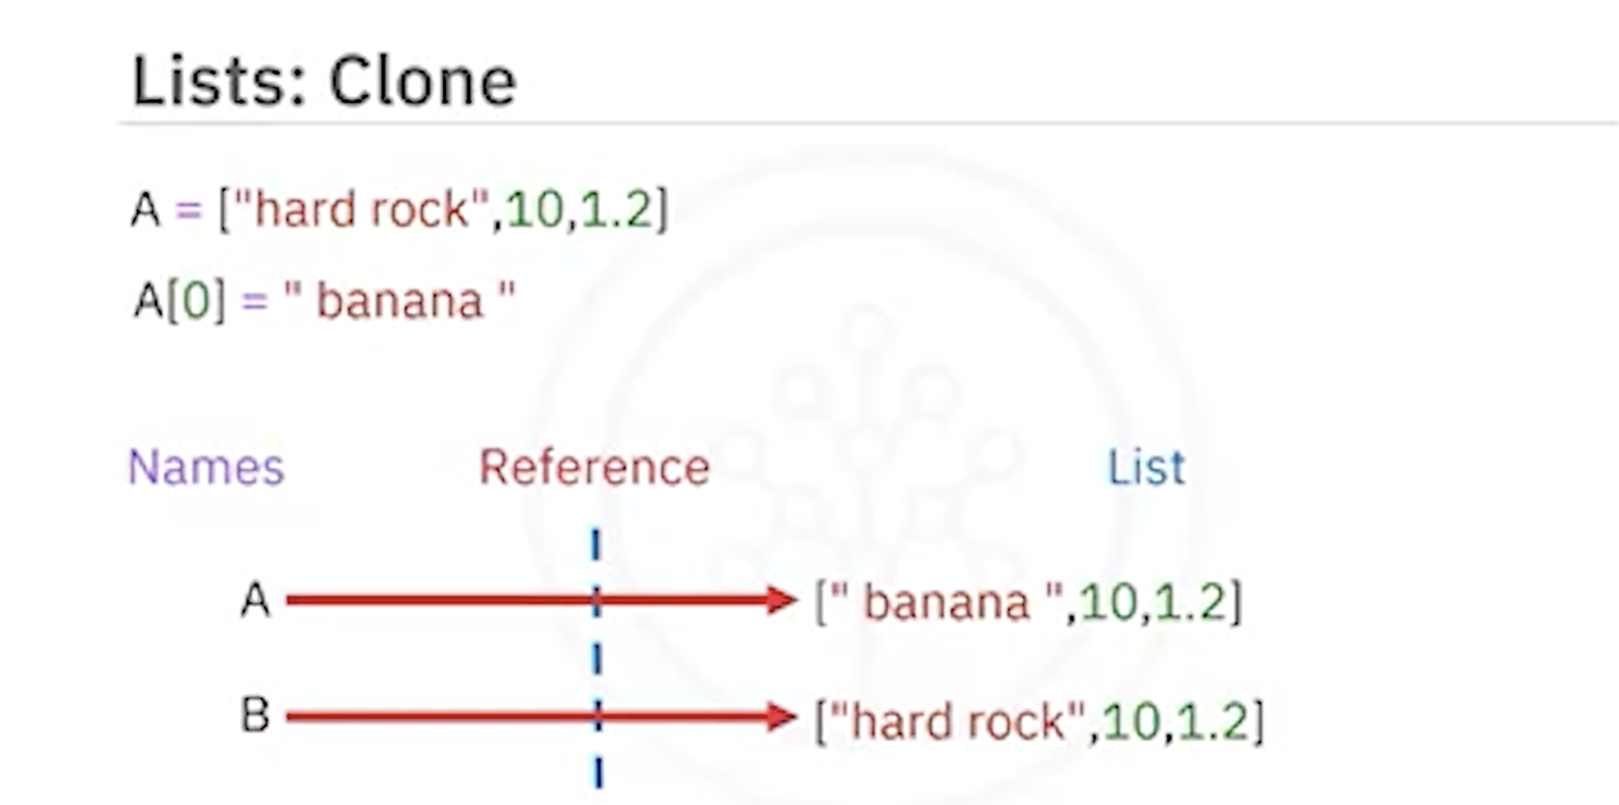

Conversion
- Strings can be converted into lists using the .split() method.
- A delimiter can be passed to .split() to control how the string is divided.

Summary
- Tuples: Ordered, immutable, represented by parentheses ( ).
- Lists: Ordered, mutable, represented by square brackets [ ].
- Both support indexing, slicing, concatenation, and nesting.
- Tuples are often used when data should remain constant, while lists are preferred when modifications are needed.

Dictionaries

Definition
- Dictionaries are collections of key-value pairs in Python.
- Represented using curly brackets { }.
- Keys act like indexes but do not have to be integers. They are usually strings and must be immutable and unique.
- Values can be immutable, mutable, and can include duplicates.

Structure
- Each key is followed by a value, separated by a colon :.
- Each key-value pair is separated by a comma.

Example
albums = {
"Back in Black": 1980,
"The Dark Side of the Moon": 1973,
"The Bodyguard": 1992,
"Thriller": 1982
}
- Keys: Album titles (e.g., "Back in Black").
- Values: Release years (e.g., 1980).

Accessing Values
- Values are accessed using square brackets with the key.
albums["Back in Black"] # Output: 1980
albums["The Dark Side of the Moon"] # Output: 1973

Modifying Dictionaries
- Add Entry: Assign a new key with a value.
albums["Graduation"] = 2007
- Delete Entry: Use the del command.
del albums["Thriller"]

Checking Membership
- Use the in command to check if a key exists.
"Back in Black" in albums # Output: True
"Random Album" in albums # Output: False

Dictionary Methods
- Keys: albums.keys() returns all keys.
- Values: albums.values() returns all values.

Visualization
- Think of a dictionary like a table:
  - The first column represents keys (e.g., album titles).
  - The second column represents values (e.g., release years).

Summary
- Dictionaries store data as key-value pairs.
- Keys must be unique and immutable.
- Values can be duplicates and may be mutable or immutable.
- They are powerful for lookups, modifications, and managing structured data.

Sets

Definition
- Sets are a collection type in Python.
- Like lists and tuples, they can contain different data types.
- Key Characteristics:
  - Unordered: They do not record element positions.
  - Unique Elements: Duplicate values are not allowed.

Creating Sets
- Defined using curly brackets { }.
- Duplicate items are automatically removed.
- You can convert a list to a set using the set() function (typecasting).
my_list = ["ACDC", "BackInBlack", "ACDC"]
my_set = set(my_list)
print(my_set) # Output: {"ACDC", "BackInBlack"}

Basic Set Operations

Adding Elements
- Use the add() method.
A = {"Thriller", "ACDC"}
A.add("inSync")
- Adding the same item again has no effect (no duplicates).

Removing Elements
- Use the remove() method.
A.remove("inSync")

Membership Test
- Use the in keyword.
"ACDC" in A # Output: True
"Who" in A # Output: False

Mathematical Set Operations

Intersection
- The intersection of two sets contains only the elements present in both sets.
AlbumSet1 = {"ACDC", "BackInBlack", "Thriller"}
AlbumSet2 = {"ACDC", "BackInBlack", "The Bodyguard"}
AlbumSet3 = AlbumSet1 & AlbumSet2
print(AlbumSet3) # Output: {"ACDC", "BackInBlack"}

Union
- The union of two sets contains all unique elements from both sets.
AlbumSet1 | AlbumSet2

Subset
- Check if a set is a subset of another using issubset().
AlbumSet3.issubset(AlbumSet1) # Output: True

Visualization with Venn Diagrams
- Sets can be represented as circles.
- Intersection: Overlapping area.
- Union: A Combination of both circles.
- Subset: One circle fully inside another.

Summary
- Sets are unordered collections of unique elements.
- They support operations like add, remove, and membership checks.
- Mathematical operations include intersection, union, and subset checking.
- Useful for managing collections with no duplicates and for mathematical computations.

Module 2 Summary: Python Data Structures

Tuples
- Ordered and immutable collections of elements.
- Defined using parentheses () with comma-separated values.
- Can include strings, integers, floats, and even nested tuples.
- Access elements using positive and negative indexing.
- Operations include combining, concatenating, and slicing.
- Since tuples are immutable, new tuples must be created for modifications.

Lists
- Ordered and mutable collections of items.
- Defined using square brackets [].
- Can contain mixed data types such as strings, integers, floats, and nested lists.
- Elements are accessed using positive and negative indexing.
- Support operations like adding, deleting, splitting, concatenating, and appending.
- Aliasing occurs when multiple names refer to the same list object.
- Lists can be cloned to create independent copies.

Dictionaries
- Store key-value pairs for flexible data retrieval.
- Defined using curly brackets {}.
- Keys must be immutable and unique, while values can be mutable and allow duplicates.
- Key-value pairs are separated by commas.
- Access values using keys.
- Support operations like adding, deleting, and checking for the existence of keys (returns True/False).
- Provide methods to retrieve lists of keys and values.

Sets
- Unordered collections of unique elements.
- Defined using curly brackets {}.
- Automatically remove duplicate items.
- A list passed through the set() function generates a set of unique elements.
- Support set operations such as adding, removing, and membership checks.
- Mathematical operations include:
  - Intersection (&) → Common elements between sets.
  - Union (|) → All unique elements from both sets.
  - Subset check (issubset()) → Determine if one set is contained within another.

Summary
- Tuples: Ordered, immutable, suitable for fixed collections.
- Lists: Ordered, mutable, versatile for dynamic collections.
- Dictionaries: Key-value storage with unique keys and flexible values.
- Sets: Unordered, unique elements, ideal for duplicate removal and set operations.

Module 3

Exploring Python Functions

Objectives
After reading this, you should be able to:
- Describe the function concept and the importance of functions in programming
- Write a function that takes inputs and performs tasks
- Use built-in functions like len(), sum(), and others effectively
- Define and use your own functions in Python
- Differentiate between global and local variable scopes
- Use loops within a function
- Modify data structures using functions

Introduction to Functions
A function is a fundamental building block that encapsulates specific actions or computations. Similar to mathematics, functions in programming take inputs, perform operations, and return outputs.

Purpose of Functions
Functions promote modularity and reusability. Instead of duplicating code, you can define a function once and call it wherever needed, making code cleaner and easier to maintain.

Benefits of Using Functions
- Modularity: Break complex tasks into manageable parts
- Reusability: Use functions multiple times without rewriting code
- Readability: Enhance understanding with meaningful function names
- Debugging: Isolated functions simplify troubleshooting
- Abstraction: Simplify complex processes with easy-to-use interfaces
- Collaboration: Teams can work on separate functions concurrently
- Maintenance: Changes in a function reflect everywhere it is used

How Functions Work

Inputs (Parameters)
Functions receive inputs (parameters) that allow them to work with specific data.

Performing Tasks
Functions execute predefined tasks such as calculations, operations on data, formatting, or fetching information.

Producing Outputs
Functions return results (outputs) that can be reused, stored in variables, or passed to other functions.
Example:
def calculate_total(a, b): # Parameters: a and b
total = a + b # Task: Addition
return total # Output: Sum

result = calculate_total(5, 7)
print(result) # Output: 12

Python’s Built-in Functions
Python offers many built-in functions that simplify coding tasks.

Common Examples
# len()
string_length = len("Hello, World!") # Output: 13
list_length = len([1, 2, 3, 4, 5]) # Output: 5

# sum()
total = sum([10, 20, 30, 40, 50]) # Output: 150

# max()
highest = max([5, 12, 8, 23, 16]) # Output: 23

# min()
lowest = min([5, 12, 8, 23, 16]) # Output: 5

Defining Your Own Functions
def function_name():
pass
- pass is a placeholder statement to maintain correct syntax until code is added.

Example with Parameters
def greet(name):
return "Hello, " + name

print(greet("Alice")) # Output: Hello, Alice

Docstrings
def multiply(a, b):
"""
This function multiplies two numbers.
Input: a (number), b (number)
Output: Product of a and b
"""
print(a * b)

multiply(2, 6) # Output: 12

Return Statement
def add(a, b):
return a + b

sum_result = add(3, 5)
print(sum_result) # Output: 8

Understanding Scopes and Variables
- Global Scope: Variables defined outside functions (accessible everywhere)
- Local Scope: Variables defined inside a function (accessible only inside it)
global_variable = "I'm global"

def example_function():
local_variable = "I'm local"
print(global_variable) # Access global
print(local_variable) # Access local

example_function()
print(global_variable) # Works
# print(local_variable) # Error

Using Functions with Loops
Functions can contain loops, making tasks more organized and reusable.
def print_numbers(limit):
for i in range(1, limit + 1):
print(i)

print_numbers(5) # Output: 1 2 3 4 5

Example with Loop and Function
def greet(name):
return "Hello, " + name

for _ in range(3):
print(greet("Alice"))

Modifying Data Structures with Functions

Adding and Removing Elements in a List
# Initial list
my_list = []

# Function to add elements
def add_element(data_structure, element):
data_structure.append(element)

# Function to remove elements
def remove_element(data_structure, element):
if element in data_structure:
data_structure.remove(element)
else:
print(f"{element} not found in the list.")

# Add elements
add_element(my_list, 42)
add_element(my_list, 17)
add_element(my_list, 99)

print("Current list:", my_list)

# Remove elements
remove_element(my_list, 17)
remove_element(my_list, 55) # Not found

print("Updated list:", my_list)

Exception Handling in Python

Objectives
By the end of this reading, you should be able to:
- Understand exceptions
- Distinguish errors from exceptions
- Recognize common Python exceptions
- Manage exceptions effectively

What Are Exceptions?
Exceptions are alerts that occur when something unexpected happens while running a program. They could result from coding mistakes or unplanned situations. Python can raise exceptions automatically, but we can also trigger them manually using the raise statement. By handling exceptions, we can prevent programs from crashing.

Errors vs. Exceptions
Errors and exceptions differ in their severity and handling:
Aspect | Errors | Exceptions
Origin | Caused by environment, hardware, or operating system | Caused by problematic code execution within the program
Nature | Severe, often causing program crashes | Less severe, can usually be fixed so the program continues
Handling | Not usually caught or handled by the program | Can be caught using try-except blocks
Examples | SyntaxError (incorrect syntax), NameError (undefined variable) | ZeroDivisionError, FileNotFoundError
Categorization | Not classified | Categorized into classes (ArithmeticError, IOError, ValueError, etc.)

Common Exceptions in Python
Here are some commonly encountered exceptions:

ZeroDivisionError
Occurs when dividing a number by zero.
result = 10 / 0 # Raises ZeroDivisionError

ValueError
Occurs when inappropriate values are used, e.g., converting a non-numeric string to an integer.
num = int("abc") # Raises ValueError

FileNotFoundError
Occurs when trying to access a non-existent file.
with open("nonexistent_file.txt", "r") as file:
content = file.read() # Raises FileNotFoundError

IndexError
Occurs when accessing a list index out of range.
my_list = [1, 2, 3]
missing = my_list[5] # Raises IndexError

KeyError
Occurs when accessing a non-existent dictionary key.
my_dict = {"name": "Alice", "age": 30}
missing = my_dict["city"] # Raises KeyError

TypeError
Occurs when using an object in an incompatible manner.
result = "hello" + 5 # Raises TypeError

AttributeError
Occurs when accessing an attribute or method that does not exist.
text = "example"
missing = text.some_method() # Raises AttributeError

ImportError
Occurs when attempting to import a non-existent module.
import non_existent_module # Raises ImportError
Note: These are just a few examples; Python has many exceptions. With proper handling, you can manage them effectively.

Handling Exceptions
Python uses try-except blocks to handle exceptions and prevent crashes.

How It Works
- Code that might raise an exception is placed in the try block.
- If an exception occurs, control jumps to the except block.
- The except block defines how to handle the exception gracefully.
- The program continues execution after handling the exception.

Example: Division by Zero
try:
result = 10 / 0
except ZeroDivisionError:
print("Error: Cannot divide by zero")

print("Outside of try and except block")

Objects and Classes in Python
Estimated time needed: 20 minutes

Objectives
By the end of this reading, you should be able to:
- Understand objects and classes in Python
- Identify data attributes and methods
- Create your own classes and objects
- Work with constructors and methods
- Recognize how to modify and interact with objects

Introduction to Objects
Python has many different data types: integers, floats, strings, lists, dictionaries, and Booleans. In Python, each is an object.

Characteristics of an Object
Every object has:
- A type
- An internal representation
- A set of functions (methods) to interact with the data
An object is an instance of a particular type. For example:
- Each integer you create is an integer object.
- Each list you create is a list object.
We can find out the type of an object by using the type() command.

Examples of Objects
- Integer object
- List object
- String object
- Dictionary object

Classes and Methods
A class is a blueprint for creating objects. It defines:
- Data attributes/State: characteristics of the object
- Methods/Behavior: functions that interact with the object
We have already used methods, such as list.sort() or list.reverse(), which change the state of the list object.

Creating Your Own Classes
You can create your own classes in Python. A class defines the structure of objects:

Circle Class Example
Data attributes:
- radius
- color

Rectangle Class Example
Data attributes:
- color
- height
- width

Class Definition
To create a class in Python:
class Circle(object):
def __init__(self, radius, color):
self.radius = radius
self.color = color

Creating Objects from a Class
circle1 = Circle(4, "red")
circle2 = Circle(2, "green")
Similarly, you can create rectangle objects with height, width, and color.

Constructors and the __init__ Method
The __init__ method is a constructor. It initializes the object when it is created.
- self refers to the instance of the class.
- Parameters (e.g., radius, color) initialize the object’s data attributes.
class Rectangle(object):
def __init__(self, height, width, color):
self.height = height
self.width = width
self.color = color

Accessing and Modifying Attributes
You can access attributes with the dot operator:
print(circle1.radius)
print(circle1.color)
You can also modify them directly:
circle1.color = "blue"

Methods in Classes
Methods are functions inside a class that interact with its data attributes.

Example: Adding to Radius
class Circle(object):
def __init__(self, radius, color):
self.radius = radius
self.color = color

def add_radius(self, r):
self.radius = self.radius + r

Using the Method
circle = Circle(2, "red")
circle.add_radius(8)
print(circle.radius) # Output: 10

Drawing Methods
You can also define methods like drawCircle or drawRectangle to visualize objects. (See lab exercises for implementation.)

Summary
- Objects are instances of classes.
- Classes define data attributes and methods.
- The __init__ method is the constructor used to initialize object attributes.
- Methods allow interaction with and modification of object data.
- You can use the dir() function to inspect available attributes and methods of an object.
For more advanced details, visit python.org.

Module 3 Summary: Python Programming Fundamentals

Conditional Statements
- Python conditions use if statements to execute code based on true/false conditions created by comparisons and Boolean expressions.
- Comparison operators include:
  - == (equal to)
  - > (greater than)
  - < (less than)
  - != (not equal to)
- You can compare integers, strings, and floats.
- Python branching uses if, else, and elif to direct program flow and execute different code blocks.
- if defines actions when the condition is true.
- else defines actions when all previous conditions are false.
- elif provides additional checks only if the initial condition is false.
- Boolean logic operators are used to perform operations on Boolean values.

Loops
- Loops are control structures that automate repetitive tasks and iterate over data structures.
- The range() function generates a sequence of numbers with a start, stop, and step value.
- For loop iterates over sequences like lists, tuples, or strings, executing code for each item.
- While loop executes a block of code as long as the condition remains true.

Functions
- Functions are reusable code blocks that perform tasks, accept inputs, and often return results.
- Python has many built-in functions, such as:
  - len() to find the length of a sequence
  - sum() to calculate the sum of a sequence
  - sorted() to return a sorted list
  - sort() to sort items in the original list
- You can also create your own functions.
- Functions should include documentation strings (docstrings) to ensure clarity and maintainability.
- The help() command displays documentation for a function.
- Functions can have multiple parameters.
- If no return statement is used, the function returns None by default.
- The pass keyword can be used as a placeholder.
- Functions usually perform multiple tasks.

Variable Scope
- The scope of a variable defines where it can be accessed or modified.
- Local scope: variables defined inside a block or function, accessible only within it.
- Global scope: variables defined at the top level, accessible throughout the program.

Exception Handling
- Exception handling prevents errors from crashing a program.
- try-except is used to handle errors.
- try-except-else adds an else block that runs when no exceptions occur.
- try-except-else-finally ensures the finally block always runs, regardless of exceptions.

Objects and Classes
- Objects are instances of classes that encapsulate data and behavior.
- The type() function determines the type of an object.
- Classes are blueprints for creating objects, defining attributes and methods.
- Methods can modify an object’s state while maintaining its type.
- The __init__ method initializes object attributes.
- Instances of a class can be created with specific attributes.
- Data attributes define the data of an object.
- Methods are functions that interact with and modify attributes.
- Methods require self as the first parameter, along with other parameters.

Module 4

Reading a File with Open()
Estimated Time Needed: 10 minutes

Introduction
File handling is an essential aspect of programming, and Python provides built-in functions to interact with files. This guide explores how to use Python's open() function to read text files (.txt files).

Objectives
- Describe how to use the open() and read() Python functions to open and read the contents of a text file.
- Explain how to use the with statement in Python.
- Describe how to use the readline() function in Python.
- Explain how to use the seek() function to read specific character(s) in a text file.

Plain Text Files
Plain text files contain unformatted text without any specific structure. You can read these files line by line or load all the content into memory.

Opening the File
There are two primary methods to open a file in Python.

1. Using Python’s open() Function
Suppose we have a file named file.txt. The open() function creates a file object and allows access to the file’s contents. It takes two key parameters:
- File Path: The file name and its directory.
- Mode: Specifies the purpose of opening the file (e.g., 'r' for reading, 'w' for writing, 'a' for appending).
# Open the file in read ('r') mode
file = open('file.txt', 'r')
This line opens file.txt in read mode and returns a file object stored in the variable file.

2. Using the with Statement
The with statement simplifies file handling by automatically closing the file when operations within its block are completed.
# Open the file using 'with' in read ('r') mode
with open('file.txt', 'r') as file:
# further code
The with statement ensures the file is properly closed after operations, even if an exception occurs.

Advantages of Using the with Statement
- Automatic Resource Management: The file closes automatically when exiting the with block.
- Cleaner Code: No need to explicitly call close(), making code concise and less error-prone.
Note: For most file reading and writing operations, using the with statement is best practice.

Reading Operations

1. Reading the Entire Content
You can read the entire content of a file using the read() method. The data is stored as a string in a variable.
# Reading and Storing the Entire Content of a File
with open('file.txt', 'r') as file:
file_stuff = file.read()
print(file_stuff)
Step-by-Step Explanation:
- Open the File: Open file.txt in read mode using with.
- Read Content: Use read() to get the entire file content.
- Process Content: The file’s data is now in file_stuff; you can display or manipulate it.
- Automatic Closure: The file automatically closes after the block ends.

2. Reading the Content Line by Line
Python provides multiple methods for reading files line by line.

Using readlines()
Reads the entire file and stores each line as an element in a list.

Using readline()
Reads one line at a time and can be called repeatedly.
file = open('file.txt', 'r')
line1 = file.readline()
line2 = file.readline()

print(line1)
if 'important' in line2:
print('This line is important!')

while True:
line = file.readline()
if not line:
break
print(line)

file.close()
Explanation:
- Each call to readline() reads the next line.
- The loop continues until there are no more lines.
- Always close the file using close() when finished.

3. Reading Specific Characters
You can specify how many characters to read using the read() method.

Steps:
- Open the File:
file = open('file.txt', 'r')
- Navigate to a Position (Optional):
Use seek() to move the file pointer to a specific position.
file.seek(10) # Moves to the 11th byte
- Read Characters:
characters = file.read(5) # Reads 5 characters
print(characters)
- Close the File:
file.close()

Conclusion
In conclusion, file handling is a fundamental aspect of programming. Python’s built-in functions like open(), read(), readline(), and seek() make file operations simple and efficient. The use of the with statement ensures proper resource management, making it the recommended approach for file operations.

Writing on a File with Open()

Objective
- Create and write data to a file in Python.
- Write multiple lines of text to a file using lists and loops.
- Add new information to an existing file without erasing its content.
- Compare and contrast different file modes in Python, understanding their meanings and use cases.

Writing to a File
You can create a new text file and write data to it using Python’s open() function. The open() function takes two primary arguments:
- File path: The name and directory of the file.
- Mode: Specifies the operation you want to perform on the file.
For writing, use the mode 'w'. Here's an example:
# Create a new file Example2.txt for writing
with open('Example2.txt', 'w') as file1:
file1.write("This is line A\n")
file1.write("This is line B\n")
# file1 is automatically closed when the 'with' block exits

Code Explanation
- Line 2: The open() function opens or creates a file named Example2.txt for writing ('w' mode). The with statement ensures the file is automatically closed when the block exits.
- Line 3: The write() method writes the text This is line A followed by a newline (\n).
- Line 4: Writes This is line B to a new line in the same file.

Writing Multiple Lines to a File Using a List and Loop
You can store multiple lines of text in a list and write them to a file using a loop.
# List of lines to write to the file
Lines = ["This is line 1", "This is line 2", "This is line 3"]

# Create a new file Example3.txt for writing
with open('Example3.txt', 'w') as file2:
for line in Lines:
file2.write(line + "\n")
# file2 is automatically closed when the 'with' block exits

Code Explanation
- Line 2: A list named Lines stores multiple strings to be written to the file.
- Line 5: Opens Example3.txt for writing using 'w' mode.
- Line 6–7: Iterates over each line in the list and writes it to the file, appending a newline character.
- Line 8: The file closes automatically at the end of the with block.

Appending Data to an Existing File
You can use the 'a' mode to append new data to an existing file without overwriting its contents.
# Data to append to the existing file
new_data = "This is line C"

# Open an existing file Example2.txt for appending
with open('Example2.txt', 'a') as file1:
file1.write(new_data + "\n")
# file1 is automatically closed when the 'with' block exits

Code Explanation
- Line 2: Defines the variable new_data containing the text to append.
- Line 5: Opens Example2.txt in 'a' mode. If the file doesn’t exist, it is created.
- Line 6: Appends the new data to the file, adding a newline at the end.
- Line 7: The file automatically closes after exiting the with block.

Copying Contents from One File to Another
You can copy the contents of one file to another by reading from the source file and writing to the destination file.
# Open the source file for reading
with open('source.txt', 'r') as source_file:
# Open the destination file for writing
with open('destination.txt', 'w') as destination_file:
# Read lines from the source file and copy them to the destination file
for line in source_file:
destination_file.write(line)
# Destination file is automatically closed when the 'with' block exits
# Source file is automatically closed when the 'with' block exits

Code Explanation
- Line 2: Opens source.txt in read ('r') mode.
- Line 4: Opens destination.txt in write ('w') mode.
- Line 6–7: Loops through each line of the source file and writes it to the destination file.
- Line 8–9: Both files close automatically when their respective with blocks exit.

File Modes in Python
The following table lists different file modes, their syntax, and common use cases:
Mode | Syntax | Description
Read | 'r' | Opens an existing file for reading. Raises an error if the file doesn’t exist.
Write | 'w' | Creates a new file for writing. Overwrites the file if it already exists.
Append | 'a' | Opens a file for appending data. Creates the file if it doesn’t exist.
Exclusive | 'x' | Creates a new file for writing. Raises an error if the file already exists.
Read Binary | 'rb' | Opens a binary file for reading.
Write Binary | 'wb' | Creates a binary file for writing.
Append Binary | 'ab' | Opens a binary file for appending data.
Exclusive Binary | 'xb' | Creates a binary file for writing. Raises an error if it already exists.
Read Text | 'rt' | Opens a text file for reading (default).
Write Text | 'wt' | Creates a new text file for writing.
Append Text | 'at' | Opens a text file for appending data.
Exclusive Text | 'xt' | Creates a text file for writing but raises an error if it already exists.
Read & Write | 'r+' | Opens an existing file for both reading and writing.
Write & Read | 'w+' | Creates a new file for reading and writing. Overwrites if it already exists.
Append & Read | 'a+' | Opens a file for both appending and reading. Creates the file if it doesn’t exist.
Exclusive Read & Write | 'x+' | Creates a new file for reading and writing. Raises an error if it already exists.

Conclusion
Working with files is a fundamental part of programming. Python provides flexible tools like open(), write(), and with statements to create, write, append, and copy files efficiently. Understanding file modes ensures proper use of resources and data management in any Python project.

Introduction to Pandas for Data Analysis

Objectives
- Learn what Pandas Series are and how to create them.
- Understand how to access and manipulate data within a Series.
- Discover the basics of creating and working with Pandas DataFrames.
- Learn how to access, modify, and analyze data in DataFrames.
- Gain insights into common DataFrame attributes and methods.

What is Pandas?
Pandas is a popular open-source data manipulation and analysis library for Python. It provides a powerful and flexible set of tools for working with structured data, making it a fundamental tool for data scientists, analysts, and engineers.
Pandas can handle data in various formats, such as tabular and time-series data, making it an essential part of the data processing workflow in many industries.

Key Features of Pandas
- Data Structures: Pandas offers two main data structures:
  - DataFrame: A two-dimensional, size-mutable table with labeled axes (rows and columns).
  - Series: A one-dimensional labeled array, representing a single column or row of data.
- Data Import and Export: Easily read and write data from sources like CSV, Excel, SQL, and more.
- Data Merging and Joining: Combine multiple DataFrames using methods like merge and join, similar to SQL operations.
- Efficient Indexing: Quickly access specific rows and columns using indexing and selection methods.
- Custom Data Structures: Create and manipulate data in customized ways to fit specific needs.

Importing Pandas
To use Pandas, you must first import it into your Python environment. It is commonly imported using the alias pd:
import pandas as pd

Data Loading
Pandas allows you to load data from various sources, such as CSV and Excel files. Use the read_csv() function to load CSV data into a DataFrame:
import pandas as pd
# Read the CSV file into a DataFrame
df = pd.read_csv('your_file.csv')
Replace 'your_file.csv' with the actual file path. Ensure the file is located in your working directory or provide the correct path.

What is a Series?
A Series is a one-dimensional labeled array in Pandas. It can be thought of as a single column of data with labels (indices) for each element. A Series can be created from lists, NumPy arrays, or dictionaries.
import pandas as pd
# Create a Series from a list
data = [10, 20, 30, 40, 50]
s = pd.Series(data)
print(s)
Pandas automatically assigns numerical indices (0, 1, 2, 3, 4), but you can specify custom labels if needed.

Accessing Elements in a Series
You can access Series elements using index labels or integer positions.
print(s[2]) # Access by label (value 30)
print(s.iloc[3]) # Access by position (value 40)
print(s[1:4]) # Access a range of elements

Series Attributes and Methods
Some useful attributes and methods of a Series include:
- values – Returns data as a NumPy array.
- index – Returns index labels.
- shape, size – Returns dimensions and size.
- mean(), sum(), min(), max() – Summary statistics.
- unique(), nunique() – Unique values and their count.
- sort_values(), sort_index() – Sort by values or index.
- isnull(), notnull() – Detect missing values.
- apply() – Apply custom functions to elements.

What is a DataFrame?
A DataFrame is a two-dimensional labeled data structure with columns of potentially different data types. Think of it as a table where each column represents a variable and each row represents an observation.

Creating DataFrames from Dictionaries
You can create a DataFrame from a dictionary, where keys are column labels and values are lists representing data.
import pandas as pd
# Create a DataFrame from a dictionary
data = {'Name': ['Alice', 'Bob', 'Charlie', 'David'],
'Age': [25, 30, 35, 28],
'City': ['New York', 'San Francisco', 'Los Angeles', 'Chicago']}
df = pd.DataFrame(data)
print(df)

Column Selection
Select a single column using its name or multiple columns by passing a list:
print(df['Name'])
print(df[['Name', 'Age']])

Accessing Rows
Access rows by position or label using .iloc[] and .loc[]:
print(df.iloc[2]) # Third row by position
print(df.loc[1]) # Second row by label

Slicing
Slice DataFrames to select specific rows or columns:
print(df[['Name', 'Age']]) # Select specific columns
print(df[1:3]) # Select specific rows

Finding Unique Elements
Find unique elements in a column:
unique_ages = df['Age'].unique()

Conditional Filtering
Filter data using conditional expressions:
high_above_25 = df[df['Age'] > 25]

Saving DataFrames
Save a DataFrame to a CSV file using to_csv():
df.to_csv('people_data.csv', index=False)

DataFrame Attributes and Methods
Key attributes and methods for DataFrames include:
- shape – Dimensions of the DataFrame.
- info() – Summary including data types and null counts.
- describe() – Statistical summary of numerical columns.
- head(), tail() – View first or last n rows.
- mean(), sum(), min(), max() – Column-wise summary statistics.
- sort_values() – Sort DataFrame by columns.
- groupby() – Group data for aggregation.
- fillna(), drop(), rename() – Handle missing data, drop, or rename columns.
- apply() – Apply custom functions.
For more details, refer to the official Pandas documentation.

Conclusion
Mastering Pandas Series and DataFrames is essential for effective data analysis in Python. Series handle one-dimensional labeled data, while DataFrames provide a flexible, table-like structure for two-dimensional data.
By using Pandas, you can efficiently clean, explore, and analyze datasets. Practice with real data and consult Pandas documentation to deepen your understanding and enhance your data analysis skills.

Beginner's Guide to NumPy

Objectives
In this reading, we will learn:
- Basics of NumPy
- How to create NumPy arrays
- Array attributes and indexing
- Basic operations like addition and multiplication

What is NumPy?
NumPy, short for Numerical Python, is a fundamental library for numerical and scientific computing in Python. It provides support for large, multi-dimensional arrays and matrices, along with a wide range of mathematical functions to operate on these arrays.
NumPy serves as the foundation for many data science and machine learning libraries, making it an essential tool for data analysis and scientific research.

Key Aspects of NumPy in Python
- Efficient Data Structures: NumPy arrays are faster and more memory-efficient than Python lists.
- Multi-Dimensional Arrays: Enables representation of matrices and tensors, useful in scientific computing.
- Element-wise Operations: Simplifies mathematical operations on entire datasets.
- Random Number Generation: Offers tools for simulations and statistical analysis.
- Integration with Other Libraries: Works seamlessly with libraries like SciPy, Pandas, and Matplotlib.
- Performance Optimization: Built using C and Fortran for high-speed computation.

Installation
To install NumPy, use the following command:
pip install numpy

Creating NumPy Arrays
You can create NumPy arrays from Python lists. Arrays can be one-dimensional or multi-dimensional.

Creating a 1D Array
import numpy as np

# Creating a 1D array
arr_1d = np.array([1, 2, 3, 4, 5])
Here, a one-dimensional array arr_1d is created from a Python list. It contains five elements: 1, 2, 3, 4, and 5.

Creating a 2D Array
import numpy as np

# Creating a 2D array
arr_2d = np.array([[1, 2, 3], [4, 5, 6], [7, 8, 9]])
This creates a two-dimensional array arr_2d representing a 3x3 matrix with elements from 1 to 9.

Array Attributes
NumPy arrays provide several useful attributes:
print(arr_2d.ndim) # Number of dimensions
print(arr_2d.shape) # Shape (rows, columns)
print(arr_2d.size) # Total number of elements
Output:
2
(3, 3)
9

Indexing and Slicing
Access array elements using indexing and slicing:
# Indexing and slicing
print(arr_1d[2]) # Access the 3rd element
print(arr_2d[1, 2]) # Access element at 2nd row, 3rd column
print(arr_2d[1]) # Access the 2nd row
print(arr_2d[:, 1]) # Access the 2nd column

Basic Operations
NumPy allows element-wise operations such as addition, subtraction, multiplication, and division.

Array Addition
array1 = np.array([1, 2, 3])
array2 = np.array([4, 5, 6])
result = array1 + array2
print(result) # [5 7 9]

Scalar Multiplication
array = np.array([1, 2, 3])
result = array * 2
print(result) # [2 4 6]

Element-wise Multiplication (Hadamard Product)
array1 = np.array([1, 2, 3])
array2 = np.array([4, 5, 6])
result = array1 * array2
print(result) # [4 10 18]

Matrix Multiplication
matrix1 = np.array([[1, 2], [3, 4]])
matrix2 = np.array([[5, 6], [7, 8]])
result = np.dot(matrix1, matrix2)
print(result)
# [[19 22]
# [43 50]]

Operations with NumPy
Operation | Description | Example
Array Creation | Creating a NumPy array | arr = np.array([1, 2, 3, 4, 5])
Element-Wise Arithmetic | Element-wise addition, subtraction, etc. | result = arr1 + arr2
Scalar Arithmetic | Addition, subtraction with scalars | result = arr * 2
Element-Wise Functions | Applying functions to each element | result = np.sqrt(arr)
Sum and Mean | Calculating sum and mean | total = np.sum(arr) average = np.mean(arr)
Maximum and Minimum Values | Finding max and min | max_val = np.max(arr) min_val = np.min(arr)
Reshaping | Changing array shape | reshaped_arr = arr.reshape(2, 3)
Transposition | Transposing arrays | transposed_arr = arr.T
Matrix Multiplication | Performing matrix multiplication | result = np.dot(matrix1, matrix2)

Conclusion
NumPy is a powerful and essential library for numerical and scientific computing in Python. It simplifies data handling with efficient arrays and mathematical operations. This guide introduced NumPy basics, array creation, indexing, and core operations. To explore further, visit numpy.org for more tutorials and examples.

Some Context on APIs

What are APIs?
APIs, or Application Programming Interfaces, are a crucial part of software development. They enable developers to build new applications by utilizing existing functionalities from other systems. APIs define how software components interact, facilitating communication between different products and services without requiring direct implementation.

Importance of APIs
APIs are essential for developers because they allow access to data and functionality from other systems, saving both time and resources.

Benefits of APIs
- Enable integration of applications into existing architectures.
- Facilitate communication between products and services without direct implementation.
- Allow developers to create new applications leveraging existing systems.
- Streamline the engineering and development process.
APIs are widely used across various domains, including social media, e-commerce, web, mobile, and desktop applications.

Applications of APIs
APIs serve multiple purposes across different industries and platforms.

Social Media Platforms
Platforms like Facebook, Twitter, and Instagram use APIs to let developers access their data and functionality. This allows the creation of apps that enhance user experience and interaction with these platforms.

E-Commerce Websites
E-commerce giants such as Amazon and eBay use APIs to provide access to product catalogs and transactional data. Developers can build applications that interact with these platforms for enhanced shopping features.

Weather Applications
Weather services like AccuWeather and The Weather Channel use APIs to distribute real-time weather data. Developers can integrate this data to provide users with up-to-date weather information.

Maps and Navigation Applications
Applications like Google Maps and Waze use APIs to access geolocation data and navigation details. Developers can integrate these APIs to offer directions, traffic updates, and location-based services.

Payment Gateways
Payment services such as PayPal and Stripe provide APIs that allow secure payment processing. Developers can integrate these APIs into their apps to handle transactions efficiently and safely.

Messaging Applications
Messaging services like WhatsApp and Facebook Messenger use APIs to provide access to their messaging capabilities. Developers can use these APIs to build apps that extend messaging functionalities.

Conclusion
APIs are a fundamental part of modern software development. They enable access to external data and services, enhance functionality, and promote efficiency in development. By leveraging APIs, developers can create powerful, interconnected applications across diverse domains.

Module 4 Summary: Working with Data in Python

File Handling in Python
Python provides the open() function to read and write files, allowing developers to access and manipulate file contents effectively.

File Modes
- r (read): Opens the file for reading.
- w (write): Opens the file for writing, overwriting existing content.
- a (append): Opens the file for appending data without deleting existing content.

Key Functions and Concepts
- open() function: Used to open files for reading or writing.
- with open() statement: Ensures files are properly opened and closed.
- "\n" character: Starts a new line within a file.
- Various methods exist to print and process lines from file attributes.

Pandas: Data Manipulation and Analysis
Pandas is a powerful Python library for data manipulation and analysis, offering data structures and tools for working with structured data such as DataFrames and Series.

Importing and Aliasing
- Import Pandas using the command: import pandas as pd.
- The as keyword is used to provide a shorter alias for easier access.

Working with DataFrames
- DataFrame: A two-dimensional structure consisting of rows and columns.
- You can create new DataFrames using columns from existing ones.
- DataFrames allow reading, manipulating, and saving data in multiple formats.
- The unique() method identifies unique elements in a DataFrame column.
- Inequality operators with df assign Boolean values for conditional filtering.
- You can create new DataFrames derived from existing ones containing filtered values.

NumPy: Numerical and Matrix Operations
NumPy is a foundational Python library for numerical computations and matrix operations. It provides multidimensional array objects and mathematical functions for efficient data handling.

Key Concepts
- NumPy as a Foundation: Pandas is built on top of NumPy.
- Array (ndarray): A fixed-size collection of elements of the same data type.
- 1D Array: A linear sequence of elements optimized for numerical operations.
- Elements are accessed via indexing.

Array Attributes and Methods
- dtype: Returns the data type of array elements.
- size: Returns the total number of elements in the array.
- ndim: Returns the number of array dimensions.
- Indexing and slicing are used to access specific elements or ranges.

Vector and Matrix Operations in NumPy
NumPy supports fast mathematical operations on vectors and matrices.

Vector Operations
- Vector Addition: Adds corresponding elements of arrays.
- Vector Subtraction: Replaces the addition sign with a minus sign.
- Scalar Multiplication: Multiplies each element of an array by a scalar value.
- Hadamard Product: Element-wise multiplication of two arrays with the same shape.
- Dot Product: Computes the sum of element-wise products of two arrays, often used in vector and matrix operations.

Visualization with Matplotlib
NumPy often works alongside Matplotlib to visualize numerical data from arrays through graphs and charts.

Two-Dimensional Arrays in NumPy
- A 2D NumPy array represents data in rows and columns, similar to a matrix or table.
- The shape attribute reveals the number of rows and columns in the array.
- The size attribute gives the total number of elements.
- Elements can be accessed using rectangular indexing.
- Scalars can be used to multiply all elements within an array.

Summary
- Python enables efficient file handling through the use of open() and related methods.
- Pandas enables powerful data manipulation through DataFrames.
- NumPy provides efficient numerical computation with arrays and matrix operations.
- Combined with Matplotlib, these tools allow comprehensive data processing, analysis, and visualization in Python.

Module 5

Application Program Interfaces (APIs)

Introduction
In this section, we will explore Application Program Interfaces (APIs). Specifically, we will discuss what an API is, API libraries, and REST APIs — including requests, responses, and an example using PyCoinGecko.

What is an API?
An API allows two pieces of software to communicate with each other through inputs and outputs.
For example:
- You have a program and some data.
- APIs enable communication between your program and other software components.
- Like a function, you don’t need to understand how the API works internally — you only need to know its inputs and outputs.

APIs in Python

Pandas API
Pandas is an example of a software package that provides an API. Although much of Pandas isn’t written in Python, it allows Python code to communicate with underlying components.
- When you create a dictionary and pass it to the DataFrame constructor, this is considered creating an instance in API terminology.
- The data is passed to the Pandas API, and you interact with it through the DataFrame object.
- For example:
  - head() → Displays the first few rows of data.
  - mean() → Calculates and returns mean values.

REST APIs
REST APIs (Representational State Transfer) are another type of API that allow communication over the internet, providing access to services like storage, data, and AI algorithms.

REST API Terminology
- Client: The program or code making the request.
- Resource: The web service being accessed.
- Endpoint: The URL through which the client accesses the resource.
- Request: The message sent by the client to the server.
- Response: The message sent back from the server to the client.

HTTP and JSON Communication
REST APIs typically use HTTP for communication:
- Requests and responses are sent as HTTP messages.
- These messages often contain JSON files with instructions or data.
- The web service performs the requested operation and sends back a JSON response.

Example: PyCoinGecko API
Cryptocurrency data is ideal for APIs since it updates frequently. We will use the PyCoinGecko Python client/wrapper for the CoinGecko API, which updates every minute.

Steps to Use PyCoinGecko
- Install and import the library.
- Create a client object to connect to the API.
- Request data using a function call.
Example: Retrieving Bitcoin data in USD for the past 30 days.
- The API returns a JSON response as a Python dictionary containing:
  - price
  - market_cap
  - total_volumes
- Each includes a UNIX timestamp and a value.

Data Conversion and Processing
- Select only the price data using the key price.
- Convert the nested list to a DataFrame with columns 'timestamp' and 'price'.
- Use the pandas function to_datetime() to make timestamps readable:
  - Convert the timestamp column (unit: milliseconds) into human-readable date values.

Candlestick Chart Creation
To visualize daily price data:
- Group by date to calculate the minimum, maximum, first, and last prices of each day.
- Use Plotly to create a candlestick chart.
- Open the generated HTML file and click “Trust HTML” to view the chart.

Summary
- APIs allow communication between different software components.
- REST APIs enable communication over the web using HTTP and JSON.
- PyCoinGecko simplifies cryptocurrency data retrieval and analysis.
- Using Pandas and Plotly, we can convert and visualize API data effectively.

HTTP Protocol

Introduction
In this section, we will discuss the HTTP protocol — the foundation of communication on the web. Specifically, we will cover the following topics:
- Uniform Resource Locator (URL)
- HTTP Request and Response

Overview of HTTP
The HTTP protocol (Hypertext Transfer Protocol) is a general protocol used for transferring information through the web. It forms the basis of communication for REST APIs, which function by sending requests and receiving responses via HTTP messages.
When you, the client, use a web page, your browser sends an HTTP request to the server where the page is hosted. The server then searches for the requested resource, typically index.html by default.
If the request is successful, the server responds with an HTTP response that contains the requested object along with metadata such as:
- The type of resource
- The length of the resource
- Other relevant information

Example: Web Server Resources
A typical web server contains various resources such as:
- HTML files
- PNG images
- Text files
When a request is made, the server sends the requested resource (e.g., one of the files) back to the client.

Uniform Resource Locator (URL)
A Uniform Resource Locator (URL) is the standard way to locate resources on the web. A URL can be divided into three main components:
- Scheme – Defines the protocol (e.g., http://).
- Internet Address (Base URL) – Indicates the domain or location, such as www.ibm.com or www.gitlab.com.
- Route – Specifies the path to the resource on the server, for example: /images/IDSNlogo.png.

HTTP Request and Response
HTTP communication involves requests from the client and responses from the server.

Request Message
An HTTP request message includes the following components:
- Start Line: Specifies the HTTP method (e.g., GET) and the resource requested (e.g., index.html).
- Request Header: Contains additional information about the request. In a GET request, this header may often be empty.
- Request Body: Contains data sent to the server (used in methods like POST).

Response Message
An HTTP response message includes:
- Start Line: Contains the HTTP version, status code, and a descriptive phrase.
  - Example: HTTP/1.0 200 OK indicates success.
- Response Header: Provides additional metadata about the response.
- Response Body: Contains the requested data (e.g., an HTML document).

HTTP Status Codes
HTTP status codes indicate the result of the request. They are grouped by their prefix:
Status Code Range | Type of Response | Example Code | Description
100s | Informational | 100 | Request received, continuing process
200s | Successful | 200 | The request has succeeded
400s | Client Error | 401 | Unauthorized request
500s | Server Error | 501 | Not implemented

HTTP Methods
An HTTP method defines the action the client wants the server to perform. Common HTTP methods include:
- GET – Retrieve data from the server.
- POST – Send data to the server.
- PUT – Update an existing resource.
- DELETE – Remove a resource from the server.

Summary
- The HTTP protocol enables data exchange between clients and servers across the web.
- A URL identifies the resource being accessed.
- Requests and responses are the core of HTTP communication.
- Status codes help identify the result of the request.
- HTTP methods define the type of action performed during communication.
In the next section, we will use Python to apply the GET method for retrieving data from a server and the POST method for sending data to a server.

Working with the HTTP Protocol using the Requests Library

Introduction
In this section, we will explore the HTTP protocol in Python using the requests library — a popular and easy-to-use library for handling HTTP requests. We will cover the following topics:
- Overview of the Requests library
- GET Requests
- POST Requests
- Comparison between GET and POST

Overview of the Requests Library
The requests module is one of several Python libraries (along with httplib and urllib) that work with the HTTP protocol. It allows developers to send HTTP/1.1 requests effortlessly.
To start using it, import the library as follows:
import requests
You can make a GET request to a website such as www.ibm.com using:
r = requests.get('https://www.ibm.com')
The response is stored in an object named r, which contains details about the request and the response.

Exploring the Response Object
The response object includes various attributes and methods for retrieving information:

Checking Status Code
r.status_code
- Returns the HTTP status code (e.g., 200 for success).

Viewing Request Headers
You can access the headers of the request using:
r.request.headers

Viewing Request Body
r.request.body
- For a GET request, the body will be None since no data is sent in the body.

Viewing Response Headers
r.headers
- Returns a Python dictionary containing HTTP response headers.
Examples of commonly used keys:
- Date – The date and time when the response was sent.
- Content-Type – The type of data (e.g., text/html, application/json).

Checking Encoding and Response Text
- To check encoding:
r.encoding
- To display the HTML content:
r.text[:100]
This displays the first 100 characters of the response body.

GET Requests with Parameters
The GET method can also retrieve data from APIs using query parameters.
For this example, we will use the test website httpbin.org, a simple HTTP request and response service.
A GET request URL may look like this:
https://httpbin.org/get?name=Joseph&id=123

Structure of a Query String
- Begins with a ? followed by key-value pairs.
- Each pair is separated by an =.
- Multiple pairs are separated by an &.
Example:
Parameter | Value
name | Joseph
id | 123

Sending GET Request in Python
import requests
payload = {'name': 'Joseph', 'id': '123'}
r = requests.get('https://httpbin.org/get', params=payload)
You can print out the full URL and view details:
print(r.url) # Shows the URL with parameters
print(r.request.body) # None, since data is in the URL
print(r.status_code) # 200 (OK)
To view the response as JSON:
r.json()
This converts the JSON response into a Python dictionary. The key args contains the parameters and values sent in the query string.

POST Requests
A POST request sends data to a server in the request body, not in the URL.
To send a POST request, modify the route to /post:
payload = {'name': 'Joseph', 'id': '123'}
r = requests.post('https://httpbin.org/post', data=payload)

Differences Between GET and POST
Feature | GET | POST
Data Sent | In URL as query string | In request body
Visibility | Visible in URL | Hidden from URL
Common Use | Retrieve data | Send or submit data

Comparing URLs and Bodies
- The POST request URL does not contain name-value pairs.
- Only the POST request contains a body.
- You can access the data using the key form in the response JSON.

Summary
- The requests library simplifies working with HTTP in Python.
- GET requests retrieve data and send parameters via the URL.
- POST requests send data through the request body.
- You can access headers, status codes, and content using the response object.
- httpbin.org is a helpful site for testing and learning about HTTP requests.

Web Scraping and HTML Basics

Objectives
After completing this reading, you will be able to:
- Explain key concepts related to HTML structure and tag composition.
- Explore the concept of HTML document trees.
- Familiarize yourself with HTML tables.
- Gain insight into web scraping using Python and BeautifulSoup.

Introduction to Web Scraping
Web scraping, also known as web harvesting or web data extraction, is the process of extracting information from websites or web pages using automation. It is widely used for:
- Data analysis and mining
- Price comparison
- Content aggregation
- Market research

How Web Scraping Works

HTTP Request
The process starts with an HTTP request, where a web scraper sends a request to a URL—similar to how a browser retrieves a webpage. Most scrapers use the HTTP GET method to access web content.

Web Page Retrieval
The server responds with the HTML content of the requested webpage, including visible text, images, and the underlying structure that defines its layout.

HTML Parsing
Once received, the HTML content is parsed into components (tags, attributes, and text). In Python, the BeautifulSoup library is used to parse and navigate this structure.

Data Extraction
After parsing, scrapers identify and extract the required data—such as text, links, images, or tables—by searching for relevant HTML tags and attributes.

Data Transformation
Extracted data is often cleaned or transformed by removing unnecessary HTML tags or formatting inconsistencies before use.

Storage
The cleaned data is then stored in formats like CSV, JSON, or databases depending on the project requirements.

Automation
Automation tools and scripts can perform repeated scraping across multiple pages or dynamic websites. This is especially helpful when sites frequently update content.
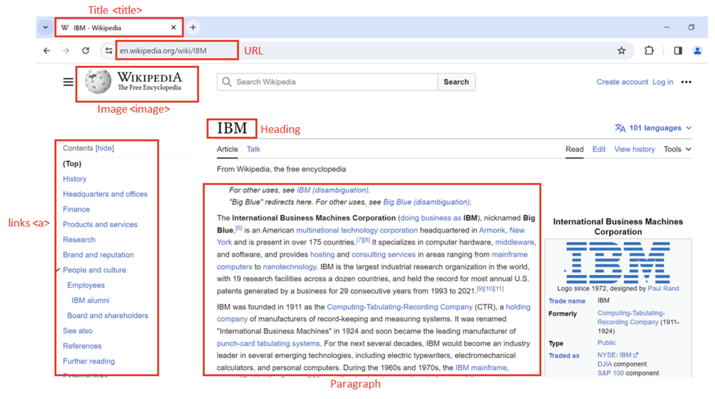

Document Tree

HTML Structure
HTML (Hypertext Markup Language) forms the backbone of web pages. Its structure consists of nested tags:
- <html>: Root element of the HTML page.
- <head>: Contains metadata about the page.
- <body>: Displays the main content.
- <h3>: Heading level 3 tag, used for titles or subheadings.
- <p>: Paragraph tag, used to hold text content.

Composition of an HTML Tag
HTML tags define how content is structured and can contain attributes for additional information:
- Tags include an opening and closing tag (e.g., <p> and </p>).
- Tags may have attributes like href or src that provide extra details.

HTML Document Tree
An HTML document can be visualized as a tree structure where each tag is a node:
- Tags may contain other tags (children) or text.
- Tags within the same parent are siblings.
- Example: <html> contains <head> and <body> as children, and both are siblings.
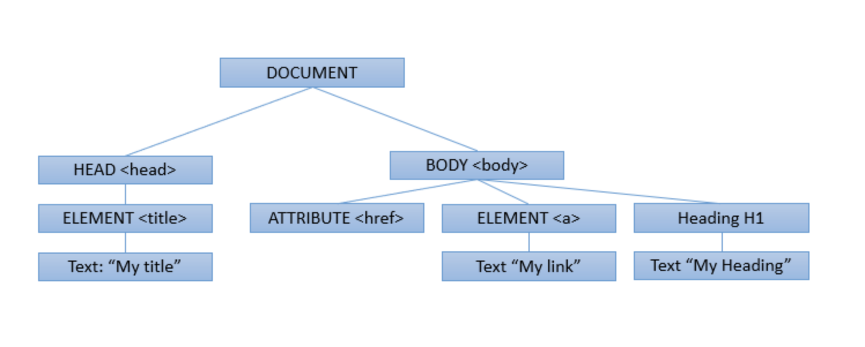

HTML Tables
HTML tables are used for displaying structured data:
- <table>: Defines the table.
- <tr>: Defines a table row.
- <th>: Table header cell (used for column headings).
- <td>: Table data cell (holds data entries).
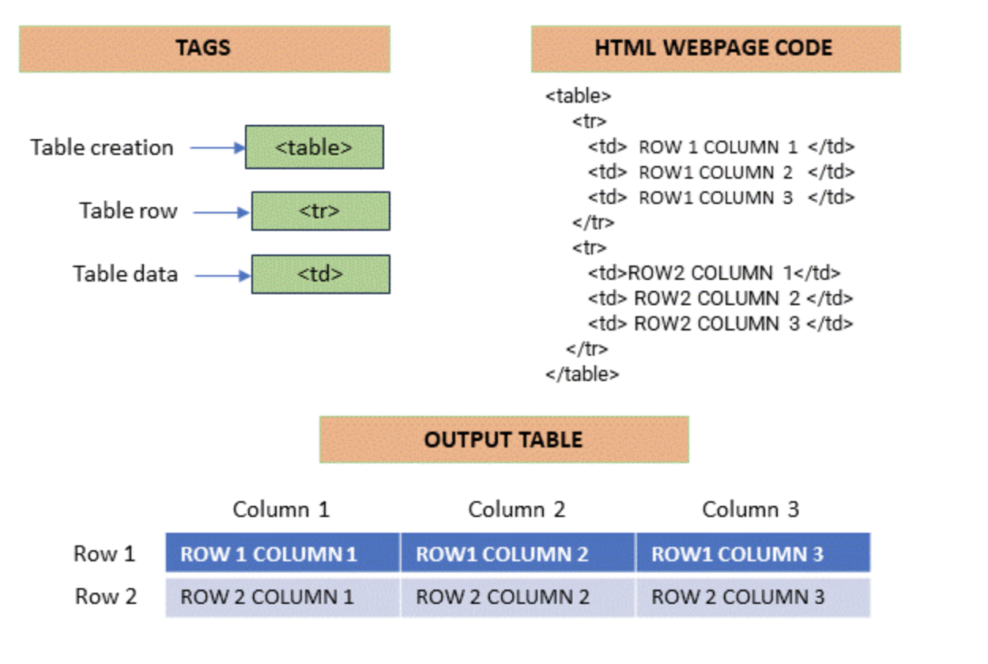

Web Scraping with Python
Web scraping in Python automates data extraction from web pages. It requires two key libraries:
- Requests – for sending HTTP requests.
- BeautifulSoup – for parsing HTML.
Example:
from bs4 import BeautifulSoup
import requests

# Specify the URL
url = 'https://en.wikipedia.org/wiki/IBM'

# Send a GET request
response = requests.get(url)

# Parse the HTML content
soup = BeautifulSoup(response.text, 'html.parser')

# Display the first 500 characters
print(response.text[:500])

Navigating the HTML Structure
BeautifulSoup treats HTML as a tree-like structure, making navigation easy. For example:
# Find all anchor (<a>) tags
links = soup.find_all('a')

# Print the text of each link
for link in links:
print(link.text)

Custom Data Extraction
Custom extraction involves locating elements based on tags, attributes, or text content using BeautifulSoup’s methods.

Using BeautifulSoup for HTML Parsing
BeautifulSoup helps you navigate, search, and extract information from HTML efficiently, providing flexibility to target specific sections of a web page.

Using Pandas read_html for Table Extraction
The pandas library provides read_html() to automatically extract HTML tables into DataFrames for analysis:
import pandas as pd
url = 'https://en.wikipedia.org/wiki/IBM'
tables = pd.read_html(url)
This method is ideal for importing webpage tables into a format suitable for data analysis.

Conclusion
In this reading, you learned about the basics of web scraping, HTML structure, and the use of BeautifulSoup and pandas for data extraction. You now understand how to parse, navigate, and extract data responsibly from web pages.

Introduction to HTML for Web Scraping

Overview
This section reviews Hypertext Markup Language (HTML) and its importance in web scraping. Understanding HTML allows developers to extract useful data such as real estate listings, player statistics, and much more using Python.

Objectives
- Review the structure and composition of an HTML document.
- Understand the composition of an HTML tag.
- Explain the concept of HTML document trees.
- Describe HTML tables and their elements.

Introduction to HTML for Web Scraping
HTML is the language used to structure and display web pages. When performing web scraping, HTML provides the framework from which data is extracted. Python libraries like BeautifulSoup allow users to parse and retrieve specific data from HTML code.
Web pages, including those on sites like Wikipedia, contain large amounts of valuable information. If you understand HTML, you can easily access and extract this data programmatically.

Basic HTML Structure
An HTML document is composed of nested elements called tags, enclosed in angle brackets < >. Tags define how the content should appear in a browser.

Common HTML Elements
- <!DOCTYPE html> — Declares that the document is written in HTML.
- <html> — The root element that contains all other elements.
- <head> — Contains metadata about the page, such as the title.
- <body> — Contains the visible content displayed in the browser.
- <h3> — Represents a level-3 heading, making text larger and bold.
- <p> — Defines a paragraph of text.

Example
In an example web page showing National Basketball League player data:
- The <h3> tags contain player names.
- The <p> tags contain player salaries.
Each piece of information is enclosed within its respective tags, defining its purpose and display.

Composition of an HTML Tag
HTML tags consist of several components:

Tag Structure
- Opening Tag: Defines where an element begins (e.g., <a>)
- Closing Tag: Defines where an element ends (e.g., </a>)
- Content: The data or text displayed within the element.
- Attributes: Additional information about an element, written as key-value pairs.

Example: Anchor Tag
<a href="https://www.ibm.com">IBM</a>
- Tag Name: a (defines a hyperlink)
- Attribute: href (specifies the URL destination)
- Displayed Content: IBM
You can think of each tag name as a class in Python and each tag instance as an object. Real-world web pages often include additional technologies like CSS and JavaScript for styling and functionality.

HTML Document Tree
An HTML document can be represented as a tree structure, known as the Document Object Model (DOM).

Parent and Child Relationships
- The <html> tag is the root element.
- The <head> and <body> tags are children of <html>.
- The <title> tag is a child of <head>.
- The <h3> and <p> tags are children of <body>.
- Tags that share the same parent are called siblings.
This hierarchical representation makes it easy to navigate and extract specific parts of a web page using tools like BeautifulSoup.

HTML Tables
HTML tables display data in a structured, grid-like format. They are composed of several key elements:

Table Elements
- <table> — Defines the table.
- <tr> — Represents a table row.
- <th> — Defines a header cell (used for column headings).
- <td> — Defines a data cell.

Example Structure
<table>
<tr>
<th>Player</th>
<th>Salary</th>
</tr>
<tr>
<td>John Doe</td>
<td>$1,000,000</td>
</tr>
</table>
Each <tr> contains multiple <td> elements, representing the individual cells of that row.

Inspecting and Extracting HTML
Modern browsers allow users to inspect web pages to view the underlying HTML structure. This is crucial for identifying which tags contain the data you want to extract.
To inspect a web page:
- Right-click on a web page.
- Select Inspect or Inspect Element.
- Review the HTML elements in the developer console.

Summary
- HTML forms the backbone of all web pages.
- Tags define structure, while attributes provide additional information.
- HTML documents are organized as trees, allowing structured navigation.
- Tables store structured data that can be easily extracted.
- Understanding HTML is the foundation for effective web scraping using Python.

Web Scraping

Overview
Now, we’ll explore Web Scraping — a powerful technique for automatically extracting data from websites using Python. Instead of manually copying information, web scraping allows you to gather large amounts of data in just minutes.

Objectives
- Define Web Scraping.
- Understand the role of BeautifulSoup Objects.
- Apply the find_all() method.
- Perform basic web scraping operations on a website.

Introduction to Web Scraping
Imagine you want to analyze hundreds of data points to find the best players on a sports team. Manually copying and pasting information into spreadsheets would take hours — or even days. Web scraping automates this process, extracting information from websites within minutes using a few lines of Python code.
To begin, we need two essential Python modules:
- Requests — to download web pages.
- BeautifulSoup — to parse and extract data from HTML.

BeautifulSoup Object
Let’s say you want to find player names and salaries from a National Basketball League webpage.

Creating a BeautifulSoup Object
- Import the BeautifulSoup library.
- Store the webpage HTML in a variable, e.g., HTML.
- Pass it to the BeautifulSoup() constructor to create a soup object.
from bs4 import BeautifulSoup
soup = BeautifulSoup(HTML, 'html.parser')
The BeautifulSoup object represents the HTML document as a nested tree structure, making it easy to navigate and search.

Tag Objects
Each tag object corresponds to an HTML tag. For example, <title> or <h3>. If multiple tags have the same name, BeautifulSoup selects the first occurrence by default.
In an example with Lebron James, the player’s name is enclosed within a bold (<b>) tag. Using the tree representation, you can navigate to child elements or move between parent and sibling elements.

Navigating the Tree
- Child Elements: Access using .contents or .children.
- Parent Element: Access using .parent.
- Siblings: Access using .next_sibling or .previous_sibling.

Accessing Attributes and Text
Each tag may contain attributes, which can be accessed like dictionary key-value pairs.
tag['href'] # Access the href attribute
The text within a tag can be retrieved using .string or .text, returning a NavigableString — similar to a normal Python string but with BeautifulSoup functionality.

The find_all() Method
The find_all() method filters HTML elements based on tag names, attributes, or text.

Example: Extracting Table Data
Suppose we have a list of pizza places in an HTML table.
- Create a BeautifulSoup object named table.
- Use find_all('tr') to find all table rows.
table_rows = table.find_all('tr')
Each element in table_rows represents a row in the table — including the header row.
- Iterate through the rows to extract each table cell.
for row in table_rows:
cells = row.find_all('td')
for cell in cells:
print(cell.text)
Each iteration retrieves cell data from the table, enabling structured extraction.

Scraping a Webpage with Requests and BeautifulSoup
To apply web scraping on a real webpage, we also use the Requests library.

Steps:
- Import the Modules:
import requests
from bs4 import BeautifulSoup
- Download the Webpage:
page = requests.get('https://example.com').text
- Create a BeautifulSoup Object:
soup = BeautifulSoup(page, 'html.parser')
- Scrape the Desired Content:
Navigate and extract the desired information from the soup using BeautifulSoup methods.

Summary
- Web Scraping automates data extraction from websites using Python.
- Requests retrieves the webpage’s HTML, while BeautifulSoup parses and organizes it.
- BeautifulSoup Objects represent HTML as a tree structure for easy navigation.
- The find_all() method is used to filter and extract specific elements.
- Together, these tools allow you to collect and analyze data efficiently from online sources.

Web Scraping: A Key Tool in Data Science

Introduction
Web scraping, also known as web harvesting or web data extraction, is a technique used to extract large amounts of data from websites. The data on websites is often unstructured, and web scraping enables us to convert it into a structured and analyzable form.

Importance of Web Scraping in Data Science
In data science, web scraping plays a vital role in data collection and analysis. It is used for multiple purposes:

Data Collection
Web scraping is a primary method for gathering data from the internet. This collected data can then be used for analysis, research, and insights.

Real-time Applications
It is widely used for real-time use cases, such as weather updates, price comparison, and news aggregation.

Machine Learning
Machine learning models require large datasets for training. Web scraping provides the raw data used to build these models.

Web Scraping with Python
Python offers several libraries to perform efficient and scalable web scraping.

BeautifulSoup
BeautifulSoup is a Python library used to extract data from HTML and XML documents. It parses page source code and organizes it in a tree structure, making data extraction simple and readable.
from bs4 import BeautifulSoup
import requests

URL = "http://www.example.com"
page = requests.get(URL)
soup = BeautifulSoup(page.content, "html.parser")

Scrapy
Scrapy is an open-source web crawling and scraping framework for Python. It is designed for large-scale data extraction.
import scrapy

class QuotesSpider(scrapy.Spider):
name = "quotes"
start_urls = ['http://quotes.toscrape.com/tag/humor/']

def parse(self, response):
for quote in response.css('div.quote'):
yield {'quote': quote.css('span.text::text').get()}

Selenium
Selenium is a powerful tool for automating web browsers. It is often used for scraping dynamic content that requires JavaScript execution.
from selenium import webdriver

driver = webdriver.Firefox()
driver.get("http://www.example.com")

Applications of Web Scraping
Web scraping is used across various industries and has many real-world applications:

Price Comparison
Web scraping tools like ParseHub gather product data from e-commerce sites and compare prices across platforms.

Email Address Gathering
Companies that use email marketing employ scraping techniques to collect email addresses for targeted campaigns.

Social Media Scraping
It is used to extract data from social media platforms like Twitter or Instagram to analyze trends, user sentiment, and engagement.

Conclusion
Web scraping is a critical skill in the data science toolkit. It transforms the web into a rich source of data for analysis and innovation. However, it must be practiced ethically and responsibly, respecting each website’s terms of use and robots.txt policies.

Web Scraping Tables using Pandas

Introduction
The Pandas library in Python contains a function called read_html() that can be used to extract tabular information directly from web pages. This function allows users to quickly collect and analyze data presented in HTML tables.

Example: Extracting Largest Banks by Market Capitalization
To understand how read_html() works, let’s extract the list of the largest banks in the world by market capitalization from the following URL:
URL = 'https://en.wikipedia.org/wiki/List_of_largest_banks'
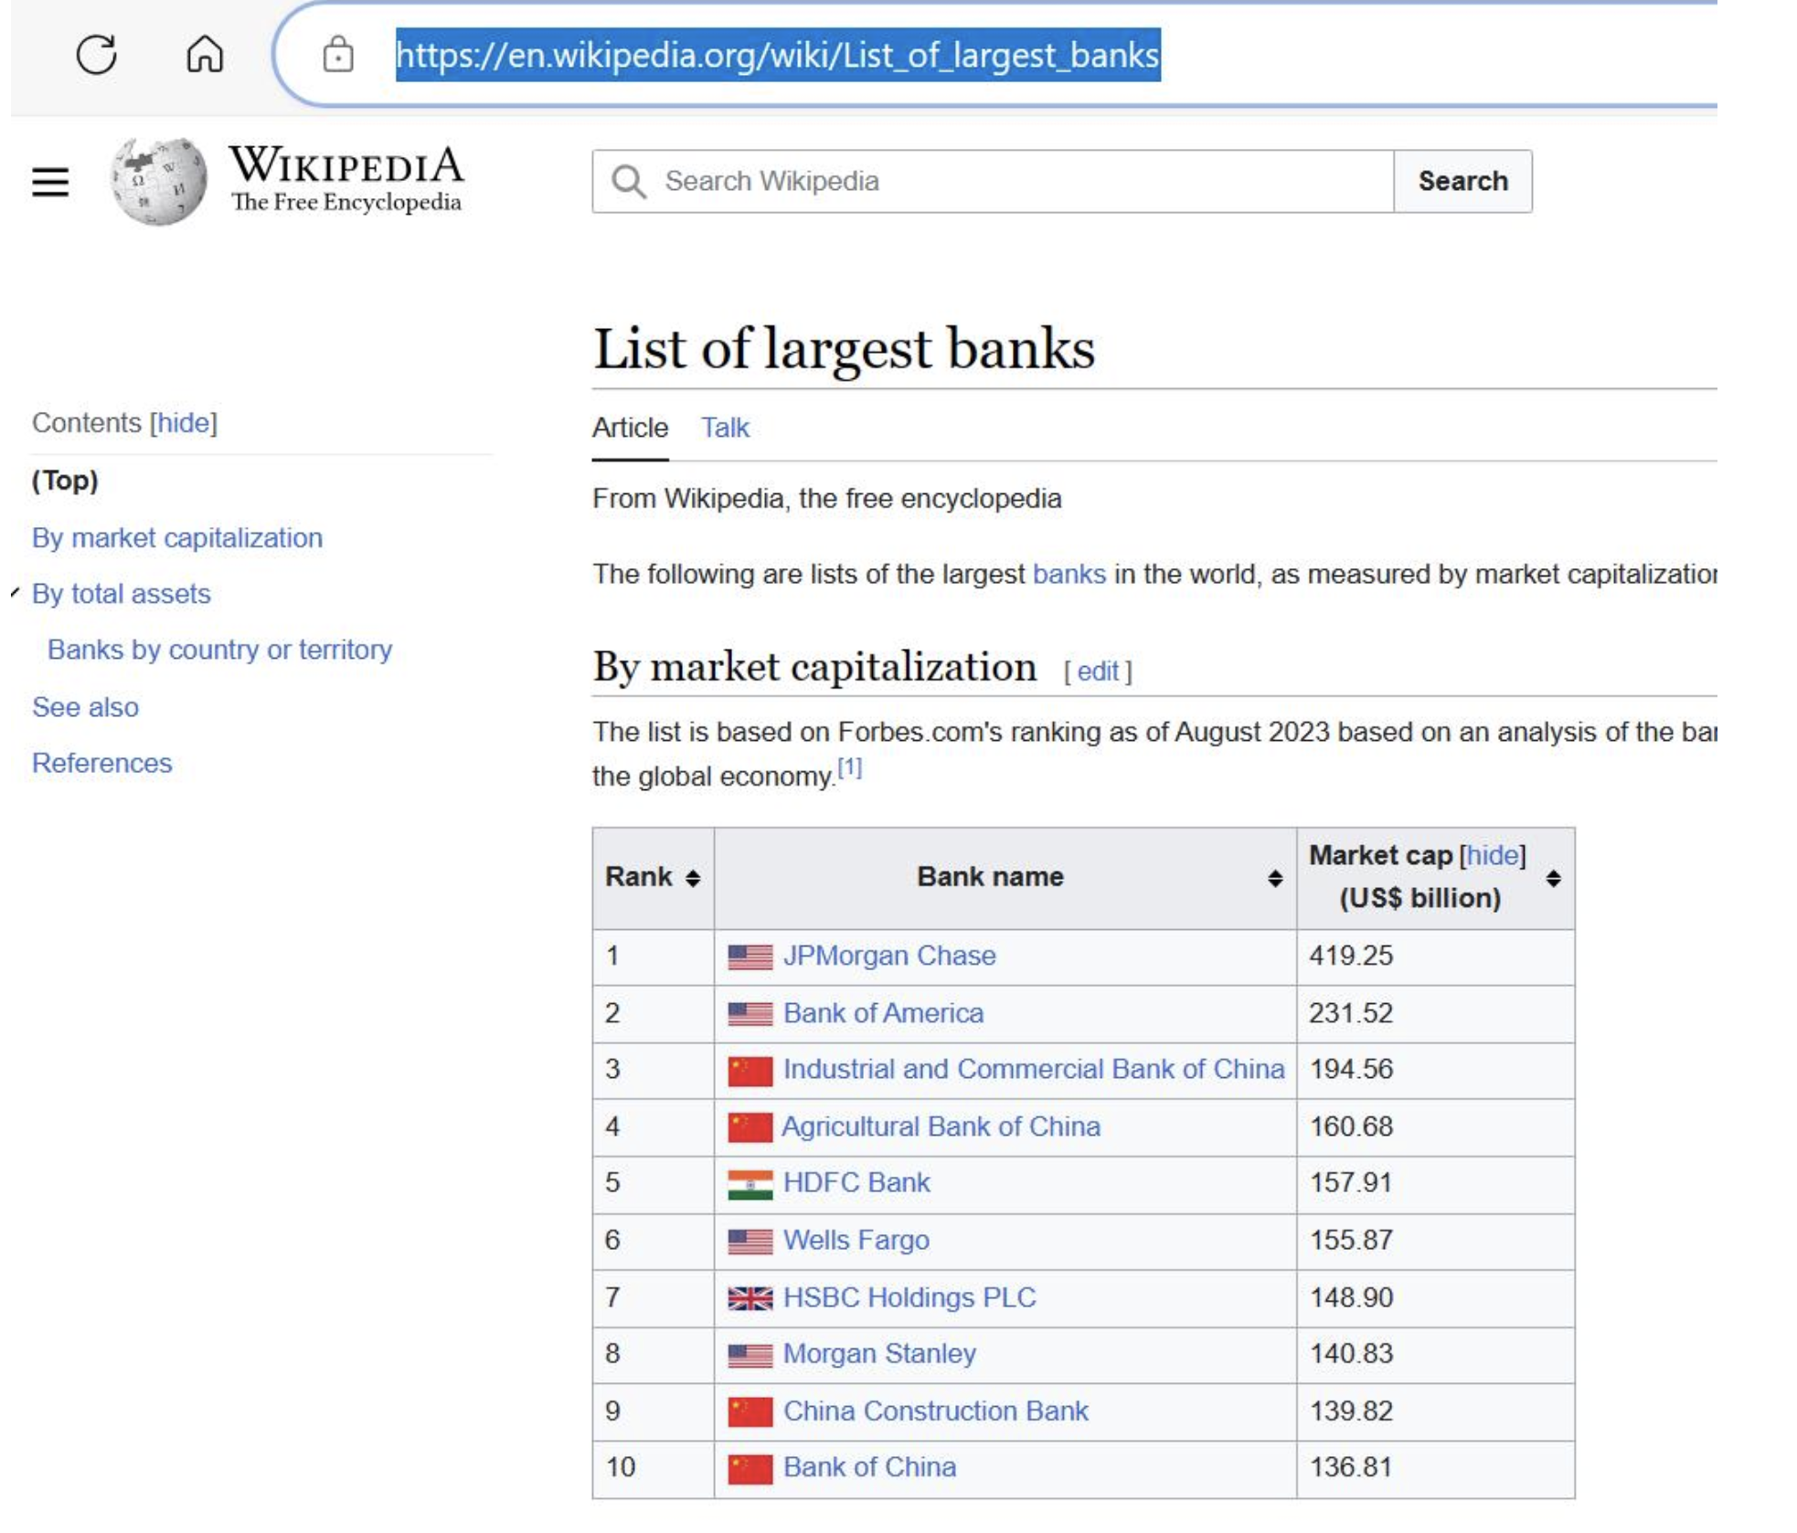
We can use the pandas.read_html() function to extract all the tables from this web page:
import pandas as pd
URL = 'https://en.wikipedia.org/wiki/List_of_largest_banks'
tables = pd.read_html(URL)
df = tables[0]
print(df)
This code extracts all tables from the web page and stores the first table (index 0) in a DataFrame called df. The extracted table displays the list of the largest banks by market capitalization.
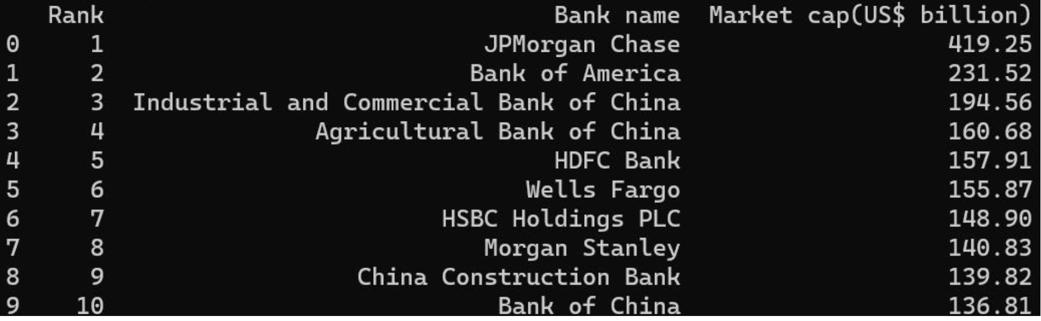
Note: The web page is live and may be updated over time. The process of extraction remains the same regardless of future updates.

Limitations of Using read_html()
Although convenient, this method has certain limitations:

1. Non-Visible Tables
Some web pages store content in table tags that do not visually appear as tables. For example:
URL = 'https://en.wikipedia.org/wiki/List_of_countries_by_GDP_(nominal)'
The page contains several tables, including ones that represent images stored in tabular form.
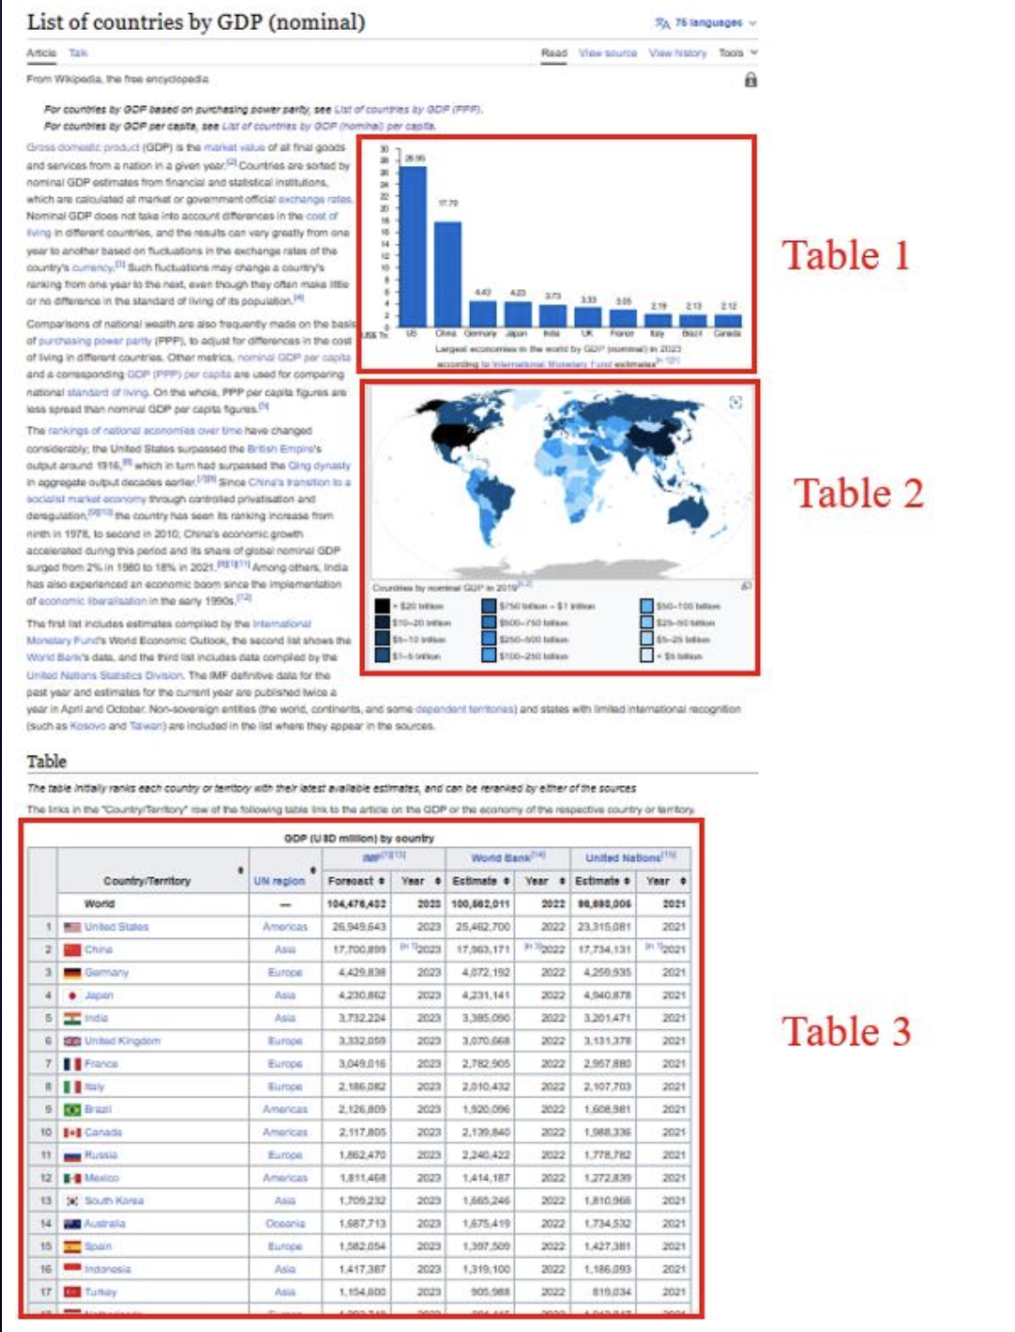

2. Extra HTML Elements
The extracted data may include unwanted elements such as hyperlinks, footnotes, or symbols. These are scraped directly by Pandas, which may require additional data cleaning.


Example: Extracting a Table with Hyperlinks
Let’s extract a table from the page listing countries by GDP:
import pandas as pd
URL = 'https://en.wikipedia.org/wiki/List_of_countries_by_GDP_(nominal)'
tables = pd.read_html(URL)
df = tables[2] # The required table has index 2
print(df)
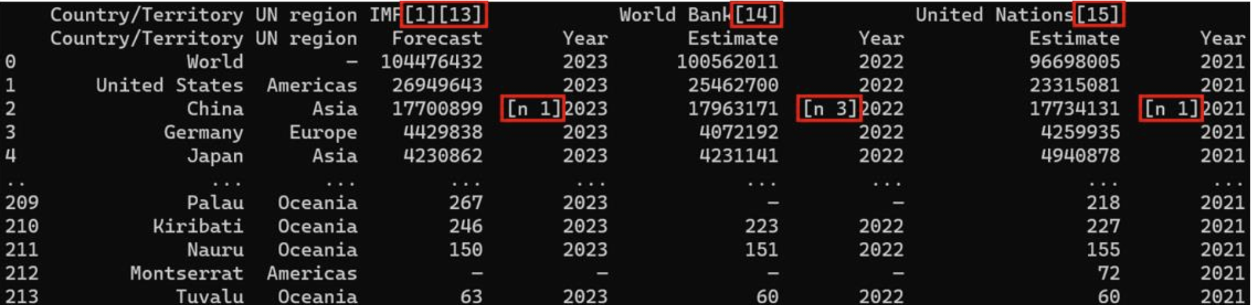
The extracted DataFrame contains hyperlink texts and other embedded elements, which need to be cleaned if only pure textual data is desired.

Comparison with BeautifulSoup
While pandas.read_html() is ideal for tabular data extraction, it only works with structured table formats. For non-tabular or complex HTML data extraction, the BeautifulSoup library remains the default and more flexible option.

Summary
- pandas.read_html() extracts tabular data directly from web pages into DataFrames.
- It is simple and effective, but may include extra HTML elements like hyperlinks.
- This method works best when the data is well-structured in HTML tables.
- For complex or unstructured data, use BeautifulSoup for customized extraction.

Working With Different File Formats

Learning Objectives
- Define different file formats such as CSV, XML, and JSON.
- Write simple programs to read and output data.
- List the Python libraries needed to extract data.

Introduction
When collecting data, you will encounter many different file formats that need to be read or processed for analysis. Python simplifies this process with its predefined libraries. Before diving into Python, let’s review some common file formats.

Understanding File Formats
Each file has an extension at the end of its name, which identifies its format and the type of software required to open it. For example:
- A file named FileExample.csv indicates it is a CSV (Comma-Separated Values) file.
- Other common file formats include JSON and XML.
When working with these file formats in Python, specific libraries help you read and extract data efficiently.

Using Pandas to Read CSV Files
The first Python library to learn for handling files is Pandas. Once imported, Pandas allows you to easily read various file types.

Reading a CSV File
Example:
import pandas as pd

file = 'FileExample.csv'
df = pd.read_csv(file)
print(df)
In this example, the CSV file had no headers, so the first line of data was automatically set as the header.

Adding Headers to a CSV File
To make the output more organized, you can manually define the headers:
df.columns = ['Column1', 'Column2', 'Column3']
print(df)
This ensures that the data is neatly organized with proper column names.

Working with JSON Files
The next file format is JSON (JavaScript Object Notation). It stores data in a structured, language-independent format similar to Python dictionaries.

Reading a JSON File
Example:
import json

with open('FileExample.json') as file:
data = json.load(file)
print(data)
Here, we import the json library, open the file, use the load() function to read it, and print the data.

Working with XML Files
The XML (Extensible Markup Language) format is used to store and transport data. Although Pandas cannot read XML directly, Python provides tools to parse it.

Reading an XML File
Example:
import xml.etree.ElementTree as ET

tree = ET.parse('FileExample.xml')
root = tree.getroot()

for child in root:
print(child.tag, child.attrib)
In this example, we import the xml library, use the etree module to parse the XML file, and loop through elements to extract information.

Creating a DataFrame from XML Data
After parsing the XML, you can assign column headers, collect the required data, and append it to a Pandas DataFrame for analysis.

Summary
In this video, you learned:
- How to recognize different file types (CSV, JSON, XML).
- How to use Python libraries such as Pandas, JSON, and XML to extract and process data.
- How to use DataFrames to organize and analyze data effectively.

Summary

Introduction
Simple APIs in Python are application programming interfaces that provide straightforward and easy-to-use methods for interacting with services, libraries, or data, often with minimal configuration or complexity. An API lets two pieces of software communicate with each other.

Using APIs in Python
Using an API library in Python involves:
- Importing the library.
- Calling its functions or methods to make HTTP requests.
- Parsing responses to access data or services provided by the API.

Pandas API
The Pandas API processes data by communicating with other software components.

Creating a Pandas Instance
An instance is created when you form a dictionary and then use the DataFrame constructor to create a Pandas object.

Common Methods
- head() – Displays the mentioned number of rows from the top (default 5) of DataFrames.
- mean() – Calculates the mean and returns the values.

REST APIs and HTTP Communication
REST APIs allow communication over the internet, providing access to resources such as storage, data, and AI algorithms.

HTTP Protocol
The HTTP (HyperText Transfer Protocol) transfers data, including web pages and resources, between a client (web browser) and a server on the World Wide Web. It is the foundation for implementing REST APIs.

HTTP Methods
- GET – Requests information from the server.
- POST – Submits data to the server.
- PUT – Updates existing data on the server.
- DELETE – Removes data from the server.

HTTP Messages and Responses
HTTP messages transmit data over the internet, typically containing JSON files with operational instructions. These responses include details like resource type, resource length, and other metadata.

URL Structure
A Uniform Resource Locator (URL) identifies and locates resources on the web. It is divided into three parts:
- Scheme – Defines the protocol (e.g., HTTP or HTTPS).
- Internet Address/Base URL – The domain name or IP address.
- Route – The specific path to the resource.
You can modify query results with the GET method and obtain multiple parameters (like name, ID, etc.) from a URL using a Query string.

Working with the Requests Library
Requests is a Python library that simplifies sending HTTP/1.1 requests. It allows developers to easily interact with web services using GET, POST, PUT, and DELETE methods.

Time Series Data and Plotting
When dealing with time series data, the Pandas time series functions help process and analyze it. You can visualize daily candlestick data using Plotly to plot interactive charts.

Web Scraping in Python
Web scraping involves extracting and parsing data from websites to gather information for analysis. Libraries like Beautiful Soup and Requests are commonly used.

Understanding HTML
HTML comprises text enclosed within elements called tags, represented inside angular brackets (e.g., <p>, <div>). Web pages often also contain CSS and JavaScript.
Each HTML document can be viewed as a tree structure with nested elements, including strings and tags. HTML tables use elements like <table>, <tr>, <th>, and <td> to organize data.

Extracting Tabular Data
You can extract tabular data from web pages using Pandas’ read_html() method.

Beautiful Soup Library
Beautiful Soup is a Python library for parsing and navigating HTML or XML documents.

Parsing a Document
Pass an HTML document to the BeautifulSoup constructor to create a structured object for navigation and data extraction.

Navigable String and find_all Method
- A NavigableString behaves like a Python string but supports Beautiful Soup operations.
- The find_all() method extracts content based on tag names, attributes, or text. It searches through tag descendants and retrieves all matching elements, returning them as a Python iterable (e.g., list).

Working with File Formats
File formats define the structure and encoding of stored data. Common examples include:
- .txt for plain text
- .csv for comma-separated values
- .xml for Extensible Markup Language
- .json for JavaScript Object Notation
- .xlsx for Excel spreadsheets
Python supports multiple file formats and provides libraries to handle them efficiently.

Accessing Different File Types
- CSV: Use Pandas to read and process CSV files.
- JSON: Use Python’s json module to parse and handle JSON data.
- XML: Use xml.etree.ElementTree for XML file parsing.
The file extension indicates the type of file and the appropriate tool required to open or process it.

Summary
- APIs enable software systems to communicate effectively.
- REST APIs use HTTP methods like GET, POST, PUT, and DELETE for operations.
- The Requests library allows interaction with APIs easily.
- Web scraping extracts data using Beautiful Soup and Pandas.
- Python supports multiple file formats, including CSV, JSON, and XML, through specialized libraries.

Next Steps

Next Steps
As our next step, we can take one of the following Python Project courses to apply our new skills in real-world scenarios:

Python Project Courses
- Python Project for Data Science
- Python Project for Data Engineering
- Developing AI Applications with Python and Flask
Note: Successful completion of this course is a pre-requisite for enrolling in these Python Project courses.

Additional Learning Opportunities
We can further develop your skills in Python and data handling by exploring the following course:
- Databases and SQL for Data Science with Python

Professional Certificates
If you are interested in starting or advancing a career in Data Science, Data Engineering, or AI & Application Development, consider pursuing one of the following IBM Professional Certificates and Specializations:

IBM Professional Certificates
- IBM Applied AI Professional Certificate
- IBM Data Analyst Professional Certificate
- IBM Data Science Professional Certificate
- IBM Data Engineering Professional Certificate
- IBM Full Stack Software Developer Professional Certificate
- IBM DevOps and Software Engineering Professional Certificate
- IBM Back-End Development Professional Certificate

IBM Specializations
- Applied Software Engineering Fundamentals Specialization
- Data Science Fundamentals with Python and SQL Specialization
- Applied Data Science Specialization

