Assignment 2 : Naive Baiyes and logistic regression classifiers
Kashif Ahmad (kac160230)

Q1) Naive Bayes

Approach: Wrote shell scripts to collect the names of all the spam/ham test and validation files

#!/bin/bash

for f in $(find . -iname "*.spam.txt" -type f)
do
echo "$(basename $f)"
done

these names were collected in csv files and were read by the file.io into the code

1) the files were loaded (file I/O)
2) the dictionary tables were made using the training datasets (makehamtable(),buildspamtable())
3) the frequencies were calculated (ret_freq)
4) the probabilities were calculated (maketable_spam(), maketable_ham())
5) the probabilities were passed into a function(final()) which took in the test datasets and outputs the values of log (p(S)|ES/p(H|ES)
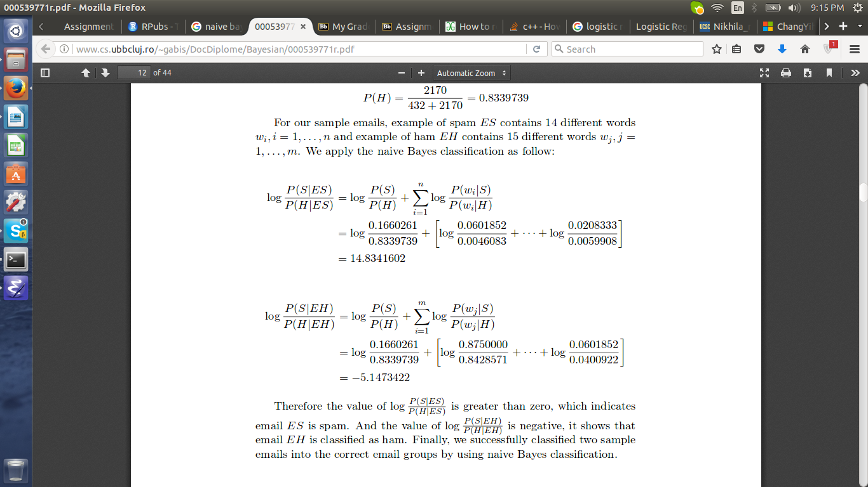
The values for the spam test data were first calculated
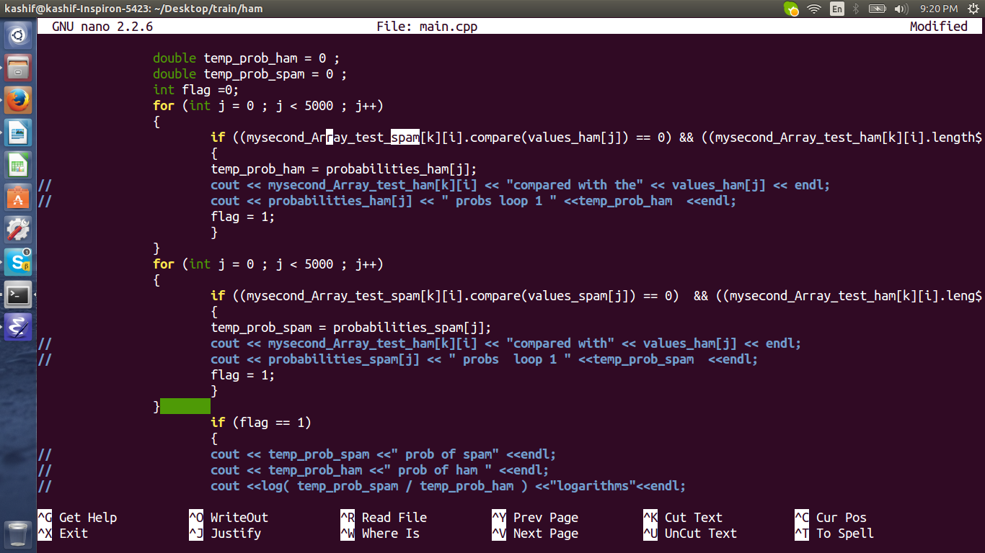
and the outputs are as follows:

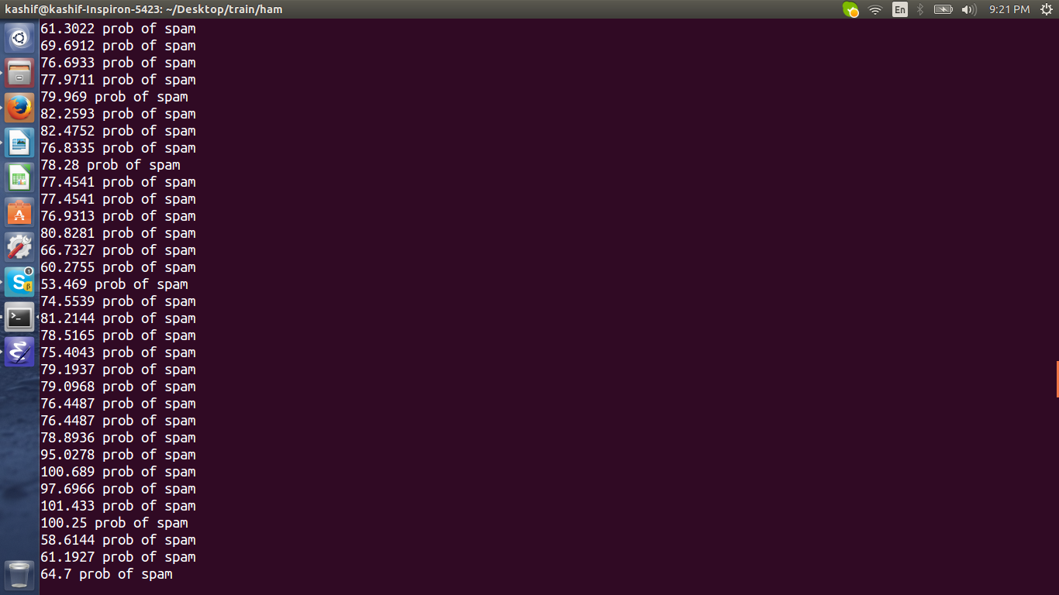
The Spam score should be below 0's but they are all above 100, maybe there is a problem with my logrithms. However the values of ham are in the 1000 range, there is a significant difference between them. The values of ham are as follows
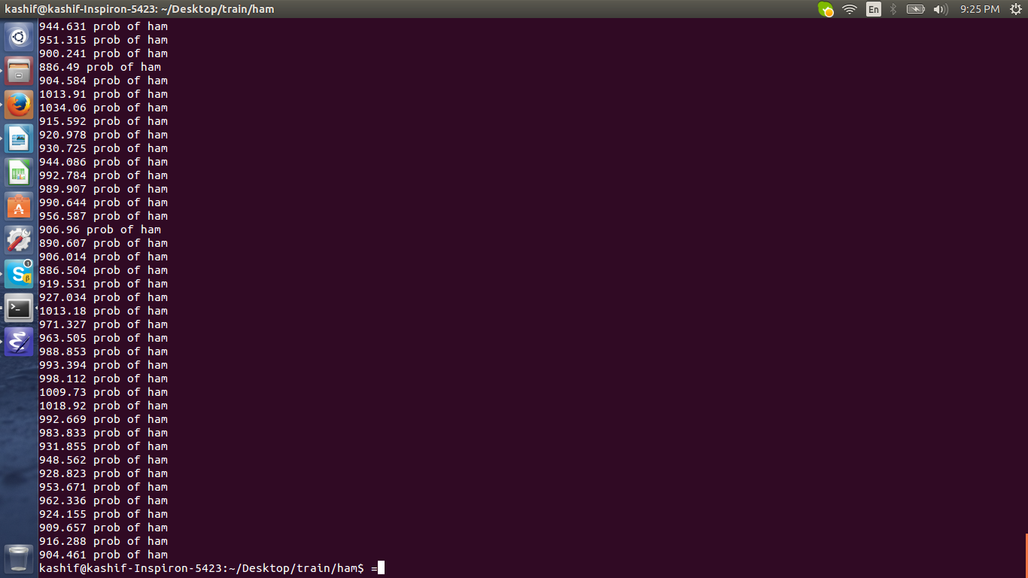
This makes it a bit difficult to calculate the accuracy, but if the threshold is taken as 500 the accuracy for correctly detecting spam is 92.8 % and the Ham is 96.4%

There are variables inside which can cout the values of individual probability but I tried debugging them and cant really find a flaw with my approach. The output of the log function is a bit odd though.

These are the accuracies without the words of, for, a. I removed these words by applying a length check of 3, it automatically filters out a lot of words like to, the, is,
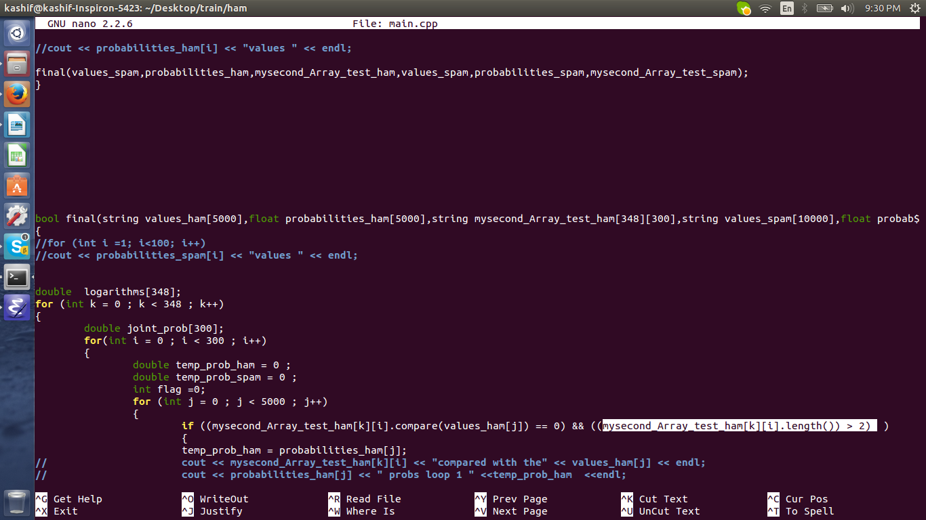
The accuracies were not significantly affected by the stop words.
Accuracy of correctly detecting the ham without stop words: 88.1%
Accuracy of the spam: 92.5 % without stop words:

The accuracy increases slightly when the stop words are avoided because although they affect the spam and ham data both ways, the training sets aren't large enough to notice a significant change, neither are the test sets. However these words can be classified as noise and generally removing them reduces the features that a classifier has to use, lessens the computation and a general better accuracy is observed.

There is only one file for running the code (main.cpp) it runs on standard commands
G++ -o main main.cpp
./main
However 4 csv files form an input to this file as these contain the names of all the ham and spam files that the File I/O loads, hence they need to be in the same folder as this main.cpp and all the training and test data emails need to be in that folder too. I will attach those 4 csv files.

--For the logistic regression classifier, I am still working on it. I have made the matrix which has all the values. I am working on calculating the weights now. I will hopefully submit it within 2 days

