DMS – Depot Management System: POC Concept Document
Oct 27, 2026 · @Abhiraj Ghosh

Executive summary
The DMS POC proves one loop end to end: a vehicle arrives, the gate registers its requirement, the right shed is alerted at once, loading is confirmed, stock updates itself and the vehicle is checked out.
- Gate Tab: registers arriving vehicles and their requirements; checks vehicles out.
- Shed Tab: receives incoming-vehicle alerts instantly; marks loading complete.
- Admin Tab: full inventory CRUD, live visibility of every vehicle, and in/out logs.
- Real-time sync: every status change reaches all tablets within about a second, with no refresh.

Background and POC objectives
The client wants a Depot Management System (DMS) that replaces manual coordination between the gate, the storage sheds and the depot office when vehicles arrive to collect ammunition. They have asked for an initial proof of concept (POC) before committing to a full build, with an estimate of price and timeline.
The POC has four objectives:
- Show the full vehicle lifecycle (arrival, requirement entry, shed alert, loading, stock update, checkout) working across three tablets.
- Show that shed users are alerted the moment a requirement is registered, with no phone calls or paper slips.
- Show that inventory and the in/out log stay correct automatically after every loading.
- Give the client a link they can open from any location, to judge the concept on real devices.
Success means the client can run a scripted demo of three to five vehicles through the full cycle without manual intervention or data correction.

Users and devices
Three tablets, three roles. Each user sees only the screens their role needs.
Tablet | Who uses it | Main actions | Key screens
Admin Tab | Depot administrator / officer in charge | Manage inventory; monitor every vehicle live; review logs | inventory list and editor, in/out log, user management
Gate Tab | Gate security / entry clerk | Register arriving vehicle and its requirement; check vehicle out | New vehicle entry, requirement form, vehicles inside, checkout
Shed Tab | Shed storekeeper (one login per shed) | Receive incoming-vehicle alert; prepare load; confirm what was loaded | Incoming queue, load confirmation, shed stock view
The tablets run the system in a browser (installable web app), so no app-store release is needed for the POC.

End-to-end workflow
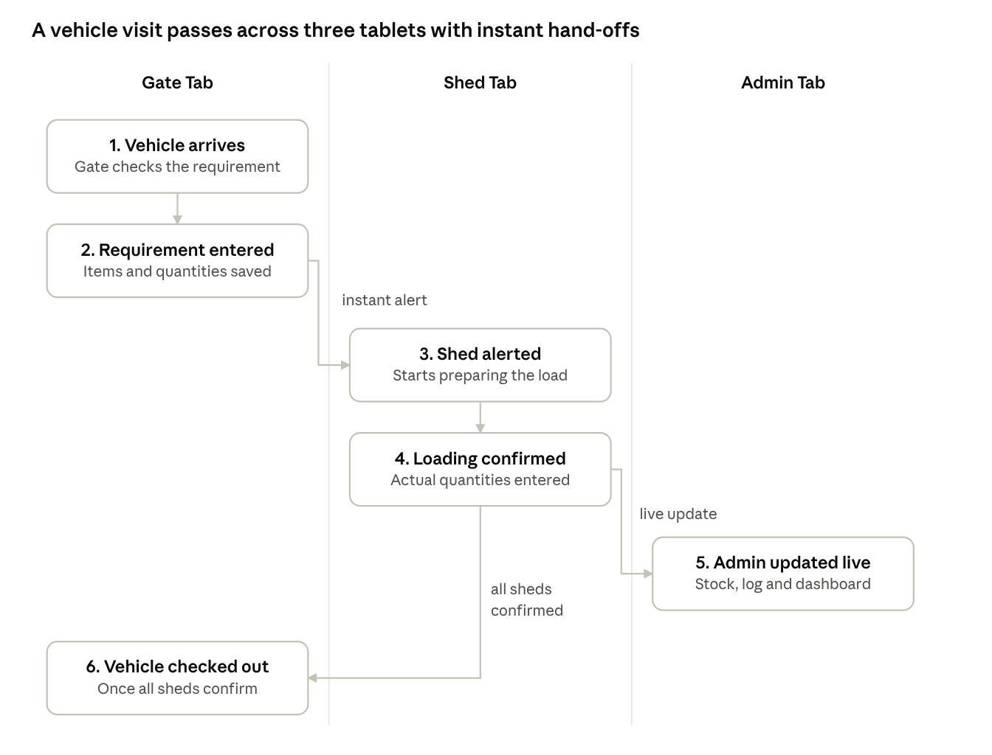
visit workflow · 6 steps across 3 tablets
The gate registers the requirement, the right shed is alerted at once, and checkout is allowed only after every shed confirms loading. The admin sees each change live.

Functional scope of the POC
The POC covers 12 capabilities. Ten are must-haves for the demo; two are small additions that make the demo more convincing.
# | Module | Capability | Tablet | Priority
1 | Access | Role-based login (admin, gate, shed); each shed tablet is tied to its shed | All | Must
2 | Gate | Register arriving vehicle (vehicle number, driver, unit or party, arrival time) | Gate | Must
3 | Gate | Enter requirement as item and quantity lines; warn when stock is short | Gate | Must
4 | Routing | Send each requirement line to the shed that holds the item and alert that shed instantly | System / Shed | Must
5 | Shed | Incoming-vehicle queue; confirm items and actual quantities loaded | Shed | Must
6 | Stock | Deduct stock automatically on loading confirmation and write a ledger entry | System | Must
7 | Gate | Check vehicle out once every shed has confirmed loading | Gate | Must
8 | Inventory | Create, view, edit and delete items; set category, unit, shed and opening stock | Admin | Must
9 | Inventory | Record stock received (Inventory In) and manual adjustments with a reason | Admin | Must
10 | Logs | In/out log: which vehicle came, when, what was loaded, who handled it; filter and search | Admin | Must
11 | Dashboard | Live view of vehicles inside, status per shed, and current stock levels | Admin | Should
12 | Logs | Export the in/out log to CSV or Excel | Admin | Should
A vehicle may need items from more than one shed. The POC handles this by tracking each shed's confirmation separately and allowing checkout only when all are complete.

Architecture and technology
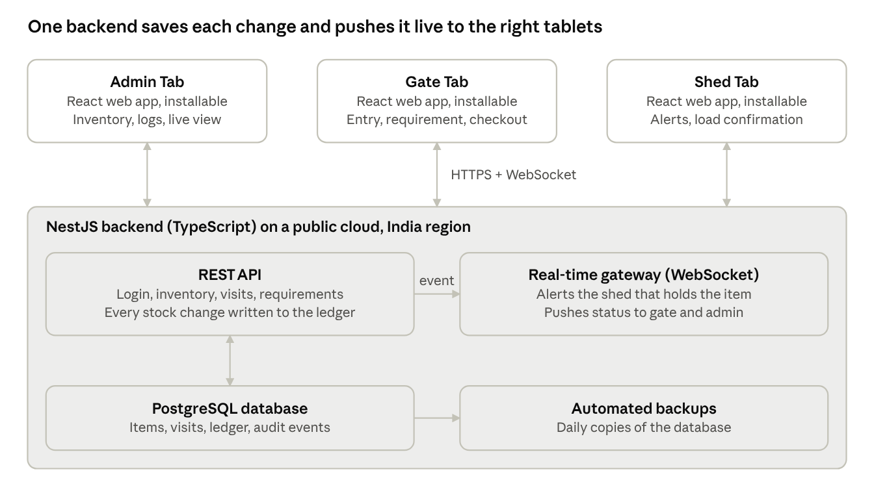
architecture · 3 tablets, 1 backend, 1 database
Each tablet is a browser web app that calls the REST API and keeps a WebSocket open. When a user saves a change, the API writes it to the database in one transaction, then the gateway pushes the event to the tablets that need it: the shed that holds the item, the gate and the admin.
Layer | Proposed choice | Why
Front end | React web app, installable, tablet-first layout | One codebase for all three role screens; no app-store release
Backend | NestJS/Express (Node.js, TypeScript) | Modular structure per domain; built-in WebSocket support
Real-time | WebSockets (Socket.IO) | Targeted pushes: one channel per shed, one for the gate, one for admin
Database | PostgreSQL | Transactions keep stock deductions and ledger entries consistent
Hosting | Public cloud, India region, containerised, HTTPS | Quick to stand up for a POC; easy to move on-premise in Phase 2

Core data model
Seven entities carry the whole workflow. Every stock change is a ledger row, so the inventory number can always be explained and audited.
Entity | Purpose | Key fields
User | Login and role | name, role (admin, gate, shed), shed (for shed users)
Shed | Storage location | name, code
Item | Inventory master | name, category, unit, shed, current stock, reorder level
Visit | One vehicle's trip through the depot | vehicle number, driver, party, status, arrival time, checkout time, gate user
Requirement line | One item and quantity needed on a visit | visit, item, shed, requested qty, loaded qty, status
Stock ledger | Every stock movement (in, out, adjustment) | item, type, quantity, visit (if any), user, timestamp, reason
Audit event | Who did what and when | user, action, entity, timestamp
Visit status moves through: Registered, Awaiting loading, Partly loaded, Loaded, Checked out.

