Predicting India's Match Outcomes with a CART Model
- Problem Statement
The dataset contains data logged by Indian cricket team's team-management and selection committee after every international match they play. Each row contains a match with their squad composition, the toss decision, ground and light conditions, the opponent, and a run of in-match statistics. The “Result” column records the final result of the match where 1 implies India lost the match, 0 implies India has won the match.
Out of 2930 matches, India lost 473 matches. That is 16.14 percent. The remaining 83.86 percent they won. We want to know now whether the pre-match decisions actually control, who is picked, whether India bowls or bats first, what format and conditions the match is played under and whether a simple, explainable model can support the conversation rather than replace it.
- Target variable and independent variables
Target variable: It will be “Result” which takes only two values (0,1).
1 - India lost the match (473 matches)
0 - India won the match (2457 matches)
Independent variables: Everything else that is left after dropping the “Game_number” column is
a part of independent variables.
- Missing Data check
There are no missing values in any column.
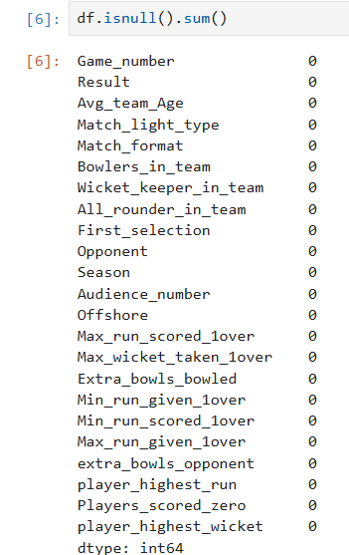
- Type 1 and Type 2 error
In this problem the two errors mean different things for the Indian cricket team's team-management and selection committee.
Type 1 error (false positive): the model says the team will lose, but the team actually wins. In the final pruned model this happened 71 times in the test data.
Type 2 error (false negative): the model says the customer will win, but the customer actually will lose. In the final pruned model this happened 192 times in the test data.
For Indian cricket team's team-management and selection committee the Type 2 error matters more, because a wrongly interpreted data is a loss of an important match. The model here makes far more Type 2 errors than Type 1 errors, which is a weakness.
- Columns dropped and why
Game_number is dropped. It is a unique code for each match and all 2930 values of matches are different. It carries no pattern, it is only a label. If it is kept, the tree can split on it and simply memorise individual matches.
Nothing else is dropped. The remaining columns all hold real match insights.
- Encoding performed in the code
Scikit-learn cannot take text columns, so Match_light_type, Match_format, First_selection and Opponent had to be converted to numbers.
- Feature importance from the model
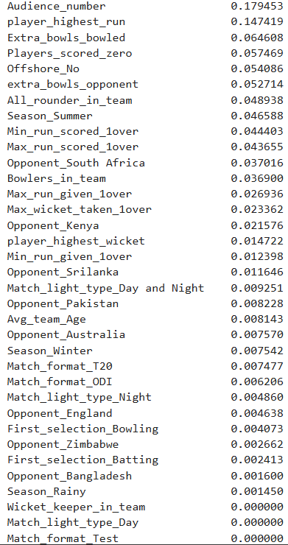
No. of Audience and Highest Runs by a Player carry the most weight. Match light type or Match format barely move the model.
- Train and test split, accuracy and confusion matrix
The data was split 70:30 between training and testing. That gives 2051 rows for training and 879 rows for testing.
The first model was built with criterion='gini', min_samples_split=2 and min_samples_leaf=1, which are the default settings.
Model 1 (Before pruning) | Train | Test
Accuracy | 100.0% | 91.01%

- Confusion matrix, training data (Before pruning)
 | Predicted 0 | Predicted 1
Actual 0 | 1722 | 0
Actual 1 | 0 | 329

- Confusion matrix, test data (no pruning)
 | Predicted 0 | Predicted 1
Actual 0 | 691 | 44
Actual 1 | 35 | 109

The training matrix has zero errors. Not a single mistake on 2051 rows. That is not a good model, that is a model that has memorised the training data. On the test data it drops to 91.01 percent and makes 44 false positives and 35 false negatives. A 9% fall from train to test is the clear sign of overfitting, which is why the tree was pruned.
- Results before and after pruning
For pruning, three limits were set on the tree: max_depth=8, min_samples_leaf=40 and min_samples_split=5. So, the tree cannot go deeper than 8 levels, every leaf must hold at least 40 customers, and a node needs at least 5 customers before it is allowed to split.

 | Before pruning | After pruning
Train accuracy | 100.0% | 87%
Test accuracy | 85.4% | 84%
Gap between train and test | 9 points | 3 points

After Pruning model, confusion matrix on training data
 | Predicted 0 | Predicted 1
Actual 0 | 1651 | 71
Actual 1 | 192 | 137

After Pruning model, confusion matrix on test data
 | Predicted 0 | Predicted 1
Actual 0 | 688 | 47
Actual 1 | 98 | 46

Classification report, pruned model
Class | Precision (train) | Recall (train) | Precision (test) | Recall (test)
0 (no response) | 0.90 | 0.96 | 0.88 | 0.94
1 (responded) | 0.66 | 0.42 | 0.49 | 0.32

Training accuracy fell from 100 percent to 87 percent after pruning, test accuracy also fell from 91.01 percent to 84 percent. Losing accuracy on the training data is exactly what should happen, because the model stopped memorising.

Second iteration: accuracy difference and fit of the model
Taking the unpruned tree as the first iteration and the pruned tree as the second, the difference is:
- Train accuracy: 100.0% to 87%, a fall of 13 points
- Test accuracy: 91.01% to 84%, a fall of 7.01 points
- Train minus test gap: 9 points down to 3 points

- Is the model underfitting or overfitting?
The first model was clearly overfitting. Perfect score on training data, 91 percent on unseen data.
The second model is not overfitting. Train and test are 87 and 84 percent, less than 3 points apart, so whatever the model learnt from the training data holds up on new data. On the train versus test test, the pruned model is a well fitted model.
But there is a second problem that the accuracy number hides. Since 84 percent of test data accuracy is lower as well with 71 and 192 of Type 1 and Type 2 errors which is an increased number from the before pruned model.
- Final Conclusion
The preliminary decision tree was checked for overfitting by comparing training and testing accuracy. A large difference between the two indicates that the tree is learning the training data too closely.
To control overfitting, pruning parameters such as max_depth, min_samples_split, and min_samples_leaf were introduced. These parameters reduce unnecessary branches and prevent the tree from creating very small, highly specific groups.
The final model was evaluated using the confusion matrix, where:
TP = correctly identified churners
TN = correctly identified non-churners
FP = Type I error
FN = Type II error
The ROC curve and AUC were also used to evaluate the model's ability to distinguish between churn and non-churn customers.
Therefore, the preferred final model is the pruned tree that provides better test performance with controlled complexity and an acceptable balance between Type I and Type II errors.

