30-06-2025

Code in the following git hub repository:

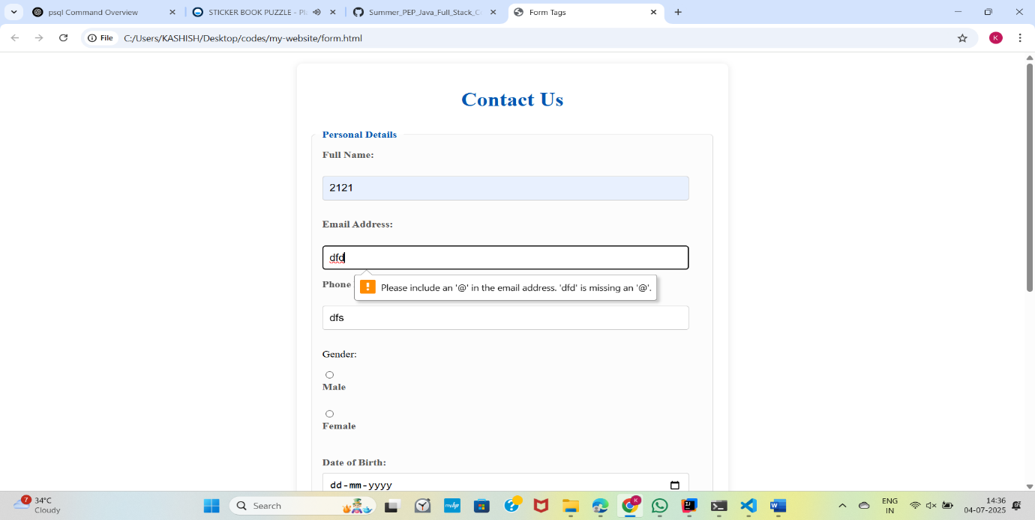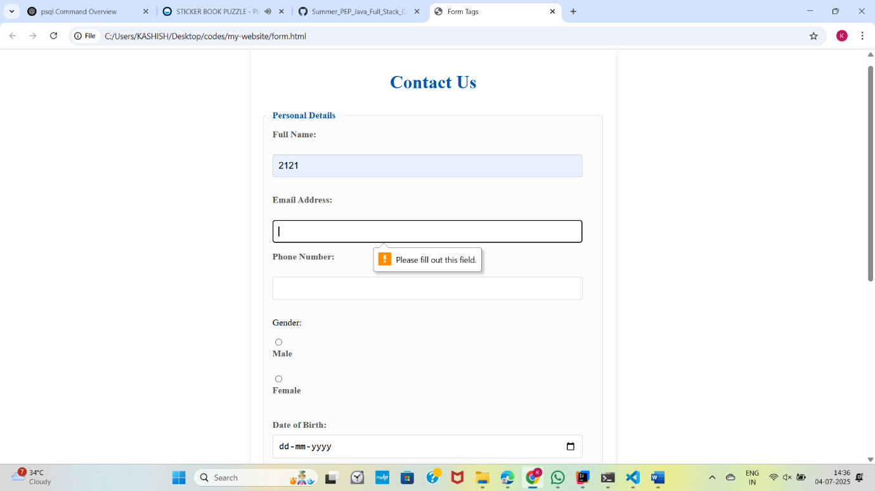Contact Us Form - <https://github.com/Kashish-HUB/Contact_Us-1->

