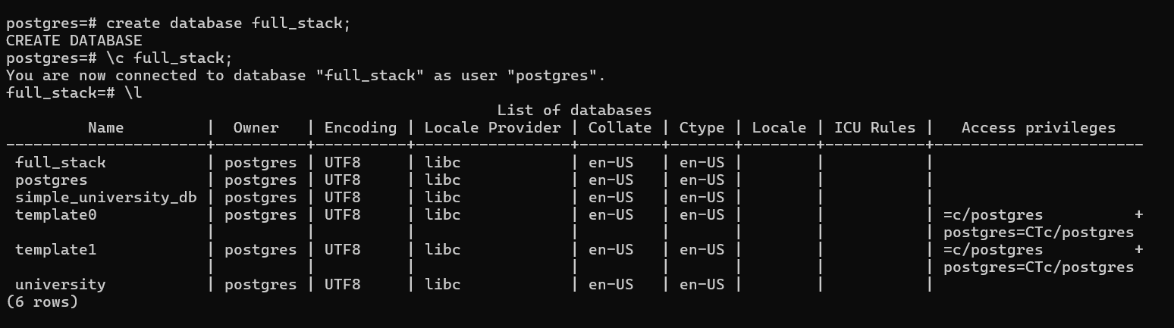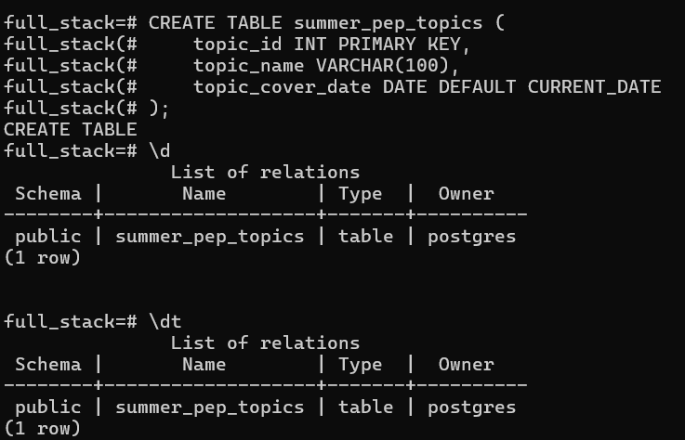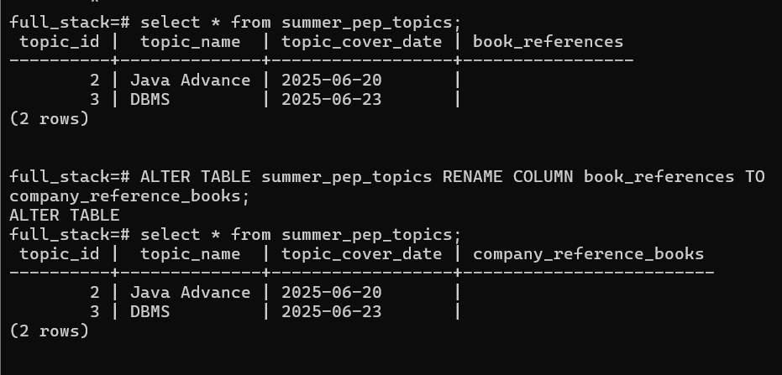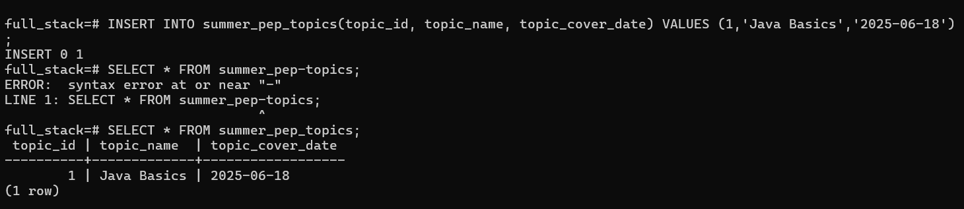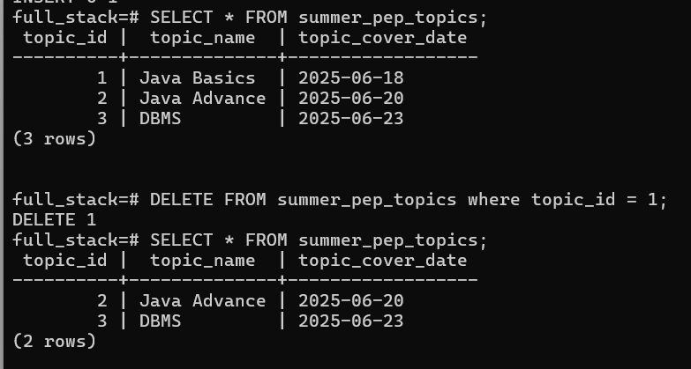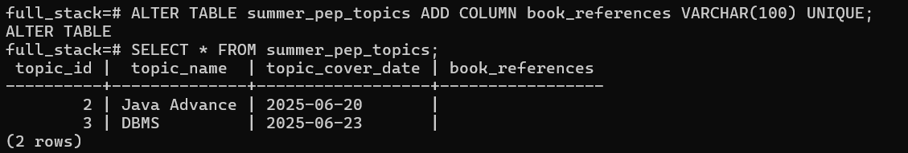

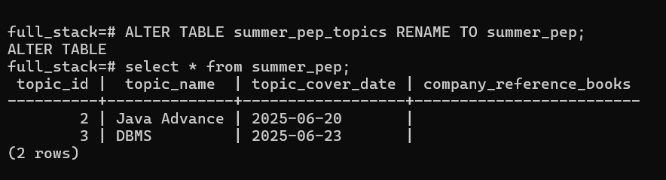

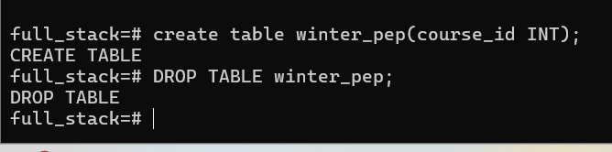

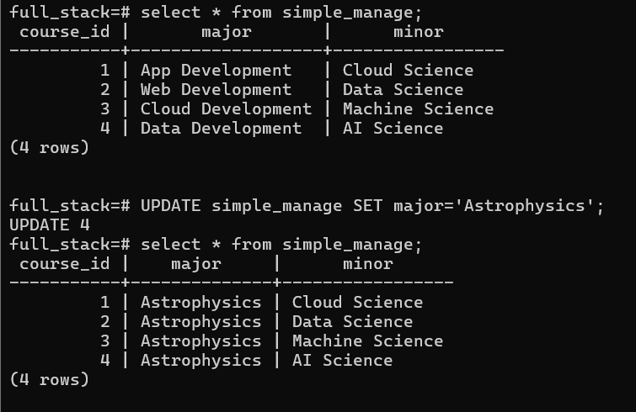

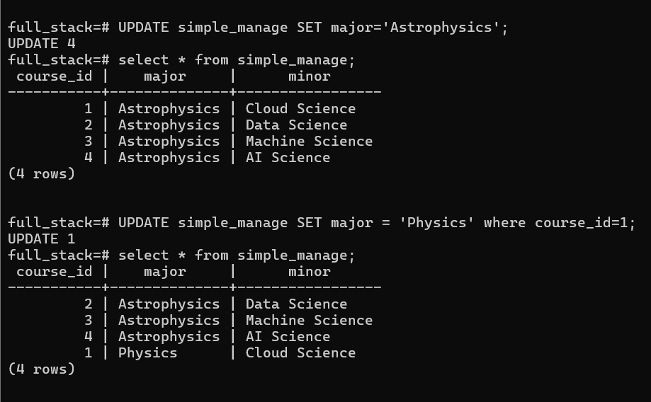

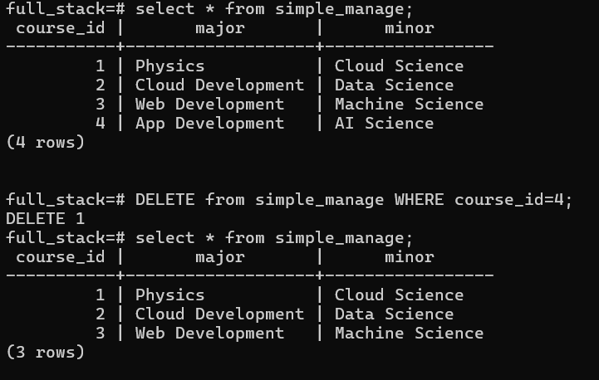

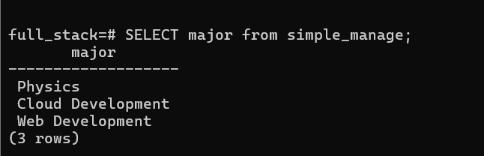

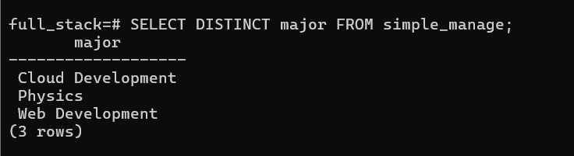

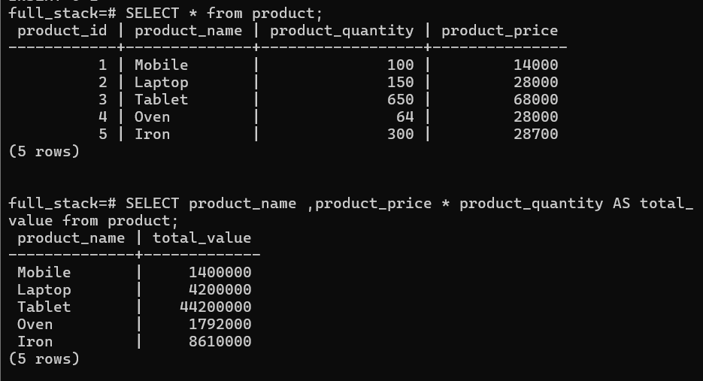

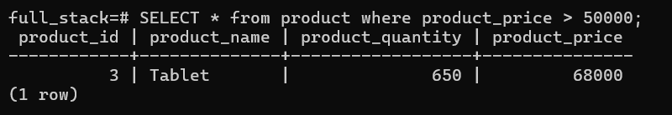

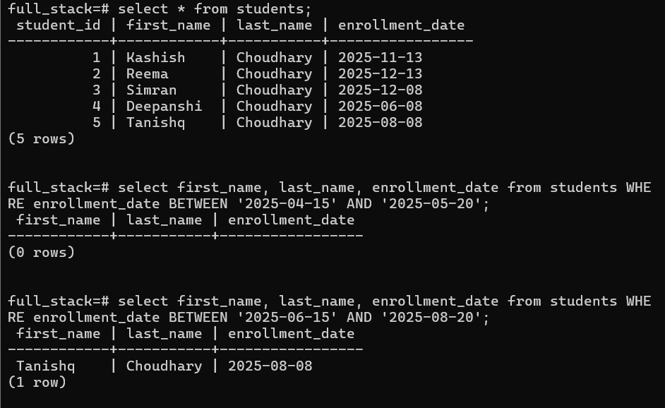

* **PostgreSQL (psql) Commands and SQL Reference**

**Basic psql Commands**

|  |  |
| --- | --- |
| Command | Description |
| \l | List all databases |
| \c dbname | Connect to a database |
| \dt | List all tables in the current database |
| \d tablename | Describe table structure |
| \q | Quit psql |
| \i filename.sql | Execute SQL file |
| \! command | Run shell command from psql |

**Arithmetic Operators**

|  |  |
| --- | --- |
| Operator | Description |
| + | Addition |
| - | Subtraction |
| * | Multiplication |
| / | Division |
| % | Modulus (remainder) |

**Comparison Operators**

|  |  |
| --- | --- |
| Operator | Description |
| = | Equal |
| != or <> | Not equal |
| < | Less than |
| > | Greater than |
| <= | Less than or equal to |
| >= | Greater than or equal to |

**SQL Functions**

NOW() – Current timestamp

LENGTH(str) – String length

ROUND(number, decimals) – Rounds a number

COALESCE(val1, val2, ...) – First non-null value

**Aggregate Functions**

|  |  |
| --- | --- |
| Function | Description |
| COUNT(*) | Count rows |
| SUM(column) | Sum of values |
| AVG(column) | Average value |
| MIN(column) | Minimum value |
| MAX(column) | Maximum value |

**Character Functions**

|  |  |
| --- | --- |
| Function | Description |
| LOWER(str) | Converts to lowercase |
| UPPER(str) | Converts to uppercase |
| SUBSTRING(str FROM x FOR y) | Extracts substring |
| TRIM(str) | Removes whitespace |
| CONCAT(str1, str2) | Concatenate strings |

**Conversion Functions**

|  |  |
| --- | --- |
| Function | Description |
| CAST(expr AS type) | Convert data type |
| TO_CHAR(date, format) | Format date/time |
| TO_DATE(text, format) | Convert text to date |

**SQL Clauses**

|  |  |
| --- | --- |
| Clause | Description |
| WHERE | Filters rows |
| GROUP BY | Groups rows |
| HAVING | Filter groups |
| ORDER BY | Sorts results |
| LIMIT | Limit number of rows |
| OFFSET | Skip rows |
| DISTINCT | Unique values |

**Composite Key**

A composite key is a primary key using more than one column.

***CREATE TABLE orders (  
 order_id INT,  
 product_id INT,  
 PRIMARY KEY (order_id, product_id)  
);***

**Foreign Key**

Used to maintain referential integrity between tables.

***CREATE TABLE orders (  
 order_id SERIAL PRIMARY KEY,  
 customer_id INT,  
 FOREIGN KEY (customer_id) REFERENCES customers(customer_id)  
);***

**SQL Joins**

|  |  |
| --- | --- |
| Join Type | Description |
| INNER JOIN | Matching rows from both tables |
| LEFT JOIN | All rows from left, matched rows from right |
| RIGHT JOIN | All rows from right, matched rows from left |
| FULL JOIN | All rows when there's a match in either table |

***SELECT a.name, b.order_id  
FROM customers a  
INNER JOIN orders b ON a.id = b.customer_id;***

**SELF JOIN**

Used to join a table to itself.

***SELECT A.name, B.name AS manager  
FROM employees A  
JOIN employees B ON A.manager_id = B.emp_id;***

**SQL Set Operations**

|  |  |
| --- | --- |
| Operation | Description |
| UNION | Combines results, removes duplicates |
| UNION ALL | Combines all results, including duplicates |
| INTERSECT | Rows common to both queries |
| EXCEPT | Rows in first query not in second |