SYMBIOSIS INSTITUTE OF TECHNOLOGY, PUNE
Department of Artificial Intelligence and Machine Learning

Applications and Use Cases of Machine Learning (TE7483)
End-Semester Examination · Case Study Project Report

Low-Lead ECG Screening
Evaluating Diagnostic Accuracy Retention with Wearable-Style Reduced-Lead Signals Using Machine Learning

Submitted by: Kashish Chelwani
Batch 2024-28 · Semester 5
Faculty: Dr. Aniket Shahade, Dr. Shrikishna Kolhar, Dr. Sumanto Dutta
October 2026

Abstract
Consumer wearables can record an electrocardiogram (ECG) continuously, but they capture only one to six of the twelve leads that clinicians rely on. This project quantifies how much diagnostic accuracy is retained when a 12-lead ECG is reduced to wearable-style lead sets. Using 21,388 ECGs from 18,617 patients in the public PTB-XL dataset, we extract 48 interpretable features per lead and train Logistic Regression, Random Forest and LightGBM classifiers for five diagnostic superclasses (normal, myocardial infarction, ST/T change, conduction disturbance, hypertrophy). Each model is trained for 12-, 6-, 3- and 1-lead inputs, Platt-calibrated on a validation fold, evaluated on a held-out patient-wise test fold, and stress-tested under simulated wearable noise at 24, 12 and 6 dB SNR. LightGBM performed best, reaching a macro AUROC of 0.925 with 12 leads. The 6-lead, 3-lead and 1-lead configurations retained 96.4%, 97.5% and 89.5% of this performance respectively. MI was the most lead-dependent category, while NORM remained detectable from a single lead. SHAP explanations link these findings to cardiac anatomy, and a Streamlit application demonstrates the system as a screening-support prototype, not a diagnostic tool.
Keywords: ECG; PTB-XL; reduced-lead; wearables; LightGBM; probability calibration; SHAP; screening.

Contents
1. Introduction and Problem Refinement
2. Related Work
3. Dataset Understanding
4. Preprocessing and Feature Engineering
5. Methodology and ML Pipeline
6. Implementation
7. Results and Evaluation
8. Limitations
9. Conclusion
10. Future Scope
References
Appendix A. How to reproduce

1. Introduction and Problem Refinement

1.1 Background
Cardiovascular disease is the leading cause of death worldwide, and the resting 12-lead ECG is the first-line test for detecting myocardial infarction, ischaemic ST/T changes, conduction disorders and ventricular hypertrophy. A 12-lead recording needs ten electrodes, trained staff and a clinic visit, so it is usually taken only after symptoms appear. Smartwatches (lead I), handheld devices (six limb leads) and adhesive patches (one to three leads) can record much more often and at far lower cost, but they see the heart from fewer angles and are recorded under noisier conditions.

1.2 Refinement from Phase-I
The Phase-I proposal framed the task as ECG classification. For the final project the problem was refined into a measurable research question that matters for deployment: how much of the 12-lead diagnostic performance survives when the input is reduced to the leads a wearable can record, and how does realistic noise change that? This turns a generic classifier into an evidence base for choosing a device and for deciding which conditions a wearable can responsibly screen for.

1.3 Objectives
- Build a reproducible multi-label classifier for the five PTB-XL diagnostic superclasses.
- Measure accuracy retention for 12-, 6-, 3- and 1-lead inputs and test whether losses are significant.
- Evaluate robustness to simulated wearable noise (baseline wander, muscle noise, motion artefacts).
- Compare Logistic Regression, Random Forest and LightGBM on discrimination, decision quality and calibration.
- Explain predictions with SHAP and deliver an interactive Streamlit screening-support prototype.

1.4 Scope, users and stakeholders
Table 1. Project scope and stakeholders.
Aspect | Description
Application domain | Cardiology screening; digital health and consumer wearables
Primary users | Screening programmes, primary-care and rural health camps, wearable users
Stakeholders | Patients, cardiologists triaging referrals, device manufacturers choosing lead count, public-health planners, ML researchers
In scope | 10 s resting ECGs, 5 superclasses, lead subsets of clinical recordings, simulated noise
Out of scope | Diagnosis, rhythm (arrhythmia) classes, real wearable recordings, deep learning

Real-world relevance: a reliable estimate of what is lost with fewer leads tells a device maker which conditions can be advertised, tells a clinic how to set referral thresholds, and protects patients from false reassurance by a device that cannot see their condition.

2. Related Work
PTB-XL [1] was released in 2020 as the largest open clinical 12-lead ECG dataset, distributed through PhysioNet [2]. Strodthoff et al. [3] benchmarked deep convolutional networks on it, reporting superclass macro AUROCs around 0.93 for 12 leads, and showed that performance falls when fewer leads are used. Most reduced-lead studies use deep networks on raw signals, which are accurate but hard to interpret and rarely report probability calibration. This project instead studies interpretable feature-based models, which train in minutes on a CPU, explains them with SHAP [5], calibrates them with Platt scaling [6], and adds a controlled noise stress test inspired by the MIT-BIH noise stress test [8].

3. Dataset Understanding

3.1 Source and description
PTB-XL v1.0.3 (PhysioNet, Creative Commons Attribution 4.0) contains 21,799 ten-second 12-lead ECGs recorded between 1989 and 1996, annotated by up to two cardiologists with SCP-ECG statements. We use the 100 Hz version, so each record is a 1000 × 12 matrix of voltages in millivolts.
Table 2. Attributes used from PTB-XL.
Attribute | Type | Description
signal (I, II, III, aVR, aVL, aVF, V1-V6) | float, mV | 1000 samples per lead at 100 Hz
scp_codes | dict | SCP statement → likelihood (0-100)
age | numeric | mean 59.4 ± 16.8 years
sex | binary | 51.9% male
patient_id | id | 18,617 unique patients
strat_fold | int 1-10 | patient-wise, label-stratified fold assignment
Target (derived) | 5-bit multi-hot | NORM, MI, STTC, CD, HYP superclasses

3.2 Target variable
Following the official benchmark, each SCP statement flagged as diagnostic is mapped to its diagnostic class, and an ECG receives every superclass any of its statements map to. 411 records without a diagnostic superclass were removed, leaving 21,388. The task is multi-label: 24.1% of ECGs carry more than one superclass (for example MI together with a conduction disturbance).
Table 3. Class distribution (multi-label, so counts sum to more than the number of ECGs).
Superclass | Meaning | ECGs | Prevalence
NORM | Normal ECG | 9,514 | 44.5%
MI | Myocardial infarction | 5,469 | 25.6%
STTC | ST/T change | 5,235 | 24.5%
CD | Conduction disturbance | 4,898 | 22.9%
HYP | Hypertrophy | 2,649 | 12.4%

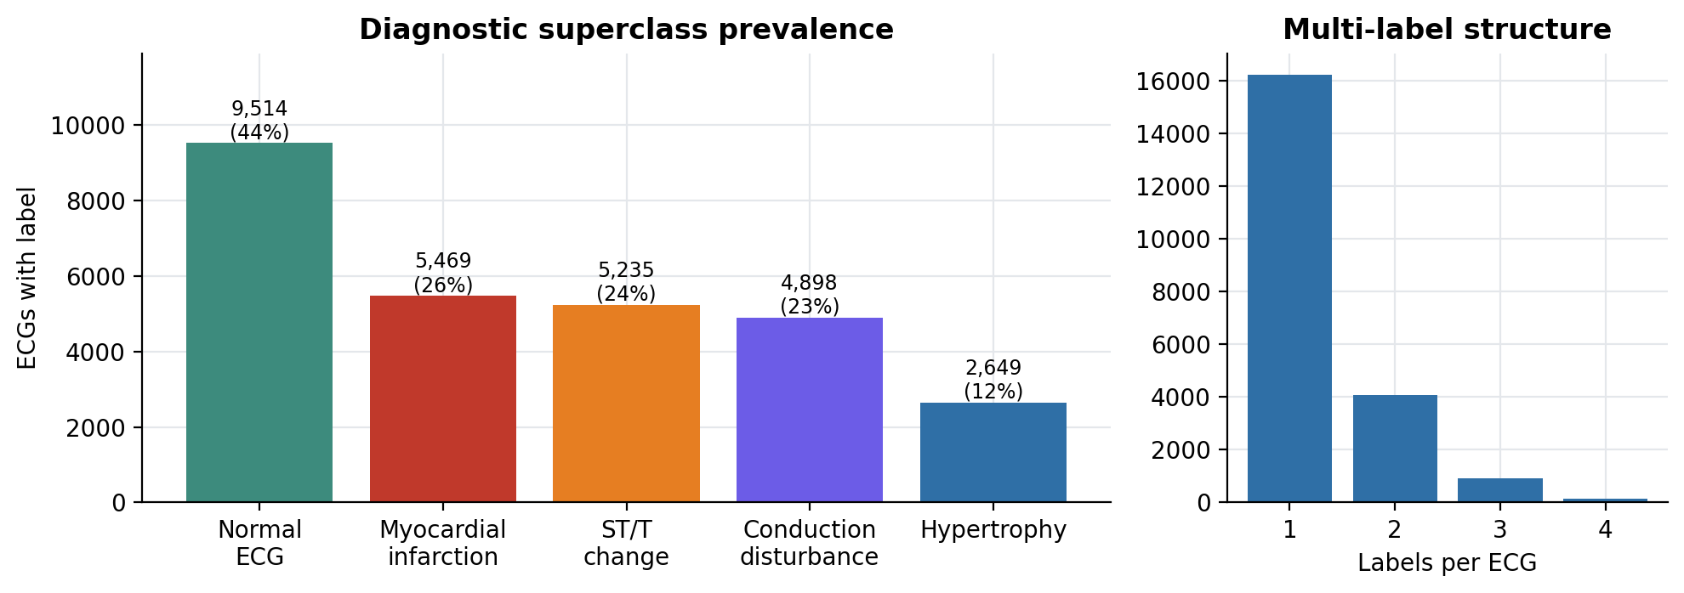
Figure 1. Superclass prevalence and the number of labels per ECG.

3.3 Data quality and missing values
The ECG signals themselves are complete. Among metadata, height and weight are missing for 68% and 56% of records, so they are not used as features; age and sex are not used either, to keep the model a pure signal-based screener. At the feature level, 0.15% of cells are missing (maximum 0.9% for a single feature) because heart-rate variability or median-beat features cannot be computed when fewer than three beats are detected. These are imputed with the training median inside each model pipeline (LightGBM handles them natively).

3.4 Validation strategy
We use the recommended PTB-XL split: folds 1-8 for training (17,084 ECGs), fold 9 for validation (2,146) and fold 10 for testing (2,158). Folds are patient-wise, so no patient appears in more than one split, which prevents identity leakage, and label-stratified, so class proportions are similar in every split. The validation fold is used only for probability calibration and threshold selection; the test fold is used once for final evaluation.
Table 4. Split sizes and class prevalence per split.
Split | ECGs | NORM | MI | STTC | CD | HYP
Train | 17,084 | 44.5% | 25.6% | 24.5% | 22.9% | 12.4%
Val | 2,146 | 44.5% | 25.2% | 24.6% | 23.1% | 12.5%
Test | 2,158 | 44.6% | 25.5% | 24.1% | 23.0% | 12.1%

4. Preprocessing and Feature Engineering

4.1 Signal preprocessing
- Band-pass filtering: 3rd-order zero-phase Butterworth, 0.5-40 Hz, removes baseline drift and high-frequency noise while preserving QRS and ST-T morphology.
- QRS detection: a polarity-independent detector smooths the squared first derivative over 100 ms, applies an adaptive threshold (30% of the 99th percentile) and a 300 ms refractory period, then refines each peak to the largest absolute deflection within ±80 ms.
- Median beat: all complete beats from -250 ms to +450 ms around R are aligned and the sample-wise median is taken, giving a noise-robust template; the PR segment defines the isoelectric baseline.

4.2 Lead reduction
Table 5. Lead configurations compared.
Configuration | Leads | Device analogue | Features
12-lead | I, II, III, aVR, aVL, aVF, V1, V2, V3, V4, V5, V6 | clinical 12-lead ECG | 576
6-lead | I, II, III, aVR, aVL, aVF | 6-lead handheld device (limb leads) | 288
3-lead | I, II, V2 | 3-lead patch (I, II, V2) | 144
1-lead | I | smartwatch (lead I) | 48

Because every feature column is named LEAD__feature, a reduced-lead model is trained on exactly the columns of the leads it can see. All configurations therefore share one identical extraction step, so differences in accuracy are caused only by the information available.
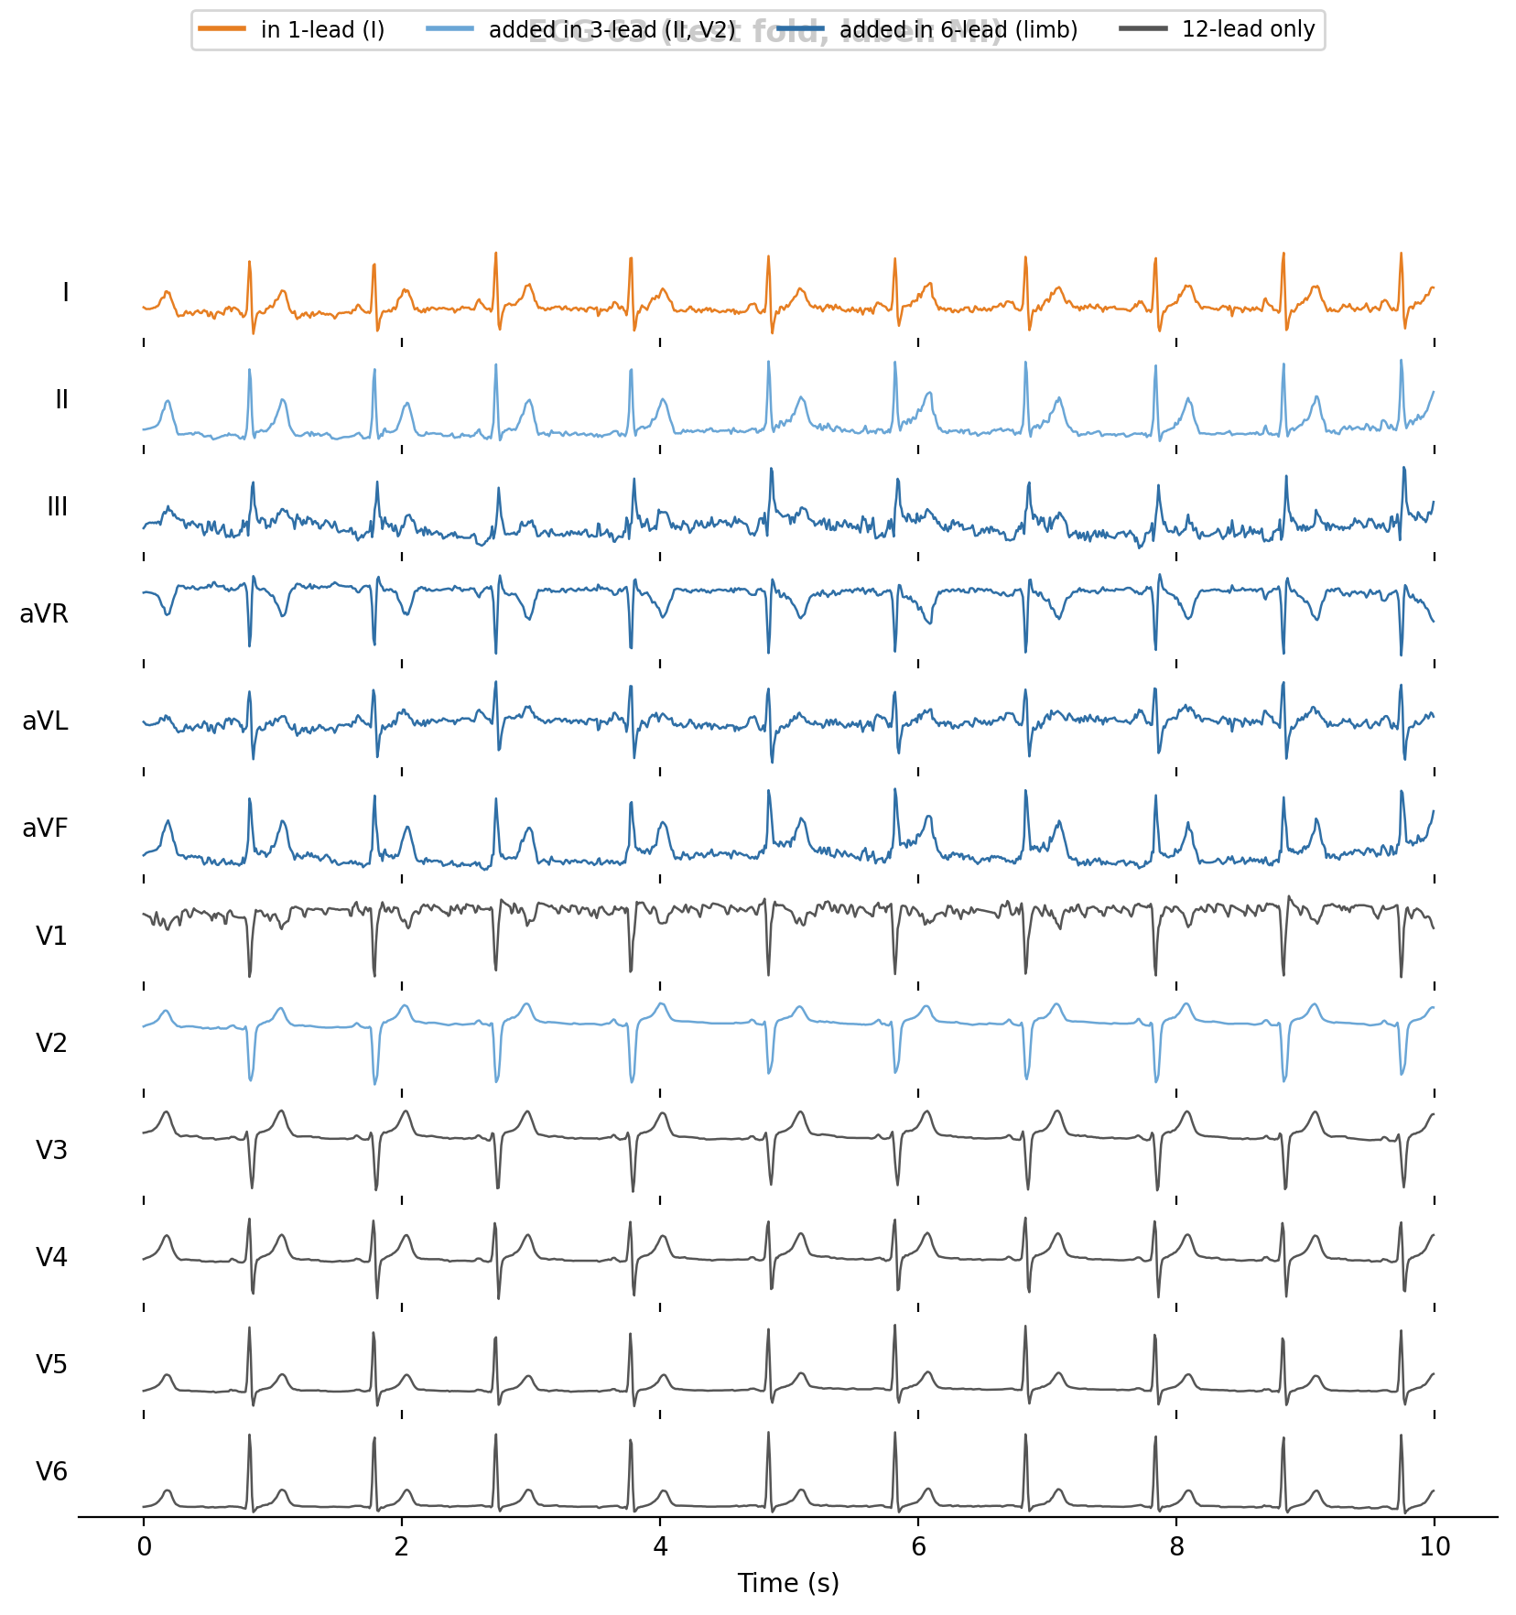
Figure 2. A test-fold ECG with the leads used by each configuration highlighted.

4.3 Features
Table 6. The 48 features computed for each lead.
Group | Features (per lead) | Clinical meaning
Rhythm (7) | beat count, HR, RR std, RR CV, RMSSD, pNN50, RR range | rate and regularity
Amplitude statistics (8) | std, peak-to-peak, skew, kurtosis, 5th/95th percentile, mean |x|, ZCR | overall voltage and shape
Spectral (5) | relative power 0.5-5, 5-15, 15-45 Hz, spectral entropy, peak frequency | energy distribution
QRS morphology (6) | Q depth, R amplitude, S depth, QRS amplitude, area, width | depolarisation, conduction, hypertrophy
ST segment (2) | ST level at R+90-120 ms, ST slope | ischaemia, injury
T wave (4) | T amplitude (signed), max, min, area | repolarisation
P wave / beat (2) | P amplitude, mean beat-to-template correlation | atrial activity, stability
Beat template (14) | median beat averaged into 14 bins | overall waveform shape

4.4 Simulated wearable noise
To mimic wearable recording conditions, test ECGs are corrupted with a reproducible mixture of baseline wander (sum of 0.05-0.5 Hz sinusoids, 45% of noise power), muscle noise (band-limited 15-45 Hz Gaussian noise, 35%) and motion artefacts (random Gaussian transients of 0.1-0.6 s, 20%). The mixture is scaled per lead to a target signal-to-noise ratio of 24, 12 or 6 dB. Noise is applied only to the test fold, so the experiment measures how models trained on clean clinical data behave when deployed on noisy devices. A unit test verifies that the achieved SNR is within 0.5 dB of the target.
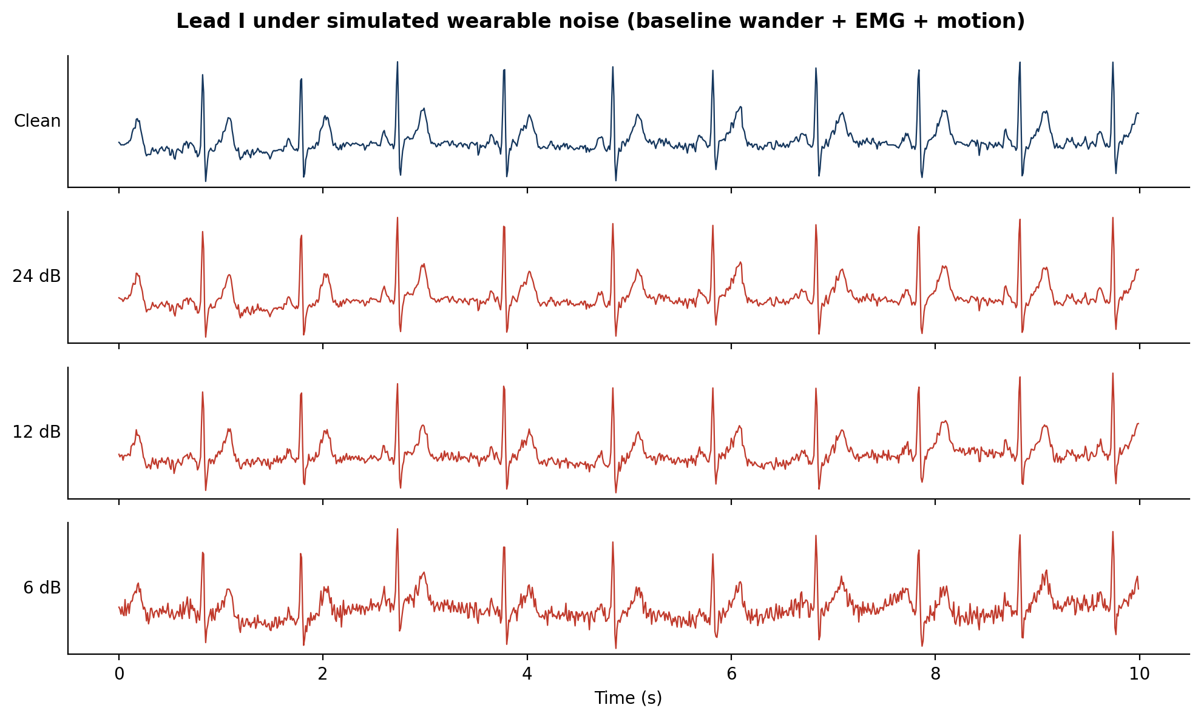
Figure 3. Lead I of the example ECG at each simulated noise level.

5. Methodology and ML Pipeline
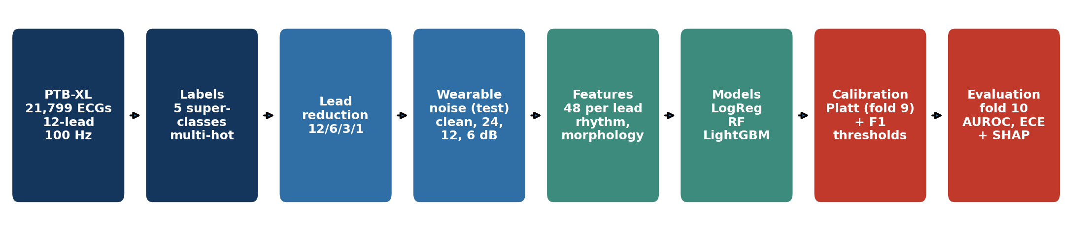
Figure 4. End-to-end pipeline.

5.1 Models and justification
Table 7. Models compared.
Model | Configuration | Why it was chosen
Logistic Regression | median imputation → standardisation → L2 (C = 0.05), class-balanced | transparent linear baseline; shows how much is gained by non-linearity
Random Forest | 300 trees, max_features = √p, min leaf 3, balanced subsampling | robust non-linear bagging ensemble, insensitive to scaling and outliers
LightGBM | 500 rounds, learning rate 0.03, 31 leaves, 80% row / 50% column subsampling | state-of-the-art gradient boosting for tabular data; native missing values; fast TreeSHAP

5.2 Multi-label strategy, calibration and thresholds
Because an ECG can carry several superclasses, each class has its own binary classifier (one-vs-rest). Each classifier is trained on folds 1-8. Its raw scores on fold 9 are then mapped to calibrated probabilities with Platt scaling, a logistic regression on the logit of the raw score. Finally a decision threshold that maximises F1 on fold 9 is stored. Calibration matters for screening because a clinic must be able to read 0.3 as roughly a 30% chance and set its own referral cut-off.

5.3 Evaluation metrics
- AUROC: threshold-free ranking quality per class; macro-averaged so rare classes count equally.
- AUPRC: precision-recall area, informative under class imbalance.
- F1, sensitivity, specificity: decision quality at the validation-tuned threshold.
- Brier score and Expected Calibration Error (ECE, 10 bins): reliability of probabilities.
- Retention: reduced-lead macro AUROC as a percentage of the same model's 12-lead macro AUROC.
- Uncertainty: 500 bootstrap resamples of the test fold for 95% confidence intervals, and a paired bootstrap of the AUROC difference between each reduced-lead model and its 12-lead counterpart on the same patients.

5.4 Experimental design
3 models × 4 lead configurations = 12 trained systems, each evaluated on the clean test fold and at 3 noise levels (48 evaluations). SHAP values are computed for the LightGBM model of every configuration with TreeSHAP on up to 1,000 test ECGs.

6. Implementation
The project is implemented in Python. The complete study lives in one commented Jupyter notebook, LowLead_ECG_Screening.ipynb, which runs top to bottom and reproduces every number and figure in this report; its last cells generate this report and the slides. The Streamlit app is started with:
streamlit run streamlit_app.py
Table 8. Project structure.
Notebook section / file | Responsibility
1. Setup | libraries and every experiment setting in one cell
2-3. Data and labels | download PTB-XL, multi-hot superclass labels, exploration, official split
4-5. Signals | reading WFDB records, band-pass filtering, R-peak detection
6. Features | 48 features per lead, checked to be identical to the app's copy
7. Noise | reproducible wearable-noise simulator at a target SNR
8. Feature table | parallel, cached feature extraction for all ECGs and noise levels
9-11. Models | calibrated one-vs-rest models, metrics, bootstrap tests, noise robustness
12. SHAP | global attribution per lead and per feature group
13-15. Outputs | JSON models for the app, example ECGs, summary.json, report and slides
streamlit_app.py + src/ | interactive demo and the small helpers it needs (features, noise, model loader)
tests/test_core.py | unit tests: QRS detection, heart rate, SNR accuracy, model loader

Reproducibility: fixed random seeds, deterministic per-record noise seeds, pinned dependencies, cached features, and a synthetic PTB-XL-format generator for quick smoke tests. The full run took 13.5 minutes on the machine used. Models are exported as JSON (LightGBM text format plus Platt coefficients and thresholds) so the deployed app does not depend on pickle compatibility. Two checks inside the notebook confirm that the app computes identical features and reproduces the trained model's probabilities to 1e-6.

6.1 Streamlit application
The app lets a user pick a held-out PTB-XL test ECG or upload a CSV, choose a device scenario (12, 6, 3 or 1 lead), add simulated noise, and see calibrated probabilities with thresholds, flagged categories and a per-ECG SHAP explanation computed with LightGBM's exact TreeSHAP. A lead-reduction explorer shows the same ECG through all four configurations side by side, and a results tab summarises the study. Every page carries a 'screening-support prototype, not a diagnostic tool' disclaimer.

7. Results and Evaluation

7.1 Overall discrimination
Table 9. Test-fold results for every model and lead configuration (clean signals).
Model | Leads | Macro AUROC [95% CI] | AUPRC | F1 | ECE | Retention
LogReg | 12-lead | 0.897 [0.888-0.905] | 0.754 | 0.703 | 0.023 | 100.0%
LogReg | 6-lead | 0.868 [0.859-0.877] | 0.693 | 0.655 | 0.019 | 96.9%
LogReg | 3-lead | 0.874 [0.864-0.882] | 0.701 | 0.663 | 0.021 | 97.5%
LogReg | 1-lead | 0.813 [0.801-0.823] | 0.601 | 0.590 | 0.019 | 90.6%
RandomForest | 12-lead | 0.910 [0.903-0.917] | 0.779 | 0.718 | 0.019 | 100.0%
RandomForest | 6-lead | 0.883 [0.873-0.892] | 0.723 | 0.676 | 0.019 | 97.0%
RandomForest | 3-lead | 0.887 [0.879-0.896] | 0.724 | 0.680 | 0.020 | 97.5%
RandomForest | 1-lead | 0.824 [0.812-0.835] | 0.630 | 0.605 | 0.020 | 90.5%
LightGBM | 12-lead | 0.925 [0.918-0.931] | 0.817 | 0.744 | 0.017 | 100.0%
LightGBM | 6-lead | 0.892 [0.883-0.900] | 0.748 | 0.689 | 0.017 | 96.4%
LightGBM | 3-lead | 0.901 [0.894-0.909] | 0.763 | 0.693 | 0.019 | 97.5%
LightGBM | 1-lead | 0.827 [0.816-0.838] | 0.643 | 0.614 | 0.017 | 89.5%

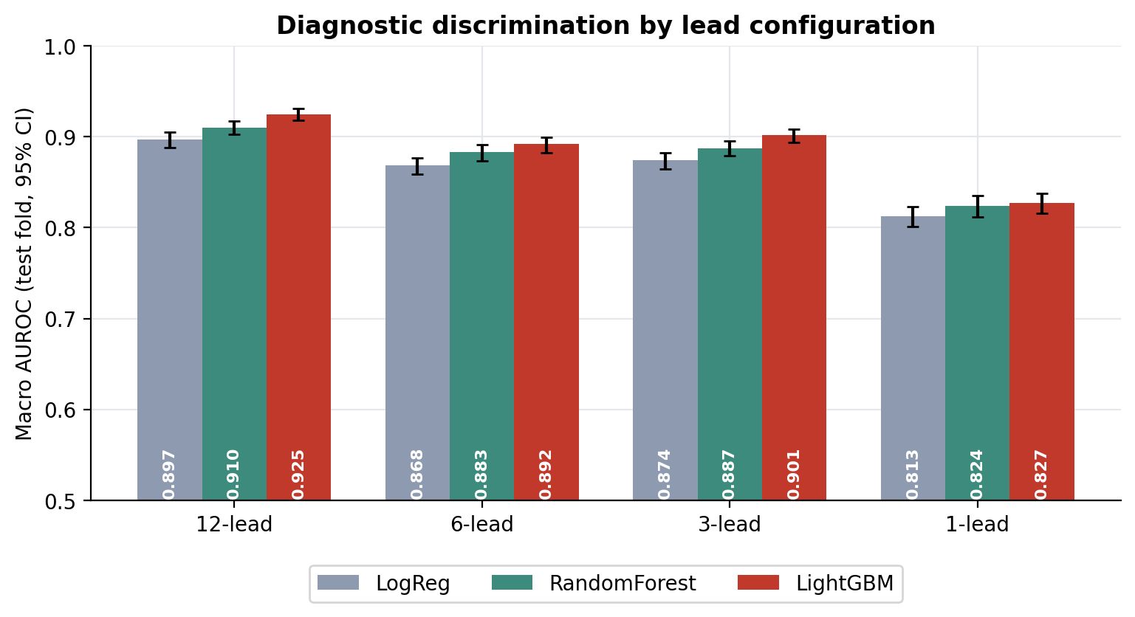
Figure 5. Macro AUROC with 95% bootstrap confidence intervals.
LightGBM was the strongest model overall; on the full 12-lead ECG it reached a macro AUROC of 0.925 (95% CI 0.918-0.931). Best model per configuration: 12-lead - LightGBM; 6-lead - LightGBM; 3-lead - LightGBM; 1-lead - LightGBM.

7.2 Accuracy retention
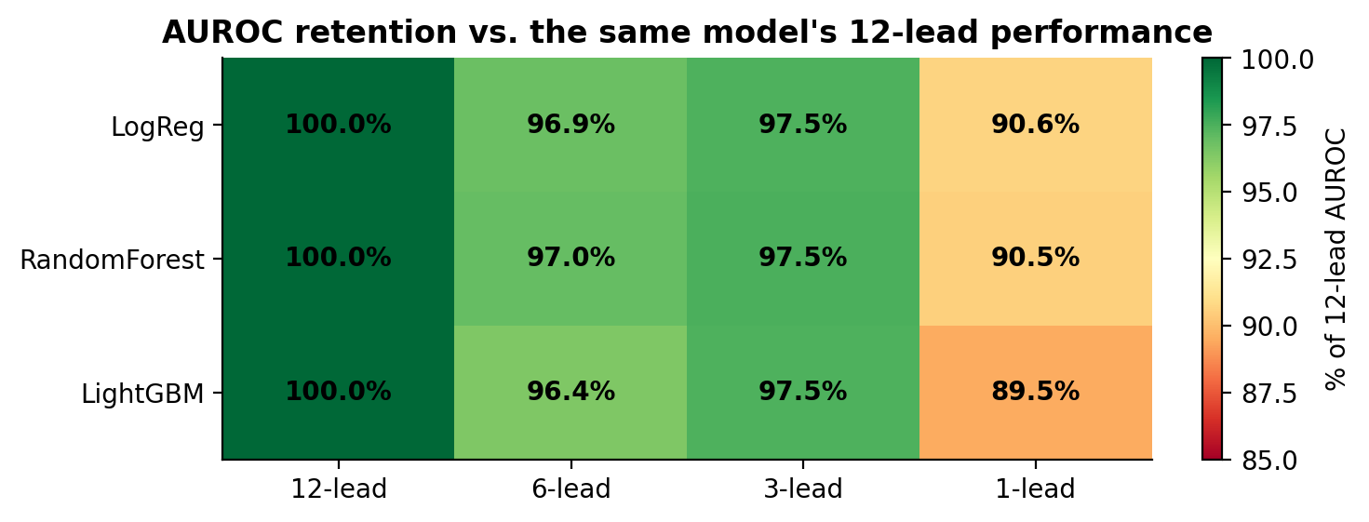
Figure 6. Reduced-lead AUROC as a percentage of each model's 12-lead AUROC.
Table 10. Paired bootstrap comparison of each reduced-lead model with its 12-lead counterpart.
Model | Configuration | ΔAUROC vs 12-lead | 95% CI | p-value
LogReg | 6-lead | -0.028 | -0.034 to -0.022 | 0.000
LogReg | 3-lead | -0.023 | -0.029 to -0.018 | 0.000
LogReg | 1-lead | -0.084 | -0.095 to -0.075 | 0.000
RandomForest | 6-lead | -0.027 | -0.033 to -0.022 | 0.000
RandomForest | 3-lead | -0.023 | -0.028 to -0.018 | 0.000
RandomForest | 1-lead | -0.086 | -0.095 to -0.077 | 0.000
LightGBM | 6-lead | -0.033 | -0.039 to -0.029 | 0.000
LightGBM | 3-lead | -0.023 | -0.028 to -0.019 | 0.000
LightGBM | 1-lead | -0.097 | -0.107 to -0.088 | 0.000

Reducing to the 6 limb leads retained 96.4% of 12-lead AUROC, the 3-lead set (I, II, V2) 97.5%, and a single smartwatch-style lead I 89.5%. For LightGBM: 6-lead ΔAUROC -0.033 (95% CI -0.039 to -0.029), a statistically significant loss; 3-lead ΔAUROC -0.023 (95% CI -0.028 to -0.019), a statistically significant loss; 1-lead ΔAUROC -0.097 (95% CI -0.107 to -0.088), a statistically significant loss.

7.3 Per-class analysis
Table 11. Per-class AUROC of LightGBM by lead configuration.
Class | 12-lead | 6-lead | 3-lead | 1-lead | 1-lead retention
NORM (Normal ECG) | 0.942 | 0.925 | 0.928 | 0.880 | 93.4%
MI (Myocardial infarction) | 0.912 | 0.872 | 0.885 | 0.771 | 84.5%
STTC (ST/T change) | 0.939 | 0.918 | 0.925 | 0.872 | 92.9%
CD (Conduction disturbance) | 0.917 | 0.889 | 0.908 | 0.809 | 88.2%
HYP (Hypertrophy) | 0.913 | 0.855 | 0.862 | 0.805 | 88.1%

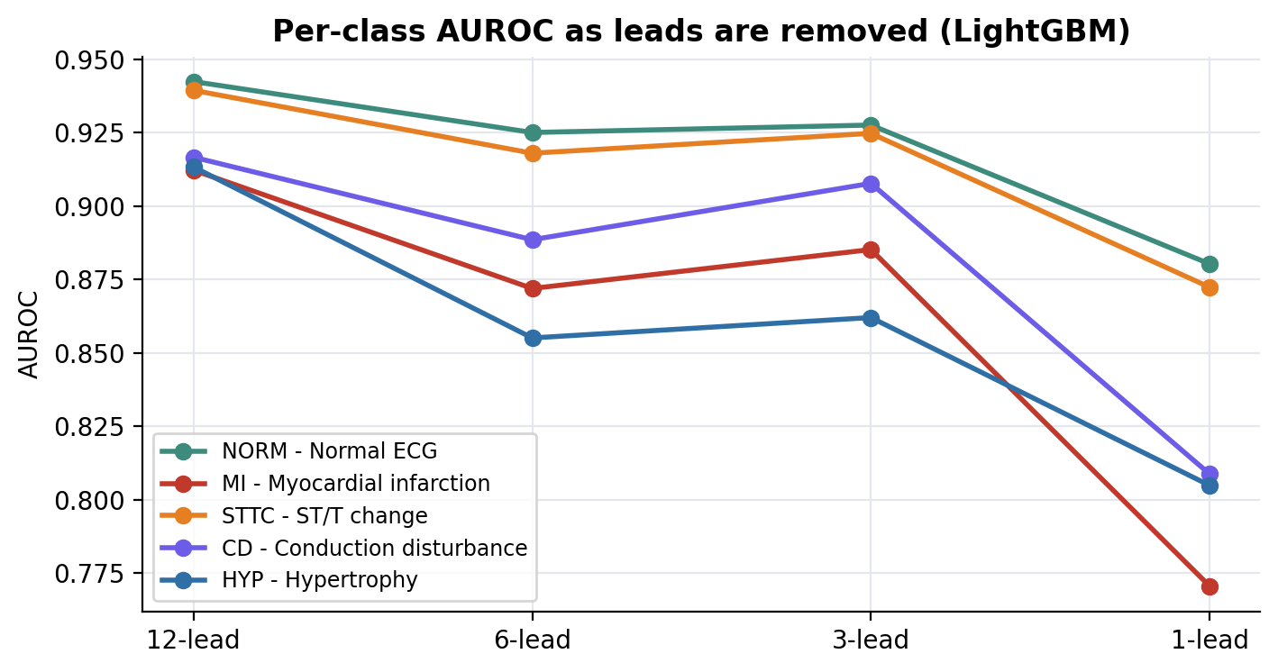
Figure 7. Per-class AUROC of LightGBM as leads are removed.
Removing leads hurt MI (Myocardial infarction) the most: with lead I alone it kept only 84.5% of its 12-lead AUROC, while NORM kept 93.4%. This matches cardiac anatomy: the signs of infarction (pathological Q waves, ST elevation, T inversion) appear in the leads facing the damaged wall, the chest leads V1-V4 for anterior and II, III, aVF for inferior infarcts, which a wrist-worn lead I does not record. Conduction disturbances and hypertrophy change QRS width and voltage globally, so they remain visible in any lead.
Table 12. Decision metrics of the 12-lead LightGBM model at the validation-tuned thresholds.
Class | AUROC | AUPRC | Sensitivity | Specificity | F1 | Threshold
NORM | 0.942 | 0.918 | 0.911 | 0.813 | 0.850 | 0.42
MI | 0.912 | 0.802 | 0.731 | 0.898 | 0.720 | 0.39
STTC | 0.939 | 0.831 | 0.791 | 0.915 | 0.769 | 0.40
CD | 0.917 | 0.842 | 0.738 | 0.933 | 0.752 | 0.36
HYP | 0.913 | 0.690 | 0.668 | 0.936 | 0.627 | 0.29

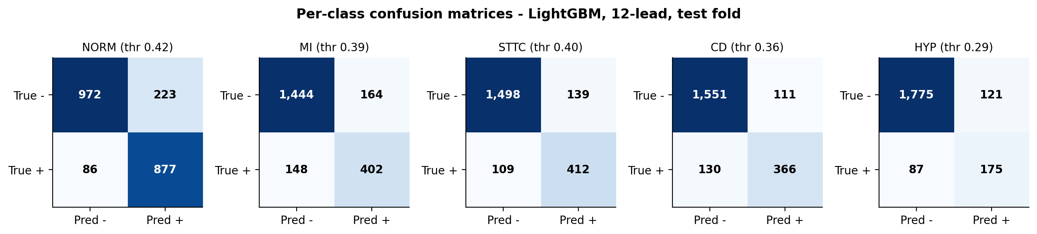
Figure 8. Per-class confusion matrices, LightGBM, 12-lead, test fold.
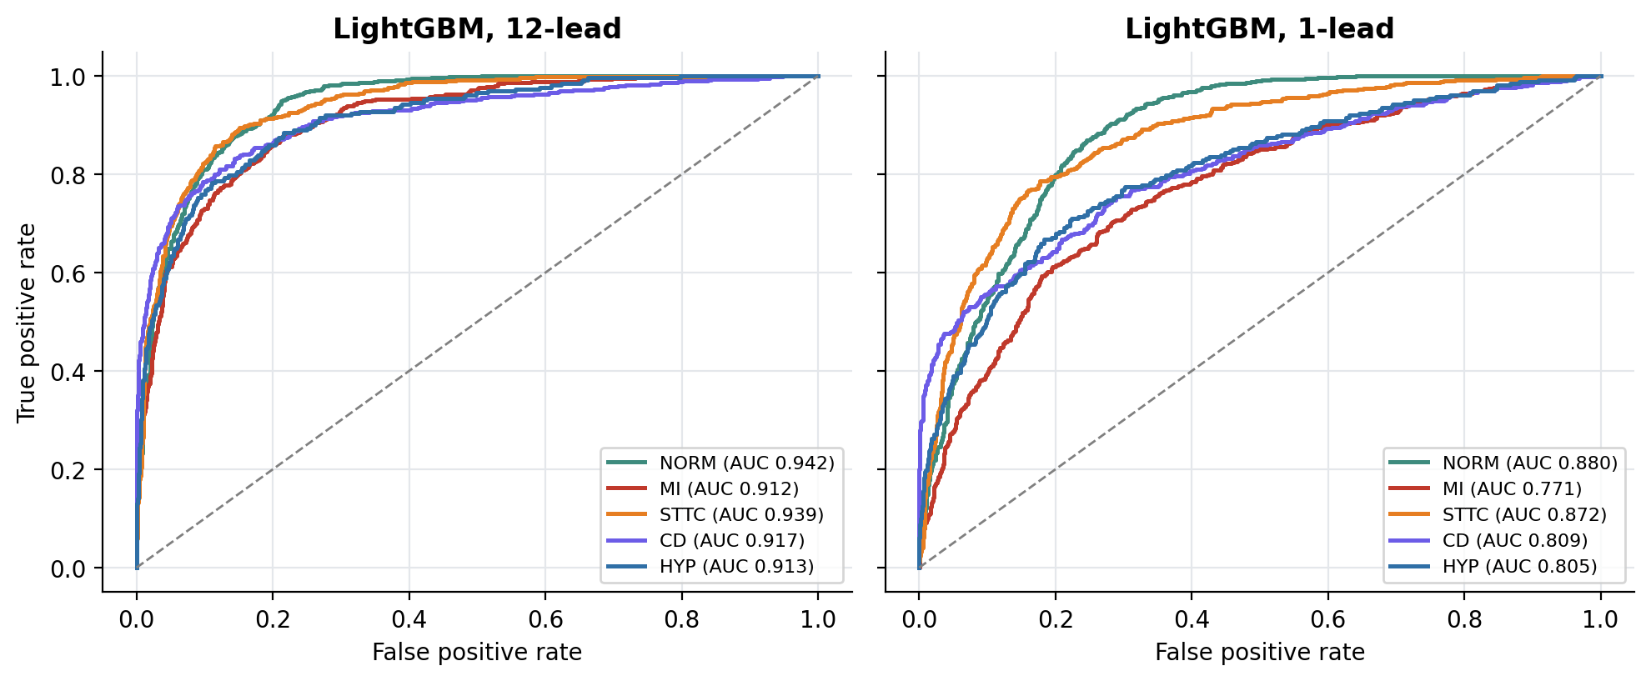
Figure 9. ROC curves of LightGBM for 12 leads and a single lead.

7.4 Robustness to wearable noise
Table 13. Macro AUROC of LightGBM under simulated wearable noise.
Configuration | Clean | 24 dB | 12 dB | 6 dB | Drop at 6 dB
12-lead | 0.925 | 0.924 | 0.924 | 0.918 | -0.007
6-lead | 0.892 | 0.891 | 0.891 | 0.887 | -0.005
3-lead | 0.901 | 0.901 | 0.899 | 0.892 | -0.010
1-lead | 0.827 | 0.828 | 0.827 | 0.818 | -0.010

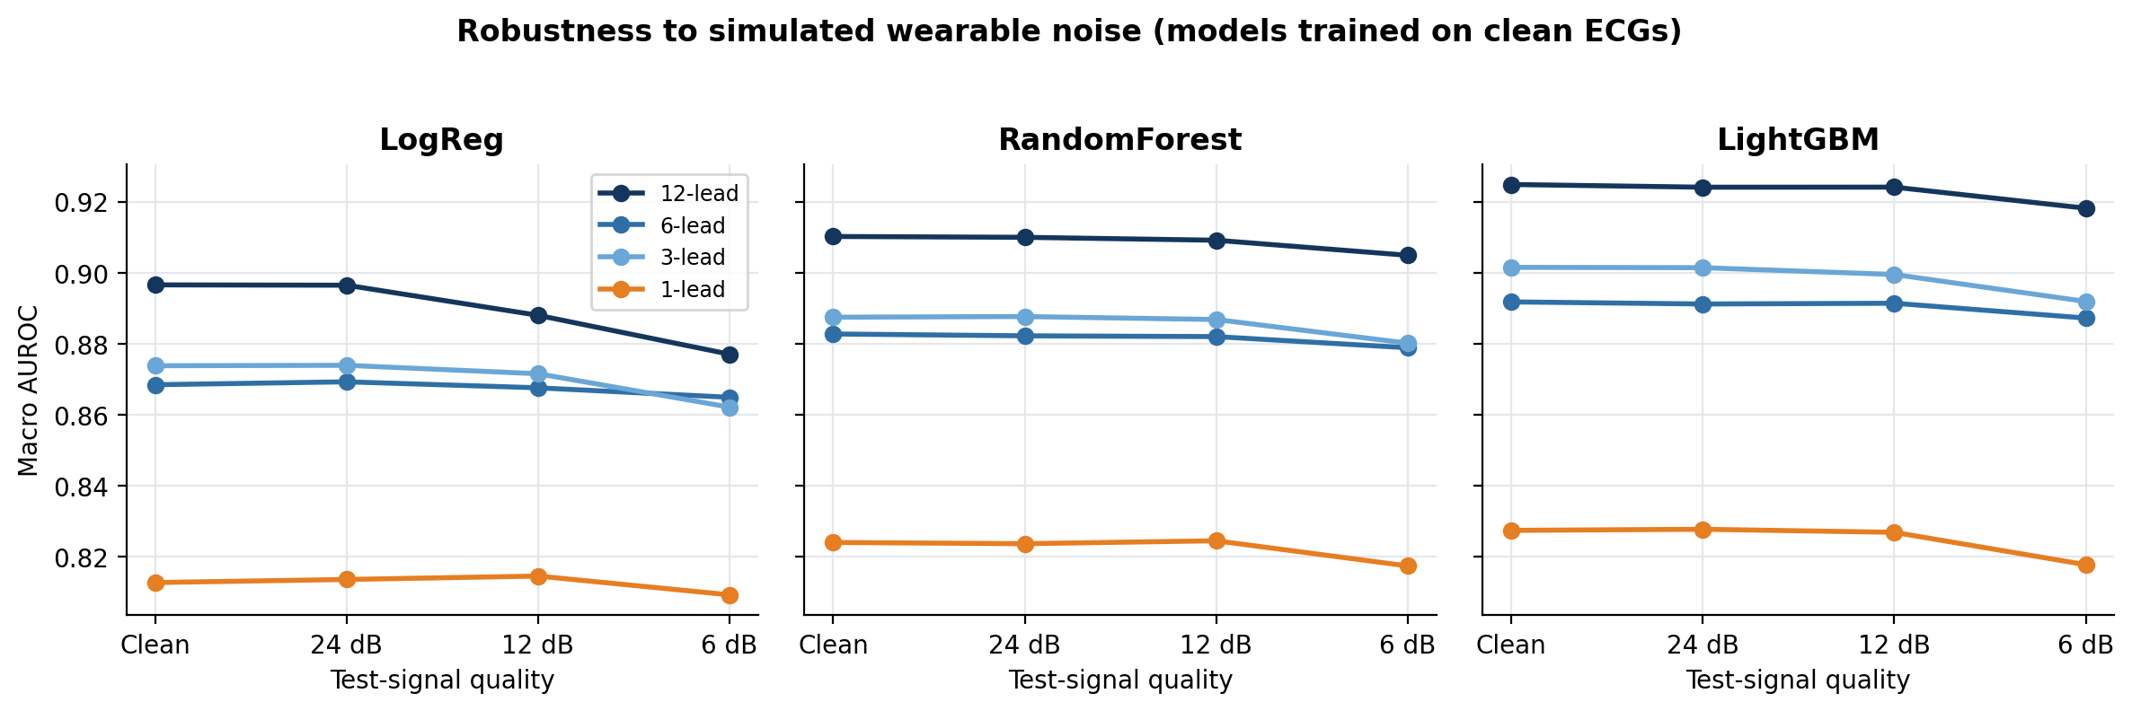
Figure 10. Macro AUROC versus noise level for all models and lead sets.
Under strong simulated wearable noise (6 dB SNR) macro AUROC fell by 0.007 for 12 leads and 0.010 for 1 lead; the 1-lead configuration was the most noise-sensitive. With more leads, the noise in each lead is independent, so the model can rely on the cleanest leads; a single-lead device has no such redundancy.

7.5 Calibration
Table 14. Calibration before and after Platt scaling (lower is better).
Model | Leads | ECE before | ECE after | Brier before | Brier after
LogReg | 12-lead | 0.102 | 0.023 | 0.118 | 0.098
LogReg | 1-lead | 0.164 | 0.019 | 0.166 | 0.129
RandomForest | 12-lead | 0.041 | 0.019 | 0.094 | 0.092
RandomForest | 1-lead | 0.037 | 0.020 | 0.125 | 0.124
LightGBM | 12-lead | 0.031 | 0.017 | 0.085 | 0.084
LightGBM | 1-lead | 0.029 | 0.017 | 0.122 | 0.122

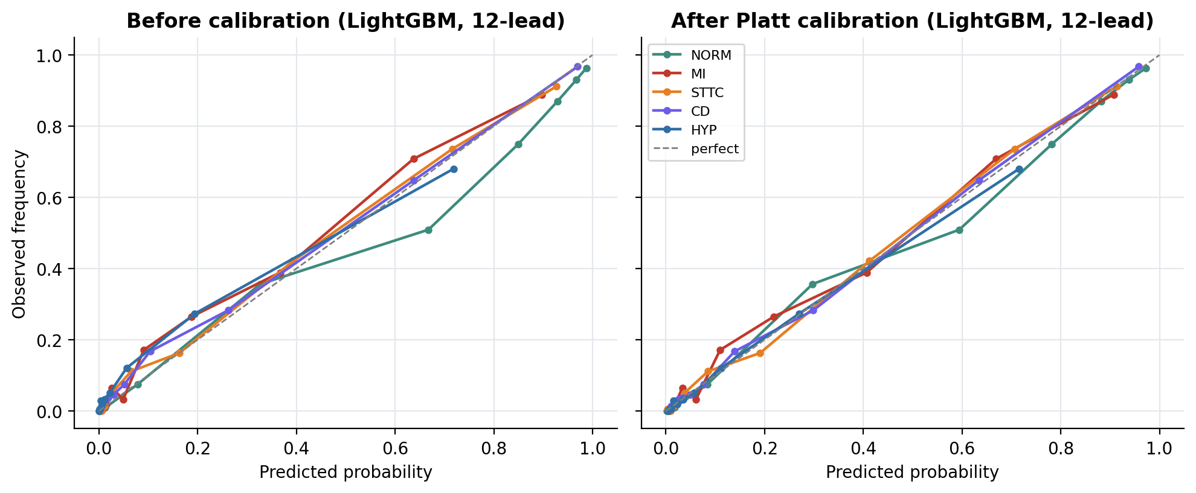
Figure 11. Reliability diagrams of LightGBM (12-lead) before and after calibration.
Platt calibration changed the 12-lead expected calibration error from 0.031 to 0.017, so the reported probabilities can be read as risk estimates.

7.6 Explainability (SHAP)
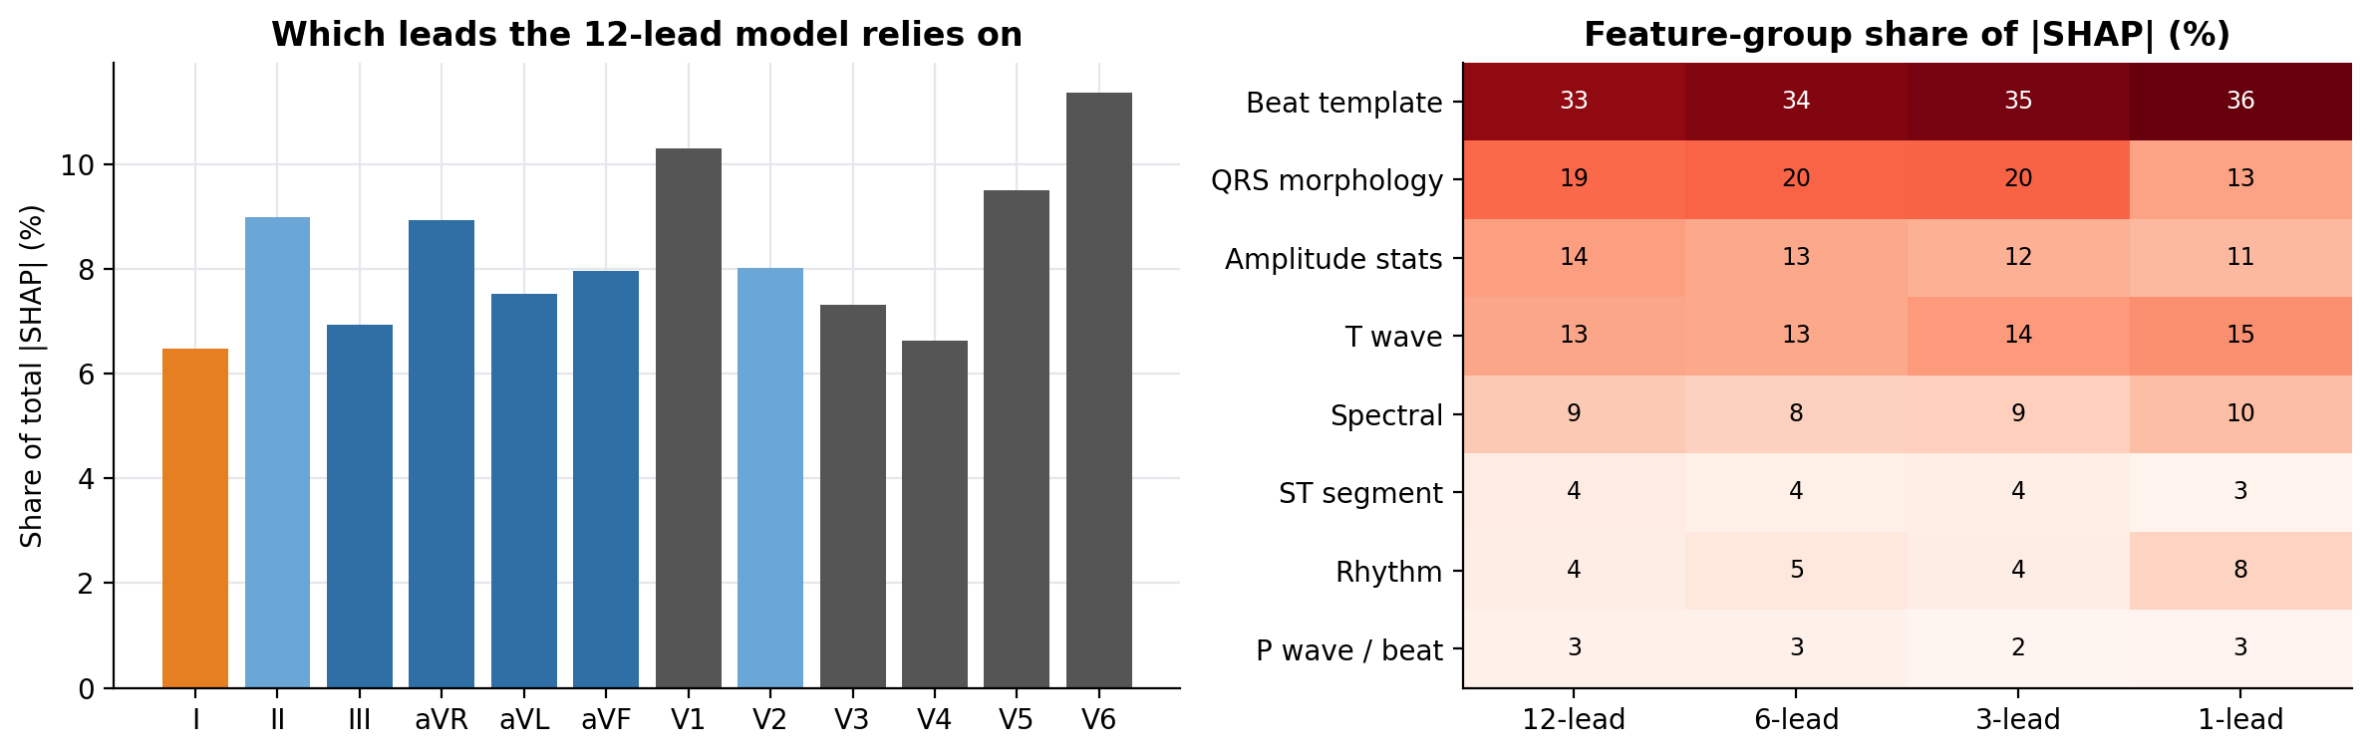
Figure 12. Share of SHAP attribution by lead (12-lead model) and by feature group (all configurations).
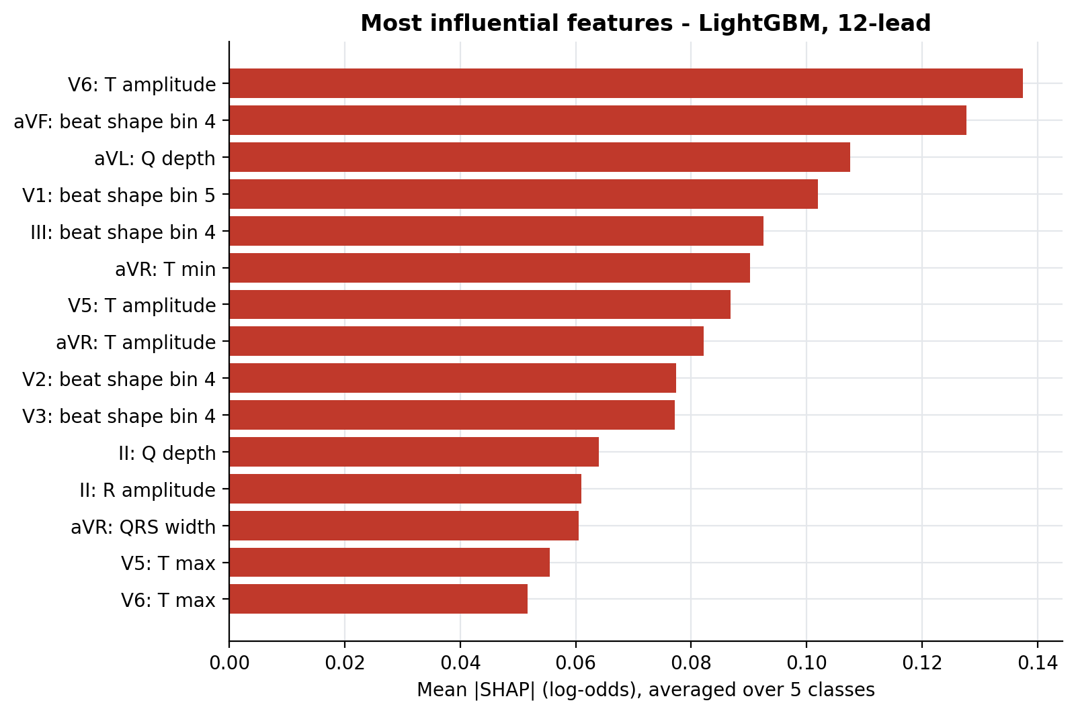
Figure 13. Top features of the 12-lead LightGBM model.
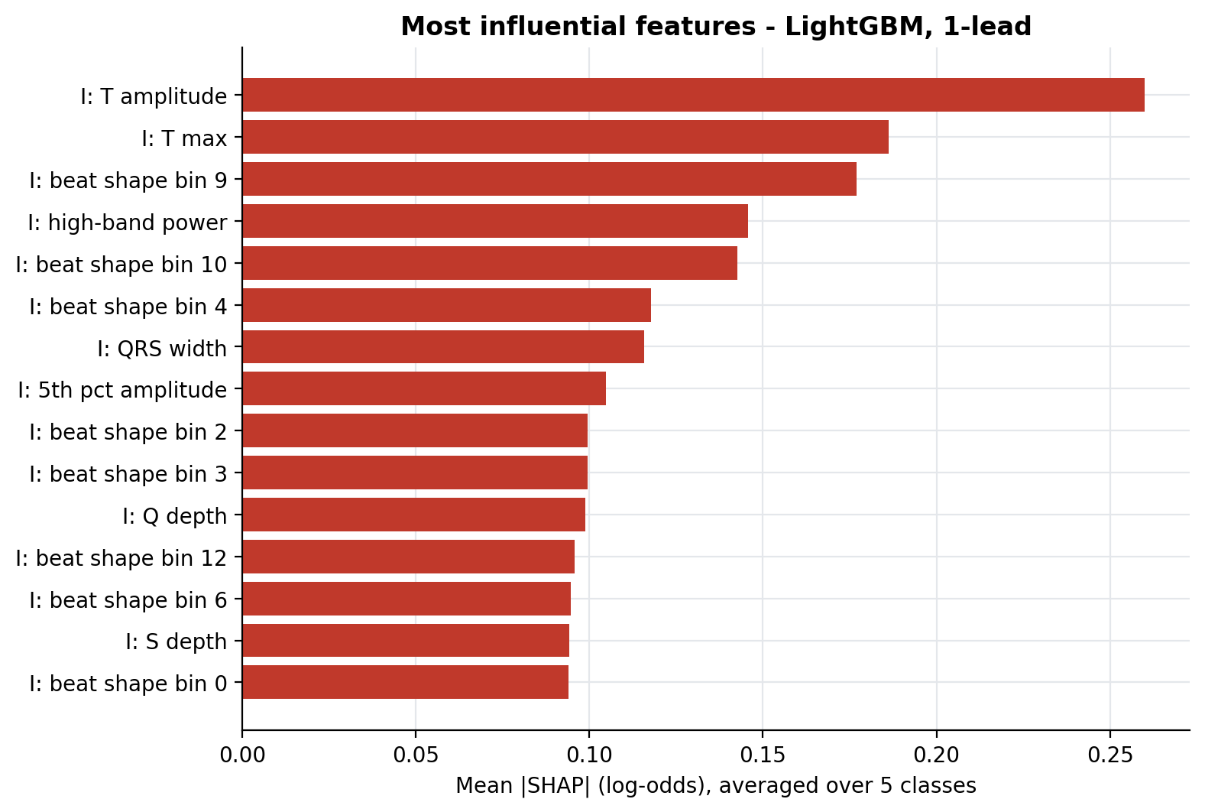
Figure 14. Top features of the 1-lead LightGBM model.
SHAP shows the 12-lead model leans most on lead V6 (11% of attribution); with one lead the dominant feature group is 'Beat template'. The most influential 12-lead features were V6: T amplitude, aVF: beat shape bin 4, aVL: Q depth, V1: beat shape bin 5, III: beat shape bin 4; for one lead they were I: T amplitude, I: T max, I: beat shape bin 9, I: high-band power, I: beat shape bin 10. Without the chest and inferior leads, the single-lead model has to rely on indirect, global descriptors, which explains its weaker detection of localised conditions.

7.7 Comparative discussion
Across configurations the ranking of models was: 12-lead: LightGBM > RandomForest > LogReg; 6-lead: LightGBM > RandomForest > LogReg; 3-lead: LightGBM > RandomForest > LogReg; 1-lead: LightGBM > RandomForest > LogReg. Tree ensembles can combine features non-linearly (for example ST elevation matters mostly together with Q waves in the same territory), which a linear model cannot do. The 3-lead set (I, II, V2) outperformed the 6 limb leads despite having fewer leads, because its single chest electrode restores part of the precordial view that all limb leads lack. For a wearable designer this suggests that one well-placed chest electrode is worth more than extra limb leads.

8. Limitations
- Simulated devices: reduced-lead inputs are subsets of clinical recordings with ideal electrode placement; real wearables differ in electrode position, contact and filtering.
- Simulated noise: real motion artefacts and dry-electrode noise are more varied than the model used.
- Population: PTB-XL was recorded at a single German centre between 1989 and 1996; external validation on other populations and devices is needed.
- Label granularity: superclasses merge sub-types (anterior vs inferior MI) with different lead dependence.
- Feature-based models: deep networks on raw signals may extract more information, at the cost of interpretability.
- Intended use: the system is a screening-support prototype. Any flag must be confirmed with a full 12-lead ECG and clinical judgement.

9. Conclusion
This project measured, on 21,388 clinical ECGs, how much diagnostic accuracy is retained when the 12-lead ECG is reduced to wearable-style lead sets. The main findings are:
- LightGBM was the strongest model overall; on the full 12-lead ECG it reached a macro AUROC of 0.925 (95% CI 0.918-0.931).
- Reducing to the 6 limb leads retained 96.4% of 12-lead AUROC, the 3-lead set (I, II, V2) 97.5%, and a single smartwatch-style lead I 89.5%.
- Removing leads hurt MI (Myocardial infarction) the most: with lead I alone it kept only 84.5% of its 12-lead AUROC, while NORM kept 93.4%.
- Under strong simulated wearable noise (6 dB SNR) macro AUROC fell by 0.007 for 12 leads and 0.010 for 1 lead; the 1-lead configuration was the most noise-sensitive.
- Platt calibration changed the 12-lead expected calibration error from 0.031 to 0.017, so the reported probabilities can be read as risk estimates.
- SHAP shows the 12-lead model leans most on lead V6 (11% of attribution); with one lead the dominant feature group is 'Beat template'.
The answer to the research question is therefore condition-specific: global abnormalities can be screened from very few leads, while localised ones such as myocardial infarction require chest leads. Calibrated probabilities and SHAP explanations make the prototype's limitations visible to its users.

10. Future Scope
- Train 1-D convolutional or transformer models on raw signals and compare with the feature models.
- Use noise augmentation during training to improve robustness on wearable data.
- Validate on real smartwatch and patch recordings.
- Reconstruct missing precordial leads from limb leads, or add lead-aware attention, to recover MI detection.
- Extend to rhythm classes such as atrial fibrillation and deploy on-device.

References
[1] P. Wagner, N. Strodthoff, R.-D. Bousseljot et al., "PTB-XL, a large publicly available electrocardiography dataset," Scientific Data, vol. 7, 154, 2020.
[2] A. L. Goldberger et al., "PhysioBank, PhysioToolkit, and PhysioNet," Circulation, vol. 101, no. 23, pp. e215-e220, 2000.
[3] N. Strodthoff, P. Wagner, T. Schaeffter, W. Samek, "Deep learning for ECG analysis: benchmarks and insights from PTB-XL," IEEE J. Biomedical and Health Informatics, vol. 25, no. 5, pp. 1519-1528, 2021.
[4] G. Ke et al., "LightGBM: a highly efficient gradient boosting decision tree," NeurIPS, 2017.
[5] S. M. Lundberg, S.-I. Lee, "A unified approach to interpreting model predictions," NeurIPS, 2017.
[6] J. Platt, "Probabilistic outputs for support vector machines and comparisons to regularized likelihood methods," Advances in Large Margin Classifiers, 1999.
[7] F. Pedregosa et al., "Scikit-learn: machine learning in Python," JMLR, vol. 12, pp. 2825-2830, 2011.
[8] G. B. Moody, W. Muldrow, R. G. Mark, "A noise stress test for arrhythmia detectors," Computers in Cardiology, vol. 11, pp. 381-384, 1984.
[9] L. Breiman, "Random forests," Machine Learning, vol. 45, pp. 5-32, 2001.
[10] C. Guo, G. Pleiss, Y. Sun, K. Q. Weinberger, "On calibration of modern neural networks," ICML, 2017.

Appendix A. How to reproduce
- git clone <your-repo-url> && cd lowlead-ecg-screening
- pip install -r requirements-train.txt
- Open LowLead_ECG_Screening.ipynb and Run All (downloads PTB-XL, ~1.7 GB, then runs everything, including this report and the slides)
- python -m pytest -q
- streamlit run streamlit_app.py

