Title: Weather Data Analysis using R
Subtitle: Understanding Weather Trends through Data Analysis
- NAME: KASHISH
- UID: 25BCD10275
- SECTION: 25BCD4B

Introduction
Content:
- Weather analysis helps understand climate patterns
- Includes temperature, humidity, rainfall
- R is used for data analysis & visualization
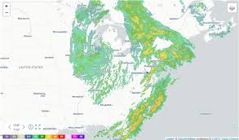
weather data visualization chart

Objectives
Content:
- Analyze weather data
- Identify trends
- Visualize data using graphs
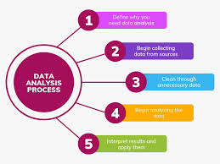
Data analysis process diagram

Dataset
Content (add table):
Day | Temp | Humidity | Rainfall
1 | 30 | 60 | 0
2 | 32 | 65 | 5
... | ... | ... | ...
R CODE:
weather <- data.frame(
Day = 1:10,
Temperature = c(30,32,35,33,31,29,28,30,34,36),
Humidity = c(60,65,70,68,64,62,61,63,67,72),
Rainfall = c(0,5,10,2,0,0,0,3,8,12)
)
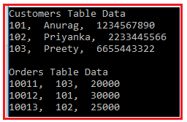
Dataset table example

Tools Used
Content:
- R Programming
- ggplot2
- dplyr
R CODE:
library(ggplot2)
library(dplyr)

R programming logo

Data Analysis
Content:
- Mean temperature calculated
- Summary statistics used
- Correlation between temperature & humidity
R CODE:
summary(weather)
mean(weather$Temperature)
cor(weather$Temperature, weather$Humidity)
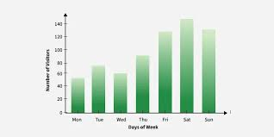
Statistics charts graphs

Temperature Trend (Line Graph)
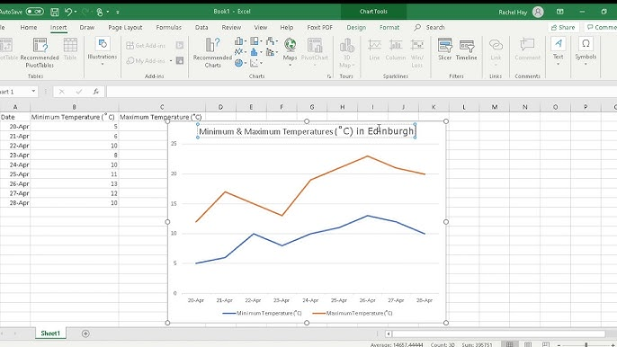
Text:
- Shows temperature variation over days

Rainfall Data (Bar Graph)
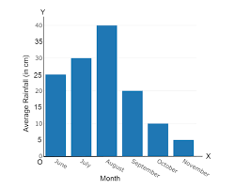
Text:
- Displays rainfall differences
Temperature vs Humidity (Scatter Plot)
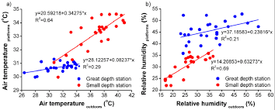
Text:
- Shows relationship between variables

Key Findings
Content:
- Temperature fluctuates over days
- Humidity is related to temperature
- Rainfall affects humidity
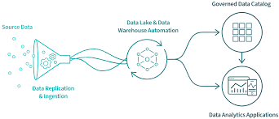
Data insights analytics

Conclusion
Content:
- Helps understand weather patterns
- Useful in prediction & planning
- R simplifies analysis
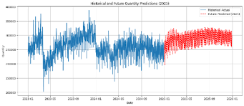
Future prediction graph
R CODE:
library(ggplot2)

ggplot(weather, aes(x=Day, y=Temperature)) +
geom_line(color="blue") +
ggtitle("Temperature Trend using ggplot2")

