Q1.

Create database connectivity with python and perform the queries given below in a single file.

1. Create database connection
2. Create a table named **student_info** with the following fields (name, SAP_ID, address, Date_of_birth)
3. Insert records of three students into the **student_info** table
4. Select students whose name starts with H from **student_info** table
5. Sort the **name** field in descending order.

Q2. Create database connectivity with python and perform the queries given below in a single file.

1. Create database connection
2. Create a table named **employee_info** with the following fields (emp_name, EMP_ID, address, Date_of_joining and salary)
3. Insert record of five employees into the table.
4. Select employee whose salary is greater than 25000 from the **employee_info** table.

Select employee whose name starts with G and Date_of_joining after july 2018.

Q3.

1. Create employee_details table in the database named “UPES” and insert the records mentioned below:

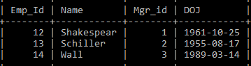

1. Create employee_salary table in the database named “UPES” and insert the records mentioned below:

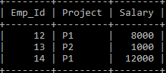

1. Execute given queries and print their results:

* Result of employees whose name starts with H
* Result of employees whose name are arranged in descending order
* Count of employees working in project 'P1'
* Name of employees working in project ‘P2’
* Employee names having salary greater than or equal to 5000 and less than or equal 10000