

BRACT’s Vishwakarma Institute of Information Technology

**PROJECT REPORT ON**

**Personalised Faculty Website**

DEPARTMENT OF COMPUTER SCIENCE AND ENGINEERING

(ARTIFICIAL INTELLIGENCE)

|  |  |  |
| --- | --- | --- |
| **Sr No.** | **Name** | **Email Id** |
| 1 | Ritesh Alkunte | ritesh.22211309[@viit.ac.in](mailto:dipali.22210638@viit.ac.in) |
| 2 | Atharva Atterkar | atharva.22211461[@viit.ac.in](mailto:mrinmayee.22210087@viit.ac.in) |
| 3 | Prasad Bachhav | prasad.22210905[@viit.ac.in](mailto:nishchay.22211583@viit.ac.in) |
| 4 | Naisargi Bagal | naisargee.22210870[@viit.ac.in](mailto:ashish.22210133@viit.ac.in) |
| 5 | Kashish Dingerja | kashish.22211470[@viit.ac.in](mailto:ashish.22210133@viit.ac.in) |

Under Guidance of

Dr. Anuradha Yenkikar, Prof. Pradnya Mehta, Prof. Pranjal Pandit

# INDEX:

ABSTRACT : 3

INTRODUCTION: 4

METHODOLOGY: 5

OBJECTIVES: 7

ER DIAGRAM: 9

UML DIAGRAMS: 11

SCREENSHOTS OF GUI: 14

FUTURE SCOPE: 18

CONCLUSION: 19

# 

# ABSTRACT :

This project concentrates on creating a customized website solution for faculty members in response to the increasing need for individualized online platforms. The current problem is the dearth of appropriate platforms, which frequently provide generic templates, that satisfy the various needs of faculty members. Our project intends to close this gap by giving faculty members the ability to successfully present their knowledge, research, and instructional resources through a configurable internet interface.

Creating a user-friendly online interface that allows faculty members to share classroom materials, submit research articles, customize their profiles, and engage with their audience is the aim. Course listings, communication tools, publication repositories, and modifiable bio sections are some of the important features. Faculty members will be able to effectively manage their online presence.

# 

# INTRODUCTION:

Personalized online platforms have become indispensable in today's quickly evolving digital ecosystem, especially in the academic domain. Nonetheless, current web-based solutions frequently fail to meet the varied requirements and inclinations of these academic experts. By developing a comprehensive and customized internet platform that is only suited to the needs of faculty members, our initiative aims to close this gap. Faculty members can build and edit their profiles on the website, which includes biographical background, educational profile, publications, projects and contact details. Additionally, the website has tools that make it simple for students and colleagues to find and get in touch with faculty members according to their areas of expertise. Gathering requirements from stakeholders and faculty members, designing the website's functionality, and putting it into use using contemporary web technologies like HTML, CSS, JavaScript, and a backend system for data management and storage were all important steps in the development process. With the help of this platform, faculty members will be able to discuss their research projects, exhibit their skills, and easily and precisely arrange their teaching materials. This effort will provide faculty members more control over their online personas, which will foster improved academic collaboration and communication.

# 

# METHODOLOGY:

Requirement Analysis:

Analyze the requirements to determine the features, functionality, and design choices that are necessary to satisfy the demands of academic institutions and faculty.

Research and Planning:

Examine the advantages, disadvantages, and user comments of the current online learning environments for faculty members. Create a thorough project plan that includes the technology stack, timetable, and scope needed for the development process.

Design Phase:

User Interface Design:

Produce wireframes and mockups of the website's user interface, emphasizing easy-to-use navigation, logical arrangement, and eye-catching styling. Take stakeholder input into consideration to improve the design concepts.

Database Design:

Create the database schema needed to hold user data, course information, research publications, faculty biographies, and other pertinent data. Describe the connections between various database objects and set limits on data integrity. Phase of Development

Development Phase:

Frontend:

Use HTML, CSS, JavaScript, jQuery, and Bootstrap to implement the website'sfrontend elements. Create web pages that are responsive to various screen sizes and devices. Based on the authorized design principles, incorporate interactive features, navigation menus, and design components.

Backend:

On the backend, the website employs SQL (Structured Query Language) for database management. SQL enables efficient storage, retrieval, and manipulation of data, crucial for handling faculty profiles, research publications, and course information.

Connectivity:

The connectivity between the frontend and backend is facilitated by PHP (Hypertext Preprocessor), a server-side scripting language. PHP interacts with the SQL database, processes user requests, and dynamically generates HTML content to be displayed on the website. XAMPP, a free and open-source cross-platform web server solution, is utilized to create a local development environment, ensuring seamless integration and testing of PHP scripts with the Apache server, MySQL database, and other components.

Testing and Quality Assurance:

To make sure the website is responsive and compatible, test it on a range of devices and browsers. To ensure that features and functionalities are accurate, conduct functional testing. To find areas for improvement and to get user feedback, do usability testing. To guarantee a seamless user experience, apply optimizations and bug fixes in accordance with testing findings.

Deployment and Launch:

Make sure the right setup and security measures are in place before deploying the website to a web server. Make final checks to make sure every feature works the way it should. Inform academic communities and faculty members about the website's launch while offering assistance and training as required

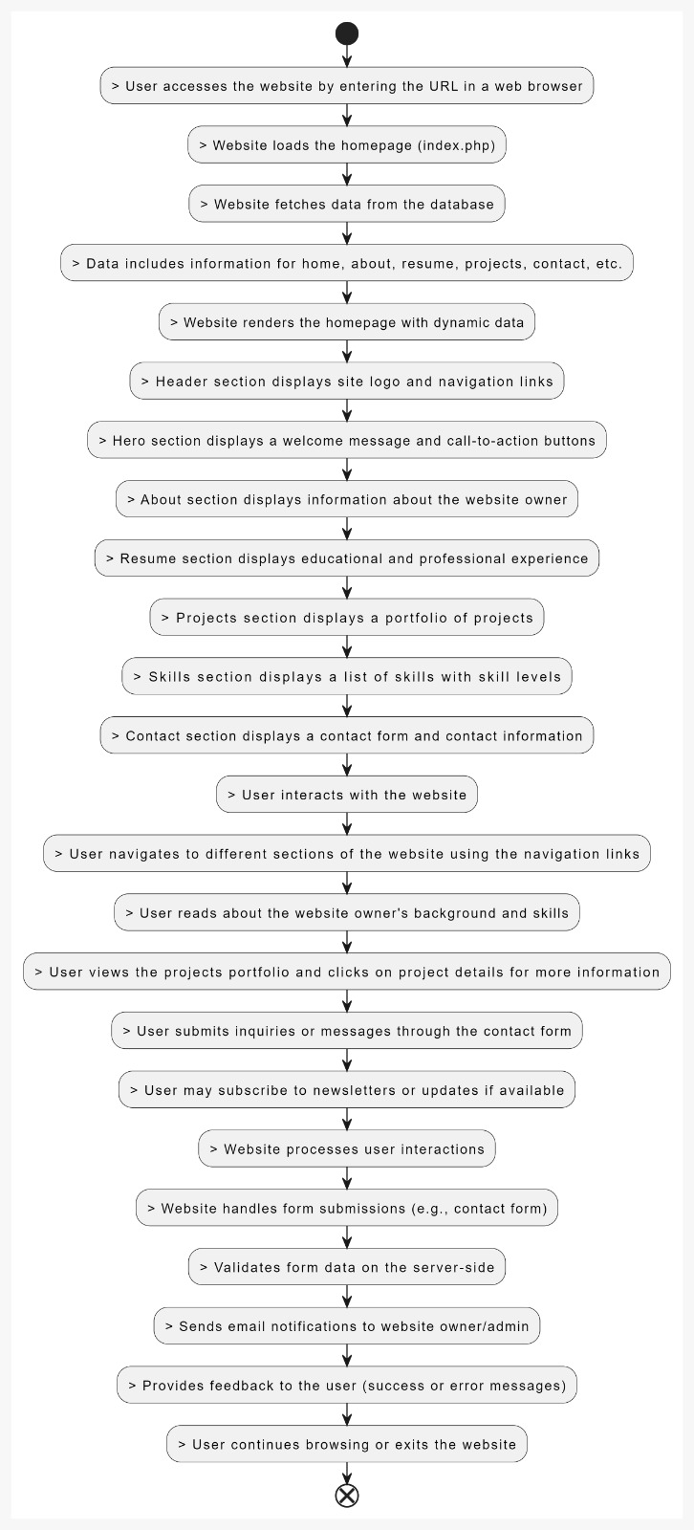

Fig.flowchart for the process

# OBJECTIVES:

Developing a faculty member's own website aims to accomplish the following:

* Building a credible internet profile to highlight teaching philosophy, research interests, and academic accomplishments.
* Encouraging communication between students, faculty, and the academic community by disseminating contact details and news about projects and research initiatives.
* Improving chances for academic networking and cooperation by presenting areas of competence and passions.
* Documenting scholarly activity and effect to support the faculty member's tenure and promotion dossier.
* Building a distinctive personal brand in academia to make a name for oneself and draw in offers of research collaborations, speaking engagements, and collaborations.

# ER DIAGRAM:

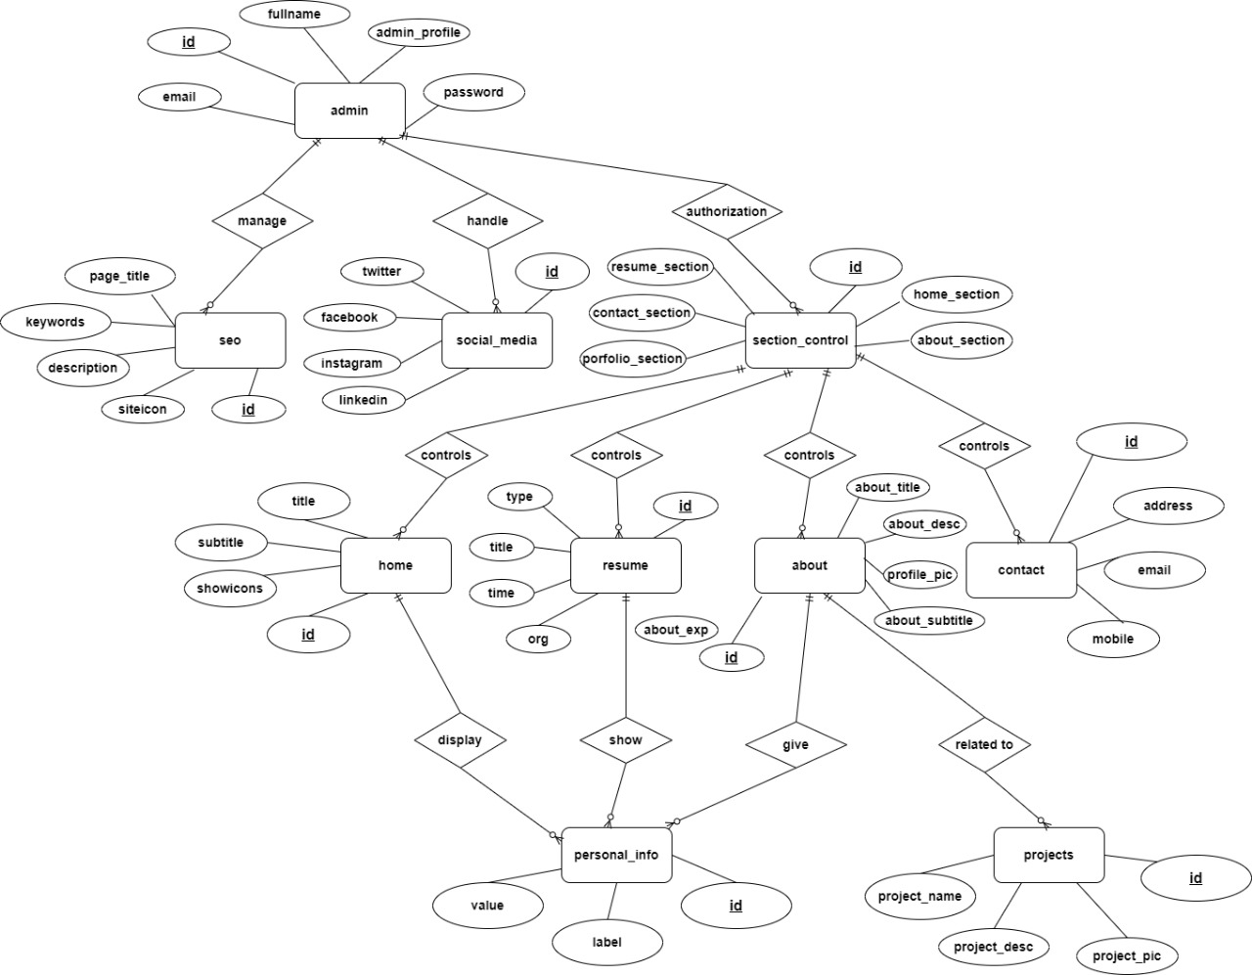

Fig 1.ER diagram

The following entities are included in the ERD:   
Administrator**:** This object contains data about the CMS administrators, such as their ID, last name, email address, and password.   
SEO: This object contains data pertaining to the website's SEO (Search Engine Optimization) settings, such as the site icon, description, keywords, and page title.   
Social_media: This object contains data regarding the website's social media connections, such as connections to Facebook, Instagram, LinkedIn, and Twitter.

Home: This item contains data about the website's main page, such as the sections to be displayed, the title, subtitle, and whether or not to display icons.

Section_control: This object holds data regarding the many sections, such as the home, about, resume, portfolio, and contact sections, that can be shown on the website.   
Resume: The user's employment history, resume type, and profile photo are all stored in this item.   
About: This object contains data related to the website's "about" section, such as the "about experience," "about subtitle," and "about description."   
Contact: This object contains data related to the website's contact section, such as the address, phone number, and email address of the user.   
Personal_info: This entity contains labels and values pertaining to the user's personal information (such as name, certifications, and so on).   
Projects: This item contains the name, description, and image of each project that the user has created.

The relationships between the entities are as follows:

* An Admin can manage many Seo records.
* A Seo record belongs to one Admin.
* A Seo record can have many Social_media records.
* A Social_media record belongs to one Seo record.
* A Home record can have many Section_control records.
* A Section_control record belongs to one home record.
* A Home record can have one Resume record.
* A Home record can have one About record.
* A Home record can have one Contact record.
* A Resume record can have many Personal_info records.
* A Personal_info record belongs to one Resume record.
* A Resume record can have many Projects records.
* A Project record belongs to one Resume record.

This ER diagram gives us a good understanding of the entities and their relationships in the system.

# UML DIAGRAMS:

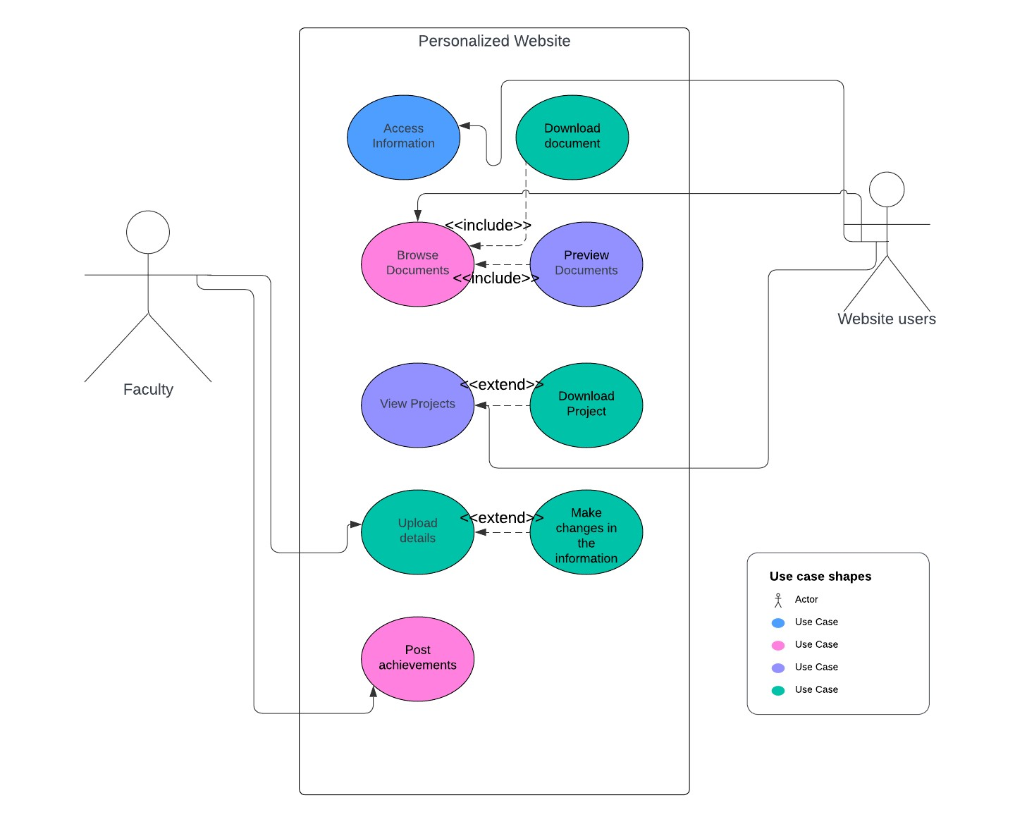

Fig 2.Use-Case Diagram

The use case diagram which illustrates the various functionalities the website offers for different users and faculty members.

Here,

Website users can access information, browser documents,view and download documents and view the projects.Faculty can upload their details, they can update and delete the documents and information and post achievements.

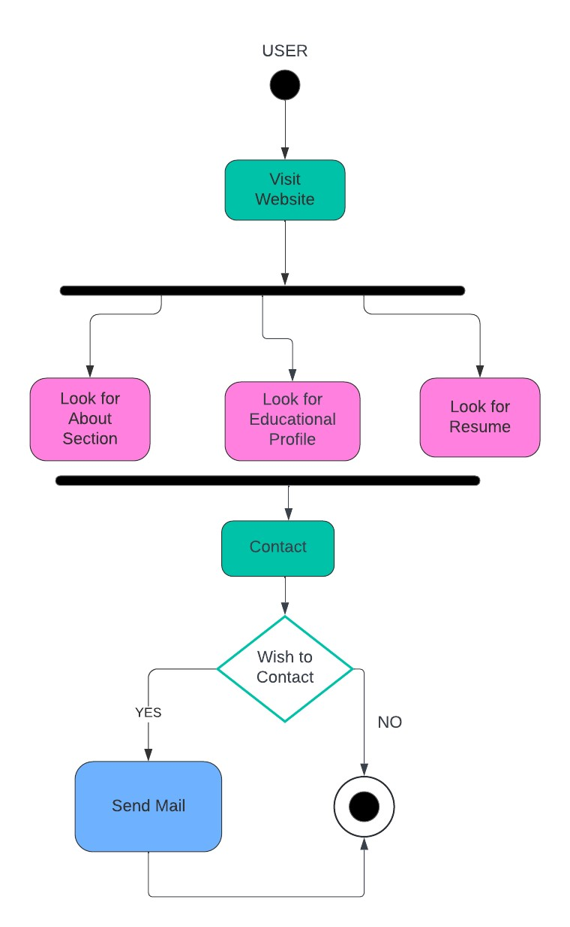 Fig 3.Activity diagram for User

The activity diagram depicts the process of a user viewing a faculty profile on a website.

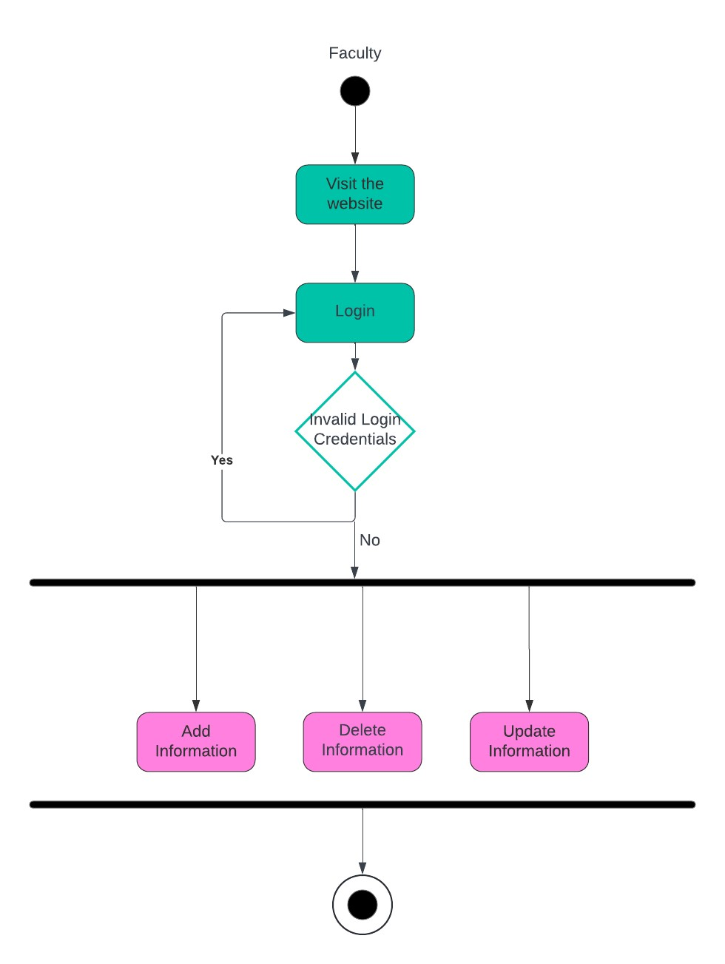Fig 4.Activity diagram for Admin

The activity diagram depicts the process of a faculty accessing a website.

# 

# SCREENSHOTS OF GUI:

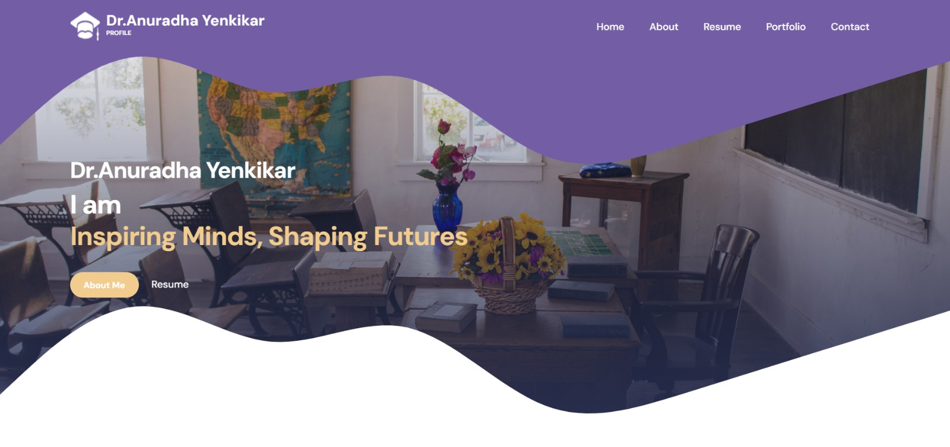

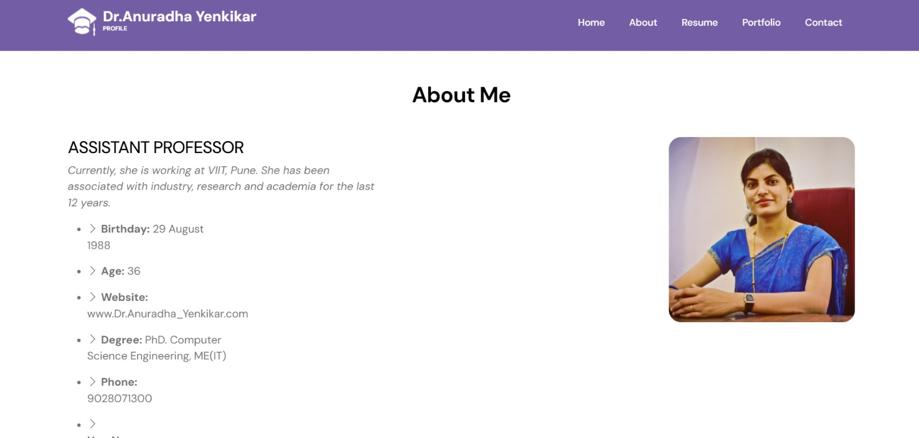

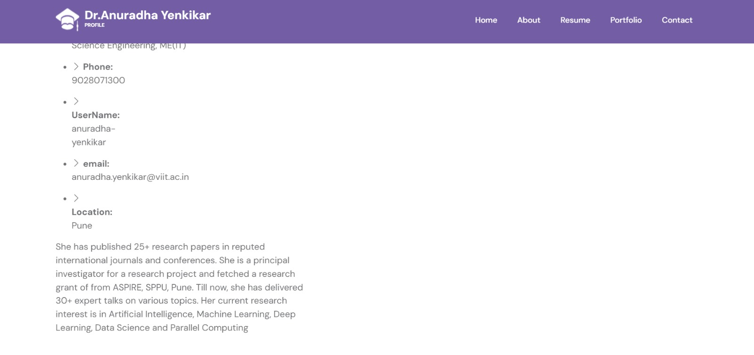

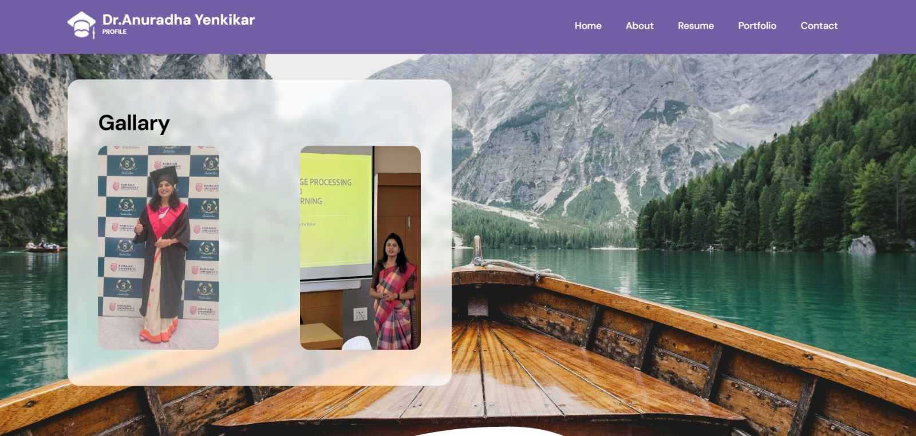

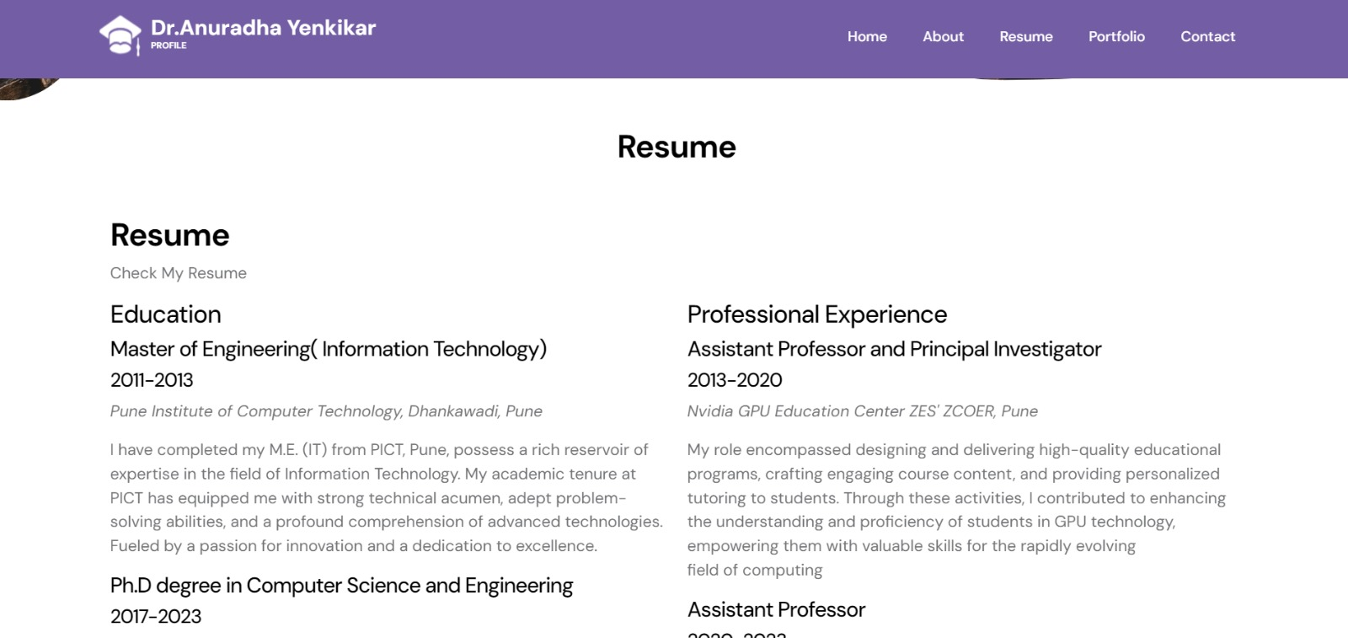

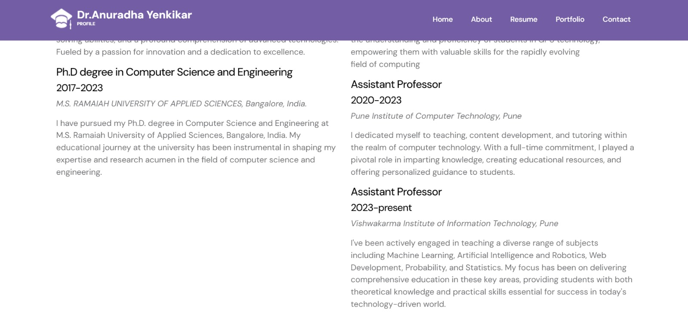

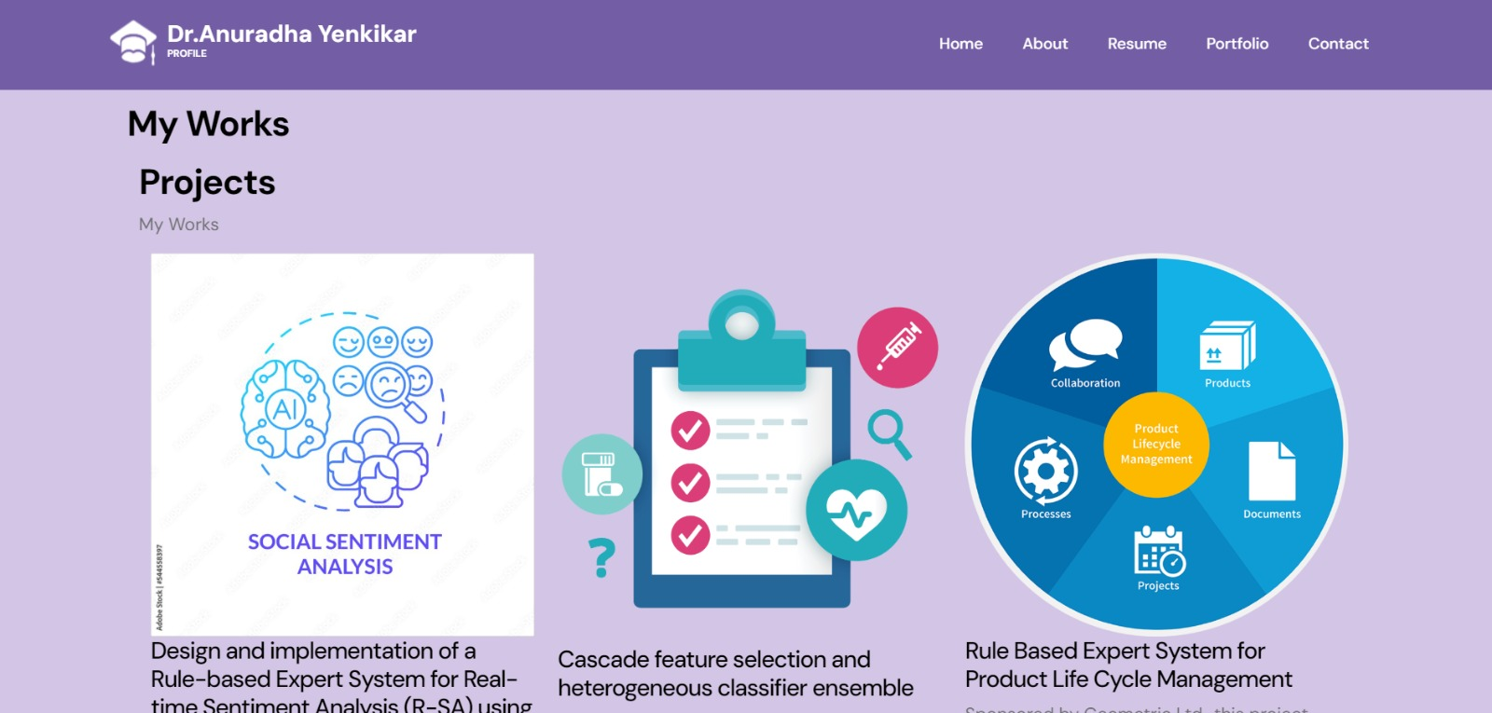

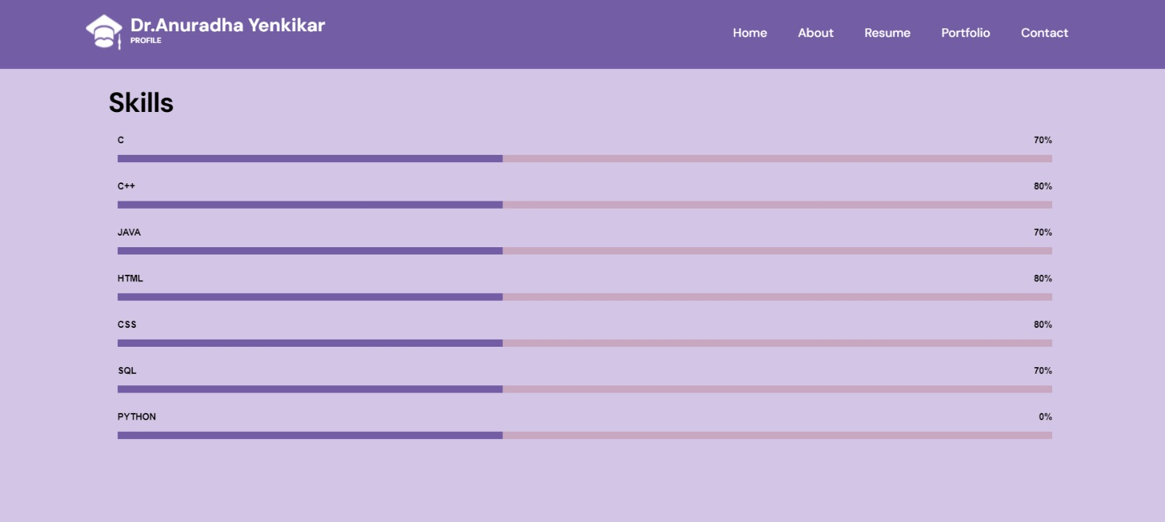

# 

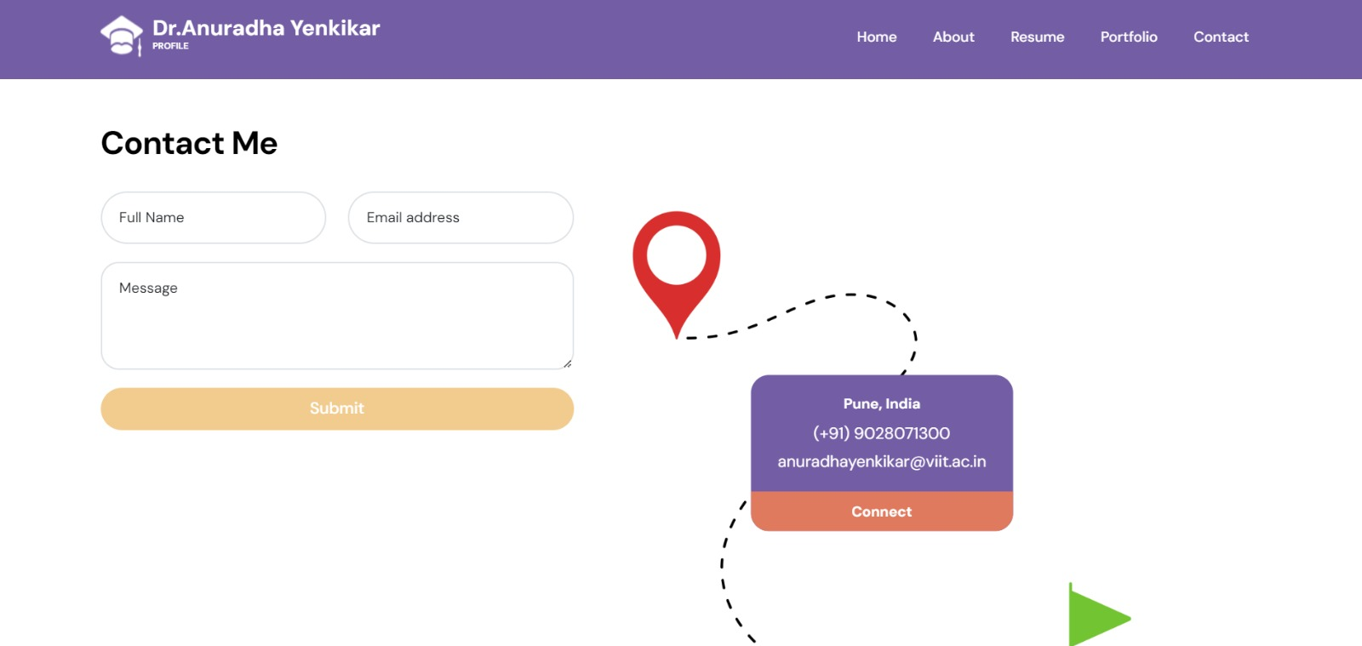

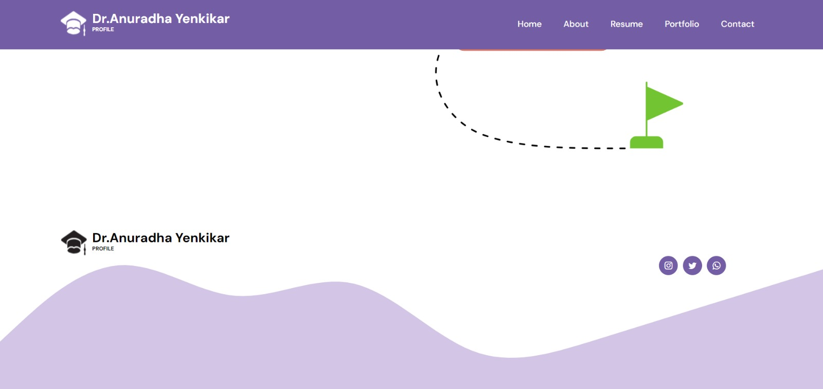

# FUTURE SCOPE:

Integration of Advanced Features: To further develop the platform, it can incorporate features like augmented reality/virtual reality aspects for interactive learning, data analytics for measuring user engagement, and machine learning algorithms for personalized content recommendations.

Mobile Application Development: By creating a companion mobile application, educators and students will be able to utilize the platform more widely and interact and access content while on the go. This would address the growing trend of mobile use in higher education.

Global Expansion and Multilingual Support: Providing multilingual support and expanding the platform to serve faculty members globally helps promote more inclusivity and collaboration across varied academic groups.

Improved Research Collaboration Tools: Adding collaborative research tools, such shared document repositories, project management dashboards, and real-time collaboration features, can further foster collaboration among faculty members.

Customization Options for Institutions: Giving academic institutions the ability to modify the platform to meet their unique needs, branding standards, and academic regulations can boost student and faculty acceptance and satisfaction.

Enhanced Security and Privacy Measures: It is crucial to have strong security and privacy policies in place to safeguard sensitive faculty and student data. Subsequent advancements may concentrate on integrating blockchain technology for data security and encryption techniques for safe data transfer.

# 

# CONCLUSION:

To sum up, building a faculty member a customized website is a wise move with many advantages. In addition to supporting teaching and learning efforts, it acts as a cornerstone for developing a professional online presence and promoting networking, communication, and collaboration within the academic community. In addition, it plays a major role in strengthening one's professional profile and recording academic accomplishments in order to improve one's career. Faculty can develop a unique personal brand within their academic discipline by using digital platforms to successfully exhibit their contributions, hobbies, and areas of expertise.