What is the basic purpose of JPA?
JPA (Java Persistence API) exists to solve one boring but painful problem:
How do Java objects get saved into a database and read back easily?
Without JPA, you write a lot of SQL, manage connections, map rows to objects manually, and clean up resources. That is slow, repetitive, and error-prone.
JPA’s purpose is:
- Let you work with Java objects
- While it automatically handles database tables and rows
- With very little SQL
Think of JPA as:
“Stop thinking in tables. Think in objects.”

How is JPA related to Hibernate?
This is critical and often misunderstood.
- JPA is a specification (rules + interfaces)
- Hibernate is an implementation (actual working code)
In simple terms:
- JPA says WHAT should be done
- Hibernate says HOW it is done
When you write:
@Entity
class Book { }
You are writing JPA code, but:
- Hibernate is the engine running underneath
- Hibernate executes the real logic
Other implementations exist (EclipseLink, OpenJPA), but Hibernate is the most popular one.
So:
JPA is the contract
Hibernate is the worker

Is JPA a wrapper over JDBC?
Yes — but with intelligence.
- JDBC talks directly to the database
- JPA uses JDBC internally
- You never see JDBC, but it is still there
Flow is:
Your Code
↓
JPA API
↓
Hibernate
↓
JDBC
↓
Database
So when you call:
entityManager.find(Book.class, 1);
Internally:
- Hibernate creates SQL
- Uses JDBC
- Executes the query
- Converts the row into a Java object
You don’t write SQL.
You don’t manage connections.
JPA + Hibernate do it for you.

One-line summary (exam-ready)
- JPA: Standard way to map Java objects to database tables
- Hibernate: Most popular implementation of JPA
- JPA over JDBC: Yes — JPA hides JDBC and automates SQL + object mapping
If JDBC is manual driving,
JPA is automatic transmission.
Same car. Less headache.
now give me basic crud example consider the book entity i am using using @Entity @Table(name = "books") public class Book { @Id @GeneratedValue(strategy = GenerationType.IDENTITY) private int id; private String isbn; private String title; private String author; private double price; // getter setter, constructor and give me crud operatin using EMF EM etc
Below is a clean, minimal, exam-safe JPA CRUD example using EntityManagerFactory (EMF) and EntityManager (EM).
No Spring. No magic. Pure JPA + Hibernate mindset.

1. Book Entity (you already gave – slightly completed)
import jakarta.persistence.*;

@Entity
@Table(name = "books")
public class Book {

@Id
@GeneratedValue(strategy = GenerationType.IDENTITY)
private int id;

private String isbn;
private String title;
private String author;
private double price;

// default constructor (MANDATORY for JPA)
public Book() {}

// parameterized constructor
public Book(String isbn, String title, String author, double price) {
this.isbn = isbn;
this.title = title;
this.author = author;
this.price = price;
}

// getters and setters
public int getId() { return id; }
public void setId(int id) { this.id = id; }

public String getIsbn() { return isbn; }
public void setIsbn(String isbn) { this.isbn = isbn; }

public String getTitle() { return title; }
public void setTitle(String title) { this.title = title; }

public String getAuthor() { return author; }
public void setAuthor(String author) { this.author = author; }

public double getPrice() { return price; }
public void setPrice(double price) { this.price = price; }
}

2. persistence.xml (minimum required)
<persistence xmlns="https://jakarta.ee/xml/ns/persistence"
version="3.0">
<persistence-unit name="bookPU">
<properties>
<property name="jakarta.persistence.jdbc.url" value="jdbc:mysql://localhost:3306/bookdb"/>
<property name="jakarta.persistence.jdbc.user" value="root"/>
<property name="jakarta.persistence.jdbc.password" value="root"/>
<property name="jakarta.persistence.jdbc.driver" value="com.mysql.cj.jdbc.Driver"/>

<property name="hibernate.dialect" value="org.hibernate.dialect.MySQLDialect"/>
<property name="hibernate.hbm2ddl.auto" value="update"/>
<property name="hibernate.show_sql" value="true"/>
</properties>
</persistence-unit>
</persistence>

3. CRUD Operations using EMF and EM

3.1 Create (INSERT)
EntityManagerFactory emf =
Persistence.createEntityManagerFactory("bookPU");

EntityManager em = emf.createEntityManager();

em.getTransaction().begin();

Book book = new Book("ISBN-101", "Java Basics", "James", 499.0);
em.persist(book); // INSERT

em.getTransaction().commit();

em.close();
emf.close();
Key idea:
persist() → new object → DB insert

3.2 Read (SELECT by ID)
EntityManagerFactory emf =
Persistence.createEntityManagerFactory("bookPU");

EntityManager em = emf.createEntityManager();

Book book = em.find(Book.class, 1); // SELECT

System.out.println(book.getTitle());

em.close();
emf.close();
Key idea:
find() → primary key lookup
First checks 1st level cache, then DB.

3.3 Update (UPDATE)
EntityManagerFactory emf =
Persistence.createEntityManagerFactory("bookPU");

EntityManager em = emf.createEntityManager();

em.getTransaction().begin();

Book book = em.find(Book.class, 1);
book.setPrice(599.0); // no update query yet

em.getTransaction().commit(); // UPDATE happens here

em.close();
emf.close();
Important truth:
- No update() method
- Dirty checking does the update automatically

3.4 Delete (DELETE)
EntityManagerFactory emf =
Persistence.createEntityManagerFactory("bookPU");

EntityManager em = emf.createEntityManager();

em.getTransaction().begin();

Book book = em.find(Book.class, 1);
em.remove(book); // DELETE

em.getTransaction().commit();

em.close();
emf.close();

4. One-screen mental model (very important)
EntityManagerFactory → heavy → create once
|
v
EntityManager → light → per request / per transaction
|
v
Persistence Context (1st level cache)
|
v
Hibernate → JDBC → Database

Final blunt summary (remember this)
- persist() → INSERT
- find() → SELECT
- modify object → UPDATE (automatic)
- remove() → DELETE
- Transaction is mandatory for write operations
- EMF is expensive, EM is cheap
If you understand this flow, 80% of JPA interviews are done.

Now i want to understand how jpa with hibernate work under the hood and ex my diaram and enhance it

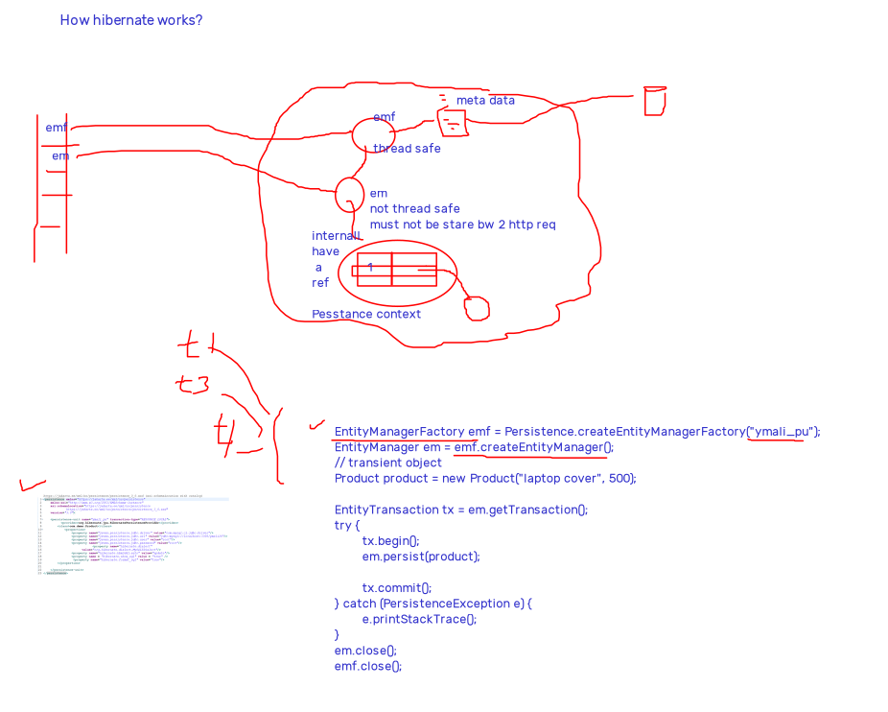
Good diagram. Your core understanding is correct. Now let me clean it up, tighten it, and explain “what really happens under the hood” in simple English, step by step, mapped directly to your drawing.
I’ll also enhance the diagram conceptually so you can redraw it cleanly for students or interviews.

Big picture first (one sentence)
JPA is the API, Hibernate is the engine, EntityManager is the session, and Persistence Context is the brain.
Now let’s open the hood.

1. What happens when the application starts?

Step 1: EntityManagerFactory (EMF) is created
EntityManagerFactory emf =
Persistence.createEntityManagerFactory("bookPU");
Under the hood:
Hibernate does heavy startup work:
- Reads persistence.xml
- Loads:
  - DB URL, user, password
  - Dialect (MySQL, Oracle, etc.)
- Parses entity metadata:
  - @Entity
  - @Table
  - @Id, @Column
- Builds mapping metadata
- Prepares SQL templates
- Configures connection pool
Important truths:
- EMF is thread-safe
- EMF is heavy
- Create once per application
- Do NOT create per request
Your diagram marking EMF as thread-safe is correct.

2. EntityManager (EM) creation – this is critical
EntityManager em = emf.createEntityManager();
Under the hood:
Hibernate creates:
- A new EntityManager
- A new Persistence Context (PC)

What is Persistence Context?
Think of it as:
A Map inside EM
Map<EntityKey, EntityObject>
Example:
Book#1 → Book object
Book#2 → Book object
Important truths:
- EM is NOT thread-safe
- EM must NOT be shared between HTTP requests
- One EM = one Persistence Context
Your note “not thread safe, must not be shared b/w http req” is 100% correct.

3. Entity life-cycle (this is where magic happens)

3.1 Transient state
Book book = new Book("ISBN1", "Java", "James", 500);
- Pure Java object
- Not known to Hibernate
- Not in Persistence Context
- No DB row
State = TRANSIENT

3.2 persist() → Managed state
em.persist(book);
Under the hood:
- Hibernate:
  - Registers the object in Persistence Context
  - Assigns an identifier (ID)
  - Marks it as MANAGED
- NO SQL yet
State = MANAGED
This is where most people get confused.
👉 persist() does NOT immediately hit the DB

4. Transaction begins – why it matters
EntityTransaction tx = em.getTransaction();
tx.begin();
Under the hood:
- Hibernate:
  - Gets a JDBC connection
  - Switches to transactional mode
  - Starts tracking changes (dirty checking)
No transaction = no DB write
Simple rule. No exceptions.

5. Flush + Commit (this is where SQL happens)
tx.commit();
Under the hood (VERY IMPORTANT):
Hibernate does this in order:
- Flush
  - Looks into Persistence Context
  - Finds:
    - New objects → INSERT
    - Changed objects → UPDATE
    - Removed objects → DELETE
- Generates SQL
- Uses JDBC to execute SQL
- Commits DB transaction
Only now the DB is hit.
This matches your diagram idea:
Persistence Context → Hibernate → JDBC → DB

6. Read operation – why DB is not hit twice
Book b1 = em.find(Book.class, 1);
Book b2 = em.find(Book.class, 1);
Under the hood:
- First find():
  - Checks Persistence Context → not found
  - Hits DB → SELECT
  - Stores object in PC
- Second find():
  - Found in PC
  - No DB hit
This is 1st-level cache (automatic, cannot be disabled).

7. Update – no update() method (by design)
book.setPrice(600);
tx.commit();
Under the hood:
- Hibernate:
  - Takes snapshot of entity when it became managed
  - Compares snapshot vs current state
  - Detects change → generates UPDATE
- This is called Dirty Checking
That’s why JPA feels “smart”.

8. Delete flow
em.remove(book);
Under the hood:
- Entity marked as REMOVED in Persistence Context
- Actual DELETE happens during flush/commit

9. EM close – end of story
em.close();
- Persistence Context destroyed
- All entities become DETACHED
- No more tracking

Enhanced clean diagram (redraw this)
Application
|
| create once (thread-safe)
v
EntityManagerFactory (EMF)
|
| per request / per transaction
v
EntityManager (EM) ---- NOT thread-safe
|
v
Persistence Context (1st Level Cache)
| (Managed Entities + Snapshots)
|
v
Hibernate Engine
|
v
JDBC
|
v
Database

Mapping your diagram notes → final clarity
Your note | Verdict
EMF thread-safe | ✅ Correct
EM not thread-safe | ✅ Correct
EM should not be shared | ✅ Correct
Persistence Context inside EM | ✅ Correct
DB not hit twice for same ID | ✅ Correct
SQL happens at commit | ✅ Correct

