ACADEMIC INTERNSHIP REPORT

Week 2: Data Collection, Cleaning, and Preprocessing for Logistics Analysis
Food Delivery Logistics Data: Collection, Cleaning, and Preprocessing Pipeline

Prepared by: Kashish Maurya
Programme: B.Tech — Artificial Intelligence & Machine Learning
Institution: IIMT University, Meerut
Internship focus: Logistics Data Analytics
Report type: Week 2 technical documentation

Dataset: 38,964 source records | 22 original variables | 27 processed variables

Prepared October 2026

Executive Summary
This Week 2 internship report documents a reproducible data preparation workflow for last-mile food-delivery logistics. The source was a public secondary dataset with 38,964 rows and 22 attributes. The aim was not to build or evaluate a new predictive model; it was to make the data more consistent, interpretable, and suitable for future analysis while preserving valid operational information.
The notebook work covered initial data profiling, numerical and categorical imputation, robust conversion of a mixed-format order-time column, exact-duplicate checks, domain validation, IQR-based outlier screening, categorical-label inspection, z-score standardization, engineering of order-hour and peak-hour features, and export verification. The processed table contains 38,964 rows and 27 columns. Total missing data cells declined from 2,909 to 2,505; the remaining cells correspond to 835 unknown original order times and the two derived fields dependent on those times. Duplicate counts were zero both before and after processing.
The IQR rule flagged 2,147 delivery-person ratings (5.51% of records). Every flagged rating fell within the legitimate 1–5 rating domain, so those observations were retained. Three standardized features—age, rating and distance—were verified with approximate mean zero and standard deviation one. The processed CSV was exported and reloaded successfully with matching shape and zero duplicate rows.
The report records not only what was done, but why each step was selected, what the notebook actually showed, and how the results affect subsequent logistics analysis. Figure explanations and an implementation-oriented roadmap for future modeling and route planning are included. No new model-performance metrics or optimization benefits are claimed.

Report at a glance
Aspect | Verified result
Source data | 38,964 rows × 22 columns
Processed data | 38,964 rows × 27 columns
Missing data cells | 2,909 before; 2,505 after
Unresolved source order times | 835 retained as missing
Duplicate rows | 0
Statistical rating flags | 2,147; retained after domain validation
Output artifact | Week_2_Preprocessed_Logistics_Dataset.csv

Contents
01 Context and problem definition
02 Objectives and task alignment
03 Dataset collection, origin and variable dictionary
04 Literature and methodological foundations
05 Preprocessing design and audit
06 Missing-value strategy and time parsing
07 Duplicate detection and domain checks
08 Outlier analysis and category validation
09 Standardization and engineered features
10 Before-and-after data quality
11 Visual results and interpretations
12 Reproducibility, export and implementation
13 Limitations, reflection and conclusion
14 References and appendices
Methodological note Section headings are structured for navigation in Word. Page locations may shift slightly if fonts or margins are changed after download.

Abbreviations
Term | Meaning
EDA | Exploratory Data Analysis
IQR | Interquartile Range
CSV | Comma-Separated Values
NaN / NaT | Missing numeric / missing datetime representation
MAE / RMSE / R² | Model evaluation metrics (not calculated in Week 2)
KPI | Key Performance Indicator

1. Introduction and logistics context
Last-mile logistics includes the final operational steps needed to move a food order from a restaurant to a delivery location. The associated datasets often combine customer geography, traffic classifications, courier characteristics, weather conditions, event flags and timestamps. These variables may be expressed using different types and conventions. Without adequate validation, an analytical pipeline can mistake formatting problems for genuine operating patterns.
The central Week 2 problem is therefore a data-readiness question: how can a secondary delivery dataset be systematically assessed and transformed into a consistent analytical resource without unnecessarily discarding information? The project addresses this question with transparent decisions that can be explained, tested and reviewed.

1.1 Link with Week 1
Week 1 explored strategic planning and delivery-performance patterns using exploratory analysis and selected models. Week 2 intentionally shifts attention away from predictive scores and towards the reliability of the underlying data. It uses the same publicly accessible dataset for continuity, while documenting a separate, focused deliverable: the preprocessing workflow and final data-quality checks.

1.2 Why data quality matters
- Missing timestamps can undermine comparisons between peak and non-peak order periods.
- Inconsistent labels can split a single operational category into multiple artificial groups.
- Invalid numeric values can distort distributions and model coefficients.
- Treating valid rare cases as mistakes can hide important service-quality issues.
- Improper scaling can cause large-magnitude features to dominate some distance-sensitive algorithms.

1.3 Scope boundary
This report assesses and prepares a recorded logistics dataset. It does not estimate causal effects, verify actual customer experiences, evaluate a newly trained Week 2 model, or prove that a proposed route plan lowers transport costs. Those are downstream activities requiring separate data, evaluation and operational assumptions.

2. Task objectives and completion mapping
The internship brief required a dataset description, realistic collection procedure, thorough cleaning and preprocessing, clear reasoning behind chosen techniques, Python snippets, reflection on logistics impacts and a professionally structured Word report.
Assignment requirement | How it was addressed
Public logistics dataset | Hugging Face food-delivery dataset and original CSV documented
Identify data problems | Missingness, types, duplicates, ranges, categorical labels assessed
Handle missing values | Median / mode imputation; unknown order times deliberately retained
Outlier detection | IQR screening with domain-based review and retention decision
Normalization / scaling | StandardScaler for three numeric predictors; outputs checked
Feature engineering | order_hour and is_peak_hour with preserved unknown status
Code documentation | Selected executable examples and pipeline summary
Report insights | Before/after audit; figure-by-figure interpretation
Professional handoff | CSV export and reload verification

2.1 Research questions
- What data-quality problems are present in the available delivery records?
- Which missing values can be treated with defensible rules, and which must remain unknown?
- When do statistical anomaly flags reflect valid delivery information instead of mistakes?
- Does standardization produce the expected feature distributions?
- Is the final dataset structurally consistent and reusable for later logistics analytics?

2.2 Deliverables
The practical notebook generated a processed CSV, a set of chart images, an outlier summary, standardization validation outputs and a final data-quality report. This DOCX consolidates the methods, results and supporting interpretations. The original Colab charts were not attached to this document-generation session; the embedded charts herein were reconstructed from the confirmed numeric summary values, not copied from the notebook.

3. Data acquisition and provenance
The project used the public Hugging Face dataset “allenborochin/zomato_delivery_EDA,” which identifies an original Kaggle source and describes food-delivery data from India. The already available cleaned public table contains 38,964 records and 22 columns. These counts refer to the publicly shared input as loaded in this Week 2 notebook; they should not be confused with the rawer upstream source described on the dataset card. [1]
The CSV was uploaded into Google Colab and read from /content/zomato_delivery.csv.csv. This was secondary data reuse rather than new field collection, new tracking, or independently verified operational data gathering. A preserved dataframe, df_original, allowed later transformations to be checked against the exact loaded source.
Source property | Recorded / verified description
Platform | Hugging Face dataset repository
Dataset ID | allenborochin/zomato_delivery_EDA
Upstream attribution | Kaggle source acknowledged on dataset card
Loaded input | /content/zomato_delivery.csv.csv
Loaded shape | 38,964 × 22
Target field for future modeling | Time_taken (min)
Notebook environment | Python in Google Colab

3.1 Data governance and limitations
The published dataset should be treated as a research and educational secondary source. The report does not claim ownership of original delivery operations or independent confirmation that every row corresponds to a verified live transaction. Because couriers and locations may be identifiable when data are linked with other sources, ID and exact coordinate fields require considered handling before public sharing or deployment.

3.2 Example data load
import pandas as pd
import numpy as np
df_original = pd.read_csv("/content/zomato_delivery.csv.csv")
df = df_original.copy()
print(df.shape) # recorded: (38964, 22)

4. Dataset description and data dictionary
The 22 original attributes cover identifiers, courier characteristics, position, time, order characteristics, traffic and weather conditions, and delivery outcomes. It is important to understand the semantic purpose of each field before selecting imputation and scaling rules.
Variable / group | Interpretation | Analytical caution
ID, Delivery_person_ID | Order and courier identifiers | Do not use as ordered numerical inputs
Delivery_person_Age | Courier age | Numeric; domain checks needed
Delivery_person_Ratings | Service ratings from 1 to 5 | Valid low ratings are not automatically errors
Restaurant_latitude/longitude | Restaurant coordinates | Geospatial information
Delivery_location_latitude/longitude | Delivery coordinates | Geospatial information
Order_Date | Order calendar date | Still string in final export
Time_Orderd | Order clock time | Mixed original time representations
Time_Order_picked | Pickup clock time | Still string; not newly parsed
Weather_conditions | Weather class | Categorical labels
Road_traffic_density | Traffic condition category | Categorical labels
Vehicle_condition | Coded condition 0/1/2 | Do not assume linear physical distance
Type_of_order | Category of order | Categorical input
Type_of_vehicle | Mode of delivery | Categorical input
multiple_deliveries | Reported order aggregation code | Requires domain-aware interpretation
Festival | Yes/No contextual flag | Categorical class imbalance
City | Area category | Preserved original spelling
Time_taken (min) | Observed delivery duration | Future numeric prediction target
distance_km | Delivery distance in km | Numeric input
delivery_speed | Slow/Average/Fast class | Categorical despite its name

Methodological note The list reflects the public dataset field descriptions and confirmed notebook column names. A full independent source-system schema validation was outside Week 2 scope.

5. Literature and theoretical basis

5.1 Logistics analytics
Jahani, Jain and Ivanov survey data-science and big-data-analytics approaches in supply-chain and logistics research and organize their practical application areas. The review supports the idea that meaningful analytics requires a deliberate process connecting available data, analytical methods and logistics decisions. In this project, preprocessing is treated as part of that chain rather than a disposable preliminary task. [2]

5.2 Incomplete observations
Emmanuel and co-authors review missing-data problems in machine learning and the range of possible treatment strategies. Their work provides context for why a single rule should not be applied indiscriminately: some fields can be imputed, whereas inventing a timestamp without a reliable source may create false operational evidence. [3]

5.3 Outliers versus errors
Smiti’s survey emphasizes that outlying observations can contain valuable information, not merely noise. That distinction motivates the two-stage rating review used here: first apply a numerical screening criterion; then check whether the flagged values violate the field’s legitimate domain. [4]

5.4 Documentation-backed implementation
The pandas missing-data documentation provides the behavior of fillna() and related methods used for data cleaning, while scikit-learn’s StandardScaler documentation defines the transformation based on training-set mean and standard deviation. The latter is especially important for preventing leakage in future predictive modeling. [5–6]

5.5 Gap addressed by this project
Prior guidance commonly explains individual techniques, but a student logistics project also needs evidence of how they interact. This report brings collection, missingness, parsing, validation, anomaly screening, scaling, derived features and export checks into one traceable workflow, with a reason and an observable outcome for each step. This is a practical documentation contribution, not a claim of novel scientific methodology.

6. Workflow design and quality audit
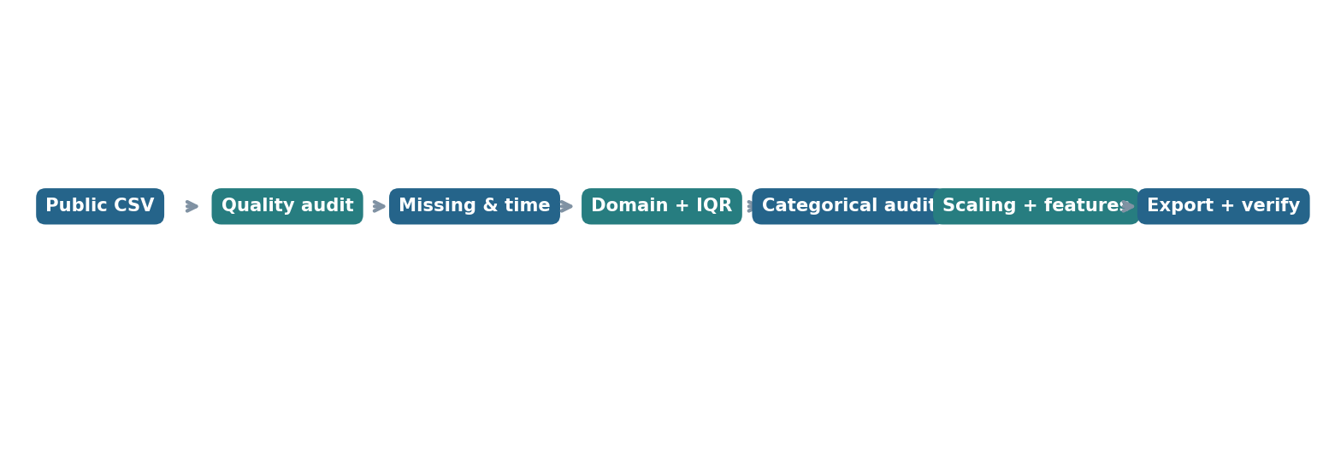
Figure 1. Documented preprocessing sequence. Source: charts recreated from recorded Week 2 notebook summary outputs.
The diagram presents the processing order used for the report. Each block has a different purpose: profiling detects potential issues; treatment changes selected fields; and final validation tests whether saved results match the in-memory dataframe.

6.1 Initial profile checks
print(df.shape)
print(df.info())
print(df.isna().sum().sort_values(ascending=False))
print(df.duplicated().sum())
print(df.describe(include="all"))
These checks established column types and revealed missing entries, making it possible to choose methods by data type. A categorical label such as delivery_speed must not be forced into numeric quartile arithmetic even though its name resembles a measurement.

6.2 Audit design principles
- Keep untouched raw data for corrections or reprocessing.
- Record before-and-after states instead of reporting only cleaned totals.
- Validate suspicious values against domain rules before deleting them.
- Preserve missing values whenever inference would be speculative.
- Confirm that the output file can be reloaded with the intended dimensions.

7. Missing-value assessment and treatment
Missing-value counts are measurements of absent table entries (cells), not necessarily counts of unique records. The starting dataset contained 2,909 missing cells across its 22 columns. The applied imputations and parsing steps reduced this count to 2,505 in the expanded 27-column output.
Field | Action | Reason | Observed implication
Delivery_person_Age | Median fill | Resists influence of extremes | Missing age values filled
Delivery_person_Ratings | Median fill | Central, valid scale value | Missing ratings filled
Weather_conditions | Mode fill | Valid categorical level | Missing weather levels filled
Road_traffic_density | Mode fill | Valid categorical level | Missing traffic levels filled
Festival | Mode fill | Retains Yes/No label | Missing festival levels filled
Time_Orderd | Parse available formats; keep unknowns | No defensible clock-time inference | 835 remain missing

7.1 Why median and mode?
Age and rating fields are quantitative; median values can be filled without assuming symmetric distributions. The selected weather, traffic and festival fields consist of discrete labels, making mode imputation a straightforward category-preserving choice. Such replacements simplify later analysis but can compress natural variation and make imputed records seem more certain than they are. This limitation should be revisited in model validation.
for col in ["Delivery_person_Age", "Delivery_person_Ratings"]:
df[col] = df[col].fillna(df[col].median())
for col in ["Weather_conditions",
"Road_traffic_density", "Festival"]:
df[col] = df[col].fillna(df[col].mode().iloc[0])
Methodological note The aggregate reduction of 404 missing cells is verified. Individual filled-cell counts by variable were not supplied in the saved summary and are not invented here.

8. Mixed-format order-time correction
The source Time_Orderd column included recognizable HH:MM strings, Excel-like fractional-day numbers such as 0.833333333, numeric values equal to 1, and genuinely blank entries. A simple pd.to_datetime(..., format="%H:%M", errors="coerce") first produced 4,345 missing outputs by treating fractional-day encodings as invalid strings. That was a parser mismatch, not evidence of thousands of new source errors.
The correction began by restoring the original unmodified source column from df_original. The function first checks missing inputs. If the nonmissing input converts to a number between 0 and 1, it interprets that number as a fraction of a 24-hour day and transforms it into hours and minutes. Otherwise, it attempts an HH:MM parse. The 1-day boundary wraps to 00:00 through modulo 1,440; this is a clock representation, not an inferred order date.
def clean_time(value):
if pd.isna(value):
return pd.NaT
text = str(value).strip()
try:
number = float(text)
if 0 <= number <= 1:
minutes = round(number * 1440) % 1440
return pd.Timestamp(1900, 1, 1,
minutes // 60, minutes % 60)
except (ValueError, TypeError):
pass
return pd.to_datetime(text, format="%H:%M", errors="coerce")
df["Time_Orderd"] = df_original["Time_Orderd"].apply(clean_time)
Validation point | Recorded outcome
Naïve parser result | 4,345 missing — rejected as a parser artefact
Final mixed-format conversion | 835 genuine missing source order times
Final Time_Orderd dtype | datetime64[ns]
Correction method | Reload from preserved original, then parse both encodings

Methodological note The encoded reference date 1900-01-01 is a technical placeholder. Analyses requiring full event chronology must combine valid clock time with the actual order date and handle overnight crossing.

9. Duplicate detection and domain validation
Exact duplicate checking returned zero rows before and after preprocessing. The notebook therefore did not delete any rows as duplicates. Exact duplication is distinct from repeated couriers or similar deliveries; those repeated real-world events must not automatically be removed.
duplicate_count = df.duplicated().sum()
df = df.drop_duplicates().copy()
invalid_ratings = (
(df["Delivery_person_Ratings"] < 1) |
(df["Delivery_person_Ratings"] > 5)
).sum()

9.1 Domain rules and what they establish
Field | Screening concept | Verified result in saved outputs
Delivery_person_Age | Check age outside 18–60 | Test performed; specific invalid count not recorded
Delivery_person_Ratings | Check outside 1–5 | 0 invalid ratings
Time_taken (min) | Check nonpositive duration | Test performed; specific invalid count not recorded
distance_km | Check nonpositive distance | Test performed; specific invalid count not recorded
Exact duplicate rows | Compare all current row values | 0 duplicates

Statistical extremeness and invalidity are separate concepts. A rating of 3.0 may be unusual compared with a high-rating distribution while remaining a legitimate customer assessment. By contrast, a rating of 7 would violate the stated scale. The project recorded no ratings outside the valid 1–5 range.

9.2 Impact on logistics analysis
Domain-aware validation helps keep operationally important cases. Unusually low but valid ratings may help analysts study dissatisfaction, while deleting them could bias descriptive comparisons. Conversely, genuinely invalid negative delivery times would need investigation before deriving delivery KPIs.

10. IQR-based outlier analysis
The interquartile-range method sets lower and upper screening thresholds at Q1 − 1.5×IQR and Q3 + 1.5×IQR, where IQR = Q3 − Q1. It was applied only to numeric continuous variables. In the initial run, delivery_speed caused a type error because its values are the words Slow, Average and Fast; the field was correctly excluded from arithmetic screening.
Variable | Q1 | Q3 | IQR | Lower limit | Upper limit | Flags
Age | 25 | 35 | 10 | 10 | 50 | 0
Ratings | 4.5 | 4.8 | 0.3 | 4.05 | 5.25 | 2,147
Delivery time | 19 | 33 | 14 | −2 | 54 | 0
Distance (km) | 4.658009 | 13.681590 | 9.023581 | −8.877362 | 27.216962 | 0

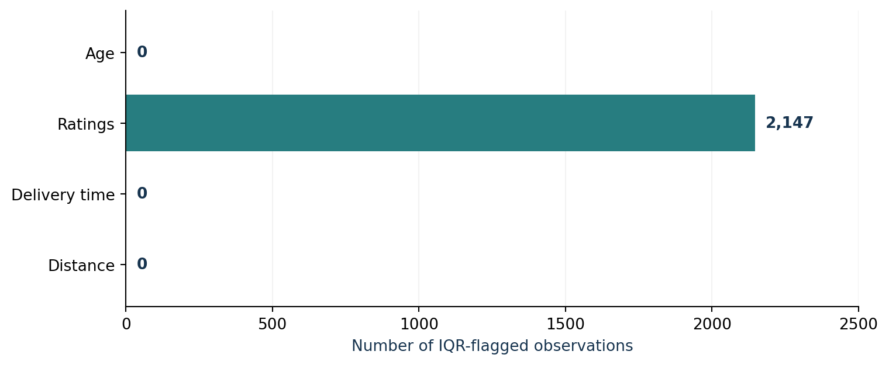
Figure 2. IQR screening outcome. Source: charts recreated from recorded Week 2 notebook summary outputs.
Only the rating distribution generated IQR flags. The chart shows counts, not confirmed errors. Because all flagged ratings were within 1–5, retaining them avoids unnecessary data loss and preserves legitimate low-scoring experiences.

10.1 Retention decision
Exactly 2,147 rating observations (about 5.51% of rows) were statistically flagged. The flagged values ranged from 2.5 to 4.0, and the rating-domain check found no values below 1 or above 5. Therefore, no records were removed solely due to IQR screening. This illustrates why statistical detection should precede, rather than replace, domain validation.

11. Categorical consistency checks
The analysis reviewed observed levels and counts for weather, traffic, festival, city, vehicle condition and delivery speed. This identified no obvious extra category spellings, capitalization conflicts or unwanted missing labels in these reviewed fields after selected imputation steps.
Variable | Recorded categories / frequencies
Weather | Fog 6,660; Stormy 6,572; Cloudy 6,563; Sandstorms 6,489; Windy 6,436; Sunny 6,244
Traffic | Low 13,139; Jam 12,414; Medium 9,556; High 3,855
Festival | No 38,180; Yes 784
City | Metropolitian 30,036; Urban 8,782; Semi-Urban 146
Vehicle condition | 0: 13,101; 1: 12,936; 2: 12,927
Delivery speed | Average 19,982; Fast 10,164; Slow 8,818

The spelling Metropolitian is retained as it appears in the source. Silent replacements risk creating differences between the notebook, original dataset and report. If a standardized label is needed in a downstream system, that mapping should be explicit and documented.

11.1 Interpretation
The high frequency of “No” for Festival suggests a strong category imbalance. That is a description of the sample, not proof that festivals have no effect on delivery times. Similarly, counts of traffic categories do not indicate whether congestion causes delay without analyzing observed times under appropriate controls.

11.2 Data-type caution
Although Vehicle_condition values appear as integers, they are coded categories or ordered labels rather than guaranteed interval-scale measurements. Likewise, a pandas value_counts output ending with dtype: int64 describes the counts, not necessarily the source column type.

12. Standardization of selected predictors
Three numeric predictors were standardized with scikit-learn StandardScaler: Delivery_person_Age, Delivery_person_Ratings and distance_km. Standardization expresses each value relative to the variable’s mean and standard deviation. The transformation does not change the underlying information but changes its unit and center. [6]
The observed scaled means were approximately zero and standard deviations approximately one for each of the three features. The notebook retained the original columns and created new “_scaled” columns, supporting interpretability alongside subsequent modeling.
from sklearn.preprocessing import StandardScaler
scaling_columns = [
"Delivery_person_Age",
"Delivery_person_Ratings",
"distance_km"
]
scaler = StandardScaler()
scaled_values = scaler.fit_transform(df[scaling_columns])
for i, col in enumerate(scaling_columns):
df[col + "_scaled"] = scaled_values[:, i]
Scaled field | Recorded mean | Recorded std. deviation
Delivery_person_Age_scaled | ≈ 0.0000 | ≈ 1.0000
Delivery_person_Ratings_scaled | ≈ 0.0000 | ≈ 1.0000
distance_km_scaled | ≈ 0.0000 | ≈ 1.0000

12.1 Why other fields were not scaled
Time_taken (min) was not standardized as part of this workflow because it is the future prediction target. delivery_speed is a categorical class. City, traffic, festival and other categorical or coded-ordinal features need appropriate encoding decisions rather than automatic continuous scaling.

12.2 Important future modeling precaution
StandardScaler was fitted on the full descriptive Week 2 dataset. That is acceptable for documenting a dataset-level transformation, but **a future predictive experiment must split the data first** and fit its imputer/scaler on training observations only. The held-out set must be transformed using learned training parameters to avoid data leakage and overly optimistic evaluation.

13. Feature engineering for order timing

13.1 Order hour
After parsing Time_Orderd, the hour was extracted into a new numeric feature order_hour. Exactly 835 values remain missing because the original time is missing for those records. No artificial hour was assigned.
df["order_hour"] = df["Time_Orderd"].dt.hour

13.2 Peak-hour indicator
For demonstration, the notebook designated hours 12, 13, 14, 19, 20 and 21 as peak hours. A derived binary field is_peak_hour was set to 1 for those hours and to 0 otherwise. Records with unknown order hour retain a missing indicator so they are not incorrectly classified as off-peak.
peak_hours = [12, 13, 14, 19, 20, 21]
df["is_peak_hour"] = np.where(
df["order_hour"].isna(),
np.nan,
df["order_hour"].isin(peak_hours).astype(int)
)
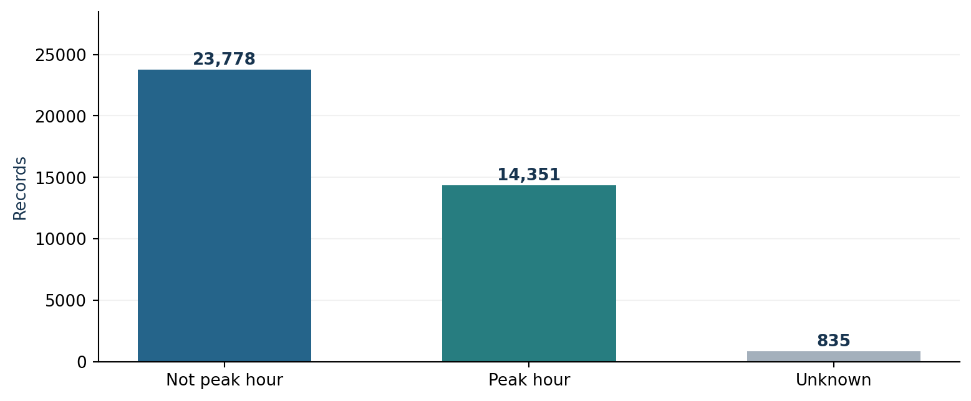
Figure 3. Distribution of the engineered peak-hour feature. Source: charts recreated from recorded Week 2 notebook summary outputs.
The counts are 23,778 non-peak, 14,351 peak and 835 unknown. They document the engineered flag distribution; they do not establish that peak hours actually have longer delivery times or that the chosen hours are optimal.
Methodological note The peak-hour definition was an analytical assumption, not an externally validated operating policy. Alternative time windows should be tested before drawing scheduling conclusions.

14. Before-and-after data quality results
Indicator | Original dataset | Processed dataset | Meaning
Records | 38,964 | 38,964 | No row loss
Columns | 22 | 27 | Five added features
Missing cells | 2,909 | 2,505 | 404-cell net reduction
Duplicate rows | 0 | 0 | No exact duplication
Missing Time_Orderd | 835 | 835 | Unknown time retained

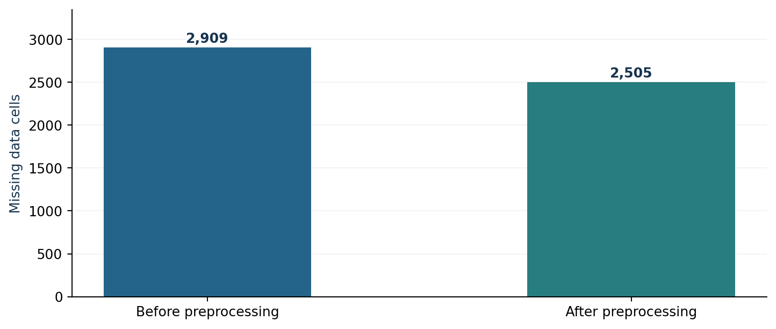
Figure 4. Total missing cells before and after cleaning. Source: charts recreated from recorded Week 2 notebook summary outputs.
The chart compares missing-cell totals across datasets of different widths. The 404-cell reduction is genuine, but should not be confused with an equivalent number of newly complete records. Remaining missingness is intentionally retained.

14.1 Interpretation of the remaining 2,505 cells
Field remaining incomplete | Missing cells | Why retained
Time_Orderd | 835 | Source lacks trustworthy order clock time
order_hour | 835 | Cannot derive hour from an unknown time
is_peak_hour | 835 | Cannot assign peak/off-peak when hour is unknown
Total | 2,505 | Three linked fields per affected record

The 835 source records represent about 2.14% of the 38,964 rows. In the processed dataset, the 2,505 missing cells occur across three related columns; reporting this as 2,505 different affected records would be incorrect.

15. Final validation, export and reproducibility
The processed dataframe was copied, its index reset, and a CSV export created. The exported CSV was then reloaded and checked against the in-memory dataframe. The final verification returned matching dimensions and zero duplicates.
df_processed = df.copy()
df_processed.reset_index(drop=True, inplace=True)
output_path = "/content/Week_2_Preprocessed_Logistics_Dataset.csv"
df_processed.to_csv(output_path, index=False)
exported = pd.read_csv(output_path)
print(exported.shape)
print(exported.isna().sum().sum())
print(exported.duplicated().sum())
Export quality check | Verified result
In-memory processed shape | (38,964, 27)
Reloaded CSV shape | (38,964, 27)
Reloaded missing cells | 2,505
Reloaded duplicate rows | 0
Shape check | Passed
Duplicate check | Passed

15.1 File handoff and repeatability
The notebook and CSV should be stored alongside the report in the dedicated Week 2 GitHub repository. Four notebook-generated images have been recorded by filename: missing_values_before_after.png, outlier_analysis.png, scaling_comparison.png and preprocessing_pipeline.png. The figure illustrations embedded here use recorded aggregates and are not presented as the original notebook graphics.

15.2 Further safeguards for downstream models
- Create explicit training, validation and test splits before fitting imputers and scalers.
- Check for time-based leakage and repeated delivery-person IDs across split boundaries.
- Store fitted preprocessing objects in a reusable pipeline when training a model.
- Verify that operational categories and allowed values match the intended deployment period.
- Document whether 835 unknown order times are excluded from time-specific tests or handled via explicit missing indicators.

16. Consequences for logistics decision-making
A more consistent dataset supports credible measurement and analysis of delivery performance. For example, trustworthy distance measurements and labeled traffic conditions may be compared with time outcomes, provided proper confounding checks are performed. Consistent categories help avoid accidentally splitting similar conditions into separate dashboard labels.

16.1 Future predictive model implementation
A concrete next-stage experiment could define delivery duration (Time_taken (min)) as the target, select appropriate numeric and categorical predictors, split data without leakage, fit preprocessing on the training split, and compare a simple baseline regression with more flexible models. Evaluation should include MAE and RMSE, and R² where useful. R² is a goodness-of-fit measure, not a classification accuracy score. No such new Week 2 metrics are reported.

16.2 Future optimization implementation
A route-planning study would require additional decision data beyond this dataset: restaurant/depot assignments, road-network travel-time matrices, promised delivery windows, available couriers, capacity and operational costs. A concrete implementation path would be: (1) estimate travel times or use a routing service, (2) represent stops and constraints, (3) create a feasible baseline schedule, (4) solve a constrained vehicle-routing problem, and (5) compare distance, lateness and operational cost on held-out scenarios. Google OR-Tools documents routing with capacities and time windows. [7]

16.3 Why preprocessing matters to these proposals
A missing order clock time may invalidate a promise-window calculation, while the preserved lower rating scores may identify service-quality risk worth monitoring. Appropriate scaling can support selected prediction methods, and consistent categories make robust segmentation possible. These are expected analytical benefits, not measured reductions in costs or delivery time.

17. Limitations, reflection and conclusion

17.1 Limitations
- This is a reused public dataset; its source operational truth was not independently audited.
- The 835 missing source order times could not be recovered without external records.
- Median and mode imputation may reduce the natural variation of predictors.
- The peak-hour window was chosen for illustration and not tested against actual demand or delays.
- Full parsing of Order_Date and Time_Order_picked was not part of the recorded processing result.
- No fresh forecasting experiment, causal inference or optimization improvement was executed in Week 2.

17.2 Practical reflection
The most important technical lesson was that a failed conversion is not the same as missing source information. The first time parser produced an artificially large number of missing values; keeping df_original made it possible to correct the interpretation and preserve genuine clock-time data. A second lesson was that columns should be classified by their actual values and meanings rather than by their names. The delivery_speed label sounded numeric, yet its values were categorical. A third lesson was that outliers require domain reasoning: valid low ratings must not be erased simply to make a distribution look cleaner.

17.3 Conclusion
The Week 2 preprocessing pipeline was completed and its export verified. It retained all 38,964 source rows, expanded the dataset from 22 to 27 columns, reduced missing data cells from 2,909 to 2,505, and preserved 835 genuinely unknown order times across three related fields. The 2,147 IQR-flagged ratings were retained after verifying that none violated the 1–5 scale. Age, rating and distance standardization passed the expected summary checks. These outcomes provide a traceable dataset-preparation base for later logistics analysis, provided future models handle leakage, source limitations and missing timestamps appropriately.

References
[1] Hugging Face. (n.d.). allenborochin/zomato_delivery_EDA [Dataset card]. https://huggingface.co/datasets/allenborochin/zomato_delivery_EDA
[2] Jahani, H., Jain, R., & Ivanov, D. (2023, online publication). Data science and big data analytics: A systematic review of methodologies used in the supply chain and logistics research. Annals of Operations Research. https://doi.org/10.1007/s10479-023-05390-7
[3] Emmanuel, T., Maupong, T., Mpoeleng, D., Semong, T., Mphago, B., & Tabona, O. (2021). A survey on missing data in machine learning. Journal of Big Data, 8, Article 140. https://doi.org/10.1186/s40537-021-00516-9
[4] Smiti, A. (2020). A critical overview of outlier detection methods. Computer Science Review, 38, Article 100306. https://doi.org/10.1016/j.cosrev.2020.100306
[5] pandas development team. (n.d.). Working with missing data. pandas documentation. https://pandas.pydata.org/docs/user_guide/missing_data.html
[6] scikit-learn developers. (n.d.). StandardScaler documentation. https://scikit-learn.org/stable/modules/generated/sklearn.preprocessing.StandardScaler.html
[7] Google OR-Tools. (n.d.). Vehicle routing problem with time windows. https://developers.google.com/optimization/routing/vrptw

Citation and evidence note
External references above support the general methodology and identify the dataset origin. Every project-specific count and decision was drawn from the recorded Week 2 notebook outputs supplied in the project conversation. These references should not be read as independent verification of every source-table value.

Appendix A — Detailed processing decision matrix
Problem / observation | Detection | Selected action | Reason | Downstream consequence
2,909 missing input cells | isna() audit | Targeted fill + retention | Different columns have distinct meanings | Clearer analytics; some unknowns preserved
Mixed order-time types | Inspect value types / parsing | Custom time parser | Avoid false NaT on decimal fractions | Restores usable order-hour values
835 unknown order times | Post-correction missing audit | Keep NaT | No trusted timestamp evidence | Time-based features remain unavailable
Exact duplicate rows | duplicated() | No deletions | Zero duplicates observed | Keeps 38,964 records
2,147 IQR rating flags | Quartiles + limits | Retain | All lie within 1–5 | Does not erase valid negative ratings
delivery_speed object type | dtype and unique review | Exclude from numeric IQR | Slow/Average/Fast labels | Prevents invalid arithmetic
Mixed numeric scales | Summaries + field purpose | Z-score 3 predictors | Comparable feature scales | Useful for later selected algorithms
Order time has hourly signal | Time parser + .dt.hour | Add order_hour and peak flag | Operationally interpretable grouping | Enables later time-of-day analysis
Need reusable output | CSV export and reload | Verify dimensions/missing/duplicates | Catch file handoff errors | Reusable Week 3/4 input

Appendix B — Numerical audit and chart notes

B.1 Recorded category distribution
Weather: Fog 6,660; Stormy 6,572; Cloudy 6,563; Sandstorms 6,489; Windy 6,436; Sunny 6,244. Traffic: Low 13,139; Jam 12,414; Medium 9,556; High 3,855. City: Metropolitian 30,036; Urban 8,782; Semi-Urban 146. Festival: No 38,180; Yes 784.

B.2 Rating outlier distribution
Flagged rating | Count | Flagged rating | Count
2.5 | 18 | 3.3 | 23
2.6 | 19 | 3.4 | 30
2.7 | 20 | 3.5 | 228
2.8 | 17 | 3.6 | 187
2.9 | 18 | 3.7 | 197
3.0 | 5 | 3.8 | 211
3.1 | 25 | 3.9 | 169
3.2 | 26 | 4.0 | 954

The counts across the values shown total 2,147, matching the notebook’s IQR flag count. Ratings are statistically flagged relative to the sample distribution, not marked invalid in the 1–5 rating system.

B.3 Figure provenance
Figure 1 (pipeline), Figure 2 (IQR counts), Figure 3 (peak-hour group counts) and Figure 4 (missing-cell totals) were rendered for this report using the summarized, verified notebook results. They are explanatory reproductions. To use exactly the original Week 2 Colab images for the mentor’s submission, replace these graphics with the four exported PNGs listed in Section 15.

