BUSINESS ANALYTICS REPORT

Customer Acquisition &
Marketing Analytics
Dashboard

An end-to-end analytics project examining channel efficiency,
customer lifetime value, and churn risk across 10,127 credit card customers
Prepared by | Kashish Mudliyar
Tools Used | Python · SQL · Power BI
Dataset | BankChurners — 10,127 records

1. Executive Summary
This report presents the findings of an end-to-end data analytics project built to address a core business challenge faced by retail banks: optimising marketing spend across acquisition channels while retaining high-value customers. Using a dataset of 10,127 credit card customers, the project delivers actionable insights through a Python-and-SQL data pipeline and a two-page interactive Power BI dashboard.
Key Performance Indicators
10,127 | 16.1% | $39.58 | $314,958
Total Customers | Overall Churn Rate | Lowest CPA (Google Ads) | Highest Segment LTV

The analysis surfaces three findings with immediate business value:
- Google Ads is the most cost-efficient acquisition channel at $39.58 per customer, while Email wastes budget — generating the most leads (3,361) yet converting at the lowest rate (35.4%).
- Platinum card holders in the $60K–$80K income bracket carry an estimated lifetime value of $314,958 — 17 times higher than the lowest Blue card segment — making them the priority retention target.
- Gold card customers earning $80K–$120K churn at 23.8%, the highest rate in a high-value tier, representing a significant and addressable revenue risk.

Business Recommendation
Reallocate 15–20% of Email and Branch marketing spend toward Google Ads and Referral channels. Launch a targeted retention programme for Gold card customers in the $80K–$120K income bracket before churn compounds.
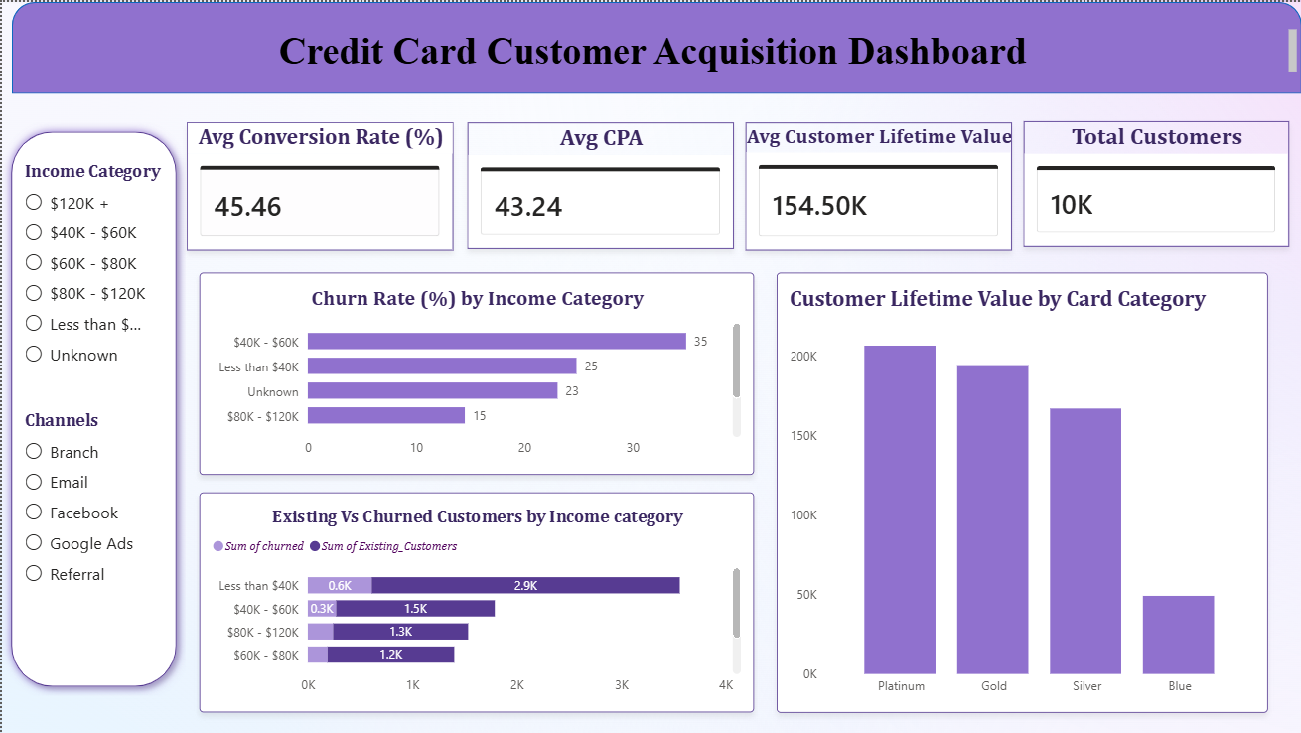

Dashboard Page 1

2. Problem Statement & Objectives
Business Context
A retail bank operates five marketing channels — Google Ads, Facebook, Email, Referral, and Branch — and spends approximately $271,858 annually on customer acquisition campaigns. Despite this spend, management has no unified view of which channels are generating quality customers and which are producing leads that never convert. Simultaneously, a 16.1% overall churn rate suggests that retention strategy requires attention, but without segment-level visibility it is impossible to know where to focus.
Problem Statement
Marketing and product teams are unable to make data-driven budget allocation decisions because channel performance, customer value, and churn risk data are siloed across multiple sources and have never been modelled together. This results in continued spend on underperforming channels and a lack of proactive retention action.
Project Objectives
- Quantify the conversion rate and cost-per-acquisition for each marketing channel
- Estimate customer lifetime value (LTV) segmented by card category and income bracket
- Identify which customer segments carry the highest churn risk
- Deliver an interactive dashboard enabling non-technical stakeholders to explore findings independently
- Produce a customer segmentation model using RFM scoring and K-Means clustering to enable personalised targeting

Scope
This project covers acquisition analytics (channel performance, cost efficiency, monthly trends) and customer analytics (LTV, churn, RFM segmentation, K-Means clustering). It uses a 10,127-row customer dataset supplemented by a synthetic 50-campaign marketing table to simulate real multi-channel acquisition data.

3. Data Sources & Methodology
Data Sources
Source | Description | Rows | Origin
BankChurners.csv | Credit card customer demographics, transaction behaviour, attrition flag | 10,127 | Kaggle (Sakshi Goyal)
marketing_campaigns | Channel, spend, leads, and customers acquired per campaign | 50 | Synthetic — generated via NumPy
analytics_output.xlsx | SQL pipeline output: 5 KPI tables exported for Power BI | — | Generated
segmentation_output.xlsx | RFM scores and K-Means cluster labels per customer | 10,127 | Generated

Pipeline Architecture
The project follows a sequential, reproducible pipeline. Raw data enters a SQLite database, is queried for KPIs, enriched through Python machine learning, then exported to Excel for Power BI consumption.
1 | Ingest | BankChurners.csv loaded into SQLite via pandas. Synthetic campaigns table generated with NumPy random seed 42 for reproducibility.
2 | SQL KPIs | Five queries calculate: (a) conversion rate by channel, (b) campaign ROI and CPA, (c) CLV proxy by segment, (d) monthly acquisition trend, (e) attrition rate by card and income.
3 | Segment | RFM scoring assigns quintile scores (1–5) for Recency, Frequency, and Monetary value. Total RFM score maps to five segment labels: Champions, Loyal, Potential Loyalists, At Risk, Lost.
4 | Cluster | K-Means clustering (k=4) applied to five standardised features: age, credit limit, transaction count, transaction amount, utilisation ratio. StandardScaler applied prior to fitting.
5 | Visualise | All outputs exported to Excel. Power BI imports both files, builds relationships on shared keys, and renders a two-page interactive dashboard.

CLV Methodology Note
Customer Lifetime Value is estimated as: (Average Credit Limit × Average Transaction Count) / 12. This is an intentional simplification for portfolio demonstration — a production CLV model would incorporate discount rates, retention probability, and margin data. The formula captures the two primary value drivers (credit utilisation potential and transaction frequency) without requiring unavailable revenue margin data.

4. Channel Performance Analysis
This section examines the efficiency of each marketing channel using two complementary lenses: conversion rate (lead quality) and cost-per-acquisition (spend efficiency). Together, these metrics paint a complete picture of where marketing budget generates the best return.

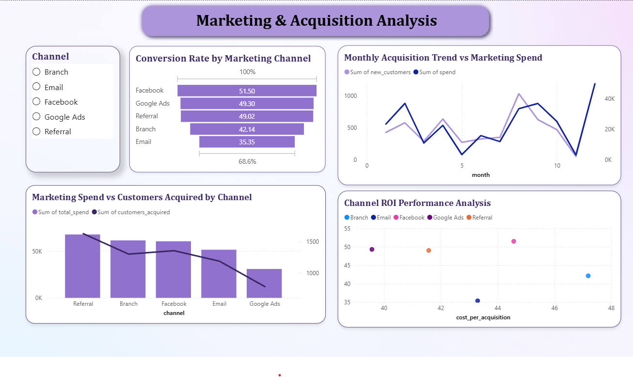
Power BI Dashboard 2
4.1 Conversion Rate by Channel
Channel | Total Leads | Customers Acquired | Conversion Rate | Assessment
Facebook | 2,633 | 1,356 | 51.50% | Best converter
Google Ads | 1,582 | 780 | 49.30% | Strong converter
Referral | 3,323 | 1,629 | 49.02% | High volume + solid rate
Branch | 3,087 | 1,301 | 42.14% | Average
Email | 3,361 | 1,188 | 35.35% | Poor — most leads, worst rate

Facebook converts over half of all leads into customers and also the strongest performance across all channels. The Email channel presents the most glaring inefficiency: it generates the largest volume of leads (3,361) yet converts fewer than 1 in 3. This suggests systematic audience targeting failure — the Email channel is reaching people who have low intent to acquire a credit card.
Key Finding — Email Inefficiency
Email generates 24% more leads than any other channel yet produces the fewest customers relative to investment. Improved audience segmentation or lead qualification criteria could recover significant conversion value without additional spend.

4.2 Campaign ROI & Cost Per Acquisition
Channel | Total Spend | Customers Acquired | Cost Per Acquisition | Rank
Google Ads | $30,870 | 780 | $39.58 | Best
Referral | $67,727 | 1,629 | $41.58 | 2nd
Email | $51,437 | 1,188 | $43.30 | 3rd
Facebook | $60,432 | 1,356 | $44.57 | 4th
Branch | $61,392 | 1,301 | $47.19 | Worst

Google Ads achieves the lowest CPA at $39.58 while spending significantly less than every other channel ($30,870 vs $51K–$68K). This positions it as the clear budget-efficiency winner. Branch is the most expensive channel both in total spend ($61,392) and per-customer cost ($47.19) while delivering below-average conversion rates — a compounding inefficiency.
Referral is strategically interesting: despite the highest total spend, it delivers the most customers (1,629) and maintains a reasonable CPA. The spend level likely reflects incentive costs (referral bonuses), which are often more efficient than paid media at scale.

Strategic Implication
Google Ads delivers 20% lower CPA than Branch at less than half the spend. A budget reallocation of even $15,000 from Branch to Google Ads would be projected to yield approximately 380 additional customers based on current CPA ratios.

5. Customer Lifetime Value Analysis
Understanding which customer segments generate the greatest long-term value is essential for both acquisition targeting and retention prioritisation. The following analysis segments LTV by card category and income bracket to identify the highest-value profiles.
5.1 Top LTV Segments
Card Category | Income Bracket | Avg Credit Limit | Avg Transactions | Estimated LTV
Platinum | $60K – $80K | $34,516 | 109.5 | $314,959
Platinum | $120K+ | $34,516 | 99.5 | $286,195
Gold | $120K+ | $33,428 | 91.7 | $255,355
Gold | $60K – $80K | $33,540 | 79.9 | $223,410
Silver | Unknown | $33,510 | 77.7 | $216,975
Blue | Less than $40K | $3,331 | 65.6 | $18,219

The LTV spread across segments is stark. Platinum card holders in the $60K–$80K bracket are worth an estimated $314,959 — 17 times more than a Blue card customer earning under $40K. The top four segments are all Platinum or Gold with incomes above $60K.
Notably, Silver card customers with unknown income closely track Gold card mid-income segments in LTV, suggesting that Silver customers may be underserved and ripe for card upgrade offers if income data were captured.
5.2 LTV Drivers
LTV in this model is driven by two factors: credit limit (a proxy for customer quality and bank confidence) and transaction frequency. Platinum customers hold 10x the credit limit of lower-tier Blue customers and transact nearly twice as often. The implication for product strategy is that increasing credit limits for eligible mid-tier customers could significantly elevate their LTV trajectory.
Acquisition Targeting Insight
The highest-LTV customers are concentrated in Platinum and Gold tiers with incomes above $60K. Marketing campaigns should enrich audience targeting with income proxies (e.g. postcode, employer data) to increase acquisition of these segments through Google Ads and Referral channels.

6. Churn & Retention Analysis
Of 10,127 customers, 1,627 (16.1%) have attrited. While this overall rate is the headline figure, the business risk is not evenly distributed. Churn concentrated in high-value segments carries disproportionate revenue impact.
6.1 Churn by Segment — High-Risk Highlights
Card Category | Income Bracket | Total | Churned | Churn Rate | Risk Level
Gold | $80K – $120K | 21 | 5 | 23.81% | HIGH
Gold | Unknown | 9 | 2 | 22.22% | HIGH
Gold | $60K – $80K | 29 | 6 | 20.69% | HIGH
Silver | $80K – $120K | 117 | 22 | 18.80% | MEDIUM
Blue | $120K+ | 645 | 113 | 17.52% | MEDIUM
Blue | Less than $40K | 3,403 | 586 | 17.22% | LOW-MEDIUM

Gold card customers in the $80K–$120K bracket churn at nearly 24% — the highest rate of any segment and particularly concerning because these customers have high LTV potential. The small segment size (21 customers) means this is addressable through personalised outreach rather than mass campaigns.
The largest absolute churn volume comes from Blue card customers earning under $40K (586 churned), though this is partly a function of segment size (3,403 customers). The churn rate for this group (17.2%) is below the Gold tier risk levels, making it lower priority despite the volume.
6.2 Retention Priority Matrix
Segment | Churn Rate | LTV Level | Action Priority
Gold / $80K–$120K | 23.8% | High | Immediate
Gold / $60K–$80K | 20.7% | High | High
Silver / $80K–$120K | 18.8% | Medium-High | Medium
Blue / $120K+ | 17.5% | Medium | Monitor

7. Acquisition Growth Trends
Monthly acquisition data reveals significant variance in both volume and efficiency across the year, offering opportunities to time campaigns for maximum return.
Month | New Customers | Spend ($) | CPA ($) | Efficiency
January | 427 | 23,275 | 54.51 | Below avg
February | 578 | 36,751 | 63.58 | Poor
March | 289 | 10,905 | 37.73 | Excellent
April | 636 | 22,428 | 35.27 | Best CPA
May | 272 | 3,347 | 12.31 | Outlier — low spend
June | 326 | 15,738 | 48.28 | Average
July | 350 | 11,873 | 33.92 | Strong
August | 1,033 | 33,292 | 32.23 | Best volume + efficiency
September | 628 | 36,684 | 58.41 | Poor efficiency
October | 471 | 24,958 | 52.99 | Below avg
November | 51 | 3,193 | 62.61 | Lowest volume
December | 1,193 | 49,414 | 41.42 | Highest volume

August and December are the strongest acquisition months by volume, generating 1,033 and 1,193 customers respectively. August is particularly efficient — second-highest volume with a CPA of $32.23, well below the annual average. February and September both show poor CPA above $58 despite relatively high spend, suggesting campaign saturation or poor timing.
Seasonality Opportunity
Concentrating media spend in July–August and November–December (when efficiency is historically high) while pulling back in February and September could yield the same customer volume at materially lower total spend. Q1 and Q3 dips may also represent competitive windows worth testing.

8. Business Recommendations
Based on the analysis across channel performance, customer lifetime value, churn risk, and acquisition trends, the following recommendations are presented in priority order.
8.1 Immediate Actions (0–30 Days)
- Launch a personalised retention campaign targeting Gold card customers in the $80K–$120K income bracket. This segment churns at 23.8% and has high LTV — even recovering 30% of churned customers in this group would materially impact revenue.
- Pause or significantly reduce Branch marketing spend. At $47.19 CPA and below-average conversion rates, Branch is the least efficient channel. Redirect a minimum of $15,000 toward Google Ads.

8.2 Short-Term Actions (1–3 Months)
- Audit Email audience targeting. The channel reaches more people than any other (3,361 leads) but converts the worst (35.4%). A/B test audience segments or introduce a lead qualification step before Email outreach.
- Replicate August campaign conditions in other months. August achieved the best combination of volume and efficiency. Analyse which campaigns ran in August and attempt to reproduce or scale them.
- Introduce a card upgrade offer for Silver customers with unknown income — these customers have LTV comparable to Gold tier and may respond to targeted upgrade incentives if income data can be enriched.

8.3 Strategic Actions (3–6 Months)
- Build a predictive churn model using the existing attrition data. The current analysis identifies at-risk segments retrospectively; a model trained on Months_Inactive, Transaction_Count, and Utilisation_Ratio could flag customers before they churn.
- Implement income-based audience enrichment for paid media targeting to direct Google Ads and Facebook spend toward the $60K–$120K income profiles that generate the highest LTV.
- Set quarterly CPA targets by channel and track against dashboard — the Power BI dashboard built in this project provides the infrastructure to monitor these targets in near-real-time.

ROI of Recommendations
If Email conversion rate improves from 35% to 42% through better targeting, and Branch CPA is reduced by reallocating $15K to Google Ads, the combined effect is an estimated 350–400 additional customers acquired annually at zero incremental spend. At an average estimated LTV of $50K+ per customer, this represents multi-million dollar revenue impact.

