**Assignment 2 Mandatory Project**

**1. Create an ER diagram or draw a schema for the given database.**

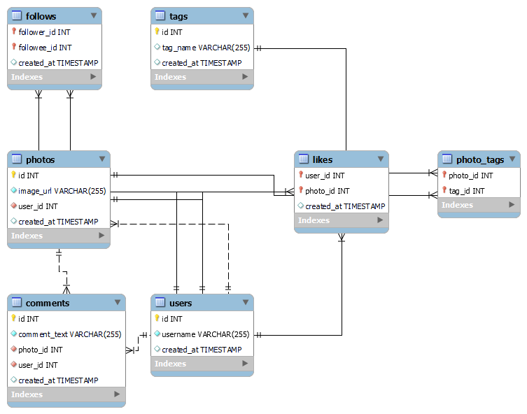

**2. We want to reward the user who has been around the longest, Find the 5 oldest users.**

**Query** Select * from users

order by created_at desc

limit 5;

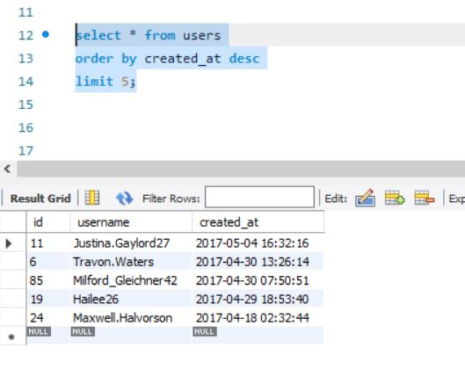

**3. To understand when to run the ad campaign, figure out the day of the week most users register on?**

Query - select Max(DAYNAME(created_at)) as weekday,count(*)

from users

group by DAYNAME(created_at)

order by count(*) desc limit 1;

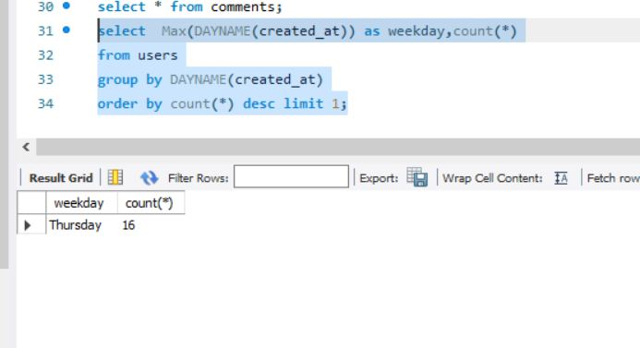

**4. To target inactive users in an email ad campaign, find the users who have never posted a photo.**

Query - select a.* from users as a

where a.id not in(select distinct b.user_id from photos as b);

Output – 26 Rows

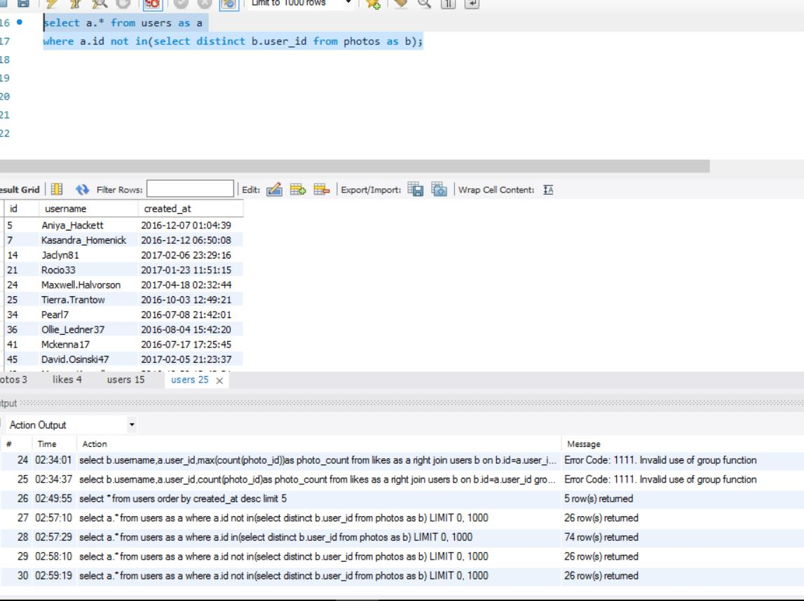

**9. To know who the celebrities are, find users who have never commented on a photo.**

Query - select a.* from users as a

where a.id not in(select distinct b.user_id from comments as b);

Output -23 rows

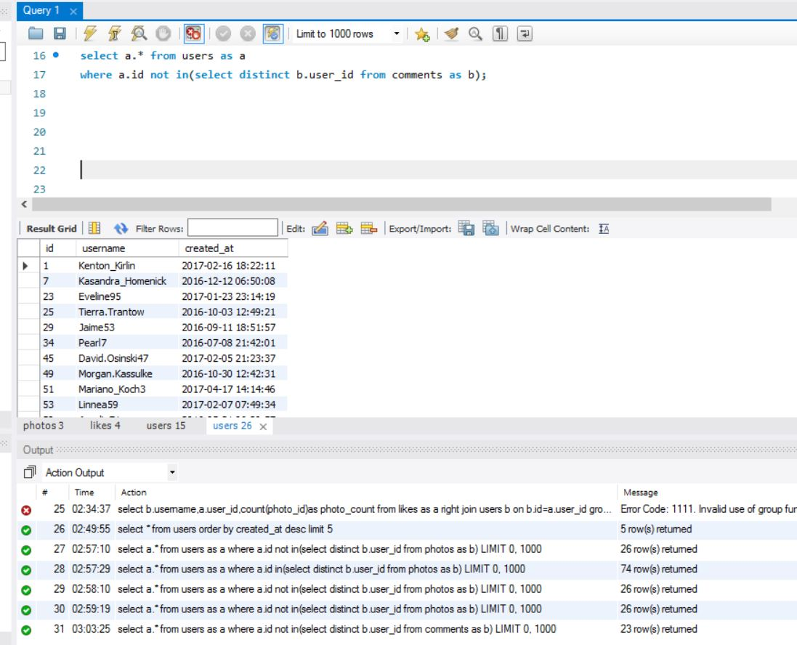

**5. Suppose you are running a contest to find out who got the most likes on a photo. Find out who won?**

Query - select photos.user_id,users.username,

photo_likes.like_count from photos

inner join(select photo_id,count(*)as like_count from likes group by photo_id)as photo_likes

inner join users

on users.id=photos.user_id

order by like_count desc limit 1;

