**SQL - Project**

**##1.Group the customers based on their income type and find the average of their annual income.**

select Ind_ID,Type_Income,avg(annual_income) from credit_card group by Type_Income;

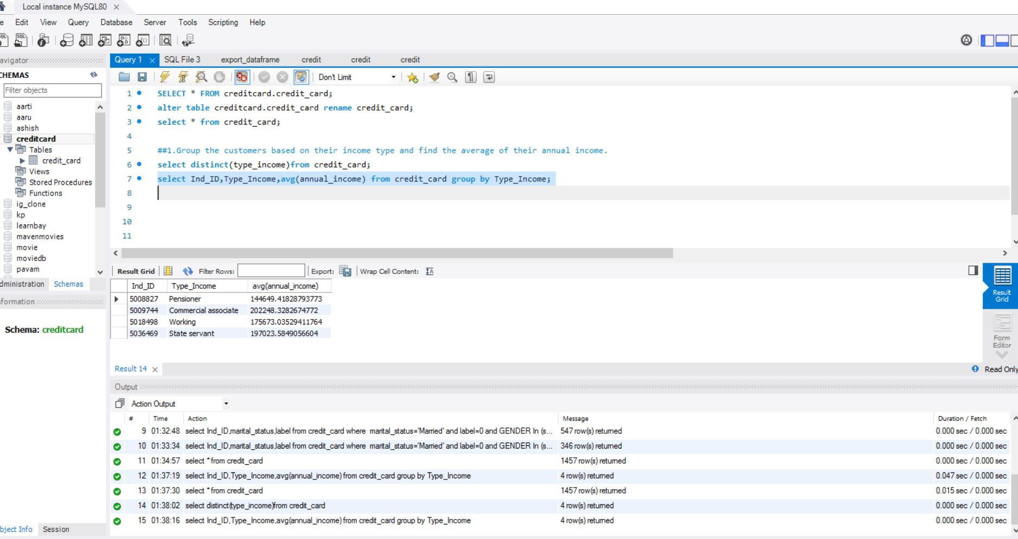

**2...Find the female owners of cars and property.**

select Ind_ID,GENDER,Car_Owner,Propert_Owner from credit_card where car_owner='Y' and propert_Owner='Y' and GENDER IN (select GENDER from credit_card where GENDER='F');

###OUTPUT ----- THERE ARE 170 females who are owner of both cars and property

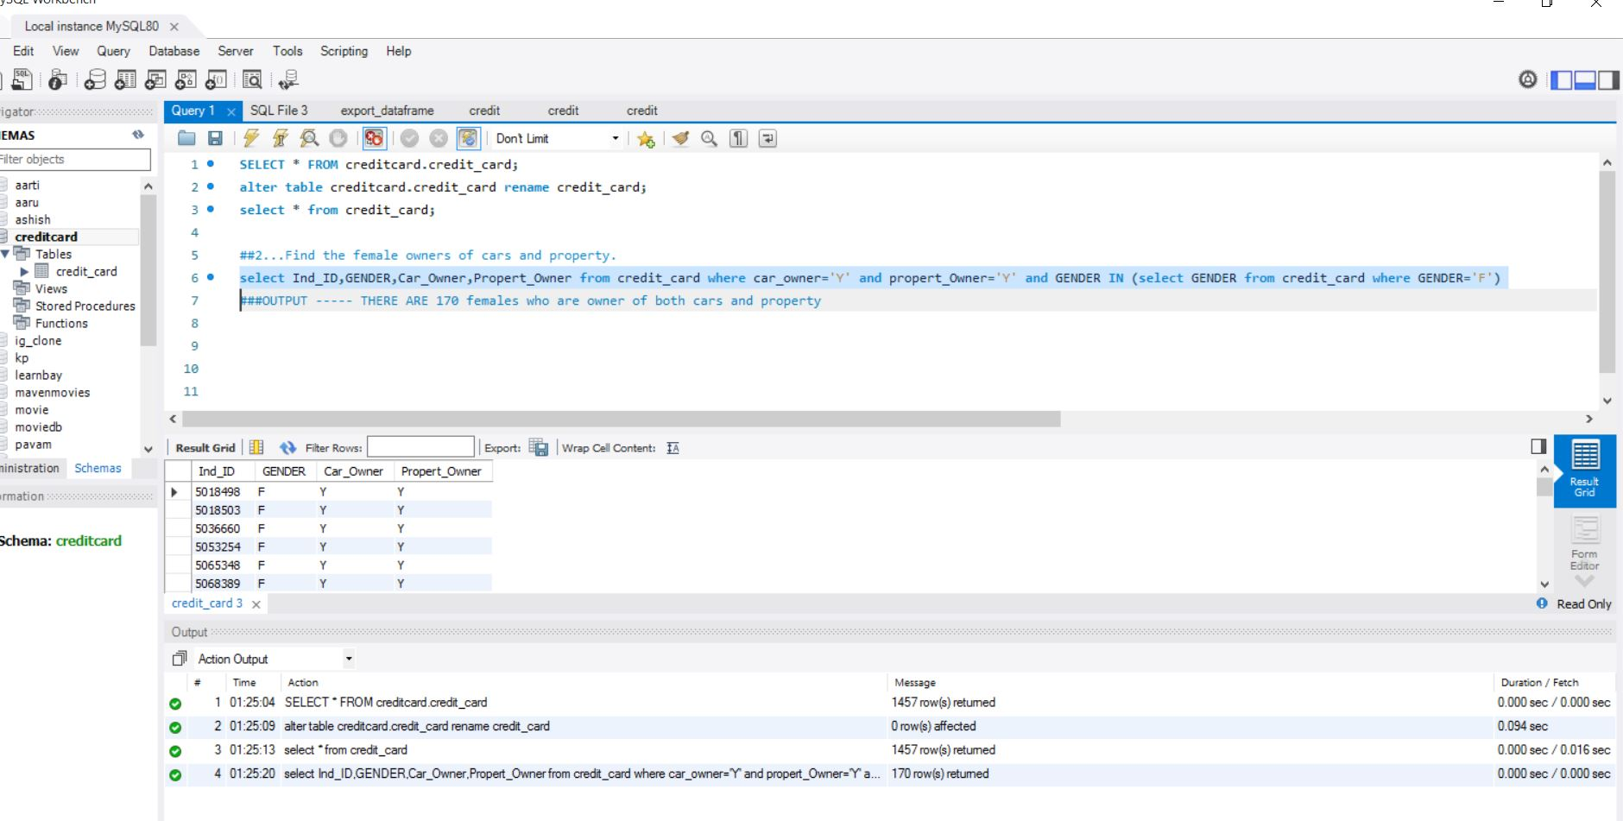

**##3. Find the male customers who are staying with their families.**

select Ind_ID,GENDER,Housing_type from credit_card where GENDER='M' and Housing_type='With parents';

###OUTPUT-- 34 male Customers stay with their families

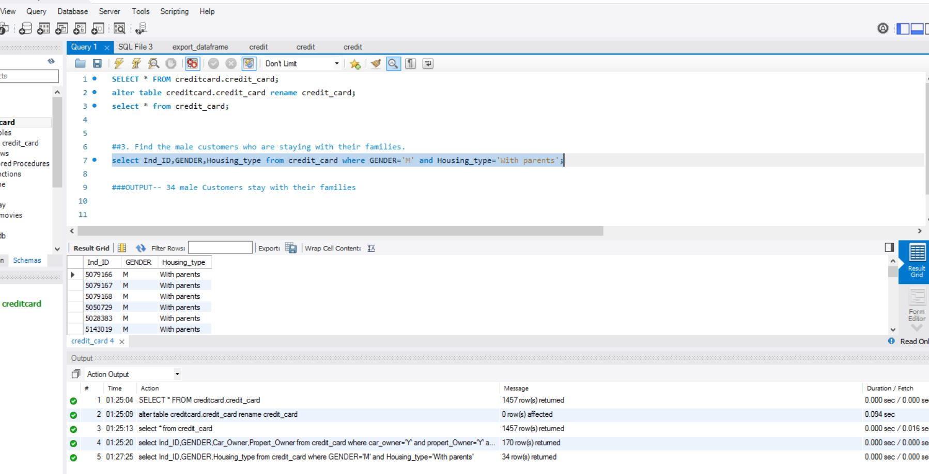

**##4.Please list the top five people having the highest income**

select Ind_ID, annual_income from credit_card order by annual_income desc limit 5;



**###5...How many married people are having bad credit?**

select Ind_ID,marital_status,label from credit_card where marital_status='Married' and label=0;

##OUTPUT-----893 MARRIED People are having bad credit



**##6.What is the highest education level and what is the total count?**

select education,count(education)from credit_card group by education;

select max(counts)from (select education, count(*)as counts from credit_card group by education)x;



**###7. Between married males and females, who is having more bad credit?**

select Ind_ID,marital_status,label from credit_card where marital_status='Married' and label=0 and GENDER In (select GENDER from credit_card where GENDER='F');

##OUTPUT ----RETURNS- 547 FEMALES HAVE BAD CREDIT

select Ind_ID,marital_status,label from credit_card where marital_status='Married' and label=0 and GENDER In (select GENDER from credit_card where GENDER='M');

##OUTPUT -----RETURNS - 346 MALES HAVE BAD CREDIT

###RESULTS ---- SO BETWEEN MARRIED MALES AND FEMALES FEMALES ARE HAVING MORE BAD CREDIT

