|  |  |
| --- | --- |
| **Ex No: 5**  **Date: 23 Sep** | **Implementation of Simple, Deep, CNN and Denoising Autoencoders** |

**Objective:**The primary objective of this report is to explore and implement various types of autoencoders, focusing on their applications in dimensionality reduction, denoising, and image reconstruction. These autoencoders are evaluated using well-known datasets like MNIST and Fashion MNIST, with different architectural approaches such as simple autoencoders, deep autoencoders for capturing more complex features, convolutional autoencoders to leverage spatial hierarchies in image data, and denoising autoencoders for reconstructing noisy inputs. Through these implementations, the report aims to analyze the performance and effectiveness of each architecture in handling these tasks.

**Description:**

1. **Simple Autoencoder:**

A simple autoencoder consists of an encoder and decoder network, where the encoder compresses the input data into a latent, lower-dimensional representation, and the decoder reconstructs the original input from this compressed form.

* **Dataset:** MNIST (handwritten digits)
* **Process:** The encoder reduces the 28x28 pixel images into a smaller latent space (for instance, 32 units), capturing the essential features of the data. The decoder then attempts to reconstruct the original image from this compressed representation. By minimizing the difference between the input and reconstructed output, the model learns to represent the data efficiently.
* **Key Concept:** The autoencoder operates in an unsupervised manner, meaning it learns the most important features or patterns within the data without requiring labeled output. The model identifies a compressed encoding that retains critical information for reconstruction while ignoring less important details, which helps in dimensionality reduction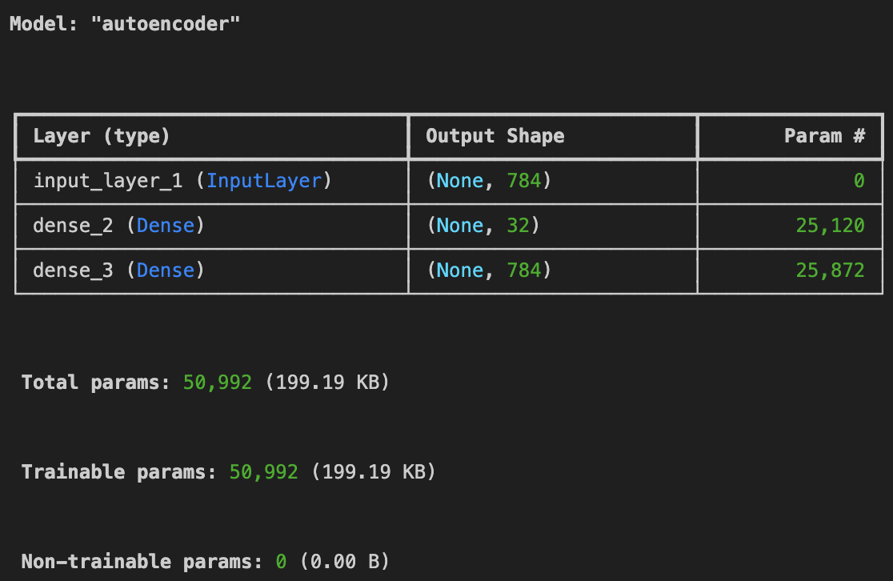

Fig 1: Autoencoder Model of the simple autoencoder

1. **Deep Auto-encoder**

A deep autoencoder has multiple layers in both the encoder and decoder, allowing the network to learn complex, hierarchical representations.

* **Dataset:** MNIST
* **Process:** The encoder consists of several hidden layers, progressively reducing the dimensionality. The decoder mirrors this structure, gradually reconstructing the input from the latent space.
* **Key Concept:** The deeper architecture enables the network to learn more abstract and non-linear features of the data, allowing for better compression and reconstruction.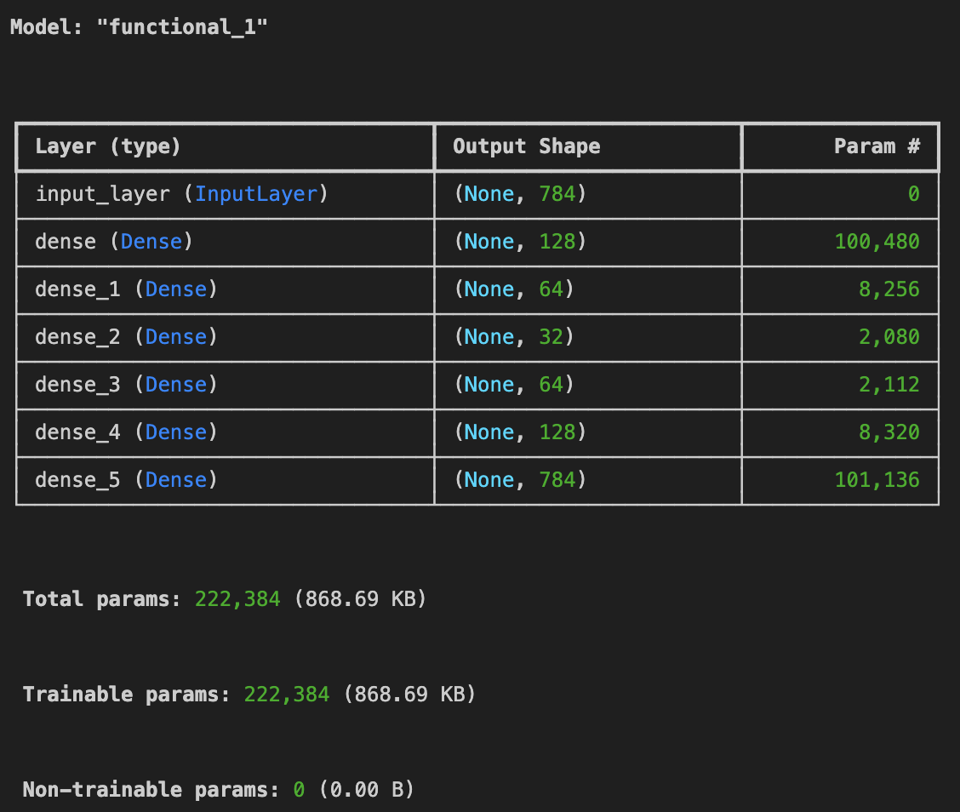

**FIg 2**: Autoencoder model of the Deep Autoencoder

1. **CNN Autoencoder**

CNN autoencoders replace fully connected layers with convolutional layers, which are particularly effective for image data.

* **Dataset:** Fashion MNIST (images of clothing items)
* **Process:** The encoder uses convolutional layers to capture spatial features, and the decoder uses deconvolutional layers to reconstruct the image.
* **Key Concept:** CNNs excel at capturing spatial relationships in the data, making this type of autoencoder ideal for image processing tasks.

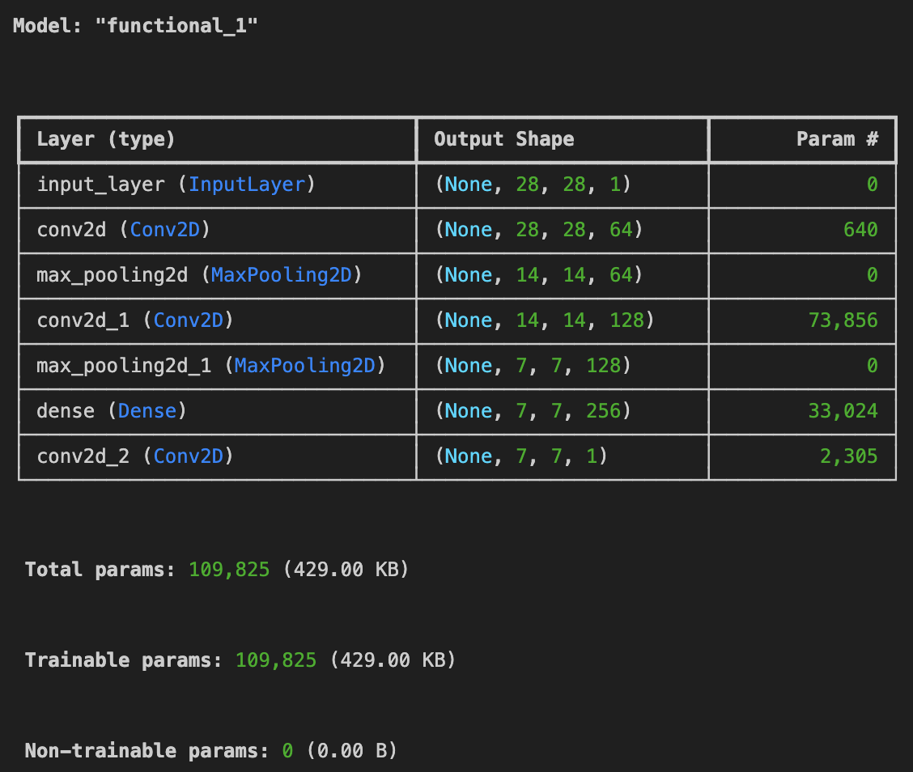

**FIg 3**: Autoencoder model of the CNN Autoencoder

1. **Denoising Autoencoder:**

A denoising autoencoder is designed to remove noise from data by training the model to reconstruct a clean version from corrupted input.

* **Dataset:** MNIST or Fashion MNIST
* **Process:** The input images are corrupted by adding noise, and the autoencoder is trained to recover the original clean images.
* **Key Concept:** The network learns to filter out noise and irrelevant information, improving the quality of the reconstructed data.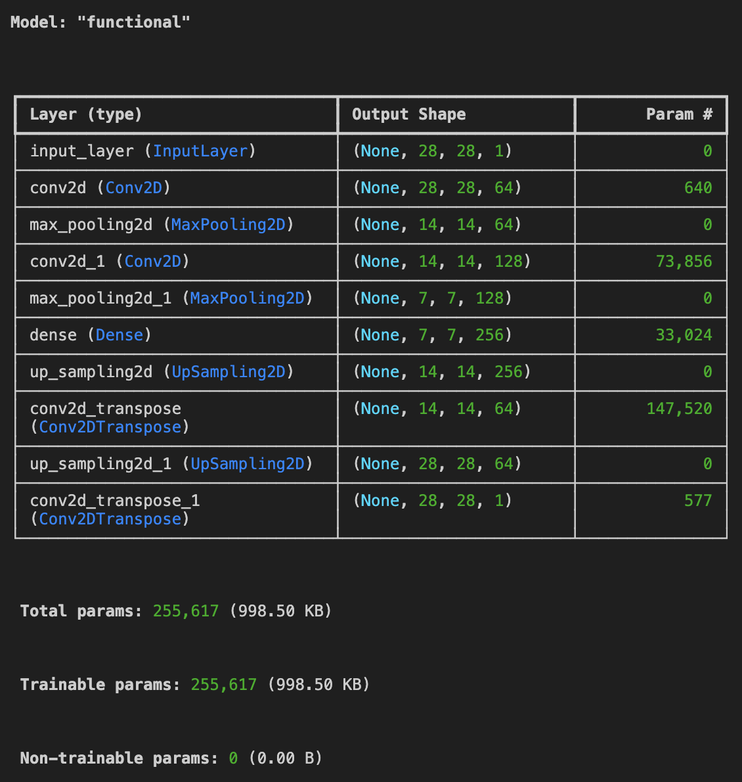

**Fig 4:** Autoencoder model of the Denoising Autoencoder

**Building the parts of the algorithm**

**1. Encoder:** The encoder reduces the input data into a compressed latent space. Depending on the autoencoder type:

* **Simple/Deep Autoencoder:** Uses fully connected (dense) layers to reduce the dimensionality.
* **CNN Autoencoder:** Uses convolutional layers to capture spatial hierarchies in the input image.
* **Denoising Autoencoder:** The encoder compresses noisy data into a cleaner latent space representation.

**2. Decoder:** The decoder reconstructs the original input from the compressed latent space.

* **Simple/Deep Autoencoder:** The decoder mirrors the encoder using fully connected layers to recreate the original image.
* **CNN Autoencoder:** The decoder uses deconvolutional (transposed convolution) layers to up-sample and reconstruct the image.
* **Denoising Autoencoder:** The decoder reconstructs the clean version of the input by learning how to reverse the corruptions applied to the data.

**3. Loss Function:** Autoencoders typically use Mean Squared Error (MSE) as the loss function, which measures the reconstruction error between the original input and the reconstructed output.

**4. Training Process:** The training process involves minimizing the reconstruction error using backpropagation. Optimizers such as Stochastic Gradient Descent (SGD) or Adam are employed to update the model’s weights.

**Conclusion:**

Autoencoders are powerful tools for dimensionality reduction, feature extraction, and noise removal, with different architectures catering to specific tasks. Simple and deep autoencoders excel at compressing data while retaining essential features, making them useful for efficient data storage and analysis. Deep autoencoders capture more complex, hierarchical patterns, while CNN autoencoders are particularly suited for image-based tasks due to their ability to capture spatial features. Denoising autoencoders further extend their utility by effectively reconstructing clean data from noisy input. Overall, autoencoders are versatile, enabling efficient data representation and preprocessing in a variety of machine learning applications.